Occurrence and Habitat Association of the Indian Common Myna (Acridotheres tristis) in Small Urban Centre in Zimbabwe

.

Aims: This study examined the occurrence and habitat association of the invasive Indian Common Myna (Acridotheres tristis) in Gokwe Town, Midlands Province, Zimbabwe.
Study design: Systematic transect surveys were conducted across major urban land-use zones.
Place and Duration of Study: Study done in Gokwe Town (11, 200km²) in the Midlands Province of Zimbabwe with a human population of 33,075. The surveys were conducted from June to September 2025.
Methodology: Systematic transect surveys were conducted along transects measuring 900 m in length and 50 m in width across major land-use zones (high-density, medium-density, low-density residential area, the Central Business District and along the major highway corridor) and all the observations were recorded using Kobo Collect Toolbox with GPS integration. Data were analyzed in IBM SPSS non-parametric analyses: chi-square tests and Density Estimation (DE) in QGIS.
Results: A total of 81 observations were made and pairs of individuals (67.9%) dominated sightings across all times of day. The distribution of A. tristis was significantly associated with land-use type (χ² = 259.571, P = 0.01), with the species most frequently observed in open grounds, shopping areas, factories, and service businesses zones characterized by high human activity. Roosting-site selection showed no significant association with canopy cover type, despite a tendency toward dense canopy areas.
Limitations of the study: The study was limited to a single small urban town and did not consider long term seasonal variation in abundance, habitat use behaviour.
Conclusion: Overall, the study demonstrates A. tristis strong adaptability to human-modified environments and highlights critical spatial and behavioral patterns relevant for invasive species management in urban centres as well as implications for protected areas adjacent to urban areas.

Keywords: Indian Common Myna, Urban Ecology, Invasive Species, Spatial Distribution, Habitat Utilization

1. INTRODUCTION

Biological invasions have emerged as one of the defining ecological challenges of the twenty-first century, posing significant threats to global biodiversity, ecosystem stability, and socio-economic well-being. Invasive alien species are widely recognised as major drivers of ecological change (Peller & Altermatt, 2024; N. B. Sanda et al., 2018), often leading to the displacement of native species, alteration of ecological processes, and the disruption of ecosystem services (Pyšek et al., 2020). These impacts are particularly pronounced when invasive species possess traits such as ecological generalist, behavioural flexibility, rapid reproduction, and the capacity to exploit anthropogenic habitats. Human-mediated environmental modifications including urbanisation, agricultural expansion, and habitat fragmentation further facilitate the introduction and establishment of invasive species (Borden & Flory, 2021), creating novel ecosystems in which native biodiversity is often poorly equipped to compete. The consequences of such invasions are multifaceted, encompassing ecological, economic, and social dimensions. Ecologically, invasive species can reduce species richness, alter trophic interactions, and affect ecosystem functioning (Linders et al., 2019). Economically, they can damage crops, compromise livestock, and necessitate costly management interventions. Socially, invasive species can generate human-wildlife conflicts, compromise public health, and affect cultural and recreational values (Ramadhan, 2024).

Among avian invasive species, the Indian Common Myna (Acridotheres tristis) has attracted substantial attention due to its extraordinary adaptability and pronounced ecological impacts (Magory Cohen et al., 2021). Originally native to South and Southeast Asia, the species has successfully colonised multiple continents, including Africa, Australia, the Middle East, and various island ecosystems (Hart et al., 2020). Its rapid proliferation in urban and peri-urbarn landscapes worldwide has been facilitated by its ability to exploit human-modified environments. In these contexts, the Myna often becomes highly abundant, displaying aggressive interactions with native avifauna, utilising artificial nesting sites, and thriving on anthropogenic food resources. As a result, the Indian Common Myna has been included in the International Union for Conservation of Nature (IUCN) list of the world’s 100 worst invasive alien species (Feare et al., 2022), reflecting its capacity to significantly alter native ecosystems, reduce biodiversity, and create social nuisances.

The ecological success of the Indian Common Myna can be attributed to a combination of behavioural, physiological, and ecological traits (Lermite, 2025). As a generalist feeder, the species consumes a diverse diet including fruits, seeds, insects, and human food waste (Engel et al., 2025). This dietary flexibility allows it to exploit a wide range of habitats, from natural woodlands to densely built urban areas. Its opportunistic nesting behaviour further enhances its adaptability. The species readily utilises cavities in buildings, streetlights, and other artificial structures that are abundant in urban landscapes. Aggressive and territorial by nature, Mynas frequently displace native bird species from nesting and foraging sites, intensifying competition for limited resources and contributing to declines in native populations (Charter et al., 2016). Additionally, the species’ ability to form large roosting aggregations enables rapid population growth and facilitates the spread of individuals into new areas, reinforcing its invasive potential.

Globally, the impacts of the Indian Common Myna have been extensively documented. In Australia, studies have demonstrated that Mynas out-compete native hollow-nesting species such as rosellas and parrots (Lermite, 2025), leading to measurable declines in their populations. Large urban roosts contribute to noise pollution, fouling of public spaces, and heightened risk of disease transmission. Similarly, in South Africa, the proliferation of Mynas in urban centres and agricultural landscapes has raised concerns among conservationists and farmers alike. Their foraging behaviour causes significant crop damage, particularly in fruit orchards, vineyards, and grain storage facilities, while roosting behaviour in urban centres generates sanitation challenges and public health risks. These examples illustrate the species’ capacity to thrive in human-dominated landscapes and underscore the importance of understanding its ecological and socio-economic impacts within local contexts.

In Zimbabwe, reports of Indian Common Myna presence was first documented by Douthwaite in 2015 in the Victoria Falls (Kopij, 2025). Since then, the presence of the bird species has increased over recent years in urban cities (Craig et al., 2021). While anecdotal accounts suggest rapid population growth and expanding distribution, systematic research documenting the species’ ecology, proliferation, and impacts remains scarce. This knowledge gap is of particular concern given the ongoing urbanisation in Zimbabwe, which generates ecological conditions favourable to invasive species. Urban centres often provide abundant food resources in the form of improperly managed waste, accessible water sources, and artificial structures suitable for nesting. Human behaviours, such as deliberate feeding of birds, waste disposal practices, and urban construction designs, inadvertently enhance habitat suitability for invasive species like the Indian Common Myna. Consequently, cities not only facilitate the establishment of such species but also act as hubs for their dispersal into surrounding natural and semi-natural landscapes, making urban ecology a critical lens for studying biological invasions.

Urbanisation itself is a central driver of ecological change in Zimbabwe and across the globe (Marondedze & Schütt, 2019; Carlon and Dominoni, 2024). Rapid population growth, expansion of built-up areas, and increased human activity have transformed landscapes, creating a complex mosaic of habitats that can either inhibit or facilitate the spread of invasive species. The availability of anthropogenic resources food, water, and shelter combined with reduced predation pressure, often creates conditions where invasive species such as the Myna can out-compete native fauna (Rogers et al., 2023). Furthermore, urban centres frequently serve as nodes in broader ecological networks, linking rural and peri-urbarn areas and enabling the dispersal of highly mobile species. Within this context, understanding the interaction between urban environmental drivers and invasive species dynamics is critical for designing effective management and conservation strategies (Walker et al., 2017). This study sought to provide a snapshot of A.tristis the status of this invasive species invasive species to contribute to current knowledge of invasive species in the region.

2. material and methods

2.1 Study Site
The study was conducted in Gokwe Town Centre Figure 1, located in the Midlands Province of Zimbabwe. The town is positioned within agro-ecological region IV (Musasa, 2024), which is characterised by relatively low and erratic rainfall patterns, typically ranging between 450–650 mm annually (Muchazondida & Mukorera, 2022). Temperatures in the region are generally high, with summer peaks often exceeding 30°C (Jaison et al., 2023). The area experiences a single rainy season from November to March, while the remainder of the year is predominantly dry, a climatic pattern that influences agricultural practices, vegetation cover, and ultimately the availability of habitats for bird species.

Gokwe Town is a rapidly growing urban centre (Ndemo et al., 2024). According to the Zimbabwe National statistical Agency's Population and Housing Census 2022 Report the town has a population of 33, 075 people (https://zimstat.co.zw). The urban morphology of Gokwe Town is defined by a mix of residential areas, commercial centres, open-air markets, and peri-urban fringes (Maswoswere et al., 2023). Waste management in Gokwe Town remains a key urban challenge. Like many rapidly growing towns in Zimbabwe, municipal waste disposal systems are under strain, resulting in visible accumulations of solid waste in open dumps, markets, and residential areas (Chireshe, 2020). Open waste dumps and poorly managed disposal sites attract large numbers of scavenging birds, providing consistent and predictable food sources providing favourable habitat for omnivorous invaders (Randriamiharisoa & Rakotomanana, 2021).

From an ecological perspective, Gokwe Town and its peri-urbarn edges feature a mosaic of habitats, including modified savanna woodlands, cultivated fields, and built-up areas. While natural habitats are increasingly fragmented due to urban expansion, the availability of anthropogenic habitats compensates for this loss, creating ecological niches that invasive species can exploit. The peri-urbarn zone, in particular, represents a transitional area where interactions between natural and urban ecosystems occur (Wolff et al., 2021), offering additional opportunities for Myna dispersal and colonisation.

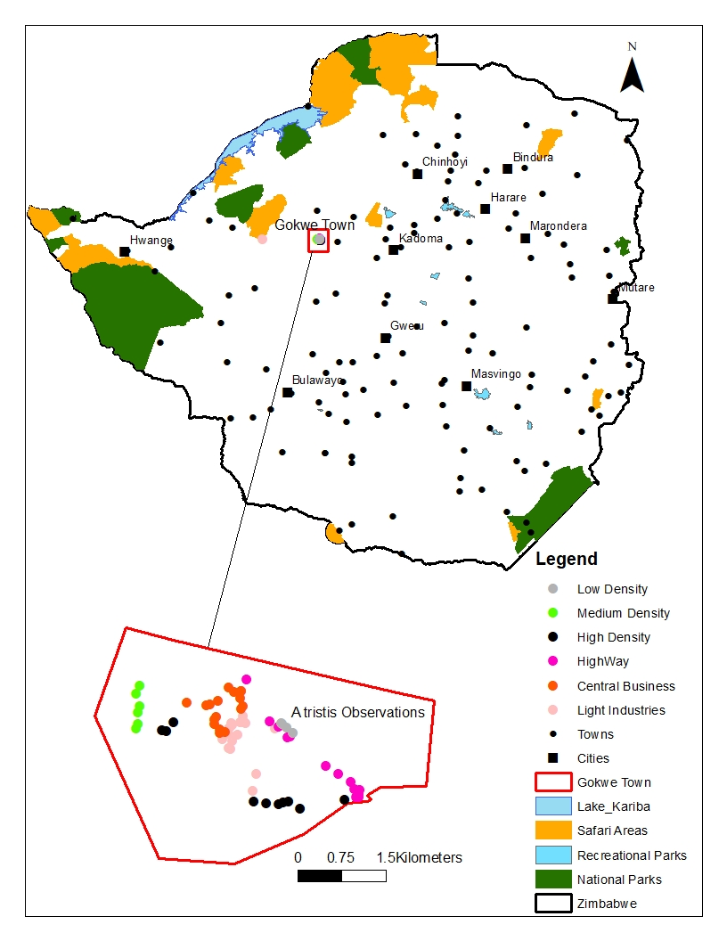
Fig 1: Location of Study area: Gokwe Town Centre: Gokwe- South: Midlands Zimbabwe

2.2 Data Collection
Data collection for this study was conducted within Gokwe Town Centre encompassing a range of distinct land-use zones which were high-density residential area, the Central Business District (CBD), low-density residential area, medium-density residential area, and the stretch along the major highway corridor to ensure spatial representation. A systematic line transect method was employed to standardize observations and reduce spatial bias. Each transect measured approximately 900 meters in length, with an observation buffer width of 50 meters on both sides, allowing for comprehensive coverage of avian activity across varying habitat types and urban land-use categories. Field observations were systematically documented using the KoboToolbox data collection platform, which enabled real-time digital recording, georeferencing, and structured data management. The specific habitat type and land-use category associated with each observation were noted to facilitate spatial mapping and statistical analysis.

2.3 Data Analysis
All data collected for this study were analyzed using IBM SPSS Statistics (Version 26), complemented by Microsoft Excel for data organization and QGIS 3.32 for geospatial analysis. Tests of normality indicated that the data set did not meet the assumptions of a normal distribution. Both the Kolmogorov–Smirnov test (D = 0.390, P < 0.001) and the Shapiro–Wilk test (W = 0.653, p < 0.001) revealed significant deviations from normality; therefore, non-parametric statistical tests were employed in subsequent analyses. All field data were initially recorded using the KoboToolbox platform, which ensured standardized data entry and facilitated seamless export into Coma Separated Value (CSV) format for further processing. Following fieldwork, datasets were imported into Excel and SPSS for data cleaning, verification, and statistical analysis. Spatial datasets including Global Positioning System (GPS) coordinates of observations, nests, and roosting sites were processed in QGIS to support mapping and spatial interpretation. Graphs and descriptive statistics were then used to summarize species abundance and distribution across land-use types, including high-, medium-, and low-density residential areas, the Central Business District, and highway corridors.

3. results and discussion

A total of 81 A. tristis observations were made during the survey period (Figure 2). There were no statistically significant variation in the abundance of group sightings across the land-use types (high-density, medium-density, low-density residential area, the Central Business District and along the major highway corridor). In all the areas, 67.9% of sites recorded two birds per observation while observations of single individuals were the second most frequent (23.5%), groups of three (1.2%), group of four (6.2%), and group of six (1.2%). The highest observation of the A. tristis were made in the Industrial sites and the least in low residential areas (Figure 3 and 4). There was significance difference in the number of observation in the six land use sites of the study area (χ² = 259.57, d.f = 210, P = .01). The majority of roosting sites (50%) were found in areas characterized by dense canopy cover, while moderate canopy cover accounted for 18.8%, sparse canopy cover for 25.0%, and only 6.3% of sites were located in areas with very little canopy cover. The Indian Common Myna was most frequently recorded in open grounds, shopping areas, factories, service businesses, and church premises.

Fig 2. Number of observations made in each land use category during the survey period in Gokwe town.

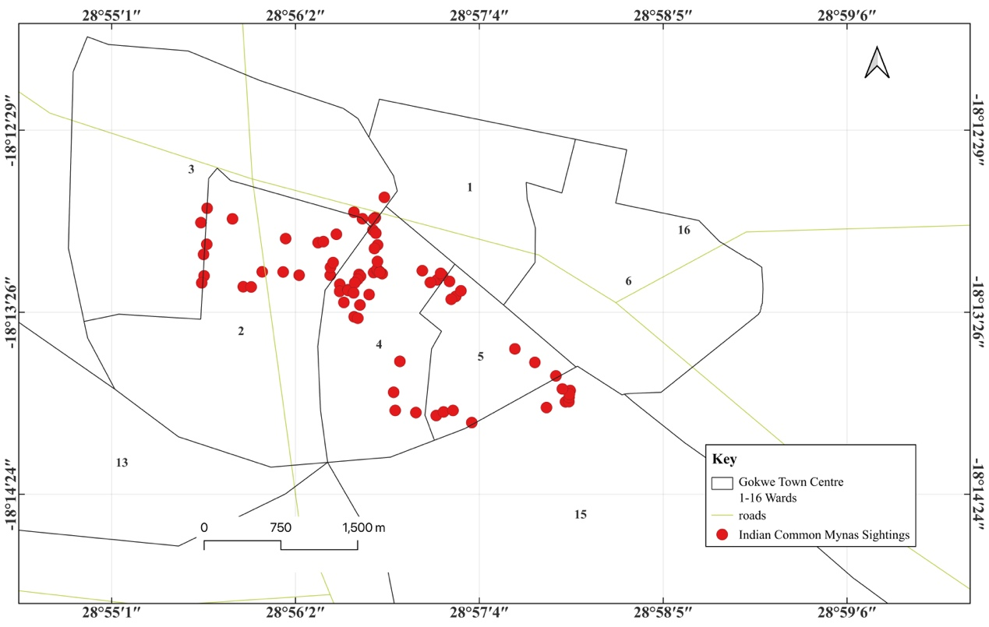

Fig 3: Spatial Distribution of Indian Common Myna: Gokwe- Town Centre
The density polygon map fig 4 of the A. tristis sightings in Gokwe Town Centre reveals a clearly uneven spatial distribution, with the highest densities concentrated in the central-western portion of the study area. This area is represented by the darkest red polygons, indicating the greatest frequency of recorded sightings. Additional moderate-density clusters extend toward the central and south-central zones, while sightings decrease markedly toward the eastern and peripheral wards, where the map shows lighter density shades. Overall, the map demonstrates that myna presence is not uniform across the town but is instead clustered around Ward 2 and Ward 4, Fig 4.

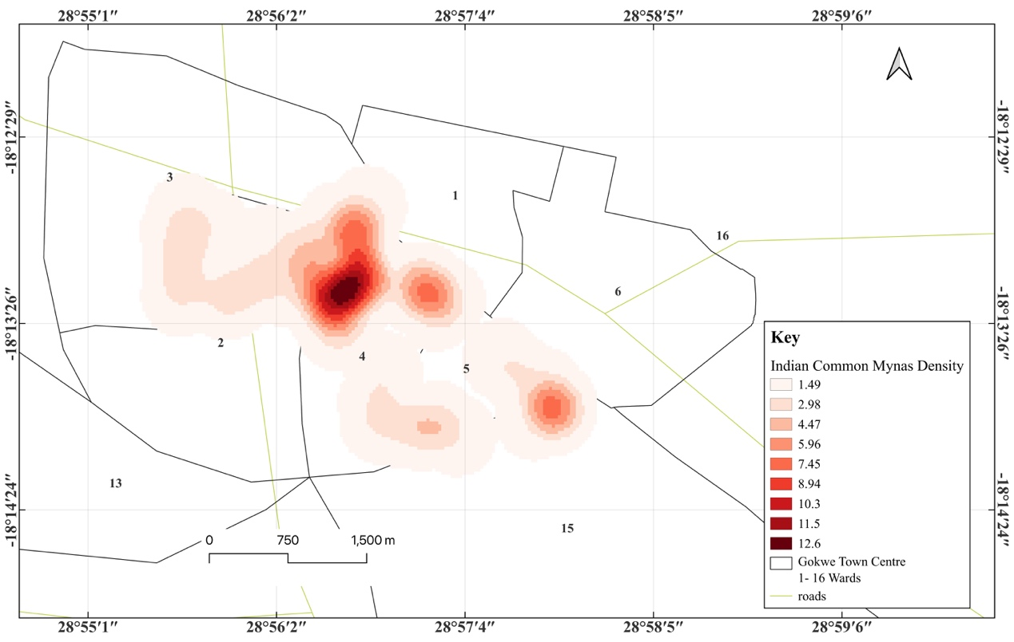

Fig 4: Kernel Density Map of A. tristis sightings in Gokwe Town. The highest densities concentrated in the central portion of the study area constituting the town centre.

The Indian Common Myna (Acridotheres tristis) is known for its adaptability and strong association with human-dominated landscapes (Pyšková et al., 2022). The results in this study showed that higher counts of A. tristis were observed in Light Industrial and Central Business District which are modified areas with high human density and activity that create resources and habitat conducive for the bird species. Industrial and residential zones provide abundant foraging opportunities from open waste bins, food outlets, and refuse associated with human activity. The A. tristis omnivorous diet enables them to exploit these resources effectively (Sadam et al., 2021). Urban structures such as building cavities, signage, and roof spaces offer plentiful nesting and roosting sites. The Mynas are cavity nesters and readily utilize artificial structures in place of natural sites (Grarock et al., 2013). Densely built areas often have fewer natural predators and high levels of human activity, which Indian common Mynas adapt to well compared to other bird species. Their behavioral flexibility allows them to thrive in noisy and disturbed environments. Our findings are consistent with existing literature that describes the species as a successful urban environment exploiter (Palita et al., 2011; Bhattacharya et al., 2022; Moran, 2025).

Conversely, the relatively low numbers recorded in low density residential and highway areas could be linked to reduced food sources, greater vegetation cover, and fewer nesting structures. These environments may be less favorable for an opportunistic species that depends on anthropogenic resources (Magory Cohen et al., 2019). The predominance of two individual birds per observation across all land-use types aligns with typical myna social behavior, where pairs often forage and defend territories together. This could also suggest stable breeding pairs distributed throughout the urban matrix.

Overall, the study highlights A. tristis ecological versatility and its ability to exploit human-dominated landscapes. These findings carry important ecological and urban environmental management implications to reduce proliferation of invasive bird species. Research highlight strong evidence that Common Mynas can negatively affect native birds through nest predation and dispossession (Engel, 2024; Engel et al., 2025). Protected areas that share boundaries with urban settlements are therefore at high risk of invasion by common mynas. In terms of environmental management practise, good waste management practices and efforts to reduce population boom will be critical to mitigating the ecological risks to indigenous birds posed by this invasive species.

4. Conclusion

This study has highlighted that A. tristis invasion rate is high in urban environments where food waste and insects are more abundant. Based on this finding, more studies are required to explore the status of invasion in protected areas that share boundaries and are in proximity to urban settlements. Little has also been done to explore the ranging patterns of the bird species as well as developing management measures to reduce or exterminate the invasive bird where it has become abundant.

Disclaimer (Artificial intelligence)

Authors hereby declare that NO generative AI technologies such as Large Language Models and text-to-image generators have been used during the writing or editing of this manuscript.

References

- Bhattacharya, S., Roy, K., Saha, G. K., & Mazumdar, S. (2022). Habitat-use patterns of common myna, Asian pied starling and jungle myna in an urban landscape, India. Biologia, 77(1), 115-124. https://link.springer.com/article/10.1007/s11756-021-00900-z

- Borden, J. B., & Flory, S. L. (2021). Urban evolution of invasive species. Frontiers in Ecology and the Environment, 19(3), 184–191. https://doi.org/10.1002/fee.2295

- Carlon, E., & Dominoni, D. M. (2024). The role of urbanization in facilitating the introduction and establishment of non-native animal species: a comprehensive review. Journal of Urban Ecology, 10(1), juae015. https://doi.org/10.1093/jue/juae015

- Charter, M., Izhaki, I., Ben Mocha, Y., & Kark, S. (2016). Nest-site competition between invasive and native cavity nesting birds and its implication for conservation. Journal of Environmental Management, 181, 129–134. https://doi.org/10.1016/j.jenvman.2016.06.021 .

- Chireshe, A. (2020). Evaluation of municipal solid waste illegal disposal in Masvingo city, Zimbabwe: Towards a sustainable solid waste management model. University of South Africa (South Africa).

- Craig, A. J. F. K., Hulley, P. E., & Mullins, R. L. G. (2021). Urban birds in the Eastern Cape: local observations from Makhanda (Grahamstown) and future questions. Ostrich, 92(1), 70–82. https://doi.org/10.2989/00306525.2020.1820188

- Engel Iris. (2024). How Does Invasive Common Myna (Acridotheres Tristis) Affect the Breeding of Native Cavity Breeders?. (Master's thesis, University of Haifa (Israel)).

- Engel, I. F., Izhaki, I., & Charter, M. (2025). Effects of the Invasive Common Myna (Acridotheres tristis) on Nest Site Competition and Predation in Native Birds: A Before-After-Control-Impact Study. Biology, 14(7), 828. https://doi.org/10.3390/biology14070828

- Feare, C. J., Bristol, R. M., & Van de Crommenacker, J. (2022). Eradication of a highly invasive bird, the Common Myna Acridotheres tristis, facilitates the establishment of insurance populations of island endemic birds. Bird Conservation International, 32(3), 439–459. https://doi.org/10.1017/S0959270921000435

- Grarock, K., Lindenmayer, D. B., Wood, J. T., & Tidemann, C. R. (2013). Does human-induced habitat modification influence the impact of introduced species? A case study on cavity-nesting by the introduced common myna (Acridotheres tristis) and two Australian native parrots. Environmental Management, 52(4), 958–970. https://doi.org/10.1007/s00267-013-0088-7

- Hart, L. A., Rogers, A. M., & van Rensburg, B. J. (2020). Common Myna (Acridotheres tristis Linnaeus, 1766). In Invasive birds: global trends and impacts (pp. 25–32). CABI. https://doi.org/10.1079/9781789242065.0003

- Jaison, C., Reid, M., & Simatele, M. D. (2023). Asset portfolios in climate change adaptation and food security: Lessons from Gokwe South District, Zimbabwe. Journal of Asian and African Studies, 59(8). https://doi.org/10.1177/00219096231158340

- Kopij, G. (2025). Alien Birds in Sub-Saharan Africa: An Overview. Conservation 5(16).
- https:// doi.org/10.3390/conservation5020016

- Lermite, F. (2025). Biological, behavioural and life history traits associated with range expansion of common mynas (Acridotheres tristis) in Australia (Doctoral dissertation, University of Newcastle).

- Linders, T. E. W., Schaffner, U., Eschen, R., Abebe, A., Choge, S. K., Nigatu, L., Mbaabu, P. R., Shiferaw, H., & Allan, E. (2019). Direct and indirect effects of invasive species: Biodiversity loss is a major mechanism by which an invasive tree affects ecosystem functioning. Journal of Ecology, 107(6), 2660–2672. https://doi.org/10.1111/1365-2745.13268

- Magory Cohen, T., Major, R. E., Kumar, R. S., Nair, M., Ewart, K. M., Hauber, M. E., & Dor, R. (2021). Rapid morphological changes as agents of adaptation in introduced populations of the common myna (Acridotheres tristis). Evolutionary Ecology. https://doi.org/10.1007/s10682-021-10107-y

- Magory Cohen, T., McKinney, M., Kark, S., & Dor, R. (2019). Global invasion in progress: modeling the past, current and potential global distribution of the common myna. Biological Invasions, 21(4), 1295–1309. https://doi.org/10.1007/s10530-018-1900-3

- Marondedze, A. K., & Schütt, B. (2019). Dynamics of land use and land cover changes in Harare, Zimbabwe: a case study on the linkage between drivers and the axis of urban expansion. Land, 8(10), 155. https://doi.org/10.3390/land8100155

- Maswoswere, P., Matsa, M. M., & Sibanda, N. (2023). Town planning and development for disaster prevention: insights from gokwe town, Zimbabwe. Journal of Urban Planning and Development, 149(1), 05022045. https://doi.org/10.1061/(ASCE)UP.1943-5444.0000903

- Moran, S. (2025). Wildlife in the urban environment: from habituation to conflict. Israel Journal of Ecology and Evolution, 71(1–2), 56–68. https://doi.org/10.1163/22244662-bja10101
- Muchazondida, J., & Mukorera, N. (2022). Gokwe Food System Study Report. Welthungerhilfe Zimbabwe. https://www.researchgate.net/publication/364000000_Gokwe_Food_System_Study_Report

- Musasa, T. (2024). Livelihood Diversification for Climate Change Adaptation Among Smallholder Farmers in Gokwe North District of Zimbabwe. In Climate Change Resilience in Rural Southern Africa: Dynamics, Prospects and Challenges (pp. 231–244). Springer. https://doi.org/10.1007/978-3-031-73600-1_16

- Ndemo, N., Magande, T., & Mpahlo, R. (2024). Rural towns in Zimbabwe urbanisation without growth and implications for sustainability. The Review of Rural Resilience Praxis. https://doi.org/10.71458/aq7wts96
- Orabi, G. M., Semida, F. M., Medany, D. M., Issa, M. A., Ragab, S. H., & Kamel, M. (2024). Predicting the invasion range of the common Myna, Acridotheres tristis Linnaeus, 1766 in Egypt under climate change. Sustainability, 16(15), 6495. https://doi.org/10.3390/su16156495

- Palita, S. K., Ponkshe, A. V, & Dhar, U. (2011). Habitat enrichment and its impact on avian diversity: a study at GBPIHED, Kosi-Katarmal, Uttarakhand, India. Current Science, 1681–1689.
- Peacock, D. S., van Rensburg, B. J., & Robertson, M. P. (2007). The distribution and spread of the invasive alien common myna, Acridotheres tristis L. (Aves : Sturnidae), in southern Africa. South African Journal of Science, 103(11), 465–473. https://doi.org/10.10520/EJC96625

- Peller, T., & Altermatt, F. (2024). Invasive species drive cross-ecosystem effects worldwide. Nature Ecology & Evolution, 8(6), 1087–1097. https://doi.org/10.1038/s41559-024-02380-1

- Pyšek, P., Hulme, P. E., Simberloff, D., Bacher, S., Blackburn, T. M., Carlton, J. T., Dawson, W., Essl, F., Foxcroft, L. C., Genovesi, P., Jeschke, J. M., Kühn, I., Liebhold, A. M., Mandrak, N. E., Meyerson, L. A., Pauchard, A., Pergl, J., Roy, H. E., Seebens, H., ... Richardson, D. M. (2020). Scientists’ warning on invasive alien species. Biological Reviews, 95(6), 1511–1534. https://doi.org/10.1111/brv.12627

- Pyšková, K., Pyšek, P., & Foxcroft, L. C. (2022). Introduction and invasion of common myna (Acridotheres tristis) in Kruger National Park, South Africa: still time for action? Biological Invasions. https://doi.org/10.1007/s10530-022-02790-x

- Ramadhan, A. L. (2024). Understanding Human-Wildlife Interactions in Urban Environments: Implications for Conflicts, Disease Transmission, and Conservation. Law and Economics, 18(2), 99–109. https://doi.org/10.35335/laweco.v18i2

- Randriamiharisoa, L. O., & Rakotomanana, H. (2021). Analysis of wetland uses by Common mynas (Acridotheres tristis) in the urban environment of Antananarivo, Madagascar. Madagascar Conservation & Development, 16(2s), 33–40. https://doi.org/10.4314/mcd.wetlands.5

- Rogers, A. M., Lermite, F., Griffin, A. S., van Rensburg, B. J., & Kark, S. (2023). Alien vs. predator: Impacts of invasive species and native predators on urban nest box use by native birds. Animals, 13(11), 1807. https://doi.org/10.3390/ani13111807

- Sadam, A., Khan, R. U., & Mahmood, S. (2021). Identifying bird traits that enable them to become urban exploiters in an urban area of Mardan, Pakistan. Pakistan Journal of Zoology, 53(5), 1-10. https://doi.org/10.17582/journal.pjz/20190805080803

- Walker, G. A., Robertson, M. P., Gaertner, M., Gallien, L., & Richardson, D. M. (2017). The potential range of Ailanthus altissima (tree of heaven) in South Africa: The roles of climate, land use and disturbance. Biological Invasions. https://doi.org/10.1007/s10530-017-1597-8

- Wolff, S., Mdemu, M. V, & Lakes, T. (2021). Defining the peri-urban: A multidimensional characterization of spatio-temporal land use along an urban–rural gradient in Dar es Salaam, Tanzania. Land, 10(2), 177. https://doi.org/10.3390/land10020177

- N. B. Sanda, M. Sunusi, H. S. Hamisu, B. S. Wudil, H. Sule & A. M. Abdullahi. (2018). Biological Invasion of Tomato Leaf Miner, Tuta absoluta (Meyrick) in Nigeria: Problems and Management Strategies Optimization: A Review. Asian Journal of Agricultural and Horticultural Research, 1(4), 1–14. https://doi.org/10.9734/AJAHR/2018/41959

