Characterisation of Plastics and their Relation to Benthic Organisms in Metsina Stream, Punakha Dzongkhag

.
ABSTRACT

Plastics in freshwater ecosystem is an emerging environmental concern, yet spatial characterisation and ecological assessment remain limited in Bhutan. The study provides a baseline of the presence, types, and concentration of plastics classified as macro, meso, and microplastics across upstream, midstream, and downstream transects of the Metsina Stream. It also examined the relationship between plastic contamination and benthic organisms. Macro and mesoplastics were collected and weighed (items·kg⁻¹) from each plot while microplastics were extracted from the sediment samples using ZnCl₂ density separation. Macroinvertebrate diversity were assessed using the EPT index (57%) and HKH Biotic score (4.53). The Kruskal-Wallis test indicated significant difference between macro, meso and microplastics (p < .001) concentration across the stream transects with Mann-Whitney U tests confirming significant pairwise differences across stream transects. Inverse Distance Weighted interpolation revealed increasing plastic concentrations from upstream to downstream, suggesting anthropogenic influence. However, no significant correlation between plastic concentration and macroinvertebrate abundance (r = .029, p = .87) under current conditions. Principle Component Analysis explained 85.68% of variance among variables. These findings highlight the threats posed by plastics to freshwater ecosystem specifically benthic organisms and offers framework to integrate plastic contamination monitoring in Bhutan’s national freshwater assessment protocols for improved waste management strategies and conservation efforts.

Keywords: Benthic organism, freshwater, macroplastics, mesoplastics, microplastics.

- INTRODUCTION
Plastics have become integral in the 21st century, with widespread applications across commercial, industrial, and municipal sectors (Wright et al., 2013; Ampadu et al., 2020). Global plastic demand reached USD 712 billion in 2023, contributing 4.5% to greenhouse gas emissions and is projected to double and triple by 2050 and 2100 respectively (Cabernard et al., 2022; Stegmann et al., 2022; Plastic Industry Worldwide, 2024). Consequently, mismanagement and indiscriminate disposal have led to increased plastic concentration in the freshwater ecosystem (Pawar et al., 2016; A. Lami et al., 2019). While prior studies have primarily focused on microplastics, plastics also include macro and mesoplastics which are equally prevalent in freshwater environments and must be comprehensively assessed to understand their ecological implication (Noik & Tuak, 2015; Blettler et al., 2018).
Plastic pollution poses significant threats to benthic organisms, which are vital bioindicators due to their close association with sediments (Lathlean & McQuaid, 2017; Berlino et al., 2021). These organisms often ingest plastic particles, leading to internal injuries, reduced feeding efficiency, and bioaccumulation of toxic substances such as heavy metals (D’Alessandro et al., 2018; Lin et al., 2022). Larger plastic particles also disrupt sediment structure, altering habitat conditions (Lannili et al., 2019). Since benthic organisms play a foundational role in aquatic food webs, their decline can signal broader ecological degradation (Lathlean & McQuaid, 2017; Bellasi et al., 2020).

Despite Bhutan’s strong environmental policies and nationwide bans on plastic bags, plastic accounts for 17.1% of the waste generated (ESCAP, 2021). The Metsina Stream in Punakha Dzongkhag, a significant water system, has been subject to increasing pollution, yet no studies have been conducted to assess plastic contaminations and its biological impacts. A stream clean up in 2017 removed over 180 sacks of plastic waste from a 300 m stretch, underscoring the need for scientific investigation (Guardians, 2020).

This study addresses a critical knowledge gap by characterising plastics across all size classes as macro, meso, and microplastics in Metsina Stream and examining their relationship with benthic organism abundance. The specific objectives were to classify and characterise the macro, meso, and microplastics in Metsina Stream, to measure and compare the concentration of plastic across defined transect areas in the stream, and to analyse the relationship between plastic pollution levels and the abundance of benthic organism. By integrating plastic characterisation with ecological assessment, this research contributes to understanding the ecological threats of plastic contamination in Bhutan’s freshwater systems and informs evidence-based conservation and waste management strategies.

2. MATERIALS AND METHODS
2.1 Study Area
The study was conducted along the Metsina Stream under Bapisa Gewog of Punakha Dzongkhag. Punakha Dzongkhag is located at 27°46’N to 27°85’ N and 89°76’ E to 89°92’ E and its elevation ranges between 1100 to 2500 m above sea level and an average rainfall of Punkha is 650 mm (NCHM, 2024). The Metsina Stream flows within the geographical coordinate of 27°51’N to 27°50’N and 89°88’E to 89°85’E with an elevation range of 1,167 m to 1,659 m. The stream flows from the upper valley above Metsina town and passes through settlements, agricultural fields and eventually joins the major Punatshang Chhu River which is important for hydropower generation. A total of 4,942 people live in Bapisa Gewog which accounts for 17.2% of the whole population of Punakha (National Statistics Bureau of Bhutan, 2018). The Stream is heavily polluted by anthropogenic activities from automobile workshops, household waste, and unregulated dumping due to a designated disposal site. Despite these challenges, the stream remains a vital ecosystem providing services such as irrigation, washing and drinking water supply with upstream communities relying on improvised filtration systems to access potable water (Guardians, 2020).

2.2 Materials Required
The materials required for this study were: A high-density polyethylene water bottles (1 L) to collect the water samples; stainless shovel and Ziploc bags to collect microplastic sediment and store it respectively. Macroinvertebrates were sampled using a 500 µm mesh D-Frame dip net. The PCS Tester was used to measure pH, electrical conductivity, temperature, salinity, and total dissolved solids. Additional materials such as segregation trays, forceps, sample jars, datasheets, and preservatives were used. Sodium hexametaphosphate, Hydrogen peroxide (30%), ferrous sulphate, Zinc chloride, vacuum filtration, Whatman filter papers grade 1, desiccators and a Dino-Lite microscope were used for microplastic lab analysis.

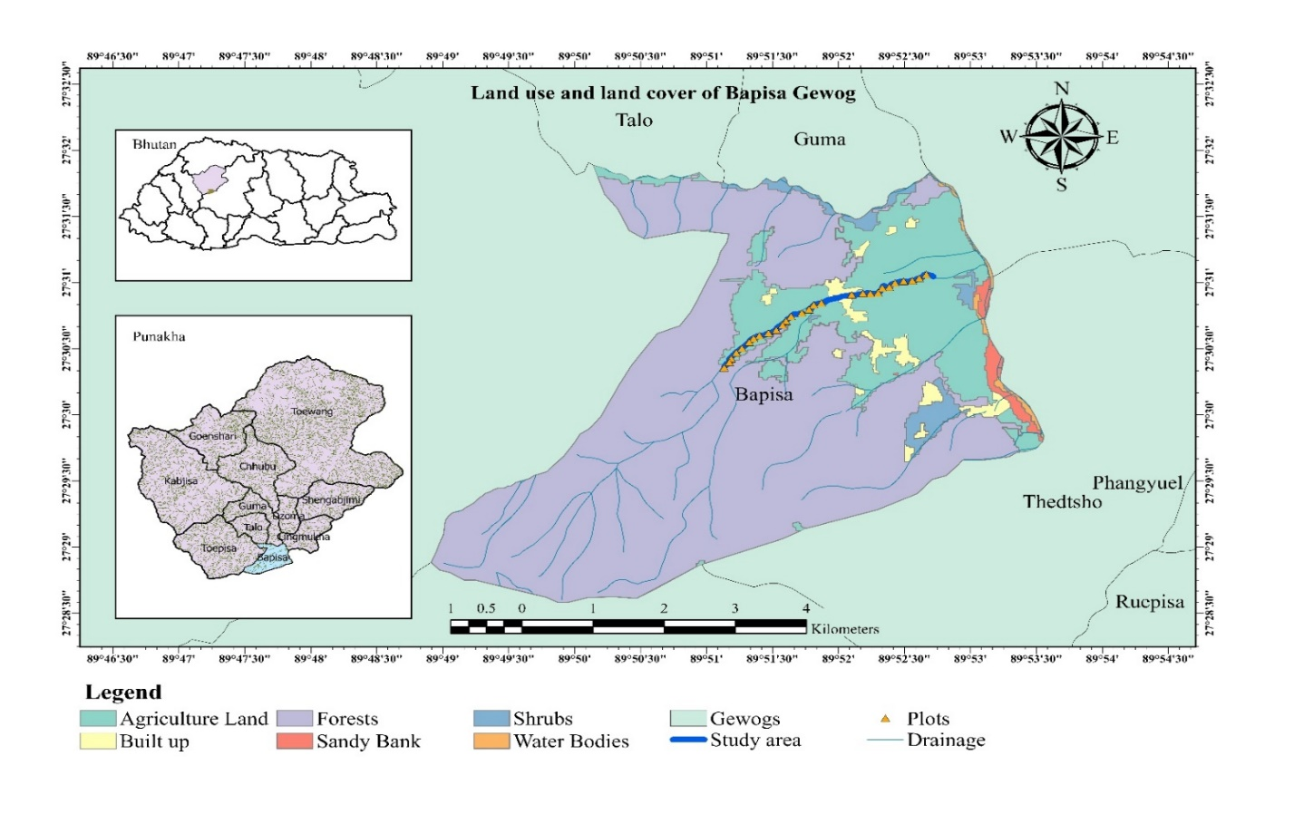
Fig 1: Study area map showing land use and land cover

2.3 Sampling Design
Stratified systematic sampling design was employed along the 4 km Metsina Stream transect, with 100 m plot distance across downstream, midstream, and upstream strata based on visual inspection of plastics and different land uses with 100 m plot distance (Blettler et al., 2018). Macroinvertebrates were sampled from pool, run, and riffle habitat (Noik and Tuah, 2015). Macroplastics were collected from the stream within 100 × 5 m wide, mesoplastics from the triplicate samples of 1 m² quadrat (Lippiatt et al., 2013), and microplastics were collected from 25 × 25 × 3 cm quadrats from same transects(Klein et al., 2015). The study was limited to single-season sampling.

Plot 1 Plot 2 Plot 3

Sampling stretches 100 m
Fig 2: Sampling design

2.4 Laboratory Analysis
The collected macroplastics were washed, weighed, counted, and classified by origin and resin type (Lippiatt et al., 2013). Mesoplastics were similarly washed, weighed, counted and classified into foams, fragments, films, and others (Gündoğdu & Çevik, 2017). Microplastics extraction followed Masura et al. (2015) where sediment samples were oven dried (40℃, 20-24 hrs.), dispersed using sodium hexametaphosphate (5.5g/L), and sieved (25µm). Density separation was conducted using zinc chloride (1.7g/cm³) followed by organic matter digestion using 30% hydrogen peroxide and ferrous sulphate. The floating fraction was filtered using Whatman Grade 11 filter paper using vacuum filtration. Filters were dried in desiccators and microplastics were identified under a Dino-Lite microscope (200 X).

2.5 Statistical Analysis
The biodiversity indices of macroinvertebrates were commuted using the Shannon-Weiner index (Shannon, 1948). The similarity and dissimilarity between different strata were calculated followed by the calculation of the EPT Index and HKH Biotic score. The data was cleaned, sorted and organised in Microsoft Excel. The statistical tests were conducted using R (version 4.5.2) and IBM SPSS (version 31.0.0) software. A non-parametric test (Kruskal-Wallis test) was performed to compare plastic concentration followed by Spearman correlation to test the relationship between plastic concentrations and macroinvertebrate abundance.

- RESULTS AND DISCUSSION
3.1 Characterisation of Macro, Meso, and Microplastics
3.1.1 Descriptive Statistics of Macroplastic Samples
A total of 672 macroplastics were recorded across all transects of the Metsina Stream, with highest concentration downstream (n= 626), while no macroplastics were found in upstream. This spatial disparity is likely due to greater human activity including automobile workshops, retails in downstream, contrasted with limited anthropogenic influence in upstream. Eighteen categories of macroplastics were initially identified (Lippiatt et al., 2013) and condensed into eight following Blettler et al. (2018) (Table 1).

Food wrappers (n = 205), beverage bottles (n = 174), and plastic bags (n =156) (Fig 3) were most prevalent, consistent with global trends in plastic waste where fast-moving plastic consumer goods and beverage bottles were reported to be most prevalent (Jambeck et al., 2015). On average, 20.93 macroplastics were recorded with per plot (SD = 30.36) with a median of 6.30 macroplastics. Macroplastic weights ranged from 3.62 g to 564.72 g (M = 81.81 g, SD = 120.36). Beverage bottles, contributed the most to total weight (655.22 g), despite being few in number. Spatial patterns showed food wrappers peaking at plot 13, and hard plastics concentrated between plots 5 to 13, indicating localised dumping near Metsina Town and transport dynamics influenced by runoff and stream flow (Wagner et al., 2014). Other types such as cleaning products, personal care items, revealed higher concentration in downstream plots (1 to 12) and little to none upstream, indicating spatial heterogeneity in macroplastic deposition.
Table 1: Categorisation of plastic items observed in Metsina Stream
Plastic Category | Specific Items Included
1. Plastic Bags | Shopping bags, garbage bags
2. Food Wrappers | Wrappers of biscuits, potato chips, noodles, etc.
3. Hard Containers | Jugs, plastic containers, plastic utensils
4. Foam Food Containers | Foamed plastic cups, polystyrene containers
5. Beverage Bottles | Soft drink bottles, water bottles, 6-pack rings, bottle caps
6. Personal Care Products | Shampoo containers, toothbrushes, hairbrushes
7. Cleaning Products | Cigarette lighters, plastic ropes, straws, plastic toys, buoys, floats
8. Others | Balloons, cigar tips, miscellaneous unidentifiable plastic fragments
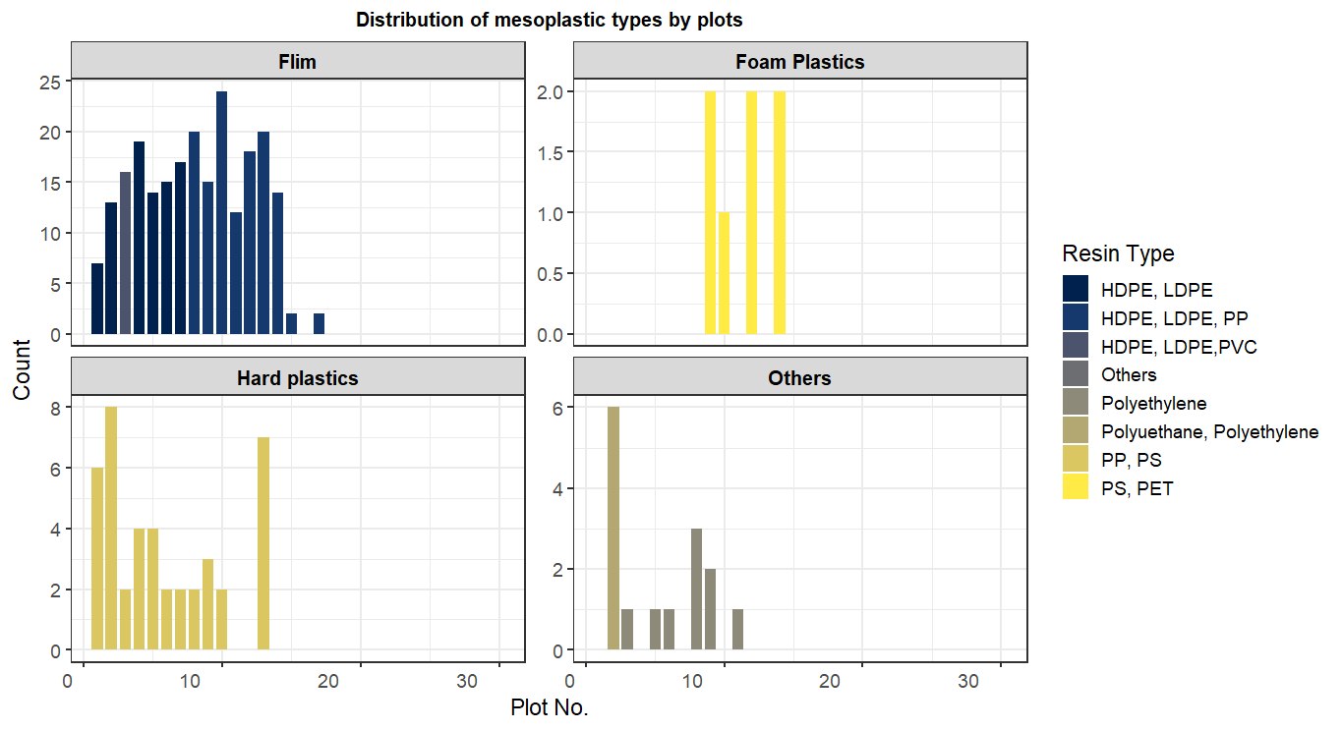
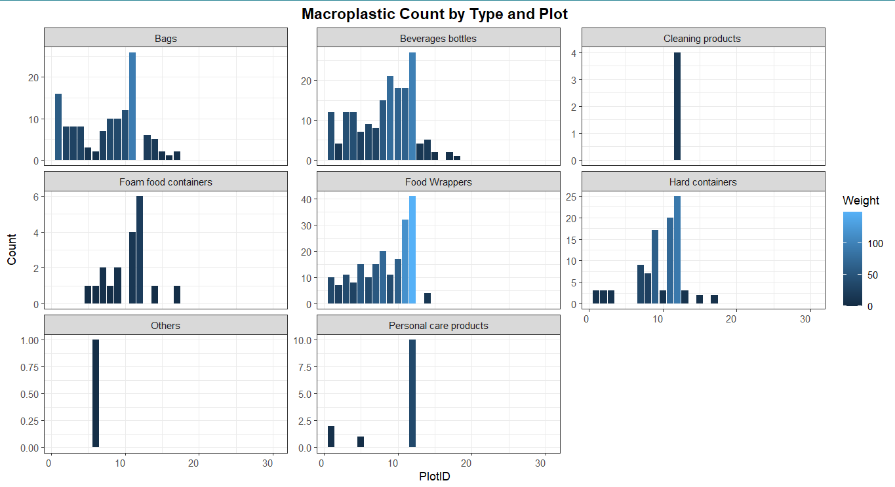
Fig 3: Distribution of different types of macroplastics in the study area
3.1.2 Descriptive Statistics of Mesoplastic Samples
Fig 4: Distribution of different types of mesoplastics found in the study area
A total of 292 mesoplastics were recorded, with plastic films (HDPE, LDPE; n = 228) being most dominant, followed by hard plastics (PP, PS; n = 42) and other polymers (n = 15). Film plastics were most frequent and heaviest mesoplastics (2.37 g), primarily concentrated in downstream plots (1 to 14), reflecting anthropogenic influence (Gago et al., 2016; Blettler et al., 2018). Hard plastics and other mesoplastics showed moderate distribution, reflecting their common packaging use by Metsina community. Foam plastic appeared only from plot 10 to 15, suggesting localised dumping of polystyrene; that breaks easily and settles in slow-moving water bodies (Lebreton et al., 2017). Overall, the frequency and diversity of polymers depicts potential microplastic formation and underscore poor waste management of stream health (Zbyszewski and Corcoran, 2011).
3.1.3 Descriptive Statistics of Microplastic Samples
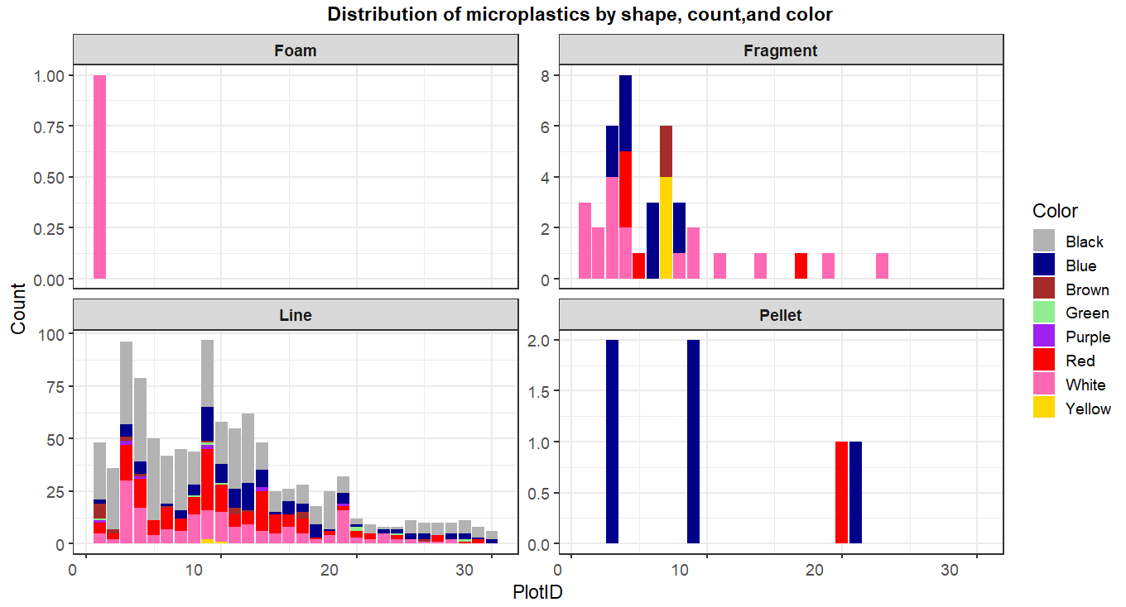
A total of 1,073 microplastics were recorded, categorised by shape (fragments, foam, film, line, pellets) and colours following GESAMP (2019). Line-shaped microplastics were most dominant (n = 1,008) found across all transects, likely originating from synthetic fibers (Browne et al., 2011), Black was the most frequent color, often associated with automotive and household sources (Horton et al., 2017; Kole et al., 2017). Microplastic counts ranged from 6 to 108 (M = 35.77, SD = 0.11) and length ranged from 155 µm to 1500.50 µm (M = 542.89 µm, SD = 28.91). Foam and film types were rare, while pellets appeared sporadically, possibly due to the absence of nearby industries (Enders et al., 2015). Fragments were more common downstream, likely resulting from macroplastic degradation under UV exposure (Andrady, 2011). Overall, microplastics were numerically dominant, whereas macroplastics contributed most to the total plastic mass, highlighting a clear pattern of spatial variation and plastic fragmentation across the stream.
Fig 5: Distribution of different types of microplastics
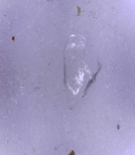
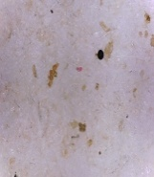


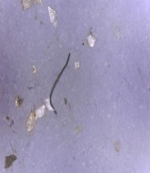
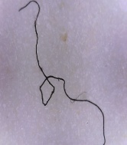
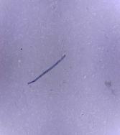
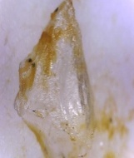
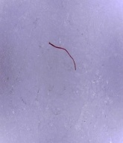
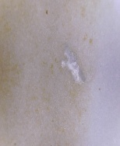
a)
b)
d)
e)
c)
f)
g)
h)
j)
i)
Fig 6: Microplastics types: Fragment (a); Pellet (b); Line (c); Line (d); Line (e); Line (f); Line (g); Fragment (h); Line (i); Foam (j)

3.1.4 Descriptive Statistics of Macroinvertebrates
A total of 2,136 macroinvertebrates from 28 families and 14 orders were recorded, with Baetidae being the most dominant family (n = 722, RA = 33.8%) while Asellidae, Planorbidae, and Psephenidae were the least dominant family (n = 1, RA = 0.05%) (Fig 7). The overall species diversity was high (H’ = 2.31, D = 0.84) with moderate species evenness (EH = 0.69) and species richness SR was calculated to be 3.52. Biodiversity indices showed moderate similarity (50%), and dissimilarity across upstream, midstream, and downstream transects, reflecting ecological continuity but spatial variations influenced by factors like flow, substrate, and riparian conditions (Heino et al., 2005; Mather et al., 2024). Higher pollution near urbanised downstream areas favours tolerant species (Medeiros et al., 2021), while upstream supports sensitive taxa, consistent with the River Continuum Concept which explains that biological communities alter along the length of the water body due to changing physical and chemical conditions (Vannote et al., 1980).
3.1.5 Descriptive Statistics for Water Quality Parameters

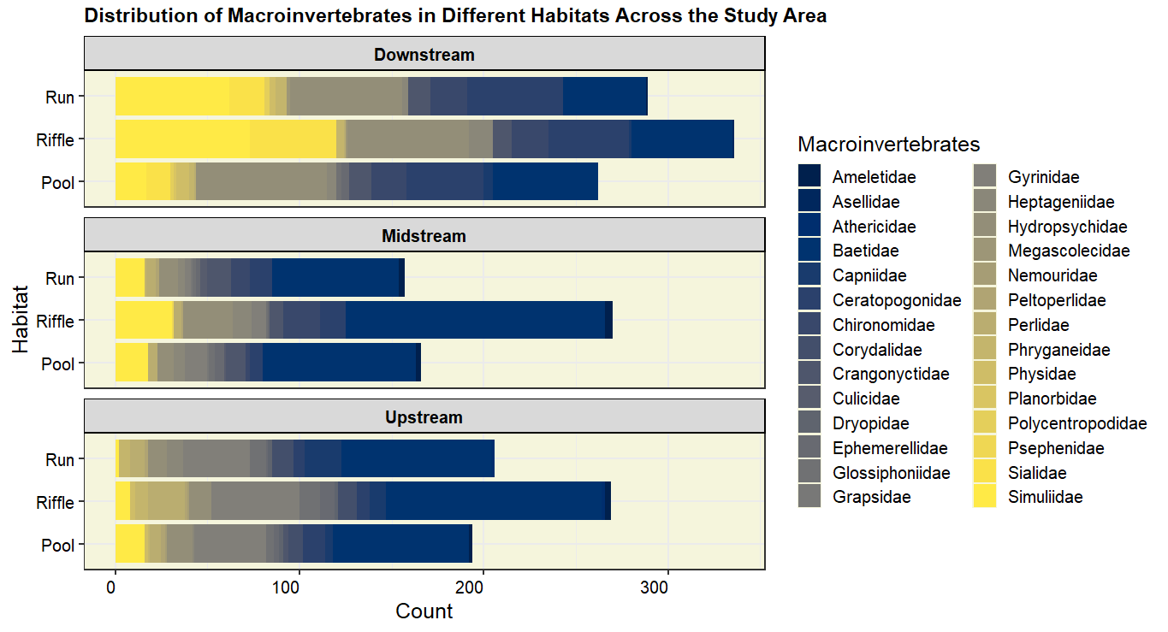
Fig 7: Macroinvertebrates found across the Metsina Stream
The water quality of Metsina Stream was evaluated by comparing measured parameters including pH, temperature, EC, TDS, and salinity against established standard set by EPA and WHO. Descriptive statistical analysis revealed that all parameters fell within the permissible limit indicating that water quality of the stream meets the criteria for various uses.

Table 2: Descriptive statistics of water quality parameters along with standard water quality

 | BDWQS | AWQS | EPA | WHO | Mean | Median | SD | Min | Max
pH | 6.5 - 8.5 | 6.5 – 8.5 | 6.5 – 8.5 | 6.5- 8.5 | 8.11 | 8.10 | 0.33 | 7.46 | 8.96
EC (µS/cm) | - | 800 | 2500 | 1500 | 234.37 | 234 | 68.67 | 153 | 482
Temp (°C) | - | - | 25 | - | 16.01 | 16 | 1.16 | 13.5 | 18.4
Salinity (ppm) | - | - | <500 | - | 0.12 | 0.12 | 0.04 | 0.07 | 0.29
TDS (ppm) | 1000 | <1000 | 500 | <1000 | 181.23 | 178.5 | 59.98 | 113 | 418
Note: BDWQS: Bhutan Drinking Water Quality Standards, 2016; AWQS: Ambient Water Quality Standards; EPA: Environmental Protection Agency; WHO: World Health Organization

3.2 Comparison of Macro, Meso, and Microplastics across the Stream Transects
To compare the plastic pollution level (macroplastic, mesoplastics, and microplastic) across three stream transects (Upstream, midstream and downstream) of Metsina Stream, Kruskal-Wallis test was performed following a Shapiro-Wilk Normality test, which indicated non-normal data distribution. The results revealed significant difference across transects for macroplastic (H = 79.31, p < .001), mesoplastic (H = 64.04, p < .001) and microplastic (H = 77.24, p < .001), indicating that plastic abundance varied significantly among transects. These finding are consistent with Bletter et al. (2018), who reported significantly difference in macro and microplastic counts between streams transects. However, unlike their study, this study found significant difference in mesoplastic distribution. This suggests variations in land use patterns, anthropogenic activities and hydrodynamic factors have influenced in significant distribution of plastics across the stream.

Table 3: Kruskal-Wallis Independent test to compare plastic concentrations
 | Macro | Meso | Micro
Kruskal-Wallis H | 79.31 | 64.04 | 77.24
df | 2 | 2 | 2
Asymp. Sig. | .000** | .000** | .000**

3.2.1 Pairwise Comparison between Three Transect Of Metsina Stream
To determine which specific transect differs; a series of Mann-Whitney U test was performed as post-hoc analysis for three pairwise comparisons between Upstream vs. Midstream, Upstream vs. Downstream, and Midstream vs. Downstream. Midstream transect exhibited significantly higher concentration than upstream for macroplastics (U = 49.50, Z = -6.29, p < .001), mesplastics (U = 165, Z = -4.58, p < .001), and microplastics (U = 0, Z = -6.17, p < .001). Similarly, downstream revealed highly significant results compared to upstream (U = 0, Z = -7.15, p <.001) and midstream (macroplastics: U = 0, Z = -6.26, p < .001; mesplastics: U = 117, Z = -4.35, p < .001; microplastics: U = 9, Z = -6.11, p < .001).

Mean rank comparisons further confirmed a progressive increase in plastic concentrations from upstream to downstream: for macroplastics (18.50 to 41.64 to 51.50), mesoplastics (22.00 to 36.14 to 51.50), and microplastics (17.00 to 44.00 to 51.50). This trend suggest midstream and downstream transects acts as key accumulation zones, likely due to anthropogenic inputs and hydrodynamic factors. While limited studies exist on macro and mesoplastic gradients, similar downstream accumulation patters have been reported for microplastics (Hoellein et al., 2017). These findings align with hydrological theories, where increased discharge and reduced stream gradient downstream promote plastic deposition (Blettler et al., 2018; van Emmerik and Schwatz, 2020). Furthermore, the proximity of the stream to human settlements in downstream sections likely exacerbates plastic accumulation.

Table 4: Mann Whitney U test to compare different transects

 | Variable | U | W | Z | p-value
Upstream vs. Midstream | Macroplastic | 49.50 | 610.50 | -6.29 | .000**
Upstream vs. Midstream | Mesoplastic | 165.00 | 726.00 | -4.58 | .000**
Upstream vs. Midstream | Microplastic | .000 | 561.00 | -6.17 | .000**
Upstream vs. Downstream | Macroplastic | .000 | 561.00 | -7.56 | .000**
Upstream vs. Downstream | Mesoplastic | .000 | 561.00 | -7.57 | .000**
Upstream vs. Downstream | Microplastic | .000 | 561.00 | -7.15 | .000**
Midstream vs. Downstream | Macroplastic | .000 | 231.00 | -6.26 | .000**
Midstream vs. Downstream | Mesoplastic | 117.00 | 348.00 | -4.35 | .000**
Midstream vs. Downstream | Microplastic | 9.00 | 240.00 | -6.11 | .000**

3.2.2 Spatial Distribution of Macro, Meso, and Microplastics in Study Area
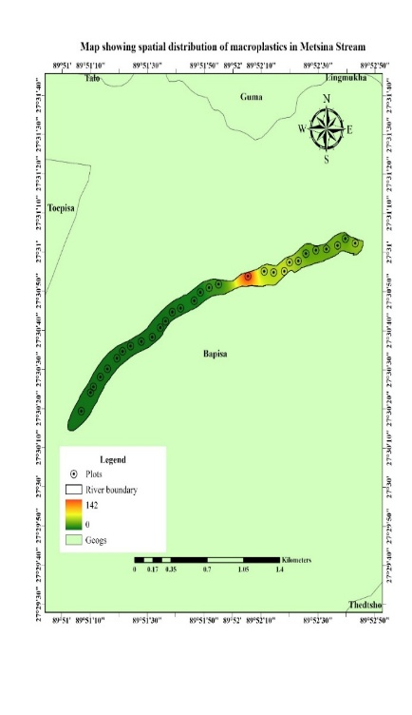
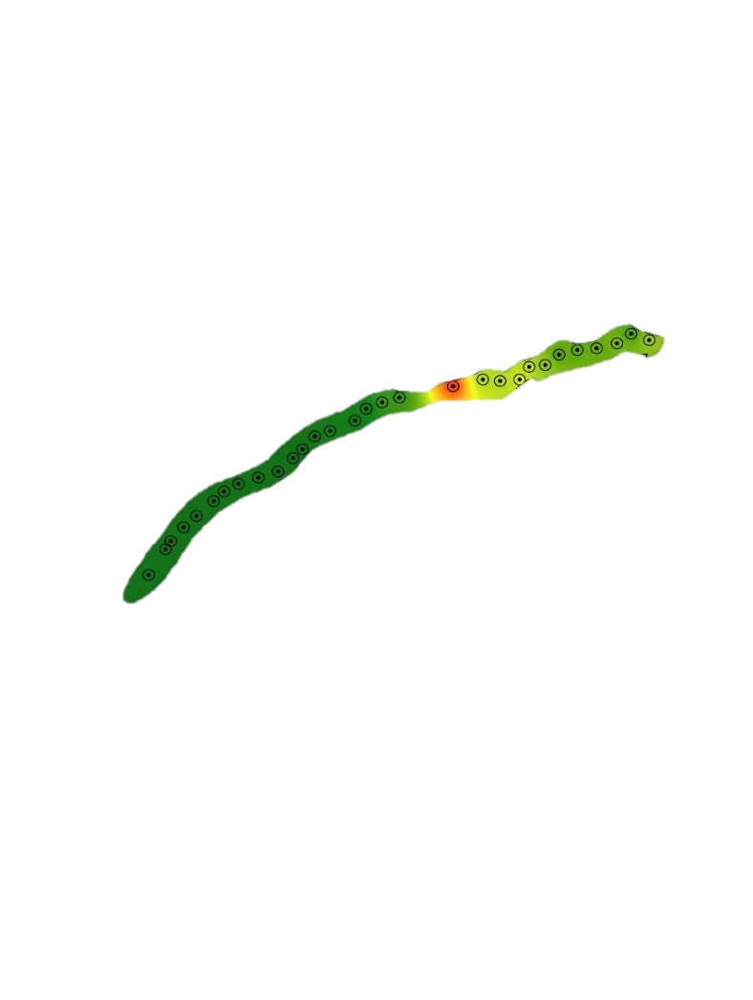
Spatial distribution of micro, meso, and macroplastics was analysed using Inverse Distance Weighted (IDW) method in ArcGIS Pro based on data from 30 sampling plots. IDW interpolation was selected for its ability to estimate values in unknown sample locations. The results revealed highest plastic concentrations of macroplastics (up to 142 items) in downstream plots with gradual increase towards upstream areas. Similarly, mesoplastics ranged from 0 to 26, showing elevated levels in downstream to midstream zones and diminishing upstream. Microplastics also followed this gradient, with moderate to high concentrations in downstream plots to declining levels upstream. (Fig 8).
Highest macroplastic concentration in Plot No.12

These findings align with Bletter et al. (2018), suggesting anthropogenic and hydrodynamic factors significantly influence plastic accumulation. The proximity of downstream plots to human settlements and automobile workshops in Metsina significantly contributes to the plastic concentration. Similar findings were reported by Van Emmerik and Schwarz (2020), identifying urban-river as a critical hotspot for plastic leakages in waterways. Additionally, hydrodynamic factors such as gentle slope and
Fig 8: Spatial distribution of macroplastics in Metsina Stream

reduced flow in downstream promote plastic deposition (Bletter et al., 2018), whereas steeper and faster flow velocity in upstream transect facilitate transportation of plastics to downstream (Mai et al., 2020). Poor waste management and lack of clean up in downstream also contributed to plastic accumulation and cause plastics to enter waterways during rainfall in developing areas (Zhang et al., 2020). Overall, IDW interpolation depicts a combined influences of stream morphology, anthropogenic activities, and land use regarding downstream as the primary accumulation zone.
3.3 Correlation between Plastic Concentration and Macroinvertebrate Abundance
Spearman’s correlation was performed to determine the relationship between plastic concentration and macroinvertebrate abundance, following the Shapiro-Wilk Normality test which confirmed non-normal distribution. The results revealed no significant correlation for macroplastics (r = .029, p = .87), mesoplastics and macroinvertebrate abundance (r = -.046, p = .81), suggesting that plastic presence does not directly influence macroinvertebrate abundance.
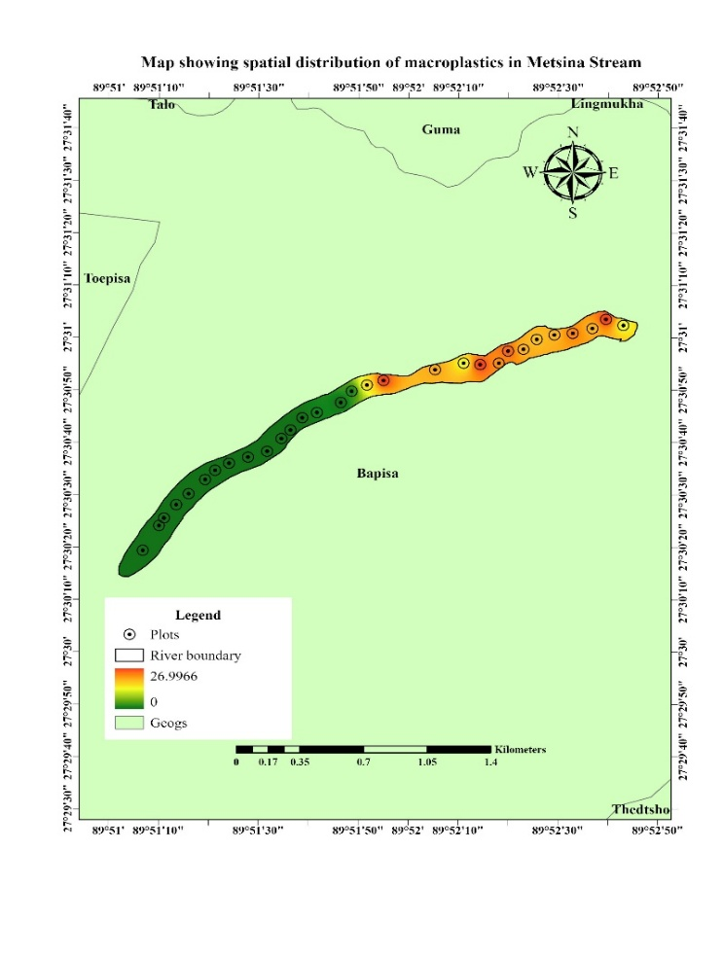
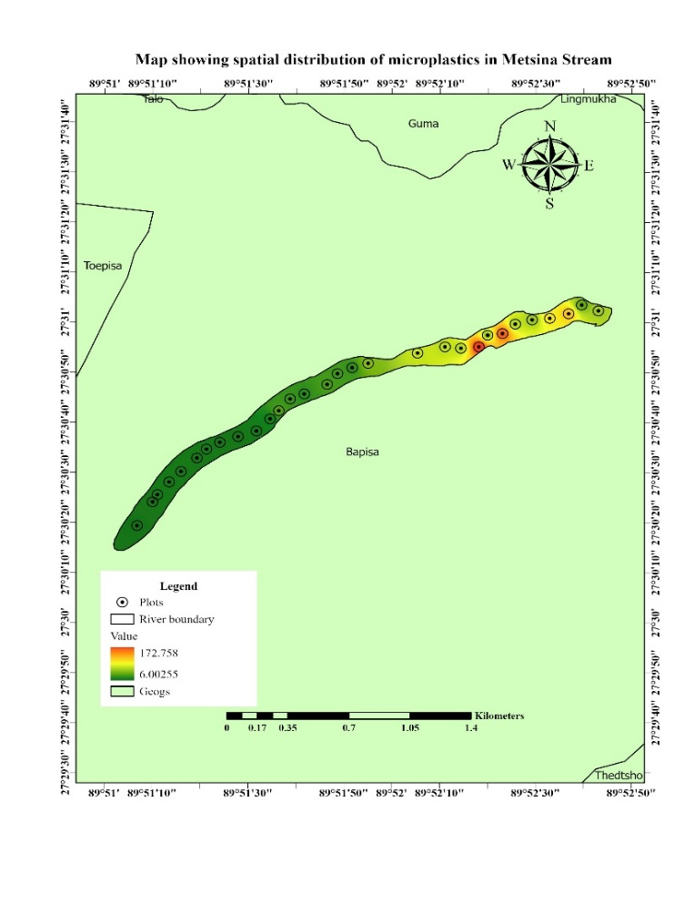
These findings are consistent with previous studies (Wright et al., 2013; Lwanga et al., 2017; Kettner et al., 2020), which attribute to the lack of effect to the spatial behaviour of macroplastics and mesoplastics tend to accumulate on banks and surface waters rather than benthic substrates where macroinvertebrates reside, while microplastics’ ingestion by Macroinvertebrates appear to have negligible impact (Jin et al., 2020). Additionally, confounding factors including sediment granulometry, organic matter, and chemical pollution are more likely influential in shaping macroinvertebrate communities (Rohal et al., 2020).
Fig 9: Spatial distribution of mesoplastics (a); microplastics (b) in Metsina Stream
a
b

Despite the absence of significant correlations, spatial patterns indicate that downstream transects with higher plastic concentration also support greater abundance of pollution-tolerant taxa such as Chironomidae (n = 76), whereas pollution-sensitive families like Baetidae (n = 95) predominate upstream with lower plastic levels. This distribution suggests that plastics alongside other pollutants, may contribute to water quality degradation and drive shifts in macroinvertebrate community composition along the stream gradient.

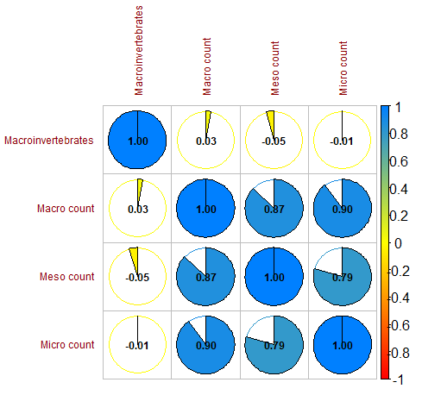
Fig 10: Spearman correlation between plastics and macroinvertebrate abundance.

3.3.1

Relationship between Macroinvertebrates and Other Independent Factors
Multiple regression was performed to determine the relationship between macroinvertebrates and predictors including plastic concentration (macro, meso, and microplastic) and water quality parameters (pH, temp, EC, TDS, and salinity). The results indicated no significant correlation between plastic concentrations and macroinvertebrate abundance (Table 5). However, TDS and Temperature revealed a strong positive and negative correlation with macroinvertebrate abundance.

The result aligns with Olson and Hawkins (2017), who reported enhanced macroinvertebrate performance under higher TDS level due to beneficial role of dissolved ions in promoting growth of macroinvertebrates. Conversely, the negative correlation between macroinvertebrates and temperature aligns with Becker et al. (2019), who noted that increased temperate elevates metabolism but also oxygen depletion, thereby reducing macroinvertebrate abundance. Oxygen-sensitive taxa such as Ephemeroptera, Plecoptera, and Tricoptera are vulnerable to such stressors, leading to decreased diversity (Durance & Ormerod, 2007). Although plastics showed no direct relationship with macroinvertebrate abundance, previous studies have linked the concentration of plastics to a variety of water quality indicators, including turbidity, TDS, EC and BOD (Buwono et al. 2021), likely because plastics facilitate accumulation of suspended solids influencing these parameters (Eamrat et al., 2022).

3.3.2 Association between Plastics, Macroinvertebrates, and Water Quality Parameters
Principal Component Analysis (PCA) was conducted to determine the association between plastic concentration, macroinvertebrate abundance, and water quality parameter. The dataset was suitable for PCAS as indicated by a Kaiser-Meyer-Olkin Test value of .82 and a significant Bartlett’s test of sphericity (p < .001). Two principal components with eigenvalues greater than 1 were retained, explaining 85.85% of total variance. A PCA with variance 70% or higher is typically ensures the primary components summarizes the dataset appropriately (Raviv, 2019). Component 1 accounted for 60.48% and represented water quality gradients (pH, temp, salinity, TDS), while component 2 accounted for 25.2% and reflected plastic contamination with strong negative loadings from macroplastics and mesoplastics. This distinct separation between water quality parameters and plastic related variables in components 1 and 2 respectively aligns with earlier results that plastic concentration does not correlate with macroinvertebrates.

The PCA conducted reported that downstream locations are characterised by higher macroplastic and mesoplastics accumulation, consistent with prior studies by Lebreton et al. (2017) and Schmidt et al. (2017), which resulted in accumulation of plastics in

Table 5: Linear regression between macroinvertebrate abundance and other factors
 | Unstandardized Coefficients |  | Standardized Coefficients | t | Sig.
 | B | Std. Error | Beta
pH | -26.501 | 35.369 | -.202 | -.749 | .461
EC (µS/cm) | .153 | .115 | .360 | 1.333 | 195
Temp (°C) | -9.153 | 2.707 | -.277 | -3.381 | .003**
Salinity (ppm) | 179.961 | 171.139 | .219 | 1.052 | .304
TDS (ppm) | .518 | .099 | .881 | 5.216 | .000**
Plastic Concentration | .011 | .010 | .019 | 1.086 | .289

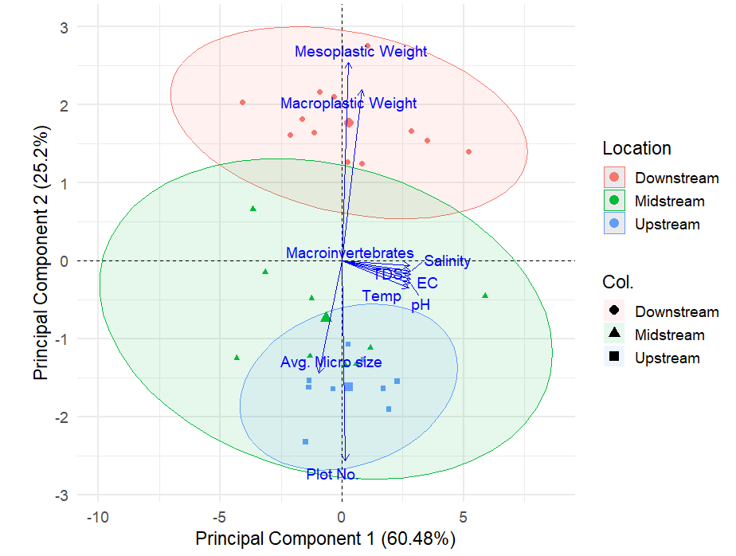
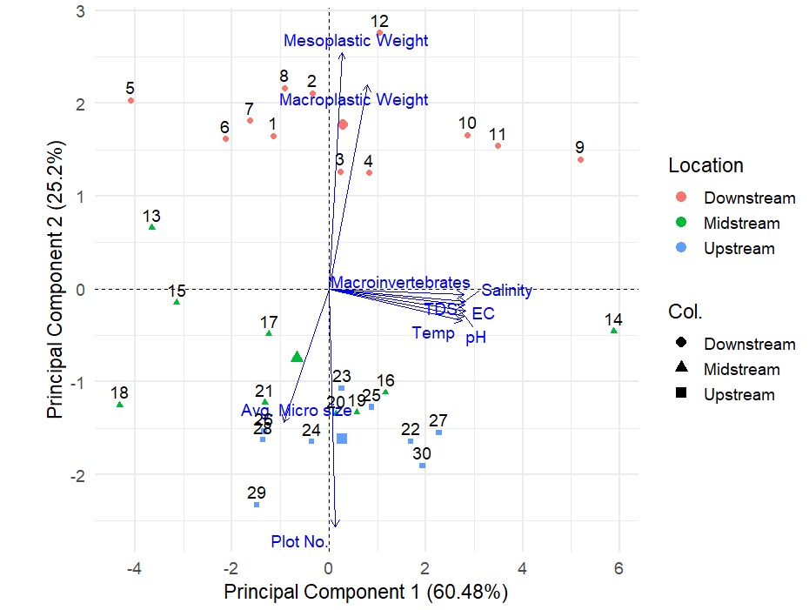
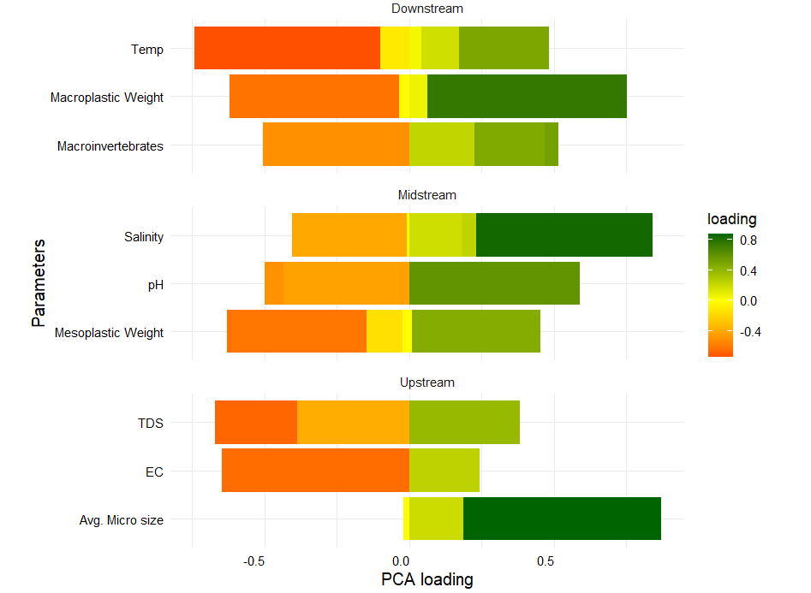
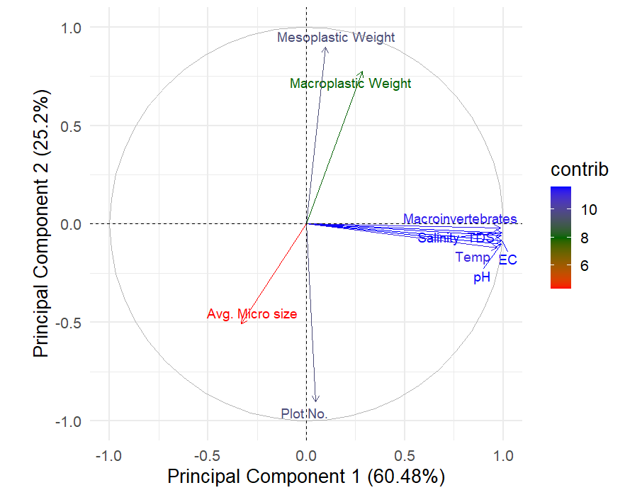
Fig 11: PCA plots for: loading (a); individuals by location (b); Biplot (c); Variable contribution (d)
a)

b)

c)

d)

downstream regions. Upstream locations are associated with water quality parameters namely TDS, EC and microplastics, while midstream locations revealed intermediate characteristics between upstream and downstream with association with salinity, pH, and mesoplastics. Notably, downstream transects exhibited positive loadings of macroinvertebrates, macroplastics and temperature, suggesting ecological stress from plastic accumulation and thermal stress linked to plastic pollution.

3.3.3 Cluster Analysis
A hierarchical cluster analysis was performed using Ward’s D2 linkage to group plots based on plastic concentration (macro, meso, and micro), macroinvertebrate abundance and water quality parameters (pH, temperature, TDS, salinity, and EC) based on similar characteristics. Three groups of plots were identified where group 1 (red cluster: plots 14, 9, 10, 11, 28) exhibited highest concentration of macro, meso, and microplastics clustered alongside elevated TDS and salinity, indicating poor water quality influenced by intense human activity and urbanisation. This finding aligns with Schmidt et al. (2017) which revealed accumulation of plastics in low-velocity zones.

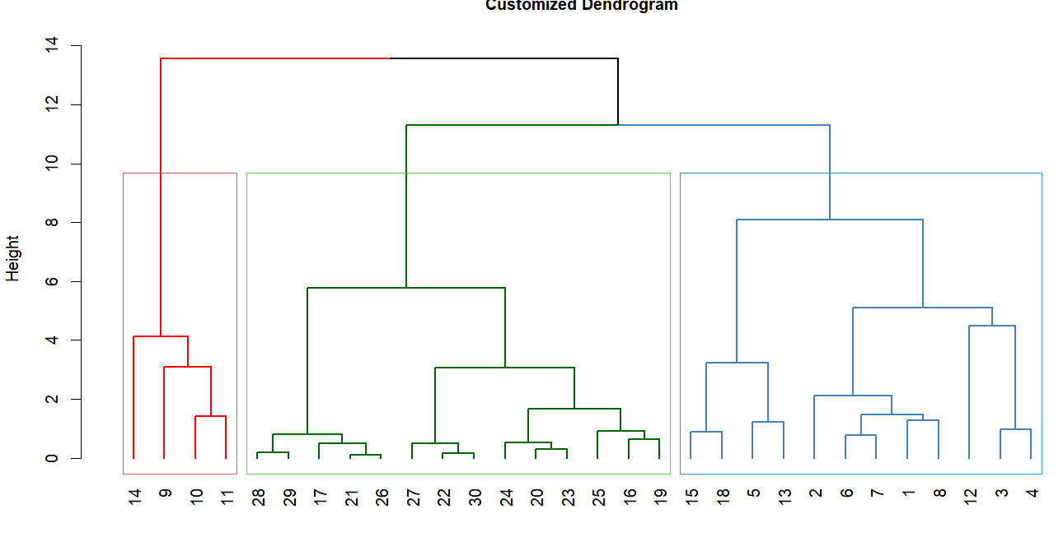
Group 2 (green clusters: plots 17, 29, 27, 26, 30, 23, 20, 24, 22, 21, 19, 25) characterised by higher macroinvertebrate abundance and minimal plastic concentration with relatively stable water quality parameters, reflecting healthier ecological conditions consistent with Karaolia et al. (2021). Group 3 (blue clusters: plots 15, 18, 16, 3, 13, 6, 2, 8, 7, 1, 12, 14) showed cluster of moderate salinity and TDS, suggesting intermediate water quality and ecological stress. These plots act as a transitional zone between group 1 and group 2. Similar results were obtained from a study by Hurley et al. (2018) which revealed streams with moderate pollution exhibited moderate ecological stress.
G1
G2
G3
High plastic concentration grouped
High macroinvertebrates grouped
Similar water quality parameter grouped

- CONCLUSION
The findings of this study highlight the pervasive nature of plastic pollution in Metsina Stream and its relation to benthic macroinvertebrates. Through this comprehensive plastic characterisation of macro, meso and microplastics across the stream, it is evident that plastics are spatially visible with downstream predominantly polluted with higher plastic concentration. This was tested through Kruskal-Wallis test (H = 79.31, p < .001) and Mann Whitney U-Test (p < .001). This suggests that although the stream is plastic free from the source (upstream), different anthropogenic activities along the way have polluted the stream. Analysis of macroinvertebrates indicated Baetidae was the most dominant family (n = 722, RA = 33.8%) among all 28 families recorded. The overall species diversity recorded to be H’ = 2.31.

Spearman correlation test revealed no significant relation between plastics and macroinvertebrate abundance (r = .029, p = .87) indicating plastics as of now had not impacted the diversity of macroinvertebrates. PCA reported that 85% of the variance is explained by the first two components, suggesting a strong correlation between variables. Cluster analysis was performed, and significant groupings of environment factors, plastic and macroinvertebrates were obtained. Spatial distribution of plastics across the stream using IDW interpolation method in GIS revealed higher plastic concentration in downstream locations

This research is among the first to characterise plastics and has added to the growing information on plastic characterisation in freshwater ecosystem emphasising impacts of plastic contamination on benthic organisms. Traditionally, plastics research focuses on only one size class, usually microplastics. However, this study provides a holistic picture of plastic contamination capturing the entire fragmentation spectrum. The study also underscores the need for waste management as tributaries like the Metsina Stream act as gateways for plastics into larger river system. Thus, this study offers framework to integrate plastic contamination monitoring in Bhutan’s national freshwater assessment protocols.
Fig 12: Hierarchical clustering of plastics, macroinvertebrate abundance and water quality parameters

COMPETING INTEREST
I declare that I have no known financial interests or personal relationships that could have appeared to influence the work reported in this research. This study was conducted as part of my Bachelor of Science in Forestry degree program at the College of Natural Resources, Royal University of Bhutan. The research was entirely student-led and received no external funding. All findings and interpretations presented are based on primary data collected in the field, and the work reflects my genuine academic interest in freshwater ecology, plastic pollution, and benthic community dynamics.

Disclaimer (Artificial intelligence)
Author(s) hereby declare that NO generative AI technologies such as Large Language Models (ChatGPT, COPILOT, etc.) and text-to-image generators have been used during the writing or editing of this manuscript.

REFERENCES
Andrady, A. L. (2011). Microplastics in the marine environment. Marine Pollution Bulletin, 62(8), 1596–1605. https://doi.org/10.1016/j.marpolbul.2011.05.030
Bellasi, A., Binda, G., Pozzi, A., Galafassi, S., Volta, P., & Bettinetti, R. (2020). Microplastic Contamination in Freshwater Environments: A Review, Focusing on Interactions with Sediments and Benthic Organisms. Environments, 7(4), 30. https://doi.org/10.3390/environments7040030
Berlino, M., Mangano, M. C., De Vittor, C., & Sarà, G. (2021). Effects of microplastics on the functional traits of aquatic benthic organisms: A global-scale meta-analysis. Environmental Pollution, 285, 117174. https://doi.org/10.1016/j.envpol.2021.117174
Blettler, M. C. M., Abrial, E., Khan, F. R., Sivri, N., & Espinola, L. A. (2018). Freshwater plastic pollution: Recognizing research biases and identifying knowledge gaps. Water Research, 143, 416-424. https://doi.org/10.1016/j.watres.2018.06.015
Browne, M. A., Crump, P., Niven, S. J., Teuten, E., Tonkin, A., Galloway, T., & Thompson, R. (2011). Accumulation of microplastic on shorelines worldwide: Sources and sinks. Environmental Science & Technology, 45(21), 9175–9179. https://doi.org/10.1021/es201811s
Cabernard, L., Pfister, S., Oberschelp, C., & Hellweg, S. (2022). Growing environmental footprint of plastics driven by coal combustion. Nature Sustainability, 5(2), 139-148. https://doi.org/10.1038/s41893-021-00807-2
Durance, I., & Ormerod, S. J. (2007). Climate-change effects on upland stream macroinvertebrates over a 25-year period. Global Change Biology, 13(5), 942-957. https://doi.org/10.1111/j.1365-2486.2007.01349.x
Earth Guardians Bhutan CNR. (2016, October 1). Earth Guardians Bhutan CNR’s Cleaning Campaign along Metsina Stream. https://www.earthguardians.org/earthguardian-blog/2016/10/1/earth-guardians-bhutan-cnrs-cleaning-campaign-along-messina-stream
Gündoğdu, S., & Çevik, C. (2017). Micro- and mesoplastics in Northeast Levantine coast of Turkey: The preliminary results from surface samples. Marine Pollution Bulletin. https://doi.org/10.1016/j.marpolbul.2017.03.002
Horton, A. A., Walton, A., Spurgeon, D. J., Lahive, E., & Svendsen, C. (2017). Microplastics in freshwater and terrestrial environments: Evaluating the current understanding to identify the knowledge gaps and future research priorities. The Science of the Total Environment, 586, 127–141. https://doi.org/10.1016/j.scitotenv.2017.01.190
Hurley, R., Woodward, J., & Rothwell, J. J. (2018). Microplastic contamination of river beds significantly reduced by catchment-wide flooding. Nature Geoscience, 11(4), 251-257. https://doi.org/10.1038/s41561-018-0080-1
Jambeck, J. R., Geyer, R., Wilcox, C., Siegler, T. R., Perryman, M., Andrady, A., Narayan, R., & Law, K. L. (2015). Plastic waste inputs from land into the ocean. Science, 347(6223), 768–771. https://doi.org/10.1126/science.1260352
Jin, X., et al. (2020). Impact of microplastic contamination on freshwater organisms: A review. Environmental Pollution, 263, 114530.
Karaolia, P., Tsagkaris, A. S., & Hapeshi, E. (2021). Ecotoxicological effects of microplastics on freshwater ecosystems: Insights from benthic organisms. Ecotoxicology and Environmental Safety, 220, 112401.
Klein, S., Worch, E., & Knepper, T. P. (2015). Occurrence and spatial distribution of microplastics in river shore sediments of the Rhine-Main area in Germany. Environmental Science & Technology, 49(10), 6070-6076 https://doi.org/10.1021/acs.est.5b00492
Kole, P. J., Löhr, A. J., Van Belleghem, F. G. A. J., & Ragas, A. M. J. (2017). Wear and tear of tyres: A stealthy source of microplastics in the environment. International Journal of Environmental Research and Public Health, 14(10),1265. https://doi.org/10.3390/ijerph14101265
Kettner, M. T., et al. (2020). The impact of plastic debris in freshwater systems: A review of ecological consequences. Science of the Total Environment, 727, 138798.
Lathlean, J. A., & McQuaid, C. D. (2017). Biogeographic variability in the value of mussel beds as ecosystem engineers on South African rocky shores. Ecosystems, 20, 568-582. https://doi.org/10.1007/s10021-016-0041-8
Lebreton, L. C. M., Van Der Zwet, J., Damsteeg, J., Slat, B., Andrady, A., & Reisser, J. (2017). River plastic emissions to the world’s oceans. Nature Communications, 8(1) https://doi.org/10.1038/ncomms15611
Lippiatt, S., Opfer, S., & Arthur, C. (2013). Marine debris monitoring and assessment: Recommendations for monitoring debris trends in the marine environment. NOAA Technical Memorandum NOS-OR&R-46. https://repository.library.noaa.gov/view/noaa/10940
Lwanga, E. H., et al. (2017). Microplastic pollution in riverine ecosystems: A critical review of the literature. Science of the Total Environment, 589, 524–535.
Mai, L., Bao, L. J., Shi, L., Wong, C. S., & Zeng, E. Y. (2018). A review of methods for measuring microplastics in aquatic environments. Environmental Science and Pollution Research. https://doi.org/10.1007/s11356-018-1692-0
Masura, J., Baker, J., Foster, G., & Arthur, C. (2015). Laboratory methods for the analysis of microplastics in the marine environment: Recommendations for quantifying synthetic particles in waters and sediments. NOAA Technical Memorandum NOS-OR&R-48. https://repository.library.noaa.gov/view/noaa/10000
Medeiros, C. R., Heino, J., dos Santos, P. J. P., Molozzi, J., & Ligeiro, R. (2021). Spatial scale drives diversity patterns of benthic macroinvertebrate communities in tropical estuaries. Limnology and Oceanography, 66(3), 727-739. https://doi.org/10.1002/lno.11636
NCHM. (2024). State of the Climate 2023 National Centre for Hydrology and Meteorology Royal Government of Bhutan 2024.
Noik, V. J., & Tuah, P. M. (2015). A first survey on the abundance of plastics fragments and particles on two sandy beaches in Kuching, Sarawak, Malaysia. IOP Conference Series Materials Science and Engineering, 78, 012035. https://doi.org/10.1088/1757-899x/78/1/012035
Olson, J. R., & Hawkins, C. P. (2017). Effects of total dissolved solids on growth and mortality predict distributions of stream macroinvertebrates. Freshwater Biology, 62(4), 779–791. https://doi.org/10.1111/fwb.12901
Pawar, P. R., Shirgaonkar, S. S., & Patil, R. B. (2016). Plastic marine debris: Sources, distribution and impacts on coastal and ocean biodiversity. PENCIL Publication of Biological Sciences, 3(1), 40-54.
Rohal, C. B., Fesenmyer, K. A., Merritt, D. M., & Peek, R. A. (2020). Flow regime and fine sediment drive aquatic macroinvertebrate composition in semi‐arid rivers. Freshwater Science, 39(1),126–140. https://doi.org/10.1086/707782
Schmidt, C., Krauth, T., & Wagner, S. (2017). Export of Plastic Debris by Rivers into the Sea. Environmental Science & Technology, 51(21), 12246–12253. https://doi.org/10.1021/acs.est.7b02368
Vannote, R. L., Minshall, G. W., Cummins, K. W., Sedell, J. R., & Cushing, C. E. (1980). The River Continuum Concept. Canadian Journal of Fisheries and Aquatic Sciences, 37(1), 130–137. https://doi.org/10.1139/f80-017
van Emmerik, T., & Schwarz, A. (2020). Plastic debris in rivers. Wiley Interdisciplinary Reviews: Water, 7(1) https://doi.org/10.1002/wat2.1398
Wagner, M., Scherer, C., Alvarez-Muñoz, D., Brennholt, N., Bourrain, X., Buchinger, S., Fries, E., Grosbois, C., Klasmeier, J., Marti, T., Rodriguez-Mozaz, S., Urbatzka, R., Vethaak, A. D., Winther-Nielsen, M., & Reifferscheid, G. (2014). Microplastics in freshwater ecosystems: what we know and what we need to know. Environmental Sciences Europe, 26(1) https://doi.org/10.1186/s12302-014-0012-7
Wright, S. L., Thompson, R. C., & Galloway, T. S. (2013). The physical impacts of microplastics on marine organisms: A review. Environmental Pollution, 178, 483–492. https://doi.org/10.1016/j.envpol.2013.02.031
Zbyszewski, M., & Corcoran, P. L. (2011). Distribution and degradation of fresh water plastic particles along the beaches of Lake Huron, Canada. Water Air & Soil Pollution, 220(1–4), 365–372. https://doi.org/10.1007/s11270-011-0760-6
Zhang, Y., Kang, S., Allen, S., Allen, D., Gao, T., & Sillanpää, M. (2020). Atmospheric microplastics: A review on current status and perspectives. Earth-Science Reviews https://doi.org/10.1016/j.earscirev.2020.103118
Ampadu-Ameyaw Richard, Nkum Richard & Anderson Kwasi Ahwireng. (2020). Integrated Waste Management System as a Sustainable Option for Managing Plastic Waste in Ghana: The Case of Madina-La Nkantanan Municipality. Journal of Scientific Research and Reports, 26(9), 20–31. https://doi.org/10.9734/jsrr/2020/v26i930306
A. Lami, A. G. Fada & H. Y. Sanda. (2019). Assessment of Challenges Associated with Waste Disposal in Zuru Town, Kebbi State. Asian Journal of Geographical Research, 2(4), 1–9. https://doi.org/10.9734/ajgr/2019/v2i430090

