Ecological Observation of a Trichodesmium erythraeum Bloom in the Lagoon Waters of Minicoy Island, Lakshadweep Archipelago

Abstract
A widespread bloom of the filamentous cyanobacterium Trichodesmium erythraeum was observed in the lagoon waters of Minicoy Island, Lakshadweep Archipelago. This genus is widely distributed in tropical and subtropical oceans and is known for forming dense, yellowish-brown, mat-like surface aggregations commonly referred to as “sea sawdust.” The bloom event in Minicoy Lagoon was notable due to its extensive surface coverage and the visible discoloration of lagoon waters, a phenomenon seldom reported from the Lakshadweep Islands. Hydrographic and nutrient analyses indicated that the prevailing environmental conditions were conducive to bloom development, with warm temperatures (28–30°C), high salinity (35–36.5 psu), and a stable water column. A marked reduction in nitrate concentration (0.04–0.28 µM) during the bloom period suggested active nitrogen fixation by Trichodesmium, while relatively high phosphate levels (up to 0.35 µM) supported its continued growth. Silicate concentration ranged from 2.1 to 3.3 µM, consistent with oligotrophic lagoon environments. Microscopic observations revealed that T erythraeum dominated the phytoplankton assemblage, comprising about 67% of the total community, with cell densities reaching 3.09 × 10⁵ cells L⁻¹ and filament counts ranging between 75 and 4,808 filaments L⁻¹. The findings suggest that the combination of warm, saline, and nutrient-modified conditions within the lagoon facilitates Trichodesmium proliferation, emphasizing its ecological role in nitrogen fixation and primary productivity within tropical coral reef-associated environments like the Minicoy Lagoon.
Keywords: Tropical and subtropical oceans, Lakshadweep Islands, Oligotrophic lagoon environments, Nitrogen fixation
- Introduction
The marine cyanobacterium Trichodesmium spp. (Ehrenberg, 1830) is one of the most ecologically significant diazotrophic phytoplankton groups in the world’s oceans. These filamentous cyanobacteria typically form colonies that aggregate near the sea surface, appearing as visible patches or streaks often described as “sea sawdust” (Capone et al., 1997; Westberry & Siegel, 2006; Arpita et al., 2024). Trichodesmium thrives predominantly under oligotrophic (nutrient-poor) conditions due to its unique ability to fix atmospheric nitrogen and efficiently produce organic carbon through photosynthesis (Carpenter, 1983; Sellner, 1997; D. P. Singh et al., 2016). This dual role makes it a crucial primary producer in tropical and subtropical marine ecosystems, significantly contributing to global nitrogen and carbon cycling (Capone et al., 1997).
Ecologically, Trichodesmium serves as an important food source for marine copepods, larval fish, and other microzooplankton, thus playing a pivotal role in the marine food web (Carpenter, 1983). Its blooms are frequently observed in nutrient-depleted tropical oceans during periods of high temperature, intense solar radiation, and elevated salinity (Sellner, 1997; Lugomela et al., 2002). Globally, massive blooms of Trichodesmium have been reported from the Arabian Sea, Bay of Bengal, Red Sea, and other warm oceanic regions (Devassy et al., 1978; Qasim, 1970; Ramamurthy et al., 1972).Along the Indian coast, Trichodesmium blooms typically occur during the pre-monsoon months (February–May) when hydrographic stability, high salinity (>33 psu), and strong solar irradiance prevail (Santhanam et al., 1994; Anoop et al., 2006; Sarangi et al., 2004). The Arabian Sea is particularly recognized as a hotspot for Trichodesmium proliferation, where dense surface mats have been frequently observed extending over vast areas of coastal and offshore waters (Ramamurthy et al., 1972; Jyothibabu et al., 2003; Padmakumar et al., 2010).
Since Trichodesmium preferentially grows in nitrate-depleted waters, it often dominates primary productivity during nitrogen-limited periods, enriching the marine environment with bioavailable nitrogen through fixation processes (Capone et al., 1997; Krishnamurthy et al., 2007). In this context, the present study aims to investigate the appearance, spatial distribution, hydrographic characteristics, and ecological implications of Trichodesmium blooms observed in the lagoon waters of Minicoy Island, Lakshadweep, during the pre-monsoon season.
- Materials and Methods
Minicoy Island located at 08 ̊ 17’N and 73 ̊ 04’ E is the southernmost Island in the Lakshadweep group with a land area of 4.4Km² and length of 9.5Km. The lagoon occupies about 30.5Km² area with an average depth of 4m. The Atoll of Minicoy is situated on the South Western side of Peninsular India and is about 400Km from the main land (fig.1). In the month of April 2018, bloom of Trichodesmium spp. were observed in the lagoon waters. A pale-yellow brown color surface spread over the lagoon (fig.4). To understand the bloom area environment, analyzing the physico chemical parameters, such as temperature, salinity, pH and nutrients were taken from the eight stations inside the lagoon waters. The surface water samples were collected using Niskin water sampler with the help of a motorized boat. The temperature in the atmosphere and surface water was measured using a portable thermometer at the time of sample collection. The salinity was measured using DIGI AUTO, TS salinometer (MODEL 5; accuracy ± 0.001). Samples for nutrient concentrations (nitrate, phosphate and silicate) were analyzed following standard methods (Grasshoff et al.,1983; Zhang and Fischer,2006). For quantitative and qualitative studies of phytoplankton, 1 L of water samples was taken and also accumulation of Trichodesmium at the surface water were sampled using a clean plastic bucket ~10L filtered through 60µ bolting silks and fixed with few drops of Lugol’s iodine solution. After the settling and siphoning procedure, 1ml of the aliquot of the sample were taken in a Sedgwick – Rafter counting cell in duplicate under the inverted microscope (Leica DFC- 450), for identifying and counting the phytoplankton cells (Tomas 1997, Devassy et al.,1978). The graphical representation of data is portrayed using Ocean Data View (ODV) software developed by Alfred-Wegener-Institute for Polar and Marine Research (AWI).
- Results
The bloom of the filamentous cyanobacterium Trichodesmium erythraeum was observed in the lagoon waters of Minicoy Island under hydrographic conditions typical of tropical pre-monsoonal environments, characterized by high temperature, elevated salinity, and strong solar irradiance. During the study period, surface water temperature remained consistently high, ranging between 28 °C and 30 °C, with negligible spatial variation among the sampling stations (Fig. 2a). This narrow temperature range indicates a thermally stable lagoonal system, a condition that favors the physiological functioning, growth, and surface aggregation of Trichodesmium colonies. Salinity values ranged from 35 to 36.5 psu (Fig. 2b), reflecting a high-salinity and hydrodynamically stable environment resulting from evaporation and the absence of freshwater inflow during the pre-monsoon season. Such elevated salinity conditions are known to be conducive to Trichodesmium proliferation, as the species exhibits a narrow salinity tolerance and performs optimally in oceanic, high-salinity waters. The combined effect of high salinity and calm surface conditions likely enhanced buoyancy regulation and facilitated the formation of dense surface accumulations.The pH and dissolved oxygen (DO) levels showed no marked spatial variation across the lagoon, suggesting an overall stable and well-oxygenated system during the bloom event. The absence of pronounced fluctuations in these parameters indicates that the bloom did not substantially alter oxygen dynamics or induce stress conditions within the lagoon. This stability is characteristic of moderate to intense Trichodesmium blooms in oligotrophic tropical environments, where biomass accumulation occurs without immediate negative impacts on water quality.
In contrast, nutrient concentrations displayed distinct patterns closely associated with bloom development. Nitrate concentrations were consistently low, ranging from 0.04 to 0.28 µM (Fig. 2c), with minimum values recorded during peak bloom conditions. This depletion of nitrate suggests active nitrogen fixation by Trichodesmium, enabling it to sustain high biomass under nitrogen-limited conditions and outcompete non-diazotrophic phytoplankton groups. The low nitrate regime thus appears to be both a driver and a consequence of bloom formation. Phosphate concentrations exhibited moderate spatial variability, with a maximum value of 0.35 µM recorded at Station 4 (Fig. 2d). The availability of phosphate likely played a crucial role in supporting bloom persistence, as phosphorus is essential for cellular metabolism and nitrogen fixation processes. Spatial differences in phosphate availability may have contributed to localized variations in bloom intensity within the lagoon. Silicate concentrations ranged between 2.1 and 3.3 µM (Fig. 2e), values typical of oligotrophic coral reef–associated lagoon systems. Although silicate is primarily required by diatoms, the relatively low concentrations observed may have limited diatom growth, indirectly favoring the dominance of Trichodesmium during the bloom period.
Microscopic analysis confirmed T. erythraeum as the dominant phytoplankton species, contributing approximately 67% of the total phytoplankton biomass, while diatoms, dinoflagellates, and other unidentified taxa together comprised the remaining 33% (Fig. 3). The bloom formed dense, interwoven surface mats, resulting in conspicuous yellow-brown discoloration of the lagoon surface (Fig. 4), a visual feature commonly associated with Trichodesmium bloom events. Maximum cell density reached 3.09 × 10⁵ cells L⁻¹, indicating an intense bloom, yet without apparent adverse ecological effects such as oxygen depletion or fish mortality. Overall, the bloom observed in Minicoy Lagoon represents a typical pre-monsoonal Trichodesmium proliferation, driven by warm, saline, and nutrient-imbalanced conditions. The dominance of T. erythraeum highlights its ecological significance in oligotrophic lagoon ecosystems, where it contributes substantially to nitrogen input, nutrient regeneration, and primary productivity, thereby influencing biogeochemical processes and sustaining ecosystem functioning in coral reef–associated environments.
- Discussions
The occurrence of a Trichodesmium bloom in Minicoy Lagoon during the pre-monsoon season is consistent with the well-documented seasonal pattern of Trichodesmium proliferation in tropical and subtropical oceans, where blooms are favoured by high temperature, elevated salinity, and stable water column conditions. Previous studies have shown that Trichodesmium blooms typically develop in warm, stratified, nutrient-poor waters, especially when nitrate concentrations are depleted and phosphate remains available (Sellner, 1997; Capone et al., 1997). The recorded environmental conditions in the present study high temperature (28–30°C), elevated salinity (35–36.5 psu), and low nitrate concentration (0.04–0.28 µM) closely match the optimal parameters reported for bloom development in the Arabian Sea (Devassy et al., 1978; Padmakumar et al., 2010). In addition to seasonal hydrographic stability, the pre-monsoon period is characterized by prolonged solar irradiance and reduced cloud cover, which further enhances Trichodesmium growth and surface aggregation. Trichodesmium possesses gas vesicles that regulate buoyancy, allowing colonies to remain near the surface where light availability is maximal, a feature particularly advantageous during calm pre-monsoon conditions (Walsby, 1978; Villareal & Carpenter, 2003). Elevated temperatures during this period accelerate metabolic and nitrogen fixation rates, with optimal activity generally reported between 26 and 32 °C, closely matching the conditions observed in Minicoy Lagoon (Breitbarth et al., 2007; Staal et al., 2003). High salinity, a typical feature of pre-monsoon lagoon and offshore waters in the Lakshadweep region, has also been shown to favor Trichodesmium physiology and competitive success. Increased salinity enhances colony stability and reduces grazing pressure by zooplankton, indirectly contributing to bloom persistence (O’Neil et al., 1996; Turner et al., 2002). Moreover, pre-monsoon evaporation-driven salinity enrichment often coincides with low dissolved inorganic nitrogen but sufficient phosphate and iron availability, conditions known to stimulate Trichodesmium nitrogen fixation and biomass accumulation (Karl et al., 1997; Mills et al., 2004; Moore et al., 2009).
The iron requirement of Trichodesmium is particularly relevant during pre-monsoon months, when aeolian dust deposition from continental sources increases over the Arabian Sea and adjoining island systems. Dust-derived iron has been identified as a crucial micronutrient regulating bloom initiation and spatial extent of Trichodesmium in oligotrophic tropical oceans (Duce & Tindale, 1991; Lenes et al., 2001; Mahowald et al., 2005). In coral reef–associated lagoon systems such as Minicoy, localized sediment resuspension and reef-derived inputs may further supplement iron availability, supporting sustained bloom development during pre-monsoon periods.
The dominance of T. erythraeum observed here is consistent with earlier findings that this species frequently forms dense surface blooms in Indian coastal and offshore waters (Ramamurthy et al., 1972; Jyothibabu et al., 2003). The low nitrate concentrations recorded during the bloom confirm the diazotrophic nature of Trichodesmium, which compensates for nitrogen limitation by fixing atmospheric nitrogen. This ability enables Trichodesmium to outcompete other phytoplankton groups under oligotrophic conditions, thereby influencing nitrogen cycling and enhancing local primary productivity (Capone et al., 1997; Westberry & Siegel, 2006). From an ecosystem perspective, pre-monsoon Trichodesmium blooms play a dual role by both enhancing nutrient availability and altering planktonic community structure. Fixed nitrogen released through exudation, cell lysis, or grazing supports the growth of picoplankton, diatoms, and heterotrophic bacteria, thereby strengthening microbial loop processes and secondary productivity (Glibert & Bronk, 1994; Mulholland et al., 2004; Bonnet et al., 2016). However, prolonged dominance of Trichodesmium under stable pre-monsoon conditions may suppress diatom growth by maintaining low nitrate concentrations, potentially influencing food web dynamics in lagoon ecosystems (Devassy et al., 1978; Hood et al., 2001).
In coral reef–associated lagoons, such as Minicoy, the ecological implications of pre-monsoon Trichodesmium blooms are particularly significant. Nitrogen fixation by Trichodesmium can alleviate nutrient limitation in oligotrophic reef waters, indirectly supporting coral productivity and reef-associated primary producers (Capone et al., 1997; Lesser et al., 2007). At the same time, excessive or recurrent blooms, potentially intensified under future warming scenarios, may contribute to localized eutrophication, hypoxia, or shifts toward cyanobacteria-dominated systems if coupled with anthropogenic nutrient inputs (Paerl & Huisman, 2008; Hoegh-Guldberg et al., 2017).
The absence of fish mortality during this event contrasts with earlier reports of Trichodesmium-induced fish kills along the Indian coast (Chacko, 1942; Devanesen, 1942). Certain strains of Trichodesmium have been shown to produce neurotoxins such as β-N-methylamino-L-alanine and anatoxin (Bhat & Verlencar, 2006), but their occurrence and toxicity vary geographically and are often influenced by bloom density and environmental factors (Satpathy et al., 2007). In Minicoy Lagoon, environmental stability and moderate bloom intensity may have prevented the accumulation of toxic concentrations. Taken together, the repeated observation of Trichodesmium blooms during the pre-monsoon season, under conditions of high temperature, elevated salinity, strong irradiance, and nutrient imbalance, highlights the sensitivity of these systems to climatic forcing. With projected increases in sea surface temperature and prolonged stratification in tropical oceans, pre-monsoon conditions conducive to Trichodesmium dominance may become more frequent and persistent (Boyd et al., 2014; Dutkiewicz et al., 2015). Long-term monitoring of lagoon and reef systems in the Lakshadweep archipelago is therefore essential to understand bloom recurrence, biogeochemical impacts, and potential ecosystem-level consequences in a changing climate.
Overall, the bloom in Minicoy Lagoon appears to have been driven by warm temperature, high salinity, and low nitrate availability, creating conditions ideal for diazotrophic cyanobacteria. These results support earlier findings that pre-monsoonal hydrographic stability and nutrient imbalance promote Trichodesmium dominance in tropical oceans (Suvapepant, 1992; Krishnamurthy et al., 2007). The event underscores the ecological importance of Trichodesmium in nitrogen fixation, nutrient enrichment, and sustaining productivity in coral reef–associated lagoon systems such as Minicoy.

- Conclusions
The present investigation documents a rare occurrence of a Trichodesmium bloom in the lagoon waters of Minicoy Island, Lakshadweep, highlighting its ecological significance in a coral reef–associated ecosystem. Although Trichodesmium blooms are common along the southwest coast of India, reports from the Lakshadweep Archipelago are limited. The observed bloom was characterized by high cell densities of T erythraeum under hydrographic conditions typical of pre-monsoonal periods warm temperature, elevated salinity, and low nutrient availability, particularly nitrate depletion coupled with moderate phosphate levels. These parameters collectively provided an optimal environment for bloom proliferation and sustained surface aggregation. Unlike some previously reported Trichodesmium events that resulted in fish mortality along the Indian coast, no adverse biological effects or mass mortalities were recorded during the Minicoy bloom. This suggests that the bloom was non-toxic or that environmental concentrations of any potential toxins were below harmful thresholds. The absence of negative impacts on local fisheries indicates that the bloom was part of a natural ecological process rather than a harmful algal event.
The findings underscore that Trichodesmium blooms, while sometimes associated with deleterious effects, play an important ecological role in marine biogeochemical cycling. Through nitrogen fixation, Trichodesmium enriches nutrient-poor tropical waters, enhancing primary productivity and supporting the microbial and planktonic food webs. The present study thus emphasizes the dual role of Trichodesmium as both a natural contributor to oceanic productivity and a potential ecological indicator of nutrient and climatic variations in tropical lagoon ecosystems such as Minicoy.

Disclaimer (Artificial intelligence)
Author(s) hereby declare that generative AI technologies such as Large Language Models, etc. have been used during the writing or editing of manuscripts. This explanation will include the name, version, model, and source of the generative AI technology and as well as all input prompts provided to the generative AI technology
Details of the AI usage are given below:
1. Language modification we used AI (Chatgpt)
2.
3.

Reference:
Anoop, A. K., Krishnakumar, P. K., & Rajagopalan, M. (2007). Trichodesmium erythraeum (Ehrenberg) bloom along the southwest coast of India (Arabian Sea) and its impact on trace metal concentrations in seawater. Estuarine, Coastal and Shelf Science, 71, 641–646. https://doi.org/10.1016/j.ecss.2006.09.012.
Capone, D. G., Zehr, J. P., Paerl, H. W., Bergman, B., & Carpenter, E. J. (1997). Trichodesmium, a globally significant marine cyanobacterium. Science, 276, 1221–1229. https://doi.org/10.1126/science.276.5316.1221 .
Bhat, S. R., & Verlencar, X. N. (2006). Toxicity of Trichodesmium erythraeum (Ehrenberg) bloom in the Arabian Sea. Marine Pollution Bulletin, 52(11), 1359–1364. https://doi.org/10.1016/j.marpolbul.2006.05.014
Bonnet, S., Caffin, M., Berthelot, H., & Moutin, T. (2016). Hot spot of N₂ fixation in the western tropical South Pacific. Nature Communications, 8, 529. https://doi.org/10.1038/ncomms14270
Boyd, P. W., Lennartz, S. T., Glover, D. M., & Doney, S. C. (2014). Biological ramifications of climate-change–mediated oceanic multi-stressors. Nature Climate Change, 5, 71–79. https://doi.org/10.1038/nclimate2441
Breitbarth, E., Oschlies, A., & LaRoche, J. (2007). Physiological constraints on the global distribution of Trichodesmium. Biogeosciences, 4(1), 53–61. https://doi.org/10.5194/bg-4-53-2007
Capone, D. G., Zehr, J. P., Paerl, H. W., Bergman, B., & Carpenter, E. J. (1997). Trichodesmium, a globally significant marine cyanobacterium. Science, 276(5316), 1221–1229. https://doi.org/10.1126/science.276.5316.1221
Carpenter, E.J .1983. Physiology and ecology of the marine plankton Oscillatoria (Trichodesmium). Mar. Biol. Lett. 4: 69-85.
Chacko, P. I. (1942). A note on a fish mortality associated with algal blooms on the Malabar Coast. Current Science, 11, 162–163.
Devanesen, D. W. (1942). Fish mortality off the Madras Coast. Current Science, 11, 409–410.
Devassy, V. P., Bhattathiri, P. M. A., & Qasim, S. Z. (1978). Trichodesmium phenomenon. Indian Journal of Marine Sciences, 7, 168–186.
Duce, R. A., & Tindale, N. W. (1991). Atmospheric transport of iron and its deposition in the ocean. Limnology and Oceanography, 36(8), 1715–1726. https://doi.org/10.4319/lo.1991.36.8.1715
Dutkiewicz, S., Morris, J. J., Follows, M. J., Scott, J. R., Levitan, O., Dyhrman, S. T., & Berman-Frank, I. (2015). Impact of ocean acidification on the structure of future phytoplankton communities. Nature Climate Change, 5, 1002–1006. https://doi.org/10.1038/nclimate2722
Ehrenberg, C. G. (1830). Neue Beobachtungen über blutartige Erscheinungen in Aegypten, Arabien und Sibirien, nebst einer Uebersicht und Kritik der früher bekannten. Annalen der Physik und Chemie, 8, 477–514. https://doi.org/10.1002/andp.18300940402 .
Glibert, P. M., & Bronk, D. A. (1994). Release of dissolved organic nitrogen by marine diazotrophic cyanobacteria. Marine Ecology Progress Series, 103, 191–201.
Grasshoff, K., Ehrhardt,M. and Kremling, K .1983. Methods of seawater analysis. WileyVCH, New York.
Hoegh-Guldberg, O., et al. (2017). Coral reef ecosystems under climate change and ocean acidification. Frontiers in Marine Science, 4, 158. https://doi.org/10.3389/fmars.2017.00158
Hood, R. R., Subramaniam, A., May, L. R., Carpenter, E. J., & Capone, D. G. (2001). Remote sensing of Trichodesmium blooms in the Arabian Sea. Deep-Sea Research Part II, 48(6–7), 1259–1279. https://doi.org/10.1016/S0967-0645(00)00141-X
Jyothibabu, R., et al. (2013). Trichodesmium blooms and nitrogen fixation in the eastern Arabian Sea. Biogeosciences, 10, 695–710. https://doi.org/10.5194/bg-10-695-2013
Jyothibabu, R., Madhu, N. V., Maheswaran, P. A., Jayalakshmi, K. J., & Nair, K. K. C. (2003). Bloom of Trichodesmium erythraeum in the Arabian Sea during the pre-monsoon period. Marine Ecology Progress Series, 257, 81–88.
Jyothibabu, R., Madhu, N. V., Murukesh, N., Haridas, P. C., Nair, K. K. C., & Venugopal, P. (2003). Intense blooms of Trichodesmium erythraeum (Cyanophyta) in the open waters along east coast of India. Indian Journal of Marine Sciences, 32, 165–167. http://nopr.niscpr.res.in/handle/123456789/4266 .
Lugomela, C., Lyimo, T. J., Bryceson, I., & Semesi, A. K. (2002). Trichodesmium in coastal waters of Tanzania: diversity, seasonality, nitrogen and carbon fixation. Hydrobiologia, 477, 1–13. https://doi.org/10.1023/A:1021017125376 .
Karl, D. M., Letelier, R., Tupas, L., Dore, J., Christian, J., & Hebel, D. (1997). The role of nitrogen fixation in biogeochemical cycling in the subtropical North Pacific Ocean. Nature, 388, 533–538. https://doi.org/10.1038/41474
Karl, D. M., Michaels, A., Bergman, B., et al. (2002). Dinitrogen fixation in the world’s oceans. Biogeochemistry, 57/58, 47–98.
Krishnamurthy, A., Moore, J. K., Zender, C. S., & Luo, C. (2007). Effects of atmospheric inorganic nitrogen deposition on ocean biogeochemistry. Journal of Geophysical Research: Biogeosciences, 112(G2), G02019. https://doi.org/10.1029/2006JG000334 .
Krishnamurthy, V., et al. (2007). Seasonal variability of Trichodesmium blooms in the Indian Ocean. Journal of Marine Systems, 68, 17–27.
Lenes, J. M., Darrow, B. P., Cattrall, C., et al. (2001). Iron fertilization and Trichodesmium blooms in the Gulf of Mexico. Limnology and Oceanography, 46(5), 1261–1275.
Lugomela, C., Lyimo, T. J., Bryceson, I., Semesi, A. K., & Bergman, B. (2002). Trichodesmium in coastal waters of Tanzania: diversity, seasonality, nitrogen and carbon fixation. Hydrobiologia, 477, 1-13. https://doi.org/10.1023/A:1021017125376
Madhupratap, M., Kumar, S. P., Bhattathiri, P. M. A., et al. (2000). Mechanism of the biological response to winter cooling in the northeastern Arabian Sea. Nature, 384, 549–552.
Mahowald, N. M., Baker, A. R., Bergametti, G., et al. (2005). Atmospheric global dust cycle and iron inputs to the ocean. Global Biogeochemical Cycles, 19, GB4025. https://doi.org/10.1029/2004GB002402
Mills, M. M., Ridame, C., Davey, M., La Roche, J., & Geider, R. J. (2004). Iron and phosphorus co-limit nitrogen fixation in the eastern tropical North Atlantic. Nature, 429, 292–294.
Moore, C. M., Mills, M. M., Arrigo, K. R., et al. (2009). Large-scale distribution of Atlantic nitrogen fixation controlled by iron availability. Nature Geoscience, 2, 867–871.
Mulholland, M. R., Bronk, D. A., & Capone, D. G. (2004). Dinitrogen fixation and release of ammonium by Trichodesmium. Limnology and Oceanography, 49(3), 669–676.
O’Neil, J. M., Metzler, P. M., & Glibert, P. M. (1996). Ingestion of Trichodesmium by copepods. Limnology and Oceanography, 41(3), 508–516.
Padmakumar, K. B., Menon, N. R., Sanjeevan, V. N., & Ashraf, T. T. M. (2010). Pre-monsoon Trichodesmium blooms in the southeastern Arabian Sea. Journal of the Marine Biological Association of India, 52(1), 32–38.
Padmakumar, K. B., Smitha, B. R., Thomas, L. C., Fanimol, C. L., SreeRenjima, G., Menon, N. R., & Sanjeevan, V. N. (2010). Blooms of Trichodesmium erythraeum in the South Eastern Arabian Sea during the onset of 2009 Summer Monsoon. Ocean Science Journal, 45(3), 151-157. https://doi.org/10.1007/s12601-010-0013-4 .
Qasim, S. Z. (1970). Some characteristics of a Trichodesmium bloom in the Laccadives. Deep-Sea Research and Oceanographic Abstracts, 17, 655–660. https://doi.org/10.1016/0011-7471(70)90077-X .
Paerl, H. W., & Huisman, J. (2008). Blooms like it hot. Science, 320(5872), 57–58.
Qasim, S. Z. (1970). Some characteristics of a Trichodesmium bloom in the Laccadives. Deep Sea Research, 17(3), 655-660. https://doi.org/10.1016/0011-7471(70)90077-X
Ramamurthy, V. D., Purushothaman, A., & Devassy, V. P. (1972). Occurrence of Trichodesmium blooms along the Indian coast. Indian Journal of Marine Sciences, 1, 56–61.
Santhanam, R., Srinivasan, A., Ramadhas, V., & Devaraj, M. (1994). Impact of Trichodesmium bloom on the plankton and productivity in Tuticorin Bay, southeast coast of India. Indian Journal of Marine Sciences, 23, 27–30.
Sarangi, R. K., Prakash, C., & Nayak, S. R. (2004). Detection and monitoring of Trichodesmium blooms in the coastal waters off Saurashtra coast, India using IRS-P4 OCM data. Current Science, 86(12), 1636–1641. http://www.currentscience.ac.in/php/toc.php?vol=086&issue=12 .
Satpathy, K. K., Mohanty, A. K., Sahu, G., Natesan, U., Venkatesan, R., & Prasad, M. V. R. (2007). On the occurrence of Trichodesmium erythraeum (Ehr.) bloom in the coastal waters of Kalpakkam, east coast of India. *Indian Journal of Science and Technology*, *1*, 1-11. https://doi.org/10.17485/IJST/2007/V1I2/29204
Satpathy, K. K., Nair, K. V. K., Sahu, G., & Mohanty, A. K. (2007). Toxicity assessment of Trichodesmium blooms along the Indian coast. Environmental Monitoring and Assessment, 134, 1–10.
Sellner, K. G. (1997). Physiology, ecology, and toxic properties of marine cyanobacteria blooms. Limnology and Oceanography, 42(5), 1089–1104.
Shaika NA, Alhomaidi E, Sarker MM, An Nur A, Sadat MA, Awal S, Mostafa G, Hasan SJ, Mahmud Y, Khan S. Winter bloom of marine cyanobacterium, Trichodesmium erythraeum and its relation to environmental factors. Sustainability. 2023 Jan 10;15(2):1311.
Staal, M., Meysman, F. J. R., & Stal, L. J. (2003). Temperature excludes nitrogen fixation in Trichodesmium. Nature, 425, 504–507.
Subramanian, B. R. (1990). Seasonal distribution of Trichodesmium in the Indian seas. Indian Journal of Marine Sciences, 19, 119–123.
Suvapepant, S. (1992). Distribution of Trichodesmium in tropical waters. Journal of Plankton Research, 14, 123–134.
Tomas, C. R. (Ed.). (1997). *Identifying marine phytoplankton*. Academic Press. https://www.elsevier.com/books/identifying-marine-phytoplankton/tomas/978-0-12-693018-4
Turner, J. T., Tester, P. A., & Shea, D. (2002). Zooplankton feeding ecology on cyanobacteria. Marine Ecology Progress Series, 237, 301–312.
Villareal, T. A., & Carpenter, E. J. (2003). Buoyancy regulation and vertical migration of Trichodesmium. Limnology and Oceanography, 48(2), 547–556.
Walsby, A. E. (1978). The properties and buoyancy-providing role of gas vesicles in cyanobacteria. British Phycological Journal, 13(2), 103–116.
Westberry, T., & Siegel, D. A. (2006). Spatial and temporal distribution of Trichodesmium blooms. Global Biogeochemical Cycles, 20, GB4016. https://doi.org/10.1029/2005GB002673
Zhang, J.-Z., & Fischer, C. J. (2006). A simplified resorcinol method for direct spectrophotometric determination of nitrate in seawater. Marine Chemistry, 99(1-4), 220-226. https://doi.org/10.1016/j.marchem.2005.09.008 .
Arpita Kabasi, Sahana Ghosh & Gargi Saha Kesh. (2024). Effects of Cadmium on the Marine Cyanobacteria. South Asian Journal of Research in Microbiology, 18(10), 37–43. https://doi.org/10.9734/sajrm/2024/v18i10392
D. P. Singh, J. I. S. Khattar, Gurdeep Kaur & Yadvinder Singh. (2016). Toxicological Impact of Herbicides on Cyanobacteria. Annual Research & Review in Biology, 9(4), 1–39. https://doi.org/10.9734/ARRB/2016/22614

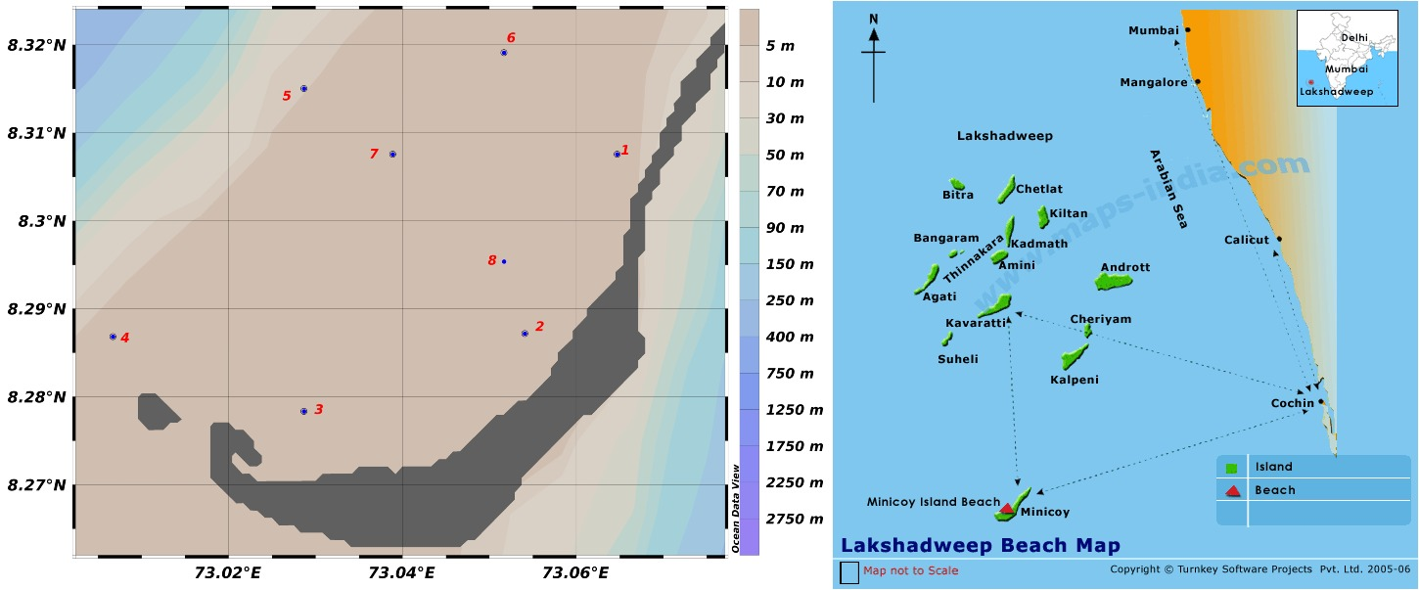
Fig.1 Study area in the Lagoon waters of Minicoy Island

Table 1. Meteorological and hydrographic parameters recorded during the Trichodesmium bloom in the lagoon waters of Minicoy Island
Parameter | Units | Range / Mean Values | Remarks / Observation
Meteorological Parameters
Mean Sea Level Pressure | hPa | 1010.1 | Stable atmospheric condition
Relative Humidity | % | 81 | Moderately high humidity
Mean Wind Speed | km h⁻¹ | 3.3 | Calm wind conditions
Rainfall | — | Nil | No precipitation during bloom
Hydrographic Parameters
Surface Water Temperature | °C | 28–30 | Warm tropical waters favorable for bloom formation
Salinity | psu | 35–36.5 | High and stable salinity supporting Trichodesmium growth
pH | — | 7.9–8.2 | No significant spatial variation
Dissolved Oxygen (DO) | mg L⁻¹ | 5.8–6.5 | Well-oxygenated surface waters
Nutrient Parameters
Nitrate (NO₃⁻) | µM | 0.04–0.28 | Low during bloom; indicates active nitrogen fixation
Phosphate (PO₄³⁻) | µM | 0.18–0.35 | Moderate levels; supports metabolic activity
Silicate (SiO₄⁴⁻) | µM | 2.1–3.3 | Typical for oligotrophic lagoon waters

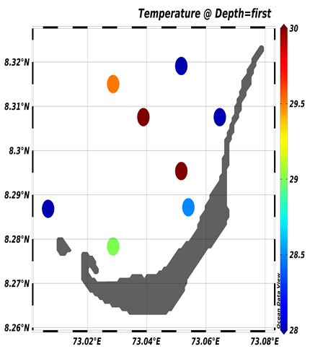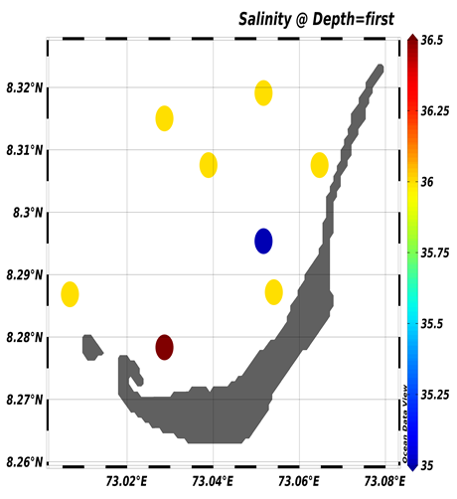
a.Temperature (̊ C) b.Salinity (psu)
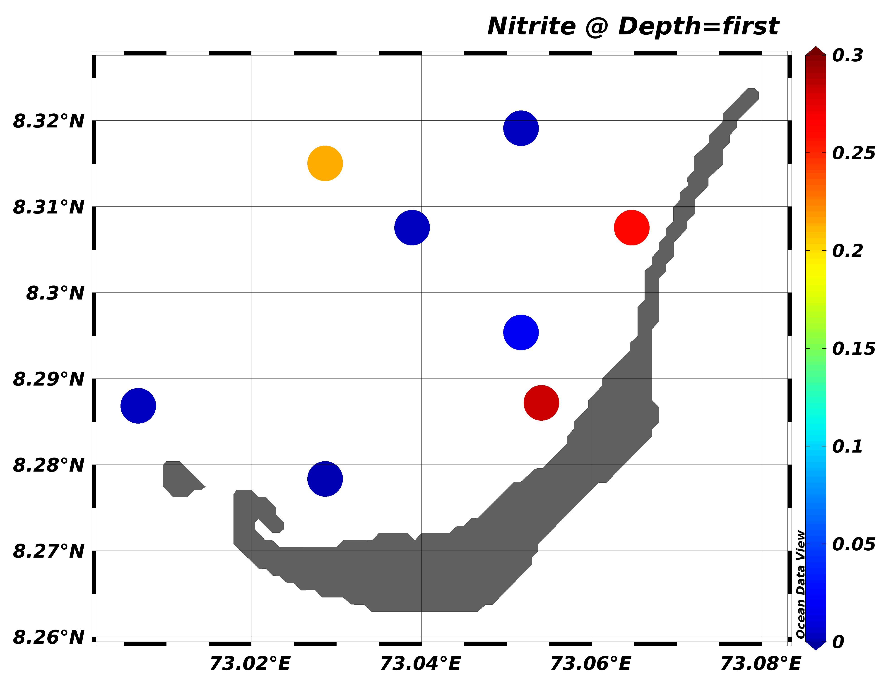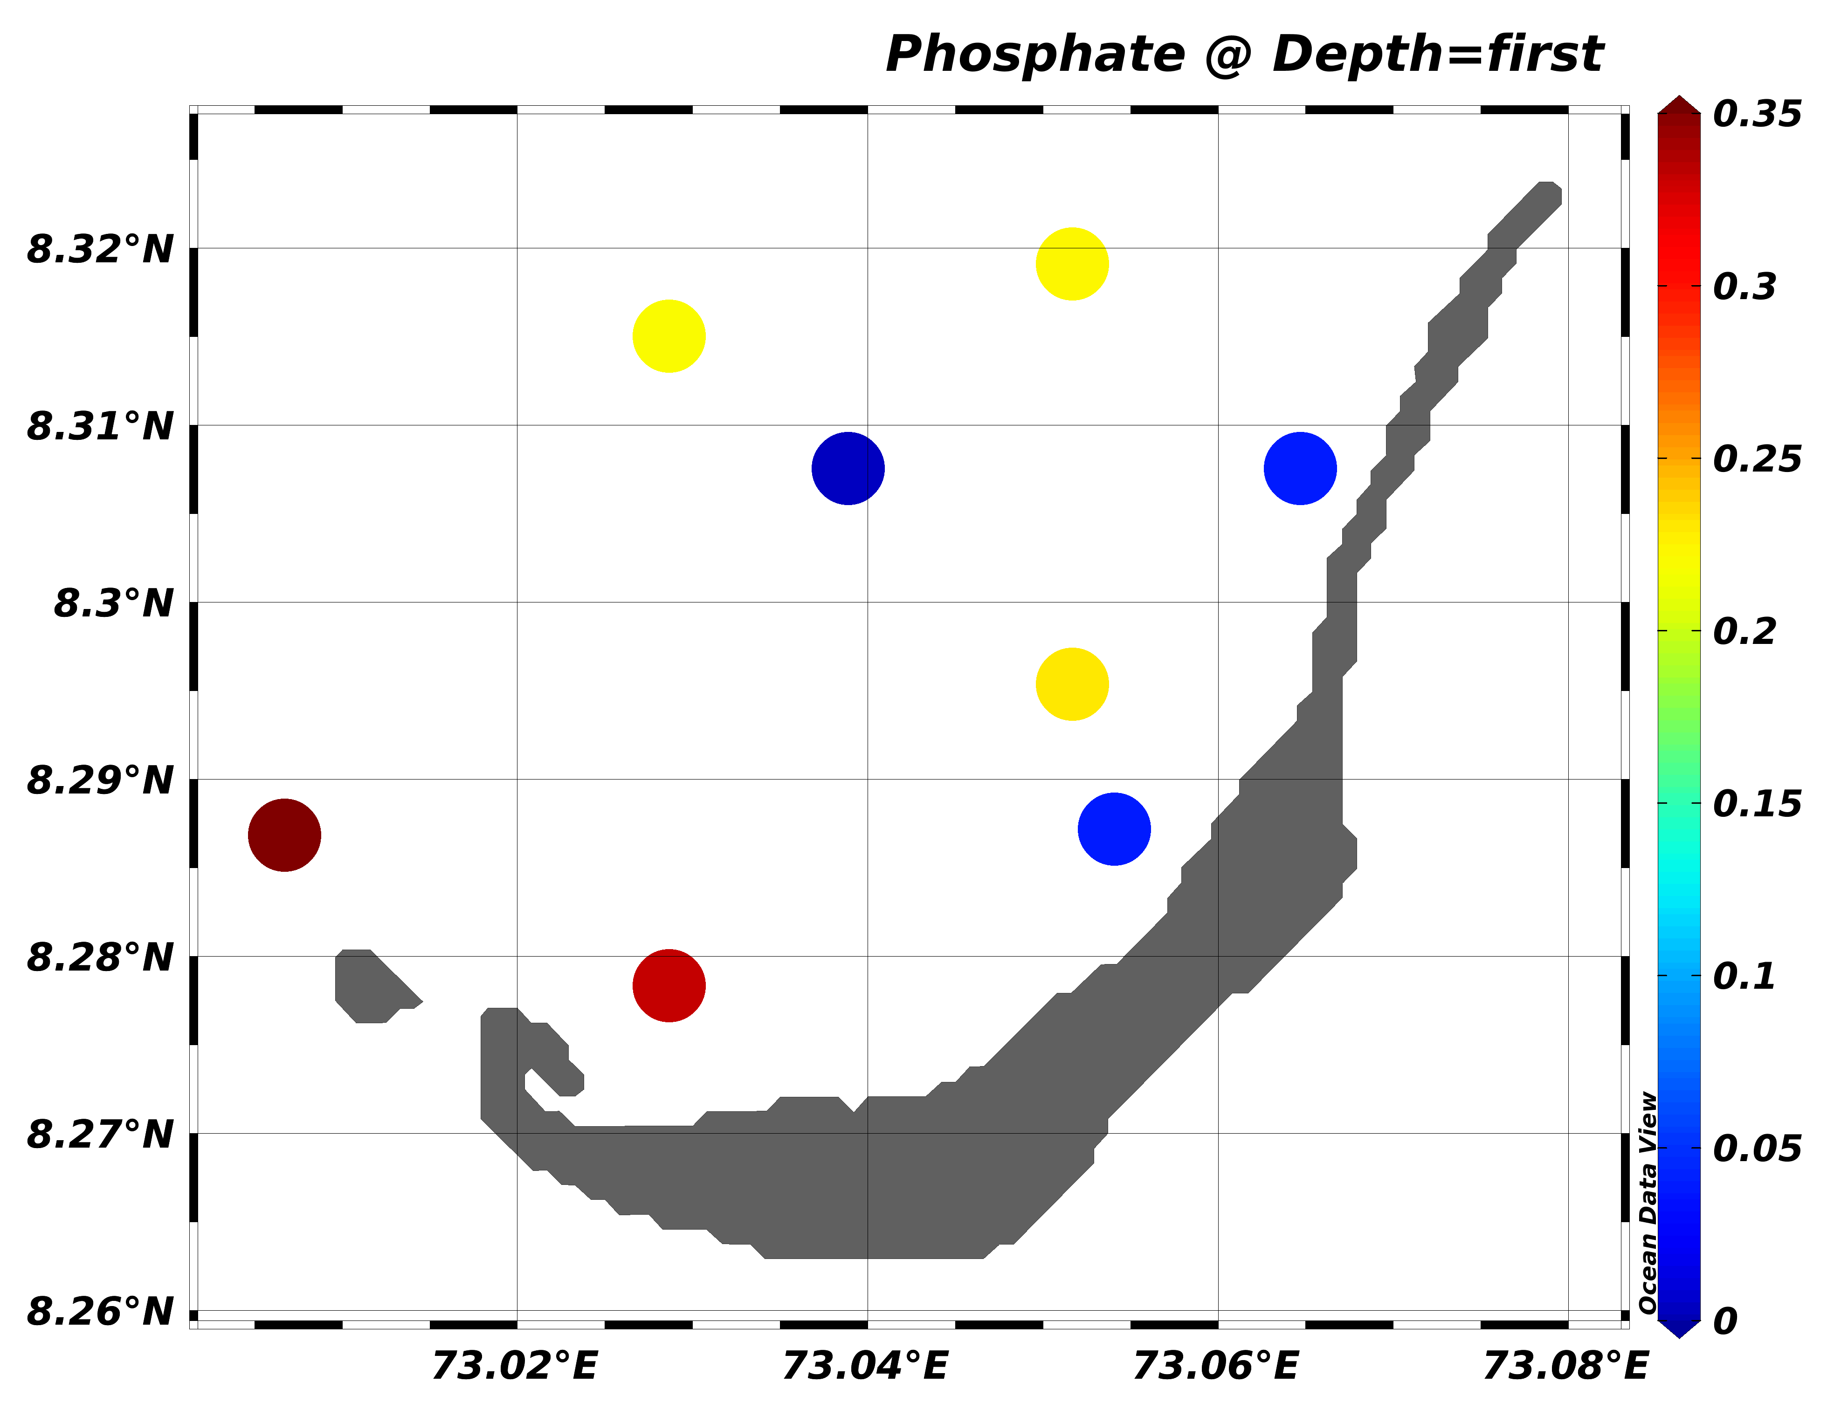
c. Nitrate (µM) d. Phosphate (µM)

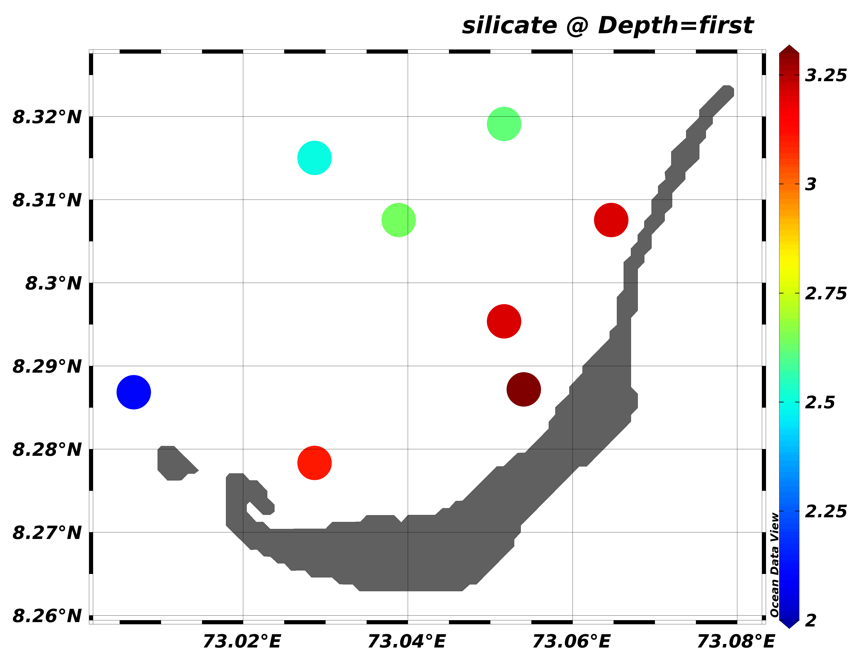
e.Silicate (µM)
Fig. 2. Water quality parameters recorded in the lagoon waters of Minicoy Island during study period

Fig.3. Cumulative Species composition of Phytoplankton
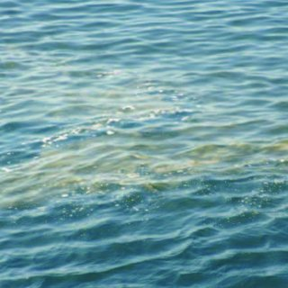
Fig. 4. Sea Sawdust (Trichodesmium erythraeum) Bloom in Lagoon Waters and Its Microscopic Observation

