Flora of the Wetlands: A Documentation of Lower to Higher Plant Groups from Gautam Buddha Nagar, Uttar Pradesh, India

.
ABSTRACT
The aim of the research was an inventory of macrophytes and algal assemblages in freshwater wetlands, which is vital for evaluating ecosystem health and interpreting ecological processes. This study marks a pioneering initiative to record both macrophytes and algal communities across several local water bodies in the Gautam Buddha Nagar district of western Uttar Pradesh, India. The survey identified 35 higher plant species, representing 31 genera and 22 families. There were several genera present belonging to the kingdoms Protista and Bacteria, as well as to the phyla Euglenophyta and Heterokontophyta (49 genera from 34 families).

Among the higher plants, distinct ecological groups emerged: three species were floating leaved, five were submerged, eight were free floating, and 19 were emergent. Poaceae with seven species was the dominant family followed by Araceae (three species). Field observations also highlighted the widespread presence of five major invasive species, Alternanthera philoxeroides, Eichhornia crassipes, Pistia stratiotes, Phragmites karka, and Typha domingensis—all actively encroaching upon the wetland habitats.
Algal assemblages displayed marked seasonal variation. Cyanobacterial taxa such as Anabaena, Arthrospira, Cylindrospermum, Lyngbya, Microcystis, and Synechococcus were dominant during the summer months. In contrast, diatoms prevailed in December at Bodaki, Beel Akbarpur, and Chithara. By February, Stigeoclonium species became prominent in Chithara, whereas Chlorococcum, Cosmarium, Scenedesmus, and Oedogonium dominated algal communities in Beel Akbarpur. Surrounding agricultural fields were largely characterised by Spirogyra species, while long chains of Fragilaria represented the most common diatoms across sites.
Overall, the assessment reveals that several water bodies experience excessive algal proliferation, particularly of Microcystis, leading to odour problems and rendering the water unfit for domestic use. A key recommendation emerging from this study is the adoption of community-based conservation and management approaches, recognising that local communities maintain continuous and direct interactions with these ecosystems.
Keywords: Algae, Macrophytes, Aggressive aquatic weeds, Water quality indicator, Wetlands.

1. INTRODUCTION

Biodiversity documentation plays a crucial role in the conservation of both flora and fauna. Documenting algae and macrophytes in urban and peri-urban freshwater bodies is critical for understanding, managing, and conserving these ecosystems. Phytoplankton communities are widely employed to evaluate current conditions related to eutrophication, as well as the physical and chemical characteristics of aquatic environments (Essien et al., 2024).
For this reason, they are considered effective bio-monitoring agents. This documentation provides valuable insights into water quality, ecosystem health, biodiversity, and the impacts of urbanisation and climate change. Conducting extensive surveys across various habitat types at regular intervals is essential for accurately documenting species in a given area. However, the lack of knowledge about the species present, along with difficulties in taxonomic identification, complicates the assessment of plant and algal diversity. Proper documentation provides baseline data that is critical for wetland conservation, restoration, and monitoring. Macrophytes and algae are especially important due to their pivotal roles in nutrient cycling, habitat structure, and carbon sequestration (Md. Foysul et al., 2024).
A research team from SNU (Shiv Nadar University), Dadri, Greater Noida, Gautam Buddha Nagar, has undertaken an effort to document macrophytes and algal assemblages from the surrounding wetlands, as well as within the university campus. The presence of several natural and man-made wetlands in Beel Akbarpur, Bodaki, and Chithara creates a unique ecosystem in this peri-urban setting. Since algal studies are often neglected, this motivated the team to explore the species growing in local water bodies near SNU campus. Water bodies like ponds are vital social-ecological systems where ecological processes and the activities of humans are closely linked. Ponds are crucial nodes in the local hydrological cycle and provide essential habitats for numerous plant and animal species, enhancing biodiversity. Ecologically, ponds play a vital role in nutrient cycling, water filtration, and climate regulation. Socially, ponds are crucial resources for nearby communities, offering water for domestic use, agriculture, and recreation. They also hold cultural, historical, and spiritual significance, often serving as community gathering spots and sites of traditional practices.
Freshwater algae and macrophytes are indispensable components of aquatic ecosystems. They support biodiversity by creating habitats, improving water quality, and sustaining complex food webs, making them essential for the conservation and sustainability of freshwater ecosystems. Wetlands, often referred to as "nature’s kidneys" and "nature’s supermarket," are among the most important ecosystems on Earth. They provide food, water, and protection against floods and storm surges, supporting millions of people (Keddy, 2010; Mitsch & Gooselink, 2015). The ecological significance of wetlands includes their roles in the global carbon cycle, hydrological cycle, nutrient cycling, and trophic interactions, while also maintaining high species diversity. The importance of wetlands has been recognized globally, leading to conservation laws and their inclusion in management plans. Preserving algal biodiversity is particularly important for sustaining ecosystem functions, especially in the face of regional and global environmental changes (Cardinale et al., 2006; Cardinale et al., 2012). For over a century, algae have played a key role in environmental assessments of water bodies and are now widely utilised across the globe. They form the base of aquatic food webs and are directly influenced by changes in nutrient concentrations, light availability, hydrology, temperature, and contaminants. Because algae have short life cycles and rapid growth rates, they react quickly to shifts in environmental conditions, making them ideal early-warning indicators (Round, 1991). In aquatic ecosystem evaluations, the species composition, biomass, and other characteristics of algal assemblages are analyzed to identify potential threats to drinking water, fisheries, and recreational water use (Stevenson, 2014). Over the years, the ecological preferences of algal species have been documented and refined, resulting in comprehensive lists of algal taxa and their associated environmental conditions (Sladecek, 1973; Lowe, 1974; Van Dam, 1994; Stevenson & Smol, 2003; Potapova & Carlisle, 2011).
Macrophytes (aquatic plants) and algae serve as bioindicators of water quality, reflecting nutrient levels, pollution, and habitat conditions. Monitoring the health of aquatic ecosystems is becoming increasingly challenging due to population pressures and rising freshwater demand. With limited freshwater resources and growing consumption, conserving these habitats—particularly peri-urban and urban wetlands- is essential for ensuring a sustainable future. Urban and peri-urban freshwater bodies play a crucial role in advancing Sustainable Development Goals (SDGs), particularly those related to clean water (SDG 6), sustainable cities (SDG 11) and climate action (SDG 13). These ecosystems support biodiversity, provide essential ecosystem services, and contribute significantly to urban resilience.
GB Nagar is equipped with a number of small to large-sized wetlands. Some prominent ones include Surajpur, Hasanpur, Beel Akbarpur and Shahpur Khurd wetlands (Ansari & Ram, 2016). Except for the Surajpur wetland (Ansari et al., 2016), most of the wetlands in the district are not surveyed for their biodiversity. In this paper, we present a survey of local wetlands and water bodies, using algae and macrophytes as ecological indicators to assess their health.
2. material and methods
2.1 Study area
The study area, encompassing Chithara (including SNU campus), Bodaki and Beel Akbarpur villages within the district of Gautam Buddha Nagar in western Uttar Pradesh, lies in the eastern part of Delhi NCR. The district is home to approximately 4,153 ha of wetland area, both natural as well as man-made (Murthy et al., 2013). Many of them are spectacular (like Surajpur Bird Sanctuary) habitats to birds, amphibians and reptiles and several herbivores. Along with rivers and streams (24.87%), natural wetlands include lakes/ponds (17.29%), waterlogged areas (6.65%), and oxbow lakes (Murthy et al., 2013). Man-made wetlands include waterlogged areas, reservoirs, and tanks/ponds.
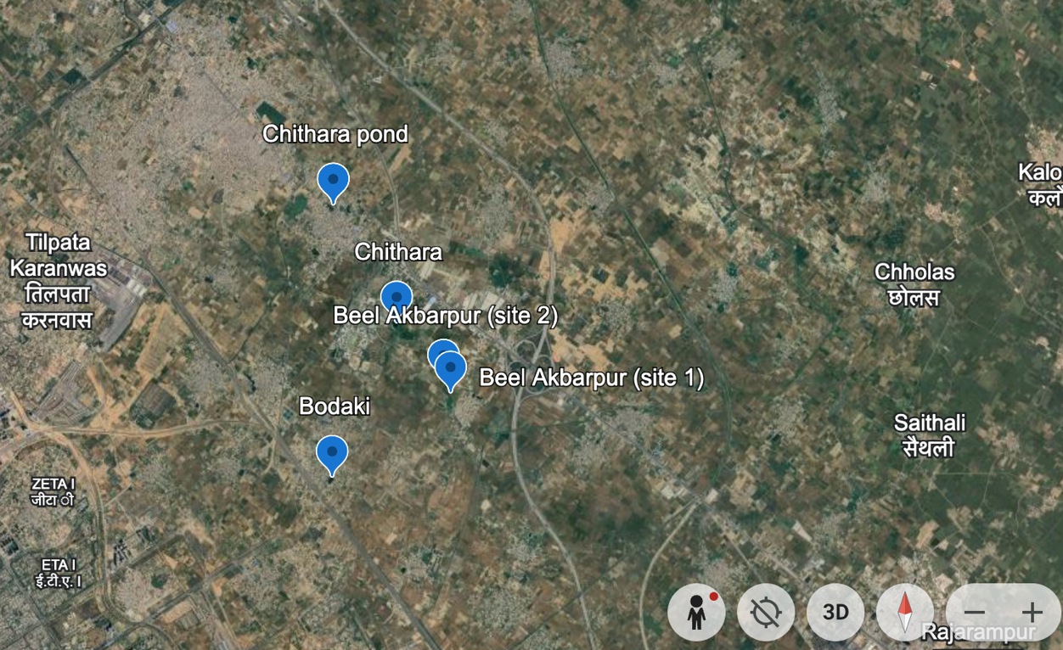

Fig. 1. Google map showing study sites: Chithara, Beel Akbarpur and Bodaki

All the villages included in this study are adjacent to each other, and Dadri is the nearest town for major economic activities. Chithara has a total geographical area of 770.78 hectares, while Bodaki and Beel Akbarpur cover 115 and 362.19 hectares area respectively. Delhi is approximately 40 km away from Chithara. Surrounded by numerous man-made and natural wetlands, agricultural fields, and wild plant growth, the study sites boast rich biodiversity, including phytoplanktons. Therefore, documenting phytoplankton assemblages is crucial for monitoring the health of these water bodies. Beel Akbarpur features various water bodies such as ponds, fish culture ponds, wetlands, grasslands, and agricultural fields. Samples were taken from various water bodies identified on Google Maps in December 2021 and April 2022 (Fig. 1). The general appearance of water bodies consisting of Chithara, Bil Akbarbar and Bodaki is shown in Fig. 2.

The climate of the study area is typically monsoonal, characterised by three distinct seasons: summer (March to mid-June), rainy (mid-June to September), and winter (October to February). The hottest month is June, with an average temperature of 32.85ºC, followed by May at 31.9ºC. January is the coldest month, with an average temperature of 14.2ºC, followed by December at 15.4ºC (Joshi, 2008-2009). The monsoon typically begins in the last week of June and continues until September, with maximum rainfall occurring during this period. Generally, August sees the highest rainfall, followed by July. The soil in the study area is fertile alluvial soil typical of the Wheat-Rice agriculture system in the southwestern plains of the Upper Gangetic Plain. The water pH ranges from 6.5-9.2. Dissolved oxygen (DO) ranges from 4-10 mg/l.

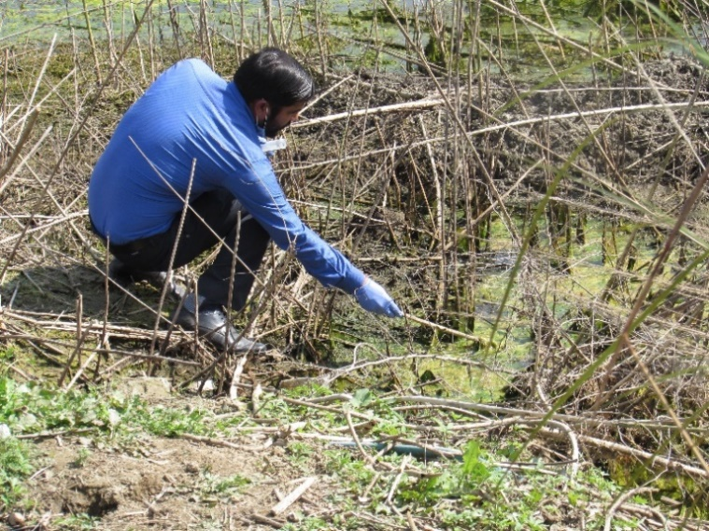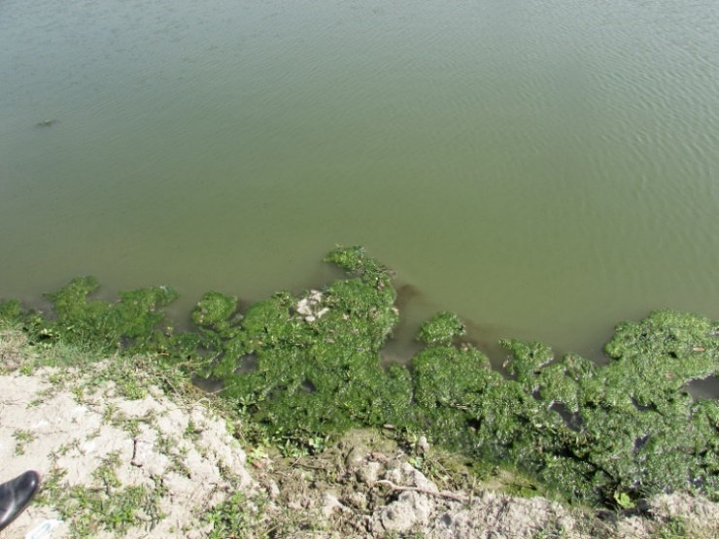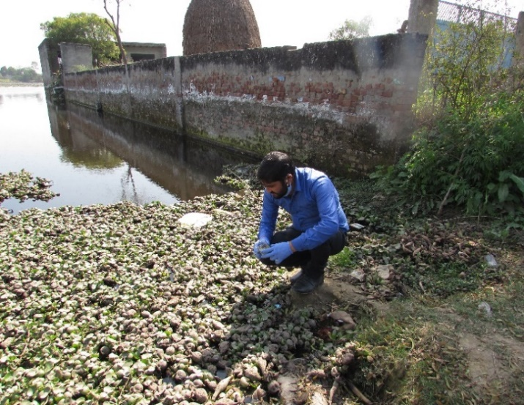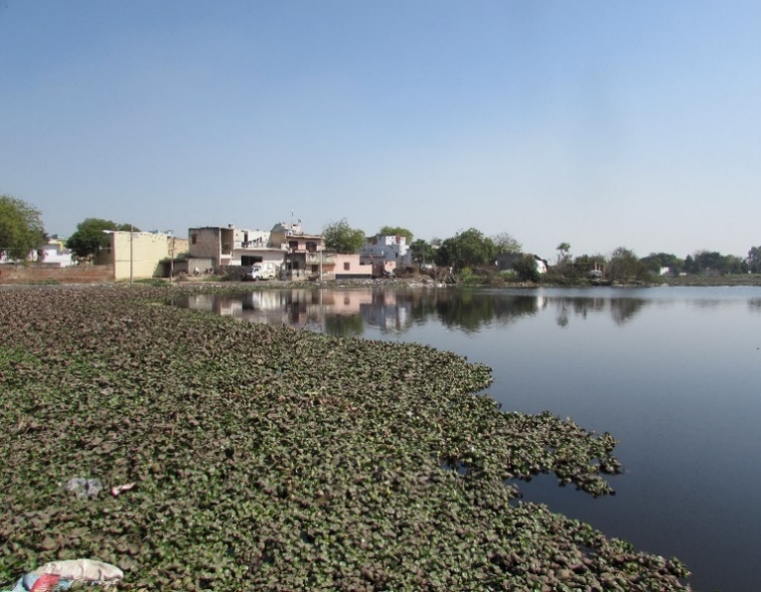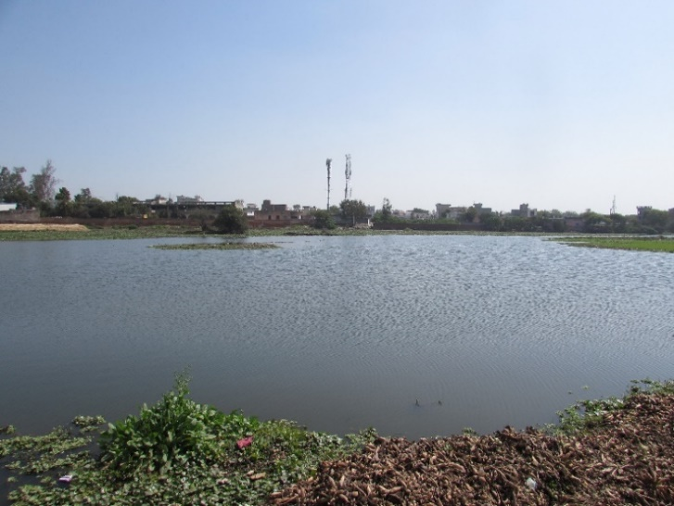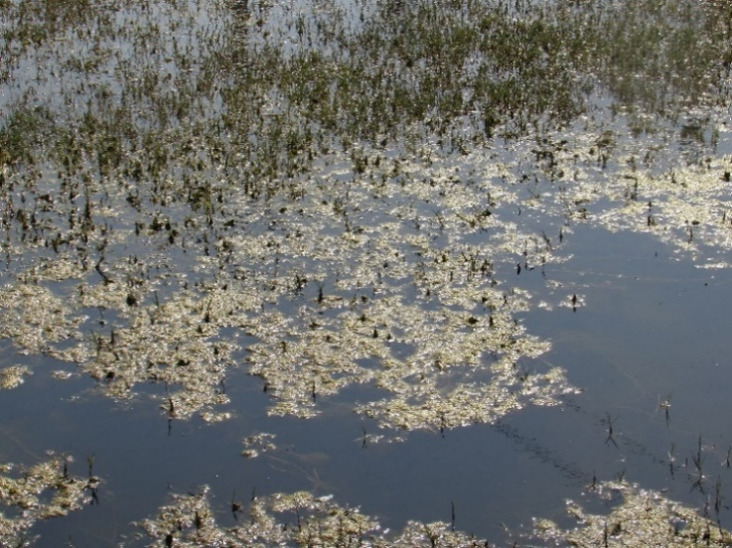
(C) Bodaki water bodies

A) Chithara water bodies
B) Beel Akbarpur water bodies
Fig. 2. General appearance of water bodies: A) Chithara; B) Beel Akbarpur; C) Bodaki

2.1.1 METHODOLOGY
For algal documentation, only two sampling months are considered here, December, 2021 and April 2022. Algal samples were mainly collected by scooping. Plant parts as well as floating, submerged, macrophytes were also collected. Slides (from live samples) were prepared using glycerin gel and identification was done by means of Nikon (Ci series) microscope at 20X, 40X magnification. For a few 100x, oil immersion was used. Community composition was followed by the slide transect method of sample count. Identification was mainly based on Deshikachary (1959), Karthick et al. (2013), and online resources like Algae Base.
For macrophytes documentation, the water bodies in the study sites were surveyed frequently throughout the year, covering different seasons, and all the macrophytes were documented. Photographs were taken in the field, and plant collections were made for identification purposes. The plants were identified following available floras (Duthie, 1903-1929; Vardhana, 2007). All the plants were broadly grouped into four distinct ecological groups, namely, floating-leaved (leaves float on the water surface while roots are attached to the bottom), free-floating (float freely on the water surface), submerged (grow completely under water) and emergent (usually rooted in shallow water with stems and leaves extending above the water surface). Plants growing adjacent to water bodies in marshy soil are considered emergent plants. The taxonomic identity of the plant specimens was verified by Plants of the World Online (POWO, 2024). Among the macrophytes, the exotic species that had very aggressive growth and covered a large area of the water bodies were identified. The possible impacts of these aggressive macrophytes on the aquatic ecosystem are also discussed.

3. results and discussion

Overall, lower plants constitute 46 genera from 34 families (Table 1). Among which algal genera of chlorophyta were dominated in all the study sites (Table 1). Among the study sites, Beel Akbarpur water bodies have maximum number of species that represent different families. Phytoplankton species composition and biomass provide reliable indicators of trophic status. For example, oligotrophic lakes are typically dominated by small flagellates and diatoms, whereas eutrophic waters exhibit higher densities of cyanobacteria and chlorophytes (Wetzel, 2001). Phytoplankton biodiversity is fundamental to aquatic ecosystems, functioning as primary producers and integral components of food webs, while supporting oxygen generation, carbon sequestration, and nutrient cycling (Nurhatika et al. 2018; Tucong et al. 2024). Owing to their rapid and pronounced responses to environmental change, phytoplankton serve as effective bioindicators of water quality (Tang et al. 2024). Their particular sensitivity to pollution, especially in estuarine environments, enables changes in community composition to be used for evaluating anthropogenic impacts (Febriansyah et al. 2023).

Among BGA, Anabaena, Arthrospira and Synechococcus were present in all the study sites. Microcystis was documented only from one fish culture pond of Beel Akbarpur. Cosmarium, Scenedesmus, Closterium, Chlorococcum, Oedogonium, Selenastrum, Spirogyra, Stauridium sp. were common Chlorophyta in all the study sites (Table 1). A long chain of Fragilaria was dominant in Bodaki, and this waterbody was dominated by water hyacinth. Nitzschia sp. was one of the common diatom genera in all the study sites, which indicates polluted water (Table 2) (Smol, 2008). Aulacoseira granulata was found in Chithara water body. Gomphonema, navicula, Cymbella, and Pinnularia were common in all the study sites. Dominance of algal species such as Oscillatoria, Stigeoclonium, Pinnularia, Nitzschia, Cyclotella, indicated sewage contamination (Palmer, 1969; Dokulil, 2003). All of these bodies of water are receiving domestic sewage and/or agricultural runoff, and the presence of certain algae confirms the presence of organic pollution.

Light, temperature, nutrients and disturbances play an important role in the growth of different algal species. The algal abundance and community composition would change along with the change in the environmental variables such as pH, nutrients (phosphorus, nitrogen, etc.), etc. The growth of cyanobacteria like Microcystis, Anabaena, and Dolichospermum is closely linked to high nutrient concentrations, warmer conditions, and stable water columns (Paerl & Otten, 2013). Due to excessive algal growth or ‘algal bloom’ aquatic system may experience changes in the appearance, odour issues, and summer kill or fish kill. Excessive algal growth negatively affects the other aquatic organisms, such as fish, especially during the summer months, due to low amounts of dissolved oxygen; fish kill events are common in many water bodies in India. Among all the study sites, Beel Akbarpur mainly witnessed a thick mat of algae. These aquatic systems are relatively shallow that of Chithara or Bodaki. The microscopic images of selected algal genus from the study sites are provided in Fig. 3.

Table 1. List of algae growing in the water bodies of the study sites

Families (genus/species) | Species | Habitat distribution | Occurrence
Families (genus/species) | Species | Habitat distribution | Chithara | Beel Akbarpur | Bodaki
Achnanthaceae (1/1) | Achnanthes sp. | Submerged leaf | - |  | -
Aphanizomenonaceae (1/1) | Anabaena sp. | Water column
Aphanizomenonaceae (1/1) | Cylindrospermum sp. | Water column | -
Aulacoseiraceae (1/1) | Aulacoseira granulata | Water column |  |  | -
Bacillariaceae (1/10) | Nitzschia spp. | Water column, Submerged leaf
Catenulaceae (1/1) | Amphora sp. | Submerged leaf |  | - | -
Characeae (1/1) | Chara sp. | Submerged | - |  | -
Chlamydomonadaceae (1/1) | Chlamydomonas sp. | Water column |  |  | -
Chlorellaceae (3/3) | Chlorella sp. | Water column | - |  | -
 | Dictyosphaerium sp. | Water column |  |  | -
 | Micractinium sp. | Water column | - |  | -
Chlorococcaceae (1/1) | Chlorococcum sp. | Water column | - |  | -
Cymbellaceae (1/6) | Cymbella spp. | Submerged leaf
Desmidiaceae (2/5) | Closterium spp. | Water column
 | Cosmarium sp. | Water column
Euglenaceae (1/1) | Euglena acus | Water column | -
Fragilariaceae (1/1) | Fragilaria sp. | Water column
Fritschiellaceae (1/1) | Stigeoclonium sp. | Submerged leaf |  | - | -
Gomphonemataceae (1/1) | Gomphonema sp. | Submerged leaf
Hydrodictyaceae (2/2) | Pediastrum boryanum | Water column
 | Stauridium tetras | Water column
Microcoleaceae (2/2) | Arthrospira sp. | Water column
 | Lyngbya sp. | Water column | -
Microcystaceae (2/2) | Microcystis sp. | Water column | - |  | -
 | Merismopedia sp. | Water column |  |  | -
Monodopsidaceae (1/1) | Nannochloropsis sp. | Water column |  |  | -
Naviculaceae (1/2) | Navicula spp. | Submerged leaf
 |  | Submerged leaf | -
Oedogoniaceae (1/1) | Oedogonium sp. | Attached on submerged leaf |  |  | -
Phacaceae (1/1) | Phacus sp. | Water column | - |  | -
Pinnulariaceae (1/1) | Pinnularia sp. | Submerged leaf
Radiococcaceae (1/1) | Gloeocystis sp. | Water column
Rhopalodiaceae (1/1) | Rhopalodia sp. | Submerged leaf | -
Scenedesmaceae (3/6) | Desmodesmus communis | Water column
 | Scenedesmus arcuatus | Water column
 | Scenedesmus quadricula | Water column
 | Scenedesmus obliquus | Water column
 | Scenedesmus dimorphus | Water column
 | Tetradesmus sp. | Water column |  |  | -
Selenastraceae (3/3) | Ankistrodesmus falcatus | Water column | -
 | Monoraphidium sp. | Water column |  |  | -
 | Selenastrum sp. | Water column
Spirogyraceae (1/9) | Spirogyra spp. | Floating, attached on macrophytes
Stauroneidaceae (1/1) | Craticula sp. | Submerged leaf | - |  | -
Stephanodiscaceae (2/2) | Cyclotella sp. | Water column |  | - | -
 | Discostella sp. | Water column | - |  | -
Synechococcaceae (1/1) | Synechococcus sp. | Water column
Volvocaceae (2/2) | Eudorina sp. | Water column |  | - | -
 | Pandorina sp. | Water column
Zygnemataceae (1/1) | Mougeotia sp. | Water column, bloom forming | - |  | -

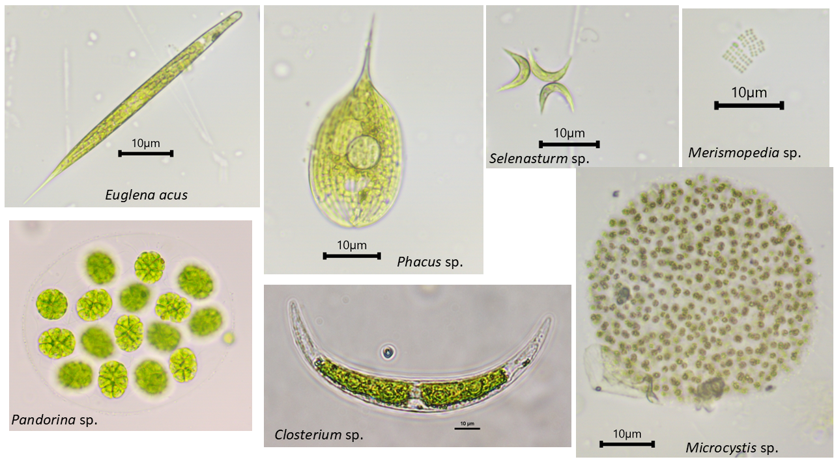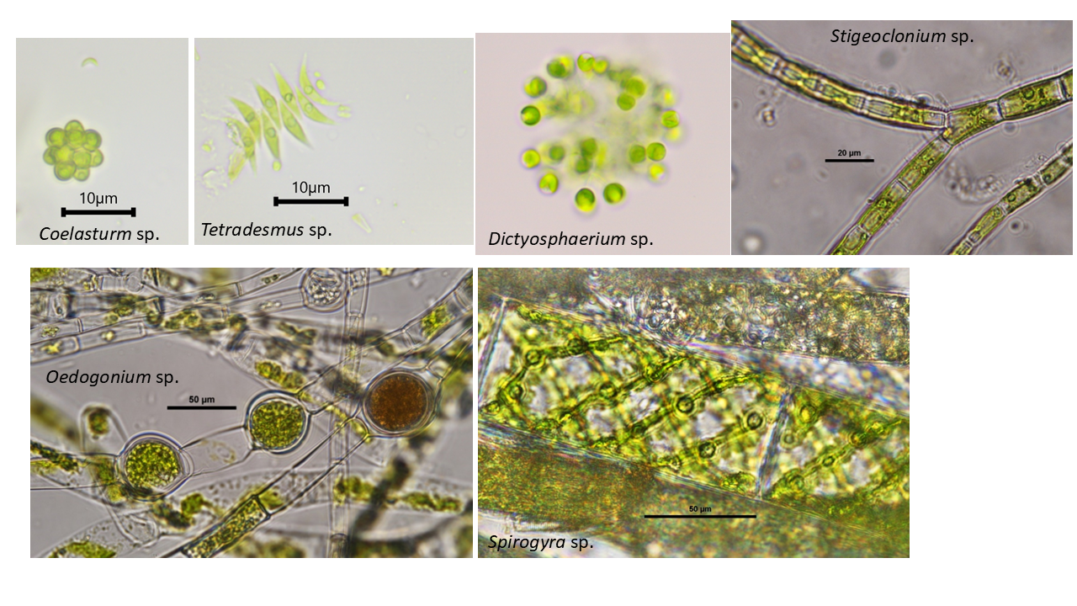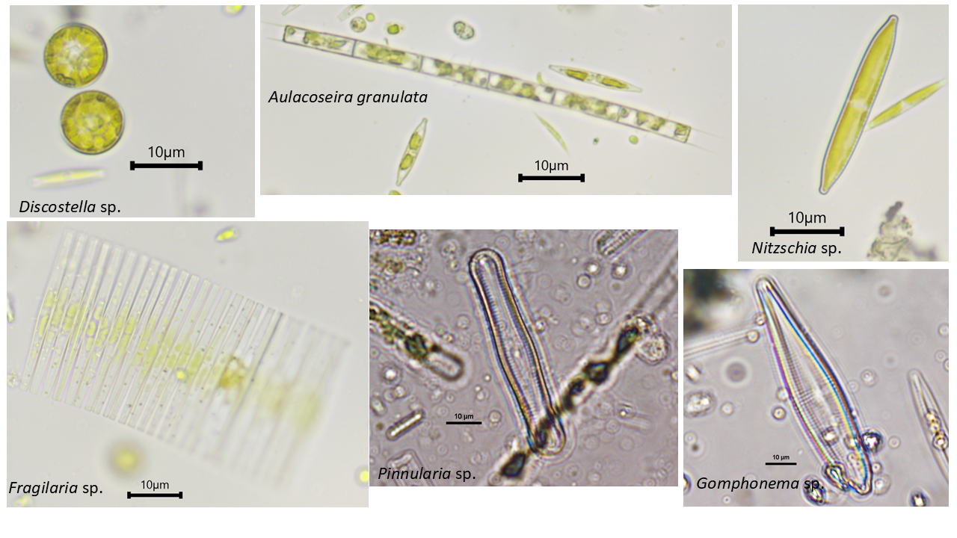
Fig. 3. Microscopic images of selected algal genus from the study sites
All these water bodies are constantly receiving domestic discharge which are enriched with nutrients such as phosphorus and nitrogen. These cluster of water bodies are also surrounded by agricultural fields and receiving agricultural runoff. The presence of certain algae is an important indicator of water quality (Table 2). For e.g., Euglena and Scenedesmus indicate high level of pollution (Palmer, 1969) (Table 2). Different algal genera indicate the trophic status of aquatic systems (Reynolds, 1997). Certain genera found at these study sites suggest eutrophic conditions, such as Anabaena, Eudorina, Pandorina, Staurastrum, Fragilaria, Chlorella, Monoraphidium, Cylindrospermum, Euglena, Pediastrum, and Scenedesmus (Table 2).

Table 2. List of water quality indicator algal species found in the study sites
Name of algae | Pollution index (Palmer 1969 | Trophic status (modified from Reynolds 1997)
Anabaena sp. | 1 | Eutrophic
Ankistrodesmus falcatus | 2
Ceratium sp. |  | Meso-eutrophic
Closterium sp. | 1
Chlamydomonas | 4
Chlorella | 3
Cosmarium sp. |  | Oligo-mesotrophic
Cyclotella | 1
Cylindrospermum sp. |  | Eutrophic
Euglena | 5
Eudorina sp., |  | Eutrophic
Fragilaria sp. |  | Eutrophic
Gomphonema | 1
Navicula | 3
Nitzschia | 3 | Eutrophic
Monoraphidium sp. |  | Eutrophic
Microcystis sp. |  | Meso-eutrophic
Pediastrum sp., |  | Eutrophic
Phacus | 2
Scenedesmus | 4 | Eutrophic
Stigeoclonium sp. | 2
Staurastrum sp. |  | Eutrophic

With respect to macrophytes documentation, altogether 35 higher plants belonging to 31 genera and 22 families were recorded from all the study sites (Table 3). Out of 35 higher plants, three species were floating leaved, five were submerged, eight were free floating, and 19 were emergent plants (Fig. 4). The majority of the species were angiosperms (32 species), while ferns constituted only three species. In general, emergent plants show a higher number compared to other categories in wetlands (Silva et al., 2023). With seven species, Poaceae was the most dominant family followed by Araceae (three species); overall, five additional families each had two species, and the remaining 15 families each had one species.
In Chithara village panchayat, including SNU campus, all 35 plants were recorded. However, Bodaki and Beel Akbarpur comprise 20 and 14 species, respectively (Table 3). Overall, 12 species were common to all sites. Among the list, several plants such as Ampelopteris prolifera, Ipomoea carnea, I. aquatica, Marsilea quadrifolia, Nymphaea pubescens, Ranunculus sceleratus, Saccharum bengalense, S. spontaneum, Salix tetrasperma are also known for their medicinal values in the traditional system of medicines (Sharma et al., 2019).

Table 3. List of macrophytes growing in and adjacent to the water bodies of the study sites

Families (Genus/Species) | Species Name | Habitat distribution | Occurrence
Families (Genus/Species) | Species Name | Habitat distribution | Chithara | Beel Akbarpur | Bodaki
Angiosperms
Amaranthaceae (1/1) | Alternanthera philoxeroides (Mart.) Griseb. | Free floating
Araceae (3/3) | Lemna perpusilla Torr. | Free floating
Araceae (3/3) | Pistia stratiotes L. | Free floating
Araceae (3/3) | Spirodela polyrhiza (L.) Schleid. | Free floating
Ceratophyllaceae (1/1) | Ceratophyllum demersum L. | Submerged |  | -
Convolvulaceae (1/2) | Ipomoea aquatica Forssk. | Free floating
Convolvulaceae (1/2) | Ipomoea carnea Jacq. | Emergent |  | -
Cyperaceae (2/2) | Cyperus alopecuroides Rottb. | Emergent
Cyperaceae (2/2) | Fimbristylis sp. | Emergent
Hydrocharitaceae (2/2) | Hydrilla verticillata (L.f.) Royle | Submerged
Hydrocharitaceae (2/2) | Vallisneria spiralis L. | Submerged |  | - | -
Lentibulariaceae (1/1) | Utricularia stellaris L.f. | Free floating |  | - | -
Lythraceae (1/1) | Ammannia baccifera L. | Emergent |  |  | -
Menyanthaceae (1/1) | Nymphoides cristata (Roxb.) Kuntze | Floating leaved |  | - | -
Nymphaeaceae (1/1) | Nymphaea pubescens Willd. | Floating leaved |  | -
Onagraceae (1/2) | Ludwigia hyssopifolia (G.Don) Exell | Emergent |  | - | -
Onagraceae (1/2) | Ludwigia octovalvis (Jacq.) P.H.Raven | Emergent |  |  | -
Poaceae (5/7) | Echinochloa colonum (L.) Link | Emergent |  | -
Poaceae (5/7) | Eriochloa procera (Retz.) C.E.Hubb. | Emergent |  | -
Poaceae (5/7) | Paspalum distichum L. | Emergent
Poaceae (5/7) | Paspalum scrobiculatum L. | Emergent
Poaceae (5/7) | Phragmites karka (Retz.) Trin. ex Steud. | Emergent |  | - | -
Poaceae (5/7) | Saccharum bengalense Retz. | Emergent |  | - | -
Poaceae (5/7) | Saccharum spontaneum L. | Emergent |  | -
Polygonaceae (1/1) | Persicaria lanigera (R.Br.) Soják | Emergent |  |  | -
Pontederiaceae (1/1) | Eichhornia crassipes (Mart.) Solms | Free floating |  | -
Potamogetonaceae (2/2) | Potamogeton crispus L. | Submerged |  | - | -
Potamogetonaceae (2/2) | Stuckenia pectinata (L.) Börner | Submerged |  | - | -
Ranunculaceae (1/1) | Ranunculus sceleratus L. | Emergent
Salicaceae (1/1) | Salix tetrasperma Roxb. | Emergent |  | - | -
Typhaceae (1/1) | Typha domingensis Pers. | Emergent
Urticaceae (1/1) | Gonostegia pentandra (Roxb.) Miq. | Emergent |  | - | -
Ferns
Marsileaceae (1/1) | Marsilea quadrifolia L. | Floating leaved (shallow water) |  | - | -
Salviniaceae (1/1) | Azolla pinnata R.Br. | Free floating |  | - | -
Thelypteridaceae (1/1) | Ampelopteris prolifera (Retz.) Copel. | Emergent |  | -

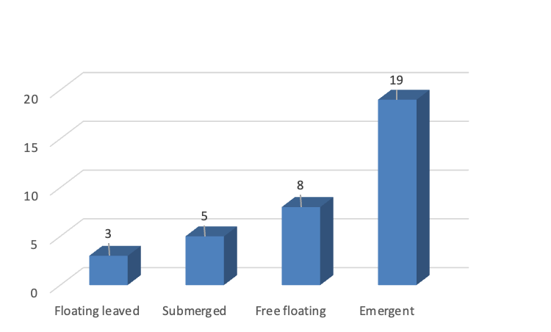

Fig. 4. Macrophytes recorded under various categories
Major Aggressive weeds of Water Bodies
The field observations during the study highlighted the widespread presence of five major aggressive weed of water bodies, namely, Alternanthera philoxeroides, Eichhornia crassipes, Pistia stratiotes, Phragmites karka, and Typha domingensis (Fig. 5). These macrophytes were growing aggressively and actively encroaching upon the wetland habitats.

1. Alternanthera philoxeroides (alligator weed)

Alligator weed, Alternanthera philoxeroides, is a perennial aquatic alien plant, floating at the water surface (Tripathi et al., 2021). The field observation identified its occurrence in all water bodies; however, the wetland on the SNU campus in Chithara, showed dense growth of Alternanthera covering the whole surface. It is one of the major noxious invasive species in Delhi NCR of India (Tripathi et al., 2021).

Growing most vigorously, it has an ability to grow in aquatic, sub-aquatic to terrestrial habitats. Its aggressive growth is mainly due to its vegetative reproduction. Vegetative reproduction causes increased habitat compatibility, hence, for successful invasion (Sharma et al., 2005). It is one of the most aggressive noxious weeds in this area, significantly impacting the local biodiversity (Tripathi et al., 2021). Its aggressive growth was found replacing other vegetation rapidly in wetlands of this region, therefore, the species is considered a major threat to biodiversity.

2. Eichhornia crassipes (water hyacinth)

Eichhornia crassipes, commonly known as water hyacinth, is a free-floating herb that floats on the water surface. The native of tropical America, water hyacinth is generally regarded as the most troublesome weed of freshwater systems, including wetlands (Tripathi et al., 2021). The water hyacinth infestation was seen covering entire water bodies in Chithara and Bodaki wetlands.

E. crassipes is considered one of the worst aquatic weeds across the globe (Global Invasive Species Database 2025). Its invasion causes a severe risk to the native flora in India (Sharma et al., 2005). The primary causes of E. crassipes' invasiveness are its free-floating growth form and stolon-based asexual reproduction (Sharma et al. 2005). However, if the plant is utilized positively, it has some beneficial attributes like the production of paper and fertilizer, generation of biogas, and in phytoremediation of wastewater (Ayanda et al., 2020).

3. Pistia stratiotes (water cabbage)

Pistia stratiotes, a free-floating aquatic herb, is generally found growing gregariously in wetlands, ponds, ditches, and other aquatic bodies (Sharma et al., 2019). In the present study, the eutrophic wetlands in Beel Akbarpur and Chithara recorded dense mats of water cabbage. It has negatively impacted several wetlands and other aquatic habitats (Tripathi et al. 2021).
P. stratiotes is an aggressive macrophyte in India and found throughout the tropics and subtropics (Sharma et al., 2019). It spreads rapidly through stolons, and once established, it covers the whole surface of the water. Thus, it forms a monodominant vegetation in water bodies. The species has posed a serious threat to native flora in India (Sharma et al. 2005).

4. Phragmites karka (tall reed)
The tall reed, Phragmites karka is an emergent macrophyte. It is a large perennial grass with elongated creeping rhizome. It is a common wetland grass found throughout India (Sharma et al., 2019). The major aggressive growth of plant was observed in wetland of Chithara.

P. karka is considered one of the most productive species of wetland ecosystems due to its ability to spread vegetatively by a robust system of creeping rhizome and stolons and through seeds by forming new plants in areas devoid of vegetation (Nayak et al. 2020). Its invasiveness is also due to its tolerance for higher salinity levels than other aquatic species (Nayak et al., 2020). Its widespread occurrence may cause severe ecological challenges in wetland ecosystems, including, reduction in local species diversity, and alterations to plant community structure. However, the plant is capable of removing potentially harmful heavy metals from aquatic systems, hence, it is assumed to be promising for sustainable use in municipal wastewater or sewage treatment following the horizontal subsurface flow constructed wetlands (Angassa et. al., 2019).

5. Typha domingensis (southern cattail)

Typha domingensis is an emergent macrophyte. It is a 2-3 m high rhizomatous herb with long leaves; abundant in marshy areas, generally along the bank of wetlands (Tripathi et al. 2019). Its presence was recorded in all studied water bodies. Typha may spread over great distances in aquatic systems because it produces a lot of wind-dispersal seeds. In addition, it also spreads rapidly through the underground fleshy rhizomes and forms a monodominant vegetation (Bansal et al. 2019). The rapid growth of the plant could establish its dense monotypic stands which could be difficult to control. This way, the species may pose a great threat to aquatic ecosystems (Tripathi et al. 2021).

In contrast to this, if the species is utilized ecologically, T. domingensis exhibits phytoremediation potential to absorb heavy metals such as pb, cu, zn, etc., from the polluted water (Soliman et al., 2024). This way, the species can be used as a promising plant to restore degraded water bodies by removing pollutants and can be utilized in constructed wetlands for the treatment of wastewater (Soliman et al., 2024).

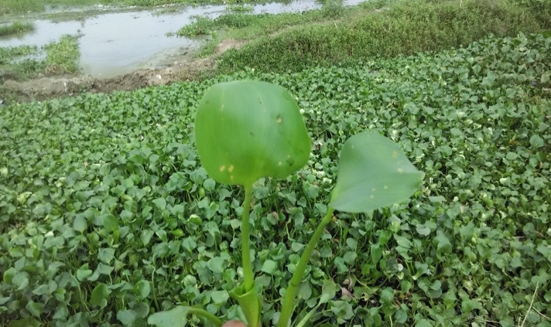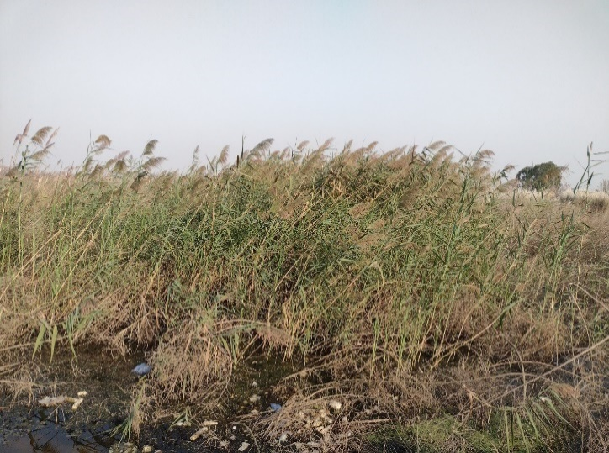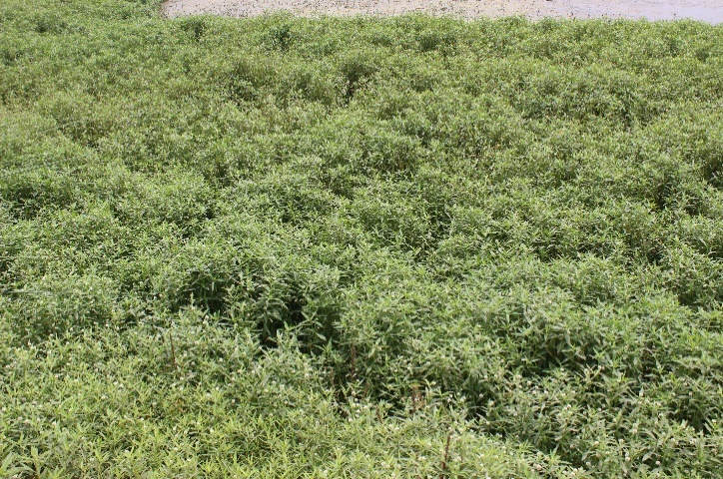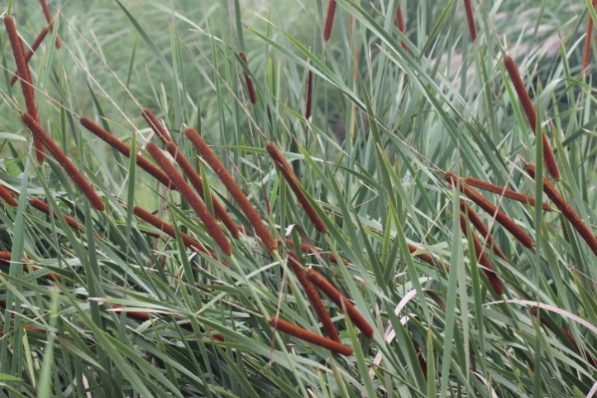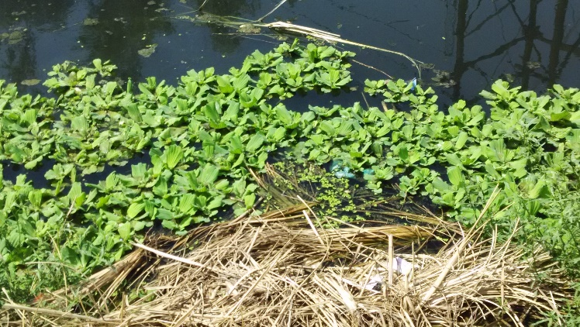
2
3
4
5
Fig. 5. Five major aggressive macrophytes in study sites; 1- Alternanthera philoxeroides, 2- Eichhornia crassipes, 3- Pistia stratiotes, 4- Phragmites karka, 5- Typha domingensis
1

Conclusion
The present study provides a comprehensive account of the algal and macrophyte diversity across the selected water bodies, highlighting clear ecological signals of nutrient enrichment and organic pollution. Among the sites, Beel Akbarpur exhibited the highest phytoplankton diversity, representing a wide range of families and indicating comparatively higher productivity. The overall phytoplankton community structure, characterised by the dominance of chlorophytes, cyanobacteria, and pollution-tolerant diatoms, suggests predominantly eutrophic conditions across the water bodies.
The widespread occurrence of cyanobacterial genera such as Anabaena, Arthrospira, and Synechococcus, along with chlorophytes like Scenedesmus, Cosmarium, and Spirogyra, and diatoms such as Nitzschia, Pinnularia, and Cyclotella, clearly indicates nutrient-rich and organically polluted conditions. Site-specific dominance patterns, including the prevalence of Fragilaria in Bodaki and the occurrence of Microcystis blooms in Beel Akbarpur, further reflect differences in hydrology, macrophyte cover, and nutrient loading. The consistent presence of algal taxa known to indicate sewage contamination and eutrophication confirms the influence of domestic wastewater discharge and agricultural runoff on these aquatic systems. Such conditions promote excessive algal growth, leading to blooms, oxygen depletion, and an increased risk of fish kill events, particularly during warmer months.
Macrophyte assessments revealed substantial diversity, with 35 higher plant species belonging to 22 families, dominated by emergent angiosperms. The presence of several medicinally important species, underscores the ecological and socio-economic significance of these wetlands. However, aggressive macrophytes appear to be a major threat to aquatic systems, hence, it is essential to maintain the ecological balance of these water bodies. Strategies may include controlling invasive species and promoting sustainable land-use practices. The reduced macrophyte diversity in some sites may be linked to shallow water depth, nutrient overload, and dense algal mats.
Overall, the combined phytoplankton and macrophyte assemblages serve as robust bioindicators of water quality, collectively pointing towards eutrophic conditions driven by sustained nutrient inputs. The findings emphasise the urgent need for effective management interventions, including regulation of domestic sewage discharge, control of agricultural runoff, and regular ecological monitoring, to prevent further degradation and to support the long-term ecological health and multifunctional value of these freshwater ecosystems.

AcknowledgEments
The authors are thankful to Shiv Nadar University for providing funding to execute the field work and logistics. Field work would not even possible without the help of Mr. Ved Prakash. We acknowledge gratefully the help rendered by Dr. Kate Laird (Dept. of Biology, Queen’s University, Kingston, Canada) and Prof. Jai Prakash Keshri (Botany Dept., University of Burdwan, West Bengal) for helping in the identification/confirmation of diatoms and green algae, respectively.
Authors’ Contributions

MK conceived the idea, prepared the manuscript, AKT prepared the manuscript, JKS helped with editing. All authors read and approved the final manuscript.

Disclaimer (Artificial intelligence)
Option 1:
Author(s) hereby declare that NO generative AI technologies such as Large Language Models (ChatGPT, COPILOT, etc.) and text-to-image generators have been used during the writing or editing of this manuscript.
Option 2:
Author(s) hereby declare that generative AI technologies such as Large Language Models, etc. have been used during the writing or editing of manuscripts. This explanation will include the name, version, model, and source of the generative AI technology and as well as all input prompts provided to the generative AI technology
Details of the AI usage are given below:
1.
2.
3.

References

Adl, S. M., Bass, D., Lane, C. E. et al. (2019). Revisions to the classification, nomenclature, and diversity of eukaryotes. Journal of Eukaryotic Microbiology, 66(1), 4-119.

Angassa, K., Leta, S., Mulat, W., Kloos, H., & Meers, E. (2019). Evaluation of pilot-scale constructed wetlands with Phragmites karka for phytoremediation of municipal wastewater and biomass production in Ethiopia. Environmental Processes, 6, 65-84.

Ansari, N. A., & Ram, J. (2016). Satellite wetlands and its avifaunal diversity in an urban landscape Gautam Budh Nagar, National Capital Region, India. Global Journal of Environmental Research, 10(1), 01-13.
Ansari, N. A., Khan, A. A., & Ram, J., (2016). Vascular plants of Surajpur wetland, National Capital Region, India. Indian Journal of Plant Sciences, 5(1), 54-69.
Ayanda, O. I., Ajayi, T., & Asuwaju, F. P. (2020). Eichhornia Crassipes (Mart.) Solms: uses, challenges, threats, and prospects. The Scientific World Journal, Article ID 3452172, 12 pages. doi: 10.1155/2020/3452172.

Bansal, S., Lishawa, S. C., Newman, S., & Tangen, B. A. et al. (2019). Typha (Cattail) invasion in North American wetlands: biology, regional problems, impacts, ecosystem services, and management. Wetlands, 39, 645–684.

Beck, H. E., Zimmermann, N. E., McVicar, T. R., Vergopolan, N., Berg, A., & Wood, E. F. (2018). Present and future Köppen–Geiger climate classification maps at 1-km resolution. Scientific Data 5, 180214.

Cardinale, B. J., Duffy, J. E., Gonzalez, A. et al. (2012). Biodiversity loss and its impact on humanity. Nature, 486, 59-67.
Cardinale, B. J., Srivastava, D. S., Duffy, J. E. et al. (2006). Effects of biodiversity on the functioning of trophic groups and ecosystems. Nature, 443, 989-992.
Deshikachary, T. V. (1959). Cyanophyta. In: Monograph in Algae. New Delhi: I.C.A.R. Pages 686.
Dokulil, M. T. (2003). Algae as ecological bio-indicators, p. 285-327. In: B. A. Markert., A.M. Breure & H. G. Zechmeister (Eds.). Bioindicators and Biomonitors. Elsevier Science Ltd.
Duthie, J. F., Parker, R. N., & Turrill, W. B. (1903-1929). Flora of the upper Gangetic Plain and of the adjacent Siwalik and Sub-Himalayan tracts. Superintendent of Government Printing, Calcutta.
Febriansyah, S. C., Hakim, L., Saptoyo, S., & Retnaningdyah, C. (2023). Phytoplankton diversity as a bioindicator of water quality mangrove ecosystems in Clungup Mangrove Conservation, Kondang Merak and Sempu Island, Malang Regency. Journal of Tropical Biodiversity and Biotechnology, 8, 73002. DOI: 10.22146/jtbb.73002.

Global Invasive Species Database (2025) Species profile: Eichhornia crassipes. Downloaded from http://www.iucngisd.org/gisd/species.php?sc=70 on 03-12-2025.

Joshi, B. C. (2008-2009). District brochure of Gautam Budh Nagar, UP. Central Ground Water Board, Ministry of Water Resources, Government of India.

Karthick, B., Hamilton, P. B., & Kociolek J. P. (2013). An illustrated guide to common diatoms of Peninsular India. Gubbi: Gubbi Labs.

Keddy, P. A. (2010). Wetland ecology: principles and conservation (2nd ed.). Cambridge: Cambridge University Press.

Kottek, M., Grieser, J., Beck, C., Rudolf, B., & Rubel, F. (2006). World map of the Köppen-Geiger climate classification updated. Meteorologische Zeitschrift, 15, 259-263.

Lowe, R. L. (1974). Environmental requirements and pollution tolerance of freshwater diatoms. US Environmental Protection Agency, EPA-670/4-74-005. Cincinnati, Ohio.
Mitsch, W. J., & Gosselink, J. G. 2015. Wetlands (5th ed.). New Jersey: John Wiley and Sons Inc.
Murthy, T. V. R., Patel, J. G., Panigrahy, S., & Parihar, J. S. (2013). National Wetland Atlas: Wetlands of International Importance under Ramsar Convention, SAC/EPSA/ABHG/NWIA/ATLAS/38/2013, Space Applications Centre (ISRO), Ahmedabad, India.
Nayak, S. S., Pradhan, S., Sahoo, D., & Parida, A. (2020). De novo transcriptome assembly and analysis of Phragmites karka, an invasive halophyte, to study the mechanism of salinity stress tolerance. Scientific Reports, 10, 5192.

Nurhatika, S., Ermavitalini, D., Saputro, T. B., & Apriyatmoko, Y. (2018). Biodiversity and characterization of high lipid content microalgae in Porong River Estuary East Java, Indonesia. Biodiversitas, 19, 627-632. DOI: 10.13057/biodiv/d190234.

Paerl, H. W., & Otten, T. G. (2013). Harmful cyanobacterial blooms: causes, consequences, and controls. Microbial Ecology, 65(4), 995-1010.
Palmer, C. M. (1969). A composite rating of algae tolerating organic pollution. Journal of Phycology, 5, 78-82.
Palmer, C. M. (1969). A composite rating of algae tolerating organic pollution. Journal of Phycology, 5(1), 78–82.

Potapova, M., & Carlisle, D. M. (2011). Development and application of indices to assess the condition of algal assemblages in U.S. streams and rivers. Open-File Report 2011–1126, U.S. Geological Survey.
POWO (2024). Plants of the World Online. Facilitated by the Royal Botanic Gardens, Kew. Published on the Internet.
Raven, P. H., Evert, R. F., & Eichhorn, S. E. (2013). Biology of Plants (8th ed.). New York: W. H. Freeman.
Reynolds, C. S. (1997). Vegetation processes in the pelagic: a model for ecosystem theory. In: Kinne, O. (Ed.). Excellence in Ecology 9. Germany: Ecology Institute, Oldenburg.

Round, F. E. (1991). Diatoms in river water-quality assessment. Institute of Environmental and Water Management.
Sharma, G. P., Singh, J. S., & Raghubanshi, A. S. (2005). Plant invasions: Emerging trends and future implications. Current Science, 88: 726-734.
Sharma, J. K., Tripathi, A. K., & Ahmad, M. (2019). Illustrated Flora: Part of western Uttar Pradesh and Delhi NCR, India. New Delhi: Astral International Pvt. Ltd.
Silva, C. P., Dutra, Jr. D. L. S., Machado, D. N. S., Barros, A. A. M., & Pontes, J. A. L. (2023). Structure and floristics of the plant community in Lagoa do São Bento, Maricá, Rio de Janeiro state, Brazil. Rodriguésia, 74, e00072021.

Sladecek, V. (1973). System of water quality from the biological point of view. Archiv f€ur Hydrobiologie und Ergebnisse Limnologie, no. 7.

Smol, J. P. (2008). Pollution of lakes and rivers: A paleolimnological perspective (2nd ed.). New York: Oxford University Press.

Soliman, M. A., Ahmed, D. A., Mansour, K. H., Gharib, F. A., Galal, T. M., & Slim, D. F. (2024). Typha domingensis (Pers.) Poir. ex Steud. Potential to restore contaminated wetlands in Egypt. Journal of Soil Science and Plant Nutrition, 24, 8005-8015.

Stevenson, J. (2014). Ecological assessment with algae: a review and synthesis. Journal of Phycology, 50, 437-461.

Stevenson, R. J., & Smol, J. P. (2003). Use of algae in environmental assessments in fresh water algae of North America. In: Freshwater algae of North America. Amsterdam: Elsevier Inc.
Tang, Q., Xu, L., Wang, L., Ning, J., Huang, D., Li, Y., & Du F. (2024). Positive linear relationship between phytoplankton diversity and productivity in an artificial reef ecosystem. Aquatic Ecology, 58, 1267-1279. DOI: 10.1007/s10452-024-10140-3.

Tripathi, A. K., Sharma, J. K., & Ahmad, M. (2021). A preponderance of alien species in Delhi NCR of western Uttar Pradesh: possible impacts on ecosystem. Tropical Plant Research, 8, 50–62.
Tucong, E. J. A., Tubio, E. G., & Leopardas, V. E. (2024). Diversity of epipelic microalgae in a shallow, tropical estuary of Northern Mindanao, Philippines. Biodiversitas, 3237-3245. DOI: 10.13057/biodiv/d250946.

Van Dam, H., Mertens, A., & Sinkeldam, J. A. (1994). Coded checklist and ecological indicator values of freshwater diatoms from the Netherlands. Netherland Journal of Aquatic Ecology, 28, 117-133.
Vardhana, R. (2007). Flora of Ghaziabad District. New Delhi: Shree Publishers & Distributors.

Wetzel, R. G. (2001). Limnology: Lake and River Ecosystems (3rd ed.). Academic Press.

Essien-Ibok, M. A., George, U. U. & Ituen, A. M. (2024). Comparative Analysis of Phytoplankton Communities in Newly Inundated Ponds Using Organic and Inorganic Fertilizers. Asian Journal of Biology, 20(7), 64–77. https://doi.org/10.9734/ajob/2024/v20i7424

Md. Foysul Hossain, Gazlima Chowdhury, Tamzid Ahsan Nabil, Abrar Hossain, Sumiya Bhuyain, Mst. Meherin Farzana Mithi, Nazmin Begum & Alim Hossen. (2024). Diversity, Abundance, and Seasonal Variation of Aquatic Macrophytes in Southeastern Bangladesh. Asian Journal of Fisheries and Aquatic Research, 26(7), 55–66. https://doi.org/10.9734/ajfar/2024/v26i7783

