(Original Research Article)

River Hydrological Assessment through Cross-Sectional Water Discharge Estimation in the Jamuna River of Assam, India

Abstract: Rivers in North-Eastern region of India are known for sustaining the regional hydrology and contributing to the local livelihoods. Due to the limited field-based research works in the remote locations to quantify the river’s discharge characteristics, this field remains unexplored. Addressing this gap, this study aims to assess the hydrological behaviour of the Jamuna River (Assam), using the cross-sectional discharge estimation method. Jamuna River is a tributary of the Kopili River in Karbi Anglong (East Karbi Anglong) and Hojai districts of Assam. Through field-based data collected from three key cross-sections in Jamuna River, viz. from Manja (upstream), Bokolia (midstream) and Doboka (downstream); and subsequent estimation of water discharge using observed velocity, depth and channel width. This work reveals the spatial variability in the hydrological characteristics of the Jamuna River of Assam. The analysis shows a clear longitudinal increase in discharge volume from upper to the lower reaches, indicating cumulative catchment contributions. It establishes that variations in water discharge are closely linked with the geomorphology and land use patterns inside the basin. The increasing anthropogenic pressures and climate-induced hydrological variability in the micro regions like Jamuna watershed of Assam draws serious concerns regarding the basin sustainability and human interventions. The study also emphasizes the value of field-based hydrological assessments in complementing satellite and GIS-based models to develop grounded and location specific management strategies.
Keywords: Cross-Sectional Water Discharge; Hydrological Assessment; flow meter; Jamuna Watershed.

1. INTRODUCTION
The water resources are the most primary element to sustain the ecological balance and human well-being in the world; with increasing climatic variability, urban population expansion and unregulated extraction of natural resources, the global water percentage is under severe stress. In different countries, the rivers act as lifelines for societies; agriculture, economy and biodiversity all are dependent towards the fresh water source; but their hydrological regimes are being altered by various modern day anthropogenic activities (Kundzewicz et al., 2018). Therefore the understanding of river hydrology is important for maintaining the water security and prediction of water related hazards. River hydrological assessment ensures watershed sustainability for the future in the current scenario of climatic variations in terms of temperature, rainfall variation patterns, which affects the natural discharge and runoff patterns in the basins.
The river systems in Indian subcontinent sustain a large agrarian population from decades; highly populated industrial cities are also situated in the banks of the rivers. The present day scenario of rivers flowing beside major cities is miserable. They become heavily polluted and ecologically degraded due to severe human negligence.
In the north-eastern region, characterized by intense monsoonal rainfall, hilly terrain and frequent flooding in the plains, hydrological assessments are particularly critical for understanding watershed sustainability (Gogoi & Jain, 2020; Das & Goswami, 2003). Assam’s various smaller tributaries like Jamuna River in Karbi Anglong have received limited hydrological attention despite their greater ecological and livelihood significance (Phukan et al., 2012) supporting local agriculture, fisheries and forest dependent communities. However there was no comprehensive discharge based study exists for this river, leaving a gap in understanding its hydrological behavior and seasonal water dynamics. Addressing this gap, this study applies a field based cross-sectional discharge estimation to establish baseline hydrological characteristics for the Jamuna watershed.
Assam has the impressive river network with heavy monsoonal rainfall, mixed topography comprising hills to extensive plains; with frequent flood hazards in those plains (Goswami, 1985; Deka et al., 2018). Various techniques of hydrological assessments help in regional water planning and mitigation of water related disaster. Therefore study of the river hydrology is important for knowing the water demand and capacity (Garg et al., 2017) and innovating techniques to make sustainable water management in stressed areas (Gogoi & Jain, 2020; Nasrin & Barman, 2025). The Jamuna River, which flows through East Karbi Anglong and Hojai districts of Assam, forms an extensive floodplain region (Das & Goswami, 2003; Phukan et al., 2012); supporting people’s livelihood and agriculture. Despite its regional significance, no study has been conducted to understand its hydrological behavior based on primary field data, therefore no discharge and velocity data is available for this river; not in the government office of water resources department of Assam and record’s archive.
In the river related studies, the estimation of water discharge is one of the most fundamental hydrological parameters and to calculate this, the needed equipments are flow meter or current meter to collect it in different cross sections of the river, measuring tape, ranging rods etc. Hydrological study helps to determine river flow capacity, sediment transport potential, flood forecasting and overall watershed dynamics (Gogoi & Jain, 2020). The satellite-based DEM data and GIS analysis provide a broad-scale understanding of it with 15 meter or 30 meter resolutions (freely available satellite data); but the field-based cross-sectional analysis helps in calculating real-time flow estimation of remote points with more accuracy.
This paper presents a cross-sectional analysis of water discharge in the Jamuna River across three representative zones, viz., upstream (Manja), midstream (Bokolia) and downstream (Doboka). By evaluating the variations in depth, velocity and channel width across these points, the paper aims to assess spatial variations in hydrological behavior and interpret them in the context of geomorphological and anthropogenic influences within the watershed.
There are some limitations of cross-sectional methods, despite their effectiveness. The limitations include temporal constraints, spatial discontinuity and challenges in capturing peak flow variations (Montanari et al., 2013; Lane, 2014). Although this method is suitable for small and medium-sized rivers, with well designed repeated measurements; it shows high quality data, where automatic gauging systems are not available. Modern hydrological research emphasizes combining cross-sectional field measurements with morphometric and rainfall analysis to establish longitudinal discharge relationships and identify hydrological anomalies within a watershed (Sivapalan & Blöschl, 2015).

2. Objectives
The main objective of this work is to explore the hydrological condition of the Jamuna River; and to observe the rainfall pattern in the last two decades inside the basin to understand the hydrological behaviour and water availability inside the basin. The basin’s lower part is facing frequent flood occurrences; through the cross sectional analysis and rainfall distribution pattern, the flood occurrence can be interpreted in relation to discharge and catchment response to rainfall.
The objectives of this research are:
- To quantify the spatial variation in water discharge along upstream, midstream and downstream reaches of the Jamuna River.
- To analyze how geomorphological and land-use factors influence discharge variability across these zones.
3. STUDY AREA
The study area, Jamuna watershed of Assam, can be divided into the upstream zone with hilly terrain and sparse settlements with dense vegetation; the mid stream zone has moderate slope and moderate concentration of settlements can be seen; and the downstream zone has alluvial plain and settlement concentration is high (Nasrin & Barman, 2025) with small urban market places. The downstream zone is suitable for various agricultural crops and fish farming; numbers of fisheries were there in this zone producing fish commercially. Communities living in this zone are mostly farmers and they mainly practice rice, vegetable and jute cultivation.
The Jamuna River is a tributary of Kopili River. The Jamuna watershed is located in the East Karbi Anglong and Hojai district of Assam. It extends from 25°41ʹ N to 26°27ʹ N latitude and from 92°44ʹ E to 93°40ʹ E longitude (Nasrin & Barman, 2025) (Figure 1). The Jamuna River originates from Khumbaman hills at the altitude of 1300 meters in East Karbi Anglong and joins with Kopili River near Jamunamukh town in Hojai district of Assam. Total area of the Jamuna watershed is about 3900 sq. km (Borah & Deka, 2019; Borah & Deka, 2020; Nasrin & Barman, 2025). The Jamuna River flows through varied terrain including tribal-inhabited uplands, agricultural mid-valleys and the flood-prone alluvial plains of Hojai before merging with the Kopili River. The total length of the river is approximately 175.92 kilometers and it traverses through ecologically sensitive and socioeconomically diverse zones (Dutt, 1979; Nasrin & Barman, 2025).
Geologically the watershed features with Precambrian gneissic rocks in the upper reaches, weathered lateritic formations in the mid-zone and quaternary alluvium in the lower plains (Dutt, 1979). Soils vary from coarse sandy loams in the uplands to fine silt-clay alluvium in the lowlands of Doboka and Jamunamukh region; it directly influence the infiltration process and surface runoff patterns. The river’s longitudinal gradient decreases from 1,360 m to 70 m, creating a distinct hydrological zone of erosion in upstream, transition in mid and deposition in downstream. Dense forests are in the hills of upstream and flat open agricultural lands with marshy land, wetlands are common in downstream.
The tropical monsoonal climate brings 1,800-2,600 mm of annual rainfall in the region, during June to September. Various small tributaries and lateral inflows contribute significantly to the seasonal discharge variation. The watershed supports various tribal and non-tribal communities with different agricultural practices, fishing behaviours and livestock rearing as their livelihood; which depends on the Jamuna River’s flow regime.
For this study, the watershed is divided into three zones as upstream zone, midstream zone and downstream zone with three survey locations, they are as follows-
- Manja (Upstream survey location): Characterized by forest, high relief and steep slopes. The terrain here is rugged with relatively low anthropogenic interference and low population density. The altitude of Manja is 147 meters.
- Bokolia (Midstream survey location): Represents the transitional zone with mixed land use, moderate slope and increasing human activity in the form of agriculture and settlement. The altitude of Bokolia is 102 meters.
- Doboka (Downstream survey location): Situated in the low-lying plains with wider valleys, intensive agricultural activity with lots of fisheries and population density is higher here. The river channel is broader and deeper due to the cumulative effects of upstream discharge. The altitude of Doboka is 72 meters.

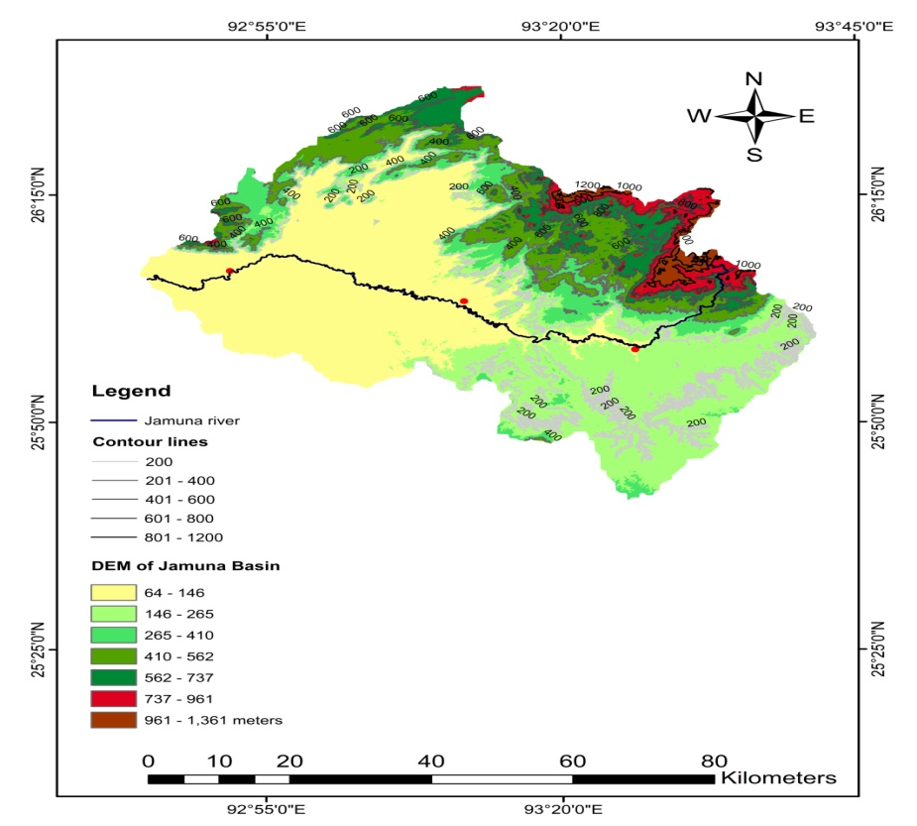
Doboka
Manja
Bokolia
Fig. 1. Map of Jamuna watershed, Assam.

4. METHODOLOGY

4.1 Field Data Collection
Hydrological fieldwork was conducted on 15th January 2025 to collect depth, width and velocity data from multiple across-sections in the Jamuna River. The equipment used included:
- Current meter or flow meter reading for velocity
- Graduated poles for depth measurement
- Measuring tapes for width
- GPS for location
Each cross-section was divided into 3 sub-sections (ai), with corresponding velocity (Vi) and depth (di) measurements taken. The field data were averaged for each cross-section to determine mean values for discharge calculation. To maintain data reliability the calculations were manually verified and checked with hydrological references (Chow, 1959; Subramanya, 2013). The use of cross-sectional analysis helps to estimate spatial discharge variability and contributes to a baseline hydrological understanding for the Jamuna River of Assam.

4.2 Discharge Calculation
The discharge (Q) at each cross-section, calculated using the following formula:
Q_{A}= V_{A}×d_{A}×W_{A}
where,
V_{A} is average velocity (m/s)
d_{A} is average depth (m)
W_{A} average width of the channel (m)
The final average velocity and depth were computed by averaging all sub-section values. All calculations were performed manually to validate and simplify real-world field-based assessments (Ward, 2000) and the velocity and discharge table were made.

5. RESULTS

Table: Estimation of water discharge from different cross sections of Jamuna River, Assam
Sl no. | Cross section | Sub cross-section | Velocity  (m/s) | Depth  (m) | Average velocity (m/s) | Average depth  (m) | Avg. Width of the channel  (m) | Water Discharge ($m^{3}$/s)
1 | A  (Manja) | a | V₁= 0.1 | d₁= 1.245 | 0.225 | 1.25 | 14.93 | Q_{A}=V_{A}×d_{A}×W_{A}  = 4.199
1 | A  (Manja) | b | V₂= 0.2 | d₂= 1.118
1 | A  (Manja) | c | V₃= 0.3 | d₃= 1.346
1 | A  (Manja) | d | V₄= 0.3 | d₄= 1.31
2 | B  (Bokolia) | e | V₅= 0.5 | d₅= 1.82 | 0.45 | 1.82 | 19.812 | Q_{B}=V_{B}×d_{B}×W_{B}  = 16.22
2 | B  (Bokolia) | f | V₆= 0.5 | d₆= 2.43
2 | B  (Bokolia) | g | V₇= 0.4 | d₇= 1.52
2 | B  (Bokolia) | h | V₈= 0.4 | d₈= 1.52
3 | C  (Doboka) | i | V₉= 0.3 | d₉= 1.82 | 0.3 | 5.76 | 24.38 | Q_{C}=V_{C}×d_{C}×W_{C}  = 42.12
3 | C  (Doboka) | j | V₁₀= 0.3 | d₁₀= 1.82
3 | C  (Doboka) | k | V₁₁= 0.3 | d₁₁= 1.52
3 | C  (Doboka) | l | V₁₂= 0.3 | d₁₂= 2.43
(Data estimated by the researcher) Date: 15-01-2025

Cross-Section A - Manja (Upstream Zone)
Average Velocity: 0.225 m/s
Average Depth: 1.25 m
Channel Width: 14.93 m
Calculated water Discharge: 4.199 m³/s
This headwater zone exhibits low discharge due to reduced surface runoff, high forest permeability and low land disturbance; although the data collection was done in winter. The low velocity and narrow channel width match the early-stage fluvial characteristics (Chow, 1959). The river has scenic high waterfalls in Longvoko (near Manja, Karbi Anglong), but the velocity and discharge drastically changed in Manja because of the dam constructed just a few kilometers above of Manja. These small dams help in water distribution to the agricultural fields but the river water and sediment discharge got affected and it makes the river dried up during winters.

Cross-Section B – Bokolia (Midstream Zone)
Average Velocity: 0.45 m/s
Average Depth: 1.82 m
Channel Width: 19.812 m
Calculated water Discharge: 16.22 m³/s
The discharge increase in this transitional zone is attributed to cumulative lateral inflows, surface drainage and moderate anthropogenic activities and presence of a dam lowering the water velocity.

Cross-Section C – Doboka (Downstream Zone)
Average Velocity: 0.3 m/s
Average Depth: 5.76 m
Channel Width: 24.38 m
Calculated water Discharge: 42.12 m³/s
Doboka records the highest discharge due to the cumulative upstream flow, broader valley and agricultural run-off. It is a typical depositional zone of sediments, also susceptible to annual extensive flooding (Singh, 2003; Ward & Robinson, 2000).
Overall the measured discharge values show a longitudinal increase from the upstream to downstream reaches; Manja (Upstream) 4.19 m³/s, Bokolia (Midstream) 16.22 m³/s and Doboka (Downstream) 42.12 m³/s. This pattern reflects cumulative catchment inputs due to numerous feeder tributaries which increases the lateral inflow and broader channel geometry towards downstream. Low discharge at Manja corresponds with high infiltration in forested uplands, the midstream and downstream zones exhibit enhanced flow due to more runoff accumulation and reduced slope gradient. The slope, terrain pattern and land-use dynamics inside the basin influence the hydrological response of the Jamuna River. The upper course, with steep gradients and dense forest cover, reduces runoff and sustains base flow. The midstream area, undergoing agricultural expansion and deforestation in many areas due to constructional activities and settlement expansion, shows increased discharge variability. The downstream plains have higher water accumulation with very gentle slope and sand mining activities, which modify the channel morphology and increase flood events in the region. The longitudinal discharge pattern represents the watershed’s morphometric and geomorphological transitions. The steep upstream slopes encourage vertical erosion, the midstream zone represents a transitional environment where lateral erosion begins, in the downstream the channel widens with very gentle slope and deposition takes place. These findings corroborate with the longitudinal profile, which derived from AsterDEM confirms the systematic gradient decline from 1,300 m to 72 meters in the basin.

6. DISCUSSION

6.1 Longitudinal profile of the River

The Longitudinal profile of the Jamuna River is derived with the help of Aster DEM in ArcGIS software (Nasrin & Barman, 2025) and the profile helps us to know about the river’s erosional and depositional dynamics across its course. In the Longitudinal profile of Jamuna River, the upper course (right side of the graph) shows a steep gradient, indicating the river originates in hilly or mountainous terrain, the middle and lower course (left side of the graph in Figure 2), becomes progressively flatter, indicating the river flows through gentler slopes or plains of Hojai district.

Upper Course of Jamuna: Steep elevation gain from around 200 meters to over 1,300 meters, signifying a high-energy zone; dominated by vertical erosion, with rapids and waterfalls and narrow valleys. Due to high erosion rates this upper course is a sediment source zone.

Middle Course of Jamuna: This part has moderate slopes and fluctuating altitudes. It is a transition zone where the river starts meandering and depositing finer sediments; supporting agricultural activities in the banks. The presence of short knick points indicates structural or lithological controls and presence of a dam affects its natural flow here.

Lower Course of Jamuna: The lower course of Jamuna has a very gentle gradient; the elevation is around 90 meters indicating a low-energy zone where lateral erosion dominates the area and floodplains and meanders are common here with the formation of natural levees due to deposition; and natural wetlands, point bars, ox-bow lakes can be seen in here.

6.2 Longitudinal Discharge Variation
From the upstream (4.199 m³/s) to downstream (42.12 m³/s), discharge shows a tenfold increase. This trend reflects the expansion of contributing area, change in slope and lithology, increased anthropogenic influence in the downstream (Subramanya, 2013). The downstream part of the river has very gentle slope with extensive floodplain zone, experiencing frequent floods every year.

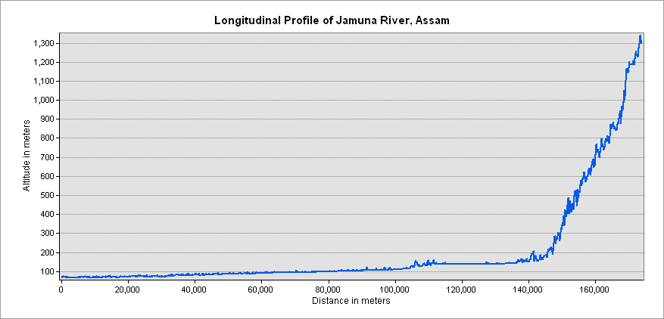
Fig. 2. Longitudinal profile of Jamuna River, Assam.

6.3 Role of Terrain and Land Use
The role of prevailing terrain conditions is very important in terms of the hydrological pattern of a particular river; and the terrain condition is ever changing due to various anthropogenic activities. Mostly agriculture and constructional activities changes the terrain characteristics and its impacts can be seen directly and indirectly in the hydrological behaviours of a river. The upstream zone's of Jamuna watershed has hilly forest areas; and the forest cover reduces runoff (Dogan, 2022; Costa et al. 2023); while the midstream zones experiencing agricultural expansion and deforestation (Welde 2017; Shiferaw, 2025); which elevates the discharge. The downstream areas mostly Doboka and Jamunamukh (parts of Hojai district), with gentle slope and increasing construction and settlement stress, affecting the natural flow of the river (Besha 2024; Liu et al. 2025) and also increasing flood risk (Das & Goswami, 2003).
This study was conducted during the dry season (winters); the discharge rise significantly in the monsoon season. Many villages of Doboka and Jamunamukh are inundated by flood every year by the Kopili and Jamuna River. The lower part of the Jamuna watershed area is a confluence zone of three rivers viz., Kopili, Jamuna and Nikhari noi (Sharma & Bharali, 2017; Nasrin & Barman, 2025); this low lying zone is good for fishing and agriculture, mostly rice and vegetable production.

6.4 Rainfall Variability in Jamuna watershed
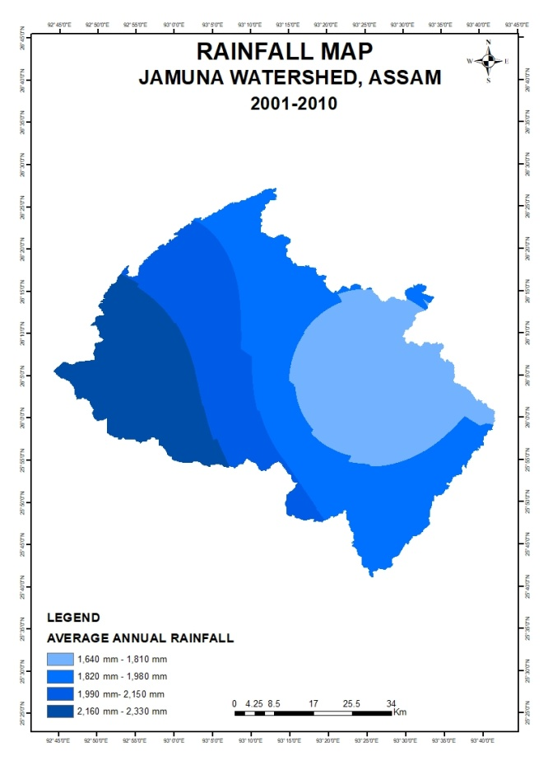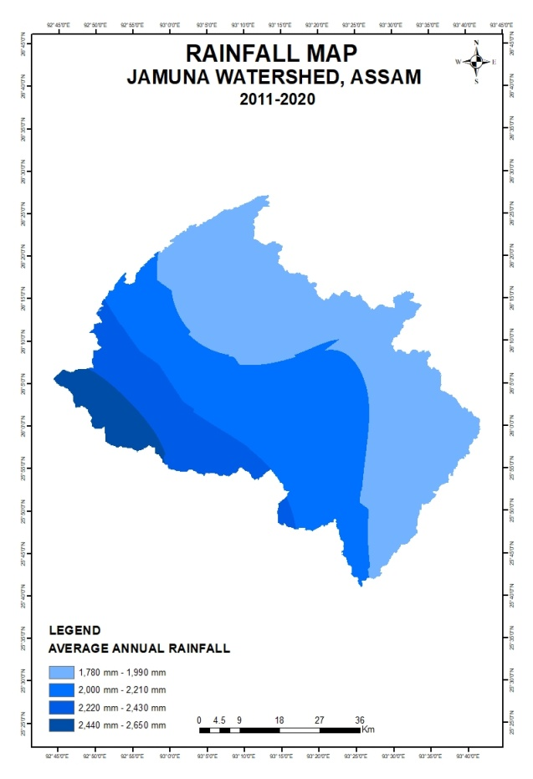
Fig. 3 Rainfall map (2001-2010) Fig. 4 Rainfall map (2011-2020)

Rainfall plays the most important role in the pattern of discharge and hydrological conditions of the basin. The decadal rainfall distribution maps of the Jamuna watershed in Figure 3 and Figure 4, shows a clear spatio-temporal variation in the basin over the last two decades. The rainfall maps show a progressive increase in average annual precipitation in the Jamuna watershed. The old map (2001-2010) shows a dominance of the lower rainfall classes (1,640-2,330 mm); but the 2011-2020 maps indicates a north central shift into moderately higher classes (1,780-2,650 mm). The mid to downstream zone of the watershed show more rainfall, while the Diphu, Manja and nearby areas shows smaller relative change.
The comparative analysis of the two rainfall maps shows a slight spatial shift in the rainfall concentration in the basin. This indicates the regional climatic changes and land-cover alterations with forest depletion due to Jhum cultivation in the upstream zones and agricultural expansion in the downstream zone. The rainfall variations and the observed discharge pattern from 4.19 m³/s in the upstream section to 42.12 m³/s downstream suggests that cumulative rainfall and catchment response in downstream make the overall flow regime. The seasonal rainfall in monsoon intensifies the processes; the rainfall and discharge relationship reflects the hydrological system and sediment deposition in lower reach intensify the flood risk due to gentle slope in the floodplains.
In the recent two decades, a marginal shift in average rainfall in the watershed can be seen. The spatial rainfall variability combined with anthropogenic and topographic controls, determines the hydro-geomorphological dynamics of the Jamuna River and its seasonal discharge behaviour.
Rainfall analysis (2001-2020) indicates a gradual spatial increase in precipitation in the Jamuna watershed. The downstream and central parts receive higher rainfall compared to the upper reaches. This spatial pattern aligns with the observed discharge variations, suggesting cumulative rainfall and catchment responses for flow dynamics in the basin (Dogan, 2022; Costa et al., 2023). Forest degradation in the upper catchment due to Jhum cultivation and agricultural expansion in the downstream modify the local hydrology.
6.5 Hydro-Geomorphological Integrity
The overall hydrological behaviour of the Jamuna River reflects a close interaction of terrain, rainfall variability, land-use pattern and human interventions (McMillan et al., 2012; Aboelnour 2021; Guo 2023). The steep gradient and high forest cover in the upper course regulate runoff and sustain the base flow during the pre-monsoon period. The midstream is the transitional zone; it is affected by deforestation, agricultural techniques and structural modifications, resulting irregular flow dynamics and localized channel adjustments. The lower course has very gentle slope and higher cumulative rainfall (Dwarakish & Ganasri2015); which supports large-scale discharge accumulation and also very frequent floodplain inundation too.
The rainfall maps (figure 3, 4) indicate a gradual spatial shift in the upper catchment zones; and in downstream areas continue to receive higher mean precipitation but the area experiencing this is reducing and it has effects on the local farmers; but the flood potential near Doboka and Jamunamukh is prevails for many reasons and one of the most important is the confluence of three rivers- Jamuna, Nikhari noi and Kopili river, with low land zones nearby. Together, these hydrological and geomorphological responses shows a system in transition, from a stable, forest dominated headwater zone to a human-modified floodplain (downstream zone) with hydrological variability. This integrated interpretation shows that the Jamuna watershed’s water regime is not solely controlled by rainfall amount, but majorly it is controlled by rainfall. The other influences include the slope pattern, land use, vegetation cover and structures on the channels like dams etc which affects the natural flow inside the basin.

6.6 Implications for Watershed Management

It is important to maintain the natural balance of a watershed with its wetland settings, inlet and outlet systems for water availability and sustainability for the future generations. In this study we are suggesting a few implications for different parts of the basin. The upstream zones needs to implement the following measures for the future sustainability concerns-
- To encourage community-led forest conservation
- To maintain natural vegetative buffer zones in the basin
- Reduce land clearing on hill slopes for Jhum cultivation

The midstream zone needs to focus on-
- Need for sustainable farming and check dams
- Need to introduce land-use zoning to reduce runoff
- Monitor sediment flows

The downstream zone needs to focus on-
- Strengthening the embankments
- Check on unregulated sand mining in the river
- Focus on drainage infrastructure and garbage disposal methods in the small market places

7. CONCLUSION
In this work the cross sectional discharge data were collected of Jamuna River of Assam; these data helps to know about the hydrological characteristics of the river. Although various small dams, sluice gates are there, affecting the natural flow of the river; and also affects the fish availability in those locations which were once known for fishing. The results of cross sectional discharge data shows spatial variability in river discharge; that is controlled by the topography, land use and land cover settings and other geo-hydro-anthropogenic factors. The two decades of rainfall patterns also showing a slight shift due to changes in regional climate and various human activities. The finding shows the importance of sustaining local hydrological monitoring in small tributaries of Assam to inform effective regional water management policies for the big rivers. Strengthening field-based data collection and integrating it with GIS and remote sensing analyses will ensure location specific water resource planning for Assam and North East India. This study also helps in understanding the river behavior, water availability during winters and agriculture, livelihood practices which is related to the river and riparian environment.

Disclaimer (Artificial intelligence)
Author(s) hereby declare that NO generative AI technologies such as Large Language Models (ChatGPT, COPILOT, etc.) and text-to-image generators have been used during the writing or editing of this manuscript.

Supplementary materials

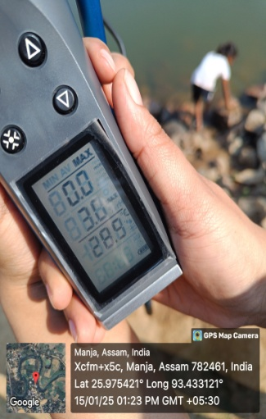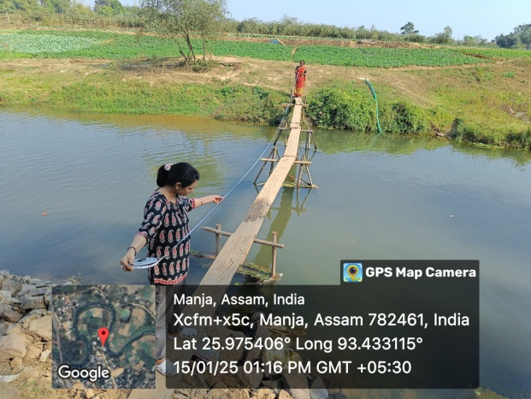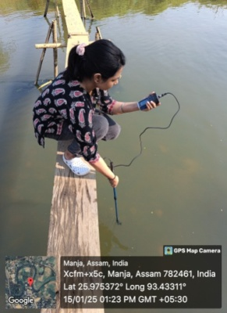

Photos of data collection in Manja, East Karbi Anglong

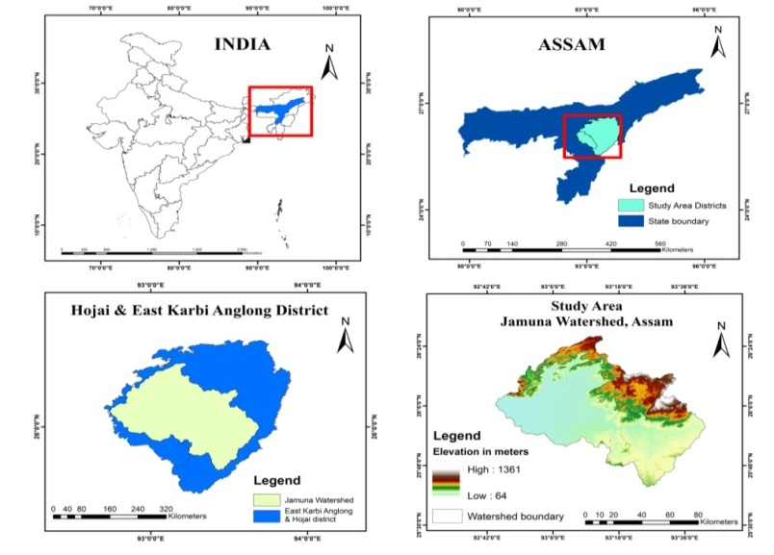
Location map of the study area
References
Aboelnour, M. A., Tank, J. L., Hamlet, A. F., Bertassello, L. E., & Ren, D. (2021). Impacts of Watershed Physical Properties and Land-use on Streamflow Using Multiple Regression Models at 130 Sites. Science of The Total Environment, 754, 142092. https://doi.org/10.1016/j.scitotenv.2020.142092
Besha, K. Z., Tadele, G., Gebrehiwot, S. G., & Haile, G. G. (2024). Effects of Land use/land Cover Change on Hydrological Components of a Watershed Using Multivariate Statistics. Hydrology Research, 55(2), 83–98. https://doi.org/10.2166/nh.99967
Borah, H., & Deka, S. (2019). Hypsometric Analysis of Jamuna Watershed, Assam with Application of Geographical Information System. Journal of Emerging Technologies and Innovative Research, 6(6), 676–684. https://doi.org/10.1729/Journal.21724
Borah, H., & Deka, S. (2020). Morphometric Analysis for Prioritization of Sub-Watersheds of Jamuna River Watershed, Assam, India Using Remote Sensing and GIS Technique. International Journal of Control and Automation, 13(2s), 18–26. https://doi.org/10.9790/0990-0403013649
Chow, V. T. (1959). Open-Channel Hydraulics. McGraw-Hill: New York, NY, USA.
Costa, R. C. A., Santos, R. M. B., Fernandes, L. F. S., Carvalho de Melo, M., Valera, C. A., Valle Junior, R. F. d., Silva, M. M. A. P. d. M., Pacheco, F. A. L., & Pissarra, T. C. T. (2023). Hydrologic Response to Land use and Land Cover Change Scenarios: An Example From the Paraopeba River Basin based on the SWAT model. Water, 15(8), 1451. https://doi.org/10.3390/w15081451
Das, P. J., & Goswami, D. C. (2003). Hydrological Impacts of Small Rivers in Assam. NEHU Journal of Science and Technology, 1(2), 35–47.
Dogan, F. N. (2022). Effect of Land use Change on Hydrology of Forested Watersheds. Ecological Processes, 11, 59. https://doi.org/10.1002/eco.2367
Dutt, K. N. (1979). Gazetteer of India, Assam State. U. M. & N. C. Hills District (KarbiAnglong and North Cachar Hills Districts). Government of Assam: Guwahati, India.
Dwarakish, G. S., &Ganasri, B. P. (2015). Impact of Land use Change on Hydrological Systems: A review. Cogent Engineering, 2, 1115691. https://doi.org/10.1080/23311941.2015.1115691
Garg, V., Singh, V. P., & Raj, V. (2017). Development of Water Resources in India. Springer: Cham, Switzerland.
Gogoi, M., & Jain, V. (2020). River Basin Hydrology and Sustainable Water Management in Northeast India. Environmental Earth Sciences, 79(5), 1–14. https://doi.org/10.1007/s12665-020-08976-9
Guo, Q., Zhao, F., Zhang, L., & Liu, S. (2023). Impacts of Climate and Land-use Changes on Water Yields - A Global Meta-Analysis. Journal of Hydrology: Regional Studies, 45, 101062. https://doi.org/10.1016/j.ejrh.2022.101062
Kundzewicz, Z. W., Krysanova, V., Dankers, R., Hirabayashi, Y., Kanae, S., Hattermann, F. F., Huang, S., Milly, P. C. D., Stoffel, M., Driessen, P., & Schellnhuber, H. J. (2018). Differences in flood hazard projections in Europe – their causes and consequences for decision making. Hydrological Sciences Journal, 63(9), 1152–1171. https://doi.org/10.1080/02626667.2018.1446213
Lane, S. N. (2014). Acting, predicting and intervening in a socio-hydrological world. Earth Surface Processes and Landforms, 39(1), 4-25. https://doi.org/10.1002/esp.3436
Liu, H., Yan, H., & Guan, M. (2025). Evaluating the Effects of Topography and Land-use Change on Hydrological Signatures: A Comparative Study of two Adjacent Watersheds. Hydrology and Earth System Sciences, 29, 2109-2132. https://doi.org/10.5194/hess-29-2109-2025
McMillan, H., Krueger, T., & Freer, J. (2012). Benchmarking Observational Uncertainties for Hydrology: Rainfall, River Discharge and Water Quality. Hydrological Processes, 26(26), 4078-4111.
Montanari, A., Young, G., Savenije, H. H. G., Hughes, D., Wagener, T., Ren, L. L., Koutsoyiannis, D., Cudennec, C., Toth, E., Grimaldi, S., Blöschl, G., Sivapalan, M., Beven, K., Gupta, H., Hipsey, M., Schaefli, B., Arheimer, B., Boegh, E., Schymanski, S. J., ... Hubert, P. (2013). “Panta Rhei—Everything Flows”: Change in hydrology and society—The IAHS Scientific Decade 2013–2022. Hydrological Sciences Journal, 58(6), 1256–1275. https://doi.org/10.1080/02626667.2013.809088
Nasrin, M., & Barman, B. (2025). Digital Terrain Analysis to Understand Watershed Characterization Using ASTER DEM: A case Study of Jamuna Watershed of Assam, India. International Journal for Innovative Research in Technology, 11(9).
Phukan, M., Goswami, D. C., & Das, P. J. (2012). Riverine Hazards and Floodplain Management in Assam. Current Science, 103(3), 288–294.
Sharma, C., & Bharali, B. (2017). River Basin Studies and Water Resource Challenges in Northeast India. Asian Journal of Water, Environment and Pollution, 14(1), 67–75.
Shiferaw, N., Wondie, A., Assefa, Y., & Choi, Y. (2025). Land use Dynamics and Their Impact on Hydrology and Water Quality in the Gap-Cheon Watershed. Environmental Science and Pollution Research. https://doi.org/10.1007/s11356-025-35946-y
Singh, V. P. (2003). Hydrology and Water Resources. Springer: Dordrecht, The Netherlands.
Sivapalan, M., & Blöschl, G. (2015). Time scale interactions and the coevolution of humans and water. Hydrological Processes, 29(3), 518–525. https://doi.org/10.1002/hyp.10414
Subramanya, K. (2013). Engineering Hydrology (4th ed.). Tata McGraw-Hill: New Delhi, India.
Ward, R. C., & Robinson, M. (2000). Principles of Hydrology. McGraw-Hill: London, UK.
Welde, K., Girmay, G., &Gebresamuel, G. (2017). Effect of Land Use-Land Cover Dynamics on Hydrological Response - A case Study of the Iida-Swamp Watershed, Japan. Journal of Environmental Management, 187, 247–258. https://doi.org/10.1016/j.jenvman.2016.11.046

