Pitting-Corrosion of Metals by Indigenous Bacteria Isolated from Soils of Oil Producing Areas of Delta State in Nigeria

ABSTRACT

Background: Microorganisms are able to affect various corrosion mechanisms, such as general corrosion and localized corrosion, including pitting and stress corrosion cracking. Corrosion of most metals is inevitable as presence of microbes is inevitable in the environment. The presence of microorganisms where those pipelines are buried allows the corrosion of metals of which these pipelines are made.

Aims: The study aimed to investigate metal corrosive potential of indigenous bacteria in the soil of oil producing areas of Delta State in Nigeria.

Study design: Bacteria isolated from soil samples collected along oil pipelines in oil producing communities of Delta State, identified using standard methods and screened for their potential to corrode metals were used for these analyses.
Place and Duration of Study: Department of Environmental Management and Toxicology Federal University of Petroleum Resources Effurun, Delta state Nigeria. The study lasted for twelve months.
Methodology: Biocorrosion potential was determined on the selected isolates by immersing sterile carbon steel coupons in sterile soil samples inoculated with the test organisms and weight loss and bacterial growth were determined monthly for a period of four months. Scanning Electron Microscopy (SEM EDX) was carried out to ascertain product composition and type of corrosion.
Results: The isolates used in screening for corrosion capacity were Pseudomonas putida, P. aeruginosa, P. stutzeri, Shewanella putrefaciens, Desulfovibrio vulgaris and Vibrio vulnificus. The highest corrosion rate was 1.67 mpy and least was 1.21 mpy for Desulfovibrio vulgaris and V. vulnificus respectively. The scanned electron micrograph of metals showed that the isolates induced pitting corrosion while the control showed little or no pitting corrosion.
Conclusion: This study ascertained that oil pipelines made of metals are prone to corrosion induced by bacteria in the soil. Thus, it is imperative to pay proper attention to microbially induced corrosion and to take appropriate measures to curb this menace to achieve desirable life spans of pipelines and other oil facilities and consequently reduce environmental pollution.

Keywords: Corrosion, Isolates, oil pipelines, soil samples, metals, weight loss

1. INTRODUCTION
The deteriorated corrosion caused by microorganisms in oil-containing environments is universal and complex. However, the understanding of the deterioration mechanism of metal materials by microbial metabolism in the pollutant degradation environment is still insufficient. Hydrocarbon-degrading microorganisms have changed the physical and chemical properties of the medium, changed the composition of corrosion products, and accelerated the pitting corrosion of steel (Guo et al., 2024; Saini et al., 2020). Microbial-induced corrosion plays a major role in material deterioration and most importantly in underground pipelines. It is evaluated all over the world that losses worth billions of dollars to pipelines and other facilities have been a result of microbial corrosion. In spite of the use of precautionary measures, corrosion persists. Pitting, which is a localized form of corrosion results in minute holes in the structural material and is usual visual evidence indicating microbial-induced corrosion (Nuhoglu, 2004; Javed, 2024; Xiao et.al.2022 and Sun et.al.2020). Microorganisms play a substantial involvement in the corrosion process. Microorganisms contribute to the corrosion of metallic materials and can accelerate corrosion rates up to 1000–10,000 folds (Videla, 1996). Microorganisms can affect various corrosion mechanisms, such as general corrosion and localized corrosion, including pitting and stress corrosion cracking. Sulfate-reducing bacteria (SRB), are mainly recognized to cause corrosion of steel materials. Other bacteria involved in corrosion are acid-forming bacteria, exopolysaccharide or extracellular polymeric substances or slime forming bacteria, manganese-oxidizing bacteria, iron-oxidizing/reducing bacteria and sulphur-oxidizing bacteria (Videla, 1996; Chen et al., 2019; Gu et al., 2019). Steel continues to stay as a supporting pillar of almost all industries owing to its recyclable nature, economic viability, constructability features like affordability, durability, and sustainability. Biocorrosion poses a major hindrance in galvanized steel and articles. Stainless steel has good capability to resist corrosion due to chromium, nickel, and molybdenum present in its composition. Its competence to resist corrosion is because of the formation of a thin chromium oxide passive layer that adheres strongly to the surface. However, passive layers are also subjected to localized corrosion when kept close to chlorides and reduced Sulfur compounds (Maji & Lavanya, 2024).
Microbially influenced corrosion (MIC) is a notable concern, where the metabolic activities of bacteria and archaea accelerate the corrosion of metallic surfaces in contact with oil and water (Videla, 2020). MIC can lead to the development of biofilms on pipelines and equipment, further exacerbating corrosion processes (Dinh et al., 2023). This biofilm formation not only compromises the integrity of infrastructure but also hinders fluid flow, reducing the overall efficiency of oil extraction operations.
One prominent negative impact is the phenomenon of "souring," where microorganisms facilitate the production of hydrogen sulfide (H₂S) within the reservoir. Several microorganisms contribute to souring, with sulfate-reducing bacteria (srb) being the primary culprits. These bacteria utilize sulfate as a terminal electron acceptor during anaerobic respiration, producing h₂s as a metabolic byproduct (Gieg et al., 2020). H₂s is a highly toxic and corrosive gas that poses significant challenges to oil extraction and processing (Magot et al., 2023). The presence of h₂s not only compromises the quality of the extracted oil but also leads to corrosion of metal components in reservoirs and associated pipelines (Head et al., 2022). This corrosion can result in equipment failure, increased maintenance costs, and, consequently, a reduction in overall operational efficiency.
Corrosion causes a lot of damage all over the globe with severe socio-economic impacts. According to Cheng (2014) pipelines designed with life span of over 50 years and 100 years fail within far lesser years due to corrosion. Again, the failures of these facilities are sudden without warning. Some damages done by corrosion range from a decline in the life of structures, bridge collapse, environmental degeneration, failure of structures and facilities, calculable losses yearly to incalculable damages and losses (Mignogna, 2010).
To mitigate these deleterious microbial activities, researchers and industry professionals are exploring strategies such as biocide application, sulfate reduction inhibition, and the use of corrosion-resistant materials (Ravenschlag et al., 2021). Corrosion of most metals is inevitable as the presence of microbes is inevitable in the environment. The presence of microorganisms where those pipelines are buried allows the corrosion of metals of which these pipelines are made. Furthermore, understanding the microbial community dynamics and metabolic pathways involved in these negative processes is crucial for developing targeted interventions to minimize their impact on oil reservoirs.
The study was therefore aimed at investigating metal corrosive potential of bacteria from the soil of oil producing areas of Delta State of Western Niger-Delta Region.

2. material and methods

Collection of Samples
- Soil
Soil samples were obtained from land where there is oil exploration in oil-producing communities and within oil flow stations. Soil samples were collected from a depth of 15 to 30 cm and a distance of 20 cm from pipelines and flow stations. Soils were collected from the respective locations using a soil auger, air-dried and sieved to remove gravel, debris and chunks. The soils were thoroughly mixed to make them more homogenous and placed in labelled sterile polyethylene bags and transported to the Microbiology laboratory at Federal University of Petroleum Resources Effurun, Warri Delta State Nigeria for further analysis.
- Bacterial Isolates
Bacteria associated with corrosion were isolated from these soil samples using different selective media. Corrosive bacterial isolates were identified using an analytical profile index and molecular method. Preserved cultures of identified and screened bacteria for corrosion potential by the same authors were used (Odesiri-Eruteyan and Omonigho, 2022).

Samples Preparation

Metal Sheets
Carbon steel normally used for production of pipelines was obtained from a steel village in Otokutu, near Warri in Delta State. The carbon steel coupons were cut into pieces (semi circular rods) with dimensions of 5 mm by 2 mm with a hacksaw blade. The edges were polished into smooth surfaces. These were cleaned and washed in distilled water and alcohol to remove any dirt and rust. They were washed with acetone to remove grease and were air-dried (Wu et al., 2020). The coupons were sterilized in dry form and wrapped with aluminum foil paper by autoclaving at 121ºC for 15 minutes. The initial weight was taken before use and final weight was taken after use.?
Standardization of Bacterial Suspension
This was done by subculturing isolated organisms from fresh pure culture plates into normal saline, and incubated at 37⁰C for 24hrs. The turbidity of the growth was adjusted by dilution with sterile saline until equal to the turbidity of a 0.5% McFarland standard. The adjusted suspensions were used as inocula within 15 minutes (Cheesebrough, 2006; Song and Bartha, 1990).
Preparation of Soil Samples used for Burying of Metal Sheets
Soil samples used in the experimental set-up were collected from Ugbomro Community (an oil-producing community) in Delta State. The soil samples were sieved, mixed and 1.2kg was weighed into bottles, tightly sealed with foil papers. They were then sterilized by autoclaving at 121⁰C for 15 minutes for three consecutive times and allowed to cool before use (Cheesebrough, 2006; Song and Bartha, 1990).
Experimental Set-up
Sterile soil samples of about 1.2kg were introduced aseptically into sterile bottles, sterile metal sheets were immersed also into the bottles, and bacteria suspensions of 10ml were introduced into the bottles. Sterile water (50ml) was introduced into the soil samples at intervals of three weeks. The experimental set up was sealed up with sterile cotton wool and foil papers and tightened and kept at a temperature of 26±2⁰C. The set-up was inoculated with the seven organisms singly and left for four (4) months to determine the metal corrosion potential of the isolated organisms. At end of every month the metal sheets were brought out, cleaned and final weights taken. About 1g of the soil samples was taken for bacteria counts using pour plate method at end of each month. The control set-up was without test bacteria.
Treatment Procedure
i) 1.2kg of sterile soil + 10ml of Pseudomonas aeruginosa + a metal coupon
ii) 1.2kg of sterile soil + 10ml of Desulfovibrio vugaris + a metal coupon
iii) 1.2kg of sterile soil + 10ml of Pseudomonas putida (1) + a metal coupon
iv) 1.2kg of sterile soil + 10ml of Shewanella putrefacien + a metal coupon
v) 1.2kg of sterile soil + 10ml of Pseudomonas putida(2) + a metal coupon
vi) 1.2kg of sterile soil + 10ml of Pseudomonas stutzeri + a metal coupon
vii) 1.2kg of sterile soil + 10ml of Vibrio vulnificus + a metal coupon
viii) 1.2kg of sterile soil + a metal coupon as the control set up.

Determination of Biocorrosion Rate
- Weight Loss Determination
Biocorrosion rates of the selected organisms were determined by weight loss. Final weights were taken and weight loss was determined by subtracting initial weights from the final weights after corrosion. Corrosion rate was calculated using the equation adopted by Callister, (1997). Corrosion rate(mpy ) = 87.6 * W/ATP (Callister, 1997).
W = Weight loss in milligrams (mg). P= Density of the specimen (metal) (g/cm³). Carbon steel = 7.85g/cm³. A = Total surface area (cm²) ^r² for a circle, ^r²/2 for semicircle. T = Time of exposure (hr) 87.6 is constant.

(B) Total Bacterial Counts.
The metal corrosion rates were also measured through the bacterial load. The bacteria concentrations, which are colony-forming units per gram (CFU/g) were determined monthly for four months. Whenever a coupon was brought out at the end of each month, bacterial count on nutrient agar was determined by pour plate technique. A 1g soil sample was introduced into 9ml of normal saline and subsequently serially diluted. Thereafter molten nutrient agar was inoculated with 1ml of the serially diluted samples, swirled to effect even distribution and then incubated at 26±2⁰C for 24-48hrs.

Determination of corrosion on the metal plates
This was done using Scanning Electron Microscopy (SEM EDX) and pictures were taken using a TM3000 Hitachi Analytical Table Top Microscope at different magnifications working at 15KV acceleration voltages.

3. results and discussion

Seven bacterial species were identified and were Pseudomonas putida(1), Vibrio vulnificus, Pseudomonas stutzeri, Shewanella putrefaciens, Pseudomonas aeruginosa, Desulfovibrio vulgaris, Pseudomonas putida(2).
Biocorrosion Potential of Selected Organisms in soil
Biocorrosion potential of the selected organisms in the soil is presented in Figure 1. Pseudomonas aeruginosa had the highest corrosion rate, followed by Desulfovibrio vugaris, Pseudomonas putida (1), Shewanella putrefacien, Pseudomonas putida (2), Pseudomonas stutzeri and Vibrio vulnificus induced the least corrosion rate. Corrosion increased within the first few weeks and declined afterwards.

Fig. 1: Metal biocorrosion rate of selected test Organisms in Soil
Measurement of Biocorrosion using total bacterial counts.
Bacterial growth was monitored during the process, from the first month till the fouth month. It was found that bacterial growth increased first and declined gradually. There was no microbial growth in the control. This is shown in Table 1 below.
Table: 1. Changes in Population of Selected Isolates with time during Biocorrosion.
Isolate | Bacterial Counts (Cfu/g) per month
Isolate | 1 | 2 | 3 | 4
Pseudomonas aeruginosa | 6.75±0.65(10⁶) | 1.45±0.08(10⁷) | 1.28.±0.06(10⁷) | 7.00±1.06(10⁶)
Desulfovibrio vugaris | 6.67±1.57(10⁶) | 1.42±0.23(10⁷) | 1.23±0.27(10⁷) | 6.60±0.20(10⁶)
Pseudomonas putida (1) | 6.20±1.06(10⁶) | 1.39±.0.21(10⁷) | 1.19±0.15(10⁷) | 6.35±1.05(10⁶)
Shewanella putrefacien | 5.85±0.58(10⁶) | 1.25±0.02(10⁷) | 1.18±0.05(10⁷) | 6.05±0.12(10⁶)
Pseudomonas putida(2) | 5.05±0.52(10⁶) | 1.13.±0.10(10⁷) | 1.03±0.25(10⁷) | 5.85±0.08(10⁶)
Pseudomonas stutzeri | 4.80±0.12(10⁶) | 1.10.±0,22(10⁷) | 8.95±1.03(10⁶) | 5.10±0.25(10⁶)
Vibrio vulnificus | 4.40±0.21(10⁶) | 8.35±1.00(10⁶) | 6.70.±0.11(10⁶) | 4.65±0.06(10⁶)

Results of the investigation into the corrosion potential of the seven tested organisms revealed that high corrosion rate was observed in a few weeks after which the rate declined in all the organisms.
Increase and decrease in corrosion rates may be attributed to corrosion acceleration by the availability of nutrients, favourable environmental conditions and secreted acid and corrosion inhibition by the biofilm, unfavourable conditions and change in nutrients concentration respectively. The decrease in corrosion rate after an initial increase could also be attributed to a rise in corrosion products on the metal surface, which could reduce the transmission of corrosive ions and molecules to the steel surface as earlier reported by Prabhakaran, et.al. (2023)
Microorganisms have a role in influencing general corrosion. The corrosion rate of microorganisms has a relationship with a growth rate of the microorganisms. An increase in growth rate indicates an increase in corrosion rate, while a decrease in growth rate indicates a decrease in corrosion rate. Growth of microbes is related to the metabolic activities of the microbes which is greatly enhanced by environmental factors. The availability of nutrients that can stimulate the development of the microbes, and the presence of favourable environmental parameters such as oxygen, moisture content, pH of the environment, temperature and so on, all have great influence on the microbial activity in an environment and hence contribute to metal damage as a result of corrosion.
More also, there were also black and brownish colourations in some of the set-ups, which may be attributed to microbial growth, metabolism and production of suphide. There was no visible growth in the control. The observed corrosion in the control coupon may be due to other types of corrosion and not microbial which in turns may be attributed to the presence of environmental factors such as air, temperature and moisture.
Scan Electron Microscopy Results.
Images of scan electron microscopy of both control and test bacteria are shown in Figure 2 to 5. The three bacterial isolates with higher corrosive potentials were used for the analysis and their images were compared with the control. Compared to control, pitting was the dominant feature observed with respect to corrosion induced by the three microorganisms (Figures 2 to 5). Pitting tended to be more dominant in D. vulgaris than with other species. It tended to be minimal with P. putida. Scanning electron microscopy results showed that there was pitting morphology. Pitting corrosion was observed in the three test metal sheets and there was a little or no corrosion in the control sample. Importantly, these bacteria were also able to increase pitting corrosion which could be due to heterogenous biofilm cover and was also a definitive proof of microbial-induced corrosion. Pitting morphology is a characteristic and visual evidence indicating microbial-induced corrosion. Pitting morphology is also a metallurgical finger print definitive proof of the presence of microbial induced corrosion (Pope, 1990, Javed, 2024, Nuhoglu, 2004 and Sun et.al. 2020).

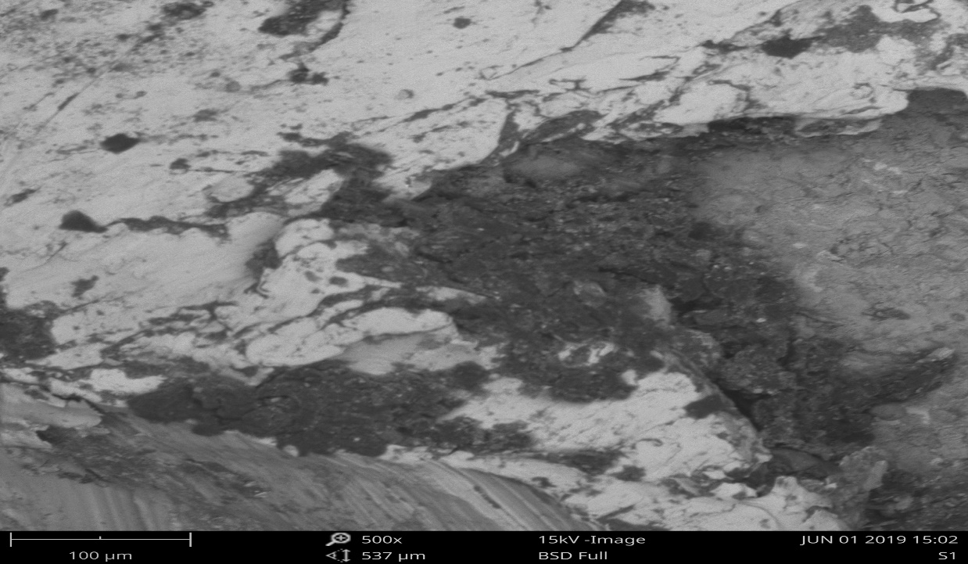
Figure 2: SEM of Metal Sheet without Microorganisms (Control) showing little or no Pitting Corrosion. This image has a magnification of 500×

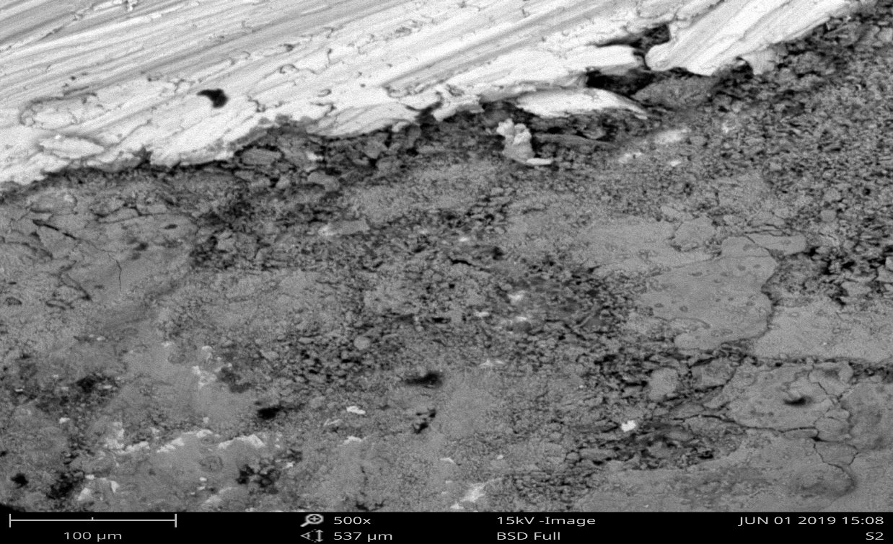
Figures 3: SEM of Corrosion induced by P. putida

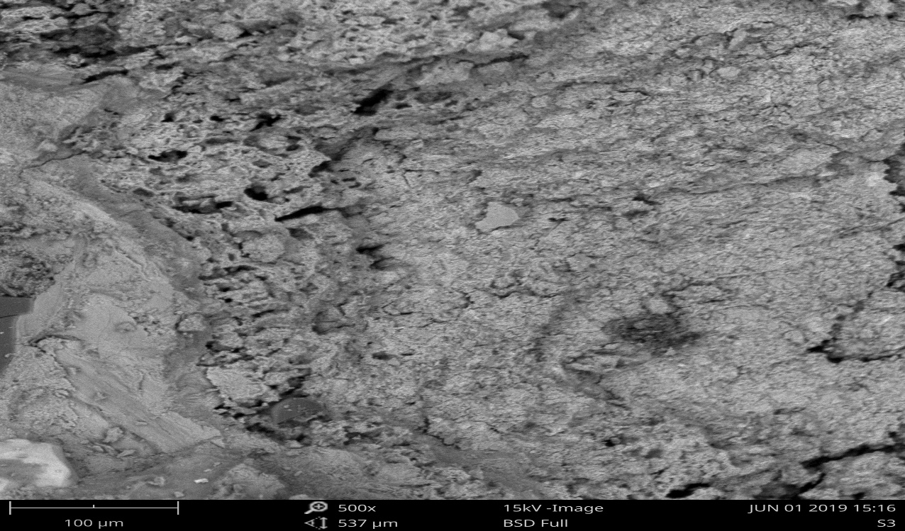 Figures 4: SEM of Corrosion induced by P. aeruginosa

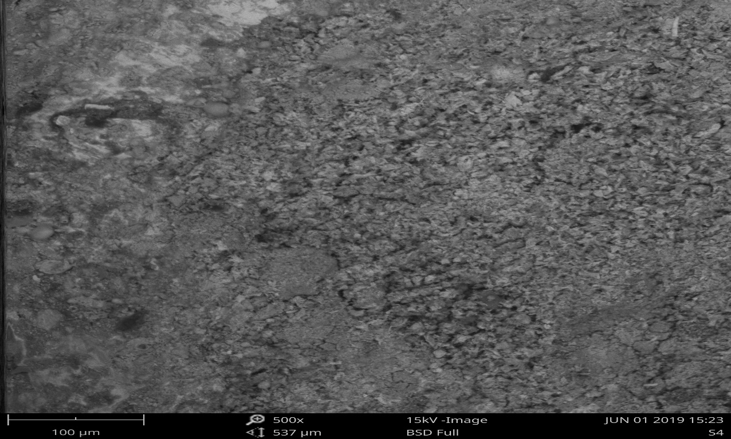 Figures 5: SEM of Corrosion induced by D. vulgaris

Elemental Composition of Corrosion Deposits on Metal Sheets as revealed by Scan Electron Microscopy (SEM EDX)
SEM EDX revealed elemental composition of corrosion deposits. Elemental composition of corrosion deposit supplied information on the cause of corrosion. The corrosion deposit on the metal sheets showed that, in the first metal sheet which was the control, chemical analysis revealed that, phosphorus, sulphur and manganese were absent but present in the other metal sheets that were test samples as presented in table 2.

Table 2: Elemental Composition of Corrosion Deposits on Metal Sheets as revealed by Scan Electron Microscopy (SEM)
Bacteria on metal sheets
Element | Control |  | P. putida |  | P.aeruginosa |  | D. vulgaris
 | Atomic Conc. | Weight Conc. | Atomic Conc. | Weight Conc. | Atomic Conc. | Weight Conc. | Atomic Conc. | Weight Conc.?
Iron | 42.58 | 72.68 | 37.39 | 69.86 | 35.33 | 65.79 | 34.37 | 64.35
Carbon | 43.5 | 17.48 | 15.04 | 5.52 | 8.48 | 3.4 | 23.09 | 9.3
Oxygen | 12.6 | 6.74 | 37.88 | 18.53 | 52.02 | 27.75 | 33.83 | 18.15
Silicon | 1.35 | 1.27 | 1.11 | 0.95 | 0.99 | 0.92 | 1.54 | 1.45
Zinc | 0.46 | 1.01 | 0 | 0 | 0 | 0 | 0.29 | 0.63
Sodium | 1.27 | 0.98 | 0 | 0 | 0 | 0 | 0 | 0
Nitrogen | 2 | 0.94 | 1.78 | 0.76 | 2.05 | 0.96 | 2.24 | 1.05
Aluminium | 0.88 | 0.79 | 0.73 | 0.6 | 0.59 | 0.53 | 2.32 | 2.1
Titanium | 0.29 | 0.46 | 0 | 0 | 0.16 | 0.26 | 0 | 0
Manganese | 0 | 0 | 0.24 | 0.4 | 0.25 | 0.46 | 0.82 | 1.51
Sulphur | 0 | 0 | 0.25 | 0.25 | 0.3 | 0.32 | 0.66 | 3.71
Magnesium | 0 | 0 | 0.26 | 0.2 | 0.21 | 0.25 | 0.53 | 0.43
Phosphorus | 0 | 0 | 0.13 | 0.12 | 0.07 | 0.08 | 0.31 | 0.33

The result showed that the iron composition in the control was the highest. While there was a reduction in the atomic weight of iron in the experimental set-up containing test bacteria. Also, the carbon concentration in the control sample was higher than in the test samples. This may indicate utilization, mineralization or degradation of the metal by the test bacteria. More also the oxygen content in the test experiment was higher than the control. This may be attributed to microbial metabolic activities taking place during the process.
Phosphorus, Magnesium, Sulphur and Manganese peaks were absent in the control sample but found on metal sheets with the test organisms. The presence of phosphorus can be related to cells involved with the corrosion deposit. Phospholipids are found in the membranes of all bacteria and contain a fairly fixed proportion of the biomass as phospholipid as reported by Little et al. (2006). Therefore, the presence of phosphorus in these other three metals was definitive proof of microbial-induced corrosion. Also, the activities of sulphate-reducing bacteria (SRB) and manganese oxidising bacteria produced surface-bound sulphur and manganese respectively. Therefore, the presence of sulphur and manganese peaks was also definitive proof of microbial-induced corrosion. The higher content of Sulphur element (3.71 wt%) was found in the presence of SRB, which verified the presence of SRB corrosion. FeS is the typical corrosion products of SRB. The presence of Sulphur element further demonstrates that SRB could grow well under deposit.

4. Conclusion
The research confirmed that biocorrosion of metals was considerably enhanced by the seven test organisms based on weight loss, changes in the population of selected bacteria during biocorrosion and corrosion morphology. All these indicated that the seven test organisms considerably induced and promoted the corrosion of metals used in this study. If these organisms are present in the soil, they may bring about corrosion of oil pipelines in the environment. Corrosion causes a lot of damage all over the globe with severe social, economic and health impacts. Corrosion is a menace to the environment. Damages done by corrosion range from decline in life of structures, failure of structures and facilities, environmental pollution and degeneration, calculable losses yearly to incalculable damages and losses and may also cause adverse effects on health. It is necessary to check and manage these metal-corrosive bacteria.
Disclaimer (Artificial intelligence)
Option 1:
Author(s) hereby declare that NO generative AI technologies such as Large Language Models (ChatGPT, COPILOT, etc.) and text-to-image generators have been used during the writing or editing of this manuscript.
Option 2:
Author(s) hereby declare that generative AI technologies such as Large Language Models, etc. have been used during the writing or editing of manuscripts. This explanation will include the name, version, model, and source of the generative AI technology and as well as all input prompts provided to the generative AI technology
Details of the AI usage are given below:
1.
2.
3.

Reference

Nuhoglu, Y. (2004). “The Biodeteriorative of Microorganisms and the Effects on Stone Monuments Under Air Pollution and Continental Cold Climatic Condition in Erzurum, Turkey” Fresenius. Environmental Bulletin, 4(5), 32-35.
Javed, M.A., Ivanovich, N., Messinese, E., Liu, R., Astorga, S. E., Yeo, Y.P. et. al. (2024).The Role of Metallurgical Features in the Microbially Influenced Corrosion of Carbon Steel. ‘A critical Review’ Microorganisms, 12(5), 892.

Xiao. L., Jie, Z., Zaifeng, W., Ruiyong, Z., Wolfgang, S., Liang, Z. et. al. (2022). Corrosion of an AZ31B Magnesium Alloy by Sulphate- Reducing Prokaryotes in a Mudflat Environment. Microorganisms, 10(5), 839

Sun, K., Huang, S., He, X., Hu, Z.and Li, W. (2020). Direct and Indirect Evidence of the Microbially Induced Pitting Corrosion of Steel Structures in Humid Environments.’ Coatings, 10 (10), 983

Videla, H. A. (1996). Manual of Biocorrosion. First edition. CRC Lewis Publishers, Florida, USA. pp. 273-291.
Chen, S., Liu, G. and Zhang, D. (2019). Corrosion of Q235 carbon steel in seawater containing Mariprofundus ferrooxydans and Thalassospira sp. Frontier Microbiology, 10, 936-942.
Gu, T., Jia, R., Unsal, T. and Xu, D. (2019). Toward a better understanding of microbiologically influenced corrosion caused by sulfate reducing bacteria. Journal Material Science and Technology, 35, 631–636.

Videla, H. A. (2020). Microbiologically Influenced Corrosion: Looking to the Future.
International Biodeterioration & Biodegradation, 49(2-3), 115-123.
Dinh, H. T., Magot, M., Oren, A., Pires, A. C. C., Lima-Bittencourt, C. I., Albuquerque, L. S., et al. (2023). Microbially Influenced Corrosion in Oil Reservoirs: Mechanisms and Implications. Frontiers in Microbiology, 17, 211-226.
Gieg, L. M., Jack, T. R., Foght, J. M. (2020). Sulfate-Reducing Bacteria and Hydrogen Sulfide Production in Oil Reservoirs. Journal of Applied Microbiology, 15(5), 175-188.

Magot, M., Ollivier, B., Krumholz, L. R., Garcia, J. L., Fardeau, M. L., Guasco, S., Lépine, F. (2023). Impact of Hydrogen Sulfide on Oil Extraction and Processing. Journal of Petroleum Science and Engineering, 28, 407-422.
Head, I. M., Larter, S. R., Gray, N. D. (2022). Hydrogen Sulfide Production by Microorganisms in Oil Reservoirs. Environmental Microbiology, 14(8), 2111-2121.
Cheng, F. (2014). An Overview of Microbiologically Influenced Corrosion of Oil Transmission Pipelines. Journal of Electrochemical Science, 2014, 1-34.
Mignogna, R. (2010). Corrosion in soils. Corrosion Science, 98, 214-222.

Ravenschlag, K., Morgan, J., Videla, H. A., Leppe, M., et al. (2021). Strategies for Mitigating Deleterious Microbial Activities in Oil Reservoirs. Journal of Applied Microbiology, 32(6), 789-802.

Odesiri-Eruteyan, E.A and Omonigho, S.E. (2022) Isolation and Characterization of Bacteria Associated with Corrosion of Pipelines in soils of Delta State of Nigeria.
Journal of Environmental Science, Toxicology and Food Technology, 16 (6), 41-50.

Wu J, Zhang W, Chai, K. and Yu, A. (2020). Corrosion Behavior of AISI 1045 Steel in Seawater in the Presence of Flavobacterium sp. Frontiers in Microbiology, 11, 303- 320

Cheesebrough, M. (2006). Laboratory Practice in Tropical Countries. Second Edition, Cambridge University Press. Cambridge, New York, 442pp.
Song, H. and Bartha, R. (1990). Effects of jet fuel spills on the microbial community of soil. Applied environmental microbiology. 56, 646-651.
Callister, W.D. (1997). Materials Science and Engineering. An introduction (4th ed.) New York. John Wiley and Sons. p.800

Prabhakaran, V., Strange, L., Niverty, S. and Joshi, R. (2023). Investigating Electrochemical Corrosion at Mg Alloy-Steel Joint Interface using Scanning Electrochemical Cell Impedance Microscopy. (SECCIM) Scientific Reports, 13, 39961

Pope, D. (1990). Microbiologically Influenced Corrosion (MIC): Methods of detection of corrosion in the field. Corrosion Research, 2, 23-32.

Little, B. J., Lee, J. S. and Ray, R. I. (2006). Diagnosing Microbiologically Influenced Corrosion: A State-of-the-art Review. Corrosion, 62(11), 1006-1017
Guo, D., Li, Q., Zhang, Y., & Duan, J. (2024). Microbial remediation and deteriorated corrosion in marine oil pollution remediation engineering: A critical review. Marine Pollution Bulletin, 209, 117051.

Maji, K., & Lavanya, M. (2024). Microbiologically influenced corrosion in stainless steel by pseudomonas aeruginosa: an overview. Journal of Bio-and Tribo-Corrosion, 10(1), 16.

Saini, Lalita, and R. K. Upadhyay. 2020. “A Comparative Study on the Corrosion Inhibition of Mild Steel and Aluminium by Synthesized Inhibitors in Organic Acidic Medium”. Asian Journal of Chemical Sciences 8 (1):41-51. https://doi.org/10.9734/ajocs/2020/v8i119035.

