Global Spillover Effects: Indonesia’s Stock Market Response to U.S. Monetary Policy Shifts

.
ABSTRACT

Global economic developments, especially monetary policy in the United States (US), have a significant impact on the Indonesian economy. Shifts in US monetary policy can trigger changes in macroeconomic conditions and the dynamics of the Indonesian capital market, both conventional and sharia. This study aims to analyze how changes in US monetary policy affect the Indonesian economy and how US stock market movements impact the domestic stock market. Using the Structural Vector Autoregression (SVAR) model, this study finds that changes in US monetary policy have a substantial long-term effect on Indonesia's economic stability. In addition, Indonesia's conventional and Sharia stock indices show a high dependence on the movement of the US stock index, which acts as the main reference in the global financial market. These findings underscore the importance of risk mitigation strategies for investors and policymakers in dealing with global market dynamics.

Keywords: Monetary Policy, Higher for Longer, DJI, DJIM, IDX Composite, JII

1. INTRODUCTION

Numerous facets of Indonesia's economy are significantly affected by global economic trends, particularly the relationship between domestic financial market performance and monetary policy in industrialised nations. As a developing country with a globally open economy, Indonesia is highly vulnerable to global economic dynamics and policy shocks. For many central banks worldwide, maintaining financial stability and implementing monetary policy effectively continue to be top priorities (Venter, 2020). One of the monetary policies that has a wide influence is the change in the Federal Funds Rate (FFR) set by the United States Federal Reserve (The Fed). The FFR is a benchmark interest rate that functions as the main instrument in controlling liquidity and economic stability in the United States. (Kashyap & Siegert, 2020). Changes in the FFR are often responded to by global financial markets, including financial markets in Indonesia (Gursoy, 2021).
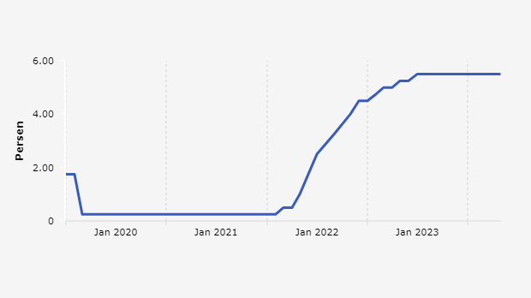
Figure 1. Federal Fund Rate Trend
Source: databoks.katadata.co.id

Over the past few years, the FFR trend shown in Figure 1 above has tended to increase, where at the beginning of the 2021 period, the FFR value was 0.09 percent, then in the third quarter of 2021 to February 2022, the FFR value stagnated at 0.8 percent and continued to decline until the end of the first quarter period. However, since the second quarter of 2022, the FFR has continued to increase from 0.77 percent to 5.33 percent at the end of the 2023 period. This trend is due to several main factors related to economic conditions and monetary policy. After the COVID-19 pandemic, the United States economy has shown signs of strong recovery, resulting in a rise in inflation and a greater demand for products and services (Doh & Yang, 2024). To control rising inflation, the Fed began raising interest rates (Clarida, 2023). High inflation was triggered by disruptions to the global supply chain, changes in people's consumption behavior from services to goods, Russia's invasion of Ukraine, the housing market, and the rise in remote work (Konczal, 2023). In addition, Figure 2 below shows that a strong labor market with low unemployment contributes to inflationary pressures, as competition for labor drives up wages. This is in line with the Phillips Curve theory, which predicts that prices will rise as aggregate demand rises. Because labour is the only resource that can raise output, companies attempt to meet demand by increasing production capacity through more labour as prices rise (inflation). Consequently, the rise in labour demand lowers unemployment and leads to more price increases (inflation) (Ruchba & Hadiyan, 2019).

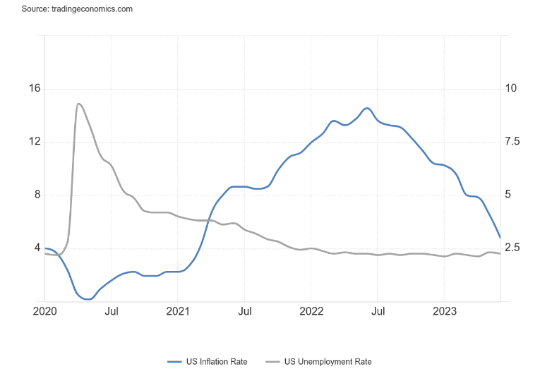
Figure 2. The Trend Between US Inflation and Unemployment
Source: tradingeconomics.com

Long-term inflation expectations also influence the Fed's decision, as interest rate hikes are needed to affirm a commitment to price stability and prevent further inflationary spirals. From trend chart 2 above, it can be seen that the inflation trend in the United States tends to fluctuate. Since the second quarter until the end of 2022, the inflation rate has continued to increase. The highest inflation rate occurred in mid-2022, precisely in June, with a figure of 9.1 percent. However, since the end of 2022, the inflation trend in the United States has continued to decline to reach 3.2 percent at the end of 2023. This indicates that the Fed, through its monetary policy, has succeeded in reducing liquidity and suppressing the inflation rate to stabilize the United States economy. According to Friedman, (2017), monetary policy can help offset major disruptions in the economic system. Tighter monetary policy, including quantitative easing, was implemented to reduce liquidity in the economy and suppress inflation. All of these factors contributed to the increase in the FFR over the past few years as the Fed attempts to maintain a balance between economic growth and price stability.

Bank Indonesia (BI), as the monetary authority, has an important role in maintaining domestic economic stability through various policies, one of which is the determination of the BI Rate. BI Rate is the primary tool for managing macroeconomic factors like inflation, exchange rate stability, and economic growth (Sanica et al., 2018). The interaction between changes in the FFR and the BI Rate is important to analyze because it can provide an overview of how the dynamics of global monetary policy affect the domestic economy. The relationship between the Federal Funds Rate (FFR) and the BI Rate is a reflection of how global and domestic monetary policies influence each other. The determination of the BI rate not only considers domestic macroeconomic conditions but also examines world interest rates (Putri et al., 2017). When the FFR rises, global liquidity tightens, and investment returns in the United States become more attractive. This often encourages global investors to move their funds to US assets, which causes capital outflows from emerging markets, including Indonesia. Foreign investors exchange their home currency investments for US dollar investments, resulting in a greater exchange rate that benefits the US dollar (Tian, 2024). As a result, pressure on the Rupiah exchange rate has increased, forcing BI to consider increasing the BI Rate to maintain exchange rate stability and prevent inflation that could arise from Rupiah depreciation.

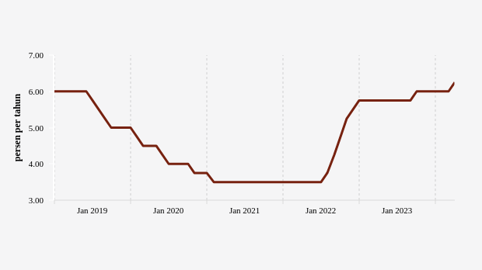
Figure 3. BI rate trend
Source: databoks.katadata.co.id

Figure 3 above shows the BI rate trend, which has the same pattern as the FFR. In the period from 2021 to the second quarter, when the FFR value tended to stagnate, a similar trend was also experienced by the BI Rate value, which also stagnated at 3.5 percent. And when the FFR started to rise in the third quarter of 2022, BI responded to the increase by raising its BI Rate. Since the third quarter of 2022, the BI Rate has continued to increase to reach 6 percent at the end of 2023. In response to changes in the FFR, BI needs to adjust its monetary policy to maintain domestic economic stability. This can help control domestic inflation and restrain capital outflows. However, this also risks suppressing economic growth because tighter credit conditions can reduce consumer spending and business investment (Wuhan et al., 2015). On the other hand, a decrease in the FFR can provide an opportunity for BI to lower interest rates and stimulate economic growth without causing excessive inflationary pressure. Low interest rates typically contribute to economic growth because people may spend their money more on purchases, and businesses can use it to develop their operations (Mohsen et al., 2022). According to Ridho (2023), the monetary policy taken by the Fed has a significant impact on global economic conditions that require coordinated policy responses from central banks in other countries, including Indonesia. By monitoring changes in the FFR, Bank Indonesia can anticipate its impact on capital flows, exchange rates, and domestic inflation and adjust the BI Rate to ensure economic stability. In this context, the relationship between the FFR and the BI Rate reflects the close linkage between global and domestic monetary policies (Suwondo et al., 2023), where decisions taken by the Fed have direct implications for monetary policy strategy in Indonesia.

In addition to FFR, the Indonesian financial market also pays attention to the performance of the American stock market. The Dow Jones Index (DJI) and the Dow Jones Islamic Market (DJIM) are two main indicators that are often used to measure the performance of the stock market in the United States. DJI reflects the performance of 30 large companies in the United States, while DJIM measures the performance of companies that comply with Sharia principles. The performance of these two indices not only reflects economic conditions in the United States but also indicates global sentiment and capital flows that can affect financial markets in other countries (Elfahmi, 2020). When the FFR rises, borrowing costs increase, which can reduce corporate profits and depress stock prices, including shares in DJI and DJIM. Higher interest rates also reduce the attractiveness of investing in stocks as investors tend to shift to bonds or other safer assets with higher returns (Yusuf et al., 2021). Conversely, a cut in the FFR tends to drive up stock prices in DJI and DJIM due to lower borrowing costs and greater liquidity for investment.

International financial conditions are determined by monetary shocks that originate in the central country. These shocks then affect financial markets and domestic demand in other open economies, causing macroeconomic and financial conditions to synchronise across nations (Ha & So, 2023). The Indonesian Stock Exchange, which represents the Indonesian stock market, plays a significant role in global stock exchange operations. The movement of the stock price index makes clear how closely the Indonesian stock exchange and the international stock exchange are related. The Indonesian Stock Exchange reacts to shifts in the global stock market more quickly these days, which can have a positive impact. However, this quick response can also have a negative impact; if the global stock market experiences a decline, the Indonesian stock market will also be quickly affected (Damajanti & Rosyati, 2018). The impact of FFR changes on DJI and DJIM can spread to the Indonesian stock market. When the FFR increases, global investors may withdraw their funds from emerging markets to reinvest in the US market, causing capital outflows from Indonesia. Pressure on the Rupiah exchange rate due to this capital outflow can force BI to raise the BI Rate, which can further depress the domestic stock market (Yusuf et al., 2021).

Global investor sentiment also plays an important role, where changes in the FFR and the performance of the DJI and DJIM affect the perception of risk and investment opportunities in the Indonesian stock market. If investors see an increase in the FFR as a sign of a strong US economy but at risk of high inflation, they may be more cautious in investing in emerging markets, including Indonesia. In addition, the DJIM and JII, as stock indices that comply with Sharia principles, show a response that may be slightly different due to their portfolio structure. According to IDX (2025), shares listed in the sharia stock category must comply with Islamic principles, where issuers may not engage in business activities prohibited by sharia, such as gambling, usury, or permissible elements (gharar). Furthermore, issuers may not have total interest-based debt compared to total assets exceeding 45 percent, and total interest and non-halal income must not exceed 10 percent. Sharia stocks tend to be more stable in some situations due to their lower dependence on the financial sector, which is very sensitive to changes in interest rates​​ (Machtra et al., 2023). Thus, changes in the FFR have a significant impact on the DJI and DJIM, which then affect the domestic stock indexes, in this case, the IDX Composite and the Jakarta Islamic Index (JII), through the mechanisms of global capital flows, investor sentiment, and domestic monetary policy responses.

As a country with a Muslim population of almost 87 percent, the development of the Sharia stock market in Indonesia continues to grow from year to year. This can be seen in 2024, when Sharia shares reached 68 percent of the total shares listed on the Indonesia Stock Exchange, with a total of 639 issuers (IndoPremier, 2024). The development and growth of the Sharia stock market are also proven by the increase in the value of the Sharia market capacity index, which grew by 6.02 percent; the growth of corporate sukuk increased by 8.71 percent, and government sukuk increased by 2.90 percent in 2022 (Amal & Musthofa, 2023). From the transaction side, the Sharia stock market also contributed 76 percent of daily transactions on the IDX, with capital amounting to 54 percent of the total capital on the IDX. (IndoPremier, 2024).

Three problem formulations that are the primary concerns in this study were identified based on the background information provided above. First, what impact does the shift in US monetary policy have on the state of the Indonesian economy? Second, what impact does the traditional Indonesian stock market have on the traditional US stock market? In what ways does the US Sharia stock market influence the Indonesian Sharia stock market? Based on the problem formulation, the goal of this study is to ascertain how shifts in the course of US monetary policy may impact the state of the Indonesian economy and how the US stock market influences the Indonesian stock market, including both the conventional and sharia stock markets.

This study offers novelty with a comprehensive approach that combines analysis of FFR changes, DJI and DJIM performance, and their impacts on BI Rate, exchange rate, inflation, production index, IDX Composite, and JII in the context of the Indonesian economy. Although many studies have examined the effect of FFR on financial markets in general, this study is unique because it specifically examines how the performance of conventional and Sharia indices in the United States stock market affects the financial market in Indonesia. In addition, this study integrates analysis of key macroeconomic variables such as inflation, exchange rate, and production index, and provides a holistic view of the impact of global monetary policy on the domestic economy. This interdisciplinary approach and focus on comparing conventional and Islamic stock markets in both countries contribute to the literature by integrating the responses of conventional and Islamic stock markets to changes in US monetary policy, an area rarely studied within a single SVAR framework. Furthermore, this research provides a new practical contribution to the economics and monetary policy literature, offering valuable insights for policymakers and market players in dealing with complex global economic dynamics. Understanding these dynamics is important for market players and policymakers to anticipate changes and take appropriate steps to maintain economic stability and growth.

2. LITERATURE REVIEW
2.1 Mundell-Fleming Theory
To study and analyze how the correlation between shifts in monetary and fiscal policies in a country with a small open economy is used, the Mundell-Fleming macroeconomic model, Mankiw (2007) and Vidakovic (2002) Argue that this Mundell-Fleming model can be assumed to study the economic conditions of countries with small open economies. In this Mundell-Fleming model, monetary instruments such as the amount of money in circulation, government consumption, and taxes are used as fiscal instruments. In the Mundell-Fleming model theory, monetary policy and fiscal policy play an important role in a small open economy. This macroeconomic model, also known as the IS-LM-BP model, provides an important foundation for understanding how monetary policy and fiscal policy correlate with the economic conditions of a small open country like Indonesia.
According to Mankiw, (2009)In the Mundell-Fleming model, the equilibrium equation is as follows:
Y = C (Y - T) + I (r) + G + NX (e) (1)
M / P = L (r, Y) (2)
R = r * (3)
Many equilibrium situations are projected by equations (1), (2), and (3). The first is a state of good market equilibrium, in which net exports (NX), government expenditure (G), investment (I), and consumption (C) add up to aggregate income (Y). For changes in the exchange rate to be proportionate to the real exchange rate, this model assumes that prices remain constant. The second is the money market equilibrium, which occurs when the real money balance supply and demand are equal (L). The third is the balance of payments, which is impacted by trade and capital scale variables like interest rate differentials, real exchange rates, and domestic income. In this instance, the interest rate in the economy is determined by the international interest rate (r*) (Mukhlis et al., 2020). The three equations show that macroeconomic conditions are vulnerable to economic turmoil. Economic conditions, policy shifts, and geopolitical conflicts in other countries can have an impact on the economies between countries. In this case, several economic indicators, such as international trade performance, capital flows, and interest rates, are very vulnerable to economic uncertainty. Research by Şeyranlıoğlu et al. (2025) also supports the perspective that there is a relationship between global uncertainty and monetary policy mechanisms.
3. METHODOLOGY

Monthly secondary data covering the years 2010–2023 is used in this study. The Central Bureau of Statistics provides statistics for the comparable comparison variable, the BI Rate, whereas the Federal Reserve Statistics (FRED) report provides data for the Federal Funds Rate (FFR). Indonesian inflation data is quoted from data published by Bank Indonesia, while US inflation data is quoted from data published by the US Inflation Calculator. While the US IP Growth data is taken from the Federal Reserve Data (FRED), the Indonesian IP Growth data is taken from the Central Bureau of Statistics. The data used for the Stock Index (DJI, DJIM, IDX Composite, and JII) is taken from the website investing.com.

To ensure alignment between the research method and objectives, this study is guided by several key questions. First, what impact does the shift in US monetary policy have on the state of the Indonesian economy? Second, what impact does the traditional Indonesian stock market have on the traditional US stock market? In what ways does the US Sharia stock market influence the Indonesian Sharia stock market? These three key questions form the basis of the analysis in selecting the SVAR model in this study.

In the meantime, the following data analysis techniques were employed in this study:

3.1 Data Stationarity Test

To ascertain whether time series data is stationary, the unit root test is the stationarity test that is employed. This exam is known as the Augmented Dickey-Fuller exam (ADF Test) because it was created by Wayne Fuller and David Dickey (Box & E.P., 2016). The following equation represents the ADF Test:

Yt = ρYt-1 + e (5)

Yt is the dependent variable that is affected by the variable itself in the preceding period, ρ is the coefficient, t is the time unit, and e is the error term (residual) in the analysis of Indonesia's response to US monetary policy and its effects on the stock market. This time series regression model encounters a non-stationary scenario when ρ = 1, which indicates the existence of a unit root (Maglearning, 2020). The aforementioned equation can be reformulated as follows:

ΔYt = (ρ-1)Yt-1 + e = δYt-1 + e (6)
Where the first difference operator is denoted by Δ. It is possible to estimate this model, and testing δ = 0, where δ = ρ – 1 is the same as testing a unit root. The critical value cannot be found using the standard t distribution since the test is conducted over the residual period of the raw data. Consequently, the Dickey-Fuller table is a particular distribution for this t-statistic (Maglearning, 2020).

3.2 Structural Autoregression (SVAR) Test

The stationary data results at that level in an ADF test are referred to as the Structural Autoregression (SVAR) model. The difference is then computed to make the data stationary at the first level if it is not at that level (Nezky & Mita, 2013). The identification limitations in the SVAR model are based on the theoretical assumption regarding the exogeneity of US monetary policy variables. The following equation represents the SVAR model that was used:
A(L)Xt-1 + Bʛt = A0Xt (7)
FFR, BI Rate, Inflation, IP Growth, and Stock Index (DJI, DJIM, IDX Composite and JII) are the six variables that make up the vector Xt. An (L) is a coefficient matrix with the lag operator L (nxn); ÿt is a vector of disturbance variables (nx1); B is a matrix whose diagonal is not zero; and A0 is an intercept vector between variables (nx1). Because SVAR offers a suitable framework for analyzing the propagation of fluctuations, it is utilized. By examining the impulse response function and its variance decomposition, the study can pinpoint pertinent variations and explain how the system reacts to them (Mukhlis et al., 2020).

3.3 Lag Determination

To ensure that the predicted results could accurately depict actual conditions, lag determination was done in this study utilizing the Lag Order Selection Criteria test.

3.4 Impulse Response Function (IRF)

Impulse Response Function (IRF) is a tool used to determine the dynamic relationship between variables in a regression analysis. IRF provides insight into how a variable responds to changes in other variables over time. By applying the impulse response function, researchers can understand the causal correlation between variables. (Peterson, n.d.).

3.5 Variance Decomposition (VD)

Its innovations (ÿi,t) and innovations in other variables (ÿj,t) account for a portion of the h-steps-ahead prediction error in yi,t, as indicated by Variance Decomposition (VD). This indicates the relative relevance of each innovation in influencing the forecast error of the variables in a VAR or VECM (Mukhlis et al., 2020).

4. results and discussion

4.1 RESULT
4.1.1 Stationarity Test
Table 1. Stationarity Test
Variable | t- Statistics | Prob.*
FFR | -3.50467 | 0.0090
DJI | -11.3676 | 0.0000
DJIM | -14.1897 | 0.0000
BI Rate | -7.72387 | 0.0000
Exchange Rate | -13.3623 | 0.0000
Inflation | -10.0988 | 0.0000
IP Growth | -3.99347 | 0.0019
JII | -12.9682 | 0.0000
IDX Composite | -11.8447 | 0.0000
Source: Author 2024
In this study, the results of the stationarity test with the Augmented Dicky Fuller (ADF) model using first differenced data show that all variables in the study, namely, FFR, DJI, DJIM, BI Rate, Exchange Rate, Inflation, IP Growth, JII, and IDX Composite, have a probability value of less than 0.05. This indicates that all variables in the study are free from unit roots and stationary in the first degree.

4.1.2 AR Root Stability Test
Table 2. AR Root Stability Test | 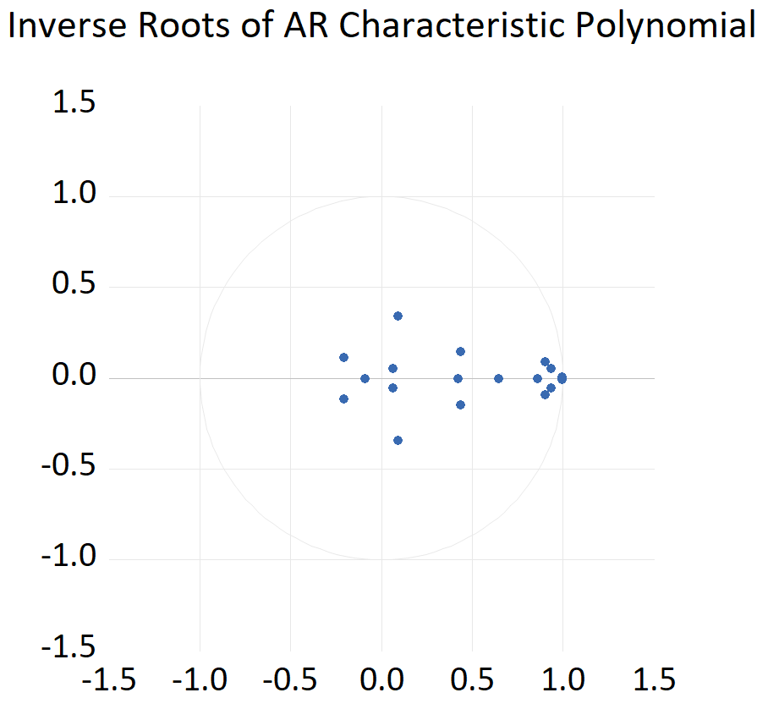  Figure 4. AR Root Stability Test  Source: Author (2024)
  Root | Modulus
  0.995200 - 0.006660i | 0.995222
  0.995200 + 0.006660i | 0.995222
  0.934485 - 0.054633i | 0.936081
  0.934485 + 0.054633i | 0.936081
  0.900622 - 0.088797i | 0.904989
  0.900622 + 0.088797i | 0.904989
  0.859014 | 0.859014
  0.646032 | 0.646032
  0.436243 + 0.149029i | 0.460997
  0.436243 - 0.149029i | 0.460997
  0.422586 | 0.422586
  0.092890 - 0.340761i | 0.353195
  0.092890 + 0.340761i | 0.353195
  -0.209123 + 0.112474i | 0.237451
  -0.209123 - 0.112474i | 0.237451
  -0.09095 | 0.090950
  0.061813 - 0.052458i | 0.081072
  0.061813 + 0.052458i | 0.081072
Source: Author (2024)

The AR Root stability test shows that the model in the study is stable. This can be seen from the modulus, which has a value of less than one, and when viewed from the diagram, all plots are spread in a circle. This indicates that the model stability requirements are met, namely, having a modulus value of less than 1, and the plots are spread in a circle.

4.1.3 Optimal Lag Test
Table 3. Optimal Lag Test
Lag | LogL | LR | FPE | AIC | SC | HQ
0 | -373.0541 | NA | 1.27e-09 | 5.060320 | 5.240158 | 5.133379
1 | 1388.001 | 3288.858 | 2.77e-19 | -17.19207 | -15.39369* | -16.46147*
2 | 1501.472 | 198.3860* | 1.82e-19* | -17.62214* | -14.20522 | -16.23401
3 | 1561.203 | 97.31005 | 2.48e-19 | -17.34043 | -12.30497 | -15.29477
4 | 1609.789 | 73.36285 | 4.01e-19 | -16.91112 | -10.25712 | -14.20792
5 | 1673.797 | 89.01687 | 5.48e-19 | -16.68605 | -8.413509 | -13.32531
Source: Author 2024

The results of the optimal lag test in this study indicate that the optimal and most recommended lag is lag 2. At lag 2, the LR, FPE, and AIC values ​​have the smallest values. Based on Bozdogan's opinion (1987)The model with the smallest complexity is the best or optimal model.

4.1.4 SVAR Test
In the SVAR model, influence restrictions are carried out based on theory, where it is assumed that fluctuations that occur in Indonesia's endogenous variables (BI Rate, Exchange Rate, Inflation, IP Growth, JII, and IDX Composite) will not affect the United States' exogenous variables (FFR, DJI, and DJIM). The results of the SVAR test are described through the following model equation: The SVAR model test is carried out to see the influence of one variable on another variable.

- @^{e}_{FFR} = 44.64@^{u}_{FFR}

Based on the equation model above, as is well known, the FFR variable is only influenced by the variable itself positively and significantly by 44.64. It is said to be significant because it has a probability value of less than 0.05.

- @^{e}_{DJI} = 1.32@^{e}_{FFR} + 2.45@^{u}_{DJI}

Based on the equation model above, as is well known, the DJI variable is significantly influenced by the FFR variable positively by 1.32 and the variable itself positively by 2.45. It is said to be significant because it has a probability value of less than 0.05.

- @^{e}_{DJIM} = 1.64@^{e}_{FFR} + 0.37@^{e}_{DJI} + 4.35@^{u}_{DJIM}

Based on the equation model above, as is well known, the DJIM variable is significantly influenced by the FFR variable positively by 1.64, the DJI positively by 0.37, and the variable itself positively by 4.35. It is said to be significant because it has a probability value of less than 0.05.

- @^{e}_{BI RATE} = -3.12@^{e}_{FFR} + 2.14@^{e}_{DJI} + 3.45@^{e}_{DJIM} + 12.08@^{u}_{BI RATE}

Based on the equation model above, as is well known, the BI Rate variable is significantly influenced by the FFR variable negatively by -3.12, DJI positively by 2.14, the DJIM variable positively by 3.45, and the variable itself positively by 12.08. It is said to be significant because it has a probability value of less than 0.05.

- @^{e}_{EXCHANGE RATE} = 0.70@^{e}_{FFR} - 0.11@^{e}_{DJI} + 0.25@^{e}_{DJIM} + 0.21@^{e}_{BI RATE} - 0.78@^{u}_{EXCHANGE RATE}

Based on the equation model above, as is well known, the Exchange Rate variable is significantly influenced by the FFR variable positively by 0.70, the DJI variable negatively by -0.11, the DJIM variable positively by 0.25, the BI Rate variable positively by 0.21, and the variable itself negatively by -0.78. It is said to be significant because it has a probability value of less than 0.05.

- @^{e}_{INFLATION} = -3.93@^{e}_{FFR} + 1.94@^{e}_{DJI} + 3.54@^{e}_{DJIM} - 0.48@^{e}_{BI RATE} + 2.31@^{e} _{EXCHANGE RATE -} 8.90@^{u}_{INFLATION}

Based on the equation model above, as is well known, the Inflation variable is significantly influenced by the FFR variable negatively by -3.93, the DJI positively by 1.94, the DJIM variable positively by 3.54, the BI Rate variable negatively by -0.48, the exchange rate variable positively by 2.31, and the variable itself negatively by -8.90. It is said to be significant because it has a probability value of less than 0.05.

- @^{e}_{IP GROWTH} = 52.37@^{e}_{FFR} - 16.62@^{e}_{DJI} + 5.31@^{e}_{DJIM} + 4.18@^{e}_{BI RATE} + 1.25@^{e}_{EXCHANGE RATE} + 9.03@^{e}_{INFLATION} + 96.21@^{u}_{IP GROWTH}

Based on the equation model above, as is well known, the IP Growth variable is significantly influenced by the FFR variable positively by 52.37, the DJI negatively by -16.62, the DJIM variable positively by 5.31, the BI Rate variable positively by 4.18, the inflation variable positively by 9.03, and the variable itself positively by 96.21. It is said to be significant because it has a probability value of less than 0.05. From the equation model, it is known that the exchange rate does not affect the IP Growth variable because it has a probability value of more than 0.05, which is 0.08.

- @^{e}_{JII} = 0.16@^{e}_{FFR} - 0.51@^{e}_{DJI} + 0.24@^{e}_{DJIM} + 0.05@^{e}_{BI RATE} + 0.06@^{e}_{EXCHANGE RATE} + 0.01@^{e}_{INFLATION} + 0.12@^{e}_{IP GROWTH} - 3.11@^{u}_{JII}

Based on the equation model above, as is well known, the JII variable is significantly influenced by the FFR variable positively by 0.16, the DJI variable negatively by -0.51, the DJIM variable positively by 0.24, the BI Rate variable positively by 0.05, the exchange rate variable positively by 0.06, the IP Growth variable by 0.12 and the variable itself negatively by -3.11. It is said to be significant because it has a probability value of less than 0.05. From the equation model, it is known that inflation does not affect the JII variable because it has a probability value of more than 0.05, which is 0.17.

- @^{e}_{IDX COMPOSITE} = 0.67@^{e}_{FFR} - 0.21@^{e}_{DJI} + 0.12@^{e}_{DJIM} - 0.06@^{e}_{BI RATE} + 0.05@^{e}_{EXCHANGE RATE} + 0.03@^{e}_{INFLATION} + 0.086@^{e}_{IP GROWTH} - 0.05@^{e}_{JII} + 1.17@^{u}_{IDX COMPOSITE}

Based on the equation model above, As is well known, the IDX Composite variable is significantly influenced by the FFR variable positively by 0.67, DJI negatively by -0.21, DJIM variable positively by 0.12, BI Rate variable negatively by -0.06, exchange rate variable positively by 0.05, inflation variable positively by 0.03, IP Growth variable positively by 0.08, JII variable negatively by -0.05 and the variable itself positively by 1.17. It is said to be significant because it has a probability value of less than 0.05.
4.1.5 IRF Test
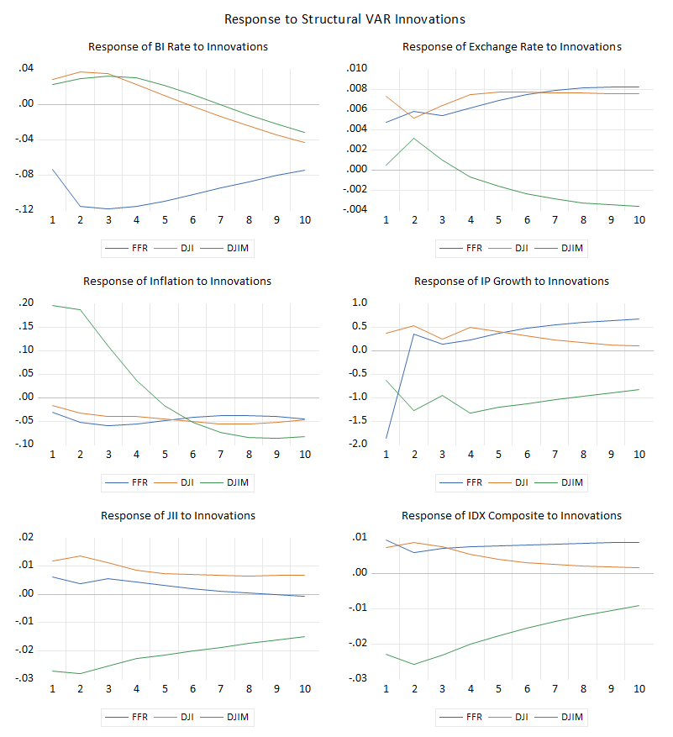
Figure 5. IRF test
Source: Author (2024)
The IRF test was conducted to see the response of the BI Rate, Exchange Rate, Inflation, IP Growth, JII, and IDX Composite variables due to shocks caused by the FFR, DJI, and DJIM variables.

Based on the IRF test, the BI Rate responded positively to the shock caused by DJIM by 0.02 points in the first period. Then it increased to 0.03 points in the fourth period. It continued to decline, and there was a negative response change in the seventh period until the end of the research method reached -0.3 points. As with DJIM, in the first period, the BI Rate responded positively to the shock caused by DJI. Where the response was 0.02 points. Which then increased to 0.03 points in the second and third periods. And continued to decline until the end of the research period, reaching -0.04 points. In contrast to the response to DJIM and DJI, the BI Rate responded negatively to the shock caused by FFR from the beginning to the end of the research period. At the beginning of the period, the BI Rate responded by -0.07 points and fluctuated at -0.07 - 0.11 points. At the end of the research period, the magnitude of the BI Rate response returned to -0.07 points.

The next variable is the exchange rate. Where from this IRF test, it is known that the exchange rate response due to shocks caused by the FFR, DJI, and DJIM is relatively small. In the FFR variable at the beginning of the period, the exchange rate responded positively by only 0.004 points. Then it fluctuated until, at the end of the research period, it reached 0.008 points. Not much different from the exchange rate response due to the FFR variable shock, the exchange rate also responded positively to the DJI shock by 0.007 points in the early period of the study. Then it fluctuated in the next period and again reached 0.007 points at the end of the research period. Slightly different from the exchange rate response to the FFR and DJI, the exchange rate responded negatively at the beginning of the third period of the study, then changed its response to negative in the fourth year to the end of the research period. Where in the first period the response was only 0.0004 points, and -0.003 points at the end of the research period.

Next is the inflation variable. The inflation variable tends to respond negatively to shocks caused by the FFR, DJI, and DJIM variables. In the FFR and DJI variables, the inflation response always reaches a negative number from the beginning to the end of the study period. In the FFR variable, inflation responded by -0.03 points at the beginning of the period. Then it decreased to reach -0.05 points in the fourth period. And reached -0.04 points at the end of the study period. Similar to the FFR variable, inflation responded negatively by -0.01 points at the beginning of the study period and continued to decline to reach -0.04 points at the end of the study. Slightly different from the response caused by the FFR and DJI variables. In the DJIM variable, the exchange rate responded positively at 0.19 points until the fourth period at 0.03 points. Then, from the fifth period to the end of the period, the inflation response to the DJIM shock changed to negative to reach -0.08 points at the end of the study period.

The next variable is IP Growth. The IP Growth variable responded negatively to shocks caused by the FFR variable only at the beginning of the study period, with a figure of -1.86 points. Then the response changed to positive from the second period to the end of the study period. In the second period, it reached a figure of 0.3 points, and reached a figure of 0.6 points at the end of the study period. In the DJI variable, IP Growth responded positively to shocks from the beginning to the end of the study period. At the beginning of the period, the magnitude of the response was 0.3 points, then fluctuated and reached a figure of 0.08 at the end of the study period. Unlike FFR and DJI, IP Growth responded negatively to shocks caused by the DJIM variable from the beginning to the end of the study period. In the early period, the magnitude of the response was -0.6 points and reached a figure of -0.8 points at the end of the study period.

Then there is the response of the JII variable due to the shocks caused by the FFR, DJI, and DJIM variables. JII responded positively to the shocks caused by the FFR at the beginning of the research period by 0.006 points. Then it continued to decline until it reached 0.0004 in the eighth period, and changed its response to negative in the next period. Until it reached a figure of -0.0005 points at the end of the research period. In the DJI variable, the JII variable responded positively from the beginning to the end of the research period. At the beginning of the period, the response magnitude was 0.01 points and reached 0.006 at the end of the research period. Similar to the IP Growth variable, the JII variable responded negatively to the shocks caused by DJIM from the beginning to the end of the research period. The magnitude of the response caused by DJIM at the beginning of the period was -0.02 points and reached -0.01 at the end of the research period.

The last variable is the IDX Composite. The response of the IDX Composite variable due to shocks caused by FFR, DJI, and DJIM is not much different from the response of the IP Growth and JII variables. The IDX Composite variable responds positively to shocks from the FFR variable from the beginning to the end of the study period. At the beginning of the period, the IDX Composite response was 0.009 points. And reached a figure of 0.008 points at the end of the study period. Similar to the FFR variable, the IDX Composite response due to shocks from the DJI variable was also positive from the beginning to the end of the study period. At the beginning of the period, the IDX Composite response was 0.007 points and continued to decline until it reached 0.001 points at the end of the study period. In contrast to the response to FFR and DJI shocks, the IDX Composite responded negatively to shocks caused by the DJIM variable from the beginning to the end of the study period. At the beginning of the period, the IDX Composite response was -0.02 points and reached -0.009 at the end of the study period.

4.1.6 VD Test
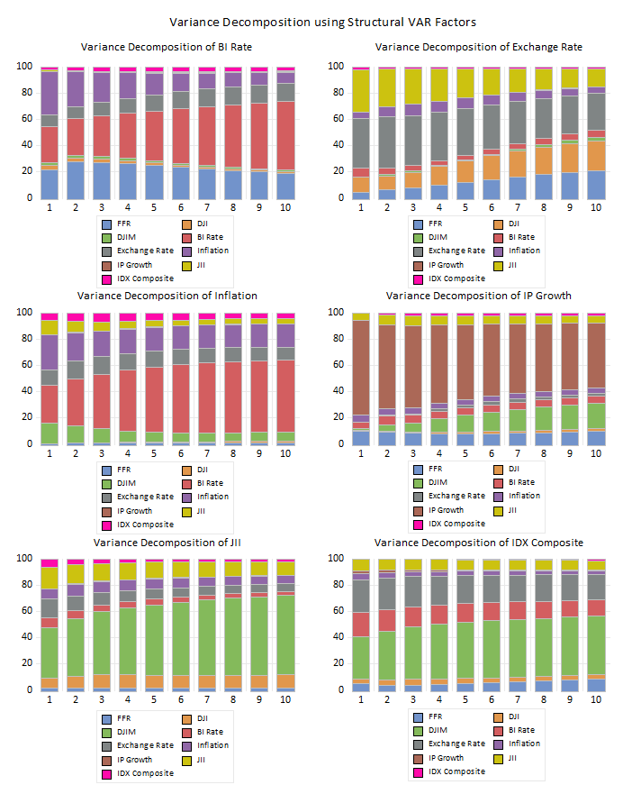
Figure 6. VD Test
Source: Author (2024)
In this study, a VD test was also conducted to see the magnitude of the influence of variables on other variables. From this VD test, the results showed that at the beginning of the research period, the BI Rate was predominantly influenced by the inflation variable by 32.5 percent, then the variable itself by 27.7 percent, 21.6 percent influenced by the FFR variable, and 9 percent influenced by the exchange rate variable, the rest were influenced by other variables with not too large an influence. In the middle of the research period, the BI Rate variable was predominantly influenced by the variable itself by 37.8 percent, which was offset by an increase in the influence of the FFR variable to 25 percent, and the exchange rate rose to 12.3 percent to become the third variable contributing the largest influence on the BI Rate variable. At the end of the period, other variables continued to experience a decrease in influence, and the BI Rate variable was predominantly influenced by itself by 52.2 percent, and the FFR variable became the variable with the second largest influence after the variable itself by 18.9 percent, 13.6 percent influenced by the exchange rate, 8.3 percent by inflation, and the rest were influenced by other variables.
The second variable is the exchange rate variable. The VD test shows that the exchange rate variable is dominated by the variable itself by 37.4 percent at the beginning of the study period, then 32.2 percent is influenced by JII, 11.1 percent is influenced by DJI, and the rest is influenced by other variables. In the middle of the period, the exchange rate and JII variables experienced a decrease in influence to 35.2 percent and 21.7 percent. This condition is accompanied by an increase in the influence of the DJI, FFR, and inflation variables by 16.4, 11.9, and 7.9 percent. Despite the decrease in influence, the exchange rate variable is still dominated by the variable itself by 27.7 percent. Then the second largest influence is by DJI by 22.6 percent, and then the third largest influence is from the FFR variable with a value of 21.1 percent. The variable contributing the next largest influence is JII with a value of 13.6 percent, and the rest is influenced by other variables.

Next is the inflation variable. From the results of the VD test, it is known that the inflation variable is predominantly influenced by the BI Rate variable. At the beginning of the period, the BI Rate has an effect of 28.9 percent. In addition to being influenced by interest rates, the inflation variable is also influenced by the variable itself by 26.6 percent, the DJIM variable by 15.4 percent, the JII variable by 10.5 percent, and the rest is influenced by other variables. In the middle to the end of the period, the influence of the BI Rate continued to increase and was greater than the variable itself and other variables in the study. In the fifth year, the influence of the BI Rate reached 49.5 percent, and at the end of the period, it reached 54.4 percent.

The next variable is IP Growth. From the beginning to the end of the research period, IP Growth was predominantly influenced by the variable itself. At the beginning of the research period, its influence reached 71.7 percent. However, in the next period, the influence of the IP Growth variable continued to decline. Where in the fifth year its influence became 56.6 percent, and reached 49.2 percent in the last period. This condition was followed by an increase in the influence of the DJIM variable, which contributed the second largest influence after the variable itself of 19.5 percent.

In the JII variable, at the beginning of the period, the largest influence was dominated by the DJIM variable with an influence of 38.4 percent. JII was also influenced by the variable itself by 16 percent, the exchange rate variable by 14.3 percent, and the rest was influenced by other variables. In the following periods, the influence of the DJIM variable was getting bigger. In the fifth year, its influence increased to 53.3 percent and reached 60.1 percent at the end of the research period. And 10.2 percent was influenced by the DJI variable, which made it the second variable with the largest influence on the JII variable.

The last variable is the IDX Composite variable. In the IDX Composite variable, the largest influence is dominated by the DJIM variable and the exchange rate. At the beginning of the research period, DJIM contributed an influence of 32 percent and the exchange rate of 24.8 percent. In addition, at the beginning of the research period, the BI Rate also contributed an influence of 18.6 percent to the IDX Composite variable. However, in the middle to the end of the period, the influence of the exchange rate and BI Rate decreased. This condition is followed by an increase in the influence of the DJIM variable, which is increasingly dominant. In the fifth year, its influence reached 42.6 percent.

DISCUSSION

Based on the research findings above, this discussion aims to explain and provide a deeper understanding of the dynamics and relationships between US variables and the Indonesian economy and stock market. This discussion is also structured to directly answer the previously formulated research questions, thus providing a comprehensive understanding of the impact of US monetary policy, conventional stocks, and Islamic stocks on the Indonesian economy and stock market.

4.2.1 The Influence of Changes in the Direction of US Monetary Policy on the Indonesian Economy
In recent decades, the world's central banks have tightened policy by aggressively raising interest rates, including the Fed, which increased the benchmark interest rate, the Federal Funds Rate (FFR) (Adrian, 2023). According to Liu, (2024)The United States implemented the policy of increasing interest rates to attract capital into the country. As the center of the global economy, the shift in monetary policy's trajectory brought about by the FFR interest rate increase certainly does not only affect the economic conditions and capital flows of the United States. According to Mukhlis et al., (2020)The FFR interest rate policy implemented by the Fed is also a reference for global monetary decision-making. The Fed's policy of continuing to raise the FFR in the long term, or what is often known as the Higher for Longer phenomenon, certainly has a significant chain effect on global economic stability, including the economic stability of countries with small open economic systems such as Indonesia (Liu, 2024).

According to the open economy benchmark model, the home country's monetary policy, in this case, the United States, influences the foreign economy in three ways. The first is through the exchange rate channel, domestic demand, and the financial channel through the country's monetary policy (Caldara et al., 2022). Teapon & Mustafa, (2018) His research also mentioned that monetary policy is transmitted through seven channels, namely the channels of direct money, interest rates, currency rates, asset prices, credit, financial balances, and expectations. Thus, the policy of increasing the FFR interest rate aggressively certainly affects the direction of Indonesia's benchmark interest rate policy (BI Rate). Bank Indonesia (BI), as Indonesia's central bank, must certainly respond to The Fed's policy to maintain the stability of the money market and domestic capital flows by raising its benchmark interest rate (BI Rate) and enacting a contractionary monetary policy.

On the other hand, quoted from the official Instagram page of Bank Indonesia (2024)The policy of increasing the benchmark interest rate also caused the US Treasury yield to continue to increase and the US dollar to strengthen, which affected the Indonesian rupiah exchange rate. The strengthening of the US dollar certainly had an impact on the depreciation of the rupiah exchange rate (Agung, 2018). To control this condition, the government, through the policy of increasing the benchmark interest rate by Bank Indonesia, aims to increase the stability of the rupiah exchange rate. Increasing the interest rate structure in the rupiah money market is done to maintain the attraction of foreign capital to domestic financial assets and suppress the amount of money in circulation, so that it will strengthen and increase the stability of the rupiah exchange rate.

The community's ability and purchasing power declined as a result of the exchange rate depreciation brought on by the policy of raising the benchmark interest rate. Indirectly and in the long term, this change in policy direction will also affect the domestic Production Index (IP Growth). This contractionary monetary policy, in the long term, will be able to increase unemployment. This is caused by high interest rates, which also cause high capital and loan costs (CFI, 2024). The high cost of capital and loans will increase the operational costs of production, which will have an impact on high output prices, which, if it occurs in the long term, will reduce Indonesia's overall production index because of the reduction in buying power and the degree of consumption and supply of goods in the market.

This decline in the Production Index in the long term will also cause economic imbalance and volatility in global financial markets, it will cause the rate of inflation to rise and a slowdown in global economic growth (Elena, 2024). According to Liu (2024), a depreciation of the exchange rate due to an imbalance can raise the price of domestically imported goods, which will undoubtedly raise the price of goods on the market. An increase in the domestic inflation rate will result from long-term conditions remaining unchanged. The increase in interest rates in the long term also encourages an increase in capital costs, which will be one of the factors causing price increases or inflation. Meanwhile, when interest rates are low, households and companies will get lower borrowing costs, but saving becomes less profitable because the interest earned is also low. This condition encourages increased consumption and public spending. Therefore, the Governor of BI (2024) stated that the policy of increasing interest rates within reasonable limits and on a certain scale is expected to maintain economic stability and regulate both the rupiah exchange rate and the rate of inflation.

4.2.2 The Influence of United States Conventional Stocks on Indonesian Conventional Stocks
Financial performance and economic stability play a crucial role in the stock market structure of a company. In his research, Rante & Hasanudin, (2024) Mentioned that key economic indicators such as Gross Domestic Product (GDP), inflation, interest rates, and exchange rates are the main variables that affect the stock market. Therefore, economic instability increases volatility in the stock market. This instability is also caused by changes in policy.

The existence of the FFR interest rate hike policy or the so-called Hingher For Longer phenomenon in the long term will greatly affect investment figures in the stock market, both conventional stock markets and Sharia stock markets. According to the European Investment Bank, (2024)Increased market volatility causes a reduction in investment figures in companies. In their research, Marcella Roring & Rita Juliana, (2022), also mentioned that market volatility is a major obstacle to the level of corporate investment. Economic stability is one of the indicators used as a consideration by investors.

The existence of an interest rate increase policy can encourage investors to be more interested in investing their assets in banking products and other investment instruments that have more potential and provide greater profits or returns. (Liu, 2024). The continued strengthening of the dollar exchange rate and the simultaneous depreciation of the rupiah exchange rate will also increase the risk of capital withdrawals from within the country to the United States.

As a country with a small open economic system, the Indonesian stock market index is certainly very dependent on stock indexes in developed countries such as the United States. As the largest developed country in the world, the United States, with its Dow Jones Industrial Average (DJI), is a reference in the global stock market, including Indonesia (Rante & Hasanudin, 2024). This is because multinational companies listed on the DJI also operate in Indonesia, so DJI fluctuations affect the conventional Indonesian stock market as reflected through the IDX Composite. This is also reinforced by the results of the VD test, which shows that the United States stock index variable is the largest contributor to the fluctuation of the Indonesian stock index.

It is known from this study's test results and the above comments that the US stock index significantly influences the Indonesian stock index over the long run. According to Natsir et al. (2019), research, there is a significant long-term association between IDX Composite and DJI, which supports this conclusion. The findings of the IRF test indicate that the IDX Composite variable's response in the short term to the shock of the DJI variable shows a very small number. This happens because, in the short term, Indonesian investors pay more attention to the fundamental analysis of the company and the political and macroeconomic conditions in the country. Therefore, companies and policymakers must maintain the stability of their performance to maintain the capital structure in Indonesia.

4.2.3 The Influence of United States Sharia Stocks on Indonesian Sharia Stocks
The Sharia stock market is all activities in the stock market that, in its implementation, pay attention to Sharia principles (IDX, 2024). The Financial Services Authority (OJK) and DSN-MUI oversee the Indonesian Sharia stock market. Given that the majority of the population is Muslim, the Indonesian Sharia stock market is expanding annually. The rise in Sharia stock issuers listed on the Indonesia Stock Exchange (IDX) further supports this. The sharia capital market is also expanding significantly in terms of capital capacity and transaction side (Amal & Musthofa, 2023). This demonstrates how eager investors are to put their money into the Sharia stock market.

Sharia stock market training programs conducted by regulators and equity companies play a crucial role in increasing investor interest in investing their capital in the Sharia stock market (Halim, 2021). Furthermore, the development of the Indonesian Islamic stock index, known as the Jakarta Islamic Index (JII), is significantly influenced by the fluctuations of the worldwide Islamic stock index. The Dow Jones Islamic Market (DJIM) or the United States Islamic Stock Index is one of the reference stock indexes that influences the global securities portfolio, including Indonesia (Halim, 2021).

According to the study's test results, there is a considerable correlation between the Indonesian Sharia stock index and the US Sharia stock index. In this instance, DJIM has long-term effects on JII. The VD test results, which indicate that DJIM is the main cause of JII variations, corroborate this. Halim's research, (2021), which claims that the DJIM variable has a considerable impact on the JII variable, further supports these findings.

4. Conclusion

From the results of the research and discussion above, it was found that: First, changes in the direction of monetary policy of the United States as a country that dominates the world economy certainly have a significant impact on the stability of the Indonesian economy as a country with a small open economy in the long term. Bank Indonesia, which responded to the interest rate hike policy implemented by the Fed, had a chain effect on the stability of the Indonesian economy. Second, the DJI, which is the reference for the global stock index, has a significant long-term influence on the conventional Indonesian stock index, namely the IDX Composite. This condition is caused by an increase in market volatility caused by global economic instability due to changes in policy direction. So it affects the condition of the global stock market, which, of course, also affects the conventional Indonesian stock index. Third, not only the DJI, but capital market volatility also certainly has an impact on the United States Sharia stock index, namely the DJIM. The results of the study also show that fluctuations in the DJIM as a global sharia stock index have a significant long-term effect on the Indonesian sharia stock index, namely the JII.

The findings of this study provide both academic and practical contributions. Academically, this article analyzes the response of conventional and Islamic stock markets in Indonesia to post-US monetary policy shocks within an integrated SVAR framework. This is further explained at the end of the Introduction. Practically, the findings of this study are expected to provide a basis for policymakers to analyze the dynamics of international monetary policy and develop adaptive strategies amidst uncertain economic conditions. Furthermore, this research is also expected to provide a basis for stock market players in making investment decisions amidst the complexity and uncertainty of the global market.

While presenting a comprehensive analysis, this study still has limitations in the research period covered. Therefore, further research is recommended to expand the observation period and consider additional variables to provide a broader perspective on the dynamics of global monetary policy and its impact on the domestic economy.

Disclaimer (Artificial intelligence)
Author(s) hereby declare that generative AI technologies have been used during the writing or editing of manuscripts. This explanation will include the name, version, model, and source of the generative AI technology and as well as all input prompts provided to the generative AI technology
Details of the AI usage are given below:
1. Scispace AI
Used to assist with literature searches and enrich perspectives in the literature review section. This technology was used to identify relevant research and understand the flow of prior research findings.
2. ChatGPT (OpenAI Model, GPT-5 / GPT-5.1)
Used to assist in the search for recommendations for literature relevant to the research. All content and AI-generated recommendations have been thoroughly reviewed and adjusted by the author.
3. Grammarly (AI-powered writing assistant)
Used to check grammar, spelling, punctuation, and make recommendations for improving writing style. This tool functions solely as a language polishing tool without producing substantive content.

References

(BI), B. I. (2024). Kebijakan Moneter AS Pengaruhi Nilai Tukar Rupiah? https://www.instagram.com/p/C6Nvc0LOxIt/?igsh=MTBhcjdtYzUxNXNoYw==
Adrian, T. (2023). Higher-for-Longer Interest Rate Environment is Squeezing More Borrowers. IMF Blog. https://www.imf.org/en/Blogs/Articles/2023/10/10/higher-for-longer-interest-rate-environment-is-squeezing-more-borrowers
Agung. (2018, October 19). “Unhealthy” Economic Structure Causes Rupiah Depreciation. FEB UGM. https://feb.ugm.ac.id/en/news/2494-unhealthy-economic-structure-causes-rupiah-depreciation
Amal, M. A., & Musthofa, M. W. (2023). The Impact of the Dow Jones Islamic Market, Interest Rate, Rupiah Exchange Rate, and Inflation on the Indonesian Sharia Stock Index during 2018-2022 Period. Jurnal Ekonomi Syariah Teori Dan Terapan, 10(2), 188–202. https://doi.org/10.20473/vol10iss20232pp188-202
Bank, E. I. (2024). The Effect of Uncertainty on Investment (Issue April).
Box, & E.P., G. (2016). Time Series Analysis-Forecasting & Control (Kelima). New Jersey : John Wiley & Sons, Inc.
Bozdogan, H. (1987). Model selection and Akaike’s Information Criterion (AIC): The general theory and its analytical extensions. Psychometrika, 52(3), 345–370. https://doi.org/10.1007/BF02294361
Caldara, D., Ferrante, F., & Queralto, A. (2022). International Spillovers of Tighter Monetary Policy. Board of Governors of the Federal Reserve System. https://www.federalreserve.gov/econres/notes/feds-notes/international-spillovers-of-tighter-monetary-policy-20221222.html
CFI. (2024). Contagionary Monetary Policy. https://corporatefinanceinstitute.com/resources/economics/contractionary-monetary-policy/
Clarida, R. H. (2023). US Monetary Policy and the Return to Price Stability. SSRN Electronic Journal, 1–16. https://doi.org/10.2139/ssrn.4533233
Collins, J., & Broten, N. (2017). The role of monetary policy. The Role of Monetary Policy, March, 1–93. https://doi.org/10.4324/9781912281091
Damajanti, A., & Rosyati, Y. (2018). The Effect Of Global Stock Price Index and Rupiah Exchange Rate on Indonesian Composite Stock Price Index (CSPI) in Indonesian Stock Exchange (IDX). Economics & Business Solutions Journal, 2(2), 49–58. http://investing.com
Doh, T., & Yang, C. (2024). Shocks, Frictions, and Policy Regimes: Understanding Inflation after the COVID-19 Pandemic. SSRN Electronic Journal, December. https://doi.org/10.2139/ssrn.4682305
Elena, M. (2024). Terungkap! Alasan BI Naikkan Suku Bunga Acuan jadi 6,25%. https://ekonomi.bisnis.com/read/20240424/9/1760107/terungkap-alasan-bi-naikkan-suku-bunga-acuan-jadi-625
Elfahmi, R. (2020). The Effect of Foreign Buy and the Dow Jones Index on Stocks Prices of Animal Feed Industry at Kompas 100. Journal of Research in Business, Economics, and Education, 2(6), 1442–1455.
Gursoy, S. (2021). The Effect of The Monetary Policy Uncertainty of US and Japan on Bitcoin Price. Yalova Üniversitesi Sosyal Bilimler Dergisi, 11(1), 7–16.
Ha, J., & So, I. (2023). Which Monetary Shocks Matter in Small Open Economies? Evidence from Canada. International Journal of Central Banking, 19(2), 389–472. https://doi.org/10.2139/ssrn.3560692
Halim, S. (2021). The Effect of Dow Jones Islamic Market World Index, Foreign Exchange, Foreign Investment and Domestic Investment with the Intervening Composite Stock Price Index on the Indonesian Sharia Stock Index. Al-Iqtishad: Jurnal of Islamic Economics, 13(2), 369–410. https://doi.org/10.15408/aiq.v13i2.22585
IDX. (2024). Pasar Modal Syariah. IDX Islamic. https://idxislamic.idx.co.id/edukasi-pasar-modal-syariah/pasar-modal-syariah/
IDX. (2025). IDX Syariah. Indonesia Stock Exchange. https://www.idx.co.id/id/idx-syariah/produk-syariah/
IndoPremier. (2024). Saham Syariah di BEI Capai 68% Dari Total Listing per 9 September 2024. IPOTNEWS. https://www.indopremier.com/ipotnews/newsDetail.php?jdl=Saham_Syariah_di_BEI_Capai_68__Dari_Total_Listing_per_9_September_2024&news_id=186581&group_news=IPOTNEWS&news_date=&taging_subtype=MARKETOVERVIEW&name=&search=y_general&q=saham syariah&halaman=1#:~:
Kashyap, A. K., & Siegert, C. (2020). Financial stability considerations and monetary policy. International Journal of Central Banking, 16(1), 231–266.
Konczal, M. (2023). Inflation in 2023: Causes, Progress, and Solutions. 1–8. https://rooseveltinstitute.org/wp-content/uploads/2023/03/RI_MikeKonczal_HouseTestimony_202303.pdf
Liu, X. (2024). The Global Impact of and Response to the Fed’s Interest Rate Hike. Highlights in Business, Economics and Management, 28, 287–294. https://doi.org/10.54097/gqe7gc61
Machtra, C., Majid, M. S. A., & Dawood, T. C. (2023). Does Foreign Interest Rate Determine Islamic Stock Prices? Amwaluna: Jurnal Ekonomi Dan Keuangan Syariah, 7(1), 1–10. https://doi.org/10.29313/amwaluna.v7i1.7001
Maglearning. (2020). UNIT ROOT TEST DI EVIEWS (AUGMENTED DICKEY-FULLER TEST). https://maglearning.id/2020/05/11/unit-root-test-di-eviews-augmented-dickey-fuller-test/
Mankiw, N. G. (2007). Teori Makro Ekonomi (Keempat). Terjemahan, Erlangga.
Mankiw, N. G. (2009). Macroeconomics (Ketujuh). Worth Publishher.
Marcella Roring, & Rita Juliana. (2022). Uncertainty Volatility, Investment, And Cash Holding In ASEAN Countries. Jurnal Akuntansi, 26(2), 176–191. https://doi.org/10.24912/ja.v26i2.905
Mohsen, A. S., Hoang, D. F. A., & Tariq, A. F. (2022). Effect of Interest Rates on Economic Growth in Bangladesh. Journal of Economics, 6(1), 36–44. https://doi.org/10.53819/81018102t5086
Mukhlis, I., Hidayah, I., & Retnasih, N. R. (2020). Interest Rate Volatility of the Federal Funds Rate: Response of the Bank Indonesia and its Impact on the Indonesian Economic Stability. Journal of Central Banking Theory and Practice, 9(1), 111–133. https://doi.org/10.2478/jcbtp-2020-0007
Natsir, K., Yusbardini, & Bangun, N. (2019). Analisis Kausalitas Antara Ihsg, Indeks Dow Jones Industrial Average Dan Nilai Tukar Rupiah/Us$. Jurnal Muara Ilmu Ekonomi Dan Bisnis, 3(2), 229–239. https://doi.org/10.24912/jmieb.v3i2.3398
Nezky, & Mita. (2013). Pengaruh Krisis Ekonomi Amerika Serikat terhadap Bursa Saham dan Perdagangan Indonesia. Buletin Ekonomi Moneter Dan Perbankan.
Peterson, C. (n.d.). Memahami Fungsi Respon Impuls dalam Analisis Regresi. https://shallbd.com/id/memahami-fungsi-respon-impuls-dalam-analisis-regresi/
Putri, N. A., Anggraen, L., & Pasaribu, S. H. (2017). Analysis of Federal Fund Rate and Bi Rate Announcement to Abnormal Return in Indonesia Stock Market. International Journal of Business and Management Review, 5(9), 65–77. www.eajournals.org
Rante, A., & Hasanudin. (2024). The Impact of STI , N225 , and DJI Indices on IHSG with IDX30 Index as the Mediating Variable : A Study of the Indonesia Stock Exchange from 2012 to 2023. International Journal Economics Development Research, 5(2), 1085–1094.
Ridho, W. F. (2023). Federal Funds Rate Spillover Effect On Emerging Market Banking Liquidity And Capital – Evidence From Indonesia. Business Management Analysis Journal (BMAJ), 6(2), 169–184. https://doi.org/10.24176/bmaj.v6i2.10162
Ruchba, S. M., & Hadiyan, F. (2019). Analysis on Unemployment and Inflation in Indonesia for The Periode of 1980 -2016 using Philipps Curve Approach. Proceeding of The 3rd International Conference on Accounting, Business & Economics, 111–122.
Sanica, I. G., Nurcita, I. K., Mastra, I. M., & Sukarnasih, D. M. (2018). Effectiveness and Forecasting of Interest Rate Reversal BI 7-Day Repo Rate in Indonesia: Lower Bound on Monetary Policy? Mediterranean Journal of Social Sciences, 9(1), 171–180. https://doi.org/10.2478/mjss-2018-0016
Şeyranlıoğlu, O., Çilek, A., Erdoğan, B., Gürsoy, S., Erguney, E. B., & Doğan, M. (2025). Do Geopolitical Risks Affect Monetary Policies? Evidence from Türkiye with the TVP-VAR. International Journal of Social, Political and Financial Researches, 5(1), 20–35. https://doi.org/10.70101/ussmad.1604848
Suwondo, J. P., Siswati, A., & Samsya Ayatillah, M. (2023). Suwondo, The Soar Of Fed Rates On Indonesia’s BI 7 Days Reverse Repo Rate. XX(Suwondo), 102–112.
Teapon, R. R. H., & Mustafa, R. D. (2018). KEJUTAN TRANSMISI KEBIJAKAN MONETER DAN VARIABEL MAKRO EKONOMI DI INDONESIA: SUATU PENDEKATAN STRUCTURAL VECTOR AUTOREGRESSION Rizal Rahman H. Teapon & Rachman Dano Mustafa. Jurnal Economia, Vol. 14(2), 177–196.
Tian, M. (2024). Impact of the Federal Reserve Interest Rate Hikes on the U . S . Dollar Exchange Rate. 0(July 2023), 67–72. https://doi.org/10.54254/2754-1169/78/20241636
Translation, O. of A. to D. C. S. for S. D. &. (2024). BI Governor: Indonesia Manages to Maintain Low Inflation Rate. https://setkab.go.id/en/bi-governor-indonesia-manages-to-maintain-low-inflation-rate/
Venter, Z. (2020). The Interaction Between Conventional Monetary Policy and Financial Stability: Chile, Colombia, Japan, Portugal and the UK. In Comparative Economic Studies (Vol. 62, Issue 3). Palgrave Macmillan UK. https://doi.org/10.1057/s41294-020-00129-w
Vidakovic, N. (2002). Application of the Mundell-Fleming Model on a Small Open Economy. 11(3), 392–423.
Wuhan, Suyuan, L., & Khurshid, A. (2015). The effect of interest rate on investment; empirical evidence of Jiangsu Province, China. Journal of International Studies, 8(1), 81–90. https://doi.org/10.14254/2071-8330.2015/8-1/7
Yusuf, M., Ichsan, R. N., & Suparmin, S. (2021). Influence Of BI Rate, FED Rate, And Inflation On Composite Stock Price Index (JCI). Journal of Management and Business Innovations, 3(01), 9. https://doi.org/10.30829/jombi.v3i01.9459
{Bibli

