Case report
“Lipswitch Vestibuloplasty Using the ‘Lock & Glide’ Technique – A Case Report”
Abstract:

Shallow vestibular depth in the anterior mandible compromises oral hygiene and predisposes to mucogingival problems. Conventional lipswitch vestibuloplasty often suffers relapse due to muscular tension from the mentalis muscle. This case report presents a 25‑year‑old male with a thin gingival phenotype and inadequate vestibular depth, treated using a dual‑suturing approach that combines simple interrupted sutures for periosteal fixation with interlocking and pterygium‑inspired anchoring sutures in the lip mucosa. The technique provided immediate flap adaptation and long‑term resistance against relapse. At six months, the patient demonstrated stable vestibular depth, improved oral hygiene, and absence of gingival recession. This case report highlights the potential of integrating ophthalmic suturing principles into periodontal surgery to achieve predictable outcomes in complex clinical scenarios.

Keywords: Lipswitch vestibuloplasty, Transpositional flap, Simple Interrupted suture, Interlocking suture, Pterygium‑inspired suturing, Mandibular vestibular depth, Mucogingival surgery, Relapse prevention.

Introduction:

Vestibular depth plays a critical role in maintaining gingival health and prosthetic stability. A shallow vestibule, particularly in the mandibular anterior region, is associated with plaque accumulation, gingival recession, and difficulty in maintaining oral hygiene^{[1].} High insertion of the mentalis muscle exacerbates this condition, pulling marginal gingiva and limiting sulcus depth.

Lipswitch vestibuloplasty, first described by Kazanjian^{[2]} and later modified by Edlan and Mejchar^{[3]}, remains a reliable method for deepening the sulcus. The technique involves transposition of mucosal and periosteal flaps to create a new vestibule. However, relapse due to muscular tension remains a major limitation.

Recent innovations in ophthalmology, particularly in pterygium surgery, have introduced suturing techniques designed to prevent fibrovascular recurrence by redirecting tissue migration^{[5,6]}. Inspired by these principles, we combined simple interrupted sutures for periosteal fixation with interlocking and pterygium‑style anchoring sutures in the lip mucosa to stabilize the lipswitch flap. This case report describes the case of a young male with inadequate vestibular depth managed successfully with this hybrid approach.

Case Presentation:

A 25-year-old male patient presented to the department of periodontology with a chief complaint of difficulty in maintaining oral hygiene due to the accumulation of plaque and calculus deposits on the lower anterior teeth. On intraoral examination, a thin gingival phenotype was noted in the lower anterior region, along with shallow vestibular depth (~4 mm). This finding was further exacerbated by the high insertion of the mentalis muscle.

The patient was administered a local anesthetic containing 2% Lidocaine with 1:100,000 epinephrine. A single horizontal incision was made at the mucogingival junction. The incision was carried down to the underlying periosteum to facilitate the initial flap elevation.
A full-thickness mucosal flap was raised from the crest of the alveolar ridge. A careful submucosal dissection was performed to release the underlying muscle and connective tissue attachments, with particular attention paid to the mentalis muscle. The supraperiosteal dissection was then extended inferiorly to the desired vestibular depth, approximately 10 mm from the crest. The exposed periosteal surface formed the new floor of the vestibule.
The labial mucosal flap was transposed apically to line the newly created vestibular space. Trial positioning confirmed adequate depth and symmetry across the midline.

The stability of the newly created vestibule was ensured by a two-stage suturing technique.
- Simple Interrupted Sutures (Primary Closure): The apical margin of the mucosal flap was secured to the periosteum using simple interrupted sutures, ensuring precise tissue adaptation and minimizing dead space^{[10]}.These sutures were placed using 4-0 resorbable polyglactin (Vicryl) sutures with a reverse-cutting needle.
- Interlocking and Pterygium‑Inspired Sutures (Secondary Stabilization): On the lip mucosa, a continuous interlocking suture line was placed to provide uniform tension and flap stability^{[8]}. In addition, pterygium‑inspired anchoring sutures were applied, passing through the periosteum, the apical margin of the mucosal flap, and into non‑mobile connective tissue of the lower lip^{[11]}. These sutures were placed using 4-0 non-resorbable silk sutures on a round-bodied needle. These sutures neutralized muscular tension and prevented relapse.

The patient received post-operative instructions for a soft diet and was prescribed analgesics and a chlorhexidine mouth rinse. The patient was followed up at one week, one month, and six months post-operatively. Healing was uneventful. At one week, the surgical site showed good tissue adaptation with minimal inflammation. At one month, the vestibular depth was stable at ~10 mm, with improved oral hygiene and reduced plaque accumulation. At six months, the vestibular depth remained unchanged, with no relapse or gingival recession. The patient reported improved comfort in brushing and chewing, and expressed satisfaction with the outcome.

Discussion:

The patient achieved a significant increase in vestibular depth from ~4 mm to ~10 mm. Healing was uneventful, with no wound dehiscence or infection. Oral hygiene improved markedly, with reduced plaque accumulation and no signs of gingival recession. The dual‑suturing technique provided both immediate flap stability and long‑term resistance against relapse.

Maintaining vestibular depth in the anterior mandible remains challenging due to muscular tension from the mentalis muscle. Traditional lipswitch techniques, while effective initially, often fail to sustain long‑term outcomes^{[2,3]}.Conventional anchorage methods in vestibuloplasty, including periosteal fixation, composite button sutures, and transcutaneous sutures, primarily provide vertical stabilization but may not effectively resist the multidirectional forces exerted by the mentalis muscle. In contrast, pterygium-inspired sutures, adapted from ophthalmic surgery, offer enhanced tissue anchorage by evenly distributing tension over a wide area, thereby enhancing resistance to relapse.

Simple interrupted sutures provide precise tissue adaptation and are widely used in oral surgery^{[7]}. Interlocking sutures add uniform tension and minimize wound dehiscence^{[8]}. However, they alone cannot counteract muscular pull. The addition of pterygium‑inspired sutures, adapted from ophthalmic surgery, offers a novel solution^{[4,5]}. In pterygium excision, these sutures redirect fibroblast proliferation away from the cornea, preventing recurrence^{[9]}. Applied in vestibuloplasty, they anchor the flap into stable connective tissue, resisting relapse.

Existing literature supports innovative suturing in vestibuloplasty. Wessberg et al. demonstrated predictable gains in vestibular depth with transpositional flaps^{[9]}. Adams et al. highlighted the role of lipswitch vestibuloplasty in implant rehabilitation^{[10]}. Nag et al. reported success using pterygium‑style sutures in periodontal surgery^{[11]}. This case corroborates these findings, showing that combining interlocking and pterygium sutures can yield stable, functional outcomes.

This hybrid approach addresses the critical issue of relapse, enhances oral hygiene, and provides long‑term stability. Limitations include the single‑case design and short follow‑up. Larger studies are needed to validate its generalizability.

Conclusion:

The described surgical technique, which combines a lipswitch vestibuloplasty with continuous interlocking and pterygium-inspired sutures in the lip mucosa offers a highly effective method for deepening and maintaining vestibular depth in the mandible. This dual approach addresses relapse, enhances oral hygiene, and provides long‑term stability. The successful outcome of this case highlights the potential for this technique to become a valuable tool in pre-prosthetic oral and maxillofacial surgery. Further controlled studies with larger cohorts and longer follow‑up are warranted.

Consent:

Written informed consent was obtained from the patient prior to surgery and for the publication of this case report and accompanying images.

Ethical Approval:

It is not applicable.

Competing Interests:

Authors have declared that no competing interests exist.
Disclaimer (Artificial intelligence)
Option 1:
Author(s) hereby declare that NO generative AI technologies such as Large Language Models (ChatGPT, COPILOT, etc.) and text-to-image generators have been used during the writing or editing of this manuscript.
Option 2:
Author(s) hereby declare that generative AI technologies such as Large Language Models, etc. have been used during the writing or editing of manuscripts. This explanation will include the name, version, model, and source of the generative AI technology and as well as all input prompts provided to the generative AI technology
Details of the AI usage are given below:
1.
2.
3.

References:
- Nandkeoliar T, Kumar A, Chungkham S, Singh SS. Estimation of vestibular depth: An observational cross‑sectional study. J Indian Soc Periodontol. 2023;27(3):320‑324. https://doi.org/10.4103/jisp.jisp_293_22
- Kazanjian VH. Surgery as an aid to more efficient service with prosthetic dentures. J Am Dent Assoc. 1935;22(4):566‑581.https://doi.org/10.14219/jada.archive.1935.0096
- Edlan A, Mejchar B. Plastic surgery of the vestibulum in periodontal therapy. Int Dent J. 1963;13:593‑596.10.7759/cureus.78346
- Li X, Mao XL. Application of interlocking suture combined with simple continuous suture in pterygium excision with conjunctival translocation. Int Eye Sci. 2015;15(8):1469‑1471. dx.doi.org/10.3980/j.issn.1672-5123.2015.8.46
- Coroneo MT, Di Girolamo N, Wakefield D. The pathogenesis of pterygia. Curr Opin Ophthalmol. 1999;10:282‑288. https://doi.org/10.1097/00055735-199908000-00011
- Wessberg GA, Hill SC, Epker BN. Transpositional flap technique for mandibular vestibuloplasty. J Am Dent Assoc. 1979;98(6):929‑932.https://doi.org/10.14219/jada.archive.1979.0200
- Mahabaleshwara CH, Francis M, Kumar DP, Amudhan CR, Pethkar R, Shravani B. Simple interrupted and continuous interlocking suturing techniques comparison in maxillofacial trauma. RJDS. 2021;13(3):198‑201.https://doi.org/10.26715/rjds.13_3_8
- Racey GL, Wallace WR, Cavalaris CJ, Marguard JV. Comparison of polyglycolic‑polylactic acid suture to silk and catgut in oral tissues. J Oral Surg. 1978;36(10):766‑770. https://pubmed.ncbi.nlm.nih.gov/280644/
- Kria L, Ohira A, Amemiya T. Growth factors in cultured pterygium fibroblasts. Graefes Arch Clin Exp Ophthalmol. 1998;236:702‑708.https://doi.org/10.1007/s004170050144
- Adams DR, Petukhova Y, Halpern LR. The versatile “lip switch” vestibuloplasty combined with alveoloplasty and implant placement. Spec Care Dentist. 2021;41(1):122‑128. https://doi.org/10.1111/scd.12546
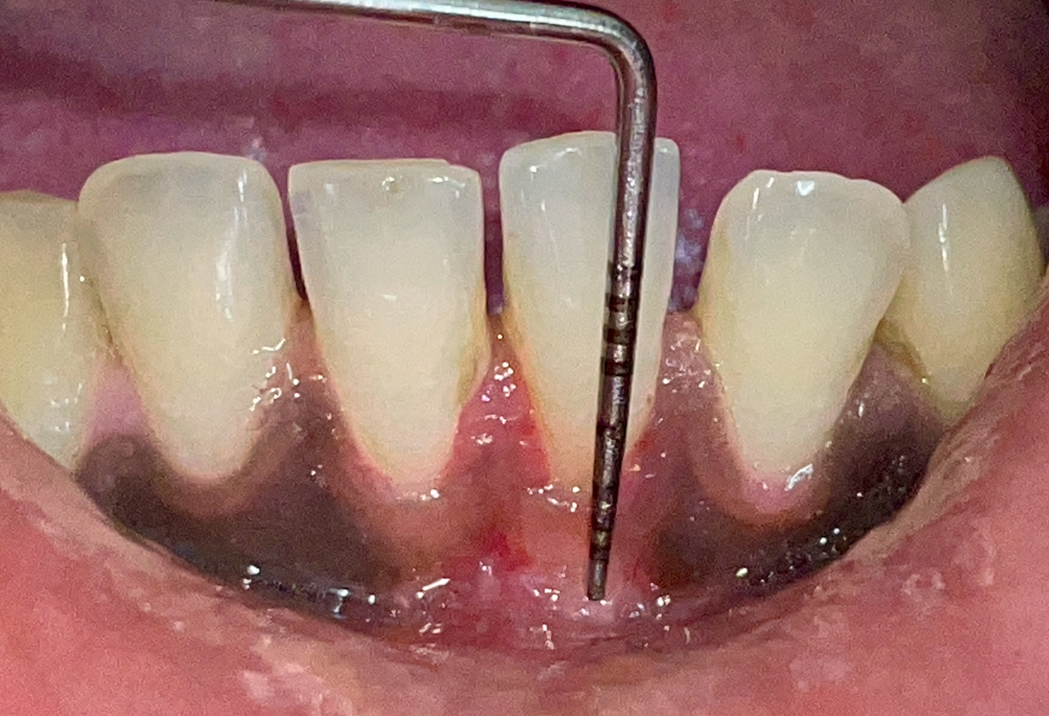
- Nag A, Dholakia S, Rathod V, Rao P. A novel suturing technique for vestibuloplasty – report of two cases. J Emerg Technol Innov Res. 2020;7(3):282‑288. https://doi.org/http://doi.one/10.1729/Journal.23216

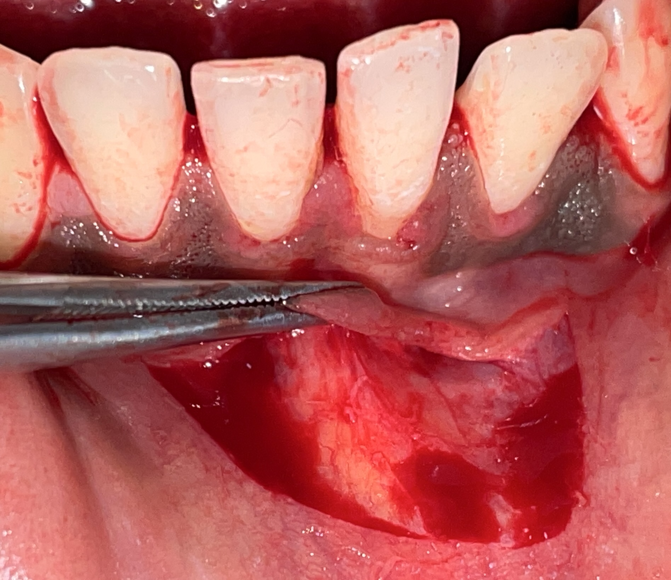
Figure 1: The preoperative view revealed the shallow vestibule

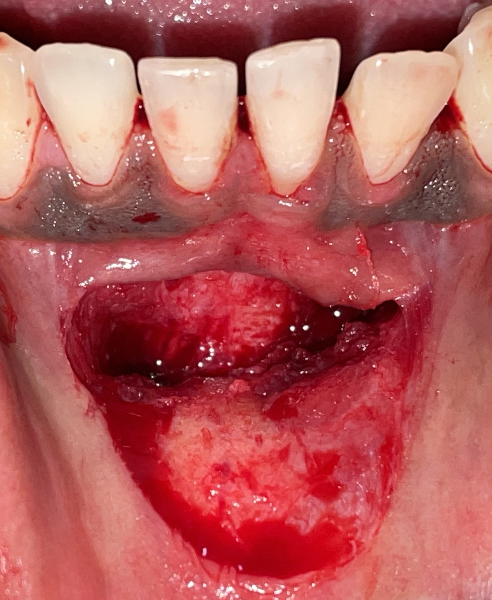
Figure 2: A horizontal incision was given at the level of the mucogingival junction. A partial-thickness flap was carefully elevated.

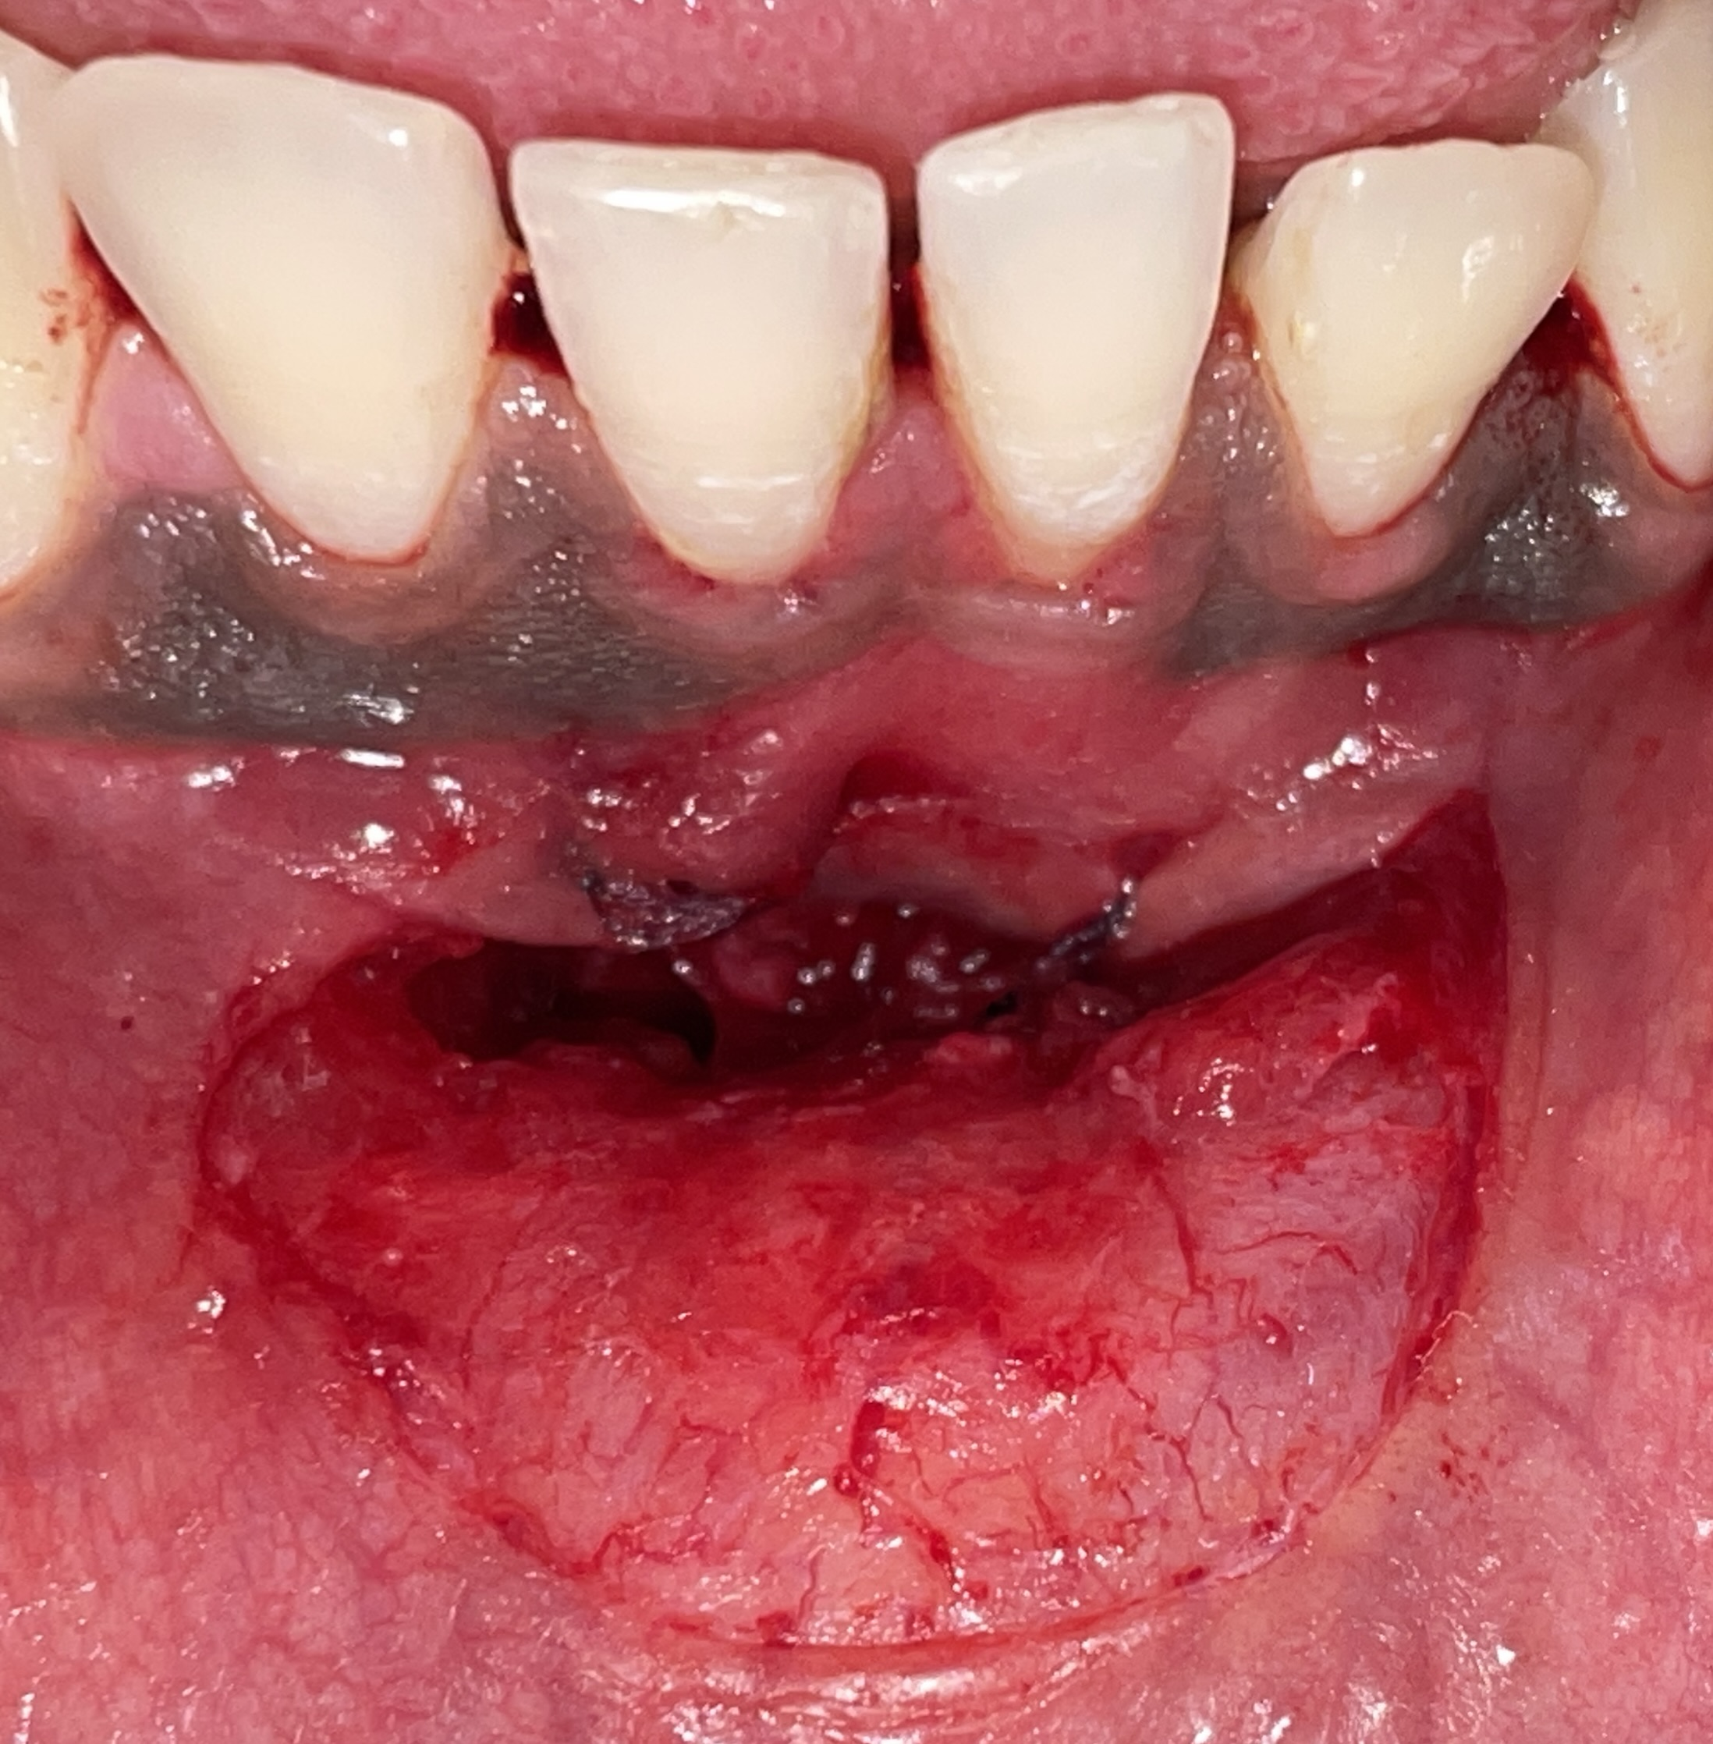
Figure 3: Vestibular deepening was performed by dissecting the muscle and connective tissue attachments to create additional vertical depth. The periosteum was then gently stripped from the underlying bone to reduce muscular tension and enhance flap mobility, thereby improving postoperative vestibular depth.

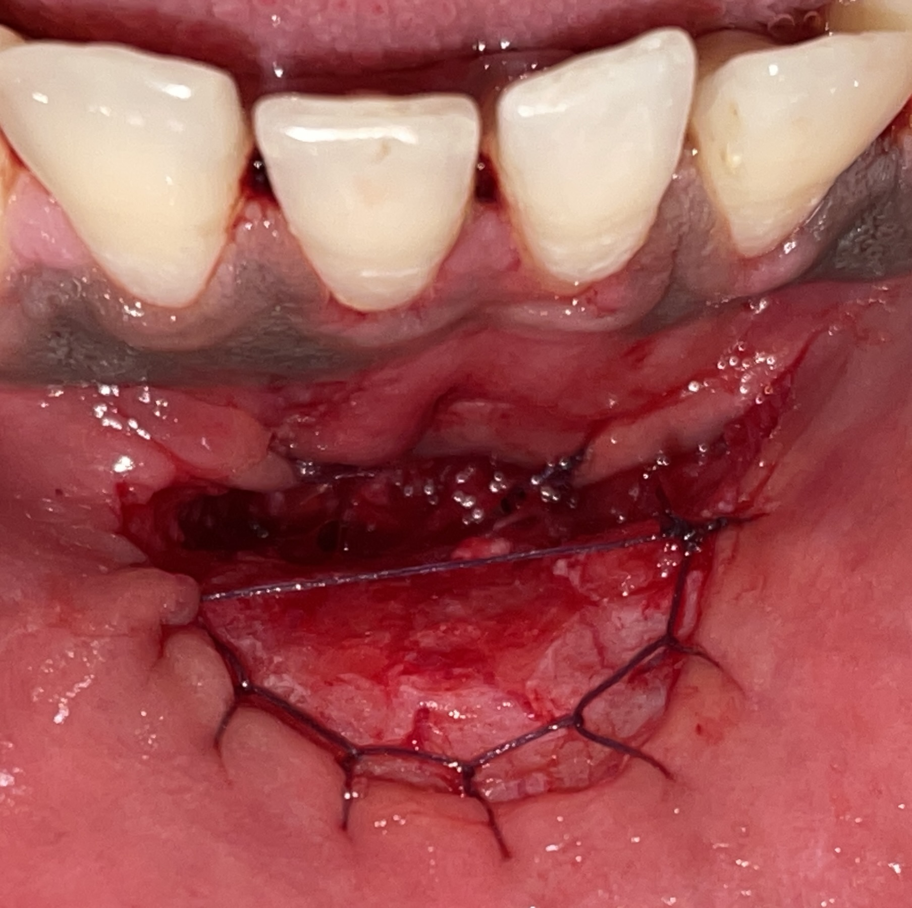
Figure 4: The elevated flap was stabilized by securing it to the underlying periosteum using simple interrupted sutures.

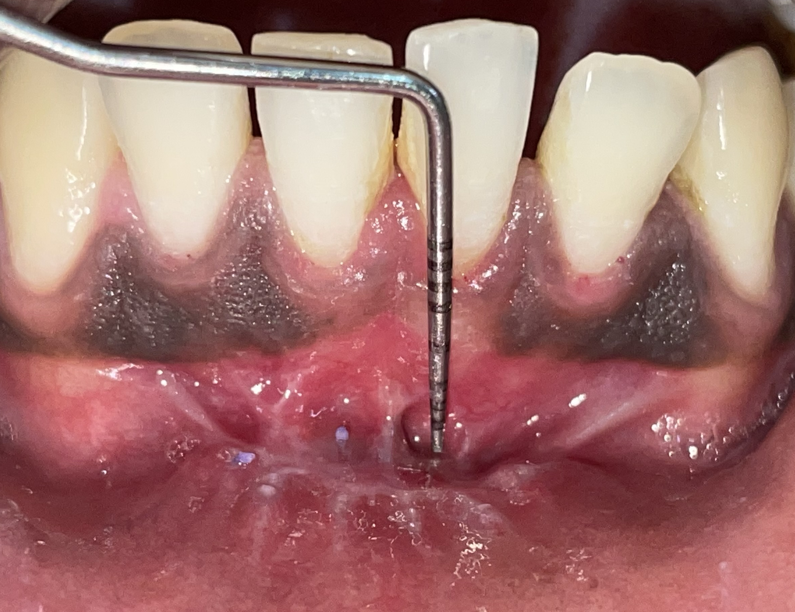
Figure 5: On the lip mucosa, continuous interlocking sutures were placed to ensure uniform tension distribution and precise tissue adaptation, followed by the placement of pterygium sutures to provide additional stabilization and prevent mucosal retraction during healing.

Figure 6: At the 6-month postoperative evaluation, the surgical site exhibited increased width of attached gingiva, and improved vestibular depth.

