Case report
What Echo Could Not See: Silent Apical HCM Revealed by MRI in a Competitive Athlete

.
ABSTRACT

AIMS
Apical hypertrophic cardiomyopathy (ApHCM) poses a significant diagnostic challenge in athletes due to its subtle presentation and the technical limitations of echocardiography. This case aims to highlight the diagnostic limitations of routine pre-participation screening in athletes and emphasize the pivotal role of cardiac MRI in detecting silent ApHCM.
INTRODUCTION
Apical hypertrophic cardiomyopathy is an uncommon phenotype of hypertrophic cardiomyopathy that may remain clinically silent and is frequently underdetected by standard screening tools. In athletes, deep T-wave inversions, which can be the earliest and sometimes only marker of the disease, should prompt further evaluation even when echocardiography appears normal. Advanced imaging modalities, particularly cardiac MRI, play a crucial role in accurately identifying apical pathology.
CASE PRESENTATION
A 29-year-old elite competitive football player, completely asymptomatic, underwent routine pre-participation evaluation. Physical examination was unremarkable and transthoracic echocardiography was normal. Resting ECG revealed deep T-wave inversions in the anterolateral and inferior leads with electrical left-ventricular hypertrophy. The discordance between the profoundly abnormal ECG and the normal echocardiogram prompted further investigation with cardiac MRI, which demonstrated apical hypertrophy with a base-to-apex wall-thickness ratio >1.2, maximal apical thickness of 15 mm, and a characteristic ace-of-spades left-ventricular configuration. Late gadolinium enhancement imaging showed no myocardial fibrosis. A maximal exercise test showed normal functional capacity with no arrhythmias.
DISCUSSION
This case illustrates how ApHCM can evade detection during routine athletic screening due to the limited apical visualization of echocardiography. Current guidelines therefore recommend cardiac MRI when repolarization abnormalities are unexplained. Deep T-wave inversions remain a key early marker and warrant comprehensive investigation. Cardiac MRI offers superior spatial resolution and tissue characterization, allowing definitive diagnosis and prognostic assessment through fibrosis evaluation. Risk stratification in athletes should integrate MRI findings, exercise testing, and clinical profile to guide shared decision-making regarding continued sports participation.
CONCLUSION
In conclusion, abnormal ECGs in athletes must not be dismissed. Silent ApHCM may be missed during routine evaluation, and ECG abnormalities should prompt advanced imaging even when echocardiography is normal. Cardiac MRI is essential for accurate diagnosis and risk assessment. In low-risk, asymptomatic athletes, continued participation may be acceptable within a framework of informed consent and structured long-term surveillance.

Keywords: apical hypertrophic cardiomyopathy, cardiac MRI, competitive athlete, deep T-wave inversion, sports cardiology, sudden cardiac death

- INTRODUCTION

Hypertrophic cardiomyopathy (HCM) is the most common genetic cardiomyopathy in young individuals and a leading cause of sudden cardiac death (SCD) in competitive athletes (Maron & Maron, 2013; Finocchiaro et al., 2024). Among its phenotypes, apical hypertrophic cardiomyopathy (ApHCM) poses a particular diagnostic challenge. This variant, characterized by predominant apical thickening, is often subtle and may be overlooked on routine transthoracic echocardiography due to limited apical visualization (Hughes et al., 2020). Although first described in East Asian populations, ApHCM is now recognized globally and may present with deep T-wave inversions as its earliest, or sometimes only, electrocardiographic abnormality (Flett et al., 2015).
The distinction between physiological remodeling and early cardiomyopathic changes is particularly challenging in athletes. Contemporary sports cardiology guidelines emphasize that unexplained deep T-wave inversion warrants systematic evaluation with cardiac MRI, especially when echocardiographic findings appear normal or inconclusive (Pelliccia et al., 2021). With its superior spatial resolution and advanced tissue characterization, cardiac MRI is considered the gold standard for clarifying ambiguous results during athlete screening (Stachera et al., 2021).
We describe a case that illustrates this diagnostic pathway. A competitive football player had a normal physical examination and echocardiogram during routine pre-participation screening, yet deep T-wave inversions on ECG prompted further investigation. Cardiac MRI ultimately revealed silent ApHCM, highlighting a critical blind spot in athlete evaluation and reinforcing the pivotal role of advanced imaging in safeguarding athlete health.

2. CASE PRESENTATION

A 29-year-old male competitive football player underwent routine pre-participation cardiovascular screening. He was completely asymptomatic, with no history of chest pain, dyspnea, palpitations, syncope, or reduced exercise tolerance. His personal and family histories were negative for cardiomyopathy or sudden cardiac death, and physical examination was normal, with no audible cardiac murmurs.
The resting 12-lead ECG demonstrated electrical left ventricular hypertrophy associated with deeply inverted T waves extending across the anterolateral precordial leads (V3-V6) and the inferior leads, raising suspicion for underlying structural heart disease (Figure 1).
Transthoracic echocardiography showed normal left ventricular size, preserved systolic function, and no detectable apical thickening or obstruction.
Because the ECG abnormalities were discordant with the normal echocardiogram, a cardiac MRI was performed. Cine two-chamber views revealed clear apical wall thickening with a base-to-apex wall-thickness ratio greater than 1.2, producing the characteristic "ace-of-spades" left-ventricular cavity configuration (Figure 2). Short-axis sequences demonstrated a maximal apical thickness of 15 mm (Figure 3). Late gadolinium enhancement imaging showed no myocardial fibrosis (Figure 4).
A maximal exercise ECG stress test demonstrated normal exercise capacity, an appropriate chronotropic response, and no ventricular arrhythmias, including no premature ventricular complexes, no couplets, and no non-sustained ventricular tachycardia, with no ischemic ST-segment changes.
These findings confirmed a diagnosis of silent apical hypertrophic cardiomyopathy in an asymptomatic competitive athlete. He was counselled regarding implications for competitive sports participation and referred for specialized cardiomyopathy follow-up.

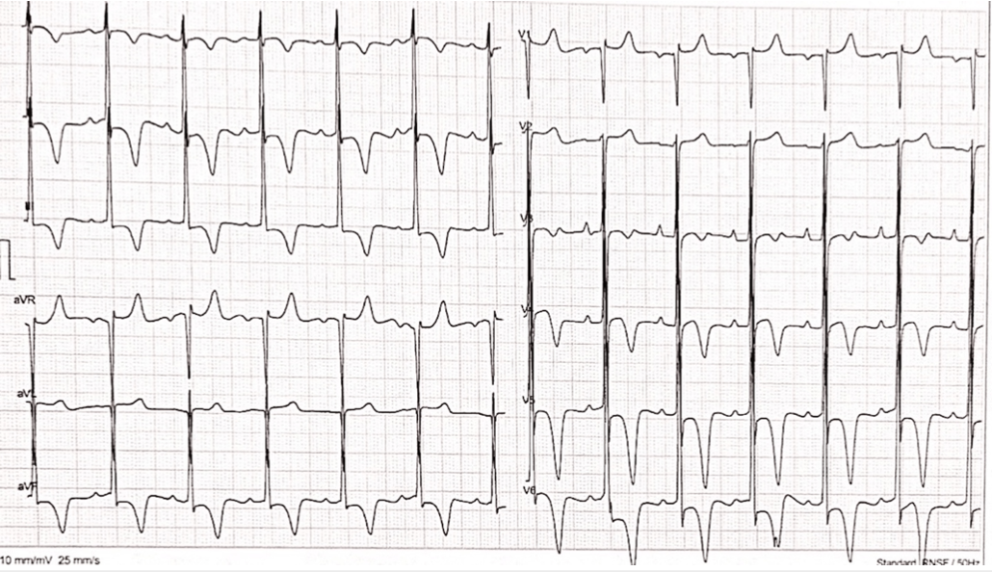

Figure 1. Resting ECG showing electrical left ventricular hypertrophy with deeply inverted T waves extending across the anterolateral precordial leads (V3–V6) and the inferior leads, prompting further structural evaluation.

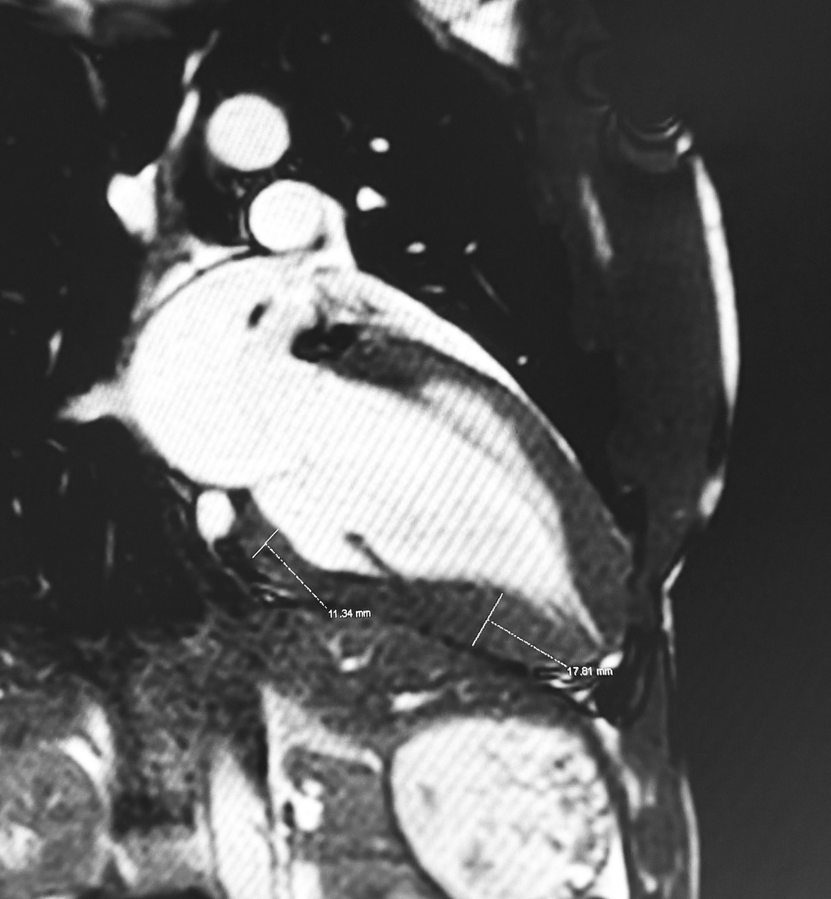

Figure 2. Two-chamber cine cardiac MRI showing clear apical wall thickening with a base-to-apex wall-thickness ratio >1.2, resulting in the characteristic “ace-of-spades” left-ventricular cavity configuration typical of apical hypertrophic cardiomyopathy.

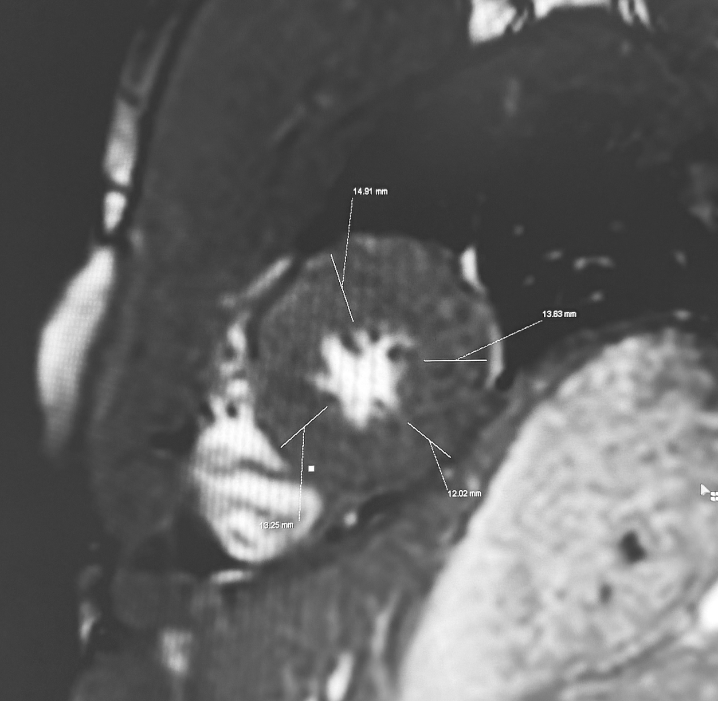

Figure 3. Short-axis cine sequence demonstrating localized apical hypertrophy with a maximal apical wall thickness of 15 mm, consistent with the diagnosis of apical hypertrophic cardiomyopathy.
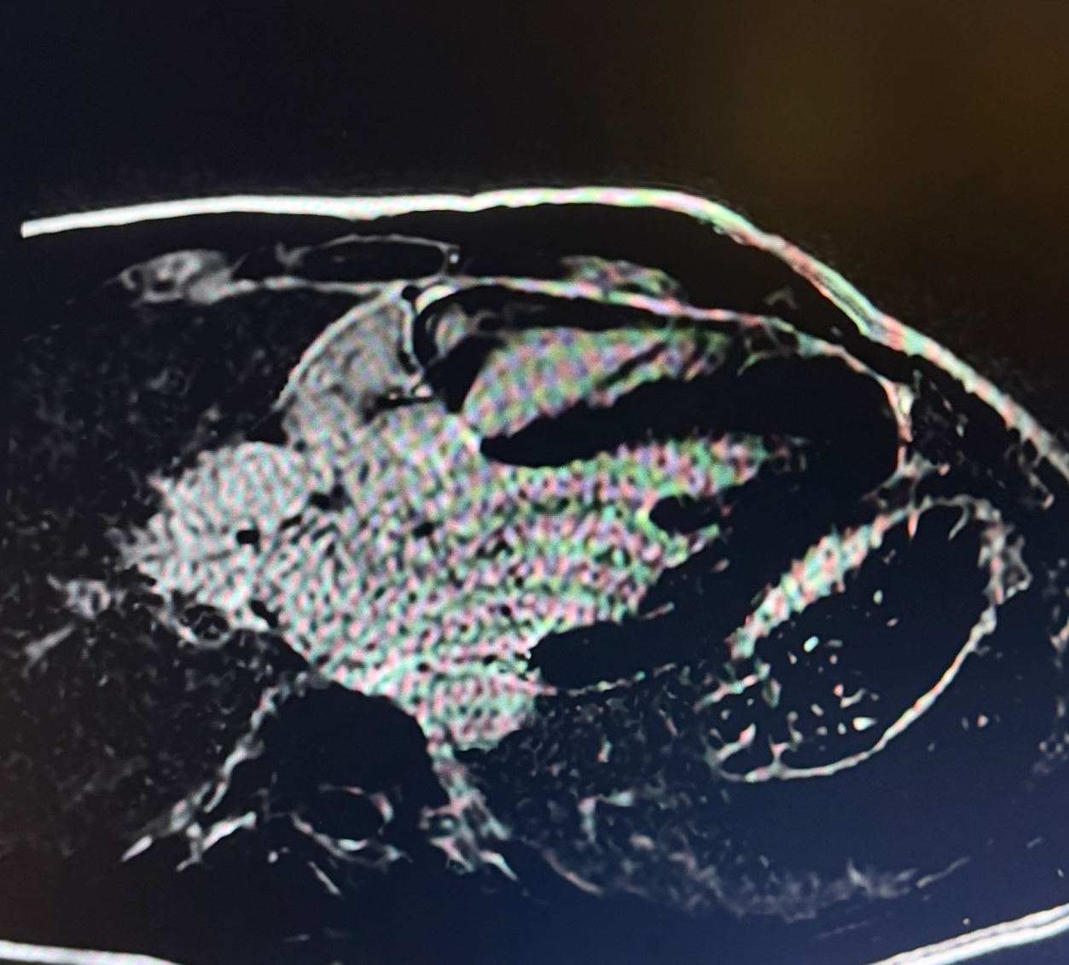
Figure 4. Four-chamber LGE cardiac MRI demonstrating absence of late gadolinium enhancement, indicating no apical scar or myocardial fibrosis.

3. Discussion

This case vividly illustrates a central challenge in sports cardiology: identifying silent apical hypertrophic cardiomyopathy (ApHCM) in an athlete where physiological cardiac adaptation can mask early structural disease. The diagnosis in our patient rested entirely on the finding of deeply inverted T-waves on a pre-participation ECG, underscoring that this electrical abnormality must never be dismissed as a benign finding in an athletic population, as it often serves as the earliest and sometimes only marker of underlying pathology (Huang et al., 2023).
Our experience highlights the critical diagnostic limitations of routine screening. While transthoracic echocardiography remains a cornerstone of cardiovascular assessment in athletes, its technical limitation in adequately visualizing the true cardiac apex renders it unreliable for ruling out ApHCM, as demonstrated in this case and documented in the literature (Lawless, 2008; Maron et al., 2009). This case reinforces the current ESC and AHA guidelines, which now specifically recommend cardiac MRI for unexplained repolarization abnormalities in athletes, even in the presence of a normal echocardiogram (Pelliccia et al., 2021).
Cardiac magnetic resonance (MRI) proved indispensable in our patient, providing unparalleled anatomical definition that readily identified the characteristic "ace-of-spades" left ventricular configuration and allowed precise quantification of apical wall thickness (Chan et al., 2014). Furthermore, the absence of late gadolinium enhancement (LGE) carried favorable prognostic implications, indicating a lower burden of myocardial fibrosis, which is a known substrate for ventricular arrhythmias (Löllgen et al., 2018).
The management of an athlete with newly identified ApHCM demands careful, individualized risk stratification. In our patient, the normal maximal exercise test provided reassurance by excluding exertional ischemia and significant ventricular arrhythmias, though it does not eliminate all disease-related risk (Löllgen et al., 2018). Contemporary consensus from both ACC/AHA and ESC now supports a shared decision-making model over automatic disqualification from competitive sports (Maron et al., 2015). For this asymptomatic athlete without evidence of fibrosis, arrhythmia, obstruction, or abnormal exercise response, continued participation was considered within a framework of informed consent and structured long-term surveillance.
Long-term follow-up is essential and should be tailored to the athlete's competitive level. This aligns with systematic reviews of clinical practice guidelines, which underscore the necessity of periodic, comprehensive reassessment for risk stratification in the management of hypertrophic cardiomyopathy (Sanghvi et al., 2025). We established a surveillance protocol including at least annual clinical review, ECG, and echocardiography, with periodic cardiac MRI every 1–2 years to monitor for the development of myocardial fibrosis or disease progression. For elite athletes like our patient, more frequent monitoring may be warranted during periods of intense training or if new symptoms emerge, ensuring both athletic performance and cardiovascular safety through sustained clinical vigilance.

4. Conclusion

Apical hypertrophic cardiomyopathy in athletes may only become apparent when multiple layers of evaluation are integrated into the screening pathway. In this case, the diagnosis emerged not from symptoms or echocardiography, but from a careful, methodical interpretation of the overall assessment. Once identified, the condition required structured clinical oversight tailored to the athlete’s competitive environment and individual risk profile.
Rather than focusing solely on exclusion from sport, contemporary frameworks emphasize continuity of care, periodic reassessment, and, when appropriate, informed participation. This experience highlights the importance of maintaining a high index of suspicion during athlete evaluations and ensuring that long-term follow-up is anchored in consistency and clarity. Ultimately, safeguarding athletic performance and cardiovascular safety relies on disciplined interpretation of findings and sustained clinical vigilance over time.

Consent

All authors declare that written informed consent was obtained from the patient for publication of this case report and the accompanying images. A copy of the written consent is available for review by the Editorial Office/Chief Editor/Editorial Board members of this journal.

Ethical approval

This case report describes a single, anonymous patient and did not require institutional ethical approval per our institution's policies. All procedures were conducted in accordance with the 1964 Declaration of Helsinki and its later amendments.

DISCLAIMER (ARTIFICIAL INTELLIGENCE)

The authors hereby declare that no generative artificial intelligence tools (ChatGPT, Copilot, etc.) were used in the writing, editing or production of this manuscript

Definitions, Acronyms, Abbreviations

ACC: American College of Cardiology
AHA: American Heart Association
ApHCM: Apical Hypertrophic Cardiomyopathy
CMR: Cardiac Magnetic Resonance
ECG: Electrocardiogram
ESC: European Society of Cardiology
HCM: Hypertrophic Cardiomyopathy
LGE: Late Gadolinium Enhancement
LV: Left Ventricle / Left Ventricular
MRI: Magnetic Resonance Imaging
SCD: Sudden Cardiac Death

References

- Maron BJ, Maron MS. Hypertrophic cardiomyopathy. Lancet. 2013;381:242–255. doi:10.1016/S0140-6736(12)60397-3
- Finocchiaro G, Westaby J, Sheppard MN, et al. Sudden cardiac death in young athletes: JACC state-of-the-art review. J Am Coll Cardiol. 2024;83:350–370. doi:10.1016/j.jacc.2023.10.032
- Hughes RK, Knott KD, Malcolmson J, et al. Apical hypertrophic cardiomyopathy: the variant less known. J Am Heart Assoc. 2020;9:e015294. doi:10.1161/JAHA.119.015294
- Flett AS, Maestrini V, Milliken D, et al. Diagnosis of apical hypertrophic cardiomyopathy: T-wave inversion and relative but not absolute apical left ventricular hypertrophy. Int J Cardiol. 2015;183:143–148. doi:10.1016/j.ijcard.2015.01.054
- Pelliccia A, Sharma S, Gati S, et al. ESC guidelines on sports cardiology and exercise in patients with cardiovascular disease. Eur Heart J. 2021;42:17–96. doi:10.1093/eurheartj/ehaa605
- Stachera M, Przybyło P, Sznajder K, et al. Cardiac magnetic resonance in the assessment of hypertrophic cardiomyopathy phenotypes and stages: pictorial review. Pol J Radiol. 2021;86:672–684. doi:10.5114/pjr.2021.112310
- Huang AL, Levine BD, Ackerman MJ, et al. Asymptomatic apical hypertrophic cardiomyopathy in an elite competitive athlete. JACC Case Rep. 2023;5:101705. doi:10.1016/j.jaccas.2022.101705
- Lawless CE. Electrocardiograms in athletes: interpretation and diagnostic accuracy. Curr Sports Med Rep. 2008;7:137–143. doi:10.1249/MSS.0b013e318164dd18
- Maron MS, Finley JJ, Bos JM, et al. Prevalence, clinical significance, and natural history of left ventricular apical aneurysms in hypertrophic cardiomyopathy. Circulation. 2008;118(15):1541-1549. doi:10.1161/CIRCULATIONAHA.108.781401.
- Oxborough D, Augustine D, Gati S, et al. A guideline update for the practice of echocardiography in the cardiac screening of sports participants: a joint policy statement from the British Society of Echocardiography and Cardiac Risk in the Young. Echo Res Pract. 2018;5:1–10. doi:10.1530/ERP-17-0075
- Chan RH, Maron BJ, Olivotto I, et al. Prognostic value of quantitative contrast-enhanced cardiovascular magnetic resonance for the evaluation of sudden death risk in hypertrophic cardiomyopathy. J Am Coll Cardiol. 2014;63:2420–2431. doi:10.1161/CIRCULATIONAHA.113.007094
- Löllgen H, Leyk D, Deuster T. Exercise testing in sports medicine. Dtsch Arztebl Int. 2018;115:409–416. doi:10.3238/arztebl.2018.0409
- Maron BJ, Udelson JE, Bonow RO, et al. Eligibility and disqualification recommendations for competitive athletes with cardiovascular abnormalities: Task Force 3: hypertrophic cardiomyopathy, arrhythmogenic right ventricular cardiomyopathy and other cardiomyopathies, and myocarditis. J Am Coll Cardiol. 2015;66:2362–2371. doi:10.1161/CIR.0000000000000239
- Sanghvi MM, Dhall E, Anwar A Chahal C, et al. Hypertrophic cardiomyopathy management: a systematic review of the clinical practice guidelines and recommendations. Eur Heart J Qual Care Clin Outcomes. 2025 Nov 4;11(7):919-933. doi: 10.1093/ehjqcco/qcae117

