Case report
Unusual Coexistence: Inferior Vena Cava Agenesis, a Free-Floating Right Atrial Thrombus, and Severe Pulmonary Embolism Successfully Treated with Tenecteplase

.

ABSTRACT

Background: Inferior vena cava agenesis (IVCA) is rare, and its association with severe pulmonary embolism (PE) is exceptional.
Case Presentation: A 56-year-old man with insulin-dependent diabetes but no major venous thromboembolic risk factors presented with repeated syncope and hemodynamic shock. He was tachycardic, hypoxemic, and hypotensive. Echocardiography showed a free-floating right atrial thrombus with severe right ventricular dysfunction. CT confirmed massive bilateral PE and revealed IVCA with azygos continuation.
Management and Outcome: Because of persistent instability and the unavailability of alteplase, weight-adjusted tenecteplase was administered, followed by unfractionated heparin. The patient improved rapidly. Echocardiography at 24 hours showed complete disappearance of the thrombus and recovery of right ventricular function. Follow-up CT demonstrated reduced clot burden. Workup for thrombophilia was negative. The patient was discharged on oral anticoagulation and remained asymptomatic at follow-up.
Conclusion: This case illustrates a rare presentation of IVCA revealed by life-threatening PE and supports considering off-label tenecteplase when no approved fibrinolytic agent is available.

Keywords: Inferior vena cava agenesis; thrombolysis; Tenecteplase; Pulmonary Embolism

1. INTRODUCTION

Inferior vena cava agenesis (IVCA) is a rare and underreported congenital malformation. Despite its low frequency, IVCA and all vena cava malformations are known to cause deep vein thrombosis [1]. Nevertheless, the pulmonary embolism (PE) remains much less described in association with this anatomical anomaly [2]. Moreover, until today, no case of inferior vena cave agenesis with severe pulmonary embolism has been reported. We report a case of a patient with agenesis of the inferior vena with azygous continuation, who presented with a severe pulmonary embolism and was treated successfully with Tenecteplase.

2. CASE PRESENTATION

A 56-year-old patient with insulin-dependent diabetes as a cardiovascular risk factor. He had no major risk factor for venous thromboembolic disease. He was admitted with a 24 hours history of syncope repeated 3 times in the same hour with profuse sweating, without prodromes, without sign of convulsion or notion of loss of urine.
On physical examination, patient in shock: hemodynamically unstable with systolic blood pressure at 85mmHg, tachycardia at 120bpm, polypnea at 33 cycles per minute with hypoxemia on room air (SaO2: 86%).
The ECG performed in first intention found a sinus tachycardia at 125 beats per minute, a right axial deviation with incomplete right bundle block. A trans-thoracic echocardiography was then performed showing a floating right auricle thrombus (Figure 1), a dilated right ventricle in severe dysfunction with paradoxical septum, and pulmonary artery systolic pressure is 62 mmHg. The global contractility of the left ventricle remained nevertheless preserved with a left ventricular ejection fraction at 50%, the whole evoking a severe pulmonary embolism. A thoracic angioscanner was performed showing a massive bilateral pulmonary embolism (Figure 2a), a situs inversus in the proximal abdomen, and anomaly of venous return with agenesis of the inferior vena cave with Azygos continuation (Figure 2b).
The patient immediately received thrombolytic therapy, tenecteplase (recombinant tissue plasminogen activator) at dose-weight, followed by unfractionated heparin. Clinically, the patient improved markedly with hemodynamic and respiratory stability. A trans-thoracic echocardiogram performed 24 hours later showed complete disappearance of the right heart thrombus with improvement in right ventricular function and a decrease in pulmonary artery systolic pressure to 36 mmHg. The follow-up angioscanner performed 48 hours after thrombolysis showed improvement compared with the initial images. The patient underwent a Doppler ultrasound of the lower limbs which came back without abnormalities. In addition, etiologic assessment looking for a thrombophilic background has been done and came back negative. The patient was then discharged from the hospital on the 8th day after stabilization of his INR (international normalized ratio) under oral anticoagulation with regular follow-up in the outpatient department. Follow up at 3 and 6 months revealed no new thrombotic episode.

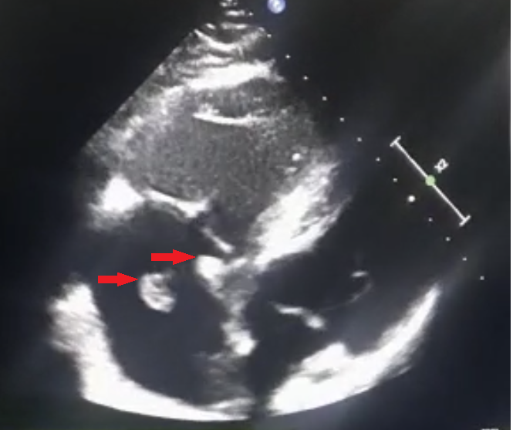

Fig. 1. Transthoracic echocardiography showing multiple mobile thrombi in the right atrium (Red arrows).
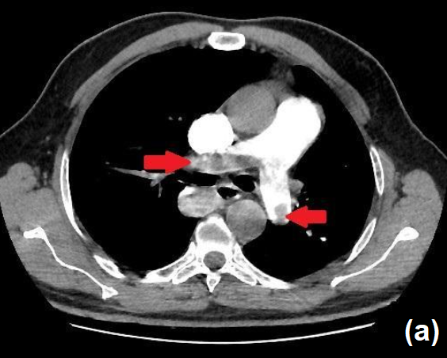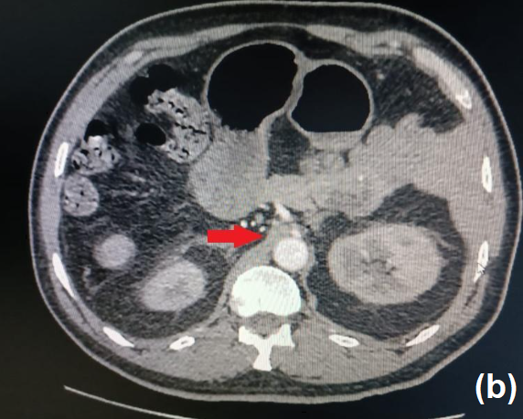

Fig. 2. (a). Thoracic angioscanner revealing a massive bilateral pulmonary embolism
(b). Thoracic angioscanner revealing agenesis of the inferior vena cave with Azygos continuation.

3. discussion

The IVCA is recognized as one of the entities responsible for deep vein thrombosis (DVT) [1].
The evolution of DVT on the IVCA rarely leads to pulmonary embolism [2]. No cases of Inferior Vena Cava Agenesis with Free-floating right heart thrombus and severe pulmonary embolism have been reported in the literature.

Pulmonary embolism is generally managed with anticoagulation, using agents such as unfractionated heparin or low-molecular-weight heparin [3]. These treatments do not dissolve the thrombus itself; rather, they prevent further clot propagation. In contrast, fibrinolytic drugs—including alteplase and tenecteplase—actively degrade established thrombi and can rapidly restore perfusion [4]. Their use, however, is limited by the risk of bleeding complications. In real-world practice, major hemorrhage has been reported in up to one fifth of patients treated with thrombolytics, and intracranial bleeding, although less frequent, remains a serious concern [5]. For this reason, thrombolytic therapy should be reserved for carefully selected patients in whom the expected benefits outweigh the potential harms.

Free-floating right heart thrombus is a severe form of thromboembolic disease that usually coexists with a massive PE and substantially increased risk of mortality compared to the presence of pulmonary thromboembolism alone [6]. A right atrial thrombus and a massive PE with presentation of shock (either a systolic blood pressure of less than 90 mmHg or a pressure drop of at least 40 mmHg that lasts 15 minutes or longer), thrombolytic therapy is recommended as first-line therapy in the absence of contraindications, [7].
Accelerated intravenous administration of recombinant tissue-type plasminogen activator (rtPA; 100 mg over 2 h) is preferable to prolonged infusions of first-generation thrombolytic agents (streptokinase and urokinase). UFH may be administered during continuous infusion of alteplase, but must be discontinued during infusion of streptokinase or urokinase. Tenecteplase has also been investigated, at present, Tenecteplase is not FDA-approved for use in PE [8,9].
In our case, faced with a high-risk pulmonary embolism and the unavailability of alteplase, the patient received systemic thrombolytic therapy with tenecteplase. This choice was supported by several meta-analyses evaluating the efficacy and safety of tenecteplase in patients with high-risk PE [10]. The Doppler ultrasound of the lower limbs - which was only performed in a second phase, after stabilization of the patient did not find DVT, raising the question of the presence of DVT before the administration of Tenecteplase.

4. Conclusion

Although the association between inferior vena cava agenesis and massive pulmonary embolism may be incidental, this case raises the question of whether such congenital anomalies could predispose to more severe presentations. Further studies are needed to explore this possible relationship.
In patients with severe pulmonary embolism, if the alteplase is not available, the physicians should take action beyond strict on-label indications and guidelines to save a life.

Consent (where ever applicable)

As per international standard or university standard, patient(s) written consent has been collected and preserved by the author(s).

Ethical approval (where ever applicable)

It is not applicable.

DISCLAIMER (ARTIFICIAL INTELLIGENCE)
Author(s) herevy declare that NO generative AI technologies such as Language Models (ChatGPT, COPILOT, etc) and text-to-image generators have been used during the writing or editing of this manuscript.

References

1. Kim S, Kunkel S, Browske K. Absent Inferior Vena Cava Leading to Recurrent Lower Extremity Deep Vein Thrombosis in a United States Marine. Mil Med. 2018 Jan 1;183(1-2):e172-e174. doi: 10.1093/milmed/usx041. PMID: 29401342.
2. Oblitas CM, García-García A, Galeano-Valle F, Palacios-Bermejo A, Ojeda-García R, Echenagusía-Boyra M, Álvarez-Luque A, Del-Toro-Cervera J, Demelo-Rodríguez P. Long-term anticoagulant treatment in patients with inferior vena cava agenesis and deep vein thrombosis. Thromb Res. 2020 Dec;196:305-307. doi: 10.1016/j.thromres.2020.09.009. Epub 2020 Sep 6. PMID: 32977127.
3. Eberle H, Lyn R, Knight T, Hodge E, Daley M. Clinical update on thrombolytic use in pulmonary embolism: A focus on intermediate-risk patients. Am J Health Syst Pharm. 2018 Sep 1;75(17):1275-1285. doi: 10.2146/ajhp170357. Epub 2018 Jun 12. PMID: 29895520.
4. Drugs that affect blood. In: Stringer J, ed. Basic Concepts in Pharmacology: What You Need to Know for Each Drug Class. 6th ed. McGraw Hill; 2022. Accessed December 16, 2022. https://accesspharmacy.mhmedical.com/content.aspx?bookid=3136&sectionid=263124011

5. Pasqui E, de Donato G, Camarri S, Molinari R, Cascinelli I, Pelini V, Abate L, Palasciano G. Case Report: Inferior Vena Cava Agenesia in a Young Male Patient Presenting With Bilateral Iliac Veins Thrombosis. Front Surg. 2022 Mar 22;9:832336. doi: 10.3389/fsurg.2022.832336. PMID: 35392062; PMCID: PMC8980272.
6. Chatterjee S, Chakraborty A, Weinberg I, Kadakia M, Wilensky RL, Sardar P, Kumbhani DJ, Mukherjee D, Jaff MR, Giri J. Thrombolysis for pulmonary embolism and risk of all-cause mortality, major bleeding, and intracranial hemorrhage: a meta-analysis. JAMA. 2014 Jun 18;311(23):2414-21. doi: 10.1001/jama.2014.5990. PMID: 24938564.

7. The European Cooperative Study on the clinical significance of right heart thrombi. European Working Group on Echocardiography. Eur Heart J. 1989 Dec;10(12):1046-59. doi: 10.1093/oxfordjournals.eurheartj.a059427. PMID: 2606115.

8. Kline JA, Nordenholz KE, Courtney DM, Kabrhel C, Jones AE, Rondina MT, Diercks DB, Klinger JR, Hernandez J. Treatment of submassive pulmonary embolism with tenecteplase or placebo: cardiopulmonary outcomes at 3 months: multicenter double-blind, placebo-controlled randomized trial. J Thromb Haemost. 2014 Apr;12(4):459-68. doi: 10.1111/jth.12521. PMID: 24484241.
9. Bach KT, Lui F. Tenecteplase. 2023 Jun 25. In: StatPearls [Internet]. Treasure Island (FL): StatPearls Publishing; 2025 Jan–. PMID: 37276288.

10. Zhang Z, Xi L, Zhang S, Zhang Y, Fan G, Tao X, Gao Q, Xie W, Yang P, Zhai Z, Wang C. Tenecteplase in Pulmonary Embolism Patients: A Meta-Analysis and Systematic Review. Front Med (Lausanne). 2022 Mar 31;9:860565. doi: 10.3389/fmed.2022.860565. PMID: 35433747; PMCID: PMC9008780.

