Case report

Early Cardiac Fabry Disease Detected by Routine Cardiac MRI in a Young Athlete

.
ABSTRACT

AIMS:
To describe how routine cardiovascular screening in an elite football player revealed subtle echocardiographic findings that prompted evaluation for an underlying cardiomyopathy, ultimately leading to the identification of early cardiac involvement in Fabry disease through cardiac magnetic resonance (CMR).
PRESENTATION OF CASE:
A young elite male athlete underwent routine cardiovascular assessment. Clinical examination and ECG were normal. Transthoracic echocardiography (TTE) showed preserved systolic function with a discretely increased inferolateral wall thickness, a finding that can fall within athletic remodeling but must also prompt exclusion of early pathological hypertrophy due to its prognostic and career implications. CMR revealed that native T1 values were markedly reduced in the basal lateral wall, and two small mid-inferolateral intramyocardial nodules were detected on late gadolinium enhancement (LGE). Although Fabry disease was not initially suspected, this radiologic profile strongly suggested early involvement. Genetic testing was not yet available, but α-galactosidase A activity testing and additional laboratory evaluation were initiated.
DISCUSSION:
Fabry disease can present with subtle, early myocardial changes that may be difficult to distinguish from physiological athlete’s remodeling. Reduced native T1 and focal mid-wall LGE constitute sensitive early markers of sphingolipid accumulation. Recognizing these patterns is crucial to differentiate emerging infiltrative cardiomyopathy from benign hypertrophy in competitive athletes.
CONCLUSION:
This case highlights the value of advanced CMR in evaluating borderline hypertrophy in athletes. Early identification of suspected Fabry cardiac involvement enables timely diagnostic clarification, potential consideration of targeted therapy, and informed guidance regarding ongoing sports participation.

Keywords: Cardiac MRI; Fabry disease; T1 mapping; Late gadolinium enhancement; Athlete screening; Sports cardiology; Pre-participation evaluation; Infiltrative cardiomyopathy.

- INTRODUCTION

Fabry disease is a rare X-linked lysosomal storage disorder caused by deficient α-galactosidase A activity, leading to progressive accumulation of glycosphingolipids in multiple organs, including the cardiovascular system (Desnick et al., 2003). Cardiac involvement is common and may represent the earliest or even the sole manifestation, presenting as left ventricular hypertrophy (LVH), conduction abnormalities, arrhythmias, or myocardial fibrosis (Desnick et al., 2003; Weidemann et al., 2013).
Cardiac magnetic resonance (CMR) is central to early detection of Fabry cardiomyopathy. Native T1 mapping is a highly sensitive marker of intracellular sphingolipid storage, often abnormal before overt hypertrophy or structural changes appear (Sado et al., 2013; Iorio et al., 2024). Late gadolinium enhancement (LGE) reflects replacement fibrosis, typically affecting the basal inferolateral wall and associated with worse prognosis (Nordin et al., 2016; Hanneman et al., 2020). Recent updates in advanced cardiovascular imaging further reinforce the role of CMR in identifying subtle tissue abnormalities in Fabry disease (European Heart Journal Cardiovascular Imaging, 2024).
In competitive athletes, distinguishing pathological cardiomyopathy from physiological remodeling (“athlete’s heart”) is essential. Athletic adaptation may cause mild concentric LVH but does not produce low native T1 values or mid-wall fibrosis (Turco et al., 2018). ESC sports cardiology guidelines emphasize careful evaluation of any abnormal structural or tissue finding given its implications for performance, risk stratification, and eligibility (Pelliccia et al., 2021).
We present the case of an asymptomatic professional football player whose routine pre-participation evaluation raised the question of early cardiomyopathy, ultimately leading to the diagnosis of early cardiac Fabry involvement on CMR.

- CASE PRESENTATION
A 20-year-old asymptomatic male athlete was referred for routine cardiovascular evaluation before joining a professional football team. He reported no chest pain, palpitations, syncope, or exercise intolerance. Physical examination was normal. Resting ECG demonstrated a normal sinus rhythm without conduction abnormalities. Transthoracic echocardiography (TTE) showed preserved left ventricular systolic function and normal chamber dimensions. A discreetly increased posterior wall thickness of 11 mm—borderline for athletic remodeling—raised the need to exclude an early cardiomyopathy. No valvular disease or regional wall motion abnormalities were identified. To further characterize this finding, CMR was performed. EDV Cine-SSFP images showed normal left ventricular volumes (EDV 147 ml; indexed 91 ml/m²) and preserved global systolic function (LVEF 61%). The LV mass was 93 g (62 g/m²). Wall thicknesses were normal except for a basal lateral thickness of 10 mm. The right ventricle also demonstrated normal dimensions and systolic function, with no hypertrophy, dilatation, or regional dysfunction. No valvulopathy, outflow obstruction, or pericardial effusion was present. T2-STIR imaging demonstrated no myocardial edema. Native T1 mapping showed a normal septal value of 920 ms (normal <1050 ms at 1.5 T), but a markedly reduced basal lateral value of 610 ms, strongly suggestive of sphingolipid storage (Figure 1). T2 mapping was homogeneous throughout the myocardium. Post-contrast LGE sequences revealed two small mid-inferolateral intramyocardial nodules with a mid-wall non-ischemic pattern, consistent with early stages of Fabry-related fibrosis (Figure 2). No ischemic scar, diffuse enhancement, or aneurysmal changes were observed (Figure 3). Biochemical evaluation demonstrated reduced α-galactosidase activity and elevated lyso-Gb3 levels, supporting the suspicion of early cardiac Fabry disease. Iron studies were normal, excluding myocardial iron overload. The patient was referred for genetic confirmation and specialized metabolic follow-up.

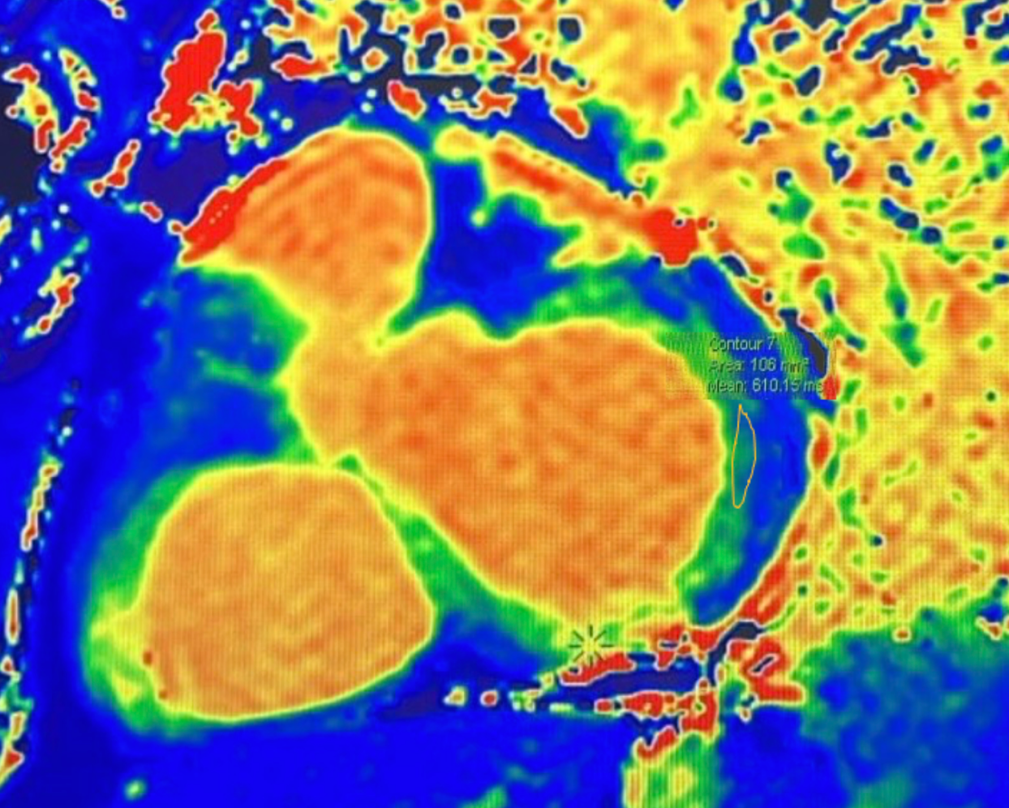
Figure 1. Native T1 mapping (1.5T, short-axis basal slice) showing a markedly reduced T1 value of 610 ms in the basal lateral segment (yellow ROI), highly suggestive of early glycosphingolipid myocardial storage in Fabry disease.

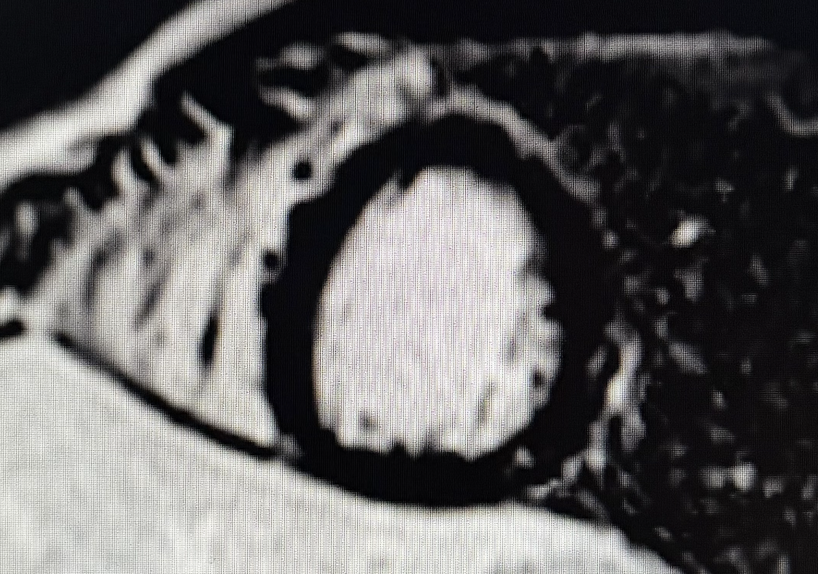

Figure 2. Short-axis mid-ventricular LGE sequence (1.5T, PSIR) demonstrating two small mid-wall intramyocardial nodules in the mid-inferolateral wall, consistent with a non-ischemic pattern of early focal fibrosis.

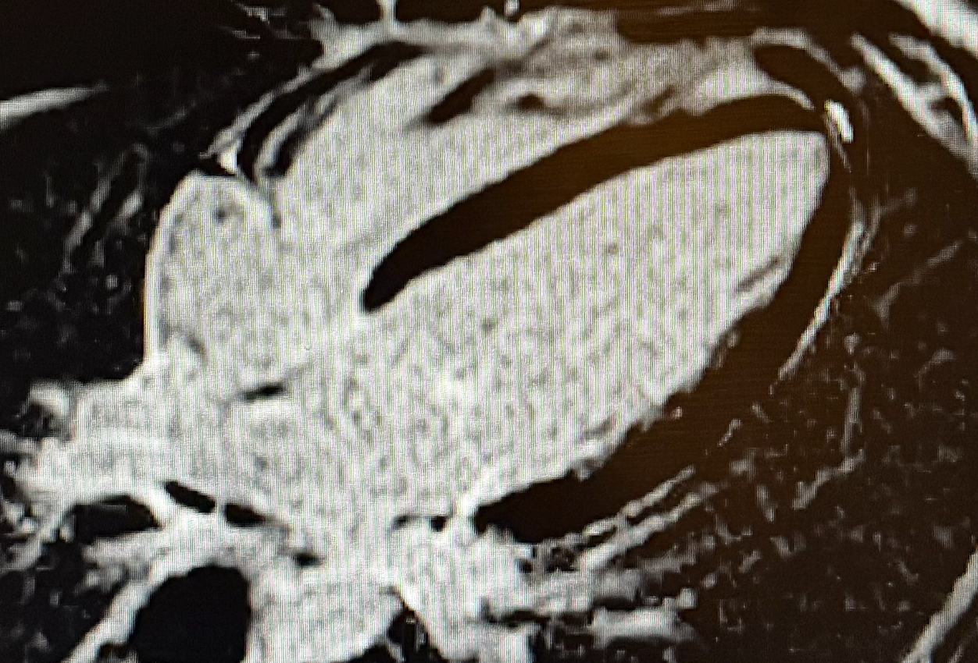

Figure 3. Four-chamber LGE sequence (1.5T, PSIR) showing no additional areas of myocardial fibrosis, no ischemic scar, and a preserved global myocardial architecture. A mild posterior wall thickness of 10 mm is noted, remaining within the upper limits expected in athletes.

3. Discussion

Fabry disease is a progressive multisystem disorder in which cardiac involvement strongly influences long-term outcomes (Desnick et al., 2003; Weidemann et al., 2013). Glycosphingolipid accumulation leads to myocardial hypertrophy, fibrosis, arrhythmias, and eventual heart failure, underscoring the importance of early recognition—particularly in athletes.
In this case, the markedly reduced native T1 value in the basal lateral wall indicated early sphingolipid storage, while the two inferolateral mid-wall LGE foci suggested initial replacement fibrosis. Even small areas of LGE have been associated with increased arrhythmic vulnerability and faster disease progression (Nordin et al., 2016; Hanneman et al., 2020). Intense athletic activity further amplifies sympathetic drive and myocardial demand, which may accentuate arrhythmogenic risk in the presence of early fibrosis (Pelliccia et al., 2021).
Disease-modifying therapies, including enzyme replacement therapy (ERT) and pharmacological chaperones such as migalastat, have demonstrated the ability to stabilize myocardial structure and limit progression when initiated before extensive fibrosis (Chiara Lanzillo et al., 2023). A recent meta-analysis confirms that early intervention favorably modifies CMR markers of myocardial involvement (Figliozzi et al., 2024). Similarly, updated CMR literature highlights the value of early tissue-characterization techniques in refining diagnosis and guiding therapy (Kaur S, et al., 2024).
This case underscores the limitations of echocardiography in early disease. While TTE may appear normal or show only borderline thickening, CMR provides the required sensitivity to detect intracellular storage and subtle fibrosis (Ponsiglione et al., 2022; Barison et al., 2025). ESC sports cardiology guidelines recommend CMR whenever wall thickness is atypical for an athlete’s heart or when an infiltrative or genetic cardiomyopathy is suspected (Pelliccia et al., 2021).
Early diagnosis facilitates individualized sports management. Athletes without high-risk fibrosis patterns or arrhythmias may continue training under structured surveillance, whereas progression of fibrosis or electrical instability may require modification or temporary restriction.
In summary, this case illustrates the pivotal role of CMR in differentiating early Fabry cardiomyopathy from physiological athletic remodeling. The association of reduced native T1 and focal LGE justified metabolic evaluation, early therapeutic planning, and continued multidisciplinary follow-up.

4. Conclusion

This case illustrates the pivotal role of cardiac magnetic resonance in detecting early Fabry involvement in athletes when echocardiographic findings are equivocal. The association of markedly reduced native T1 and discrete mid-wall LGE revealed subtle myocardial storage and early fibrosis, prompting timely metabolic evaluation. Early identification is particularly relevant in competitive athletes, where initial myocardial changes may influence arrhythmic risk, performance, and long-term eligibility. These findings reinforce the need for thorough cardiovascular assessment and the use of CMR whenever structural or tissue characteristics exceed what is expected in physiological athletic remodeling.

Consent

All authors declare that written informed consent was obtained from the patient for publication of this case report and the accompanying images. A copy of the written consent is available for review by the Editorial Office/Chief Editor/Editorial Board members of this journal.

Ethical approval

This case report describes a single, anonymous patient and did not require institutional ethical approval per our institution's policies. All procedures were conducted in accordance with the 1964 Declaration of Helsinki and its later amendments.

DISCLAIMER (ARTIFICIAL INTELLIGENCE)

The authors hereby declare that no generative artificial intelligence tools (ChatGPT, Copilot, etc.) were used in the writing, editing or production of this manuscript

References

- Desnick RJ, Brady R, Barranger J, et al. Fabry disease, an under-recognized multisystemic disorder: expert recommendations for diagnosis, management, and enzyme replacement therapy. Ann Intern Med. 2003 Feb 18;138(4):338-46. doi: 10.7326/0003-4819-138-4-200302180-00014
- Weidemann F, Niemann M, Störk S, et al. Long-term outcome of enzyme replacement therapy in advanced Fabry disease. J Intern Med. 2013;274(4):331–341. doi:10.1111/joim.12077
- Sado DM, White SK, Piechnik SK, et al. Identification and assessment of Anderson-Fabry disease by cardiovascular magnetic resonance noncontrast myocardial T1 mapping. Circ Cardiovasc Imaging. 2013 May 1;6(3):392-8. doi: 10.1161/CIRCIMAGING.112.000070.
- Iorio A, Lucà F, Pozzi A, et al. Anderson–Fabry Disease: Red Flags for Early Diagnosis of Cardiac Involvement. Diagnostics. 2024;14:208. doi:10.3390/diagnostics14020208

- Nordin S, Kozor R, Bulluck H, et al. Cardiac Fabry Disease With Late Gadolinium Enhancement Is a Chronic Inflammatory Cardiomyopathy. J Am Coll Cardiol. 2016 Oct 11;68(15):1707-1708. doi: 10.1016/j.jacc.2016.07.741.
- Hanneman K, Karur GR, Wasim S, et al. Left Ventricular Hypertrophy and Late Gadolinium Enhancement at Cardiac MRI Are Associated with Adverse Cardiac Events in Fabry Disease. Radiology. 2020 Jan;294(1):42-49. doi: 10.1148/radiol.2019191385. Epub 2019 Oct 29.
- Barison A, Timoteo AT, El Messaoudi S, et al. Cardiovascular imaging in 2024: review of current research and innovations. Eur Heart J Imaging Methods Pract. 2025;3(1):qyaf066. doi:10.1093/ehjimp/qyaf066
- Wasfy MM, Weiner RB. Differentiating the athlete's heart from hypertrophic cardiomyopathy. Curr Opin Cardiol. 2015 Sep;30(5):500-5. doi: 10.1097/HCO.0000000000000203.
- Pelliccia A, Sharma S, Gati S, et al. 2020 ESC Guidelines on sports cardiology. Eur Heart J. 2021;42(1):17–96. doi:10.1093/eurheartj/ehaa605
- Lanzillo C, Fedele E, Martino A, et al. Cardiac magnetic resonance in Fabry disease. Eur Heart J Suppl. 2023;25(Suppl C):C200-C204. doi:10.1093/eurheartjsupp/suad045
- Figliozzi S, Kollia E, Simistiras A, et al. Effects of Enzyme Replacement Therapy on Cardiac MRI Findings in Fabry Disease: A Systematic Review and Meta-Analysis. Radiol Cardiothorac Imaging. 2024;6(3):e230154. doi:10.1148/ryct.230154
- Ponsiglione A, Gambardella M, Green R, et al. Cardiovascular magnetic resonance native T1 mapping in Anderson-Fabry disease: a systematic review and meta-analysis. J Cardiovasc Magn Reson. 2022;24:31. doi:10.1186/s12968-022-00859-z
- Kaur S, Bhalla JS, Erwin AL, Jaber W, Wang TKM. Contemporary Multimodality Imaging for Diagnosis and Management of Fabry Cardiomyopathy. J Clin Med. 2024 Aug 14;13(16):4771. doi: 10.3390/jcm13164771

Definitions, Acronyms, Abbreviations
ECG: Electrocardiogram
CMR: Cardiac Magnetic Resonance
TTE: Transthoracic Echocardiography
LGE: Late Gadolinium Enhancement
ESC: European Society of Cardiology
LVH: Left Ventricular Hypertrophy
EDV: End-Diastolic Volume
LVEF: Left Ventricular Ejection Fraction
LV: Left Ventricle
SSFP: Steady-State Free Precession
STIR: Short Tau Inversion Recovery
ROI: Region Of Interest
ERT: Enzyme Replacement Therapy
Gb3: Globotriaosylceramide
RV: Right Ventricle
T1 mapping: T1 mapping

