Case report

Osteomyelitis of Great Toe Masquerades Giant Cell Tumor

Abstract
Giant cell tumor of bone is an uncommon benign but locally aggressive neoplasm that rarely involves the small bones of the feet. We present a case of giant cell tumor involving the distal phalanx of the great toe, emphasizing diagnostic challenges and management strategies. However, its presentation in the distal phalanx of the great toe remains relatively uncommon, presenting diagnostic and management challenges. In addition to it, the patient had done debridement to the same site which resulted in an ulcer that masquerades to have an osteomyelitis beneath it. The patient underwent surgical excision with marginal resection and achieved excellent functional outcomes at follow-up. This case emphasizes the importance of recognizing atypical presentations of giant cell tumor that projects as an osteomyelitis of great toe and highlights the role of comprehensive imaging and tissue diagnosis in guiding definitive surgical management.
Keywords: giant cell tumor, osteoclastoma, great toe, distal phalanx

Introduction
“Giant cell tumor (GCT) of bone is a benign but locally aggressive neoplasm that typically affects the epiphyseal-metaphyseal region of long bones in young adults between 20-40 years of age” [1]. “It accounts for approximately 5% of all primary bone tumors and 20% of benign bone tumors” [2]. “While the most common sites include the distal femur, proximal tibia, and distal radius, involvement of the small bones of the hands and feet is exceptionally rare, constituting less than 2% of all GCT cases” [3]. Giant cell tumor affecting the bones of the foot is particularly unusual [4], with the majority of reported cases involving the metatarsals or tarsal bones. Typically found at the metaphyseal or epiphyseal regions of the tibia or femur, GCT, despite its predominantly benign nature, exhibits a highly unpredictable spectrum of disease behavior. Local aggressiveness varies from focal symptoms arising from bony or cortical destruction and surrounding soft tissue expansion to the rare occurrence of metastasis. The giant cells carry out the primary task of tumor bone resorption within the tumor. The spindle-like stromal cells are pivotal in recruiting monocytes and facilitating their fusion into giant cells. The stromal cells also improve the resorptive capabilities of the giant cells, contributing to the overall bone resorption mechanism (Hosseinzadeh et al., 2024). The rarity of this presentation often leads to diagnostic delays and challenges in management.
PRESENTATION OF CASE
A 44 years old gentleman presented with progressive swelling of the right great toe over 18 months duration.The swelling was insidious in onset, slowly progressive innature, painless swelling,with no functional limitation.There was a history of prior surgery to the affected area owing to ulcer of the distal phalanx. The patient denied smoking and alcohol use.
Clinical examination revealed a firm, non-tender mass measuring 2.5 cm in the distal toe with an ulcer ~1x1cm with discharging pus. Radiographic evaluation demonstrated an expansile lytic lesion with cortical thinning of the distal phalanx. The patient first noticed a small swelling. It gradually increased in size, accompanied by discharging pus.The patient sought medical attention forthis and underwent minimal debridement elsewhere for the same, but it was an unsuccessful management, and it progressed despite debridement and now presented with an ulcer in the tip of the right great toe. Local examination of the right great toe revealed a firm, non-tender, non-pulsatile swelling measuring approximately 2.5 cm × 2 cm over the distal aspect of the toe with an ulcer over it ~1x1cm with discharging pus.The overlying skin appear erythematous with signs of inflammation. The mass was fixed to the underlying bone. There was no local rise in temperature or regional lymphadenopathy. Neurovascular examination of the foot was normal with intact sensation and adequate capillary refill time.
The range of motion at the interphalangeal joint of the great toe was slightly restricted due to mechanical obstruction from the mass. No other joints were affected, and examination of the contralateral foot and other skeletal sites were unremarkable. The patient underwent amputation of great toe and primary closure. Histopathological examination following excisional biopsy confirmed giant cell tumor. The patient was discharged on postoperative day-1. The surgical wound was managed with daily dressing and kept clean and dry.At 12-month follow-up, the patient remained disease-free with satisfactory functional outcome.
HPE showed underlying bone and the surrounding soft tissue are destroyed and expanded by a neoplasm composed of sheets of spindle to ovoid mononuclear cells and many interspersed multinucleate cells with nuclear morphology similar to that of the mononuclear cells. Foamy and hemosiderin laden macrophages are seen in a hyalinised, edematous and fibro-collagenous stroma. Giant cell rich neoplasm suggestive of giant cell tumor of boneinvolving phalanges of right great toe. No sarcomatous change.
Discussion
“Giant cell tumor of bone is a benign but locally aggressive neoplasm characterized by the presence of multinucleated osteoclast-like giant cells and mononuclear stromal cells” [6]. “While GCT commonly affects the metaphyseal-epiphyseal region of long bones, involvement of the small bones of the hands and feet is extremely rare, accounting for less than 2% of all cases” [3][7].
“The rarity of this presentation mimicking osteomyelitis often leads to diagnostic challenges and delays in treatment. The duration of symptoms before diagnosis is often prolonged, ranging from months to years, reflecting the slow growth pattern of this benign lesion” [2][3]. “GCT in digital locations typically presents as a painless, slowly enlarging mass. Pain may be a presenting feature in some cases, particularly when there is mechanical impingement, pathological fracture, or joint involvement” [9]. “The radiological appearance of GCT in the phalanx is similar to that in other locations, characterized by an expansile, lytic lesion with well-defined margins and cortical thinning” [10].In this case it was mimicking osteomyelitis, so proceeded with debridement rather than taking MRI thus making it a diagnostic challenge. Since the patient had a classical ulcer with discharging pus in the tip with supporting X ray findings, debridement was performed, however later intra operatively it was found to be a tumor origin from bone , adequate clear margin from the tumor was given by performing amputation.
Complete surgical excision remains the cornerstone of treatment for GCT [3][4]. Local recurrence has been reported in 15-45% of cases, depending on the extent of resection and tumor type (localized vs. diffuse)[2][3]. The differential diagnosis of expansile lytic lesions in the phalanges includes enchondroma aneurysmal bone cyst, giant cell reparative granuloma, and rarely, metastatic disease. Brown tumors secondary to hyperparathyroidism can mimic GCT radiologically. MRI is valuable for assessing the extent of bone involvement, soft tissue extension, and relationship to adjacent neurovascular structures and tendons[10This case adds to the limited literature on GCT of the phalanges and emphasizes the importance of considering uncommon diagnoses in unusual locations
Conclusion

Giant-cell tumor of bone primarily affects adults and is seldom seen in patients who are still growing. Giant cell tumors are found very rarely in the metatarsal bones of the foot. Giant cell tumors in the foot primarily occur in females and younger individuals, exhibiting a more aggressive nature. The preferred treatment is aggressive curettage or en bloc resection due to the increased likelihood of local recurrence.

Limitations
This case report highlights a rare sequelae of a relatively common condition; however, it offers limited evidence regarding optimal management strategies of such complications. Further validation through higher-quality studies is necessary to increase our understanding and guide treatment approaches for this condition.
DISCLAIMER (ARTIFICIAL INTELLIGENCE)
Author(s) hereby declare that NO generative AI technologies such as Large Language Models (ChatGPT, COPILOT, etc.) and text-to-image generators have been used during the writing or editing of this manuscript.

Consent
As per international standards or university standards, patient(s) written consent has been collected and preserved by the author(s).
Ethical Approval:

As per international standards or university standards written ethical approval has been collected and preserved by the author(s).
References
1.Hashimoto K, Nishimura S, Ito T, Akagi M. Malignant giant cell tumor of toe: A case report and review of literature. Medicine (Baltimore). 2022 Jun 3;101(22):e29471. doi: 10.1097/MD.0000000000029471. PMID: 35665736; PMCID: PMC9276190
2.Dellenbaugh SG, Wilkinson L, Aydogan U. Giant cell tumor of the distal phalanx of the great toe: a case report. Foot Ankle Spec. 2014 Jun;7(3):237-41. doi: 10.1177/1938640014522094. Epub 2014 Feb 11. PMID: 24521755
3.Alvarez Ramos A, Valverde García JA, García Alonso MG. Giant cell tumor of the foot phalanges in children: a case report. J Pediatr Orthop B. 1999 Apr;8(2):132-5. doi:10.15406/mojcr.2016.05.00128 PMID: 10218178
4.Dridi M, Annabi H, Ben Ghozlen R, Abdelkefi M, Trabelsi M. Giant cell tumour of a phalanx in the foot: a case report. Acta Orthop Belg. 2008 Apr;74(2):273-5. PMID: 18564489
5.Bachhal V, Rangdal S, Saini U, Sament R. Giant cell tumor of distal phalanx of great toe. A case report. Foot (Edinb). 2011 Dec;21(4):198-200. doi: 10.1016/j.foot.2011.02.001. Epub 2011 May 5. PMID: 21546242

6.Fotiadis E et al. Giant cell tumour of tendon sheath of the digits. A systematic review. Hand (N Y). 2011 Sep;6(3):244-9. doi: 10.1007/s11552-011-9341-9. Epub 2011 Jun 1. PMID: 22942846; PMCID: PMC3153624.
7.Sbaraglia M, Bellan E, Dei Tos AP. The 2020 WHO Classification of Soft Tissue Tumours: news and perspectives. Pathologica. 2021 Apr;113(2):70-84. doi: 10.32074/1591-951X-213. Epub 2020 Nov 3. PMID: 33179614; PMCID: PMC8167394.

8.Jagadeesh, N., G., S.H., S., V.M. and Mandri, A. 2020. Gaint cell tumour of phalynx: have you seen it?. International Journal of Research in Medical Sciences. 8, 6 (May 2020), 2309–2312. DOI:https://doi.org/10.18203/2320-6012.ijrms20202029

9. Salm R, Sissons HA. Giant-cell tumours of soft tissues. J Pathol. 1972 May;107(1):27-39. doi: 10.1002/path.1711070106. PMID: 4262633.

10. Choi, Joon & Ro, Jae. (2021). The 2020 WHO Classification of Tumors of Bone: An Updated Review. Advances in Anatomic Pathology. Publish Ahead of Print.
doi:10.1097/PAP.0000000000000293.

Hosseinzadeh, S., Tiwari, V., & De Jesus, O. (2024). Giant cell tumor (osteoclastoma). In StatPearls [Internet]. StatPearls Publishing. https://www.ncbi.nlm.nih.gov/books/NBK559229/
Figure:1White arrow-bone erosion of the distal phalanx, soft tissue density overlying the distal phalanx, with obvious osseous destruction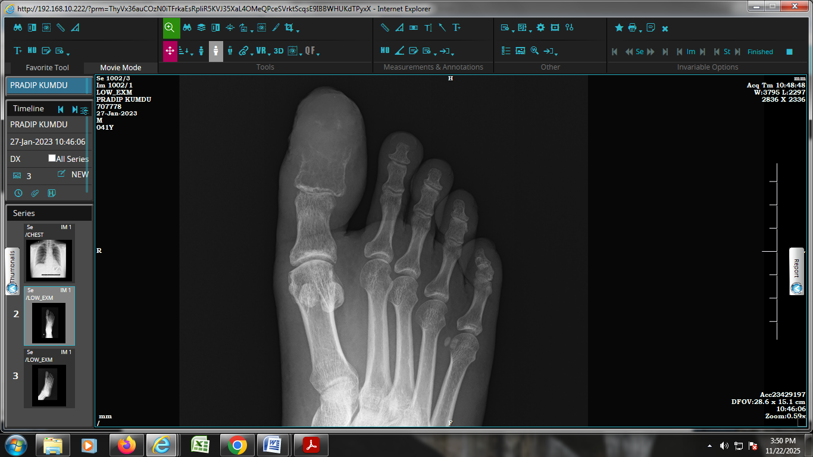
Figure:2Giant cell tumor of bone with sheets of spindle to ovoid mononuclear cells.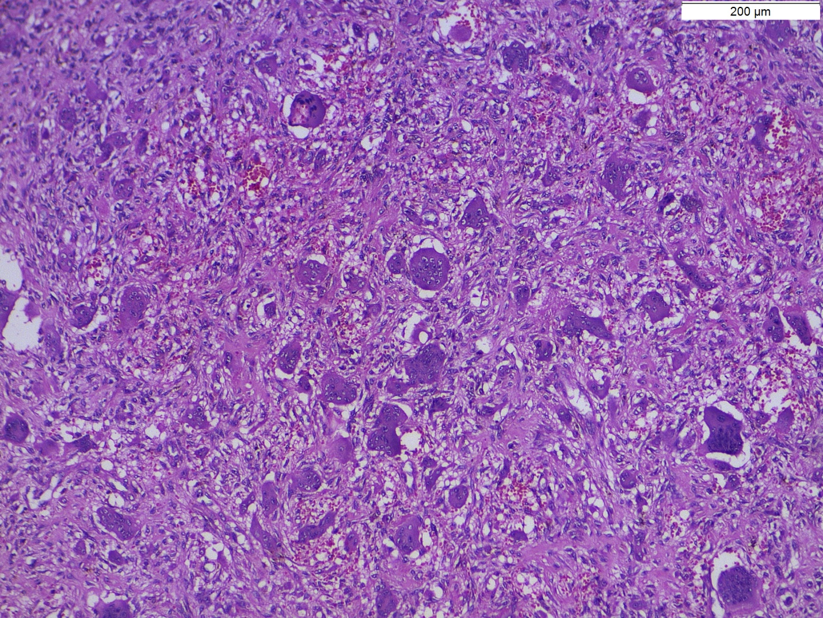
Figure:3 Manyinterspersed multinucleate cells, H&E, x 100)
