Case report
Congenital Arteriovenous Malformation of the Hand and Forearm: Integration of Clinical Staging, Vascular Imaging, and Treatment Outcomes in a Rare Anomaly
Abstract:
Congenital arteriovenous malformations (AVMs) involving the hand and forearm are exceptionally rare developmental vascular disorders and pose considerable diagnostic and therapeutic challenges because of their complex vascular anatomy. These lesions arise from anomalous direct arterial–venous connections, resulting in high-flow circulation that may progressively lead to pain, swelling, and impairment of hand function. Although AVMs are more frequently described in the central nervous system, their occurrence in the hand remains infrequent and clinically challenging.
We report the case of an 11-year-old female child presented with progressively increasing pain and swelling of the right hand. Clinical and Radiological evaluation with magnetic resonance imaging and angiography established the diagnosis of a congenital arteriovenous malformation, corresponding to Schobinger stage III. Management was planned in a staged and multidisciplinary manner. Initial endovascular embolization was performed to reduce blood flow within the lesion, followed by complete surgical excision. Careful identification and ligation of the principal feeding vessels were central to achieving effective intraoperative hemostasis and complete R0 resection.
The postoperative recovery was uneventful, with significant relief of symptom and preservation of hand and upper limb function. No recurrence was detected during the follow-up period. This case demonstrates that careful preoperative assessment, appropriate staging, and a combined endovascular and surgical approach can result in satisfactory outcomes in congenital AVMs of the hand.
Keywords: Arteriovenous malformations, Angio embolization, Schobinger stage
Introduction: AVMs originate at 4th to 10th weeks of intra uterine life due to persistence of primitive arteriovenous shunts. They are vascular anomalies having rich abnormal vascular networks in which arterial flow is directly connected with venous channels. Though they occur in any part of the body, upper limb; hand, commonly affected, after head and neck region. AVM of the hand is generally small, but can cause pain, discomfort, disability and occasionally bleeding, hence necessitating the intervention. [1]
The clinical presentation, though not the underlying pathology, may sometimes be precipitated by trauma may result in wound which then fails to heal due to a combination of venous hypertension and pulp ischemia secondary to the steal effect of the arteriovenous shunts. [2]
AVMs were categorized according to Schobinger clinical staging: 27 %t in stage I (quiescence), 38% in stage II (expansion), and 38 % in stage III (destruction) an only single patient with stage IV malformation (decompensation). Stage I lesions remained stable for long periods. Expansion (stage II) was usually followed by pain, bleeding, and ulceration (stage III). [3]
MRI provides essential insight into lesion extent and guides surgical planning, which remains the primary treatment modality for symptomatic AVMs causing nerve compression. Although recurrence is a common risk, especially in paediatric patients, careful excision of lesion and follow-up are key to reducing this risk and ensuring better long-term outcomes. [4]
Case Report: An 11 year old female came with chief complaints of pain and swelling over right hand over thumb region and over forearm since infancy.
Swellings were initially first observed at around 5 to 6 months of age which were initially small in size not painful then gradually progressed to increase in size.
History of pain over swelling over hand for 2 year, which increases on movement of hand.
History of inability and pain while closing thumb finger for 1 and half year.
History of ulceration over swelling for 6months.
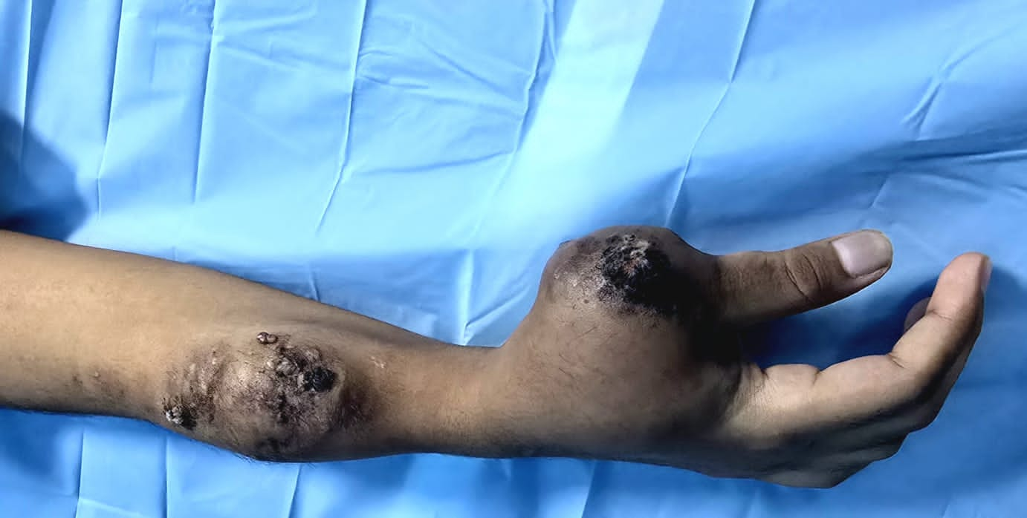
Fig 1:Pre-operative image of tumor over right hand and forearm
Patient underwent MRI of hand and forearm which revealed high flow vascular malformation as AVM. Had undergone arterial angio embolization of arterial feeder vessel under fluoroscopy guidance in 3 sittings, 2 weeks prior to plan surgery.
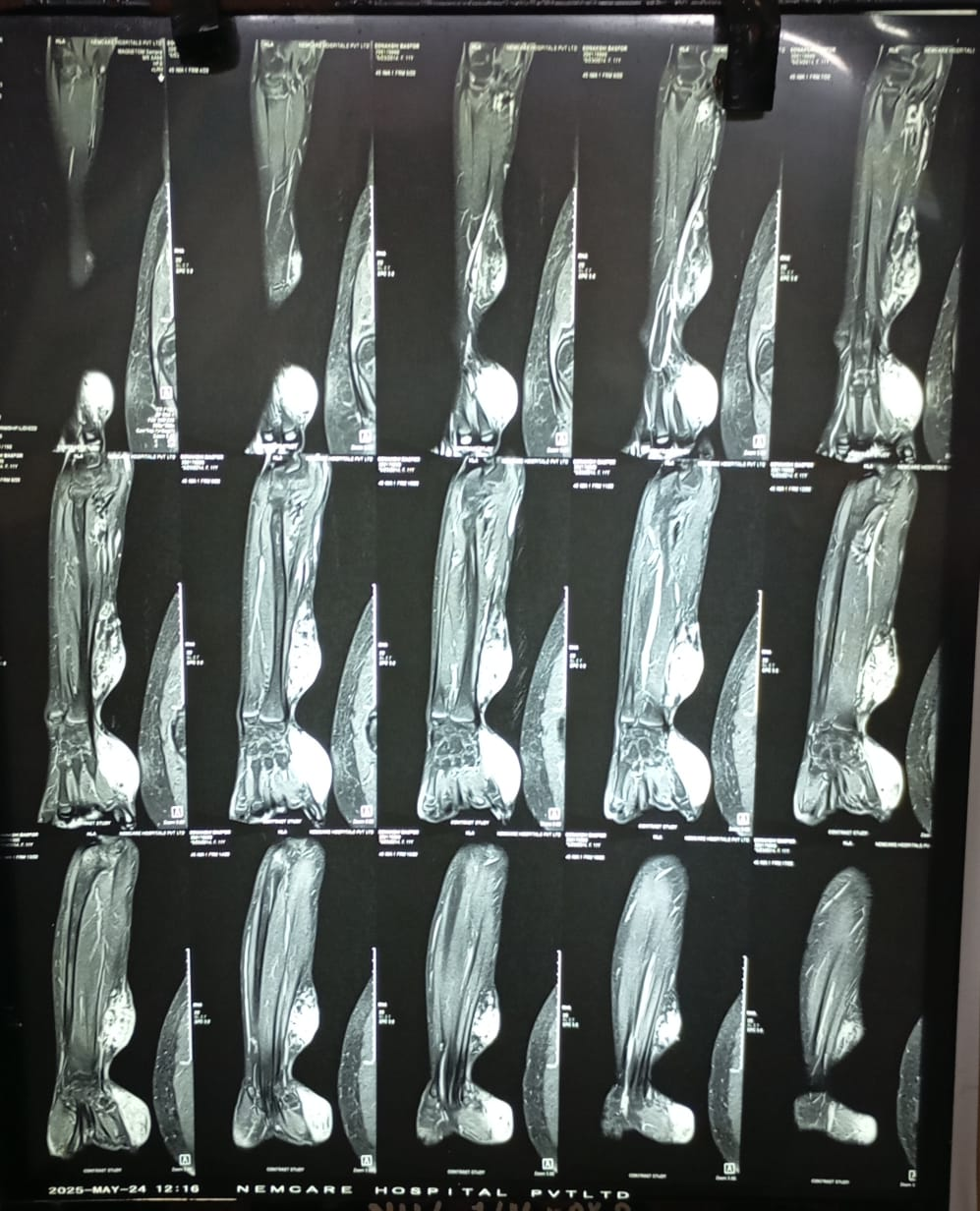
Fig 2: Coronal MRI of hand and forearm demonstrating features consistent with a congenital AVMs

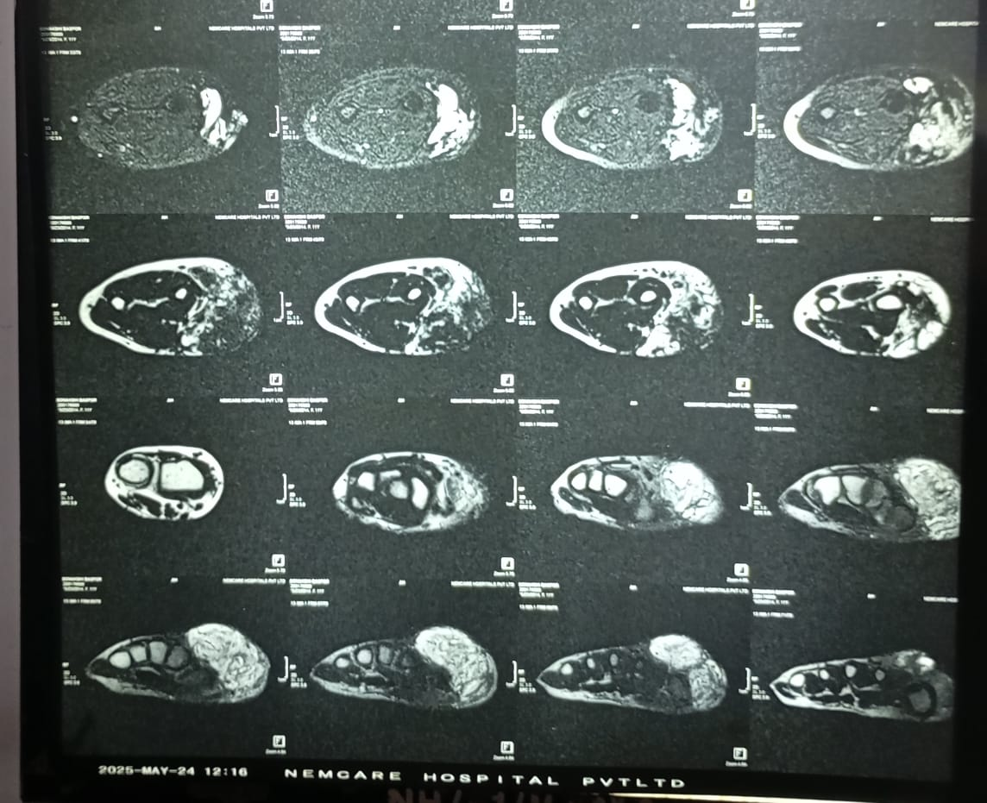
Fig 3: Cross sectional MRI of hand and forearm illustrating a high flow AVMs involving soft tissues.

Fig 4: Coronal section MRI of hand and forearm revealing imaging features of AVMs
Patient underwent complete R0 excision of both tumors of Right forearm and hand. 5*4 cm vascular swelling was excised from Right forearm and 6*5 cm lesion excised from right thumb. Both swellings had multiple collaterals which were ligated.
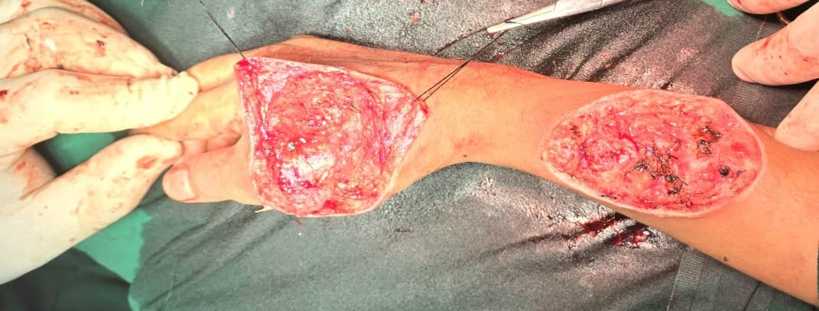
Fig 5: Intra op imaging demonstrating post excisional surgical field following resection
Dissected bed of hand and forearm after complete R0 tumor excision.

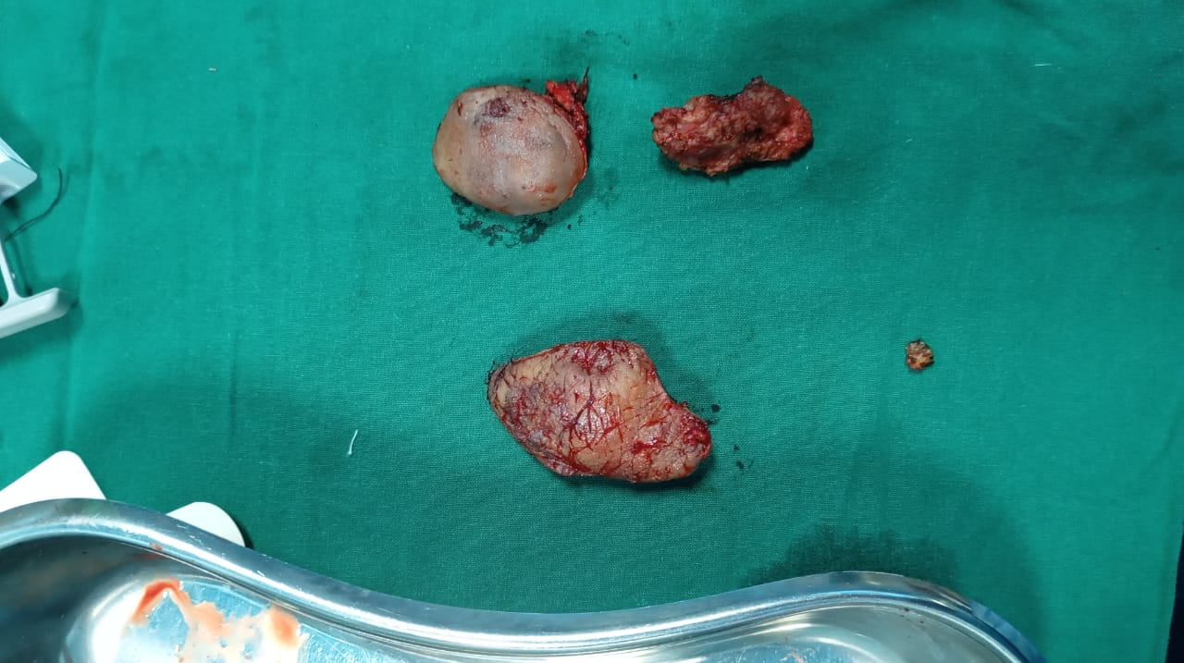
Fig 6: Specimen of tumor resected out.
Specimen are sent for Histopathological examination for confirmation of diagnosis.
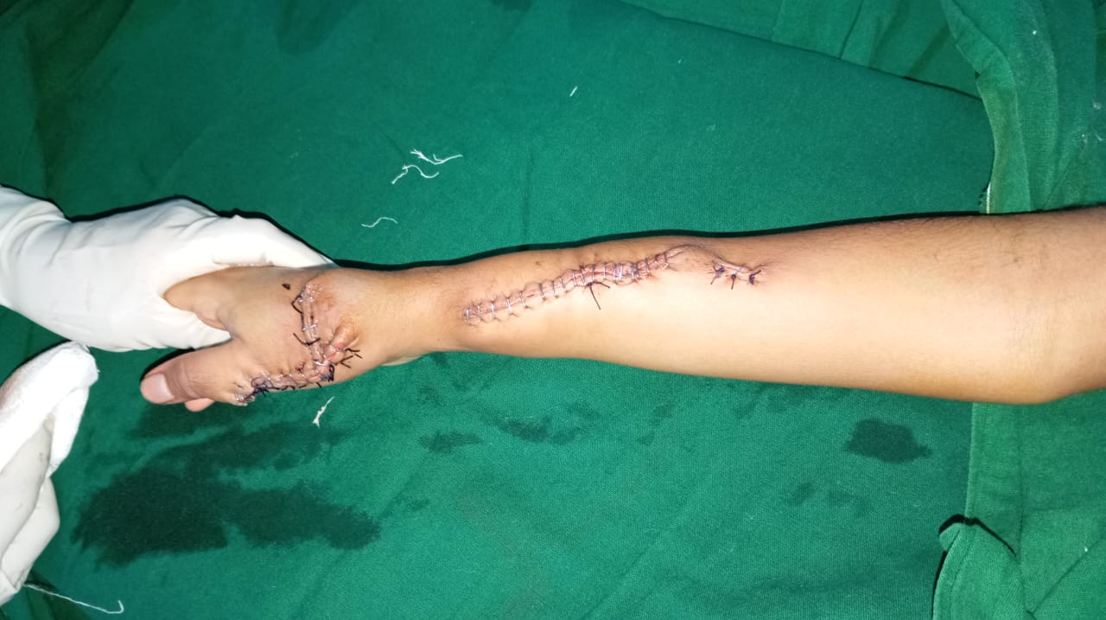

Fig 7: Immediate post op after reconstruction and repair of defect.
While closing the defect we used both skin staplers and 2-0 Vicryl sutures. Reconstruction was done in such a manner to avoid any further contracture. Sutures and stapler are removed after 20 days post op with normal return of activity of hand and forearm.

Result:
Both specimens are sent for histopathological examination for confirmation of diagnosis. Specimens were suggestive of Arṭeriovenous malformation, benign etiology.
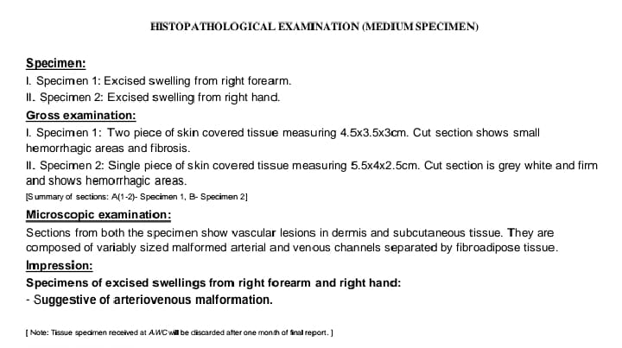
Fig 8: HPE report consistent with AVMs
Patient is reviewed after 3 months where patient had no further swelling with healthy scar tissue with no contracture and normal function of hand and forearm.
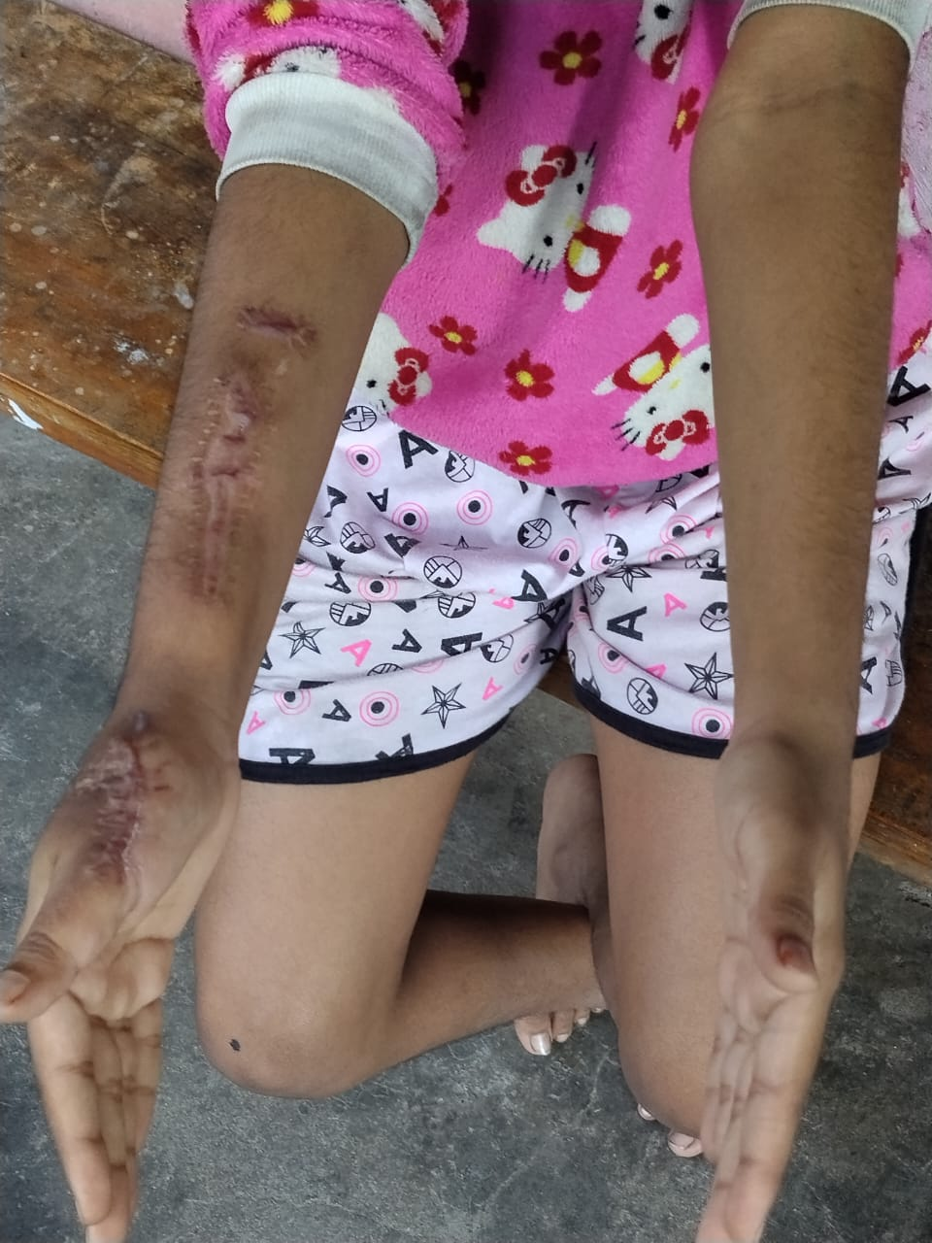
Fig 9: Upper limb in Neutral Position during follow up showing healthy scar tissue without contracture.

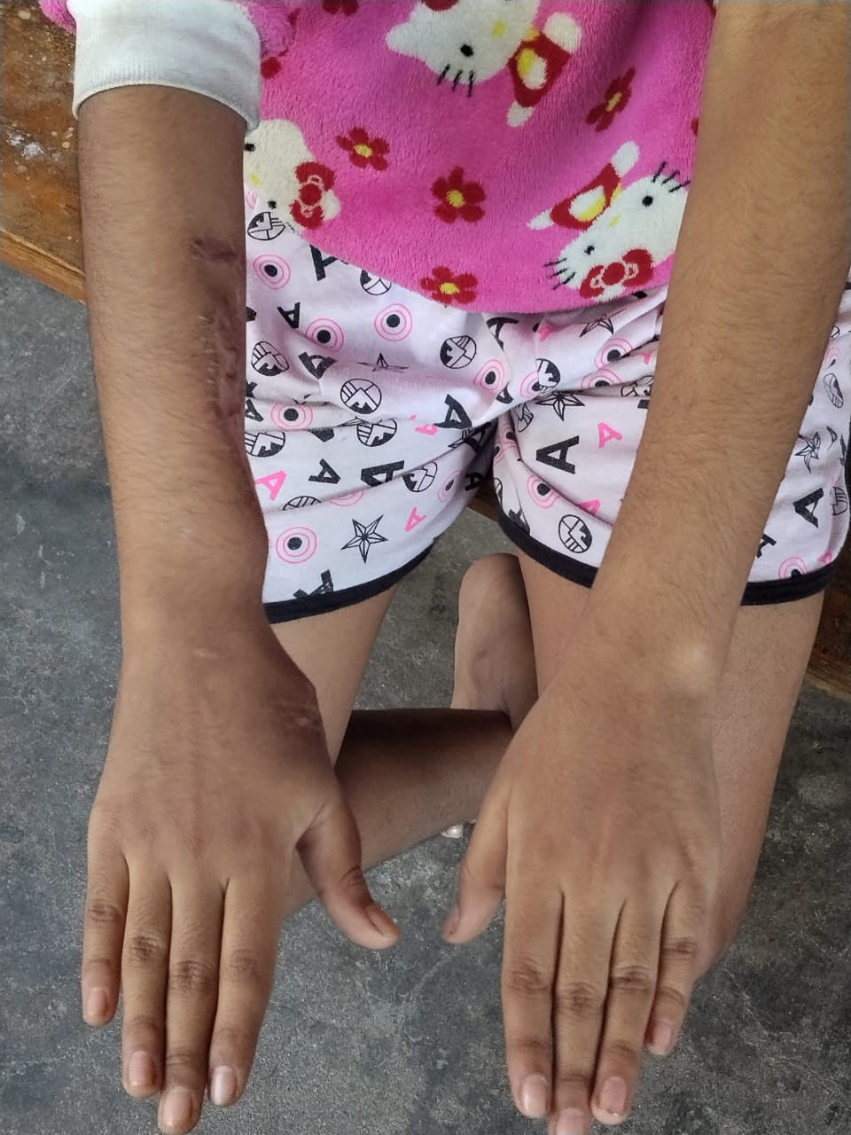
Fig 10: Upper limb in prone position during follow up

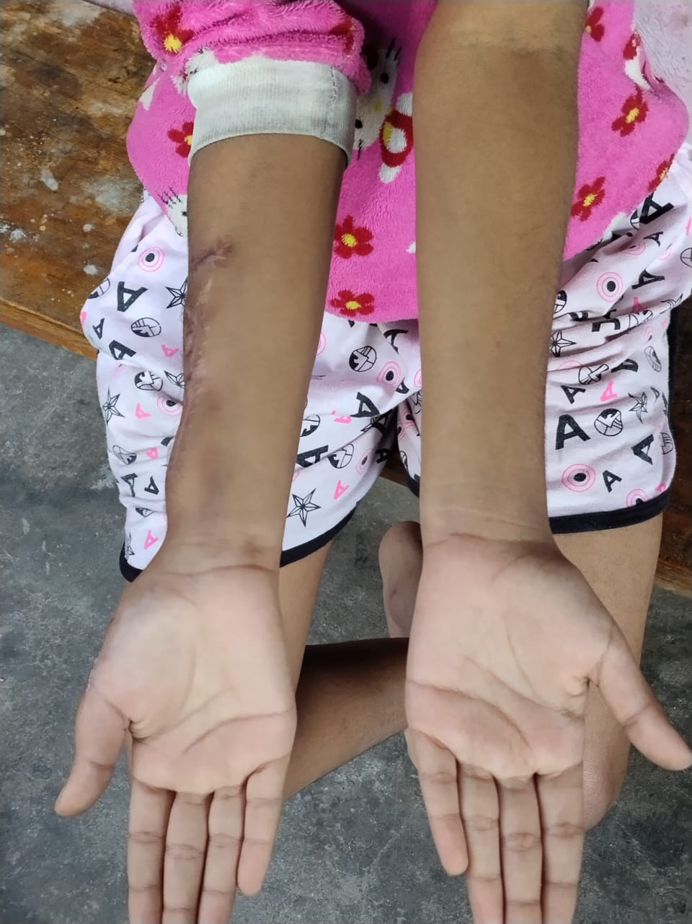
Fig 11: Upper limb in supine position during follow up

Discussion:
AVMs over upper limb may present with cosmetic disfigurement, obstruction to vital neurovascular structures of the upper limb and impairment of the function, pain, ulceration, bleeding, and nerve palsy [1]
In present case also patient exhibited significant disfigurement of hand and forearm associated with pain while doing daily routine activities.
Schobinger classification of arteriovenous malformations stages are: Stage Clinical Findings I (Quiescence) Skin warmth, discoloration; II (Expansion) Enlargement, pulsation, bruit; III (Destruction) Pain, ulceration, bleeding ; IV (Decompensation) Cardiac failure due to volume overload .[3] The Yakes Classification : Type Ia (direct AVF); Type IIa (typical AVM nidus); Type IIb (AVM nidus that shunts into an aneurysmal vein); Type IIIa (aneurysmal vein whereby the vein wall is the nidus with single out-flow vein); Type IIIb (same as Type IIIa, but with multiple outflow veins); Type IV (infiltrative form of AVM permeating a tissue).[9]
In our patient, lesion was classified as Schobinger Stage III, Yakes Type IV.
AVM management especially high flow lesion, is complex and often requires long term and staged management. Endovascular interventions such as embolization or sclerotherepy carry inherent risk. After every treatment, the lesions must be revaluated and new treatment plans must be made by the members of a multidisciplinary team. [5]
Following MRI confirmation of high flow vascular lesion we did selective angio embolization of major feeding vessel pre operatively. This is crucial as to reduce the risk of intra op bleeding and facilitate safer definitive surgical excision.
Upper extremity is a rare location of haemangioma and other vascular malformations requiring surgery. Surgical treatment of haemangioma and AVMs of the upper extremities is doubtlessly an arduous task, which calls for great microsurgical skills. [6]
Most of the AVMs are asymptomatic or require clinical observation for minimal symptoms. In Crina V. Onciu et al case report, the patient presented an impressive vascular mass in his left forearm which had constantly grown on a period of 10 years. If left untreated, the AVM could have led to heavy bleeding, distal necrosis, skin ulceration or even cardiac failure. [7]
Surgeons should consider several important points during the surgical treatment of AVM. The first is that the nidus of AVM should be completely removed for achieving a complete cure of AVM. The remnant AVM may grow and get bigger than before treatment within a short period of time. Surgical treatment of AVM is a challenging issue for vascular surgeons. To minimise the complications related with surgery, a multidisciplinary team approach should be considered. [8] Complete eradication of the nidus of an AVM is the only potential “cure.” But this, however, is often difficult if not impossible. [11]
After skin marking, meticulous dissection was performed to develop a clear surgical plane separating lesion from underlying muscle layer. Intricate microsurgery with Ligation of major feeding vessels along with ligation of other small vessel were done following which resection of both the segments were done keeping the muscle below intact. While closure of defect over forehand both the edges are approximated with silk suture and closed with skin staplers. Precautions were taken to laterally raise the flaps preserving vascularity to reduce closure tension. Over hand swelling after excision closure were done in VY advancement plasty manner, ensuring adequate soft tissue coverage and optimal functional outcome.
The management of symptomatic hand arteriovenous malformations must address the functional and cosmetic demands of hand. Nonsurgical treatment such as embolization continues to be plagued by complications such as digital ischemia and secondary need for amputation. Meticulous surgical excision with micro vascular reconstruction is an acceptable technique for management of symptomatic hand arteriovenous malformations. Potential soft-tissue loss does not preclude aggressive resection. [10]
On follow up patient demonstrated full recovery with complete functional ability of hand and forearm without limitations in activities of daily living and with no evidence of recurrence.

Conclusion:
Congenital Arteriovenous malformation of upper limb is very rarely encountered even in practice of busy surgeon. Diagnosis remain crucial on basis of imaging finding as MRI and MRI angiography. Multidisciplinary approach in managing the lesion with angio embolization of feeding vessel followed by surgery not only reduces hemorrhagic complication during surgery also allows in developing better planes and better resection margin.
Acknowledgements:
Authors would like to thank Department of Oncosurgery and Department of General surgery at Nemcare hospital.
Funding: received no funding
Conflict of interest: None
Statement of informed consent: Informed consent was obtained from all individual participants included in the study
Patient consent statement: Informed consent was obtained from the patient’s guardian for publication of clinical details and images.
Disclaimer (Artificial intelligence)
Option 1:
Author(s) hereby declare that NO generative AI technologies such as Large Language Models (ChatGPT, COPILOT, etc.) and text-to-image generators have been used during the writing or editing of this manuscript.

References:
1. | Aihole, J. S. (2024). A case of arteriovenous malformation of the hand and its outcome. International Journal of Surgery Case Reports, 120, 109806. https://doi.org/10.1016/j.ijscr.2024.109806
2. | Shokrollahi, K., Hiew, L. Y., Robinson, M., Evans, R. M., Jackson, J. E., & Laing, J. H. E. (2004). Arteriovenous malformation of the hand: challenges in diagnosis and management. J Surg, 2(1), 50–51. https://doi.org/10.1016/s1743-9191(06)60028-9
3. | Kohout MP, Hansen M, Pribaz JJ, Mulliken JB. Arteriovenous malformations of the head and neck: Natural history and management. Plast Reconstr Surg [Internet]. 1998;102(3):643–54. Available from: http://dx.doi.org/10.1097/00006534-199809030-00006
4. | Kothari, A., Chaudhari, A., Gupta, D., & Altaf, W. (2025). Successful management of a rare case of arteriovenous malformation of the forearm in a 15-year-old girl: A case report. J Orthop Case Rep, 15(4), 132–5. https://doi.org/10.13107/jocr.2025.v15.i04.5472
5. | Park, U. J., Do, Y. S., Park, K. B., Park, H. S., Kim, Y. W., Lee, B. B., & Kim, D. I. (2012). Treatment of arteriovenous malformations involving the hand. Annals of Vascular Surgery, 26(5), 643–648. https://doi.org/10.1016/j.avsg.2011.08.016
6. | Jabłecki, J., Elsaftawy, A., Kaczmarzyk, J., & Kaczmarzyk, L. (2013). Surgical treatment of hemangiomas and arteriovenous malformations in upper extermity. Polski Przegląd Chirurgiczny, 85(3), 107–113. https://doi.org/10.2478/pjs-2013-0019
  7.
  Onciu CV, Maffeis J, Popescu I-A, Teboul F. A rare case of arteriovenous malformation of the forearm. Ann Vasc Surg Brief Rep Innov [Internet]. 2024;4(2):100282. Available from: http://dx.doi.org/10.1016/j.avsurg.2024.100282
8. | Kim, J. Y., Kim, D. I., Do, Y. S., Lee, B. B., Kim, Y. W., Shin, S. W., et al. (2006). Surgical treatment for congenital arteriovenous malformation: 10 years' experience. European Journal of Vascular and Endovascular Surgery, 32(1), 101–106. https://doi.org/10.1016/j.ejvs.2006.01.004
9. | Yakes WF. Yakes’ AVM classification system. J Vasc Interv Radiol [Internet]. 2015;26(2):S224. Available from: http://dx.doi.org/10.1016/j.jvir.2014.12.596
10. | Trost J, Abu-Ghname A, Davis MJ, Maricevich RS, Pederson WC, Maricevich M. Arteriovenous malformations of the Hand: Optimizing outcomes with Palmar arch reconstruction. Plast Reconstr Surg [Internet]. 2022;150(5):1059–69. Available from: http://dx.doi.org/10.1097/PRS.0000000000009651
11. | Lee B-B, Do YS, Yakes W, Kim DI, Mattassi R, Hyon WS. Management of arteriovenous malformations: a multidisciplinary approach. J Vasc Surg [Internet]. 2004;39(3):590–600. Available from: http://dx.doi.org/10.1016/j.jvs.2003.10.048

