Case report
Unexpected cause of abdominal mass in an adult: Isolated enteric duplication cyst

ABSTRACT

Enteric duplication cysts are uncommon congenital anomalies, encountered majorly in pediatric population, with an approximate prevalence of approximately 1 in 4500 births. They usually remain asymptomatic in adults. IDEC is rarest subtype of all EDCs furthermore foregut duplication cyst present in paracaeal region adds on to its rarity. We herein present a case of A female in her late 20s presented with complaints of pain in the right lower abdomen for the last one year, with a palpable lump on examination. She underwent exploratory laparotomy and the cyst was excised with all its walls intact with no bowel resection. On HPE it was suggestive of enteric (foregut) duplication cyst presented in paracaecal region. The post-op period and follow-up were uneventful. The treatment involves surgical management with en-bloc resection without the resection of the adjacent bowel owing to an isolated or independent blood supply of the cyst.
KEYWORDS
IDEC, Foregut Duplication cyst, Enteric duplication cyst excision without bowel resection, abdominal mass in adults

INTRODUCTION
Congenital anomalies of the tubular gastrointestinal tract are an important cause of morbidity not only in infants, but also in children and adults (Ludwig et al., 2022). Enteric duplication cysts are rare congenital anomalies that can develop anywhere along the alimentary tract, from the tongue to the anus. Approximately three-quarters of enteric duplication cysts are found in the abdominal cavity, with the remaining distributed between intrathoracic and thoracoabdominal locations. More than half of cases are diagnosed during early childhood, as these cysts often present with symptoms at that age. In contrast, they are typically asymptomatic in adulthood, and diagnosis is usually incidental. Isolated duplication cysts, which have their own blood supply and no communication with the normal bowel, represent an extremely rare form of gastrointestinal duplication. In this case report, a young woman in her late 20s presented with a one-year history of right lower abdominal pain and a palpable mass.

CASE PRESENTATION
A female in her late 20s presented to the General Surgery Out Patient Clinic (OP) with complaints of pain in the right lower abdomen for the last one year, insidious in onset and gradually progressive in intensity, dull aching in character and occurred intermittently. The pain was relived on over-the-counter analgesics, showed with no obvious positional, exercise or meal related aggravating factors. There were no complaints of fever, vomiting, diarrhoea or constipation, yellowish discoloration of skin, rectal bleed, black stools. The patient was ambulatory, vitally stable and cooperative for further examination. Her general physical examination was unremarkable. The abdomen was non-distended, central inverted umbilicus with no obvious swellings, discoloration, scars, dilated vessels or pulsations. There was no local rise in temperature or tenderness, guarding or rigidity.A vaguely defined firm-non tender swelling was palpable in the right lumbar region with audible bowel sounds.

INVESTIGATIONS
Haematological Investigations revealed no significant abnormalities. A contrast-enhanced Computed Tomography of the Whole Abdomen (CECT) revealed a well-defined thin wall cystic lesion in the abdominal cavity on the right side measuring 71x 69 x101mm superiorly abutting under the surface of the liver with the distinct fat plane. No evidence of intrinsic septations/calcification or any solid component was noted. No obvious enlarged lymph nodes were noted, and no post-contrast enhancement was seen in the lesion, suggesting a mesenteric cyst/ benign cyst.

DIFFERENTIAL DIAGNOSIS
The constellation of symptoms is inclusive of chronic dull, aching abdominal pain and a palpable abdominal lump in the right lumbar region similar to the size of approximately 8x8cm. There were no signs of obstruction, no history of yellowish discolouration of the skin, no history of diarrhoea or haematochezia, no history of menstrual irregularities or signs of sepsis.
Based on the signs and symptoms, the differentials point towards any cystic abdominal lesion, including enteric duplication cysts arising from the bowel wall (or attached to it), benign mesenteric cysts and ovarian cysts (benign).
Enteric duplication cysts are a rare entity that presents with early onset and is mainly present in the paediatric age groups. These cysts appear similar on radiological imaging in adults and clinical examination. Although these cysts can be present anywhere, the most common sites for enteric duplication cyst are ileum. On laparotomy, a shared bowel wall and common blood supply would be seen, necessitating resection of the surrounding bowel segments as well. Mesenteric cysts would also present with similar clinical and radiological findings; only histopathological findings differentiated the diagnoses in this case. An ovarian cyst also made it to the list based on the epidemiological frequency in a young female with pain in the abdomen and an abdominal mass. The features that do not point in its favour are the normal blood work showing no tumour markers and no menstrual irregularities in the patient. No formal diagnostic algorithm favoured a single diagnosis during the preoperative work-up.

TREATMENT
The patient underwent an exploratory laparotomy under general anaesthesia. Intraoperatively, a well-defined cystic mass measuring approximately 120mm x 70mm x 60mm was identified in the paracaecal region. The mass exhibited no communication with the bowel or mesentery and was associated with thin, flimsy adhesions. The cyst and its wall were excised and sent for histopathological examination (HPE). Gross examination revealed a single grey-white cystic structure measuring 7.5 x 7.5 x 2 cm. The external surface appeared smooth and shiny, with prominent vessels. Upon incision, 50 ml of clear serous fluid was released. The cut surface displayed a single unilocular, smooth-walled cyst, with no solid contents observed. The cyst wall thickness ranged from 0.1 cm to 0.8 cm. The entire specimen was processed in four sections.

Microscopic examination revealed that the cystic lesion was lined by a single layer of columnar or cuboidal epithelium resembling gastrointestinal mucosa. The cyst wall consisted of smooth muscle and connective tissue. No significant atypia, mitotic activity, or necrosis was observed. These findings were consistent with a diagnosis of a foregut duplication cyst.Postoperative recovery was uneventful. On postoperative Day 5, the patient was discharged with spirometry, chest physiotherapy and instructions to ambulate with an abdominal binder. At the two-week follow-up, the patient reported complete resolution of abdominal pain and vomiting. She remained symptom-free during subsequent follow-up visits till date.

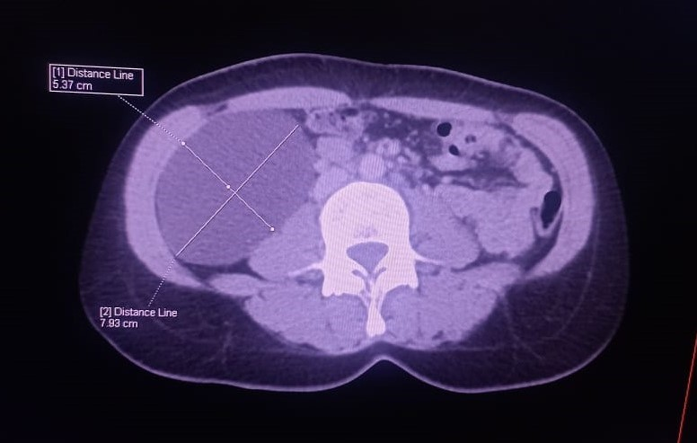
Fig.1. CT image showing well defined mass in abdomen

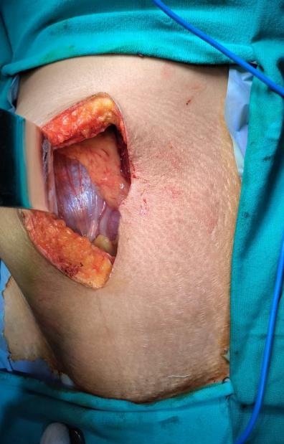
Fig.2. A fluid filled cystic lesion present
In paracaecal region

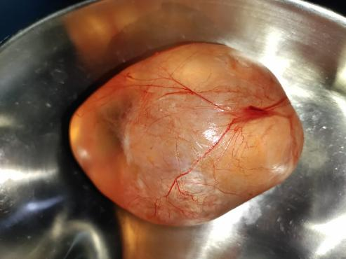

Fig3. Cyst excised en bloc with all its layers intact

DISCUSSION
Enteric Duplication cysts are uncommon congenital anomalies, encountered majorly in the pediatric population, with an approximate prevalence of approximately 1 in 4500 births (1). They usually remain asymptomatic in adults, but can otherwise have a wide clinical presentation ranging from mass per abdomen to dysphagia, cough, neck mass, stridor etc (5). These anomalies have their origins along the alimentary tract, anywhere from the tongue to the anus. The most common site reported in literature is the ileal region, and these cysts share a common wall and blood supply as the alimentary tract. This devious anatomical connection mandates surgical excision of the adjacent bowel segment along with the duplication cyst. Isolated enteric cysts are a rarer subtype of enteric cysts, with a unique blood supply and distinct walls, with less than 20 reported cases in adults worldwide to date. These cysts also at times show a metaplastic change with gastric or pancreatic tissue (6). In our case, the isolated duplication cyst had its own vascular pedicle with no luminal communication with the adjacent alimentary segments, and was histopathologically reported as a foregut duplication cyst in the paracaecal region. The combination of the age, anatomical location, anatomical variant (isolated with unique blood supply) makes this a unique presentation.
A brief review of literature of similar studies reveals that the most common presenting complaint is abdominal pain or an abdominal mass, while radiological findings such as CT provide a strong clinical suspicion thereafter.
Duplication cysts can be recognized on CT as smoothly rounded, fluid filled cysts, or tubular structures with thin, slightly enhancing walls in or adjacent to the wall of part of the alimentary tract. In our case, based upon CT and sonographic findings, mesentric cyst was impression. Diagnostically, all Isolated EDCs have a double layer smooth muscle in their wall, as observed on Histopathological examination (6).
There is no algorithm for the management of asymptomatic duplication cyst, whereas surgical excision is a treatment modality; hence, in our case, the patient underwent surgical excision with all its walls and layers intact with no bowel resection.
The vague clinical presentation shows the need for adaptations in our existing diagnostic and treatment algorithms for such presenting complaints.

Conclusion

Isolated duplication cysts, which have their own blood supply and no communication with the normal bowel, represent an extremely rare form of gastrointestinal duplication. In this report, we present the case of an adult female diagnosed with a non-communicating foregut isolated duplication cyst presented in paracaecal position. The treatment involves surgical management with en-bloc resection without the resection of the adjacent bowel owing to an isolated or independent blood supply of the cyst.

Ethical Approval:

As per international standards or university standards written ethical approval has been collected and preserved by the author(s).
Consent
As per international standards or university standards, patient(s) written consent has been collected and preserved by the author(s).

Disclaimer (Artificial intelligence)
We hereby declare that NO generative AI technologies such as Large Language Models (ChatGPT, COPILOT, etc.) and text-to-image generators have been used during the writing or editing of this manuscript.

REFERENCES
1. Tiwari, C., Shah, H., Waghmare, M., Makhija, D., & Khedkar, K. (2017). Cysts of Gastrointestinal Origin in Children: Varied Presentation. Pediatric Gastroenterology, Hepatology & Nutrition. https://doi.org/10.5223/pghn.2017.20.2.94
2. Gupta, S., Goel, V., Dahiya, M., Bishlay, A., Singh, S., & Kajal, P. (2024). Isolated Enteric Duplication Cyst: A Rare Congenital Anomaly. International Journal of Health Sciences and Research, 14(2), 137-142. https://doi.org/10.52403/ijhsr.20240217
3. Park, J. Y., Her, K. H., Kim, B. S., & Maeng, Y. H. (2014). A completely isolated intestinal duplication cyst mimicking ovarian cyst torsion in an adult. World Journal of Gastroenterology, 20(2), 603–606. https://doi.org/10.3748/wjg.v20.i2.603
4. Anand, S., & Aleem, A. (2024). Duplication Cyst. In StatPearls. StatPearls Publishing. https://www.ncbi.nlm.nih.gov/books/NBK564347/
5. Liu, R., & Adler, D. G. (2014). Duplication cysts: Diagnosis, management, and the role of endoscopic ultrasound. Endosc Ultrasound. https://doi.org/10.4103/2303-9027.138783
6. Lee, J. U., Kim, J. O., Kim, S. J., & Sul, H. J. (2010). Completely Isolated Enteric Duplication Cyst Presenting as an Inguinal Hernia. Journal of Pathology and Translational Medicine, 44(2), 204–206. https://doi.org/10.4132/KoreanJPathol.2010.44.2.204
7. Bentley, J. F. R., & Smith, J. R. (1960). Developmental Posterior Enteric Remnants and Spinal Malformations: The Split Notochord Syndrome. Archives of Disease in Childhood, 35(179), 76–86. https://doi.org/10.1136/adc.35.179.76
8. Sangüesa Nebot, C., Llorens Salvador, R., Carazo Palacios, E., Picó Aliaga, S., & Ibañez Pradas, V. (2018). Enteric duplication cysts in children: varied presentations, varied imaging findings. Insights into Imaging, 9(6), 1097–1106. https://doi.org/10.1007/s13244-018-0660-z
9. Bremer J. Diverticula and duplications of the intestinal tract. Arch Pathol. 1952;38(1):132–40.
10. Pant, N., Grover, J. K., Madan, N. K., Chadha, R., Agarwal, K., & Choudhury, S. R. (2012). Completely isolated enteric duplication cyst associated with a classic enterogenous duplication cyst. J Indian Assoc Pediatr Surg, 17(2), 68–70. https://doi.org/10.4103/0971-9261.93966
11. Ravitch, M. M. (1953). Hind gut duplication—Doubling of colon and of the genital and lower urinary tracts. Annals of Surgery, 137(5), 588–601. https://doi.org/10.1097/00000658-195305000-00002
12. Steiner, Z., & Mogilner, J. (1999). A rare case of completely isolated duplication cyst of the alimentary tract. Journal of Pediatric Surgery, 34(8), 1284–1286. https://doi.org/10.1016/s0022-3468(99)90171-9
13. Blank, G., Königsrainer, A., Sipos, B., & Ladurner, R. (2012). Adenocarcinoma arising in a cystic duplication of the small bowel: case report and review of literature. World Journal of Surgical Oncology, 10(1), 55. https://doi.org/10.1186/1477-7819-10-55
14. Kim, S. K., Lim, H. K., Lee, S. J., & Park, C. K. (2003). Completely isolated enteric duplication cyst: case report. Abdominal Imaging, 28(1), 12–14. https://doi.org/10.1007/s00261-001-0138-0
15. Nichols, K. C., Pollema, T., & Moncure, M. (2011). Laparoscopically excised completely isolated enteric duplication cyst in adult female: a case report. Surg Laparosc Endosc Percutan Tech, 21(4), e173-e175. https://doi.org/10.1097/SLE.0b013e318216f301
16. Neofytou, K., Chysochos, A., Sammouti, E., Andreou, C., & Georgiou, C. (2013). Infected completely isolated enteric duplication cyst management with percutaneous drainage and surgical excision after retreat of infection: a case report. Case Reports in Surgery. https://doi.org/10.1155/2013/108126
17. Srinivas, P., Reddy, K. V. R., Reddy, G. R., Kumar, L. V., & Geethika, M. (2020). A case report of enteric duplication cyst in adult. MedPulse – International Journal of Radiology, 13(2), 90–92. https://doi.org/10.26611/101313215
18. Pham, N. V., Mai, D. V., Duong, P. D. T., Lam, H. H., Ly, H. H. V., & Nguyen, L. V. (2024). Duplication cyst in adult cases: a journey from diagnosis to treatment. Journal of Surgical Case Reports, 2024(7), rjae460. https://doi.org/10.1093/jscr/rjae460
19. Nakashima, S., Yamada, T., Sato, G., Sakai, T., Chinen, Y., & Itakura, H. (2019). A case of completely isolated advanced enteric duplication cyst cancer performed partial pancreatectomy. *International Journal of Surgery Case Reports*, *54*, 83–86. https://doi.org/10.1016/j.ijscr.2018.11.060
20. Adama, S., Balaraba, M. L. A. A., Aliou, Z. O., Daouda, B. I., Kadi, I., Hama, Y., Lassey, J. D., & Rachid, S. (2024). Diagnostic and therapeutic approach to abdominal masses in a country with limited resources. BMC surgery, 24(1), 97. https://doi.org/10.1186/s12893-024-02371-w

- Hanafi, I., Ivan, I., Palot, J.-P., Dejugnat, L., et al. (2004). Masses abdominales de l'adulte : comment arriver au diagnostic. Journal de Radiologie, 85(9), P1505. https://doi.org/10.1016/S0221-0363(04)77664-7

- Erginel, B., Soysal, F. G., Ozbey, H., Keskin, E., Celik, A., Karadag, A., & Salman, T. (2017). Enteric Duplication Cysts in Children: A Single‐Institution Series with Forty Patients in Twenty‐Six Years. World journal of surgery, 41(2), 620-624.

- Ludwig, K., De Bartolo, D., Salerno, A., Ingravallo, G., Cazzato, G., Giacometti, C., & Dall’Igna, P. (2022). Congenital anomalies of the tubular gastrointestinal tract. Pathologica, 114(1), 40. doi: 10.32074/1591-951X-553

