Case report
Monofocal nonbacterial osteitis of the distal radius in children: case report

Abstract
Introduction:
Bacterial chronic osteitis is a rare inflammatory disease in children that can mimic certain tumor lesions, particularly eosinophilic granuloma. Forms localized to a single site, particularly at the lower end of the radius, are uncommon and make diagnosis difficult.
Observation:
A 7-year-old girl was referred for chronic pain in her right forearm. X-rays showed a metaphyseal cystic lesion of the lower end of the radius, associated with significant thinning of the cortex. Magnetic resonance imaging initially suggested an eosinophilic granuloma due to a well-defined lesion, with hypersignal on water-sensitive sequences and hyposignal on T1-weighted sequences, without collection or soft tissue invasion.
This suspicion of a tumor led to a bone biopsy. The examination revealed a weakened cortex containing a clear, non-hematic fluid. The pathological study revealed non-specific inflammatory osteitis, and microbiological samples were negative, leading to a diagnosis of chronic non-bacterial osteitis.
Treatment with anti-inflammatory drugs led to rapid improvement. Radiology showed gradual filling of the lesion, with complete healing after one year.
Conclusion:
This observation illustrates a monofocal form of chronic non-bacterial osteitis mimicking an eosinophilic granuloma on imaging. Biopsy remains essential to rule out a tumor or infectious lesion. The prognosis is favorable with anti-inflammatory treatment.
Keywords: Chronic nonbacterial osteitis, monofocal, child, distal radius, case report.
Introduction
Chronic nonbacterial osteitis is a rare inflammatory bone condition in children, the diagnosis of which is still based on a combination of clinical, biological, and radiological findings. It is characterized by persistent bone pain in the absence of documented infection and can sometimes mimic tumor or infectious diseases, making it difficult to identify (1).

Imaging plays a central role in diagnostic evaluation, although monofocal forms can be confusing, particularly with eosinophilic granuloma or Brodie's abscess, as highlighted in several reference radiological studies (2,5). The clinical and biological differences between bacterial and non-bacterial osteitis have recently been better defined, improving diagnostic guidance in children (3,4).
The classification proposed by Jansson et al. has helped to structure the diagnostic criteria (6), while more recent studies have clarified the clinical heterogeneity and favorable outcome with anti-inflammatory treatment (7–9).
The pathophysiology of chronic nonbacterial osteitis is thought to involve a dysregulated innate immune response leading to sterile bone inflammation. Studies suggest an imbalance between pro-inflammatory cytokines, particularly interleukin-1–driven pathways, and insufficient anti-inflammatory regulation, resulting in recurrent osteolytic and sclerotic lesions . Additionally, altered activation of monocytes and neutrophils contributes to persistent bone marrow inflammation, supporting the concept of chronic nonbacterial osteitis as an autoinflammatory bone disorder (1).
In this context, we report a case of chronic non-bacterial monofocal osteitis of the distal radius in a 7-year-old girl, highlighting the diagnostic difficulty of this atypical location and the decisive contribution of biopsy in confirming the diagnosis.
Case presentation
A 7-year-old girl was brought in for consultation for pain in her right wrist that had been developing for more than four months. The pain was intermittent, worsened by movement, and developed in the absence of fever. The initial clinical examination revealed tenderness on palpation of the outer edge of the lower end of the right forearm, with no swelling, redness, or local heat. Examination of the other osteoarticular segments revealed no tender points, suggesting a monofocal form of the condition.
An X-ray of the right wrist showed a lytic lesion of the metaphysis of the radius, located on its outer and anterior side, associated with marked thinning of the outer cortex, without aggressive periosteal reaction. The infectious disease tests were negative.
Magnetic resonance imaging was performed. It initially suggested an eosinophilic granuloma and, secondarily, a Brodie's abscess, due to a well-defined lesion with high signal intensity on water-sensitive sequences and low signal intensity on T1-weighted sequences. The MRI also showed marrow edema surrounding the lesion, mild cortical breach, and no soft-tissue mass, all of which reinforced the differential diagnostic dilemmas.
Given the persistence of symptoms, the radiological appearance, and the suspected lesion, a bone biopsy was decided upon. The examination revealed a thinned and fragile cortex containing a clear, non-hematic fluid. During the procedure, cortical fenestration allowed access to a cavity filled with serous fluid without purulence, and multiple samples were collected. The pathological study concluded that it was a non-specific inflammatory osteitis, with fibro-inflammatory tissue infiltrate and absence of Langerhans cells or malignant features, and the microbiological samples were sterile, leading to a diagnosis of chronic monofocal non-bacterial osteitis.
The patient was treated with anti-inflammatory drugs. The outcome was favorable, with the pain gradually disappearing. Radiological monitoring showed gradual filling of the lesion, resulting in clear restoration of the cortical bone. At six months, the pain had completely disappeared and recovery was complete.
Discussion
Chronic nonbacterial osteitis is a rare inflammatory condition in children, characterized by a heterogeneous and often misleading clinical presentation. Monofocal forms, such as that observed in our patient, pose a particular diagnostic challenge because they frequently mimic a bone tumor or subacute infection, such as eosinophilic granuloma or Brodie's abscess (1,2).
In the study by Kostik et al. (2023), the authors point out that up to 28% of nonbacterial osteitis cases may be monofocal, making it more difficult to distinguish them from bacterial osteomyelitis, especially since the two conditions share similar radiological characteristics (3). Nevertheless, several clinical and biological factors point to nonbacterial osteitis: absence of fever, intermittent pain, normal or slightly abnormal laboratory results, and, above all, moderate inflammation (3,4). These factors were consistent with our patient's presentation.
Magnetic resonance imaging is an essential tool in the initial evaluation, but its interpretation can be confusing in isolated cases. Indeed, it has been reported that certain well-defined metaphyseal lesions combining medullary hypersignal and cortical thinning readily suggest eosinophilic granuloma (2,5). This situation corresponds precisely to the imaging findings in our patient, where the tumor hypothesis was considered first.
In this context, bone biopsy remains essential. Recommendations emphasize the need to obtain a sample from any monofocal lesion in order to rule out bacterial infection or tumor, even when inflammatory markers are low (1,6). In our observation, the intraoperative appearance of a thinned cortex containing clear non-hematic fluid, combined with histology consistent with nonspecific inflammatory osteitis and negative microbiology, allowed us to formally confirm the diagnosis of chronic nonbacterial osteitis.
The clinical and radiological progression observed in our patient is consistent with recently published pediatric series: the majority of children show significant improvement with nonsteroidal anti-inflammatory treatment, with progressive bone remodeling over several months (3,7). Kostik and colleagues report a favorable outcome in more than 80% of cases when the diagnosis is made early and the child is treated appropriately (3). Similarly, the work of Gamalero et al. and Triaille et al. emphasizes that monofocal forms generally have a better prognosis and complete remodeling more quickly than multifocal forms (8,9).
Our case illustrates the diagnostic difficulties encountered in monofocal nonbacterial osteitis. It also confirms the importance of a rigorous approach combining imaging, laboratory tests, and, above all, biopsy, in order to avoid misdiagnosis and inappropriate treatments, particularly antibiotics or extensive surgery. The complete response to anti-inflammatory treatment observed here demonstrates the benign and self-limiting nature of the disease when correctly identified.

Table 1 : Comparative summary of clinical and radiologic features reported in key studies
Study | Typical Sites of Involvement | Monofocal Disease | Main Differential Diagnoses | Imaging / Diagnostic Approach | Reported Outcome
Roderick et al., 2016 | Clavicle, long bones | Less common | Bacterial osteomyelitis | Radioclinical assessment | Generally favorable under anti-inflammatory therapy
Khanna et al., 2009 | Metaphyses of long bones | Variable | Langerhans cell histiocytosis | MRI features essential for differentiation | Progressive radiologic improvement
Kostik et al., 2023 | Spine, femur, foot bones | 28% monofocal | Acute bacterial osteomyelitis | Biopsy mandatory in monofocal cases | Accurate distinction prevents overtreatment
Peltola & Pääkkönen, 2014 | Long bones (bacterial forms) | Usually monofocal | Chronic non-bacterial osteitis | Clinical + laboratory discrimination | Rapid response to antibiotics in bacterial cases
Arnoldi et al., 2016 | Long bone metaphyses | Present in subset | Brodie abscess | Whole-body MRI mapping (as in Schaal et al.) | Radiologic regression in >70%
Jansson et al., 2007 | Clavicle, pelvis, long bones | Reported | Infectious osteomyelitis | Clinical scoring system | Clinical improvement with adequate therapy
Wintrich & Horneff, 2015 | Clavicle, tibia | Documented minority | Tumor-like lesions | Stepwise imaging strategy | Partial or complete remission
Gamalero et al., 2020 | Multifocal skeletal sites | Less common | Auto-inflammatory mimickers | Imaging + clinical follow-up | Good global therapeutic response
Triaille et al., 2024 | Clavicle, tibia, femur | Present | Granulomatous lesions | Updated imaging-based algorithms | Remission in majority
Schaal et al., 2021 (10) | Clavicle, metaphyses, spine | Both forms possible | Infection, tumor, LCH | Comprehensive imaging including WB-MRI (main criterion) | Imaging crucial for diagnosis & monitoring
Current Case | Distal radius | Yes (monofocal) | Langerhans cell histiocytosis; Brodie abscess | Radiography, MRI, bone biopsy | Complete healing by 6 months

Conclusion
This case illustrates the diagnostic challenges of distinguishing monofocal non-bacterial osteomyelitis from infectious or tumoral lesions in children. The overlap in clinical and radiological features often leads to diagnostic uncertainty, as emphasized in previous reports on chronic non-bacterial osteomyelitis and its variable presentations (1,2). Imaging findings may mimic granulomatous or infectious processes, reinforcing the need for biopsy in isolated lesions to establish a definitive diagnosis and avoid inappropriate management (3,4).
The favorable response to anti-inflammatory treatment observed in our patient aligns with studies reporting good outcomes when early recognition and appropriate therapy are achieved (5,6). Increased awareness of this entity, supported by combined clinical, radiological, and histological evaluation, remains essential to guide accurate diagnosis and optimal care.
Clinical message
The monofocal form of chronic nonbacterial osteitis poses a real diagnostic challenge, as it can closely mimic the radiological appearance of a bone tumor or eosinophilic granuloma in children. When faced with a metaphyseal cystic lesion with cortical thinning and imaging suggestive of a tumor, bone biopsy remains the decisive step in establishing an accurate diagnosis. Proper recognition of this entity avoids inappropriate treatments and ensures a favorable outcome with anti-inflammatory therapy.

Consent
Written informed consent was obtained from the patient’s parents for publication of this case report and the accompanying images. A copy of the signed consent form is available for review by the Editor-in-Chief of this journal upon request.

Ethical Approval
Ethical approval was not required for this single case report, as per the institutional policy of the Centre Hospitalier Universitaire Mohammed VI, Tanger, provided that informed consent for publication was obtained.

Disclaimer (Artificial intelligence)
Author(s) hereby declare that NO generative AI technologies such as Large Language Models (ChatGPT, COPILOT, etc.) and text-to-image generators have been used during the writing or editing of this manuscript.
1. . Generative AI technology (ChatGPT, GPT-5, OpenAI) was used ONLY to assist in language editing . The authors reviewed, verified, and approved all content, ensuring the accuracy and integrity of the scientific information presented.

References
1 Roderick MR, Shah R, Rogers V, Finn A, Ramanan AV. Chronic recurrent multifocal osteomyelitis: advancing the diagnosis. Pediatr Rheumatol Online J. 2016;14(1):47.
2 Khanna G, Sato TS, Ferguson P. Imaging of chronic recurrent multifocal osteomyelitis. Radiographics. 2009;29(4):1159–76.
3 Kostik MM, Maletin AS, Petukhova VV, Mushkin AY. Nonbacterial and bacterial osteomyelitis in children: a case–control retrospective study. Front Pediatr. 2023;11:1067206.
Nonbacterial and bacterial oste…
4 Peltola H, Pääkkönen M. Acute osteomyelitis in children. N Engl J Med. 2014;370(4):352–60.
5 Arnoldi AP, Schlett CL, Douis H, Geyer LL, Voit AM, Bleisteiner F, et al. Whole-body MRI in patients with non-bacterial osteitis: radiological findings and correlation with clinical data. Eur Radiol. 2016;27(6):2391–9.
6 Jansson AF, Renner ED, Ramser J, et al. Classification of non-bacterial osteitis: retrospective study of clinical, immunological and genetic aspects in 89 patients. Rheumatology (Oxford). 2007;46(1):154–60.
7 Wintrich S, Horneff G. Characteristics and outcomes of chronic non-bacterial osteitis in children. Eur J Rheumatol. 2015;2(4):139–42.
8 Gamalero L, Belot A, Zajc Avramovic M, et al. Chronic non-bacterial osteomyelitis: a retrospective international study on clinical manifestations and response to treatment. Clin Exp Rheumatol. 2020;38(6):1255–62.
9 Triaille C, Van Nieuwenhuyse J, et al. Chronic non-bacterial osteomyelitis in children: updated concepts and management. Eur J Pediatr. 2024;183:1021–35.
10 Schaal MC, Gendler L, Ammann B, Eberhardt N, Janda A, Morbach H, et al. Imaging in non-bacterial osteomyelitis in children and adolescents: diagnosis, differential diagnosis and follow-up—an educational review based on a literature survey and clinical experience. Insights Imaging. 2021;12(1):113.

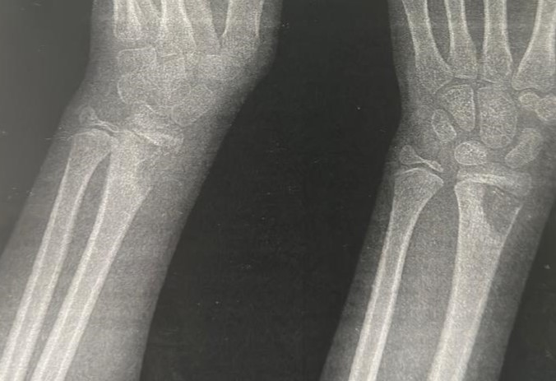
Fig 1 : Radiograph of the Right Wrist in a 7-Year-Old Girl: Anteroposterior radiograph of the right wrist showing a well-defined metaphyseal lytic lesion involving the distal radius, with marked thinning of the lateral cortical bone and no periosteal reaction.
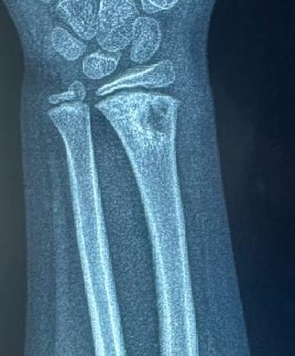
Fig 2 : wrist radiograph at two months after biopsy and initiation of anti-inflammatory therapy: Anteroposterior radiograph of the right wrist obtained two months after treatment shows clear interval improvement, with progressive filling of the metaphyseal lytic lesion of the distal radius and partial cortical restoration. No new areas of bone destruction or periosteal reaction are observed, consistent with a favorable healing response in monofocal chronic nonbacterial osteitis.
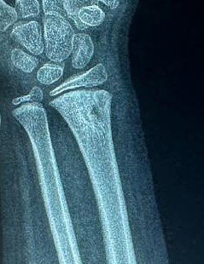
Fig 3 : Follow-up radiograph at 4 months: Anteroposterior radiograph of the right wrist obtained four months after treatment initiation, showing marked radiologic improvement with progressive infilling of the metaphyseal lesion of the distal radius and reconstitution of the cortical contour. The bone architecture appears more homogeneous, reflecting ongoing healing of monofocal chronic nonbacterial osteitis.
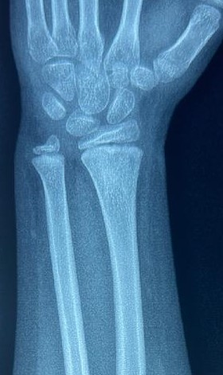
Fig 4 : Final radiographic follow-up at 6 months : Post-treatment anteroposterior radiograph of the right wrist showing complete remodeling of the distal radial metaphysis with restoration of cortical thickness and disappearance of the previous lytic defect, indicating full radiological healing of monofocal chronic nonbacterial osteitis.
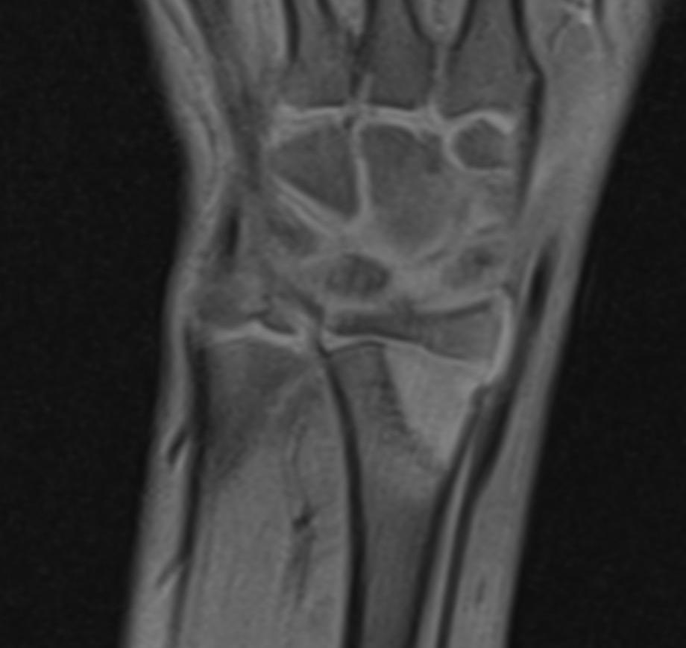
Fig 5 : Coronal MRI of the distal radius at initial presentation : Coronal MRI showing a well-defined metaphyseal lesion of the distal radius, displaying high signal intensity on fluid-sensitive sequences and low signal on T1-weighted images. No soft-tissue extension or fluid collection is observed. The imaging appearance initially suggested eosinophilic granuloma or a Brodie abscess.
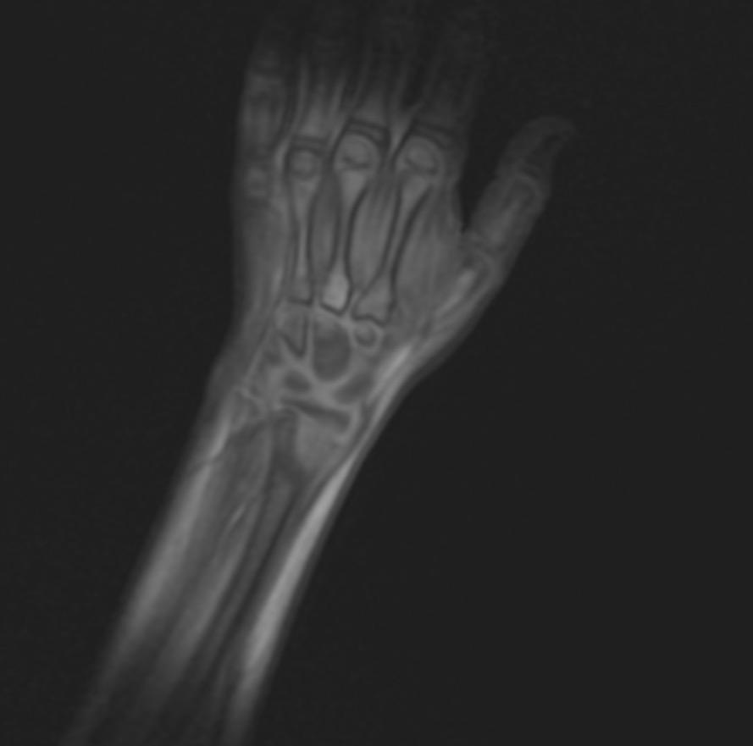
Fig 6 : Axial MRI of the Right Wrist : Axial MRI sequence showing circumscribed marrow signal alteration of the distal radius without extension to surrounding soft tissues. The absence of abscess formation or aggressive features supports an inflammatory rather than infectious or tumoral etiology.
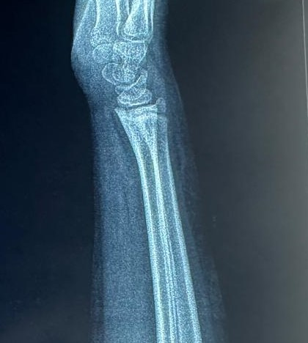
Fig 7 : Lateral wrist radiograph showing complete resolution of the lesion : Lateral radiograph of the right wrist demonstrating complete regression of the metaphyseal lytic lesion of the distal radius, with full cortical restoration and normalization of bone structure after treatment.

