Case report
Displaced Mandibular Body Fracture in a Preschool Child: A Case Managed by Closed Reduction

ABSTRACT

The management of mandibular fractures in pediatric patients is complicated by the presence of developing tooth buds and growth centers, making conservative approaches often preferable to avoid iatrogenic injury. This report details the application of such a principle in a 4-year-old male who sustained a displaced left mandibular body fracture after a fall. Confirmed by CT scan, the fracture was managed successfully with closed reduction and maxillomandibular fixation (MMF) using arch bars and elastics, performed entirely via an intraoral approach. The 30-minute procedure resulted in an excellent outcome, with the patient achieving full restoration of function and aesthetics after a four-week fixation period and no complications. This case demonstrates that closed reduction with MMF is a highly effective, minimally invasive strategy for managing select mandibular fractures in young children, preserving growth potential while ensuring optimal recovery.

Keywords: Pediatric mandibular fracture, closed reduction, maxillomandibular fixation, conservative management, intraoral approach.
1. INTRODUCTION

A mandibular fracture is a break in the continuity of the mandibular bone caused by pathological conditions or facial trauma [1,2]. Although the mandible exhibits greater resistance to impact forces than other facial bones, its fractures remain highly prevalent. Traffic accidents account for approximately 40–42% of maxillofacial fractures, followed by falls, assaults, and sports-related or occupational injuries. Males are significantly more affected than females, with a ratio of approximately 5:1 [3]. Due to their proportionally larger craniofacial volume, children are more susceptible to craniofacial trauma than adults. Maxillofacial injuries are rare in children under five (0.6%–1.4%), but their incidence rises during school age and peaks again in adolescence [4]. Anatomically, mandibular fractures are classified as follows: symphysis/parasymphysis (30–50%), body (21–36%), angle (15–26%), condyle (20-26%), ramus (2–4%), and coronoid process (1–2%). The management of these fractures has evolved significantly with advancements in medical science [5]. The overall complication rate following mandibular fracture fixation is approximately 58% [6]. While open reduction and internal fixation (ORIF) provides rapid stabilization, promotes faster healing, and shortens recovery time compared to intermaxillary fixation, it carries an average infection risk of 12.5% due to the introduction of foreign materials at the fracture site. Furthermore, no single empirical peri-operative antibiotic can effectively target all endogenous oral flora, which may permit opportunistic infections by resistant bacteria [7]. Reported complications include postoperative malunion (2.9%), malocclusion (7.6%), and unplanned reoperation (9.5%). Significant risk factors for these complications include alcohol use, smoking at the time of surgery, fractures displaced more than 2 mm, and a high Methotrexate Intolerance Severity Score (MISS) [8]. The primary goals of mandibular fracture treatment are to restore and maintain anatomical form, function, and occlusion using minimally invasive techniques for reduction and fixation. Treatment options are broadly categorized into conservative and surgical approaches. Conservative management involves clinical and radiological monitoring without surgical intervention [9]. Surgical options include closed reduction and open reduction, the latter often combined with internal fixation. In pediatric patients, however, mandibular growth and the various stages of dentition are critical considerations when selecting a treatment plan. The fracture pattern and location, the presence of tooth buds and growth centers, and the patient's adaptive capacity must all be evaluated [10]. In children, open reduction and internal fixation (ORIF) with rigid titanium miniplates is generally avoided to prevent interference with bone growth and potential facial deformity. While biodegradable plates offer an alternative, their cost can limit widespread use. Given these factors, closed reduction is often the preferred approach. This clinical overview discusses the management of mandibular fractures in children using the closed reduction technique [11,12]. While resorbable plates show promise for the future, they are not yet FDA-approved for weight-bearing areas like the mandible. Some clinicians have achieved success by using self-reinforced resorbable plates off-label. Furthermore, displaced condylar fractures in children are often successfully treated nonsurgical, with generally good long-term outcomes, though rare growth disturbances can occur and are hard to predict [13]

2. Case Presentation

A 4-year-old male patient was admitted to the emergency department following a fall from a height. According to the parents, the child landed directly on a hard surface.
General Condition: The patient was conscious, crying, and in pain, but cooperative and comforted by his parents. Sensorineural functions were intact, and the Glasgow Coma Scale (GCS) score was 15/15. He maintained normal nasal breathing with abdominal movement and showed no signs of respiratory distress. There were no signs of distal bony fractures or hemodynamic instability.
Local Condition: Examination revealed no signs of cervical spine fracture or airway obstruction. Left-sided hemifacial edema with abrasions was observed [Figure 1]. There was no soft tissue injury or active bleeding intraorally. Mandibular examination revealed a closed, displaced, Type A fracture of the left body. MDCT scans confirmed a fracture between the body and angle of the left mandible, with no involvement of the unerupted permanent tooth buds. The fracture was unfavorable (displaced), with teeth present on both sides of the fracture line. Planned skull X-rays, including Town's view, and three-dimensional CT reconstruction clearly showed the displaced fracture segment and the preserved dentition on both sides [Figures 2, 3]. The decision was made to proceed with closed reduction followed by maxillomandibular fixation (MMF).

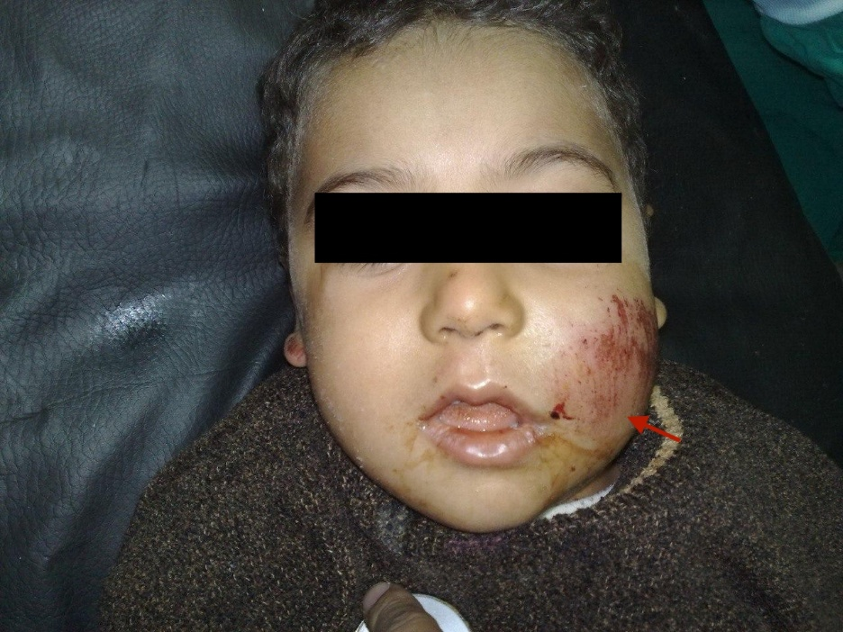
Figure 1. Left hemifacial edema with abrasions. (Red arrow).

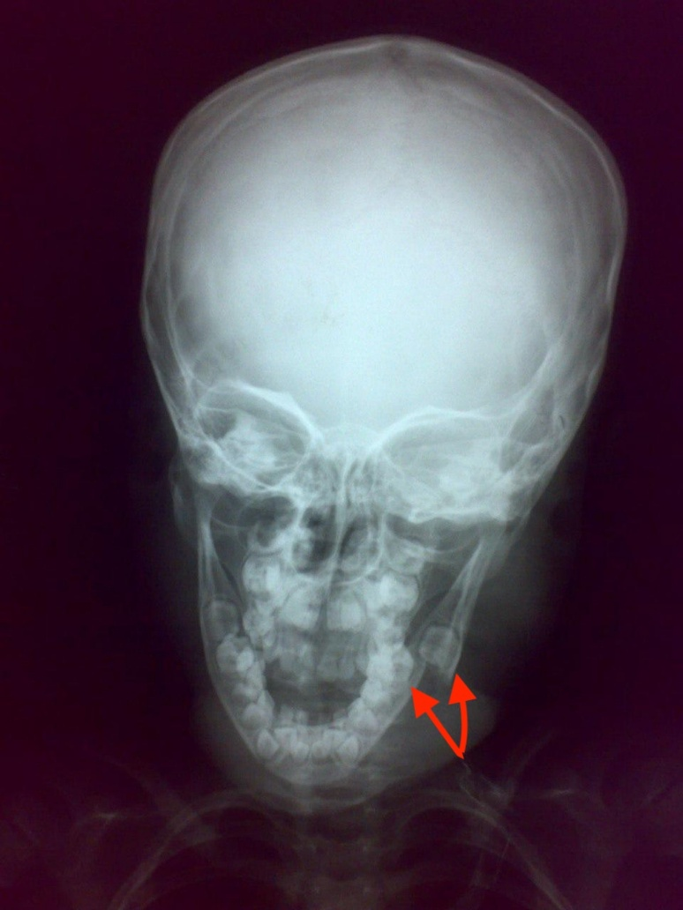
Figure 2. Skull x-rays; Town Views showing that Teeth were present at both sides of fracture line. (Red arrows)
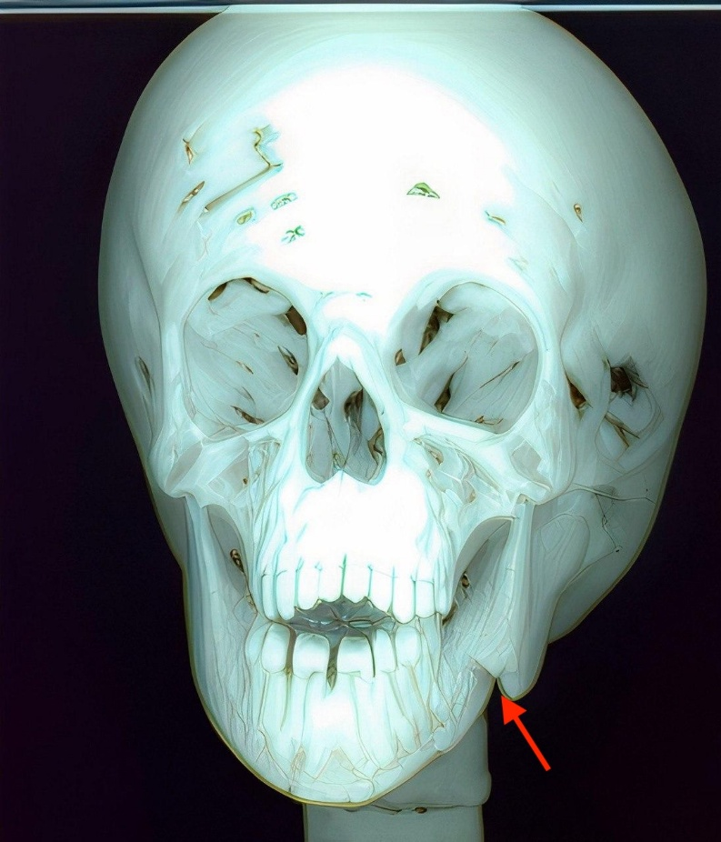
Figure 3. Multidetector computerized tomography (CT) showed fracture between body and angle of mandible. (Red arrow).
2.1 Surgical management
The patient received a prophylactic intravenous dose of 320 mg cefazolin and 240 mg Perfalgan solution. Under general anesthesia, the patient was positioned with the neck extended and the head tilted, followed by nasal intubation. A jaw retractor was used to expose the fracture site [Figure 4]. An oropharyngeal pack was placed to prevent aspiration. Initial manual reduction of the fracture was performed. Arch bars were then fixed using 0.5 mm interdental wires to achieve fracture stabilization. After removal of the oropharyngeal pack, elastics were attached to the hooks on both arches, ensuring closure of the oral cavity and immobilizing the fracture [Figure 5]. The entire procedure was completed via an intraoral approach, despite the challenging access to the fracture site, which often necessitates an extraoral technique. The total operative time was 30 minutes. Postoperative skull X-rays (Town's and lateral views) confirmed satisfactory fracture reduction, restoration of normal occlusion, and the absence of complications [Figures 6, 7].
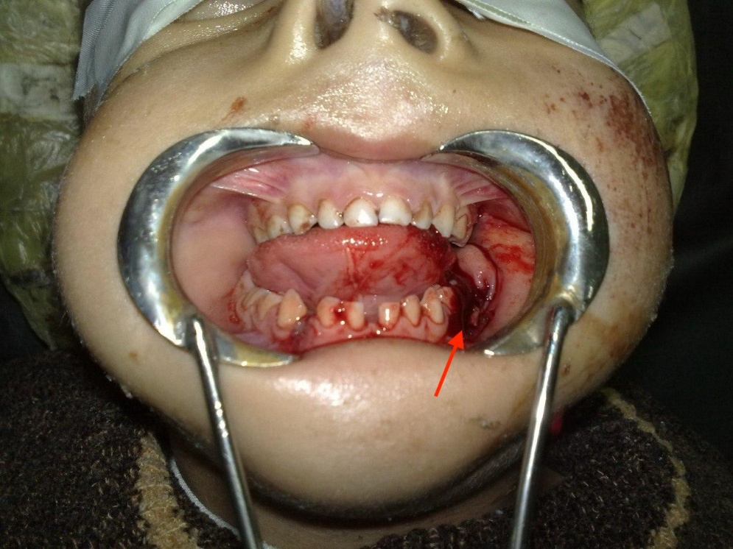
Figure 4. Mandibular fracture is exposed by jaw retractor. (Red arrow)

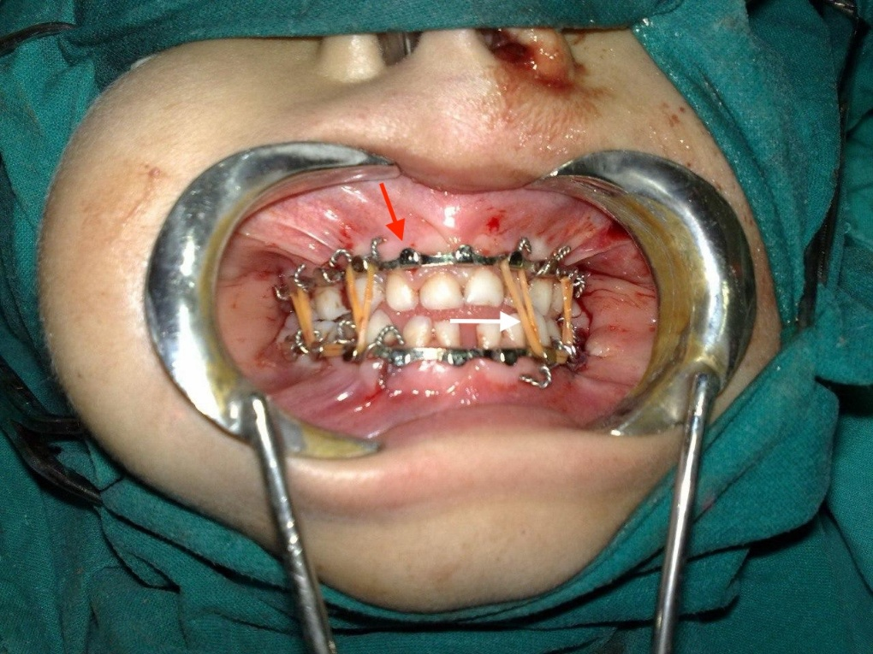
Figure 5. Maxillomandibular fixation (Red arrow) with attachment of elastics for closure of oral cavity (White arrow).
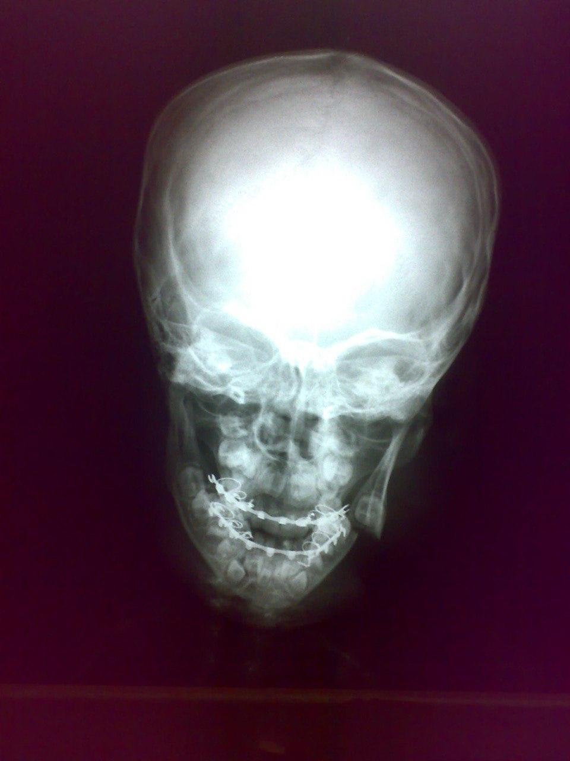
Figure 6. Postoperative x-ray Town view.
.
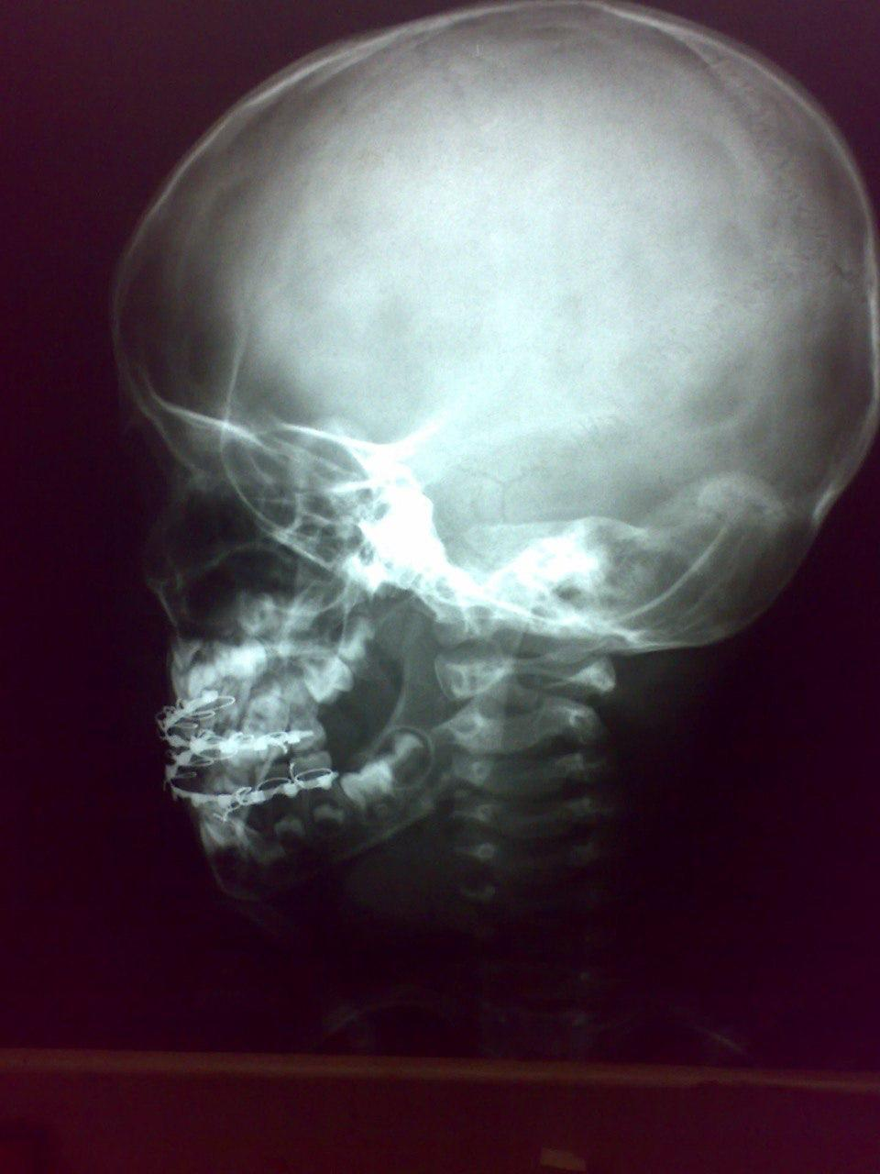
Figure 7. Postoperative x-ray Lateral view.
2.2 Results and Follow-Up
The patient regained consciousness smoothly. Feeding was initiated a few hours post-operatively by administering blended solid foods via a syringe into the retromolar space, supplemented with a semi-solid and liquid diet. The patient was hospitalized for four days and received detailed instructions on medication, oral hygiene, and the critical importance of not disturbing the intermaxillary elastics. At the two-week follow-up in the outpatient clinic, an oral examination was performed, the elastics were removed, a Towns view follow-up skull X-rays was performed which revealed stability of the fracture with normal oral occlusion (Figure 8), the parents were advised to continue with a soft diet. The arch bars were removed after a further two weeks under sedation and normal abdominal occlusion was restored with no deformity or complications (Figure 9). The patient subsequently resumed a normal life, with both masticatory function and cosmetic appearance successfully restored without any post-operative complications or recurrence.

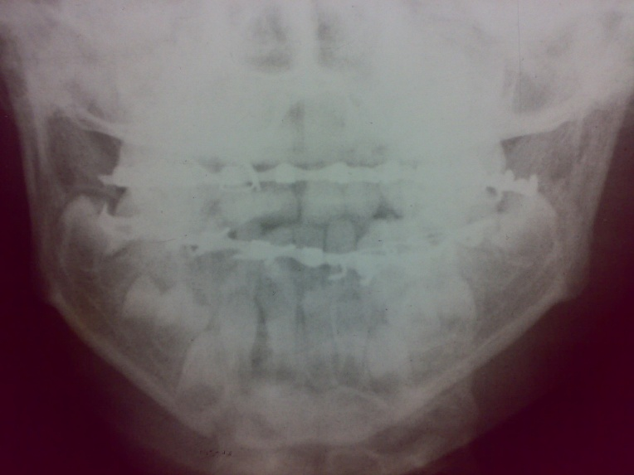

Figure 8. Skull X-rays (Town view) demonstrating the stability of the fracture with normal oral occlusion.
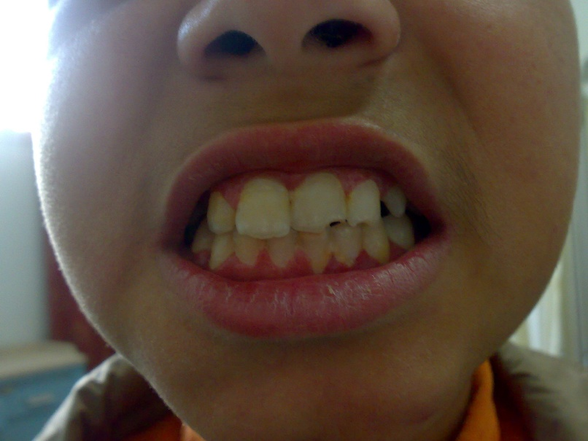
Figure 9. Postoperative photograph after removal of the elastics demonstrating normal oral occlusion with no complications or deformity.
3. Discussion

Our decision to use an intraoral approach aligns with findings in the literature. A 2014 comparative study by Devireddy et al. found that while an extraoral approach offers superior surgical accessibility for mandibular angle fractures, the transoral procedure is significantly faster (49.7 vs. 73.4 minutes) and is rated as less difficult [14]. This supports the feasibility of the intraoral route, even in complex cases. Furthermore, conservative management via intraoral closed reduction is a well-established and effective strategy in pediatric patients. As demonstrated by Li et al. (2023), such techniques successfully achieve fracture stabilization and occlusal restoration while minimizing surgical trauma and avoiding iatrogenic injury to developing dental structures [15]. While there is a growing trend toward open reduction and internal fixation (ORIF) for severely displaced and unstable pediatric fractures [16], our case demonstrates that closed reduction remains a prudent and successful primary option for select cases in the growing mandible. For most mandible fractures, closed reduction and immobilization remains a predictable treatment. The ideal treatment for children is typically the most conservative option suited to the individual case [13].So, from all the above mentioned studies besides our working experience, we choose closed reduction technique as a strategy for the mangment of pediatric facial fractures.

4. Conclusion

This case report demonstrates the successful management of a mandibular fracture in a 4-year-old patient via an intraoral approach with maxillomandibular fixation (MMF). This technique was selected to achieve two primary objectives: optimal aesthetics, by avoiding external scars and preserving facial contour, and safety, by using non-rigid stainless-steel fixation to prevent potential growth disturbance. This conservative, cost-effective strategy resulted in an excellent postoperative outcome, fully restoring function without aesthetic compromise, and highlights the importance of a tailored approach in pediatric craniofacial trauma.

Competing interests

Authors have declared that no competing interests exist.

Ethical approval
All authors hereby declare that all experiments have been examined and approved by the appropriate ethics committee and have therefore been performed in accordance with the ethical standards laid down in the 1964 Declaration of Helsinki.

Consent
As per international standards, parental written consent has been collected and preserved by the author(s)

Disclaimer (Artificial intelligence)
Authors hereby declare that NO generative AI technologies such as Large Language Models (ChatGPT, COPILOT, etc.) and text-to-image generators have been used during the writing or editing of this manuscript.

5. References

- Horswell, B. B., & Meara, D. J. (2020). Pediatric facial trauma. In M. Miloro, G. E. Ghali, P. E. Larsen, & P. Waite (Eds.), Peterson's principles of oral and maxillofacial surgery. Springer. https://doi.org/10.1007/978-3-030-91920-7_28
- Naeem, A., Gemal, H., & Reed, D. (2017). Imaging in traumatic mandibular fractures. Quantitative Imaging in Medicine and Surgery, 7(4), 469–479. https://doi.org/10.21037/qims.2017.08.06
- Chrcanovic, B. R. (2012). Factors influencing the incidence of maxillofacial fractures. Oral and Maxillofacial Surgery, *16*(1), 3–17. https://doi.org/10.1007/s10006-011-0280-y
- Sameh, S., Mekhaeel, S., Protasov, V., Taha, N., & Elshliby, A. (2025). Management of pediatric fracture mandible by closed reduction technique: A case report. Asian Journal of Case Reports in Surgery, 8(1), 119–126. https://doi.org/10.9734/ajcrs/2025/v8i1609
- Panesar, K., & Susarla, S. M. (2021). Mandibular fractures: Diagnosis and management. Seminars in Plastic Surgery, 35(4), 238–249. https://doi.org/10.1055/s-0041-1735818
- Moreno, J. C., Fernández, A., Gómez, E., Navarro, P., & García, M. A. (2000). Complication rates associated with different treatments for mandibular fractures. Journal of Oral and Maxillofacial Surgery, 58(3), 273–280. https://doi.org/10.1016/S0278-2391(00)90051-X
- Salem, S., Mekhaeel, M. S. F., Protasov, A., Nada, T., Mohamed, A., & Noureldin, S. (2024). Outcomes of a pediatric facial fracture reconstruction: Case report. Archiv Euromedica, 14(6), 1–8. https://doi.org/10.35630/2024/14/6.604
- Mekhaeel, M. S. F., Sameh, S. M. A. E., Andrey, P. V., Elsayed, T. N. A. M., & Zaky, E. A. G. (2025). Refracture and realignment of a malunited mandibular fracture: A case report. Asian Journal of Case Reports in Surgery, 8(1), 185–191. https://doi.org/10.9734/ajcrs/2025/v8i1621
- Hofmann, E., Koerdt, S., Heiland, M., Raguse, J. D., & Voss, J. O. (2023). Pediatric maxillofacial trauma: Insights into diagnosis and treatment of mandibular fractures in pediatric patients. International Journal of Clinical Pediatric Dentistry, 16(3), 499–509. https://doi.org/10.5005/jp-journals-10005-2401
- Zhao, J., Lu, C., Zhu, H., Zhang, X., Sun, H., Nie, X., Yang, C., & He, D. (2025). Open reduction and internal fixation with disc reduction for pediatric condylar fractures: Three-dimensional CT evaluation and follow-up results. Journal of Cranio-Maxillofacial Surgery. Advance online publication. https://doi.org/10.1016/j.jcms.2025.11.009
- Bansal, A., Yadav, P., Bhutia, O., Roychoudhury, A., & Bhalla, A. S. (2021). Comparison of outcome of open reduction and internal fixation versus closed treatment in pediatric mandible fractures—A retrospective study. Journal of Cranio-Maxillofacial Surgery, 49(3), 196–205. https://doi.org/10.1016/j.jcms.2020.12.013
- Mekhaeel, M., Fakhry, S., Sameh, S., Eissa, M. A., Protasov, A., Zaky, E., & Mohamed, N. A. (2025). Rehabilitation of pediatric mandibular fracture following dashboard injury: A case report. Asian Journal of Case Reports in Surgery, *8*(1), 155–161. https://doi.org/10.9734/ajcrs/2025/v8i1616
- Goth, S.D., Sawatari, Y., Peleg, M. (2012) Management of Pediatric Mandible Fractures. J Craniofac Surg, 23(1):47-56. https://doi.org/10.1097/SCS.0b013e318240c8ab
- Devireddy, S. K., Kishore Kumar, R. V., Gali, R., Kanubaddy, S. R., Dasari, M. R., & Akheel, M. (2014). Transoral versus extraoral approach for mandibular angle fractures: A comparative study. Indian Journal of Plastic Surgery, 47(3), 354–361. https://doi.org/10.4103/0970-0358.146590
- Li, L., Acharya, K., Ghimire, B., Li, Y., Xing, X., Hou, X., Hou, L., & Hu, X. (2023). Conservative management of mandibular fractures in pediatric patients during the growing phase with splint fiber and ligature arch wire. BMC Oral Health, 23(1), Article 601. https://doi.org/10.1186/s12903-023-03309-z
- Kim, T. W., Seo, E. W., & Song, S. I. (2013). Open reduction and internal fixation of mandibular fracture in an 11-month-old infant: A case report. Journal of the Korean Association of Oral and Maxillofacial Surgeons, 39(2), 90–93. https://doi.org/10.5125/jkaoms.2013.39.2.90

