Case report
Giant Multiloculated Ameloblastoma Causing Extensive Destruction of the Mandible and Midface: A Case Report

Abstract:

Ameloblastoma is a slow-growing odontogenic tumor that can cause painless swelling of the face. The local aggressive behavior of the tumor may directly damage surrounding soft and hard tissues. The study aims to report a rare case of a giant multiloculated ameloblastoma with extensive mandibular and midfacial destruction and to highlight its diagnostic and surgical management challenges. Herein we present a rare case of giant ameloblastoma in a male patient with massive enlargement of the left side of the face, resorption of hemi-mandible and left maxilla, and destruction of facial skeleton. Treatment consisted of radical hemimandibulectomy for removal of the tumorous mass, with stabilization using a reconstruction plate. For giant ameloblastoma, the diagnosis and treatment strategies for each surgical intervention depend on an accurate understanding of anatomical structures, including their positions and spatial relationships. CT imaging facilitates precise identification of the lesion's extent and location, providing additional critical information that can assist in the selection of suitable treatment options. In summary, despite the stability of human anatomy over time, accurate understanding of anatomical structures and their clinical manifestations remains essential for effective diagnosis and formulation of treatment strategies in contemporary surgical practices.

Keywords: Ameloblastoma; facial; hemi mandibulectomy; mandible;facial swelling

Introduction:

Ameloblastoma is a common but enigmatic tumour of the jaw and constitutes about 10% of all tumours that arise in the mandible and maxilla. It is one of the most common benign odontogenic tumours (Ghai, 2022; Fuchigami et al., 2021). It is a benign tumour that is destructive and aggressive locally. This tumour can become very large, which could cause bone deformity, facial asymmetry, and the soft tissues and neurovascular structures to shift. Remaining dental lamina and odontogenic epithelium in the mandible and maxilla are typically the source of ameloblastoma. It occurs between the ages of 30 and 60, and usually affects both sexes at roughly equal rates. Ameloblastoma constitutes 1–3% of all tumours and cysts of the jaws, with 80% occurring in the mandible and 20% in the maxilla. It often presents as a slow-growing, asymptomatic swelling which causes expansion and/or perforation of cortical bone (Shi et al., 2021). In the general population, the peak age at diagnosis occurs in the fifth decade of life, whereas in Europe, the peak incidence is observed in adults in their fifth and sixth decades. This case report's goal was to draw attention to an extensive and destructive ameloblastoma.

Case report

This case involves a 28-year-old man, with no particular medical past history, that was referred to our department for a 3-year developing left facial swelling, increasing in volume progressively, with a poor oral and dental condition (Fig 2 ).The patient didn’t have any pain, or trouble breathing or eating.

Medical examination revealed an enormous swelling on the left side of the face affecting the temporal, parotideomasseteric, zygomatic regions of the head, and the entire left half of the mandible, with a mimimal extension to the oral and cervical region (Fig 1,2 ).


Fig 1 : Clinical image showing a left sided facial swelling

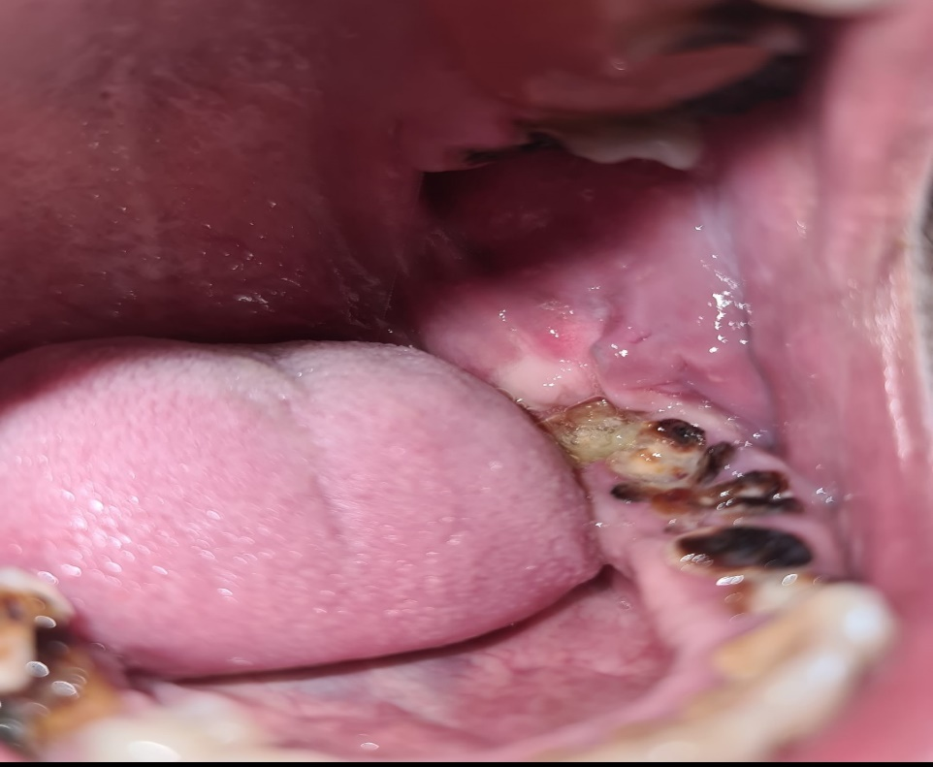
Fig 2: Clinical image showing the extent of the mass
in the oral cavity and the poor oral and dental health

3D CT imaging revealed the presence in the left angular region and ascending left branch of the mandible of an oval formation, with lobulated contours, and tissue zones enhanced after injection, delimiting cystic zones, thus realizing
the soap bubble appearance, measuring 38x56mm, extended over 76mm.
It is responsible for displacement and rhizalysis of teeth 37 and 38, associated with thinning of the cortical bone and local bone lysis.
At the top, it extends to the neck of the mandibular condyle, and comes into contact with the lower wall of the homolateral maxillary sinus, filling the left masticatory space.
Axial,coronal and 3D CT images (Fig 3,4) showed, at the expense of the left ascending ramus of the mandible, a fairly well-limited central tumoral mass syndrome, lysing the cortical bone and infiltrating the soft tissues.
Mediolaterally, it comes into contact with the medial pterygoid muscle, losing the fatty border of separation.
Posteriorly, it displaces the parotid gland, with loss of the separating fat border. In addition, a total filling of the left maxillary sinus associated with mucosal thickening of the right maxillary sinus on dental effraction is found.

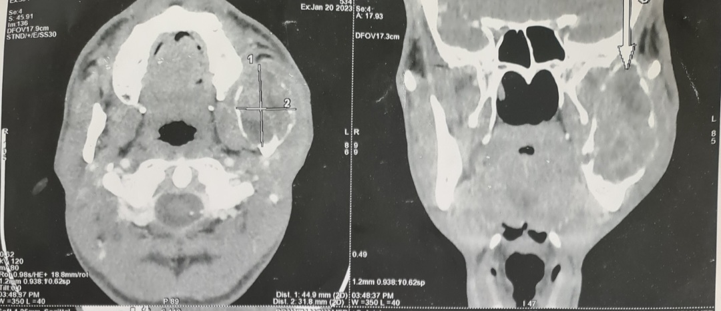
Fig 3 : Axial and coronal image showing the left mandibular mass

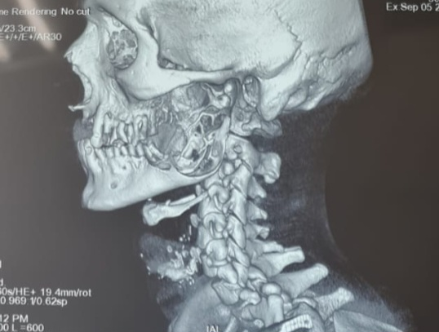
Fig 4 : 3D CT scan image showing the extent of the mass

Dental panoramic X-ray (Fig 5) showed the classic expansible soap-bubble lesions, with a well demarcated borders and no matrix calcification. There were also a resorption of adjacent teeth with a root blunting.

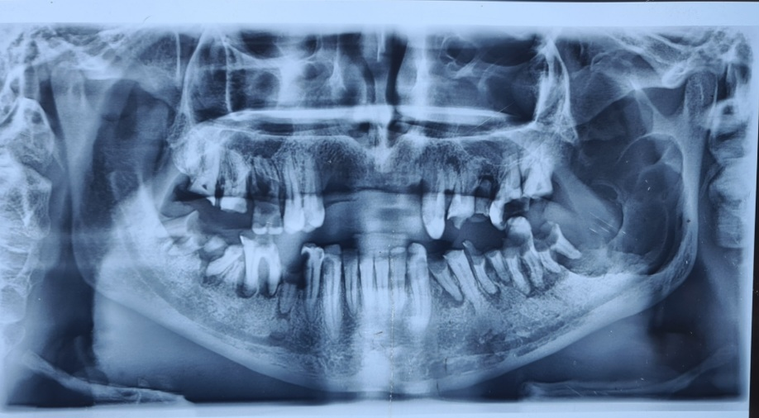
Fig 5 : dental panomaric X-ray showing the classic soap bubble lesion

The surgical procedure involved a radical excision of the tumor. A mandibular body and ascending branch resection was carried out, and a maxiplate was utilized for stabilization. The postoperative recovery was uncomplicated.

During follow-up, the patient demonstrated significant improvement and proper healing. Histopathological analysis confirmed the diagnosis of a follicular and plexiform ameloblastoma, with no evidence of malignant transformation.

Discussion:

Ameloblastoma, traditionally characterized as an intraosseous lesion, is a benign epithelial odontogenic tumor that grows slowly. It accounts for 10% of all odontogenic tumors affecting the mandible and maxilla, which together constitute about 90% of ameloblastoma cases. The majority of these tumors are diagnosed in young adults, with a median age range of 10 to 38 years [1- 3]. It affects more the male sex, and it’s is more frequent in black population [4].

There are no known risk factors at this time, and the etiology is unclear.

Approximately 80% of ameloblastomas are located in the mandible, predominantly in the posterior region [5,6]. Patients frequently remain asymptomatic due to the tumor's intermittent growth pattern, which typically does not produce noticeable swelling. In cases of rapid and extensive growth, these aggressive tumors can lead to facial asymmetry, pathological fractures, and impairment of neurovascular functions in the affected and surrounding regions [5]. The tumors may invade through the cortical bone into soft tissues, resulting in compromised facial expressions, speech difficulties, and limited mouth opening. Paresthesia and pain are uncommon symptoms [6].

The most prevalent presenting feature is a painless swelling of the face. Additional clinical signs include malocclusion, displacement of teeth, and tooth mobility [6,7].

The delay in consultation can be attributed to several factors, including the slow progression of the tumor, patient negligence , as well as the influence of low socio-economic status . In some cases, ameloblastomas are incidentally discovered through radiographic examinations conducted for unrelated reasons [8].

The most sensitive method for differential diagnosis is histological examination. Nonetheless, the final diagnosis depends too on the radiological and clinical results.

When dealing with larger tumors, magnetic resonance imaging, CT, and 3D images are helpful and offer accurate information in evaluating the lesion’s buccolingual expansion and cortical bone destruction [9].
Understanding the distinctive features of radiological imaging helps to narrow the differential diagnosis and is essential for treatment planning [9].

Ameloblastoma typically exhibits a histological architecture characterized by a central region composed of epithelial islands with radiating cells that display a loose arrangement and frequently form microcysts. The peripheral zone consists of epithelium in which the cells show inverted nuclear polarity and contain vacuoles located above the nucleus [10].

Since ameloblastoma recurs often, a drastic course of treatment is required. Two therapeutic options are available: radical treatment, which involves removal of the bone tissue while maintaining the margins of exeresis, and conservative treatment, which involves marsupialization, enucleation, and curettage.

The procedure is usually mutilating and involves surgery, particularly in more severe cases. A number of factors must be taken into account when making a therapeutic decision, including the patient's age, the lesion's anatomical location, its extension, the radiological aspect, its evolution possibilities, and the possibility of a routine follow-up [11].
Ameloblastoma is prone to return even after ostensibly well-executed surgical treatment and even extensive resections with pathologically healthy recuts, most likely because of microtumor bone foci that persist separately from the primary tumor [12].

CONCLUSION:

In summary, despite the stability of human anatomy over time, accurate understanding of anatomical structures and their clinical manifestations remains essential for effective diagnosis and formulation of treatment strategies in contemporary surgical practices. Although ameloblastoma is a locally invasive tumor, postponing surgical intervention can result in significant facial disfigurement ; consequently, prompt referral to a specialist is the most appropriate course of action.

ETHICAL APPROVAL:
Ethical approval was provided by the authors institution.

Written informed consent was obtained from the patient for publication of this case report and accompanying images.

Disclaimer (Artificial intelligence)
Author(s) hereby declare that NO generative AI technologies such as Large Language Models (ChatGPT, COPILOT, etc.) and text-to-image generators have been used during the writing or editing of this manuscript.

REFERENCES:

- Reichart PA, Philipsen HP, Sonner S. Ameloblastoma: biological profile of 3677 cases. Eur J Cancer B Oral Oncol 1995; 31B: 86–99.
- Dhanuthai K, Chantarangsu S, Rojanawatsirivej S, et al. Ameloblastoma: a multicentric study. Oral Surg Oral Med Oral Pathol Oral Radiol 2012; 113: 782–788.
- Kreppel M andZöller J.. Ameloblastoma – clinical, radiological, and therapeutic findings. Oral Dis 2018; 24: 63–66.
- Kramar I.-R.H., Pindborg J.-J. ORL; Paris): 1991. SHEAR M Histological typing of Odontogenic tumoursWorld Health Organization.3-CUDENNEC Y-F, PONCET J-L, BUFFE P Kyste du maxillaire supérieur EMC. 20482A10 :8P
- Kitisubkanchana J, Reduwan NH, Poomsawat S, et al. Odontogenic keratocyst and ameloblastoma: radiographic evaluation. Oral Radiol 2021; 37: 55–65.
- 8.Soylu E, Bayındır S, Demirbaş AE, et al . How often are ameloblastomas in middle anatolia? a 13-year retrospective study. Ann Clin Anal Med 2020; doi:10.4328/ACAM.20275.
- Almeida RAC, Andrade ES, Barbalho JC, et al. Recurrence rate following treatment for primary multicystic ameloblastoma: systematic review and meta-analysis. Int J Oral Maxillofac Surg 2016; 45: 359–367
- Janah A., Kadiri F., Chekkoury I.A., Benchakroun Y. Les tumeurs bénignes des maxillaires. Approche diagnostique et thérapeutique. Rev. Laryngol. Otol. Rhinol. 1995;30(3):164–170.
- Meng Y, Zhao YN, Zhang YQ, et al. Three-dimensional radiographic features of ameloblastoma and cystic lesions in the maxilla. Dentomaxillofac Radiol 2019; 48: 20190066.
- Ramdas K., Jose C.C. Pulmonary metastasis from améloblastome of the mandible treated with cisplatin, adriamycin, and cyclophosphamide. Cancer. 1990;66:14475. doi: 10.1002/1097-0142(19901001)66:7<1475::aid-cncr2820660707>3.0.co;2-d.
- Sophia Nitassi, Malik Boulaadass, Imane Tobi, Laila Essakali et Mohammed Kzadri . Ameloblastoma : diagnosis and treatment. Report of 26 cases
- Vallicioni J., Loum B., Dassonville O., Poissonnet G., Ettore F., Demard F. Les améloblastomes. Ann. Oto-Laryngol. Chir. Cervico-Faciale. 2007;124(4):166–171. doi: 10.1016/j.aorl.2006.08.006.
- 13. Ghai, S. (2022). Ameloblastoma: An updated narrative review of an enigmatic tumor. Cureus, 14(8), e27734. https://doi.org/10.7759/cureus.27734 Fuchigami, T., Ono, Y., Kishida, S., & Nakamura, N. (2021). Molecular biological findings of ameloblastoma. Japanese Dental Science Review, 57, 27–32. https://doi.org/10.1016/j.jdsr.2020.12.003
- Shi, H. A., Ng, C. W. B., Kwa, C. T., & Sim, Q. X. C. (2021). Ameloblastoma: A succinct review of the classification, genetic understanding and novel molecular targeted therapies. The Surgeon, 19(4), 238–243. https://doi.org/10.1016/j.surge.2020.06.009

