Case report

Rapidly Progressive Rhino-Orbital Mucormycosis in a Diabetic Patient: A Fatal Outcome

Abstract:

One of the most severe and quickly spreading types of fungal infections is mucormycosis, which typically starts in the nose and paranasal sinuses after fungal spores are inhaled. It is brought on by organisms belonging to the subphylum Mucormycotina, which includes genera like Absidia, Rhizomucor, Rhizopus, and Mucor. Every year, there are roughly 1 in 7 cases of mucormycosis for every 1,000,000 people. Because the maxillofacial regions have a rich blood vessel supply, mucormycosis affecting the maxilla is uncommon; however, more virulent fungi, like Mucor, can get past this obstacle. The rhinomaxillary region and patients with immunocompromised conditions, such as diabetes, are susceptible to the common form of this infection, that has a high fatality rate and rapid tissue destruction. Therefore, lowering the death rate depends critically on early detection of this potentially fatal illness and timely treatment, including surgery and antifungeal medication, and keeping control of diabetes.

Keywords: Mucormycosis, diabetes, necrosis, extensive, maxilla.

Introduction:

Mucormycosis is a rare opportunistic fungal infection caused by fungi belonging to the Mucorales order and the Mucoraceae family. It represents the third most common angioinvasive fungal infection following candidiasis and aspergillosis.[1] It usually affects the immunocompromised individuals and is rarely seen in apparently healthy individuals.[2] When immunity is weakened in a compromised host, fungal organisms proliferate and invade deeper tissues, leading to mucormycosis infection.[3]

The various predisposing factors for mucormycosis are uncontrolled diabetes especially in patients with history of ketoacidosis, renal failure, malignancies such as lymphomas and leukemias, long-term corticosteroid and immunosuppressive therapy, organ transplant, cirrhosis, acquired immune deficiency syndrome (AIDS), and burns.[4] Spores can be inhaled through the mouth, nose, or even a skin wound. The patient may not respond appropriately if their humoral and cellular defense systems are impaired, and a direct extension of the fungus to the paranasal sinuses could then lead to the orbit, meninges, and brain.Nonetheless, certain mucormycosis patients lack any discernible risk factors.[5] In order to successfully manage this deadly infection, early disease detection and swift, aggressive medical and surgical interventions are necessary to avoid the high morbidity and mortality rates linked to this disease process. [6] We report the case of a rhino-orbital mucormycosis in a diabetic patient.

Case Presentation

We report the case of a 70-year-old man, with a medical history of hypertension, and type 2 Diabetes on insulin, that was poorly controlled. The patient was referred to our department for a left facial and orbital swelling that appeared 3 months ago, increasing in volume progressively, along with the appearance of a black lesion in the nasal pyramid, that kept extending to the adjacent tissues. The patient experienced severe pain, headaches and a runny nose, with trouble breathing or eating (Fig 1 ).

Medical examination revealed an enormous swelling on the left side of the face affecting the left maxillary region, the left orbit and the nasal pyramid, which present a large lesion of necrosis. Rhinoscopy showed an extensive necrosis of the nasal mucosa and the septum. The ophthalmological examination showed a left palpebral edema, with multiples ecchymosis. The anterior chamber and the cornea were normal.

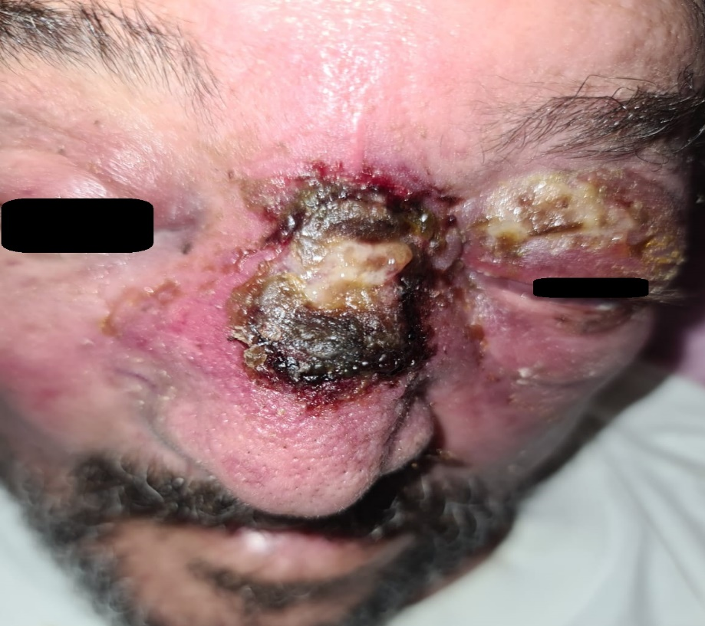
Fig 1 : Clinical image showing the swelling and the large
lesion of necrosis

CT scan imaging (Fig 2) showed a large collection regarding the the left inner canthus, along with an infiltration of the left orbito-maxillary region, extending to the nasal pyramid, in favor of a facial cellulitis due to pansinusitis.

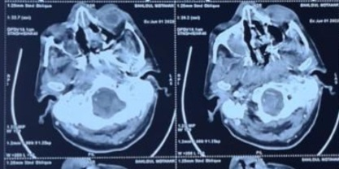
Fig 2: Facial CT scan showing the extent of the cellulitis

The patient was admitted, and intravenous treatment was started made of Ciprofloxacin, metronidazole and voriconazole, along with the treatment of his keratoacidosis.

The surgical exploration revealed a large necrosis of the nasal mucosa, and the nasal septum, without any identifiable anatomic element. A large necrosectomy was performed.

48h later, the patient presented neurological distress and was transferred to intensive care unit where he died 24h later.

The anatomopathological study performed on the necrosectomy tissue showed the presence of diffuse necrosis with large non-septate colored mycelial filaments.

Discussion:

Mucormycosis encompasses several diseases induced by Zygomycetes, a class of fungi characterized by branching, ribbon-like hyphae and sexual reproduction by the generation of zygospores. In addition to being widely present in fruits, soil, and excrement, pathogens can also be isolated from the throat, nasal passages, and oral cavity of healthy, disease-free people. A unique pattern of clinical infection is produced by the Zygomycetes subtype Mucorales. The fungi are typically avirulent; only in cases where host resistance is abnormally low, they do turn pathogenic. Mucormycosis in the maxillofacial region can enter through an oral extraction wound or mucosal ulcer, especially if the host has compromised immune function. [7] In a disease-free patient, the epithelium acts as an active barrier against tissue and vascular invasion, the presence of an epithelium that has been compromised by chromic rhino sinusitis in an immunocompetent subject may explain the development of mucormycosis [8]. The spores may be stuck at the nasosinus mucosa level. Nevertheless, if left untreated or improperly handled, they may infiltrate the orbit and/or the base of the skull, resulting in the rhino-orbito-cerebral shape, or they may enter the bloodstream and spread in the body.

In a number of ways, diabetes tends to alter the body's typical immune response to any illness. In addition to increasing fungal growth, hyperglycemia also reduces phagocytic and chemotaxis efficiency, allowing ordinarily harmless species to flourish in an acidic environment. Rhizopus oryzae generate the enzyme ketoreductase, which enables them to exploit the patient's ketone bodies, increasing the risk of mucormycosis in diabetic ketoacidosis patients. [7] It has been demonstrated that diabetic ketoacidosis momentarily impairs transferrin's capacity to bind iron, which eliminates an important host defensive mechanism and allows Rhizopus oryzae to proliferate. [9]

The most prevalent type of infection frequently observed in individuals with uncontrolled diabetes mellitus is the rhinocerebral form. [10] Clinical manifestations of rhinocerebral mucormycosis include low-grade fever, headache, facial pain, and swelling. The illness typically starts in the palate or nasal mucosa and spreads to the paranasal sinuses. Furthermore, mucormycosis may directly extend into the retro-orbital region. [11]

Squamous cell carcinoma and chronic granulomatous infection should be included in the clinical differential diagnosis of the lesion. [12]

CT scan with contrast can show bone erosion and aid in determining the severity of the illness. [12]

The histopathological differential diagnosis includes aspergillosis, in which the Aspergillus species hyphae are septate, narrower, and branch at sharper angles [12]

A combination of systemic amphotericin B administration for three months and surgical debridement of the infected area may cure mucormycosis when detected early. Another crucial factor influencing the treatment's outcome is the treatment of the underlying disease, which on our case, was diabetes. [13].

CONCLUSION:

Mucormycosis is still a deadly condition with poor prognoses. Underlying risk factors, the speed of aggressive treatment, and comorbidities that affect treatment all have an impact on the clinical presentation and outcome. Early staging of mucormycosis is necessary to evaluate response to treatment, and imaging and drug monitoring are necessary for follow-up in order to forecast response.

ETHICAL APPROVAL:
As per international standards or university standards written ethical approval has been collected and preserved by the author(s).

Consent

Written informed consent was obtained from the patient’s family for publication of this case report and accompanying images.

Disclaimer (Artificial intelligence)
Author(s) hereby declare that NO generative AI technologies such as Large Language Models (ChatGPT, COPILOT, etc.) and text-to-image generators have been used during the writing or editing of this manuscript.

REFERENCES:

- Torres-Narbona M, Guinea J, Muñoz P, Bouza E. Zygomycetes and zygomycosis in the new era of antifungal therapies. Rev Esp Quimioter. 2007;20:375–86.

- Goel S, Palaskar S, Shetty VP, Bhushan A. Rhinomaxillary mucormycosis with cerebral extension. J Oral Maxillofac Pathol. 2009;13:14–7. doi: 10.4103/0973-029X.48743.

- Salisbury PL, 3rd, Caloss R, Jr, Cruz JM, Powell BL, Cole R, Kohut RI, et al. Mucormycosis of the mandible after dental extractions in a patient with acute myelogenous leukemia. Oral Surg Oral Med Oral Pathol Oral Radiol Endod. 1997;83:340–4. doi: 10.1016/s1079-2104(97)90240-7.

- Neville WB, Damm D, Allen CM, Bouquot JE. 2nd ed. Philadelphia: W.B.: Saunders; 2001. Text Book of Oral & Maxillofacial Pathology; p. 16.

- Mohindra S, Mohindra S, Gupta R, Bakshi J, Gupta SK. Rhinocerebral mucormycosis: The disease spectrum in 27 patients. Mycoses. 2007;50:290–6. doi: 10.1111/j.1439-0507.2007.01364.x.

- Bakathir AA. Mucormycosis of the jaw after dental extractions: Two case reports. Sultan Qaboos Univ Med J. 2006;6:77–82.

- Marx RE, Stern D, editors. Carol Stream III, USA: Quintessence Publishing; 2003. Inflammatory, Reactive and Infectious Diseases in Oral and Maxillofacial Pathology; pp. 104–6.

- M. Ilharco, C.M. Pereira, L. Moreira,A.L. Proença, M. do Carmo Fevereiro, , F. Lampreia, et al. Rhinoorbital mucormycosis in the immunocompetent: experience with Isavuconazole

- Artis WM, Fountain JA, Delcher HK, Jones HE. A mechanism of susceptibility to mucormycosis in diabetic ketoacidosis: Transferrin and iron availability. Diabetes. 1982;31:1109–14. doi: 10.2337/diacare.31.12.1109.

- Spellberg B, Edwards J, Jr, Ibrahim A. Novel perspectives on mucormycosis: Pathophysiology, presentation, and management. Clin Microbiol Rev. 2005;18:556–69. doi: 10.1128/CMR.18.3.556-569.2005.
- Kim J, Fortson JK, Cook HE. A fatal outcome from rhinocerebral mucormycosis after dental extractions: A case report. J Oral Maxillofac Surg. 2001;59:693–7. doi: 10.1053/joms.2001.23407.
- Doni BR, Peerapur BV, Thotappa LH, Hippargi SB. Sequence of oral manifestations in rhino-maxillary mucormycosis. Indian J Dent Res. 2011;22:331–5. doi: 10.4103/0970-9290.84313.
- Burkets Textbook of Oral Medicine Diagnosis and Treatment. 10th edition. Canada: Elsevier; 2003. p. 79.

