Case report

A Giant cutaneous horn of the back with initial malignant transformation: A case report

Abstract
A cutaneous horn is conical projection of the skin and its soft tissue which is a result of a pathologic accumulation of material which is keratinized. There are numerous factors that are associated with cutaneous horns such as being male, increased age and lesion geometry. For people above the age of 50 years, the risk of malignant lesion is higher. A 21-year-old female presented to the clinic with a skin lesion on her back which had started 3 years ago. It began as a wound, which then progressed into a conical shaped swelling. On physical examination, it was 12 x 11 x 10 cm in size, hard, horny, fixed mass with irregular margins and heavy scarring located on the midline. X-ray and CT scan were done which showed no involvement of the spine. Wide surgical excision was done followed by skin grafting. The histology concluded that it was a cutaneous horn with early changes of verrucous carcinoma. She was then sent for radiotherapy.

Keywords: case report, cutaneous horn, surgery, split thickness skin graft

Introduction
A cutaneous horn is conical projection of the skin and its soft tissue which is a result of a pathologic accumulation of material which is keratinized. Grossly, it may look similar to an animal horn, but without bone within it (1). The true extent and prevalence of cutaneous horn is not known, but reports show that it is found more commonly in elderly population (more than 60 years). It is quite uncommon, but when it does present, it does so with numerous and various characteristics such as site, size, location and pathology (2, 3). There are numerous factors that are associated with cutaneous horns such as being male, increased age and lesion geometry. For people above the age of 50 years, the risk of malignant lesion is higher. Most common areas of predilection include the exposed areas of the head and the dorsum of the hands. About a half of these lesions are found to be benign (4). On the other hand, squamous cell carcinoma is the predominant type in malignant lesions. Exposure to extreme conditions and long duration to ultraviolet has also been reported as a risk factor. When it comes to size, most of them are relatively small, however large and giant cutaneous horns have been reported as case reports and are more likely to malignant lesions (5). Patients commonly present with pain, discharge, and or swelling. Appropriate history, a thorough examination, investigations and appropriate management is vital for best patient outcomes. The standard treatment used for cutaneous horn is surgical excision which is followed by histopathological diagnosis and thereafter radiotherapy and close follow up.

Case report.
A 21-year-old female presented to the clinic with a skin lesion on her back, which had been present for 3 years. It started as a wound, which then closed followed by a conical shape swelling. The lesion was not associated with pain, itching, bleeding, or a history of trauma or surgery. The patient reported that the lesion had increased in size and had caused any significant physical and psychological discomfort over the past 2 years. There was no any such report from any other family member.
On physical examination, a 12 x 11 x 10 cm in size, hard, horny, and curved growth was observed on the back, located on the midline. The margins were irregular and there was heavy scarring around the lesion. It was foul smelling but no active discharge. It was hard and fixed.
Investigations
X rays and CT scans were done which showed no involvement of the spine. (Figure 2)

Management
Wide surgical excision was planned and done under general anesthesia. Intra op findings confirmed the physical examination findings and additionally a foul smelling discharge was also encountered beneath the hard mass. Wide local excision was done and tissue was sent for histopathology alongside a detailed history and appropriate markings by stay sutures showing the orientation of the mass. The histopathology results showed papillomatous hyperplasia of squamous epithelium, granules and koilcytic atypia though mild and glassy cytoplasm. There was minimal atypia and mitosis at the base only. There was ample keratin formation and pushing pattern of squamous tissue islands. There was intense chronic inflammatory infiltrates in the upper dermis along with hemorrhages and pigmentary incontinence. The conclusion was a cutaneous horn with early changes of verrucous carcinoma.
After adequate granulation of the wound, the patient was taken for a split thickness skin graft which was harvested from the left thigh and transplanted into the raw area.
Thereafter she was sent for radiotherapy. The dose that was administered was 30Gy in 6Gy fractions (5 fractions).

Discussion
A new viewpoint on the variety of presentations of this uncommon dermatological condition is provided by the case of a 21-year-old woman who had a giant cutaneous horn.

For this patient, the lesion was 12 x 11 x 10 cm, making it one of the biggest horns reported in the literature. Most of the other cutaneous horns are much smaller ranging from being just 0.5mm to 2cm (6, 7). Furthermore the site of the lesion makes it interesting and perhaps more complex to manage. Most cutaneous horns are more abundant on sun-exposed parts like the face, scalp, and hands than being on the midline of the back such like the case under discussion. As seen before, cutaneous horns are quite common in head and in upper limb areas which are commonly exposed to the sun (dorsum of hand and forearm), however there are published case reports in which patients have them in unusual sites such as the heel (8). A previous review showed that almost a third of cutaneous horns are on the face and scalp whilst other areas such as chest, neck, arms and forearm have significant number seen (3).

The possibility of malignant transformation was highlighted by the histopathological findings, which showed early verrucous carcinoma alterations in this patient. This is consistent with findings from another study, which identified similar malignant relationships, where a cutaneous horn developed from verrucous cancer(2, 5). But not every cutaneous horn is cancerous. About 20% of cutaneous horns are malignant, of which squamous cell carcinoma is the most common. Some studies show that there is equal distribution of cutaneous horn amongst males and females however, males have more predilection to malignancy in additional to factors associated with the lesion including the size, hardness, large base to height ratio and being located in areas which are generally exposed to the sun(9). Few studies have also shown that infection with human papilloma virus also is a risk factor for having cutaneous horns which are malignant. It is quite important to distinguish between benign and malignant lesions as this directly affected the management and outcomes (7, 8). A study done by retrospectively looking at the histopathology of patients showed only 41.4% of the lesions were benign, the rest were premalignant or malignant. This variation emphasizes how crucial histological analysis is in ruling out cancer and directing therapy (9).
Another study (10) showed that 58% of such cases had premalignant or malignant lesions whilst another one done by showed a lower percentage (38.9%) of the lesions were malignant (11). Various studies showed that advance age is a risk factor for malignancy. The age of presentation of benign lesions is 8.9 years younger than those who present with malignant lesions. (12, 13)

Because of the size, risk for cancer, and psychological effects, enormous cutaneous horns can provide serious clinical issues. In this instance, even though there were no symptoms like pain or bleeding, the lesion still raised both functional and cosmetic issues. According to studies, wide surgical excision with distinct margins, as done here, is still the preferred course of treatment(3,9). In addition to helping identify the type of lesion, histopathology also helps determine whether further treatments are necessary, especially when there is malignant change.

In this instance, the lesion's congenital form highlights the significance of possible keratinization anomalies from birth, adding a unique perspective to our understanding of cutaneous horns. It stands in stark contrast to other instances in which prolonged irritation or exposure to sunlight was a major contributing factor(2, 5). In order to maximize results, this example highlights how crucial it is to identify the wide range of clinical symptoms, guarantee fast diagnosis, and pursue timely surgical management. Further highlighting the need for tailored therapies to this uncommon and complicated illness are comparisons with previous research.

After diagnosing appropriately, it is important to choose the appropriate management according to its characteristics such as its size and its histopathology. The gold standard of treating cutaneous horns is surgery. More extensive excision with distinct margins might be necessary in cases with malignant potential, as those linked to squamous cell carcinoma. Horns which are bigger in size are difficult to excise and also have much higher chances of being malignant. There are some cases reported which showed a lesion which was initially benign to change into malignancy (4, 7). Histological results have a significant impact on the decision to remove or wait and see since the risk of cancer demands prompt treatment. Monitoring for recurrence after surgery is crucial, particularly in cases where cancer is suspected. Wide surgical excision is still the gold standard in order to guarantee total eradication and avoid recurrence. According to the methodology outlined in circumstances comparable to this one, excision was carried out in this instance with distinct margins. To identify the type of lesion, direct future treatment, and assess the necessity of adjunct therapies particularly in cases with malignant transformation, histopathological evaluation is crucial(6, 9). Follow-up is essential to track for recurrence or progression.

Conclusion

This case report emphasizes how crucial it is to identify the diverse range of clinical manifestations of cutaneous horns. In addition to advancing knowledge of this rare dermatological condition, it emphasizes the necessity of careful assessment, prompt surgical intervention, and attentive follow-up to guarantee the best possible patient results.

Patient perspective
There was a lot of stigma and challenge for this young lady to come to the hospital for appropriate diagnosis and treatment. Emotionally this condition hampered her from during her daily activities and affected greatly her quality of life. This procedure aimed to improving her quality of life.

consent
Written informed consent was obtained from the patient for publication of this case report and accompanying images
Ethical Approval:
As per international standards or university standards written ethical approval has been collected and preserved by the author(s).

Disclaimer (Artificial intelligence)
Option 1:
Author(s) hereby declare that NO generative AI technologies such as Large Language Models (ChatGPT, COPILOT, etc.) and text-to-image generators have been used during the writing or editing of this manuscript.

Author contribution
Mohamed Muhamedhussein: Conceptualization, writing, editing.
Mohamed Manji: Conceptualization (Supporting), Writing – review & editing (Supporting)
Alihussein Molloo: Supervision (Supporting), Resources (Lead)
Shaneabbas Jaffer: Manuscript: Review and editing
Mohamed Kawambwa: Resources (Supporting)

References
- Griffiths, C. E. M., Barker, J., Bleiker, T., Chalmers, R., & Creamer, D. (Eds.). (2016). Rook’s textbook of dermatology (9th ed.). Wiley-Blackwell.
- Iro S, aadane A, Slimani F. Facial cutaneous horn in three different conditions: A highlight of a malignancy risk. International journal of surgery case reports. Volume 83, June 2021.
- Pandey R, Singh G, Behera M, Singh S. Cutaneous horn of heel: A rare case report and short review of the literature. J Cutan Aesthet Surg. :10–4103.
- Wan Aileen, Arastu, Kamran, Khachemoune Amor. Shedding New Light on Cutaneous Horns: A Comprehensive Review and Pitfall of Management. Indian Journal of Dermatology 70(1):p 50, Jan–Feb 2025.
- Bell M, Crane E, Burks R. Case report of a squamous cell carcinoma arising in a vulvar cutaneous horn. Gynecologic oncology reports, 2025.
- Bu X, Feng L, Guo J et al. Development of a cutaneous horn on a lower extremity with granuloma annulare: a rare co-occurance. Clinical, cosemetic and investigational dermatology, 2025.
- Shahi S, Bhandari TR, Pantha T. Verrucous carcinoma in a giant cutaneous horn: a case report and literature review. Case Rep Otolaryngol. 2020; (1):7134789.
- Brown R, Beatty C, Choudhary S et al. Subepidermal calcified nodule presenting as a cutaneous horn: two cases and a review of literature. Dermatology online journl. Vol 29, issue 4, 2023.
- Mantese SA de O, Diogo PM, Rocha A, Berbert ALCV, Ferreira AKM, Ferreira TC. Cutaneous horn: a retrospective histopathological study of 222 cases. An Bras Dermatol. 2010;85:157–63.
- Adni L, Norhayati M, Muhammad J, Azid A, Ramli N. An Innocent Horn: A Case Report of Giant Cutaneous Horn. Electron J Gen Med. 2022;19(1).
- Gündüz Ö. Cutaneous Horns on the Nose and Ear: Association with Malignant and Premalignant Conditions – Two Case Reports. JAMER. 2025; 10(2):49-52.
- Rohith G, Dutta S, Sreenath GS. A curious case of cutaneous horn. Cureus. 2020;12(9).
- Crawford M, Shi J, Kakadekar A, Sutherland A. Pilomatricoma presenting as a giant cutaneous horn in an 8-year-old child: A case report and literature review. SAGE Open Med Case Reports. 2024.

Fig 1 : Clinical appearance

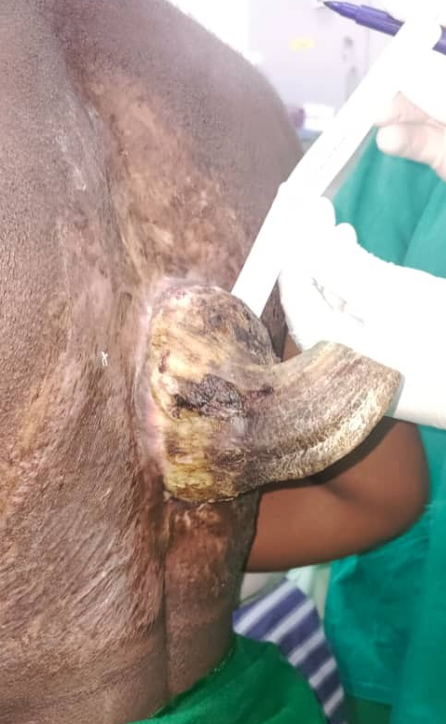

Fig 2a : Axial CT View of Large Cutaneous Horn
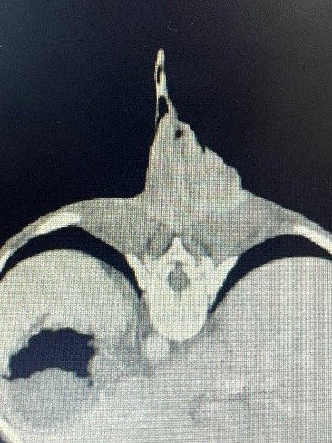

Fig 2b: Lateral Thoracoabdominal CT Scout View (Scanogram)

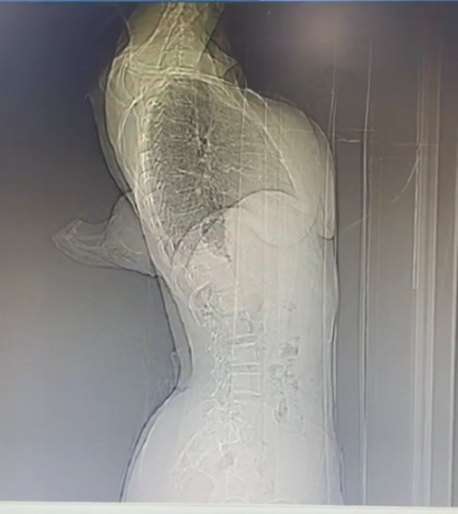

Fig 3 : Intra op - Surgical Excision of the Cutaneous Horn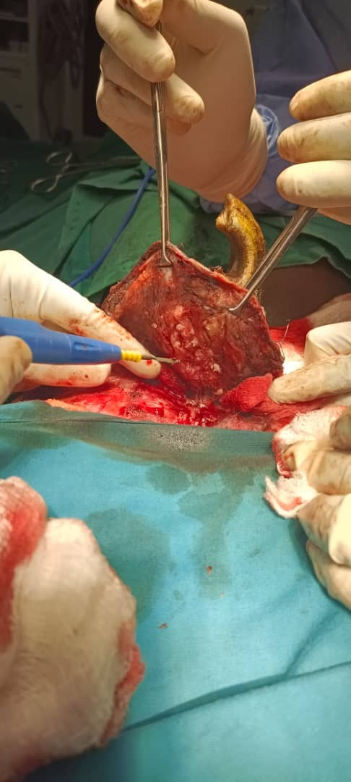
Fig 4a : Picture showing the immediate post operative state of the wound after wide local excision
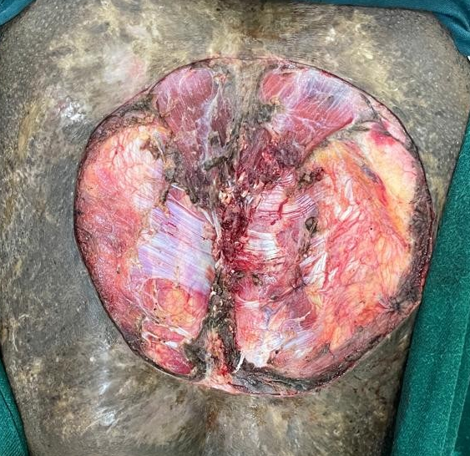

Fig 4b: well-granulated wound just before the split thickness skin graft procedure
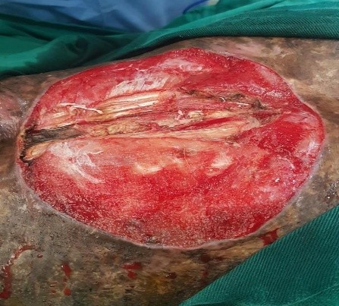

Figure 5: The below pictures shows the immediate post operative image of the graft and the wound at follow up clinic. There was good uptake of the skin graft without any wound complications.
