Case report
Simultaneous Inguinal & umbilical hernia, presentation of generalized abdominal muscle weakness: A case report

Abstract
The lifetime risk for inguinal hernia is 27% in males and 3% in females. Inguinal hernia is common among the elderly, having an incidence of approximately 13 per 1,000 individuals. Moreover, its global occurrence increased by 36% over the past three decades. Umbilical hernias are the third most common anterior abdominal wall defect and have an adult prevalence of 5-12%. This case report assesses the safety and efficacy of single-stage surgical repair in a patient presenting with concurrent inguinal and umbilical hernias. A 62-year-old male patient with a symptomatic right inguinal hernia and an incidentally detected umbilical hernia underwent concurrent Lichtenstein hernioplasty for the inguinal defect and a modified Mayo repair with mesh reinforcement for the umbilical hernia under spinal anesthesia. Total operative time was 80 minutes. Recovery after surgery was smooth, and he was discharged on the sixth postoperative day. At the 36-month follow-up, he remained asymptomatic, and no recurrence, chronic pain, or surgical site infection was demonstrated in either location. This satisfactory outcome thus attests that single-stage mesh repair under spinal anesthesia may be a feasible and resource-efficient approach. This consolidates patient care by requiring only one anesthetic event and one convalescence period, reducing the operational burden. Though promising, these results will need further validation through larger comparative studies that will firmly establish this approach as a superior alternative to staged repairs for selected patients.
Keywords: Inguinal hernia, umbilical hernia, polypуester mesh, Lichtenstein repair, Mayo repair, simultaneous repair.

Introduction
Inguinal hernias have a strong male predilection, with lifetime risks of 27% for men versus 3% for women [1]. Pathogenically, these hernias result from the protrusion of abdominal contents through acquired or inherent weaknesses in the anterolateral abdominal wall. Risk profiles that include male sex, advanced age, high BMI, COPD, and family history suggest a multifactorial origin that is genetic, environmental, and behavioral in nature [2,3]. The disease burden is significant, with an incidence of 13 per 1,000 elderly individuals [4], and has risen globally by 36% between 1990 and 2019-from 23.92 to 32.53 million cases [5,6].
Umbilical hernias, due to a patent umbilical ring, are the third most common anterior abdominal wall hernia, with an adult prevalence of 5-12% [7,8]. Risk factors are similar to those of inguinal hernias and include male sex, age >50, obesity (BMI >30 kg/m²), and multiparity [9].
Polyester; it is a multifilamentous material, polar, hydrophilic, coated by collagen preventing adhesions so it can be used intraperitoneally, degradable during infections [10-12].
The primary aim of modern hernia surgery is to minimize recurrence, a common complication of primary suture repair especially for umbilical hernias. Clinical results have been greatly enhanced with the introduction of tension-free mesh-based techniques such as the Lichtenstein repair for inguinal and the Mayo repair for umbilical defects [13-15].
The simultaneous occurrence of inguinal and umbilical hernias does, however, create a challenge regarding the choice of surgical strategy: staged repairs versus a single-stage procedure. This case report reviews the latter approach, performed under spinal anesthesia, and confirms its safety and efficacy.
Case Report

A 62-year-old male was admitted for elective repair of a right inguinal hernia, with a history of progressive, non-incarcerated enlargement over a period of one year. During preoperative evaluation, he mentioned incidental exertional pain in the umbilical region, which was diagnosed as a separate, reducible umbilical hernia with no history of complications. His medical history was non-contributory, and systemic examination was unremarkable. Local examination confirmed a 4*2*2 cm reducible right inguinal mass with a positive cough impulse and a separate 3*3*2 cm reducible umbilical protrusion, both with no signs of incarceration or skin changes. The surgical plan was to perform simultaneous Lichtenstein hernioplasty for the inguinal defect and modified Mayo repair for the umbilical hernia under spinal anesthesia.

Surgical Technique

On March 24, 2022, the patient was placed in the Trendelenburg position under spinal anesthesia, and the operative field was prepared and draped in a sterile fashion.

Lichtenstein Inguinal Hernioplasty: We followed the European Hernia society (EHS) Guidelines on Inguinal Hernia Repair (2018) [16]. An 8 cm skin incision was created parallel to the right inguinal ligament. The external oblique aponeurosis was incised to expose the spermatic cord (Figure 1). Dissection revealed a 4*2*2 cm indirect hernial sac within the cord structures, which was meticulously mobilized to its neck and reduced en masse into the preperitoneal space. An 6x11 cm Parietex™ mesh, which is composed of a macroporous polyester textile on one side and an absorbable hydrophilic collagen film on the other, was trimmed and positioned to reinforce the posterior wall of the inguinal canal (Figure 2). It was fixed with interrupted Dacron sutures to the pubic tubercle, conjoint tendon, and inguinal ligament. The external oblique aponeurosis was re-approximated over the cord, followed by a layered closure of the wound.

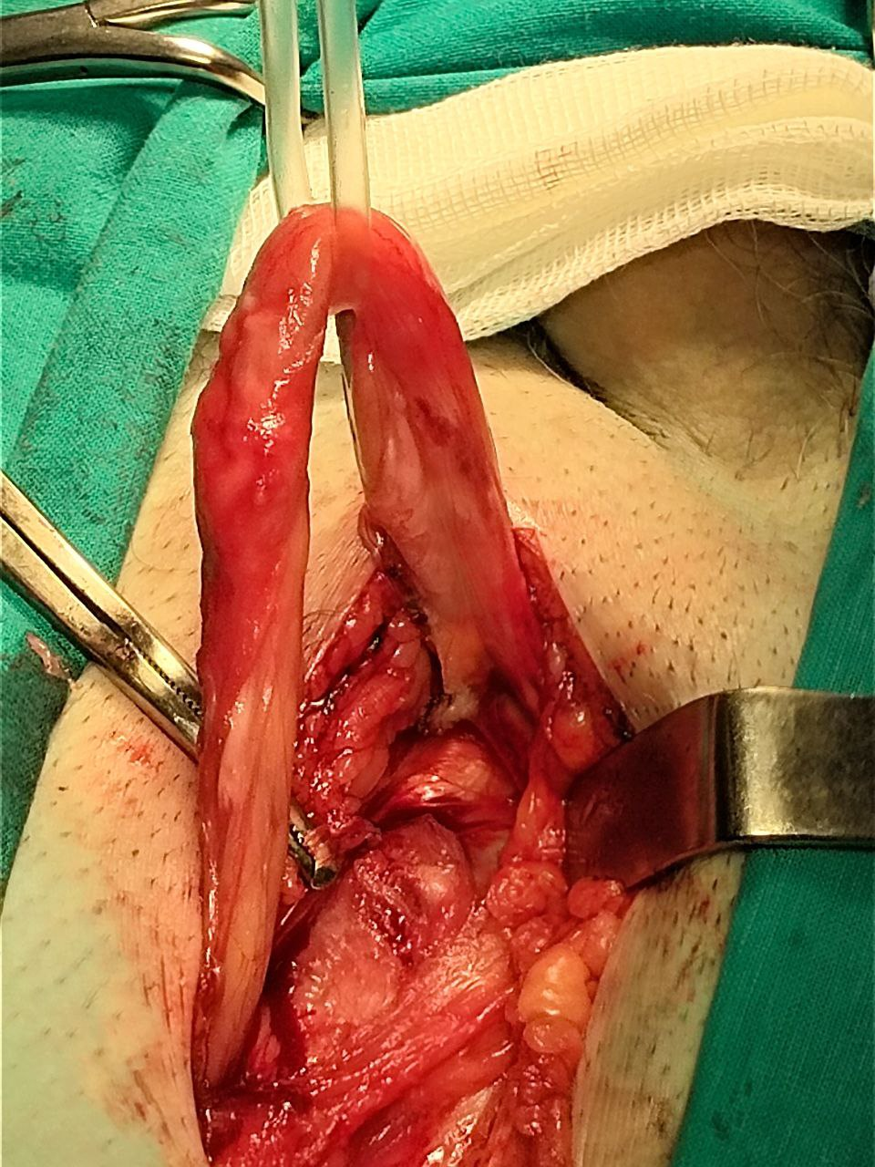

Figure 1. The Spermatic cord was isolated and elevated.

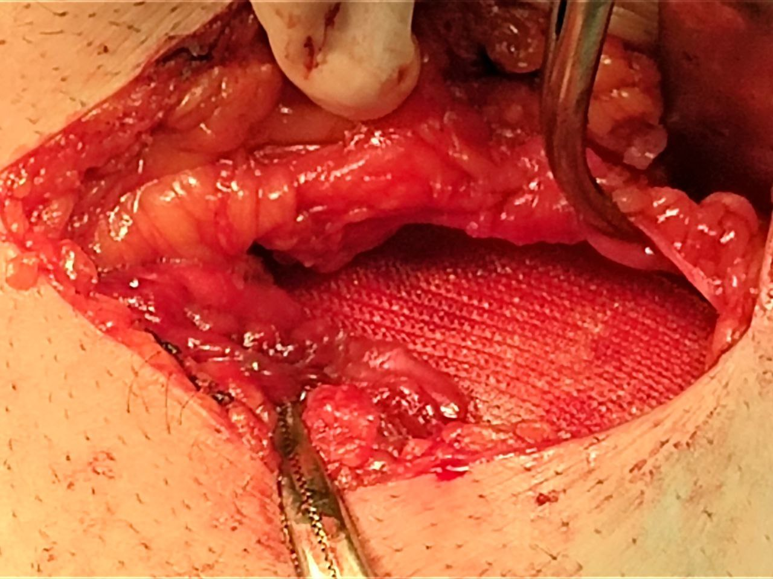

Figure 2. Reconstructing the inguinal canal's posterior wall using a 6x11 cm Parietex™ mesh.

Modified Mayo Umbilical Hernioplasty: The recommendations of American Hernia Society (AHS) [17] were followed; A distinct 6 cm vertical supra-umbilical incision was made. The hernia sac was identified, dissected free, and reduced. The fascial defect was closed with horizontal mattress sutures. To provide additional reinforcement, a 6x11 cm Parietex™ polyester mesh was positioned in an underlay fashion deep to the fascial closure and secured with interrupted sutures. Closure of the subcutaneous tissue and skin completed the procedure.

The total operative time was 80 minutes. Meticulous hemostasis was maintained throughout the dual procedures.

Postoperative Outcome

The patient's immediate postoperative recovery was uncomplicated, with pain adequately managed using oral analgesics. He was discharged on the sixth postoperative day in a stable condition. Follow-up assessments were conducted monthly for the initial six months and biannually thereafter. At the 36-month follow-up, the patient was entirely asymptomatic, with no clinical signs of recurrence, chronic groin pain, or surgical site infection at either location.

Discussion

This report illustrates that the concomitant repair of inguinal and umbilical hernias is surgically feasible and resource-effective. The cumulative operative time taken for both procedures amounts to 80 minutes, underlining a significant reduction in operational burden and patient exposure to a single anesthetic and surgical event.

This successful outcome was facilitated by several key factors. Use of spinal anesthesia was found efficient in such cases, providing comfortable surgical conditions while avoiding risk-related general anesthesia. This makes it an advantageous option, particularly for patients with significant comorbidities [10]. In addition, application of the polyester mesh in both places allowed for tension-free reconstruction. Its well-established profile provides vigorous fibroblastic proliferation and reliable tissue integration, forming the cornerstone of durable repair with low long-term recurrence, as provided by the complication-free 36 months of follow-up [5, 6].

One possible criticism of a simultaneous approach might include the theoretical increase in infective risk from multiple incisions. This was well overcome, however, with two discrete surgical fields, rigorous aseptic protocol, and standard prophylactic antibiotics. The fact that no surgical site infection occurred demonstrates that this risk is surmountable with good surgical technique.

First and foremost, the limitation inherent in this case report as a single study must be recognized. The findings presented are promising; however, this requires validation in larger, comparative studies or randomized controlled trials. Future research should aim at the ultimate determination of this simultaneous strategy over staged repairs by evaluating long-term recurrence, chronic pain, cost-effectiveness, and patient-reported quality-of-life metrics.

Conclusion

Therefore, single-stage, mesh-based repair for concurrent inguinal and umbilical hernias using spinal anesthesia is a validated, very advantageous approach: it consolidates patient care, offering the triple benefit of a single administration of anesthesia, condensing the recovery timeline, and making better use of surgical resources. This provides excellent long-term results while aligning with the principles of value-based, patient-focused care.

Consent

Patient’s informed written consent was taken to publish his case for academic purpose.

Ethical approval

As per international standards or university standards written ethical approval has been collected and preserved by the authors.

Disclaimer (Artificial intelligence)
Authors hereby declare that the role of AI was just to check the grammar and language mistakes in any of the manuscript, however, we once more have paraphrased some text of the article with using AI as a tool according to your kind demand.

References
1. Agarwal PK. Study of Demographics, Clinical Profile and Risk Factors of Inguinal Hernia: A Public Health Problem in Elderly Males. Cureus. 2023;15(4): e38053. https://doi.org/10.7759/cureus.38053
2. Sung H, He B, Song Z, et al. Current understanding of abdominal bulge with a novel classification: A retrospective study. Asian Journal of Surgery. Published online March 1, 2025. https://doi.org/10.1016/j.asjsur.2025.01.032
3. Mekhaeel, M. S. F., Protasov, A. V., & Salem, S. M. A Case Report of a Successful Bilateral Lichtenstein Repair Using Elastic Tacks. Cureus. 2025:17(6): e85475. https://doi.org/10.7759/cureus.85475
4. Engbang JP, B. Essola B, Fouda L, Dourga Baakaiwe A, Mefire Chichom M, Ngowe N. Inguinal Hernias in Adults: Epidemiological, Clinical and Therapeutic Aspects in the City of Douala. Journal of Surgery and Research. 2021;4(1). https://doi.org/10.26502/jsr.10020115
5. Mekhaeel M, Kashyzadeh KR, Protasov A, Salem S, Al Tekreeti WK, Mohareb A. AI-Based Evaluation of Polypropylene and Polyester Meshes in Lichtenstein Hernia Repair. Archiv Euromedica. 2025;15(2). https://doi.org/10.35630/2025/15/2.208
6. Wang F, Ma B, Ma Q, Liu X. Global, regional, and national burden of inguinal, femoral, and abdominal hernias: a systematic analysis of prevalence, incidence, deaths, and DALYs with projections to 2030. International journal of surgery. Published online January 23, 2024. https://doi.org/10.1097/js9.0000000000001071
7. Haskins I.N. Hernia formation: risk factors and biology. Surgical Clinics. 2023;103(5):835-846. https://doi.org/10.1016/j.suc.2023.04.020
8. Ramos-Morales PE, Alvarez-Lozada LA, Arrambide-Garza FJ, et al. Prevalence of Umbilical Hernias by Computed Tomography. Journal of Surgical Research. 2024; 302:33-39. https://doi.org/10.1016/j.jss.2024.07.014
9. Haskins IN. Hernia Formation: Risk Factors and Biology. Surgical Clinics of North America. 2023;103(5):835-846. https://doi.org/10.1016/j.suc.2023.04.020
10. Saha T, Wang X, Padhye R, Houshyar S. A review of recent developments of polypropylene surgical mesh for hernia repair. OpenNano. 2022; 7:100046. https://doi.org/10.1016/j.onano.2022.100046
11. Mekhaeel Shehata Fakhry Mekhaeel, Sameh Mohameh Ahmed Eissa Salem, Andrey Vitalevitch Protasov. DEVELOPMENT OF MESH IMPLANTS MATERIALS THROGH HISTORY REGARDING THEIR CHARACTERISTICS. REVIEW STUDY. International Journal of Medical Reviews and Case Reports. 2025;8(11):4-10. https://doi.org/10.5455/ijmrcr.172-1718440458
12. Mekhaeel Mekhaeel, S. Salem, A. Protasov. The benefits of using polyester mesh implant during anterior inguinal hernia repair. Case report. Archiv Euromedica. 2024;14(6). https://doi.org/10.35630/2024/14/6.602
13. A. Protasov, Mekhaeel Shehata Fakhry Mekhaeel, A. Dzhabiev, A. Kulakova, E. Ibragimov. Modern methods of surgical treatment of inguinal hernia. Modern Science: Actual Problems of Theory and Practice. Series: Natural and Technical Sciences. 2021; 8:199-201 https://doi.org/10.37882/2223–2966.2021.08.27
14. A. Protasov, E. Ibragimov, A. Dzhabiev, Mekhaeel Shehata Fakhry Mekhaeel, E. Mirzoev. COMPARATIVE STUDY OF ONLAY AND INLAY METHODS FOR UMBILICAL HERNIAS. Journal of Modern Science. 2020(12):225-227. https://doi.org/10.37882/2223–2966.2020.12.30
15. Protasov, A. V., Mekhaeel, M. S. F., & Salem, S. M. A. E. (2025). HERNIA BETWEEN TOPOGRAPHY AND SURGERY. PEOPLES’ FRIENDSHIP UNIVERSITY OF RUSSIA . January 1, 2025
16. The HerniaSurge Group. International guidelines for groin hernia management. Hernia. 2018(22):1–165. https://doi.org/10.1007/s10029-017-1668-x
17. Huerta, S., McAllister, J., Phung, C., & Guzzetta, A. A. Elective Umbilical Hernia Repair in Adults in the 21st Century: Challenging the Status Quo. Journal of Clinical Medicine. 2025;14(17):6324. https://doi.org/10.3390/jcm14176324

