Case report

Transcervical Excision of a Killian-Jamieson Diverticulum with Squamous Cell Dysplasia: Case Report and Literature Review

ABSTRACT

Pharyngoesophageal diverticulum is a rare clinical entity and can be broadly classified into 3 main types based on anatomical protrusion. Zenker diverticulum (ZD) represents the most common pharyngoesophageal diverticulum, followed by Killian-Jamieson diverticulum (KJD) and lastly Laimer diverticulum. These anatomical anomalities are generally thought to be benign and there is no reported literature on its potential for malignant transformation.

We present a case of Killian-Jamieson diverticulum which was surgically excised via transcervical approach. Histopathology of the diverticulum revealed squamous cell dysplasia. To the author's best knowledge, this is the first case report of a pharyngoesophageal diverticulum that showed malignant potential.

Keywords: Pharyngoesophageal diverticulum, squamous cell dysplasia, transcervical, malignant potential.

1. INTRODUCTION

Killian-Jamieson diverticulum (KJD) is a rare pharyngoesophageal diverticulum characterize by an anterolateral outpouching of oesophageal mucosa through a congenital weakness of the cervical oesophagus right below the cricopharyngeus (Alnimer et al., 2021)¹. Other pharyngoesophageal diverticulum include the more common Zenker's diverticulum and least common-Laimer's diverticulum (Yun et al., 2017)². These diverticulums are usually resected only when symptomatic as they generally are benign in nature³. Surgical approach include open resection or minimally invasive via endoscopic method. As of the author’s knowledge, there is no case report in literature that reports of carcinoma in the context of KJD. This will affect the selection of surgical treatment for KJD. We report the first case of KJD with malignant transformation potential and a literature review.

Case Presentation:

A 70 year old Chinese gentleman presented to the outpatient clinic with eight months of dysphagia. It is non-progressive in nature with sensation of globus. No constitutional symptoms. Family history was negative for malignancies. His past medical history includes well controlled hypertension and dyslipidemia. Past surgical history was unremarkable. He is a non-smoker.

Clinical examination revealed a fit gentleman with no palpable swelling over the neck region; other systemic examinations were unremarkable. An oesophagogastroduodenoscopy (OGDS) was arranged which revealed a KJD diverticulum with no suspicious mucosal lesions. (Figure 1) The outpouching of the mucosa was seen at the upper esophagus with no signs of inflammation, the rest of the esophagus, stomach and duodenum is normal. This was further confirmed with barium swallow. (Figure 2) A contrasted computed tomography of the neck revealed a lateral outpouching involving the cervical oesophagus with accompanying contrast pooling at the level of C5/C6.(Figure 3) As patient was rather concern regarding the diverticulum and symptoms were disturbing, we offered for surgery- diverticulectomy. We opted for an open transcervical approach, isolating the diverticulum and preserving the recurrent laryngeal nerve. The diverticulum is resected with a linear stapler (Figure 4) and patient had an uneventful post operative recovery. Unfortunately, histopathological examination revealed high-grade squamous dysplasia with increase ki67 proliferation index at the dysplastic areas, resection margins were clear.

A surveillance upper endoscopy performed one year later was unremarkable and patient was discharged from our surgical care.
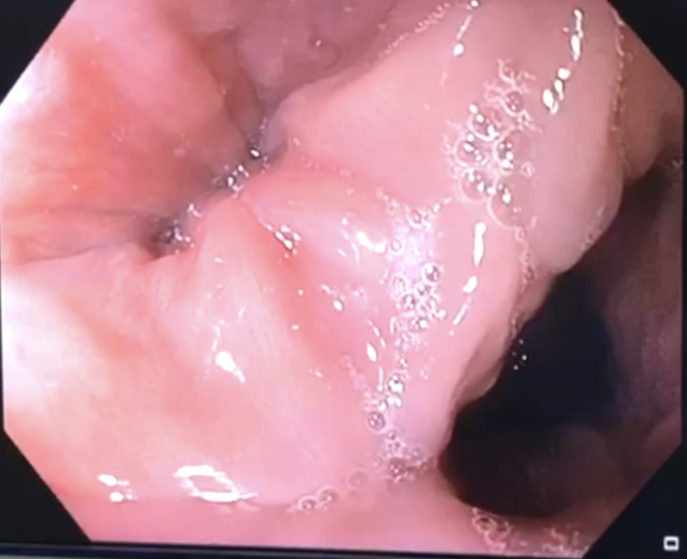
Oesophagus
Diverticulum

Figure 1: OGDS findings demonstrating the diverticulum at the upper oesophagus.

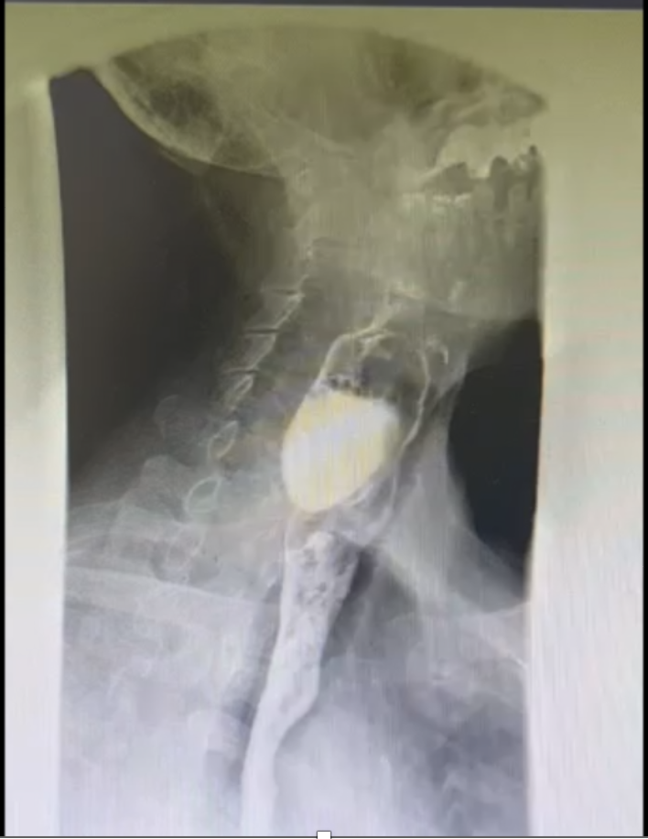

Figure 2: Contrast pooling upon barium meal swallow further confirming the presence of a diverticulum.

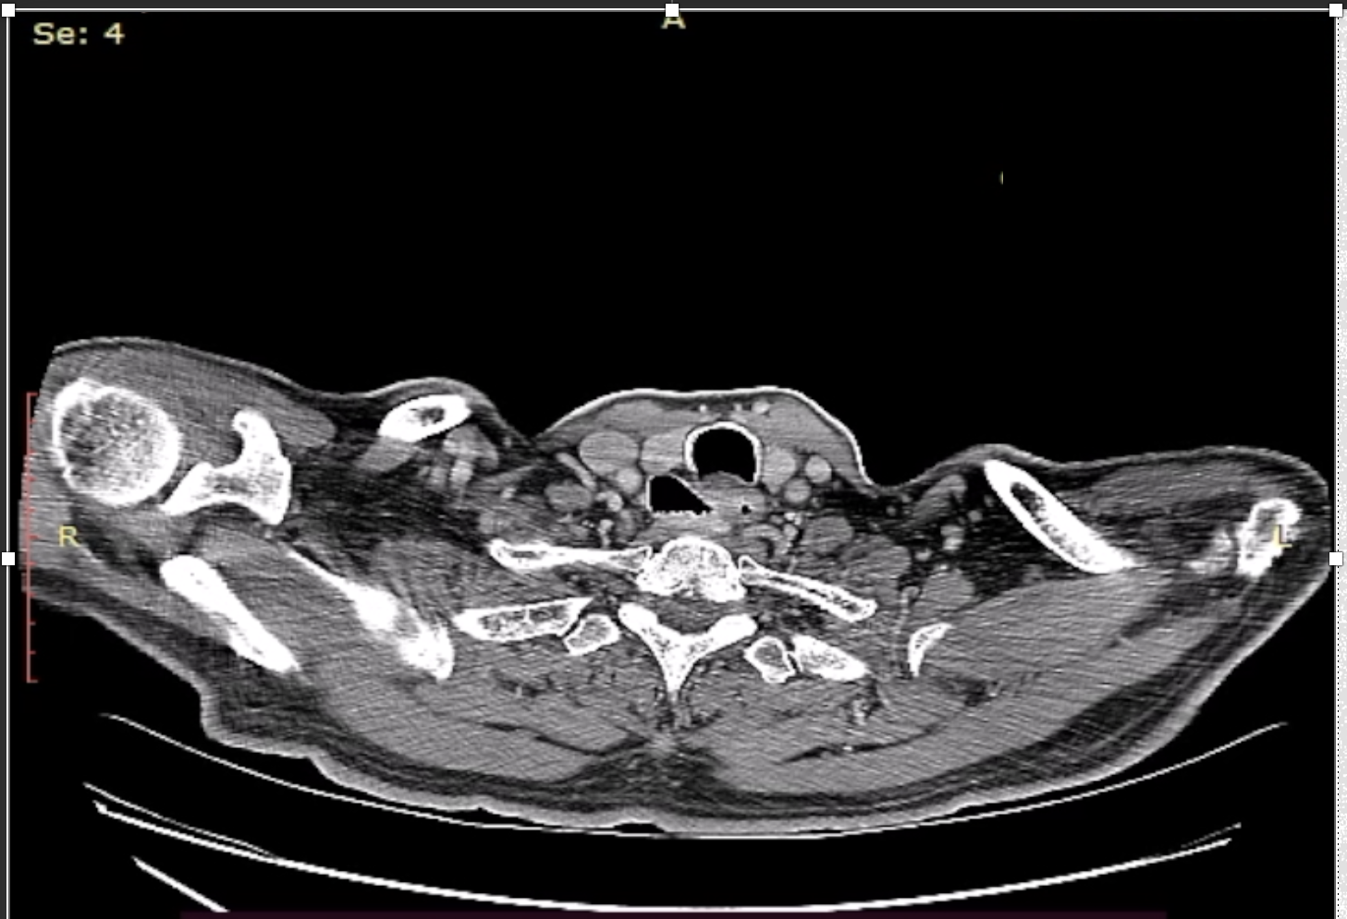

Figure 3: CT scan of the neck showing a lateral outpouching at the cervical esophagus at the level of C5/C6

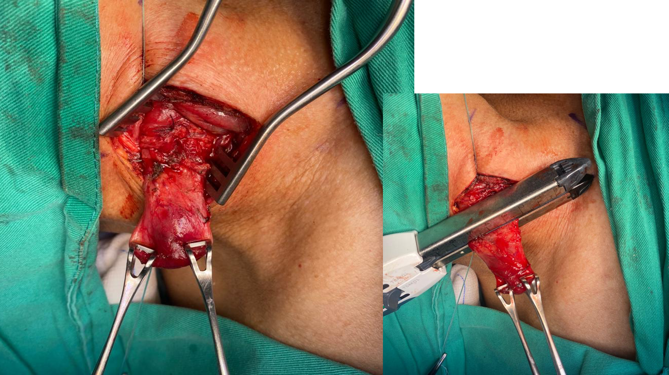

Figure 4: Open diverticulectomy done and transected using linear stapler. The stapler line was subsequently reinforced.

Discussion:

Pharyngoesophageal diverticulum (PED) is a rare clinical entity and was first described by Ludlow in 1769⁴. It is an outpouching of the oesophageal mucosa through a congenital weakness of the cervical oesophagus. The pathogenesis of this diverticulum are thought to be due to increased intraluminal pressure within the oesophagues, leading to herniation of the mucosal layer through a congenital weakness within the cervical oesophagus. The most common PED is the Zenker diverticulum, followed by Killian-Jamieson diverticulum and Laimer's diverticulum. KJD was first described in 1934 and its distinction from Zenker's diverticulum is by its anatomical location. KJD is an anterolateral outpouching of the cervical oesophagus, whereas Zenker's diverticulum protrudes posteriorly within the Killian's dehiscence- between the cricopharyngeous muscle and inferior constrictor muscle. KJD incidence is about 0.5-1% of all oesophageal diverticula.

Haddad et al⁵ studied 68 cases of KJD which show a propensity for females, and main clinical presentation was dysphagia. Majority of KJD occurs over the left side. As KJD represents a rarity, there is no standardized surgical technique. Operative strategies can broadly be divided into endoscopic diverticulectomy or open surgery-diverticulectomy or diverticulopexy. The concern for endoscopic method is risk of recurrent laryngeal nerve injury, whereas open surgery carries risk of stapler line leak. However it is not yet clear which surgical technique is better for KJD as most available literature describe the treatment of Zenker's diverticulum.

Coelho et al⁶ evaluated the post operative outcome for patients with PED who underwent open diverticulectomy with cricopharyngeal myotomy and endoscopic treatment. They have found that there were no operative mortality in both groups. However patients who underwent open surgery are reported to have low output fistula with hoarseness post operative which was treated non operatively. In contrast, patient who underwent endoscopic treatment did not have any immediate complication in the post operative period, however, up to 33% of the patient develop recurrent dysphagia which require repeated endoscopic intervention. Hence compared to open surgery, endoscopic treatment carries the advantage of no skin incision, shorter operative duration, minimal postoperative pain, and shorter hospitalization.

Additionally, Modayil et al⁷ showed that endoscopic diverticulotomy is a safe and effective treatment for KJD. There were no post operative bleeding or recurrent laryngeal nerve injury post. They reported a 92% of complete resolution of dysphagia, whereas the remaining had residual dysphagia likely due to incomplete myotomy. However, It should be kept in mind that some pharyngoesophageal diverticula may involve malignant lesions, albeit rare.

Therefore, the indication of endoscopic diverticulotomy is limited to the patients with contraindication for prolonged general anesthesia and for those who had a history of cervical surgery or radiation resulting in adhesions and fibrosis.

Conclusion:

This case report is to highlight the risk of malignant transformation of KJD.
As there are no standardized surgical approach for KJD, the management should be individualized and different treatment option for open surgery or endoscopy should be offered to the patient.

Consent

As per international standard or university standards, patient's written consent has been collected and preserved by the authors.

Ethical approval

As per international standards or university standards written ethical approval has been collected and preserved by the author(s).

DISCLAIMER -ARTIFICIAL INTELLIGENCE

The authors hereby declare that NO generative AI technologies such as Large Language Models (ChatGPT, COPILOT, etc.) and text-to-image generators have been used during the writing or editing of this manuscript.

References

1. Alnimer L, Zakaria A, Piper M. Killian Jamieson Diverticulum: A Rare Cause of Dysphagia. Cureus. 2021 Mar 2;13(3):e13654. doi: 10.7759/cureus.13654.

2. Yun, P., Huang, H., Chang, H., Lee, S., & Huang, T. (2017). Endoscopic diverticulotomy with a stapler can be an effective and safe treatment for Killian-Jamieson diverticulum. Journal Of Thoracic Disease, 9(9), E787-E791. doi:10.21037/jtd.2017.08.14

3. Howell, R., Johnson, C., Allen, J., Altaye, M., Amin, M., Bayan, S., ... & Prospective OUtcomes of Cricopharyngeal Hypertonicity (POUCH) Collaborative. (2024). Surgical outcomes in Zenker diverticula: a multicenter, prospective, longitudinal study. The Laryngoscope, 134(1), 97-102.

4. Anagiotos A, Preuss SF, Koebke J. Morphometric and anthropometric analysis of Killian's triangle. Laryngoscope. 2010 Jun;120(6):1082-8. doi: 10.1002/lary.20886

5. Haddad N, Agarwal P, Levi JR, Tracy JC, Tracy LF. Presentation and Management of Killian Jamieson Diverticulum: A Comprehensive Literature Review. Ann Otol Rhinol Laryngol. 2020 Apr;129(4):394-400. doi: 10.1177/0003489419887403

6. Coelho JC, Sousa GS, Salvalaggio PR. Laparoscopic treatment of duodenal diverticulum. Surg Laparosc Endosc. 1999 Jan;9(1):74-7

7. Modayil RJ, Zhang X, Ali M, Das K, Gurram K, Stavropoulos SN. Endoscopic diverticulotomy for Killian-Jamieson diverticulum: mid-term outcome and description of an ultra-short tunnel technique. Endosc Int Open. 2022 Jan 14;10(1):E119-E126. doi: 10.1055/a-1548-5552

