Case report
Closed Reduction of a Pediatric Le Fort I Fracture: A Case Report on Minimally Invasive Management

ABSTRACT

Pediatric facial fractures, particularly Le Fort I fractures, present unique challenges in diagnosis and management. This case report details the treatment of a 7-year-old male patient who sustained a Le Fort I maxillary fracture following a fall with a pen inside his oral cavity. Key CT findings confirmed a unilateral maxillary fracture with a deviated nasal septum, with no involvement of orbital structures. The patient was managed with closed reduction techniques, including maxillomandibular fixation (MMF), trans-maxillary fixation, and frontal suspension, under general anesthesia. Postoperative recovery was uneventful, with the patient resuming oral feeding within 4 hours and being discharged after 5 days. This conservative approach was chosen to preserve growth potential and minimize complications, avoiding the need for open reduction and internal fixation (ORIF) given the patient's age and the risk of disrupting facial growth. The case highlights the effectiveness of closed reduction techniques in pediatric fractures, offering a minimally invasive solution that restores functional and aesthetic outcomes.

Keywords: Pediatric Facial Fractures; Le Fort I Fracture, Closed Reduction Techniques; Maxillomandibular Fixation (MMF); Minimally Invasive Surgery
1.Introduction

Pediatric patients with facial fractures generally experience better outcomes compared to adults. Children are less likely to develop malunion, nonunion, postoperative infections, or the need for open reduction and rigid fixation. These advantages can be primarily attributed to a child's greater osteogenic potential, which facilitates more efficient bone healing and reconstruction. Additionally, children heal faster and recover more quickly after surgery compared to their adult counterparts [1]. Maxillary fractures in pediatric patients, though relatively rare, can occur due to trauma such as motor vehicle accidents, falls, or sports injuries. Studies indicate that facial fractures in children make up about 5% of all facial injuries, with maxillary fractures accounting for a significant portion [2]. Unlike adult fractures, pediatric facial fractures present unique challenges due to the dynamic growth and development of facial bones. The pediatric facial skeleton is more elastic, and the healing process is influenced by the child's age, skeletal maturity, and overall health [3]. These factors make the management of pediatric facial fractures different from that of adults. The treatment of pediatric maxillary fractures requires a delicate approach that takes into consideration the child's ongoing bone development. Closed reduction techniques, including maxillomandibular fixation, trans-maxillary fixation, and frontal suspension, are often employed as less invasive alternatives to open reduction and internal fixation (ORIF) procedures. Closed reduction methods are considered effective in reducing the risk of complications and promoting healing, as they do not interfere with the development of the facial skeleton or dentition [4]. Furthermore, closed reduction offers a cost-effective solution that minimizes the risks associated with more complex surgical interventions [5]. Le Fort fractures, though relatively uncommon in pediatric patients, are serious injuries that often require prompt intervention to restore facial symmetry and function. In particular, Le Fort I fractures involve a horizontal fracture of the maxilla, which can result in facial asymmetry, malocclusion, and difficulty in feeding. Closed reduction has been shown to be an effective method for managing these fractures, with minimal long-term effects on growth and development [6].

2.Case Presentation
A 7-year-old male patient was referred to our emergency department following the falling on the ground while running with a pen inside his oral cavity. The patient presented with significant oral pain and malocclusion indicating oral injury i.e., bony fracture of the maxillofacial region. The general status of the patient was satisfactory, was no signs of abdominothoracic injuries, peripheral fractures were excluded, bleeding from body orifices: Nil. Vital signs; within normal ranges. Examination of the head and neck regions revealed normal respiration with no forigen bodies in the upper respiratory tract, no signs of cervical spine fracture. The Glasgow Coma Scale (GCS) was (15/15), excluding intracranial injuries. Upon intraoral examination, a soft palatal tear was observed, about 4-5 cm length, with a 5mm with in maximum dimensions, extending nearly to the oropharynx (Figures 1), along with tenderness and transvers mobility of the maxilla, which suggesting maxillary fracture Le Forte I.
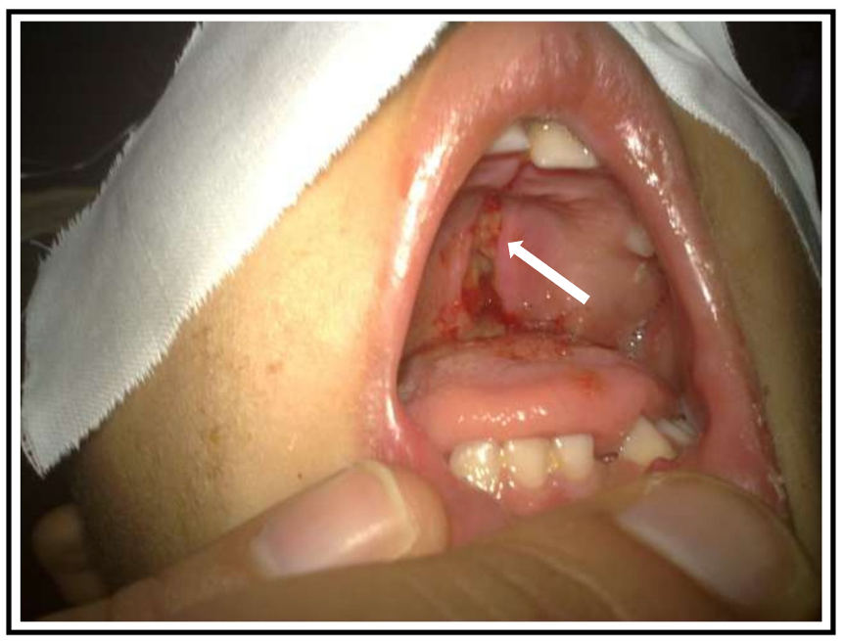

Figure 1: Preoperative Photographs of soft palatal wound (white arrow).
2.1 Radiographic Investigations
To further assess the extent of the injury, radiological imaging was performed. Multidetector CT of the head and neck were obtained, revealing a Le Fort I maxillary fracture, characterized by a horizontal displacement of the maxilla (Fig. 2A; Anterior view, Fig. 3A; Lateral view) as well as deviated nasal septum (Figures 2B; Anterior view and 3B; Lateral view), no involvement of the orbital structures was detected.

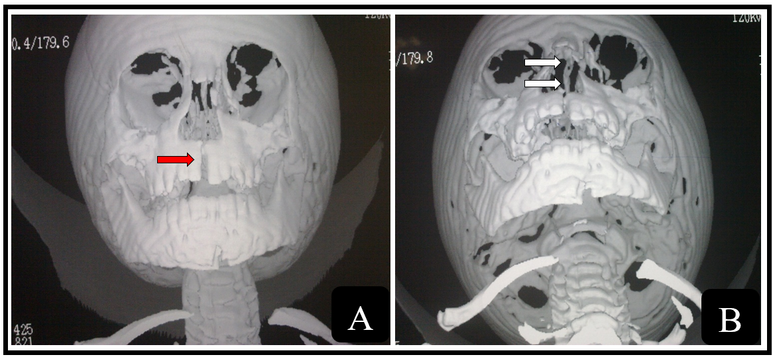

Figure 2A: Preoperative MDCT (anterior view) Showing Le Fort I Maxillary Fracture (red arrow).
Figure 2B: Preoperative MDCT (anterior view) Demonstrating deviated nasal septum (white arrows).
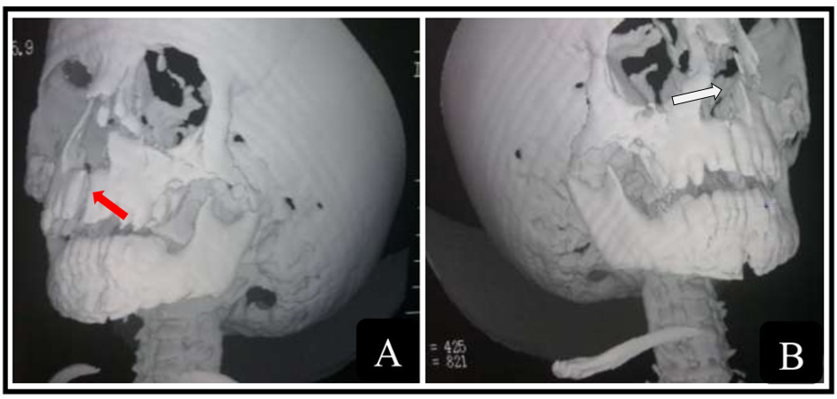

Figure 3 A: MDCT (lateral view) Showing Le Fort I Fracture and Maxillary Displacement (red arrow).
Figure 3B: MDCT (lateral view) Demonstrating deviated nasal septum (white arrow).

2.2 Surgical Management
Given the nature of the fractures and the patient's age, closed reduction was chosen as the treatment approach to avoid the potential risks of open reduction and internal fixation (ORIF), which could interfere with facial growth and lead to long-term complications. The primary concern was to align the fractured bone segments properly to restore both function and aesthetics. The patient’s soft tissue injuries were managed first, with the soft palatal tear sutured using interrupted silk sutures to ensure proper closure and prevent infection. Closed reduction was employed, utilizing maxillomandibular fixation (MMF) through fixing maxillary and mandibular arch bars to the equivalent jaws using 0.5 mm wires passing through interdental spaces, trans-maxillary fixation by stretching a single 0.5 mm wire in-between the maxillary first molars bilaterally. Maxillary fixation was furtherly achieved by attaching the maxillary arch bar to the frontal process of the zygomatic bone bilaterally using the 0.5 mm wire thought intraoral approach; Frontal suspension (Figure 4). Due to minimal displacement, a custom-made acrylic palatal splint was of no need in our case. The deviated nasal septum was reduced using Asch nasal septum forceps (Figure 5). Furthermore, vasilnezed gauzes were applied in both nostrils maintaing reduced septum in situ achieving fracture stability, restoring nasal shape as well as preventing epistaxis (Figure 6). Postoperative skull lateral view X-rays revealed proper reduction and alignment of the fractured segments (Figure 7).
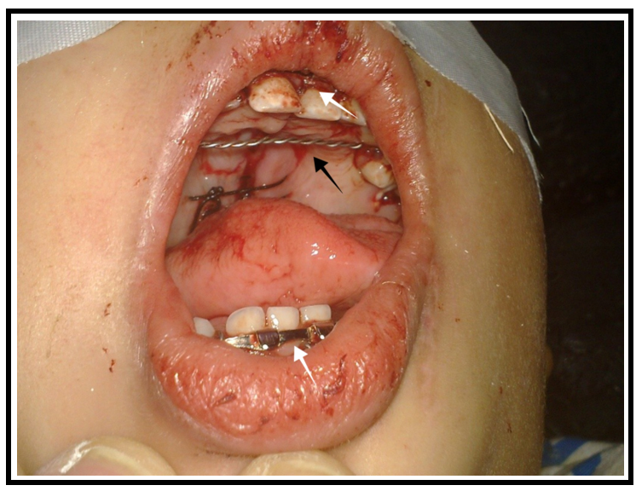

Figure 4: Postoperative Clinical Photograph Showing The soft palatal tear was sutured using interrupted silk sutures, Mandibular and maxillary arch bars (white arrows) and the transmaxillary wire (black arrow).
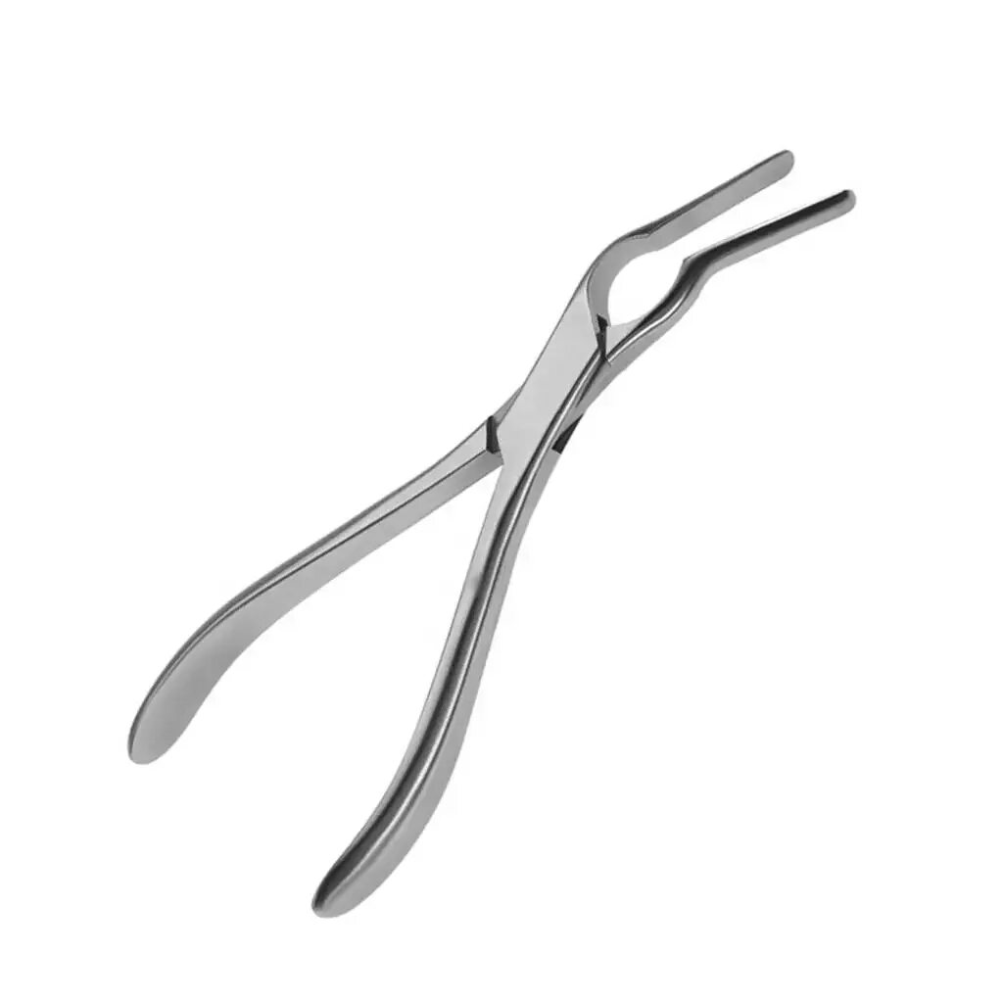
Figure 5: Asch nasal septum forceps.
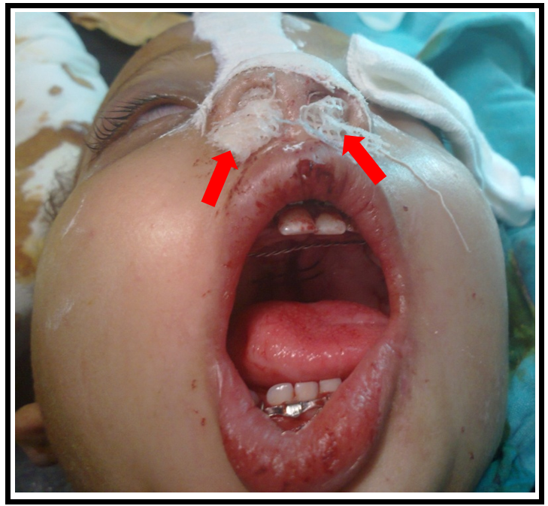

Figure 6: Postoperative Clinical Photograph Demonstrating vasilnezed gauzes have applied into the nasal cavity (red arrows).
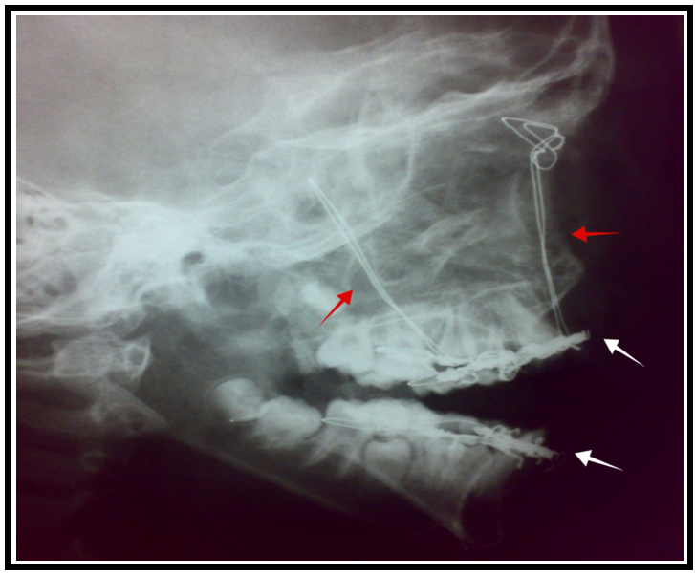

Figure 7: Postoperative Clinical Radiograph Showing the maxillary and mandibular arch bars (white arrows) and the frontal suspension wire cables (red arrows).

2.3 Follow-Up and Outcome of Interventions
The patient was closely monitored postoperatively for any complications. After surgery, the patient was able to begin oral feeding just 4 hours after the operation, indicating that the patient was recovering well and tolerating the procedure without complications. The patient was discharged at the 5th day postoperatively. The nasal packs were removed before discharge. Weekly postoperative follow-up was performed regularly and the patient showed no signs of malunion or infection, till the fixation materials were removed after 4 weeks, with no complications or recurrence. The functional and aesthetic outcomes were deemed satisfactory. The patient continued monthly follow-up visits for another five months, demonstrating stable recovery with no further complications or recurrence.

3. Discussion

Pediatric facial fractures, while uncommon, present unique challenges in both diagnosis and treatment. Unlike adult fractures, pediatric fractures benefit from better healing potential due to the higher osteogenic capacity of children. Consequently, closed reduction techniques, such as maxillomandibular fixation (MMF) and trans-maxillary fixation, are preferred over more invasive procedures. For Le Fort I fractures, which involve horizontal maxillary fractures, precise management is necessary to restore alignment and function. Closed reduction techniques are effective, offering minimal long-term effects on growth and development, and serve as excellent alternatives to surgical interventions (1). Research has consistently shown that pediatric fractures heal faster due to increased metabolic and osteogenic activity, resulting in fewer complications like malunion or infection compared to adult fractures (7). Additionally, children are less likely to experience post-operative complications such as malocclusion or facial deformities, which are common with open surgical approaches (8). MMF not only stabilizes the fractured segments but also restores natural occlusion without rigid fixation, preserving the natural growth of the midface (9). The use of trans-maxillary fixation and frontal suspension further enhances maxillary stability while minimizing infection risk and avoiding external scars (10). In cases of Le Fort I fractures, closed reduction helps maintain the anatomical position of the maxilla and supports proper healing. Our case demonstrates that closed reduction can effectively manage these fractures, ensuring functional recovery with no complications (11). Rigid fixation techniques, such as ORIF, can disrupt facial growth, leading to deformities and longer recovery times. In contrast, conservative techniques like closed reduction preserve facial growth and avoid the need for corrective surgeries. Psychologically, pediatric facial fractures can significantly affect a child's self-esteem. The closed reduction approach, which minimizes scarring, has been shown to have fewer psychological impacts and a higher rate of satisfaction with post-treatment appearance (12,13). Furthermore, closed reduction is a more cost-effective approach compared to invasive surgeries, making it an accessible treatment option for many families (14). In our case, postoperative follow-up was critical, and the absence of complications further confirms the effectiveness of the closed reduction approach. The outcome was highly satisfactory, with excellent functional and aesthetic results (15,16,17).

4.Conclusion

This case report highlights the effectiveness of conservative management in pediatric Le Fort I fractures. The use of closed reduction techniques such as maxillomandibular fixation (MMF), trans-maxillary fixation, and frontal suspension offers a minimally invasive approach that promotes faster healing and reduces complications. Closed reduction not only improves functional outcomes but also minimizes the psychological impact of facial trauma by preserving the patient's appearance. Given the positive results observed in this case, we recommend closed reduction as the first-line treatment for pediatric patients with similar fractures. This approach avoids the potential complications associated with open reduction and internal fixation (ORIF), such as disruption of facial bone growth, which may lead to facial deformities. The absence of biodegradable plates and screws, which can hinder facial bone development, further supports the use of closed reduction techniques in these cases.

Competing interests

Authors have declared that no competing interests exist.

Consent

All authors declare that ‘written informed consent was obtained from the patient (or other approved parties) for publication of this case report and accompanying images. A copy of written consent is available for review by the Editorial office/Chief Editor/Editorial Board members of this journal.

Ethical approval
All authors hereby declare that all experiments have been examined and approved by the appropriate ethics committee and have therefore been performed in accordance with the ethical standards laid down in the 1964 Declaration of Helsinki.

Disclaimer (Artificial intelligence)
Authors hereby declare that NO generative AI technologies such as Large Language Models (ChatGPT, COPILOT, etc.) and text-to-image generators have been used during the writing or editing of this manuscript.

5. References
- Haug, R. H., & Foss, J. (2000). Maxillofacial injuries in the pediatric patient. Oral Surgery, Oral Medicine, Oral Pathology, Oral Radiology, and Endodontics, 90(2), 126–134. https://doi.org/10.1067/moe.2000.107974
- Cole, P., Kaufman, Y., & Hollier, L. H. (2009). Managing the pediatric facial fracture. Craniomaxillofacial Trauma & Reconstruction, 2(2), 77–83. https://doi.org/10.1055/s-0029-1202592
- Glazer, M., Joshua, B. Z., Woldenberg, Y., & Bodner, L. (2011). Mandibular fractures in children: Analysis of 61 cases and review of the literature. International Journal of Pediatric Otorhinolaryngology, 75(1), 62–64. https://doi.org/10.1016/j.ijporl.2010.10.008
- Ragit, R., Fulzele, P. R., Wadewale, S. N., Bhola, N., Solanki, D. R., & Thosar, N. R. (2024). Conservative management of maxillary and mandibular fractures in a pediatric patient with a modified open cap splint: A case report. Cureus. https://doi.org/10.7759/cureus.55191
- Mekhaeel, M. S. F., Sameh, S. M. A. E., Andrey, P. V., Elsayed, T. N. A. M., & Zaky, E. A. G. (2025). Refracture and realignment of a malunited mandibular fracture: A case report. Asian Journal of Case Reports in Surgery, 8(1), 185–191. https://doi.org/10.9734/ajcrs/2025/v8i1621
- Kale, T. P., Urologin, S. B., Kapoor, A., Lingaraj, J. B., & Kotrashetti, S. M. (2013). Open cap splint with circummandibular wiring for management of pediatric mandibular parasymphysis/symphysis fracture as a definitive treatment modality: A case series. Dental Traumatology, 29(5), 410–415. https://doi.org/10.1111/j.1600-9657.2011.01082.x
- Ryan, M. L., Thorson, C. M., Otero, C. A., et al. (2011). Pediatric facial trauma: A review of guidelines for assessment, evaluation, and management in the emergency department. Journal of Craniofacial Surgery, 22(4), 1183–1189. https://doi.org/10.1097/SCS.0b013e31821c0d52
- Owusu, J. A., Bellile, E., Moyer, J. S., & Sidman, J. D. (2016). Patterns of pediatric mandible fractures in the United States. JAMA Facial Plastic Surgery, 18(1), 37–41. https://doi.org/10.1001/jamafacial.2015.1456
- Lodhi, T. G., Patil, S. B., Bahetwar, S. K., Nimonkar, P. V., Peter, B. K., & Sharma, A. B. (2021). Management of fracture mandible by open occlusal acrylic splint in pediatric patients: A case series. International Journal of Clinical Pediatric Dentistry, 14(6), 812–815. https://doi.org/10.5005/jp-journals-10005-2099
- Kumar, N., Richa, & Gauba, K. (2018). Modified closed cap splint: Conservative method for minimally displaced pediatric mandibular fracture. Saudi Dental Journal, 30(1), 85–88. https://doi.org/10.1016/j.sdentj.2017.11.002
- Sameh, S. M. A. E., Mekhaeel, M. S. F., Andrey, P. V., Elsayed, T. N. A. M., Gyasi, A. O., & Matambo, P. T. (2025). Management of mandibular fracture malunion: Strategies for refracture and realignment. In Medical Science: Recent Advances and Applications (Vol. 10, pp. 42–52). BP International. https://doi.org/10.9734/bpi/msraa/v10/6141
- Sameh, S., Mekhaeel, S., Protasov, V., Taha, N., & Elshliby, A. (2025). Management of pediatric fracture mandible by closed reduction technique: A case report. Asian Journal of Case Reports in Surgery, 8(1), 119–126. https://doi.org/10.9734/ajcrs/2025/v8i1609
- Agbara, R., Fomete, B., & Omeje, K. U. (2023). A retrospective observational study of pediatric mandibular fractures: Demographics, pattern, and challenges of management in a Nigerian population. African Journal of Pediatric Surgery, 20(4), 282–287. https://doi.org/10.4103/ajps.ajps_9_22
- Braun, T. L., Xue, A. S., & Maricevich, R. S. (2017). Differences in the management of pediatric facial trauma. Seminars in Plastic Surgery, 31(2), 118–122. https://doi.org/10.1055/s-0037-1601380
- Hinson, M., Wright, A., Davidson, A., Kogan, S., & Runyan, C. (2024). Pediatric facial fractures: A multi-institutional level 1 trauma center analysis of incidence, interventions, and outcomes. Craniomaxillofacial Trauma & Reconstruction, 17(4), NP192–NP203. https://doi.org/10.1177/19433875241272430
- Sameh, Salem, Mohamed Ahmed Eissa, Mekhaeel, Shehata Fakhry Mekhaeel, Protasov, Vitalevitch Andrey, Taha, Nada Ahmed Mohamed Elsayed, and Elshliby, Abdelrahman Gomaa Zaky. 2025. “Management of Pediatric Fracture Mandible by Closed Reduction Technique: A Case Report”. Asian Journal of Case Reports in Surgery 8 (1):119-26. https://doi.org/10.9734/ajcrs/2025/v8i1609.
- Mekhaeel, Shehata Fakhry Mekhaeel, Salem, Mohamed Ahmed Eissa Sameh, Protasov, Vitalevitch Andrey, Elshliby, Abdelrahman Gomaa Zaky & Taha, Nada Ahmed Mohamed Elsayed. (2025). Rehabilitation of Pediatric Mandibular Fracture Following Dashboard Injury: Case Report. Asian Journal of Case Reports in Surgery, 8(1), 155–161. https://doi.org/10.9734/ajcrs/2025/v8i1616

