Case report
Primary Mesenteric Leiomyosarcoma Presenting as a Migrating Abdominal Mass: A Rare Case Report and Literature Review

Abstract
Aim: The aim of this case report is to present and critically analyze a rare instance of primary mesenteric leiomyosarcoma, an exceptionally uncommon malignant tumour arising from smooth-muscle of the mesentery. This case highlights the unusual presentation of the tumour as a migrating abdominal mass, a feature seldom described in the literature.
Presentation of Case: A 74‑year‑old male presented with a painless, mobile abdominal swelling. Contrast‑enhanced computed tomography (CECT) revealed a heterogeneously enhancing soft-tissue lesion in the anterior pararenal space. Exploratory laparotomy revealed a 10.5 × 10.0 cm mass in the jejunal mesentery, 80 cm from the duodenojejunal flexure. The lesion was resected en bloc with a 40 cm segment of jejunum, followed by end‑to‑end anastomosis. Histopathology and immunohistochemistry confirmed leiomyosarcoma (SMA+, H‑Caldesmon+, CD117−). A small hepatic nodule showed metastatic deposits. Postoperative PET‑CT demonstrated no residual disease and adjuvant chemotherapy was initiated.
Discussion: Primary mesenteric leiomyosarcoma is an exceedingly uncommon tumour arising from smooth‑muscle elements of the mesenteric vessels. Because of the expansile nature of the mesentery, tumours often remain clinically silent until large, resulting in delayed diagnosis. Imaging, histopathology, and immunohistochemistry are essential for diagnosis, and surgical excision with negative margins remains the cornerstone of treatment. Adjuvant therapy may improve control in high‑risk cases.
Conclusion: Mesenteric leiomyosarcoma poses a diagnostic and therapeutic challenge due to its rarity and aggressive behaviour. Early recognition, complete resection, and long‑term surveillance are crucial for improving patient outcomes. In the present case, the tumour measured 10.5 × 10.0 cm and displayed metastatic spread to the liver. Despite these adverse prognostic features, the patient achieved disease-free survival at one year following R0 resection and adjuvant doxorubicin-based chemotherapy.
Keywords: Mesenteric leiomyosarcoma, Smooth muscle tumour, Jejunal mesentery, Case report, Abdominal mass, Rare malignancy

1. Introduction
Leiomyosarcoma (LMS) is a malignant neoplasm arising from smooth-muscle cells, and it accounts for approximately 10–20% of all soft-tissue sarcomas. While common primary sites include the uterus, retroperitoneum, large blood vessels, and gastrointestinal tract, primary mesenteric LMS remains exceedingly rare. Mesenteric LMS represents a diagnostic challenge because it lacks specific clinical features, and it often attains a considerable size before detection. Fewer than 80 cases have been described in the literature, with most presenting as large abdominal masses that mimic other intra‑abdominal pathologies such as gastrointestinal stromal tumour (GIST), liposarcoma, or desmoid tumours. Reported incidences vary, but population-based extrapolations suggest a frequency of roughly 1 in 350,000 individuals (Singh et al., 2021).
The mesentery’s expansile capacity allows these tumours to grow silently until they reach a significant size or cause compression symptoms (Koufopoulos et al., 2022). Histologically, LMS demonstrates fascicles of spindle‑shaped cells with eosinophilic cytoplasm, pleomorphic nuclei, and varying degrees of mitotic activity. Immunohistochemistry (IHC) remains essential in differentiating LMS from morphologically similar entities such as GIST, as LMS is typically positive for smooth-muscle actin (SMA), desmin and h-caldesmon and negative for CD117 and DOG1. Here we report a case of primary mesenteric LMS in a 74‑year‑old man and review the recent literature regarding diagnostic approaches, pathogenesis, treatment modalities, and prognostic outcomes.

2. Case Presentation
A 74-year-old man presented with a slowly enlarging, painless abdominal swelling of one year’s duration, without weight loss, vomiting, or bowel disturbances. His medical history included systemic hypertension controlled with regular medication. On physical examination, a firm, mobile, non-tender intra-abdominal mass measuring approximately 7.5 × 7.0 cm was palpable in the left lumbar and iliac regions. There was no organomegaly or ascites. Routine laboratory investigations were within normal limits.
Contrast-enhanced CT (CECT) of the abdomen revealed a well-circumscribed, heterogeneously enhancing soft-tissue lesion (7.2 × 9.3 cm) in the anterior pararenal space, displacing adjacent bowel loops. Exploratory laparotomy identified a large 10.5 × 10 cm lobulated tumour arising from the jejunal mesentery, 80 cm distal to the duodenojejunal flexure which was much larger than the size mentioned in the CECT report (greater size reflecting either growth or measurement differences). The lesion was resected en bloc with approximately 50 cm of jejunum; a primary end-to-end anastomosis was performed. In addition, a small (0.5 × 0.5 cm) subcapsular hepatic nodule on segment Ⅴof right lobe of liver was excised. The postoperative recovery was uneventful.
Histopathological analysis revealed spindle‑shaped tumour cells with elongated nuclei, eosinophilic cytoplasm, nuclear atypia, and frequent mitoses (9 per 10 high-power fields [HPF]). Areas of necrosis and haemorrhage were present. Based on the FNCLCC system, the tumor demonstrated a differentiation score of 1, mitotic score of 1 (9 mitoses/10 HPF), and necrosis score of 1, yielding a total score of 3, corresponding to FNCLCC Grade 1 leiomyosarcoma. Resection margins were free of tumour. The liver nodule demonstrated metastatic deposits with similar morphology. Immunohistochemistry was positive for SMA and h‑caldesmon and negative for CD117 and DOG1, confirming leiomyosarcoma. According to the AJCC 8th Edition staging system for soft tissue sarcomas, the tumour in this patient measured 10 cm in maximal dimension, corresponding to a T3 category. There was no evidence of regional lymph-node involvement (N0). However, the presence of a metastatic subcapsular hepatic nodule confirmed distant metastasis (M1). The patient’s disease was classified as T3N0M1, Stage IV soft tissue sarcoma. This staging reflects the aggressive biological nature of leiomyosarcoma and underscores the importance of early diagnosis and complete surgical resection to improve clinical outcomes. Postoperative PET‑CT showed no residual disease. The patient was started on adjuvant chemotherapy with doxorubicin and ifosfamide and has remained under follow-up for 12 months with no evidence of recurrence.

3. Discussion

Clinical presentation and radiology
Mesenteric LMS most commonly presents as a slowly enlarging, painless abdominal mass in middle-to-older adults (Affas et al., 2020). Our patient — a 74-year-old man with a one-year history of a painless, mobile abdominal swelling — mirrors this typical clinical picture. Imaging features reported in the literature (heterogeneous enhancement, central necrosis/cystic change, and bowel displacement) were seen in this patient’s CECT (7.2 × 9.3 cm) and at laparotomy (10.5 × 10.0 cm), consistent with prior series that document imaging underestimation or interval growth of mesenteric LMS (Deshmukh et al., 2021; Koufopoulos et al., 2022). The use of PET-CT post-operatively to exclude additional disease follows contemporary practice for staging and surveillance when metastasis is suspected.

Differential diagnosis
GIST is the most important radiologic and pathologic mimic; it typically shows continuity with the bowel wall and CD117/DOG1 positivity. In line with published diagnostic algorithms (Fletcher et al., 2020), our lesion’s mesenteric origin, absence of bowel-wall continuity on imaging and intraoperative inspection, and negative CD117/DOG1 staining supported a diagnosis of LMS rather than GIST (Affas et al., 2020; Koufopoulos et al., 2022). Other entities (desmoid, fibrosarcoma, MPNST) were less likely given the tumour’s immunoprofile (SMA+, h-caldesmon+) and the presence of frank cytologic atypia and necrosis.

Pathogenesis and molecular profile
Genomic series of extra-uterine LMS implicate RB1, PTEN and TP53 alterations and frequent chromosomal complexity (Koufopoulos et al., 2022; Mäkinen et al., 2022). Although molecular testing was not performed in this patient, the clinical phenotype — relatively rapid enlargement and early hepatic metastatic deposit — is concordant with the aggressive biology described in tumours harbouring such alterations. We therefore archived tumour tissue for potential next-generation sequencing to define prognostic markers and explore targeted therapeutic options if systemic disease progresses.
Histopathology and immunohistochemistry
Histologically, mesenteric leiomyosarcomas typically show intersecting fascicles of spindle-shaped cells with elongated, blunt-ended (“cigar-shaped”) nuclei, eosinophilic cytoplasm, and variable mitotic activity and necrosis. In our patient, the tumour demonstrated classic morphologic features, including spindle-cell fascicles, nuclear atypia, eosinophilic cytoplasm, and areas of necrosis and haemorrhage. The mitotic activity measured 9 mitoses per 10 HPF, which—together with the degree of necrosis—corresponded to an FNCLCC differentiation score of 1, mitotic score 1, and necrosis score 1, yielding a total score of 3 (FNCLCC Grade 1). This grading aligns with published descriptions noting that some extra-uterine LMSs may show relatively modest mitotic counts despite clinically aggressive behaviour.
Immunohistochemically, the tumour showed strong positivity for smooth muscle markers SMA and h-caldesmon, confirming smooth-muscle differentiation, and was negative for CD117 and DOG1, effectively excluding gastrointestinal stromal tumour (GIST). This immunophenotype is consistent with the literature on primary mesenteric LMS, which reliably demonstrates smooth-muscle marker expression and absence of GIST-associated markers (Affas et al., 2020; Koufopoulos et al., 2022). The metastatic liver deposit showed identical morphology and immunoprofile, supporting its origin from the primary mesenteric tumour.

Management
Surgical R0 resection with en-bloc bowel removal is the accepted primary modality for localized mesenteric LMS (Varghese et al., 2016; Dalal et al., 2017). Our operative approach — en-bloc resection including ~50 cm of jejunum with negative margins and excision of a 0.5 cm subcapsular hepatic nodule — conforms to best practice and mirrors several reports showing prolonged disease control when both primary and limited metastases are resected. Given the metastatic deposit and high-risk features, initiation of adjuvant doxorubicin-based chemotherapy also aligns with published strategies for high-grade or metastatic soft-tissue sarcoma despite limited site-specific randomized data (Deshmukh et al., 2021; Italiano et al., 2022).

Follow-up and prognosis
Series consistently demonstrate guarded outcomes for metastatic mesenteric LMS (5-year survival ~20–30%), with most recurrences occurring within two years (Varghese et al., 2016). The patient’s staging (T3N0M1) and histologic concern for aggressive behaviour place him in a high-risk category; nevertheless, the absence of residual disease on PET-CT and the current 12-month recurrence-free interval are concordant with case reports in which aggressive surgical and systemic management yielded meaningful short-term control. We therefore adopted an intensive surveillance schedule (CT chest/abdomen every 3–4 months for the first two years), consistent with published recommendations, to enable early detection of recurrence amenable to salvage therapy.
Implications for practice and future directions
This case reinforces several consistent themes in the literature: late clinical presentation due to mesenteric expansibility, diagnostic reliance on IHC to distinguish LMS from GIST, the primacy of R0 surgical resection, and the pragmatic use of adjuvant systemic therapy for high-grade or metastatic disease despite limited high-level evidence. Given the tumour’s aggressive biology and rarity, we recommend routine archival of tissue for molecular analysis in future cases and enrolment in sarcoma registries or clinical trials where feasible, to build evidence on the benefit of targeted or novel systemic agents in mesenteric LMS.

4. Conclusion

Primary mesenteric leiomyosarcoma is a rare and aggressive tumour that typically presents late due to non-specific symptoms. Diagnosis relies on imaging, histopathology, and immunohistochemistry. Complete surgical excision remains the cornerstone of treatment, with adjuvant chemotherapy considered for high-grade or metastatic disease. Because recurrence and metastasis are common, long-term imaging follow-up is essential. This case highlights the need for early suspicion and coordinated multidisciplinary management to optimize outcomes.

Patient Consent
Written informed consent was obtained from the patient for publication of this case report and accompanying images.

Disclaimer (Artificial intelligence)
Author(s) hereby declare that generative AI technologies such as Large Language Models, etc. have been used during the writing or editing of manuscripts. This explanation will include the name, version, model, and source of the generative AI technology and as well as all input prompts provided to the generative AI technology
Details of the AI usage are given below:
- Name, version, and source of AI used:
- ChatGPT (OpenAI GPT-5.1), accessed via the ChatGPT interface at https://chat.openai.com.
- Purpose and nature of AI involvement:
- AI was used to restructure, and refine the case report text.
- AI assisted in grammar correction, formatting, literature review expansion, and reference standardization into Vancouver style as required by the journal.
- AI helped draft the abstract, improve academic writing style, and incorporate cited information supplied by the authors.
- List of representative prompts used by the authors:
- “Expand the discussion to 900 words.”
- “Reformat all references into the journal’s preferred Vancouver style.”
- “Proofread the manuscript and identify grammatical mistakes.”

References
2. Singh V, Aggarwal L, Hazrah P, et al. Pleomorphic leiomyosarcoma of colonic mesentery: an unusual cause of lower GI bleed – case report and literature review. Int Surg J. 2021;8(2):754‑756.
3. Deshmukh SP, Jain M, Chharchhodawala T. Mesenteric leiomyosarcoma in a pregnant woman: a case report and review of literature. Indian J Cancer. 2021;58(2):267‑272.
4. Affas S, Ayas MF, Mendes JM, Hadid T. Primary leiomyosarcoma of the mesentery: case report and review of literature. Cureus. 2020;12(10):e10777.
5. Koufopoulos, N., Damaskou, V., Siozopoulou, V., Kokoropoulos, P., Gouloumis, A. R., Arkadopoulos, N., ... & Kokoropoulos Sr, P. (2022). DOG1-Positive Primary Mesenteric Leiomyosarcoma: report of a Case and Review of the Literature. Cureus, 14(5).
6. Varghese M, Bruland O, Wiedswang AM, et al. Metastatic mesenteric dedifferentiated leiomyosarcoma: a case report and literature review. Clin Sarcoma Res. 2016;6:2.
7. Dalal V, Kaur M, Menia R, Siraj F, Bhatnagar A, Agrawal U. Primary leiomyosarcoma of the mesentery: A case report. Iran J Med Sci. 2017;42(5):505‑508.
8. Fletcher CDM, Bridge JA, Hogendoorn PCW, Mertens F, eds. WHO Classification of Tumours of Soft-tissue and Bone. 5th ed. Lyon: IARC Press; 2020.
- Mizoe A, Takebe K, Kanematsu T. Primary leiomyosarcoma of the jejunal mesentery: report of a case. Surg Today.1998;28(1):87-90. doi:10.1007/BF02483615.
- Iwasaki, M., Kitaguchi, K., & Kobayashi, H. (2010). Mesenteric leiomyosarcoma in a 13-year-old boy. Journal of pediatric surgery, 45(9), 1893-1895.
- Italiano, A., Bellera, C., & D’Angelo, S. (2020). PD1/PD-L1 targeting in advanced soft-tissue sarcomas: a pooled analysis of phase II trials. Journal of hematology & oncology, 13(1), 55.

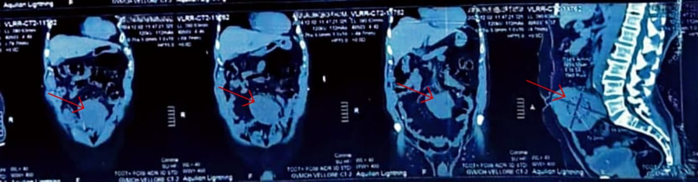
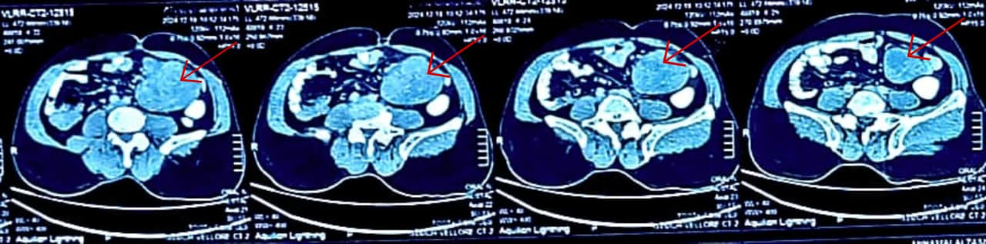
Fig 1: CONTRAST ENHANCED CT ABDOMEN- Red arrow points to the tumour in the image.

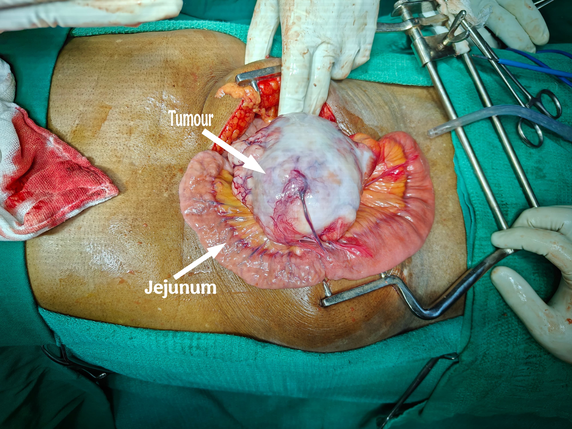
Fig 2: INTRA-OPERATIVE FINDING

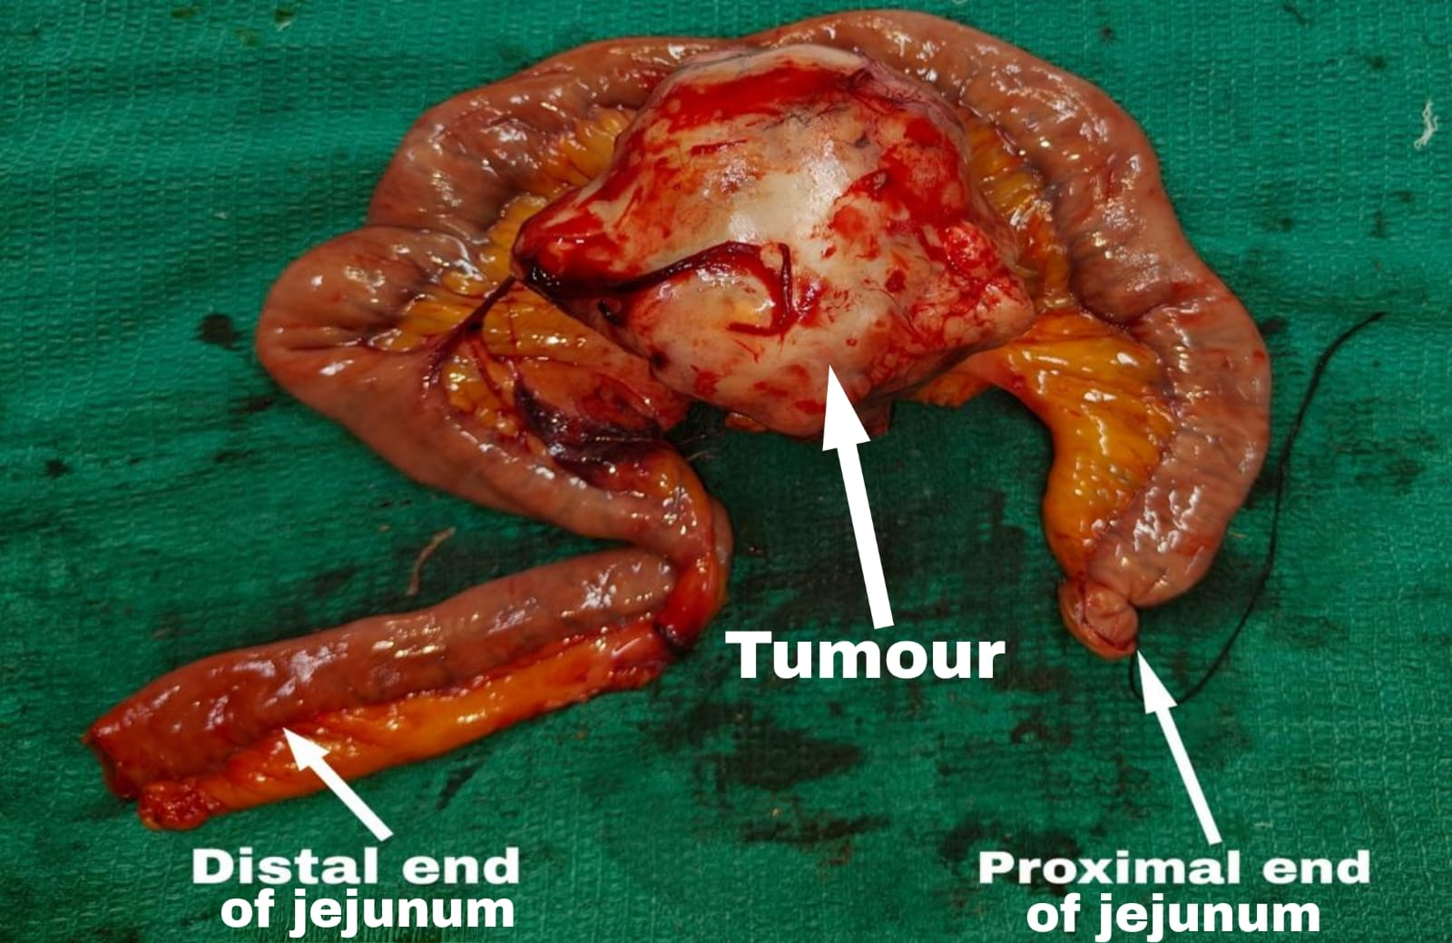
Fig 3: SPECIMEN

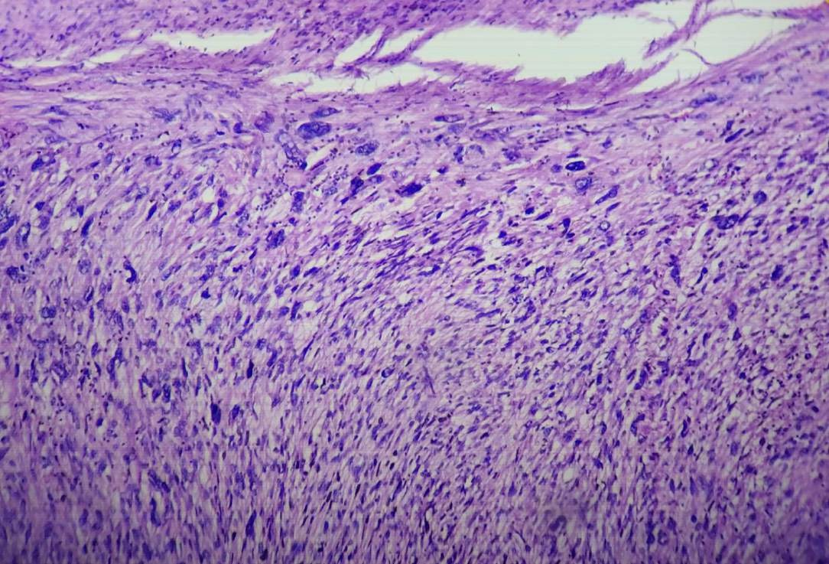
Fig 4: HISTOPATHOLOGY AND IMMUNOHISTOCHEMISTRY
[Diagnosis: Leiomyosarcoma; SMA: Positive; H-caldesmon: Positive; Ki-67 index: 11%; CD117: Negative; Liver nodule: Metastatic deposit]

