Case report
Neuroleptic Malignant Syndrome at the Crossroads of Haloperidol and Polysubstance Abuse: A Case Report

Abstract
This case reports a rare adverse reaction, Neuroleptic Malignant Syndrome (NMS), and its diagnostic challenge. The main objectives are to present the clinical symptoms and laboratory findings during the course of the case, discuss the differential diagnosis and diagnostic ambiguity arising in the case, and summarize the early recognition and role of clinicians in timely diagnosis and management of the adverse reaction. The Neuroleptic Malignant Syndrome is a rare and life-threatening adverse reaction caused by certain antipsychotics. Reporting a case of 24-year-old male at the Department of Emergency Medicine, PESUIMSR, Bangalore, India, who had complaints of tremors, sleeplessness, agitation, and weakness. For this neuropsychiatric condition, he was treated with multiple doses of Haloperidol. After two days of administering Haloperidol, he developed hyperthermia, severe muscle rigidity, tachycardia, diaphoresis, and altered sensorium. Initially, it was unclear whether these symptoms are Haloperidol- induced or due to substance abuse withdrawal. Laboratory data showed peak levels of Creatine Phosphokinase (CPK) of about 15019 U/L, indicating severe muscle damage, considered as the hallmark diagnosis of NMS. The causative drug haloperidol was immediately stopped. The patient was treated with lorazepam, bromocriptine, plenty of IV fluids, and symptomatic treatment. The clinical symptoms of agitation and tremors improved, higher levels of CPK was decreased, body temperature and heart rate decreased gradually and the patient was afebrile, referred to primary neuropsychiatric centre for further treatment. Since both symptoms of NMS and substance abuse withdrawal overlap, this case poses a significant diagnostic challenge.

Categories: Psychiatry, Emergency Medicine, Pharmacology
Keywords: Drug and substance abuse, Elevated Creatine Phosphokinase (CPK), Medical Intensive care unit (MICU), Neuroleptic Malignant Syndrome (NMS), Opioid analgesic dependence, Withdrawal syndrome.

1.Introduction
Neuroleptic Malignant Syndrome (NMS) is a rare but potentially life- threatening adverse effect that can occur in response to treatment with antipsychotic drugs like first- generation or typical antipsychotics and second- generation or atypical antipsychotics. Etiopathology of NMS includes the impact of dopamine receptor inhibition and musculoskeletal fibre toxicity.^{1,2} It is characterized by muscular rigidity, hyperthermia, elevated CPK levels and dysautonomia after the dose of antipsychotics. Associated features also include altered consciousness, leucocytosis, and various signs of vegetative dysregulation such as tachycardia, hypertension and tachypnoea.³ The syndrome usually develops after a sudden increase in dosage of neuroleptic medication or in states of dehydration.⁴ The development of NMS is primarily associated with blockage of central D2 receptors.⁵ Other theories that have been raised for the pathophysiology include disturbance of glutamate,³ serotonin receptors,^{6,7} and central hyponatremia.⁸ Complications of NMS include rhabdomyolysis, acute renal failure and acute respiratory failure.⁹ Treatment includes discontinuation of the causative agent and implementation of supportive therapy. Pharmacological intervention plays a crucial role in lowering mortality rates and improving patient outcomes.
2. Case presentation
A 24-year-old male presented to the Emergency Department with tremors, altered behaviour, sleeplessness, reduced appetite and generalized weakness. He had a history of drug abuse of Dicyclomine, Tramadol, Alprazolam, Tapentadol and other opioids indicating polysubstance dependence. The patient also had a history of drug overdose. His social history included regular smoking and consumption of alcohol for over 10 years. On admission, Haloperidol 5mg BID was administered intramuscularly, Lorazepam 4mg was administered intravenously. After administration of multiple doses of Haloperidol, the patient started developing muscle rigidity, hyperthermia and severe tachycardia. The patient was referred to Intensive Care Unit (ICU) for further management. On examination in the ICU, severe rigidity was noticed in the neck and lower limbs, with persistent fever. The Body Temperature was found to be 103-degree Fahrenheit initially and decreased over a period of time as shown in Figure 1. Tremulousness was positive and the patient was grossly oriented to place and person and disoriented to time. He was sweating profusely (diaphoresis) and tachycardia was noticed, Heart rate- 208bpm was observed initially and decreased over a period of time as shown in Figure 2. Haloperidol induced Neuroleptic Malignant Syndrome was suspected. Haloperidol stopped immediately. Phenergan 5mg was administered to counteract the effect of Haloperidol. Significant changes were observed in the levels of creatinine phosphokinase levels- 1800U/L and 15019U/L on day one and day three respectively. Co- relating to the clinical symptoms this major change confirmed the suspected diagnosis of NMS. Further investigations showed that the patient was reactive to HCV antibody, indicative of IV drug use. Blood investigations showed mild- to- moderate leucocytosis, though other parameters were within normal range. Liver Function Tests showed slight increase in total bilirubin, AST, ALT and GGT levels as mentioned in Table 1. The patient was started on Lorazepam and Bromocriptine to improve motor function and for symptomatic management of NMS. Buprenorphine patch was administered for management of opioid withdrawal. The patient was managed with Ivabradine for Tachycardia and supportive treatment included plenty of IV fluids, thiamine, multivitamins, analgesics and antibiotics. Over the course of treatment, agitation and tremors improved, heart rate was reduced, and the patient was afebrile. He was referred to the primary neuropsychiatric Centre for rehabilitation and further management with proper discharge advice and medications.
TABLE 1: LABORATORY FINDINGS
Test Parameters | Patient value | Units | Normal reference range | Comments
Creatine Phosphokinase | 1800 (Day 1) 15019 (Day 3) | U/L | 55-170 | High
WBC Count | 17800 | cells/cumm | 4500-11000 | High
Total Bilirubin | 2 | mg/dL | 0.1-1.2 | High
AST | 253 | U/L | 10-40 | High
ALT | 94 | U/L | 7-56 | High
GGT | 100 | U/L | 8-60 | High
HCV Antibody test | Reactive | - | Non-Reactive | HCV positive

FIGURE 1: The graph illustrates body temperature of the patient monitored hourly. Each data point represents body temperature (in Fahrenheit). The average body temperature values for the AM (morning) and PM (afternoon/evening) periods are highlighted on the graph, providing an overview of the patient's overall fluctuations in body temperature.
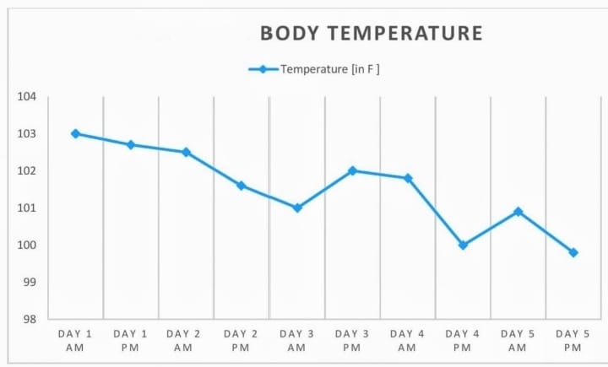
FIGURE 2: The graph illustrates the heart rate of the patient monitored hourly. Each data point represents the heart rate (in beats per minute). The average heart rate values for the AM (morning) and PM (afternoon/evening) periods are highlighted on the graph, providing an overview of the patient's overall fluctuations in heart rate.
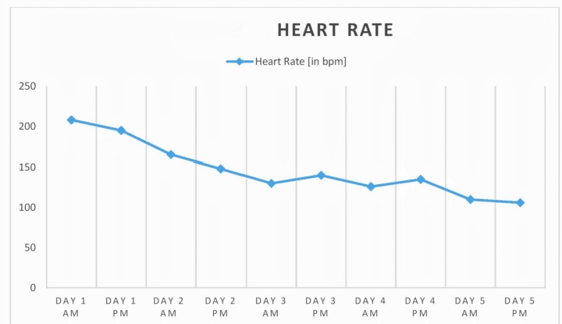

3. Discussion
Neuroleptic Malignant Syndrome (NMS) is an uncommon but potentially fatal complication associated with dopamine receptor antagonists, most frequently high- potency first- generation antipsychotics such as haloperidol.^{1,2} The clinical presentation typically includes hyperthermia, severe muscle rigidity, autonomic instability, and altered mental status, accompanied by elevated Creatine Phosphokinase (CPK) levels and leukocytosis.^{3,4} Despite its characteristic features, NMS can be difficult to diagnose in complex clinical situations where overlapping conditions are present.
Since symptoms including tremors, agitation, sleeplessness, diaphoresis, and tachycardia are frequently observed in opioid and benzodiazepine withdrawal syndrome, diagnostic ambiguity resulted from the patient's history of polysubstance dependency and withdrawal. An increase in CPK levels, persistent hyperthermia and the progressive development of noticeable muscular rigidity, however, strongly suggested NMS rather than withdrawal.
The Pathophysiology of NMS results from central dopaminergic inhibition, specifically in the hypothalamus, basal ganglia, and spinal cord. Dopamine antagonism inhibits nigrostriatal signalling, which results in rigidity and tremors, and it interferes with thermoregulatory pathways, which cause hyperthermia.^{2,7} Furthermore, hypothalamic dysregulation leads to autonomic dysfunction, which causes tachycardia, diaphoresis, and unstable blood pressure.^{1,2} As seen in our case, persistent stiffness also plays a role in hypermetabolism and rhabdomyolysis, which are manifested by noticeably raised CPK levels. Other theories have also been put up to show NMS is a multifactorial condition rather than purely dopamine in origin, including altered monoamine metabolism in CSF fluid⁷ and glutamatergic processes.³
Various case reports in Literature have described NMS as a diagnostic complicated scenario such as olanzapine induced NMS.⁶ Differential diagnosis of NMS was highlighted in previous literature, distinguishing NMS from Malignant Hyperthermia, Serotonin syndrome and withdrawal states.^{4,6,9} However, very few reports describe the similarities between polysubstance abuse withdrawal symptoms and NMS such as Strawn.et,al (2007)¹⁰ and, Caroff and Mann (1993),¹¹ emphasized the diagnostic challenge in polysubstance abuse patient, where it requires careful clinical and laboratory correlation.
Another unique aspect of this case was the rapid elevation of biochemical markers, specifically the rise in CPK levels, which provided strong confirmatory evidence for NMS and differentiated it from Polysubstance withdrawal syndrome, in which such elevations are generally not observed. Then, the presence of Hepatitis C virus Positivity (HCV) added complexity to the treatment indicating both drug abuse of the patient and hepatic damage.
This case signifies the diagnostic difficulty of NMS with substance abuse withdrawal symptoms since both symptoms overlap and the role of healthcare providers in differential diagnosis of the disease.
4. Conclusion
The diagnostic difficulty that arose when the patient was treated with Haloperidol for an initially occurring neuropsychiatric condition of polysubstance abuse, developed the symptoms which overlapped with the symptoms of both haloperidol-induced NMS and substance abuse withdrawal symptoms. It was then resolved with the key differentiating laboratory data of elevated CPK levels, considered as the hallmark for the diagnosis of NMS. Timely diagnosis of the healthcare provider enhances the quality of care of the patient.
8. Consent
Written Informed Consent for publication of their clinical details was obtained from the patient.
9. Disclaimer (Artificial Intelligence)
Authors hereby declare that any use of AI assistance was limited to language editing and authors retain full responsibility for the accuracy and integrity of the manuscript.
ABBREVIATIONS:
U/L- Units per Liter
WBC- White blood cells
Cells/cumm- Cells per cubic millimetre
mg/dL- milligrams per decilitre
AST- Aspartate Transaminase
ALT- Alanine Transaminase
GGT- Gamma-Glutamyl Transferase
HCV- Hepatitis C Virus

10.References
1. Tse, L., Barr, A. M., Scarapicchia, V., & Vila-Rodriguez, F. (2015). Neuroleptic malignant syndrome: A review from a clinically oriented perspective. Current Neuropharmacology, 13(3), 395–406. https://doi.org/10.2174/1570159x13999150424113345
2. Wijdicks, E. F. M., & Ropper, A. H. (2024). Neuroleptic Malignant Syndrome. New England Journal of Medicine, 391(12), 1130–1138. https://doi.org/10.1056/NEJMra2404606
3. Kornhuber J, Weller M, Riederer P: Glutamate receptor antagonists for neuroleptic malignant syndrome and akinetic hyperthermic parkinsonian crisis. J Neural Transm Park Dis Dement Sect. 1993, 6:63-72. 10.1007/BF02252624
4. Chandran, G. J., Mikler, J. R., & Keegan, D. L. (2003). Neuroleptic malignant syndrome: case report and discussion. CMAJ (Canadian Medical Association Journal), 169(5), 439-442. https://doi.org/10.1503/cmaj.1031692
5. Gertz, H. J., & Schmidt, L. G. (1991). Low melanin content of substantia nigra in a case of neuroleptic malignant syndrome. Pharmacopsychiatry, 24, 93-95. https://doi.org/10.1055/s-2007-101447
6. Kontaxakis, V. P., Havaki-Kontaxaki, B. J., Christodoulou, N. G., &Paplos, K. G. (2002). Olanzapine-associated neuroleptic malignant syndrome. Progress in Neuro-Psychopharmacology and Biological Psychiatry, 26(5), 897-902. https://doi.org/10.1016/S0278-5846(02)00202-6
7. Nisijima, K., & Ishiguro, T. (1990). Neuroleptic malignant syndrome: a study of CSF monoamine metabolism. Biological Psychiatry, 27(3), 280-288. https://doi.org/10.1016/0006-3223(90)90002-J
8. Sechi, G., Manca, S., Deiana, G. A., Corda, D. G., Pisu, A., & Rosati, G. (1996). Acute hyponatremia and neuroleptic malignant syndrome in Parkinson's disease. Progress in Neuro-Psychopharmacology & Biological Psychiatry, 20(3), 533-542. https://doi.org/10.1016/0278-5846(96)00015-2
9. Modi, S., Dharaiya, D., Schultz, L., & Varelas, P. (2016). Neuroleptic malignant syndrome: Complications, outcomes, and mortality. Neurocritical Care, 24(1), 97-103. https://doi.org/10.1007/s12028-015-0162-5.10.1016/0278-5846(96)00015-2
10. Strawn JR, Keck PE Jr: Case reports of NMS in substance-abusing patients . CNS Spectr. 2005, 10:322-8. 10.1176/ajp.2007.164.6.870
11. Caroff, S. N., & Mann, S. C. (1993). Neuroleptic malignant syndrome. Medical Clinics of North America, 77(1), 185-202. https://doi.org/10.1016/s0025-7125(16)30278-4

