Case report

Revisiting gabapentin safety: a rare case of serious angioedema

.
ABSTRACT
Background : Gabapentin offers an excellent safety profile and is frequently prescribed to treat neuropathic pain . however only three instances of angioedema have been documented in the published literature ,Resulting in a very rare side effect .Early recognition can be challenging as the presentation may mirror common postoperative oedema or even be misinterpreted as a surgical complication .

Case presentation :
A 61 year old male patient was prescribed gabapentin for neuropathic pain right after lumbar decompression surgery .He developed mild dysphagia and sudden swelling of the right periorbital and malar regions within 24 hours ,but his airway function was unaffected. ACE inhibitor related angioedema ,fluid overload and contact hypersensitivity are all ruled out as potential reasons . An isolated increase in CRP was identified through laboratory analysis .

Management and Outcome :
Gabapentin was stopped immediately , for managing pain pregabalin –nortriptyline was started .Antihistamines and corticosteroids administered intravenously showed a noticeable improvement and within 36 hours oedema had completely disappeared The Naranjo scale revealed a probable causal relationship between gabapentin and angioedema .

Conclusion :
This case illustrates the important role of pharmacovigilance in postoperative pain management is highlighted in this case .gabapentin can cause severe allergic reactions such as angioedema ,which is rare .quick recovery was achieved possibly by prompt identification and rapid drug withdrawal , which also prevented complications like airway compromise .when prescribing gabapentin or similar class drugs ,clinicians must be vigilant ,take a complete drug allergy history and consider angioedema into consideration .

Keywords: Gabapentin, angioedema, adverse drug reaction, neuropathic pain.

1. INTRODUCTION

Swelling caused by blood vessels leaking fluid Into the surrounding tissues and skin known as angioedema .It usually affects the face, lips, tongue, and upper airway ,In comparison with hives. which are superficial and could lead to swelling whereas angioedema affects the skin’s deep layers [1]. usually there are various types of angioedema: this case report comes under drug Induced angioedema and In pathology It Is classified as histamine mediated ,usually The common drugs causing angioedema are ACE Inhibitors And NSAID’s [2,6,7].
Gabapentin Is an anticonvulsant medication that belongs to a class Of gabapentinoids . blocks Α2δ subunit of the calcium channels and reduces nerve pain By decreasing calcium mediated release of excitatory neurotransmitters ,thereby calming irritated nerve roots [3]. here we present A 61-Year old male who was diagnosed with IVDP and treated in accordance with standard operating procedure after being sent to the Orthopaedic outpatient department with Low backache .

2. case PRESENATATION
A 61-year-old male presented to the PESUIMSR Hospital, Bangalore with complaints of chronic low backache radiating to bilateral lower limbs since 2 months. pain was insidious and gradually progressive in nature, he denied fever, allergies or any other symptoms He had no known comorbidities such as hypertension or type 2 diabetes mellitus. MRI of the lumbosacral spine revealed IVDP at the L4–L5 level with nerve root compression, for which he underwent elective lumbar decompression surgery. prior to surgery he was on medication such as thiocolchicoside (MYORIL MAX) twice daily and cholecalciferol (UPRISE D3) capsule 60,000 IU once weekly. After the surgery, he was prescribed gabapentin extended release (GABANTIN GRS) 300 mg twice daily orally for neuropathic pain and to manage postoperative pain. within 24 hours of initiating gabapentin, the patient developed sudden-onset facial swelling involving the right periorbital and malar regions, urticaria, resulting in muffled speech and suspected airway compromise. Laboratory investigations revealed elevated (CRP) at 83.2 mg/L, while liver function tests, renal profile, hematological parameters, and toxicology screening were within normal limits, with no eosinophilia or systemic abnormalities noted. He remained hemodynamically stable but required urgent nasopharyngeal intubation and was shifted to the intensive care unit (ICU). He was administered intravenous pheniramine maleate (AVIL 2ml) hydrocortisone (HYDROCORT-100) 100 mg Stat and two units of fresh frozen plasma (FFP). gabapentin was discontinued, and the patient was transitioned to pregabalin 75 mg + nortriptyline 10 mg (MAYUPREG NT) which was well tolerated without recurrence. The angioedema and urticarial symptoms resolved completely within 36 hours of drug withdrawal and supportive therapy.

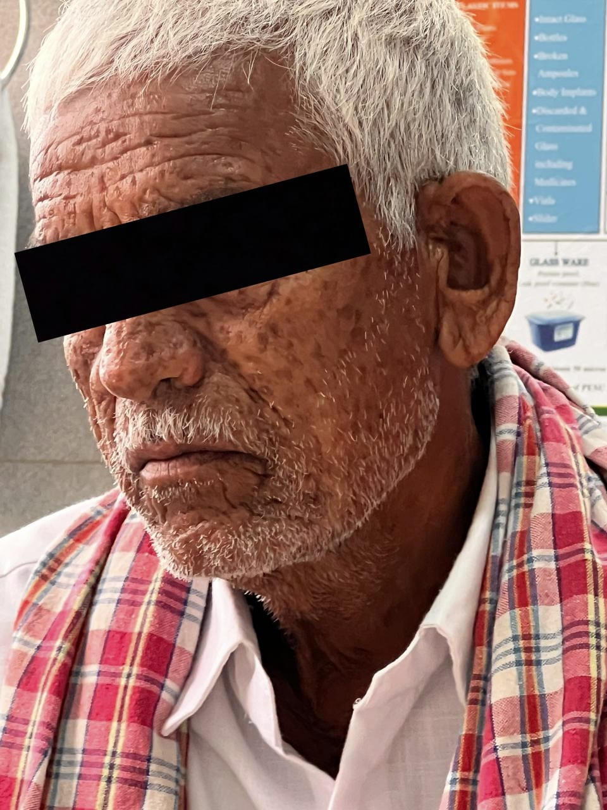

Fig 1: Clinical photograph showing facial swelling consistent with angioedema, involving the periorbital and malar regions. The oedema is non-pitting and diffuse, with associated skin changes. Image captured in ambient indoor lighting for documentation.

3. discussion

Angioedema is a localized or acute swelling of mucosal and submucosal tissues due to increased vascular permeability. It may present with or without urticaria and can be allergic (IgE-mediated) or non-allergic (bradykinin-mediated or idiopathic) [2] Drug-induced angioedema is a known adverse reaction, and while ACE inhibitors are common culprits, other agents like gabapentin have also been implicated in rare instances .in the present case ,the temporal relationship between gabapentin initiation and the occurrence of symptoms strongly suggests that gabapentin was the most likely cause, as he was on thiocolchicoside for multiple weeks before the onset of symptoms ,so making it not as the causative agent [4,5]
The patient developed swelling within 24 hrs of starting the Gabapentin, which provides the evidence of drug induced angioedema, the patient developed significant clinical improvement after immediate discontinuation of gabapentin and initiation of antihistamines and corticosteroids, this response further supports the diagnosis. gabapentin is often considered a safe adjuvant analgesic in postoperative pain management, case reports of gabapentin related angioedema are limited in literature (4)
This case report highlights a rare but clinically important adverse reaction associated with gabapentin therapy .angioedema is potentially life -threatening, especially when it affects the face and airway, and early recognition is essential to prevent complications. This report contributes valuable knowledge to clinicians prescribing gabapentin for postoperative neuropathic pain, emphasizing that even commonly prescribed medications may cause serious reactions.

4.CONCLUSION:
This case highlights the vital role of pharmacovigilance in post operative pain management, although rare gabapentin can cause serious adverse effects such as angioedema .prompt identification and treatment led to rapid recovery without serious complications like airway closure .therefore the possibility of angioedema must always be considered when initiating gabapentin therapy and clinicians must be vigilant ,obtain a complete drug allergy history and consider angioedema into consideration .

Consent
All authors declare that ‘written informed consent was obtained from the patient for publication of this case report and accompanying images.

DISCLAIMER (ARTIFICIAL INTELLIGENCE )

Author(s) hereby declare that Any use of AI assistance was limited to language editing and authors retain full responsibility for the accuracy and integrity of the manuscript .

Abbreviations

ivdp –intervertebral disc prolapse
mri –magnetic resonance imaging
CRP –C REACTIVE PROTEIN

References

- Tarbox JA, Bansal A, Peiris AN. Angioedema. JAMA. 2018;319(19):2054. https://jamanetwork.com/journals/jama/fullarticle/2681197
- Memon RJ, Tiwari V. Angioedema. [Updated 2023 Aug 8]. In: StatPearls [Internet]. Treasure Island (FL): https://www.ncbi.nlm.nih.gov/books/NBK538489/
- Yasaei R, Katta S, Patel P, et al. Gabapentin. [Updated 2024 Feb 21]. In: StatPearls [Internet]. Treasure Island (FL): StatPearls Publishing; https://pubmed.ncbi.nlm.nih.gov/29630280/
- Valdez, C., Kim, A., & Alarcon, T. (2023). A case of gabapentin-induced angioedema in a 31-year-old female. World Journal of Advanced Research and Reviews. https://scholarlycommons.hcahealthcare.com/internal-medicine/494/
- Chong KC, Hsu TH. Gabapentin-Induced Angioedema of Tongue. J Acute Med. 2021 Jun 1;11(2):72-73. doi: 10.6705/j.jacme.202106_11(2).0005
- Marliyeni, R., Kardela, W., & Bellatasie, R. (2021). Angioedema Adverse Drug Reactions Associated with ACE Inhibitor: A Review. Journal of Pharmacy and Biological Sciences, 16(1), 12-20.
- Chalise, R., Poudel, S., Bist, M., Regmi, A., & Khanal, K. (2023). Role of tranexamic acid in NSAIDs induced angioedema. Nepalese Respiratory Journal, 2(1), 31-33.

