Discovery of miliaria tuberculosa in diabetes: two case reports

Abstract
Diabetes is a chronic disease characterized by permanent hyperglycemia, leading to reduced immunity and, consequently, greater susceptibility to infections and delayed clinical manifestation of these infections. Diabetes and tuberculosis interact in two ways: on the one hand, uncontrolled diabetes predisposes patients to the risk of infection and, on the other hand, infection causes diabetes to become uncontrolled. Tuberculous miliaria is a lymphohematogenous dissemination of Mycobacterium tuberculosis in the body. It is a rare, acute, and potentially serious form of the disease. The literature remains limited, with very few studies focusing on the association between miliary tuberculosis and diabetes, highlighting the need for further research to clarify the clinical and therapeutic implications. Our two clinical cases could draw the attention of practitioners to always look for signs of tuberculosis in people with diabetes. This association is underestimated, can be life-threatening, and requires urgent, multidisciplinary care.

Key words : Diabetes, Tuberculosis, Miliary, anti-tuberculosis drugs, Burkina Faso

Introduction
Tuberculous miliary tuberculosis is a lymphohematogenous spread of Mycobacterium tuberculosis to one or more organs in the body from a pulmonary or extrapulmonary focus [1]. It is a rare, acute form of the disease that can be potentially serious and life-threatening due to its complications. It accounts for less than 2% of tuberculosis cases [2]. Tuberculous miliary tuberculosis is a medical emergency. It is most often diagnosed by radiological and clinical findings, with sputum smears rarely proving positive.
Diabetes is a chronic condition characterized by hyperglycemia, which weakens the immune system and promotes infections, including tuberculosis [3]. Diabetic patients with tuberculosis often present with severe forms, atypical locations, and often extensive radiological abnormalities [4].
Diabetes is now recognized as a major risk factor for active tuberculosis due to its impact on cellular immunity. However, in our context, the literature remains limited, with very few studies specifically focusing on the association between miliary tuberculosis and diabetes, highlighting the need for further work to better document this relationship and clarify its clinical and therapeutic implications. We report two clinical observations of patients with miliary tuberculosis associated with diabetes, hospitalized in the pulmonology department of the Yalgado Ouédraogo University Hospital Center in Ouagadougou.
Case Presentation
Case 1: This was a 68-year-old patient with diabetes who was irregularly treated with metformin. He was admitted to the pulmonology department with a dry cough causing stage III modified Medical Research Council dyspnea associated with bilateral chest pain of a heavy type, all developing in a chronic and febrile context. The initial examination revealed clear consciousness with a Glasgow Coma Scale score of 15, a World Health Organization performance status of stage III, moderately colored conjunctiva and mucous membranes without jaundice, no dehydration folds or malnutrition, and no edema of the lower limbs. blood pressure was 163/71 mmHg and pulse oxygen saturation was 94% at room temperature; signs of tuberculous impregnation, infectious syndrome (fever of 38.5°C, tachycardia at 149 beats per minute), bilateral condensation syndrome. A frontal chest X-ray (Figure 1) revealed micro-opacities scattered throughout both lung fields in a “sandcast” pattern suggestive of miliary tuberculosis.
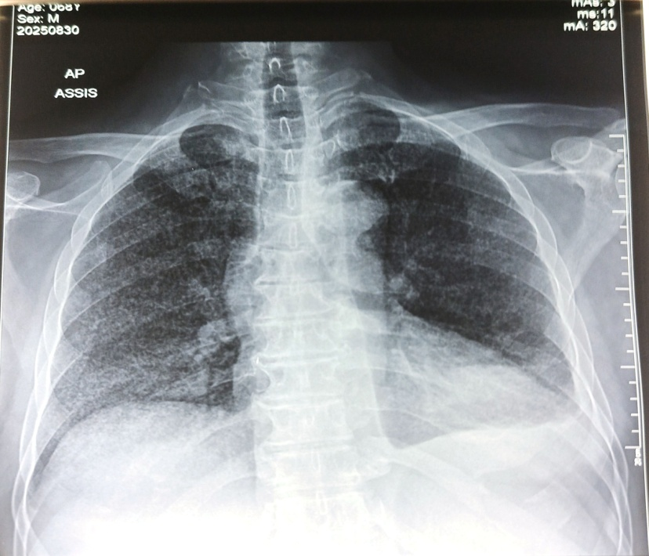
Figure 1: Radiographic appearance of miliary tuberculosis.
The Xpert test of sputum and urine sediment was negative. The tuberculin skin test was negative. Fundus examination revealed stage II Kirkendall hypertensive retinopathy in the right eye and stage I in the left eye. The electrocardiogram and cardiac ultrasound were unremarkable. Blood glucose was elevated at 3.65 g/dL. Blood ionogram and renal function were normal. HIV serology and HBS antigenemia were negative. The blood count showed normal white blood cells at 9600 mm3 and moderate microcytic normochromic anemia at 8.4 g/dL.
The diagnosis of febrile miliaria labeled as tuberculosis in a type 2 diabetic patient was made. In accordance with the national tuberculosis control protocol in force in Burkina Faso, he received a combination of rifampicin, isoniazid, pyrazinamide, and ethambutol, along with adjuvant corticosteroid therapy, a high-protein, high-calorie diet, and support with readjustment of antidiabetic drugs with insulin therapy. The patient responded well to treatment, with complete regression of symptoms. She continued to be monitored simultaneously by pulmonology and endocrinology specialists.

Case 2: This was a 60-year-old female patient, a regular chewing tobacco user with no history of illness. She was admitted for a cough producing mucopurulent sputum associated with stage III modified Medical Research Council dyspnea, which had been developing for one month in a febrile context. On admission, the general examination revealed clear consciousness with a Glasgow score of 15, a stage III deterioration in general condition according to the WHO performance status, colored and anicteric conjunctivae, the presence of dehydration folds and malnutrition, and soft, painless edema of the lower limbs that could be pitted. Good hemodynamic status (blood pressure 128/40 mmHg, temperature 36.9°C, respiratory rate 20 cycles per minute, heart rate 97 beats per minute, pulse oxygen saturation 97% in ambient air); bilateral condensation syndrome. A frontal and lateral chest X-ray (Figure 2) revealed scattered opacities in both lung fields associated with a large right apical hyperlucency surrounded by a well-defined rounded opacity.
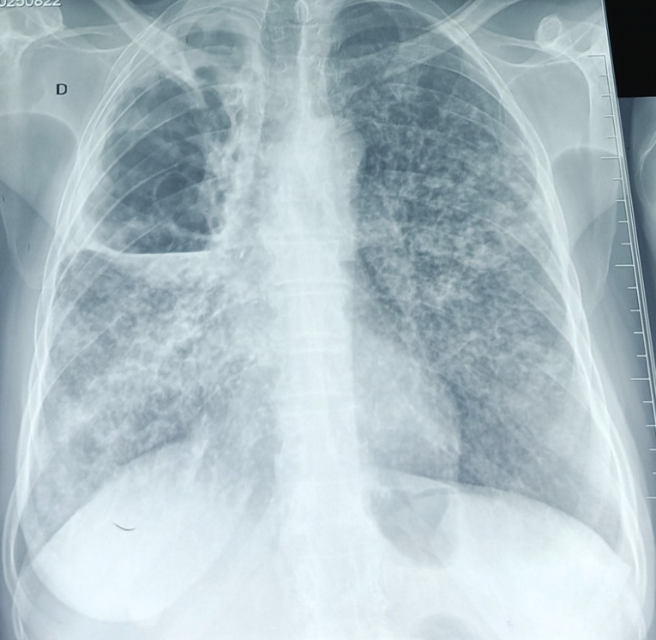
Figure 2: Radiographic appearance of miliary tuberculosis
The Xpert MTB/RIF test on sputum and urine sediment were all positive with high Mycobacterium tuberculosis detected, resistance not detected. Fundus examination and electrocardiogram were normal. Liver and kidney function and blood ionogram were unremarkable. Blood glucose was 9.26 and glycated hemoglobin was 7%. HIV serology and HBS antigenemia were negative. C-reactive protein was elevated at 303.95 mg/L, and the blood count showed hyperleukocytosis at 11,500 mm3 and moderate microcytic normochromic anemia at 9.9 g/dL.
The diagnosis was bronchogenic miliary tuberculosis in the context of recently diagnosed type II diabetes.
Anti-tuberculosis treatment was initiated according to the national tuberculosis control protocol in force in Burkina Faso: a two-month quadruple therapy in the initial phase with rifampicin, isoniazid, pyrazinamide, and ethambutol, followed by a four-month dual therapy in the continuation phase with rifampicin and isoniazid. Adjuvant treatment was instituted, consisting of corticosteroid therapy, a high-protein, high-calorie diet, and psychological support. The patient was placed on insulin therapy for his diabetes. The outcome was favorable, with complete regression of symptoms after 14 days of hospitalization.

Discussion
The link between tuberculosis and diabetes has been described in the literature, with the incidence of tuberculosis being two to five times higher in diabetic patients than in non-diabetics [5]. However, in our context, there are few studies on the association between diabetes and miliary tuberculosis, hence the interest of our clinical observations. With this in mind, we have presented these two clinical cases to draw the attention of practitioners to the importance of always looking for signs of tuberculosis in diabetic patients.
Diabetes is a particular condition in which infections in general, and tuberculosis in particular, can develop silently, explaining the incidental discovery of asymptomatic pulmonary tuberculosis [6]. Taiwan has shown that the manifestations of pulmonary tuberculosis are more asymptomatic in diabetic patients than in non-diabetics [7]. In our patients, the disease progressed silently for a long time, with symptoms only becoming apparent at an advanced stage of the disease.
Two hypotheses have been put forward to explain this frequency of respiratory signs in diabetics. Firstly, diabetes could be related to neuropathy of the autonomic nervous system involved in the reflex arc between the carotid bodies, which develops in the longest nerve fibers, given that the vagus nerve is the autonomic nerve. This nerve innervates the larynx and lower airways and is involved in the cough reflex [8]. Damage to this nerve leads to an alteration in the cough reflex and a decrease in the frequency of hemoptysis. Second, at the systemic level, there appears to be a decrease in pulmonary immune responses in diabetic tuberculosis patients. In fact, the bronchoalveolar lavage fluid of diabetic tuberculosis patients is low in activated macrophages [9] and rich in anti-inflammatory cytokines such as IL-10 but low in pro-inflammatory cytokines such as IFN-γ [10]. This could reduce the frequency of purely respiratory manifestations of tuberculosis in diabetics. The absence of functional signs is a danger that masks pulmonary tuberculosis, delays diagnosis, and delays therapeutic management [11]. Our first observation was not well monitored for his diabetes despite being on oral antidiabetic medication. The onset of miliary tuberculosis proves that his diabetes was not well controlled, either due to non-compliance with treatment or therapeutic ineffectiveness. In contrast, the second patient had no previous medical history, and the discovery of his condition was concomitant. In general, diabetes causes a decrease in immunity, which promotes the onset of infections.
In cases of tuberculosis and diabetes, radiological images are atypical due to impaired cell-mediated immunity, which disrupts the mechanisms involved in cavity formation [12]. The diagnosis of miliary tuberculosis is purely radiological, characterized by typical features such as fine opacities the size of a millet seed, low density, regularity, and distribution throughout both lung fields. Atypical features include larger, less regular micronodules or reticular micronodular images with uneven distribution, predominantly apical or basal [13]. As in the literature, the radiological images were atypical in our cases; the image of our second patient showed a large right apical excavation.
It should be noted that in cases of miliary tuberculosis, sputum confirmation is very rare and requires extensive and thorough investigation. The first patient had been labeled as having tuberculosis due to clinical signs similar to tuberculosis and the fact that Burkina Faso is a country where tuberculosis is endemic. The Xpert sputum test, urine sediment test, and tuberculin skin test were all negative. It should be noted that diabetes causes a depression of cellular immunity with qualitative and quantitative alteration of macrophages. In contrast, in the second patient, the two Xpert tests detected Mycobacterium tuberculosis.
Treatment in both cases was based on first-line anti-tuberculosis drugs, combined with adjuvant corticosteroid therapy, a high-protein, high-calorie diet, and psychological support, with adjustment of antidiabetic treatment to insulin therapy on the advice of endocrinologists. Follow-up was multidisciplinary, involving pulmonologists and endocrinologists. From a therapeutic standpoint, corticosteroid therapy in the management of tuberculosis often makes it difficult to maintain glycemic balance. From a dietary standpoint, rebalancing the diet becomes ambiguous, since tuberculosis patients need to gain weight, whereas in the case of diabetes, the opposite is true.
Miliary tuberculosis is invariably fatal if left untreated. Early initiation of specific treatment for tuberculosis can be life-saving. Monitoring for complications such as acute renal failure, air leak syndromes, acute respiratory distress syndrome, adverse reactions such as drug-induced liver injury, and drug interactions is necessary [14].

Conclusion
These cases illustrate that diabetes is a risk factor for lung disease, leading to reduced immunity with impaired macrophage function. The association between diabetes and miliary tuberculosis is rarely described in the literature, even in countries with high endemicity. This association is often underestimated, and diagnosis is clinical and paraclinical. It can be life-threatening and requires urgent, multidisciplinary care.
Disclaimer (Artificial intelligence)
Option 1:
Author(s) hereby declare that NO generative AI technologies such as Large Language Models (ChatGPT, COPILOT, etc.) and text-to-image generators have been used during the writing or editing of this manuscript.
Reference
1. Ait Ahmed F, Diani, M, Aharmim S., Mourabit S,, Bourkadi J,E. Tuberculous miliary tuberculosis: epidemiological, clinical, biological, radiological, therapeutic, and evolutionary profile. IOSR Journal of Dental and Medical Sciences. 2022; 21: 01-06. DOI: 10.9790/0853-2108070106
2. Carette MF, Azencot M, Le Blanche A, Le Breton C, Bigot JM. Contribution of imaging in the diagnosis and follow-up of thoracic tuberculosis. Rev Pneumol Clin. 1994;50(5):229-39. PMID: 7899756.
3. Sidibé A.T., Dembélé M., Diarra A.S., Cissé I., Bocoum A., Traoré A.K. et al. Pulmonary tuberculosis in diabetic patients in internal medicine at Point G Hospital, Bamako, Mali. Mali Médical 2005; 10: 25-29. PMID: 19617038.
4. Ahandar H, El Aziz S, Chadli A. Tuberculosis and diabetes. Ann Endocrinol. 2015; 76(4): 553. https://doi.org/10.1016/j.ando.2015.07.857
5. Jeon CY, Murray MB. Diabetes mellitus increases the risk of active tuberculosis: a systematic review of 13 observational studies. PLoS Med. 2008 Jul 15;5:152. https://doi.org/10.1371/journal.pmed.0050152
6. Touré, N.O.; Dia Kane, Y.; Diatta, A.; Ba Diop, S.; Niang, A.; Ndiaye, E.M. et al. Tuberculosis and diabetes. Revue des Maladies Respiratoires, 2007; 24 : 869-875. https://doi.org/10.1016/j.rmr.2010.04.017
7. Chiang CY, Bai KJ, Lin HH, Chien ST, Lee JJ, Enarson DA et al. The influence of diabetes, glycemic control, and diabetes-related comorbidities on pulmonary tuberculosis. PLoS One. 2015; 10 : 0121698. https://doi.org/10.1371/journal.pone.0121698
8. Delacourt C. Physiopathology of the cough. ArchPédiatr. 2001; 8: 600-602. https://doi.org/10.1016/s0929-693x(01)80014-2
9. Wang CH, Yu CT, Lin HC, Liu CY, Kuo HP. Hypodense alveolar macrophages in patients with diabetes mellitus and active pulmonary tuberculosis. Tuber Lung Dis. 1999; 79: 235-42. https://doi.org/10.1054/tuld.1998.0167
10. Sun Q, Zhang Q, Xiao H, Cui H, Su B. Significance of the frequency of CD4+ CD25+ CD127- T-cells in patients with pulmonary tuberculosis and diabetes mellitus. Respirology. 2012; 17: 876-82. https://doi.org/10.1111/j.1440-1843.2012.02184.x
11. Miora Maëva A.A., Rija E. R., Thierry R., Sitraka A. R., Andrianirina Dave P.k R., Radonirina L.A. Epidemiological, clinical, biological, and radiological characteristics of pulmonary tuberculosis in diabetics in Antananarivo, Madagascar. Pan African Medical Journal. 2022;42: 1-11. doi: 10.11604/pamj.2022.42.49.29199
12. Longue-Sorgho LC, Cisse R, Ouédraogo M, Ouédraogo T, Bamouni YA, Siko A. Radiological aspects of smear-positive pulmonary tuberculosis in adults in a country with a high prevalence of tuberculosis/HIV. Sidanet. 2005; 2: 870.
13. Ouédraogo M., Boncoungou K., Ouédraogo S.M., Lougue C., Cisse R., Birba E., et al. Bacilliferous miliary tuberculosis: 44 cases. Méd d’Afr Noire 2001 ; 48: 419-422.
14. Sharma, S. K., & Mohan, A. (2021). Miliary tuberculosis. Tuberculosis and nontuberculous mycobacterial infections, 415-435. https://onlinelibrary.wiley.com/doi/abs/10.1128/9781555817138.ch27

