Case report
Hypokalemic periodic paralysis secondary to distal renal tubular acidosis in a middle-aged diabetic female with Sjögren’s syndrome

.
ABSTRACT
Hypokalemic periodic paralysis (HPP) in this patient presented as episodes of muscle weakness along with low serum potassium levels. In this case, the condition is linked to an underlying renal abnormality. We report a case of a 54-year-old diabetic woman who presented with a sudden onset of weakness in both lower limbs, difficulty lifting her neck and legs, giddiness, dry mouth, dry eyes, poor appetite, constipation, and vomiting. Blood tests revealed severe hypokalemia, non-anion gap metabolic acidosis, and alkaline urine, indicating type 1 dRTA. The ECG showed first-degree AV block with ST-T changes. Despite potassium supplementation, her potassium levels remained low, suggesting renal potassium loss. She was treated with an intravenous potassium chloride infusion, intravenous magnesium sulphate, and oral sodium bicarbonate therapy, which resulted in a gradual improvement in her symptoms. The combination of metabolic acidosis and sicca symptoms supported a diagnosis of type 1 distal renal tubular acidosis, possibly associated with Sjögren’s syndrome. This case demonstrated an association between persistent hypokalemia, neuromuscular weakness, and sicca symptoms, pointing toward an underlying autoimmune-related renal disorder.

Keywords: Hypokalemia, Periodic Paralysis, Sjögren’s Syndrome, Distal Renal Tubular Acidosis.

1. INTRODUCTION

“Hypokalemic periodic paralysis (HPP) is an uncommon neuromuscular disorder characterised by brief episodes of skeletal muscle weakness in severe cases, which can cause respiratory arrest and even death. The changes in serum potassium levels determine muscle weakness, which can be either primary or secondary. Most primary causes are genetic with an autosomal dominant inheritance pattern. Secondary causes(acquired) may be linked to loss of potassium from the kidneys” [1]. “Distal Renal Tubular Acidosis (dRTA), being the secondary cause of HPP, is defined as the failure of the kidneys to acidify the urine when the glomerular filtration rate is normal. It can be characterised by normal anion gap, hyperchloremic metabolic acidosis and decreased hydrogen levels. Type 1 and Type 2 are the manifestations of Hypokalemia. Whereas RTA Type 4 is the manifestation of hyperkalemia” [2]. Sjögren’s syndrome is an autoimmune disorder characterised by sicca symptoms and manifested by extra-glandular involvement, including type 1 dRTA leading to severe loss of serum potassium levels, thereby resulting in Hypokalemia Periodic Paralysis [3,4]
Here we report a 54-year-old Female Diabetic patient with HPP who presented to the emergency department with Muscle weakness, sicca and was subsequently diagnosed with dRTA (type 1) and manifested the features of Sjogren’s syndrome.

2. Case Presentation

A 54-year-old woman presented to the emergency department at PESU Institute of Medical Sciences and Research with acute onset of weakness in both lower limbs, inability to lift her neck and legs, giddiness, symptoms of sicca (dry mouth and dry eyes), loss of appetite, constipation (bowel movements once a week) for the past week, and a single episode of vomiting since previous night of admission. There was no history of fever, diarrhea, recent illness, or drug ingestion. She had a remote history of epilepsy (last episode six years ago) and was a known case of Type 2 Diabetes Mellitus (HbA1c 6.1%) for four years, currently off medication for 2-3 days. The patient had no alcohol or smoking history.
On examination, her vital signs were: blood pressure of 130/90 mmHg, pulse of 82 bpm, temperature of 98.8◦C, breathing of 27 cycles/minute and SpO2 96% (on O2). Ocular examination revealed dry eyes. Muscle power was (3/5) in both lower limbs, 4/5 on the upper limb, affecting both proximal and distal groups of muscles.
The laboratory results are summarised in Table 1.

Table 1. Laboratory results

Test Type | Patient Value | Units | Reference Range | Comments
ABG pH | 7.34 | – | 7.35 (low)– 7.45(high) | Low
pCO₂ | 33 | mmHg | 32 – 48 | Low
HCO₃ | 8.90 | mmol/L | 22 – 26 | Low
Base Excess | -8 | mmol/L | -2 to +2 | Low
Potassium (ABG) | 1.2 | mmol/L | 3.5 – 5.1 | Critically Low
Calcium (ABG) | 1.32 | mmol/L | 1.12 – 1.32 | Low-Normal
Hemoglobin | 11.7 | g/dL | 12 – 15 | Slightly Low
PCV | 38.6 | % | 36 – 46 | Normal
WBC Count | 16,500 | /mm³ | 4,000 – 10,000 | High
GRBS (RBS) | 248 | mg/dL | 140 – 180 (post-meal) | High
Platelets | 349,000 | /mm³ | 150,000 – 450,000 | Normal
Serum Creatinine | 1.02 | mg/dL | 0.45 –0.75 | Borderline
Urea | 31 | mg/dL | 15– 40 | Normal
Serum Potassium | 1.5 | mmol/L | 3.5 – 5.1 | Critically Low
Serum Sodium | 135 | mmol/L | 135 – 145 | Normal
Serum Chloride | 116 | mmol/L | 98 – 107 | High
Urine pH | 7 | - | 5.0-9.0 (<5.5 in acidosis) | High → dRTA
Urine Sodium | 113 | mmol/L | 15-237 | Normal
Urine Potassium | 32.1 | mmol/L | 22-164 | Normal range—but inappropriate loss in hypokalemia
Urine Chloride | 134 | mmol/L | 18-209 | Normal/High

Liver function, Thyroid levels, and viral serology (HBV, HCV, HIV) were unremarkable. The electrocardiogram (ECG) showing first-degree AV block and ST-T abnormalities, is presented in (Figure 1) suggesting hypokalemia. ECG changes were consistent with severe hypokalemia.

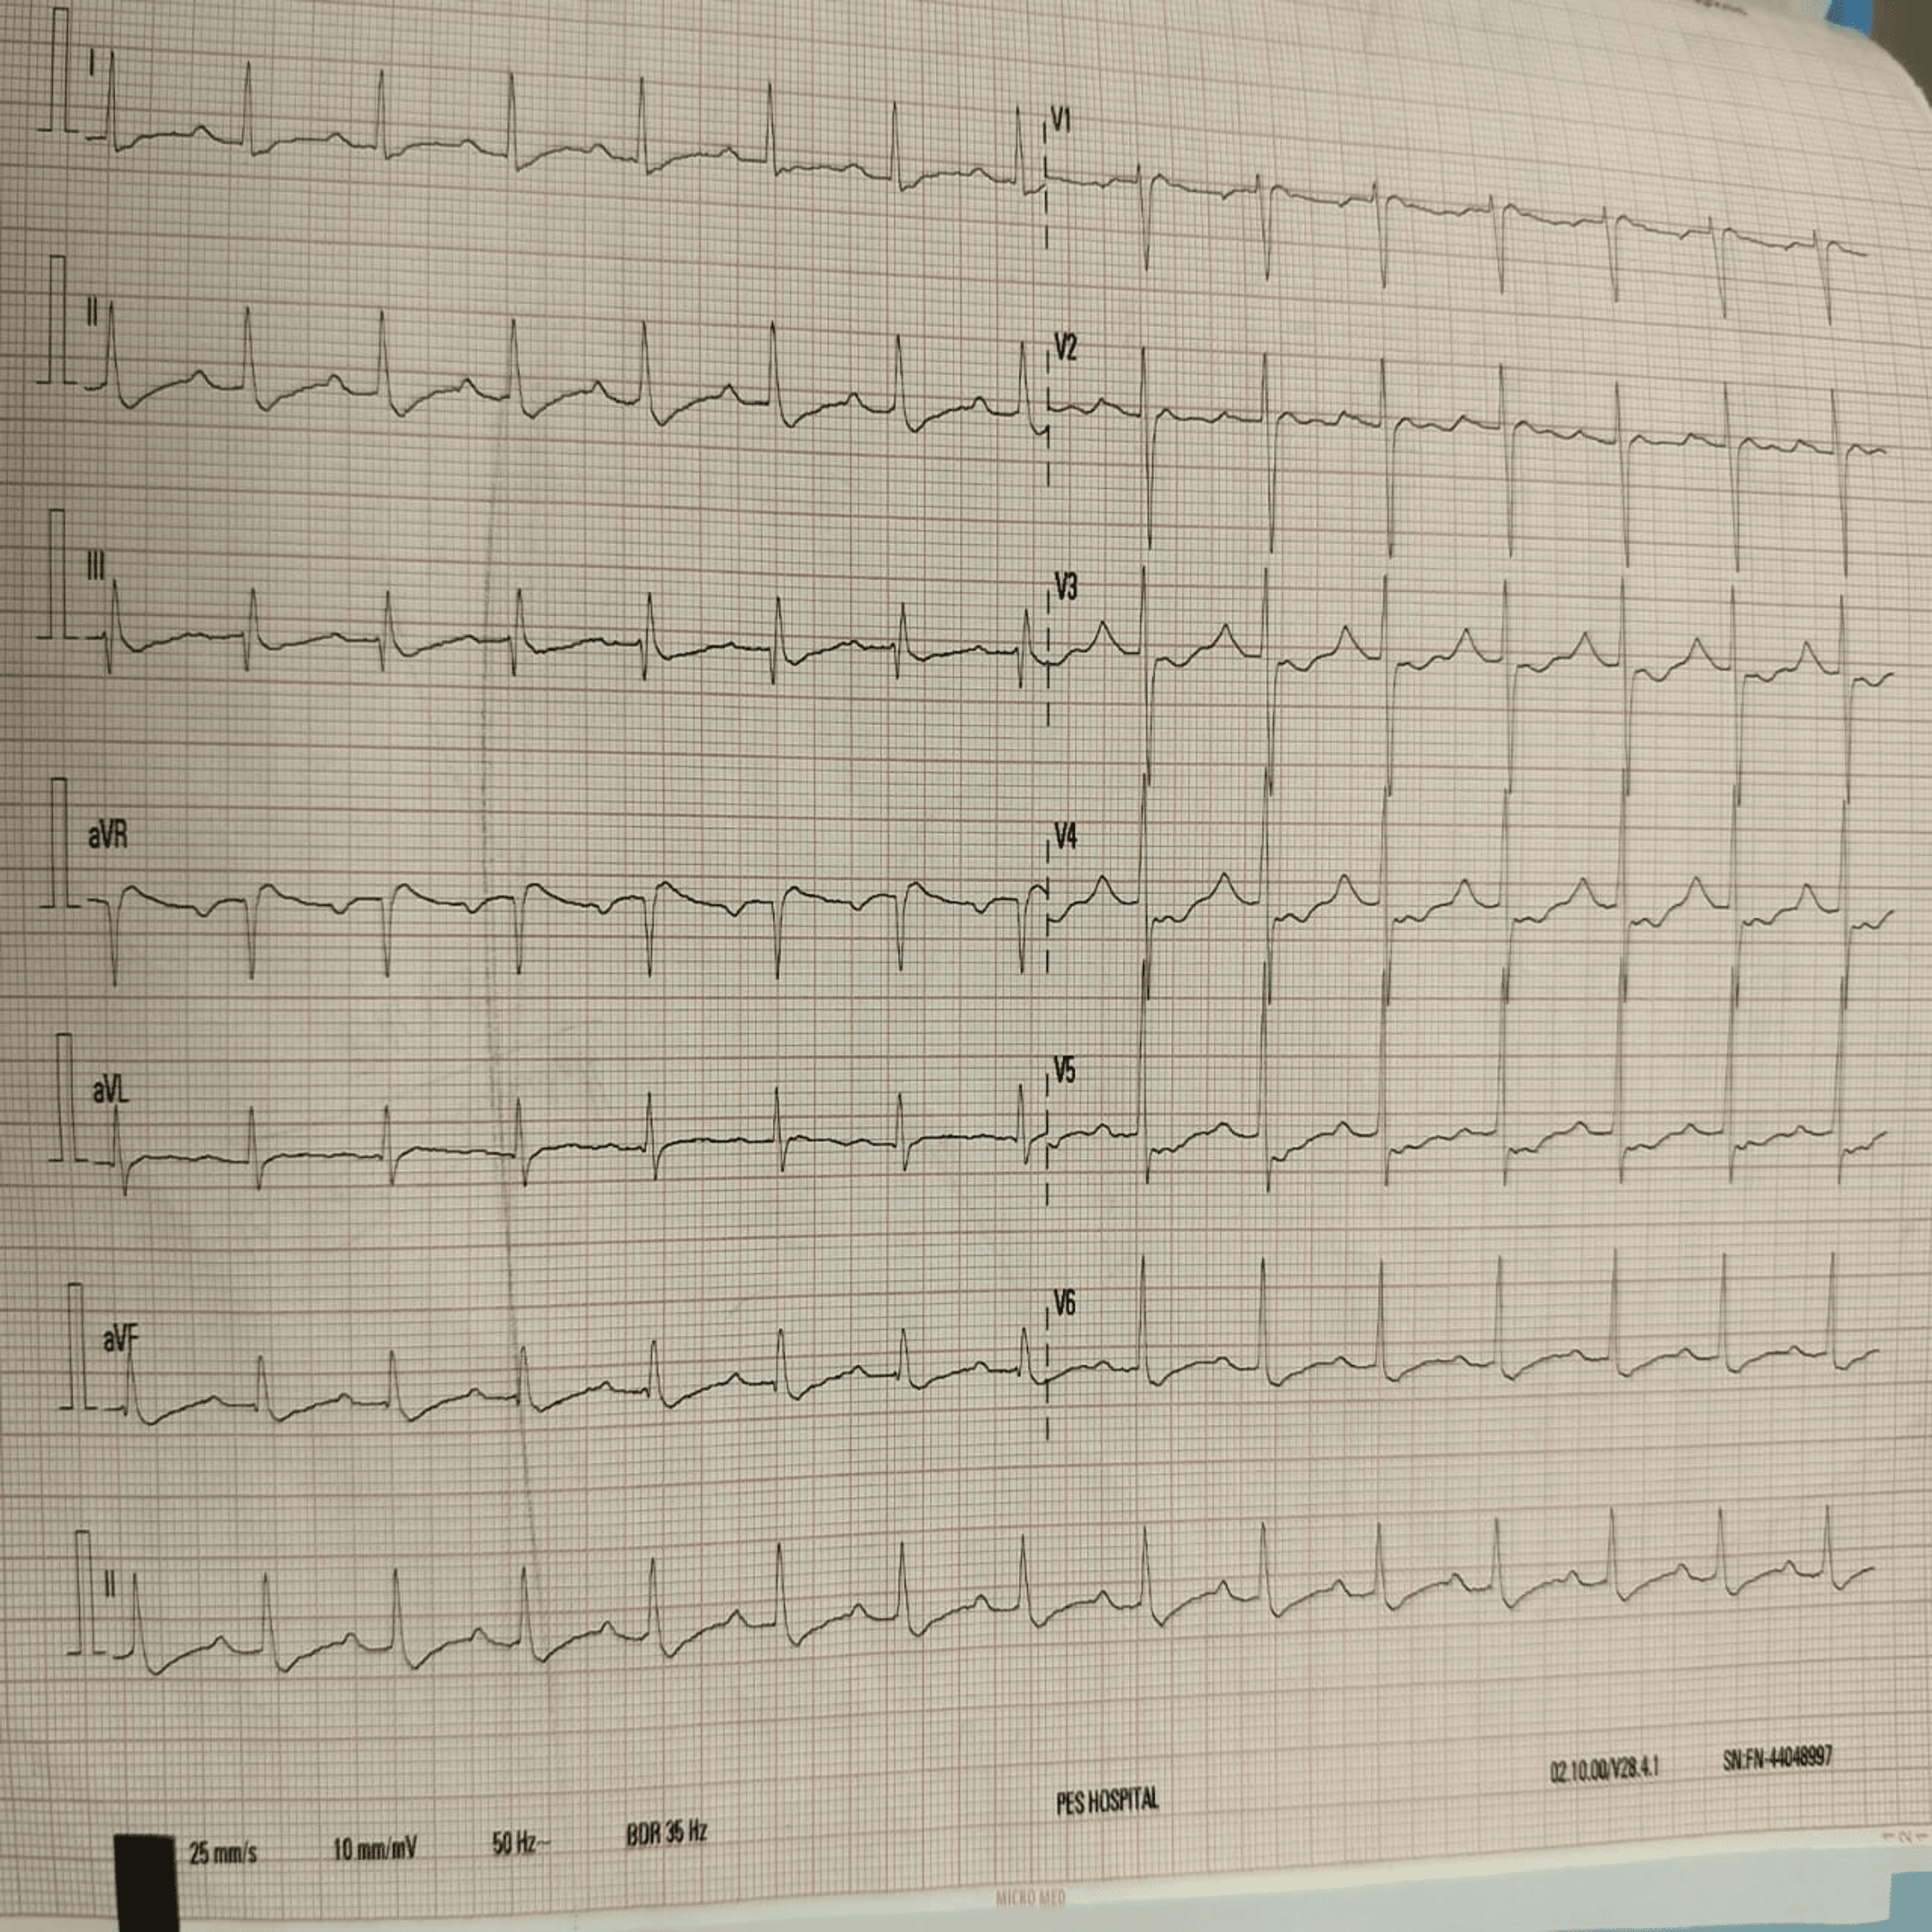

Fig. 1. ECG suggestive of 1st-degree AV block with ST-T wave abnormality.

Based on non-anion gap metabolic acidosis with alkaline urine and hypokalemia, a diagnosis of hypokalemia periodic paralysis with a secondary cause of dRTA associated with metabolic acidosis was made. Persistent hypokalemia with metabolic acidosis in a diabetic female with sicca symptoms is an unusual presentation, indicating secondary distal renal tubular acidosis (dRTA) linked to Sjögren’s syndrome. This unusual combination of metabolic and autoimmune features contributes to the unique character of the case.
She was initially treated with intravenous potassium chloride infusion (KCL), injection of magnesium sulphate, and a sodium bicarbonate tablet. During follow up the patient, despite aggressive potassium replacement, marked hypokalemia persisted over several days (1.5, 2.2, 2.3, 3.1, 3.0, 3.3, 3.4mmol/L), indicating renal potassium wasting. At the time of discharge, it was observed that clinical findings were marginally improved. The patient was discharged on oral potassium supplementation, multivitamins, moxifloxacin and a lubricating eye drop and oral hypoglycemic agents, with advice for follow-up in medicine and ophthalmology OPDs.

3. DISCUSSION

Hypokalemic periodic paralysis may rarely result from distal renal tubular acidosis (dRTA), particularly when it occurs secondary to autoimmune conditions like Sjögren’s syndrome [5]. Autoimmune injury to distal tubular intercalated cells in Sjögren's syndrome can lead to tubulointerstitial nephritis and impaired acid secretion, which results in type 1 distal renal tubular acidosis[6]. In this case, the presence of persistent hypokalemia along with non-anion gap metabolic acidosis and alkaline urine indicates a defect in distal tubular acid secretion [7]. The coexistence of sicca symptoms (dry eyes and dry mouth) with a positive Schirmer test provided strong clinical evidence of an autoimmune process, most likely Sjögren’s syndrome. The urine potassium level of 32 mmol/l confirmed ongoing renal potassium wasting and the absence of gastrointestinal potassium losses, supporting a diagnosis of secondary distal renal tubular acidosis (dRTA), most likely due to an autoimmune origin related to Sjögren’s syndrome, which was clinically suspected. However, immunological confirmation with anti-SSA and anti-SSB antibodies was not performed due to financial constraints; this is a limitation that prevents definitive confirmation of Sjögren’s syndrome; however, the clinical findings were strongly suggestive of autoimmune dRTA [5, 8].
An intracellular potassium shift is usually the cause of hypokalemic periodic paralysis (e.g., familial HPP, thyrotoxic HPP). In contrast, in dRTA, hypokalemia arises from renal potassium wasting due to defective hydrogen ion secretion, resulting in metabolic acidosis and compensatory renal potassium loss [9]. This mechanism explains why even with appropriate potassium replacement therapy, hypokalemia still occurs. In this patient, persistent hypokalemia was primarily presented as neuromuscular weakness, ST-T abnormalities, and a first-degree AV block on the ECG, indicating the potential cardiac consequences of severe hypokalemia [10]. The slow and insufficient correction of serum potassium despite sufficient supplementation suggested an underlying tubular defect. To avoid complications and to direct treatment for long-term management, early diagnosis of autoimmune-related distal renal tubular acidosis is crucial.
Treatment primarily focused on intravenous potassium chloride infusion to correct hypokalemia and oral sodium bicarbonate to correct metabolic acidosis. MgSO₄ infusion was administered to help stabilise potassium levels and allow more effective potassium repletion, as intracellular magnesium deficiency can contribute to refractory hypokalemia [8]. The initial management of Sjögren’s dry eye disease involves the use of ocular lubricants [11]. To improve the sicca symptoms, a hallmark of Sjögren's syndrome, the patient was prescribed ocular lubricants (Lubrex and Meferon eye drops). Her muscle strength showed significant improvement at the 4th-week follow-up, and her serum potassium levels were within normal range with oral potassium supplementation, and continued use of ocular lubricants improved her sicca symptoms.
This report emphasises the significance of assessing secondary causes of hypokalemic paralysis, particularly in a middle-aged female patient exhibiting sicca symptoms. A combination of autoimmune dRTA, hypokalemia-induced paralysis, diabetes mellitus, and ECG alterations makes this case both rare and educationally significant.

4. Conclusion

The case emphasises the importance of identifying secondary causes of hypokalemic paralysis. The coexistence of persistent hypokalemia, non-anion gap metabolic acidosis, and sicca symptoms pointed toward dRTA associated with Sjogren’s syndrome. Early diagnosis and management of electrolyte disturbances are essential to prevent recurrence and long-term complications.

Consent

Written informed consent for publication of their clinical details and/or clinical images was obtained from the patient

DISCLAIMER (ARTIFICIAL INTELLIGENCE)
Author(s) hereby declare that any use of ai assistance was limited to language editing and authors retain full responsibility for the accuracy and integrity of the manuscript.
Abbreviations
HPP-hypokalemia periodic paralysis
dRTA-distal renal tubular acidosis
ECG-electrocardiogram

References

- Amaranath L. Hypokalemic periodic paralysis [Internet]. Treasure Island (FL): StatPearls Publishing; 2025 [cited 2025 Nov 10]. Available from: https://www.ncbi.nlm.nih.gov/books/NBK559178/
- Venance SL, Cannon SC, Fialho D, et al. The primary periodic paralyses: diagnosis, pathogenesis and treatment. Brain. 2006;129(1):8–17. doi:10.1093/brain/awh639
- Kishor A, Rejy AM, John C, Lakshmi R, Reji K. Primary Sjögren’s syndrome unveiling type 1 renal tubular acidosis: a rare case report of hypokalemic periodic paralysis from a developing country. Int J Med Pharm Case Rep. 2025;18:48–52. doi:10.9734/ijmpcr/2025/v18i2421
- Mondal R, Aheteshamuddin M, Kumar P, Rohith A. Primary Sjogren’s syndrome presenting as life-threatening hypokalemic paralysis: a diagnostic challenge. Int J Pharm Sci. 2025; 3:1281–1284. doi:10.5281/zenodo.14878541
- Sedhain A, Acharya K, Sharma A, Khan A, Adhikari S. Renal tubular acidosis and hypokalemic paralysis as a first presentation of primary Sjögren's syndrome. Case Rep Nephrol. 2018; 2018:9847826. doi:10.1155/2018/9847826
- Sanjeevani S, Prasad P, Sharma S, Bagai S, Khullar D. Renal Involvement in Primary Sjögren's Syndrome: A Multi-centric Study From North India. Cureus. 2025;17(6):e86494. Published 2025 Jun 21. doi:10.7759/cureus.86494
- Vallés PG, Batlle D. Hypokalemic distal renal tubular acidosis. Adv Chronic Kidney Dis. 2018;25(4):303–320. doi: 10.1053/j.ackd.2018.05.003
- Giglio S, Montini G, Trepiccione F, Gambaro G, Emma F. Distal renal tubular acidosis: a systematic approach from diagnosis to treatment. J Nephrol. 2021;34(6):2073–2083. doi:10.1007/s40620-021-01032-y
- Soleimani M, Rastegar A. Pathophysiology of renal tubular acidosis: core curriculum 2016. Am J Kidney Dis. 2016;68(3):488–498. doi: 10.1053/j.ajkd.2016.03.422
- Wang X, Han D, Li G. Electrocardiographic manifestations in severe hypokalemia. J Int Med Res. 2020;48(12):300060518811058. doi:10.1177/0300060518811058
- Wu KY, Chen WT, Chu-Bédard YK, Patel G, Tran SD. Management of Sjogren's dry eye disease—advances in ocular drug delivery offering a new hope. Pharmaceutics. 2022;15(1):147. doi:10.3390/pharmaceutics15010147

