RETROGRADATION OF SORGHUM STARCH: AN INVESTIGATION INTO THE EFFECTS OF ALCOHOL AND WATER
Abstract
This study investigated the retrogradation behavior of sorghum starch (Sorghum bicolor) under the influence of alcohol and water, with emphasis on changes in physicochemical properties relevant to food, pharmaceutical, and industrial applications. Sorghum starch was extracted using a modified alkaline steeping method involving sodium hydroxide treatment, wet milling, filtration, centrifugation, and controlled drying. Preliminary qualitative tests confirmed the presence of starch carbohydrates, including amylose and amylopectin. Retrogradation was induced under controlled conditions using water and ethanol, and key physicochemical parameters such as bulk density, tapped density, water sorption capacity, true density, amylose and amylopectin fractions, hydration capacity, swelling capacity, porosity, Hausner ratio, and compressibility index were evaluated over time. The results showed that alcohol-treated starch exhibited increased structural compaction, reduced water sorption capacity, and delayed amylose recrystallization, indicating suppression of retrogradation. In contrast, water-treated starch demonstrated enhanced compressibility, higher amylopectin reorganization, and improved hydration behavior, reflecting increased molecular mobility and starch reassociation. These solvent-specific effects significantly influenced the functional and flow properties of sorghum starch. The findings highlight the potential of solvent manipulation as a practical strategy for controlling starch retrogradation and optimizing sorghum starch performance in product formulation. Understanding the differential effects of alcohol and water on sorghum starch retrogradation provides valuable insights for improving texture, stability, and shelf life in starch-based systems and supports the broader utilization of sorghum starch in diverse industrial applications.
Keywords: Sorghum starch; retrogradation; alcohol; water; amylose; amylopectin; physicochemical properties.

Introduction
Starch is one of the most abundant naturally occurring biopolymers and serves as a major source of dietary energy for humans, in addition to being a critical raw material in food, pharmaceutical, and industrial applications (Apriyanto, Compart, and Fettke 2022). Structurally, starch is composed of two polysaccharide fractions amylose, a predominantly linear molecule, and amylopectin, a highly branched polymer whose relative proportions and molecular interactions largely determine starch functionality and performance during processing and storage (Liu, Li, and Chen 2020). Owing to its versatility, starch is widely used as a thickener, binder, stabilizer, disintegrant, and texturizing agent across diverse processing systems. However, the performance of starch in these applications is strongly influenced by post-gelatinization phenomena, particularly retrogradation, which affects product texture, stability, and shelf life (Lim, Zhang, and Chen 2020).
Among cereal starch sources, sorghum starch occupies a strategically important position, especially in developing regions where sorghum (Sorghum bicolor) is a major staple crop. Sorghum is valued for its drought tolerance, adaptability to marginal soils, and relatively low production cost, making it increasingly important under changing climatic conditions (Meisah, Oduro, and Ellis 2020). The starch derived from sorghum grains is characterized by relatively high amylose content, small granule size, and distinct crystalline organization, features that differentiate it from starches obtained from maize, wheat, and rice (Zhang, Li, and Chen 2022). These intrinsic properties influence gelatinization, retrogradation behavior, and the suitability of sorghum starch for specific food and non-food applications (Adjetey 2024).
Retrogradation refers to the molecular reassociation and recrystallization of gelatinized starch chains during cooling and storage. This process occurs in a stepwise manner, involving an initial rapid recrystallization of amylose molecules followed by a slower, long-term reorganization of amylopectin chains (Zhou et al. 2021). Retrogradation is responsible for several undesirable changes in starch-based systems, including increased firmness, loss of moisture-holding capacity, gel syneresis, and product staling. In food products such as bread, porridges, and starch gels, excessive retrogradation negatively affects sensory quality and consumer acceptability, while in pharmaceutical formulations it can alter flow properties, compressibility, and disintegration behavior (Gunaratne 2023).
Water plays a central role in starch retrogradation by acting as both a plasticizer and a medium for molecular mobility. During gelatinization, water disrupts the native crystalline structure of starch granules, allowing starch chains to hydrate and swell. Upon cooling, the availability of water facilitates molecular rearrangement and hydrogen bonding between starch chains, promoting recrystallization (Zhu et al. 2018; Nawaz et al. 2023). The extent of retrogradation is therefore strongly dependent on moisture content, storage temperature, and time. While adequate water is essential for starch functionality, excessive water availability can accelerate retrogradation and lead to syneresis and structural instability in starch-based systems (Zhao and An 2024).
In contrast, alcohols particularly low-molecular-weight alcohols such as ethanol have been reported to modify starch behavior by reducing water availability and interfering with hydrogen-bonding interactions within starch matrices. Alcohol molecules can partially replace water in the starch network, limiting starch hydration and restricting chain mobility, thereby suppressing amylose recrystallization and delaying retrogradation (Allan and Mauer 2022; Ding and Yang 2021). Recent studies have further demonstrated that solvent–starch interactions can significantly influence starch physicochemical properties, including density, swelling, hydration capacity, and flow behavior (Liu, Li, and Chen 2020; Ngo et al. 2022).
Despite growing interest in sorghum starch as a sustainable alternative to conventional cereal starches, systematic investigations into the combined effects of water and alcohol on sorghum starch retrogradation remain limited. Most existing studies focus on maize or wheat starches, with relatively few reports addressing solvent-specific modulation of sorghum starch retrogradation and its physicochemical consequences (Zhang, Li, and Chen 2022). Understanding how alcohol and water differentially influence sorghum starch retrogradation is therefore essential for optimizing its functional performance and expanding its application in food processing, pharmaceuticals, and related industries.
Against this background, the present study investigates the retrogradation behavior of sorghum starch under the influence of alcohol and water. By evaluating changes in key physicochemical properties over defined storage periods, this study aims to provide insight into solvent-specific effects on starch structure, functionality, and stability. The findings are expected to contribute to improved control of sorghum starch retrogradation and support its effective utilization in industrial applications where texture, flow properties, and shelf life are critical.
Aims of this Study
The primary aim of this study is to investigate the retrogradation behavior of sorghum starch (Sorghum bicolor) under the influence of alcohol and water by evaluating changes in selected physicochemical properties over defined storage periods. Specifically, the study seeks to compare the effects of alcohol and water on starch density, hydration and swelling behavior, amylose and amylopectin fractions, flow characteristics, and structural stability during retrogradation. By elucidating solvent-specific influences on sorghum starch retrogradation, the study aims to generate information that will support improved control of starch functionality and enhance the utilization of sorghum starch in food, pharmaceutical, and related industrial applications.
LITERATURE REVIEW
Mechanisms and Factors Influencing Starch Retrogradation
Starch retrogradation is a complex physicochemical phenomenon involving the reassociation and recrystallization of gelatinized starch molecules during cooling and storage. It is widely recognized as a two-stage process, beginning with the rapid recrystallization of amylose molecules followed by the slower, long-term reorganization of amylopectin chains (Lim, Zhang, and Chen 2020; Zhou et al. 2021). Amylose, due to its linear molecular structure, readily aligns to form double helices and crystalline regions shortly after gelatinization. In contrast, amylopectin, characterized by a highly branched structure, undergoes gradual molecular rearrangement over extended storage periods, contributing significantly to long-term textural changes in starch-based systems.
Several intrinsic and extrinsic factors influence the rate and extent of starch retrogradation. Intrinsic factors include starch botanical origin, granule size, crystalline type, and the amylose-to-amylopectin ratio, while extrinsic factors encompass moisture content, storage temperature, time, and the presence of solvents or additives (Gunaratne 2023). Low storage temperatures generally promote retrogradation by facilitating molecular alignment and hydrogen bonding, whereas higher temperatures tend to slow down recrystallization processes. Moisture availability plays a particularly critical role, as sufficient water enhances molecular mobility, enabling starch chains to reassociate into ordered structures (Zhu et al. 2018). Understanding these mechanisms is essential for controlling retrogradation in starch-based products and improving their functional performance.
Role of Water in Starch Retrogradation
Water is a fundamental component in starch gelatinization and retrogradation, acting as both a plasticizer and a medium for molecular interaction. During gelatinization, water penetrates starch granules, disrupts hydrogen bonds within crystalline regions, and allows starch chains to swell and solubilize. Upon cooling, water facilitates molecular reassociation by enabling starch chains to realign and form hydrogen-bonded crystalline structures (Nawaz et al. 2023). Consequently, the extent of retrogradation is strongly dependent on water content and water activity within the system.
Studies have shown that higher water availability generally accelerates retrogradation by increasing chain mobility, particularly for amylopectin during long-term storage (Zhao and An 2024). However, excessive water can also lead to undesirable phenomena such as syneresis, where water is expelled from starch gels, resulting in structural weakening and quality deterioration. In food systems such as bread, porridges, and starch gels, water-induced retrogradation contributes to firmness development, staling, and reduced consumer acceptability. In pharmaceutical applications, changes in water-mediated retrogradation can affect powder flowability, compressibility, and tablet disintegration behavior. Therefore, controlling water content is a critical strategy for managing starch retrogradation and achieving desirable functional properties.
Impact of Alcohol on Starch Retrogradation
Alcohols, particularly low-molecular-weight alcohols such as ethanol, have been reported to significantly alter starch retrogradation behavior by modifying solvent–starch interactions. Alcohol reduces the availability of free water in starch systems and interferes with hydrogen bonding between starch chains, thereby limiting molecular mobility and inhibiting crystalline structure formation (Ding and Yang 2021). By partially replacing water molecules within the starch matrix, alcohol restricts starch hydration and suppresses amylose recrystallization, leading to delayed or reduced retrogradation.
Experimental studies have demonstrated that alcohol-treated starch systems often exhibit reduced gel firmness, lower water sorption capacity, and altered flow properties compared to water-treated systems (Allan and Mauer 2022). The magnitude of alcohol’s effect depends on factors such as alcohol type, concentration, and treatment duration. Ethanol, in particular, has been shown to delay retrogradation at moderate concentrations, while higher concentrations may almost completely inhibit starch crystallization (Liu, Li, and Chen 2020). These properties make alcohol an important tool for modulating starch functionality in specialized food products, alcoholic formulations, and pharmaceutical preparations where controlled texture and stability are required.
Sorghum Starch and Retrogradation Behavior
Sorghum starch exhibits retrogradation behavior that differs from that of more commonly studied cereal starches such as maize and wheat. Sorghum starch typically contains a relatively high amylose content and smaller granule size, characteristics that influence its gelatinization temperature, retrogradation rate, and textural properties (Meisah, Oduro, and Ellis 2020; Zhang, Li, and Chen 2022). High amylose content is often associated with an increased tendency for rapid retrogradation, which can negatively affect the quality of sorghum-based foods such as porridges, bakery products, and traditional beverages.
Recent studies have emphasized the need to better understand the physicochemical behavior of sorghum starch under different processing conditions to enhance its industrial applicability (Adjetey 2024). However, while the effects of temperature and moisture on sorghum starch retrogradation have been explored, limited attention has been given to solvent-specific effects, particularly the comparative influence of water and alcohol. Investigating how these solvents modulate sorghum starch retrogradation can provide valuable insights into controlling starch functionality and improving the performance of sorghum starch in food, pharmaceutical, and industrial applications.
MATERIALS AND METHODS
Sample Collection and Identification
Sorghum grains (Sorghum bicolor) used for this study were purchased from Sokoto Central Market, Sokoto State, Nigeria. The grains were taxonomically identified and authenticated by Dr. H. A. Gwandu, Head of the Department of Crop Science, Usmanu Danfodiyo University, Sokoto (UDUS), Faculty of Agricultural Sciences. Locally, the crop is known as Dawa and is widely cultivated and consumed in northern Nigeria. The grains are commonly used in the preparation of traditional foods and beverages such as burukutu and luwo. Only clean, mature, and undamaged grains were selected for starch extraction.
Extraction of Sorghum Starch
Sorghum starch was extracted using the method described by Singh et al. (2009), with slight modifications. A weighed quantity of sorghum grains (100 g) was steeped in 200 mL of 0.25% (w/v) sodium hydroxide (NaOH) solution for 24 hours at room temperature to facilitate protein solubilization and starch release. After steeping, the grains were decanted and washed repeatedly with distilled water to remove residual NaOH. The softened grains were then wet-milled using an equal volume of distilled water to obtain a slurry.
The slurry was filtered through a calico cloth to separate the starch-containing filtrate from the fibrous residue. The residue was washed several times with distilled water to maximize starch recovery and then discarded. The combined filtrate was allowed to stand undisturbed for 24 hours to enable starch sedimentation. Thereafter, the supernatant was carefully decanted, and the starch suspension was centrifuged at 4500 rpm for 10 minutes. Following centrifugation, the grey protein-rich layer at the top was removed using a spatula. The resulting starch cake was dried in a hot-air oven at 45 °C for 48 hours, pulverized into fine powder, and stored in airtight containers until further analysis.
Starch Modification and Induction of Retrogradation
Retrogradation of sorghum starch was induced using water and alcohol treatments. For each treatment, 20 g of starch powder was weighed into five separate beakers labeled according to storage duration (0, 1, 2, 4, and 8 days). For water-induced retrogradation, 800 mL of distilled water was added to each starch sample to form a uniform suspension. The suspension was heated in a water bath at 90 °C with continuous stirring until complete gelatinization was achieved. The gelatinized starch was immediately transferred into an ice bath and stirred continuously for 10 minutes to initiate retrogradation. The sample designated as day 0 was dried immediately in an oven at 50 °C, while the remaining samples were stored under refrigeration and dried at their respective storage times.
For alcohol-induced retrogradation, 400 mL of distilled water was first added to 20 g of starch and heated under the same gelatinization conditions described above. After gelatinization, an additional 400 mL of ethanol was added gradually with continuous stirring to ensure uniform mixing. The mixture was transferred into an ice bath for 10 minutes with continuous stirring and then stored in a refrigerator for the specified storage periods. At the end of each storage period, the supernatant liquid was decanted, and the starch sediment was collected, spread on clean trays, and dried in an oven at 50 °C to obtain alcohol-treated retrograded starch.
Preliminary Qualitative Tests for Starch
Preliminary qualitative tests were conducted to confirm the presence of starch and carbohydrate components in the extracted sample. The Molisch test was performed by treating a small quantity of starch mucilage with Molisch reagent followed by careful addition of concentrated sulfuric acid along the sides of the test tube. The formation of a violet-green ring at the interface indicated the presence of carbohydrates. The iodine test was conducted by adding iodine solution to starch mucilage, and the formation of a blue-black coloration confirmed the presence of starch, specifically amylose.
Determination of Physicochemical Properties
The physicochemical properties of native and retrograded sorghum starch samples were evaluated using standard analytical procedures. Parameters determined included bulk density, tapped density, water sorption capacity, true density, hydration capacity, swelling capacity, amylose and amylopectin fractions, Hausner ratio, compressibility index (Carr’s index), and percentage porosity. Measurements were carried out at different retrogradation time intervals (0, 24, 48, 96, and 192 hours) for both water-treated and alcohol-treated starch samples. All determinations were conducted in triplicate, and mean values were reported to ensure reliability and reproducibility of results.
RESULTS
Preliminary Qualitative Tests of Sorghum Starch
The preliminary qualitative tests conducted on the extracted sorghum starch confirmed the presence of carbohydrate components characteristic of starch. The Molisch test produced a violet–green ring at the interface of the solution layers, indicating the presence of carbohydrates. Similarly, the iodine test resulted in a distinct blue–black coloration, confirming the presence of starch, particularly amylose. These observations validate the successful extraction of starch from sorghum grains and provide a reliable basis for subsequent retrogradation and physicochemical analyses (Table 1).
Table 1: Preliminary lest of sorghum starch.
Test | Observation | Inference
Molish lest  0.lg of dried mucilage  + Molish reagent H₂S0₄ | Violet green colour was observed at the junction of two layer formed | Carbohydrate was present
Iodine test  0.1g of diced starch  Mucilage + Iodine solution | A blue black  Ppt was formed | Starch was present

Physicochemical Properties of Retrograded Sorghum Starch
The physicochemical properties of sorghum starch retrograded under alcohol (+OH) and water (+H₂O) treatments at different storage periods are presented in Table 2. Distinct trends were observed between the two solvent systems, reflecting solvent-specific effects on starch structure and functionality.
Bulk density increased during the initial stages of retrogradation for both treatments, with alcohol-treated samples showing a marked increase from 0.5092 g/mL at 0 hours to 0.6690 g/mL at 48 hours. Thereafter, a slight stabilization was observed up to 192 hours. Water-treated samples exhibited consistently higher bulk density values across most storage periods, indicating greater particle packing and structural rearrangement induced by water-mediated retrogradation.
Tapped density followed a similar trend, with values increasing during early storage and stabilizing at later stages. Water-treated starch exhibited higher tapped density values compared to alcohol-treated starch, suggesting enhanced compressibility and reduced interparticle friction in water-retrograded samples. Variations in the standard deviation of bulk and tapped density were more pronounced during early retrogradation, particularly in alcohol-treated samples, reflecting transitional structural changes during solvent interaction.
Water sorption capacity showed solvent-dependent behavior. Alcohol-treated starch recorded a peak water sorption capacity at 48 hours, followed by a decline at extended storage periods, indicating restricted moisture uptake as retrogradation progressed. In contrast, water-treated starch displayed lower and more fluctuating water sorption values, reflecting differences in hydration dynamics between the two systems. True density values decreased gradually in alcohol-treated starch over prolonged storage, suggesting internal structural rearrangements and possible void formation, while water-treated starch maintained relatively stable true density values.
Amylose and amylopectin fractions exhibited notable solvent-specific trends. Alcohol-treated starch retained higher amylose content during early storage periods, indicating delayed amylose recrystallization. Conversely, water-treated starch showed a progressive increase in amylopectin fraction over time, reflecting enhanced long-term molecular reorganization. Hydration capacity remained relatively stable in both treatments, though slightly higher values were observed in alcohol-treated samples, indicating moderated water–starch interactions.
Swelling capacity values were generally stable across storage periods, with alcohol-treated starch maintaining higher swelling indices than water-treated starch. Flow-related parameters, including Hausner ratio and compressibility index, improved over time for both treatments, with water-treated starch showing better flowability and packing efficiency. Percentage porosity decreased with storage time, particularly in alcohol-treated samples, indicating increased densification during retrogradation.

Table 2: Physicochemical Property of Sorghum Bicolor
S/N | Parameter | Retro +OH (0hrs)) | Retro +OH (24hrs) | Retro +OH (48hrs) | Retro +OH (96hrs) | Retro +OH (192hrs) | Retro +H₂0 (0hrs) | Retro +H₂0 (24hrs) | Retro +H₂0 (48hrs) | Retro +H₂0 (96hrs) | Retro +H₂0 (192hrs)
1. | Bulk Density | 0.5092 | 0.6350 | 0.6690 | 0.6412 | 0.6314 | 0.6918 | 0.590 | 0.6318 | 0.6994 | 0.6514
2. | Tapped Density | 0.787 | 0.8906 | 0.9144 | 0.8946 | 0.9008 | 0.9290 | 0.9014 | 0.8906 | 0.9028 | 0.8882
3. | SD of Bulk Density | 0.0470 | 0.0221 | 0.0140 | 0.0104 | 0.0128 | 0.0283 | 0.0292 | 0.0222 | 0.0288 | 0.0140
4. | SD of Tapped Density | 0.0530 | 0.1685 | 0.0447 | 0.0342 | 0.0637 | 0.0070 | 0.0467 | 0.0601 | 0.0584 | 0.0451
5. | Water sorption capacity | 0.2629 | 0.2935 | 0.3815 | 0.2469 | 0.1069 | 0.0378 | 0.0306 | 0.1028 | 0.0212 | 0.3206
6. | True Density | 1.2300 | 1.2935 | 0.8409 | 0.8428 | 0.8153 | 0.7810 | 0.7873 | 0.8067 | 0.8232 | 0.8130
7. | Amylose Fraction | 53.7336 | 48.5316 | 50.9796 | 53.6724 | 35.3124 | 20.7468 | 23.0724 | 28.2132 | 40.5144 | 12.3552
8. | Amylopectin Fraction | 46.2664 | 51.4604 | 49.0204 | 46.3276 | 64.6876 | 79.2532 | 76.9276 | 71.7868 | 59.4856 | 87.6448
9. | Hydration capacity | 1.3595 | 1.4316 | 1.5726 | 1.5762 | 1.5768 | 1.6725 | 1.3663 | 1.3201 | 1.4048 | 1.4132
10. | Swelling capacity | 79.99 | 80.0 | 80.00 | 79.99 | 80.00 | 80.35 | 71.98 | 70.44 | 69.88 | 72.77
11. | Hausner ratio | 1.55 | 1.43 | 1.37 | 1.39 | 1.42 | 1.34 | 1.36 | 1.37 | 1.41 | 1.41
12. | Percent Porosity | 35.3 | 28.7 | 23.6 | 26.8 | 26.0 | 25.5 | 35.5 | 29.1 | 22.5 | 26.7
13. | Compressibility index (Carr index) | 14.0 | 17.8 | 18.3 | 17.8 | 20.0 | 18.4 | 24.7 | 18.2 | 12.8 | 15.5

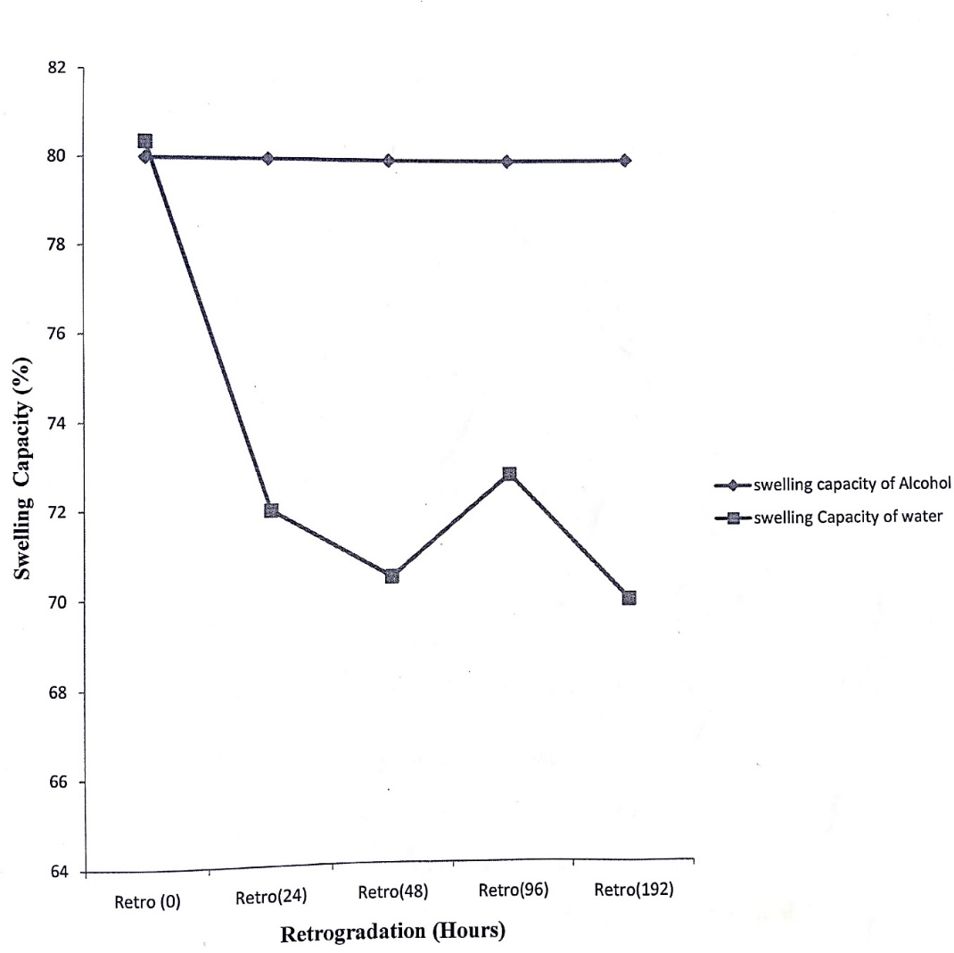
Fig. 1: Graph of % swelling capacity against retrogradation (hrs)
Figure 1 illustrates the variation in swelling capacity with retrogradation time. Alcohol-treated starch maintained relatively stable swelling behavior across storage periods, while water-treated starch showed a gradual reduction, indicating increased structural rigidity over time.

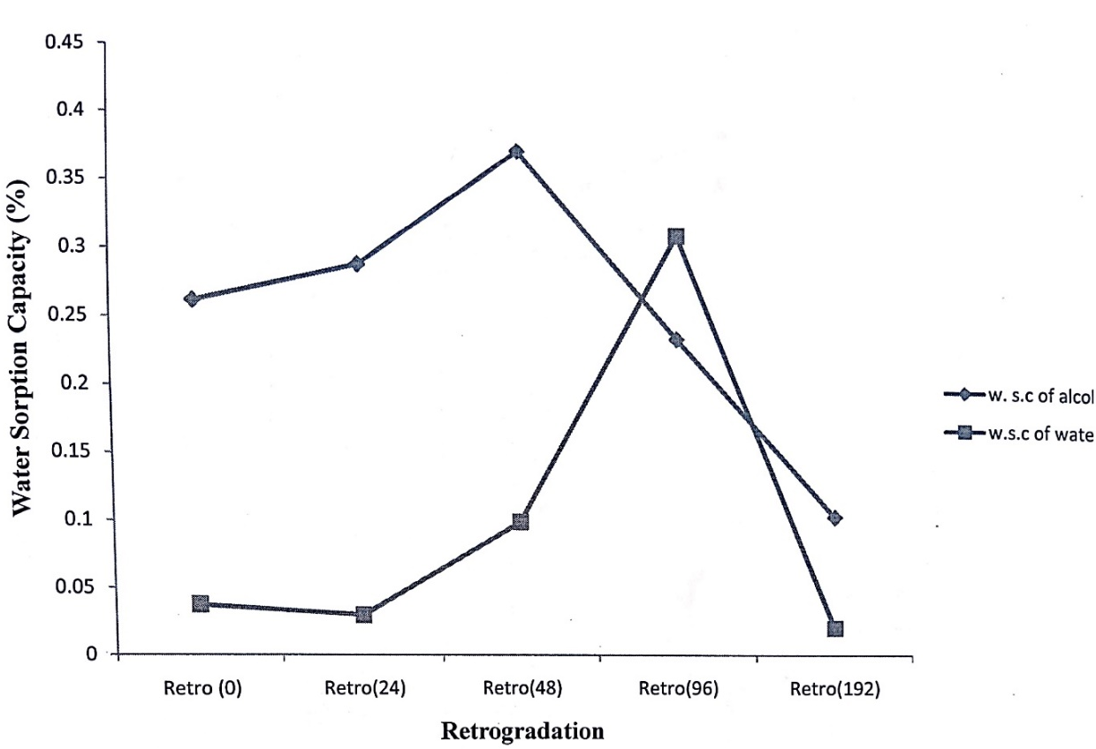
Fig. 2: Graph of % Water Sorption capacity against retrogradation (hrs)
Figure 2 presents the changes in water sorption capacity during retrogradation. Alcohol-treated samples exhibited an initial increase followed by a decline, whereas water-treated samples showed lower and irregular sorption patterns, highlighting differences in moisture interaction mechanisms between the solvents.

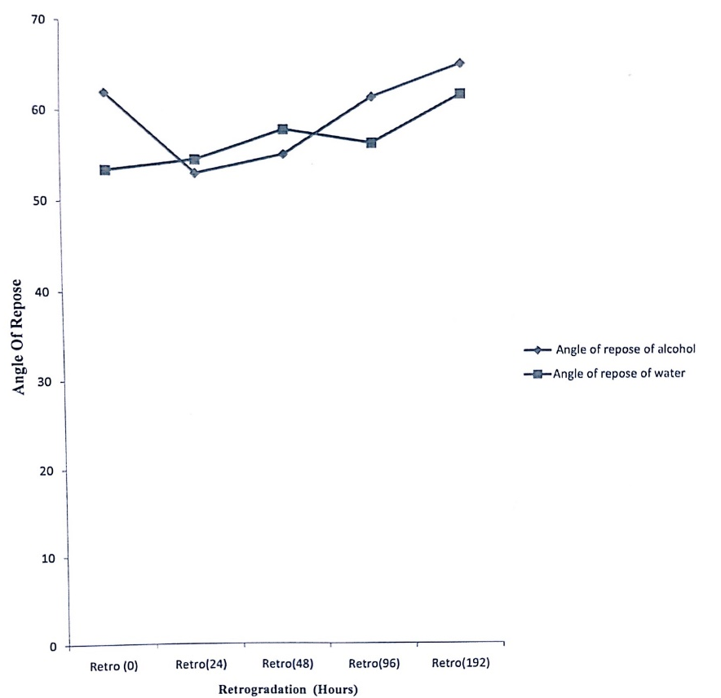
Fig. 3: Graph of Angle of Repose against retrogradation (hrs)
Figure 3 shows the relationship between angle of repose and retrogradation time. A general decrease in angle of repose was observed with increasing storage time, particularly in water-treated samples, suggesting improved flow characteristics due to enhanced particle rearrangement.

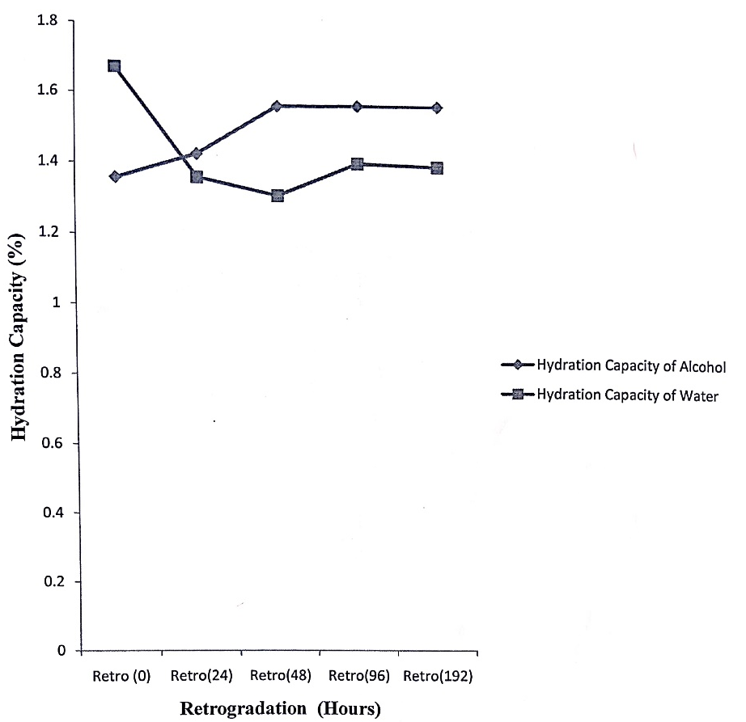
Fig. 4: Graph of Hydration capacity against retrogradation (hrs)
Figure 4 depicts hydration capacity as a function of retrogradation time. Both solvent systems exhibited relatively stable hydration behavior, though alcohol-treated starch demonstrated slightly higher hydration capacity, reflecting moderated retrogradation effects.

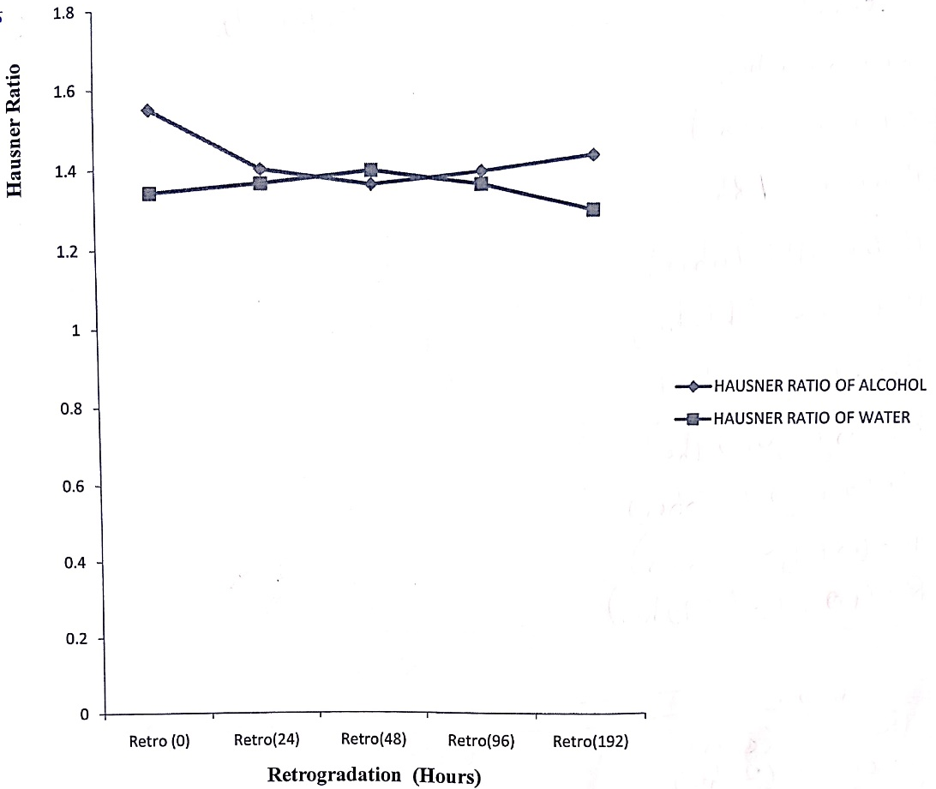
Fig. 5: Graph of Hausner ratio against retrogradation (hrs)

Figure 5 illustrates changes in Hausner ratio with retrogradation time. A gradual decrease in Hausner ratio was observed for both treatments, with water-treated starch exhibiting lower values at extended storage periods, indicating improved flowability and packing efficiency.
Discussion of Findings
The findings of this study provide important insights into the retrogradation behavior of sorghum starch under the influence of alcohol and water, with clear solvent-specific effects observed in the physicochemical properties over storage time. The observed trends are consistent with established theories of starch retrogradation and extend existing knowledge by demonstrating how solvent environment modulates molecular reassociation in sorghum starch systems.
The increase in bulk density and tapped density during the early stages of retrogradation, particularly in alcohol-treated starch, suggests enhanced particle packing and structural compaction. This phenomenon reflects the progressive reassociation of starch chains following gelatinization, leading to reduced interparticle voids. Gunaratne (2023) similarly reported that solvent-mediated molecular rearrangement contributes to densification in retrograded starch systems. The relatively higher tapped density observed in water-treated starch indicates increased compressibility, likely due to greater molecular mobility and hydration-induced rearrangement of starch granules.
Water sorption capacity exhibited distinct solvent-dependent behavior, with alcohol-treated starch showing an initial increase followed by a marked decline at extended storage periods (Figure 2). This pattern suggests that alcohol initially allows limited moisture interaction but progressively restricts water uptake as retrogradation advances. Allan and Mauer (2022) reported that alcohol disrupts hydrogen bonding within starch matrices, thereby limiting water binding and reducing moisture sorption over time. In contrast, the lower and more variable water sorption values observed in water-treated starch reflect continuous hydration and molecular reorganization, which may contribute to increased retrogradation and gel rigidity.
The reduction in true density observed in alcohol-treated starch at prolonged storage periods indicates internal structural rearrangements and possible void formation within the starch matrix. Such changes are characteristic of solvent-induced modification of starch microstructure, as previously reported by Ding and Yang (2021), who noted that alcohol can alter starch packing and crystalline arrangement. Water-treated starch, however, maintained relatively stable true density values, suggesting a more uniform molecular reorganization facilitated by sustained hydration.
Amylose and amylopectin fractions displayed pronounced solvent-specific trends. Alcohol-treated starch retained higher amylose content during early retrogradation stages, indicating delayed amylose recrystallization. This observation aligns with findings by Liu, Li, and Chen (2020), who demonstrated that alcohol suppresses amylose chain alignment by restricting molecular mobility. Conversely, water-treated starch exhibited progressive increases in amylopectin fraction over storage time, reflecting enhanced long-term reorganization of branched chains. This behavior supports the widely accepted view that amylopectin plays a dominant role in long-term retrogradation processes, particularly under high-moisture conditions (Lim, Zhang, and Chen 2020).
Hydration and swelling capacities remained relatively stable throughout storage, although alcohol-treated starch consistently exhibited slightly higher hydration capacity (Figure 4). This suggests that while alcohol limits extensive water uptake, it does not completely inhibit hydration, allowing controlled swelling without excessive structural breakdown. The relatively stable swelling capacity observed in alcohol-treated samples (Figure 1) further indicates moderated retrogradation, whereas the gradual decline in swelling capacity in water-treated starch reflects increased structural rigidity due to extensive starch chain reassociation.
Flowability indices, including Hausner ratio and compressibility index, improved over storage time for both solvent systems, with water-treated starch exhibiting superior flow properties at extended storage periods (Figure 5). Lower Hausner ratio values indicate reduced interparticle friction and improved packing efficiency, which are desirable characteristics in pharmaceutical and industrial starch applications. The observed reduction in percent porosity, particularly in alcohol-treated starch, further confirms increased densification during retrogradation. Zhao and An (2024) similarly reported that controlled solvent interactions can significantly influence starch microstructure and flow behavior.
The results demonstrate that alcohol effectively suppresses or delays sorghum starch retrogradation by limiting water availability and inhibiting amylose recrystallization, while water promotes molecular mobility and facilitates both short- and long-term starch chain reorganization. These findings highlight the critical role of solvent environment in modulating starch retrogradation behavior and provide a scientific basis for tailoring sorghum starch functionality for specific food, pharmaceutical, and industrial applications.
Conclusion
This study investigated the retrogradation behavior of sorghum starch under the influence of alcohol and water by examining changes in key physicochemical properties over defined storage periods. The findings demonstrate that solvent type plays a critical role in determining the extent and nature of starch retrogradation. Alcohol-treated sorghum starch exhibited delayed amylose recrystallization, reduced water sorption capacity, moderated swelling behavior, and increased structural compaction, indicating suppression or retardation of retrogradation. In contrast, water-treated starch showed enhanced amylopectin reorganization, greater compressibility, and increased molecular mobility, which collectively promoted retrogradation over time.
The observed differences between alcohol- and water-induced retrogradation highlight the importance of solvent–starch interactions in controlling starch structure and functionality. The results further confirm that amylose dominates early retrogradation processes, while amylopectin plays a significant role in long-term structural reorganization, particularly in high-moisture environments. By demonstrating how alcohol and water distinctly influence sorghum starch retrogradation, this study provides valuable insights into the physicochemical behavior of sorghum starch and contributes to the growing body of knowledge on non-conventional cereal starches. The findings underscore the potential of manipulating solvent environments to control starch retrogradation and optimize the functional performance of sorghum starch. This has important implications for improving texture, stability, flowability, and shelf life in starch-based food products, pharmaceutical formulations, and related industrial applications.
Recommendations
Based on the findings of this study, the following recommendations are proposed:
- Industrial Application: Food, pharmaceutical, and allied industries utilizing sorghum starch should consider alcohol-based treatments as a practical approach for suppressing retrogradation, improving structural stability, and extending product shelf life.
- Optimization of Processing Conditions: Manufacturers are encouraged to carefully regulate water content and storage conditions during sorghum starch processing to minimize excessive retrogradation and undesirable textural changes.
- Product Development: The solvent-specific behavior of sorghum starch observed in this study can be exploited in the development of novel starch-based products, such as low-staling foods, controlled-release pharmaceutical excipients, and specialty starch formulations.
- Further Research: Future studies should investigate the effects of varying alcohol types and concentrations on sorghum starch retrogradation and explore molecular-level mechanisms using advanced analytical techniques such as X-ray diffraction and differential scanning calorimetry.
- Value Addition: Stakeholders in sorghum cultivation and processing should leverage these findings to enhance value addition and promote the wider utilization of sorghum starch, particularly in regions where sorghum is a major staple crop.
Competing Interests
The authors declare that they have no known competing financial interests, non-financial interests, or personal relationships that could have appeared to influence the work reported in this study.
Disclaimer (Artificial intelligence)
Option 1:
Author(s) hereby declare that NO generative AI technologies such as Large Language Models (ChatGPT, COPILOT, etc.) and text-to-image generators have been used during the writing or editing of this manuscript.
Option 2:
Author(s) hereby declare that generative AI technologies such as Large Language Models, etc. have been used during the writing or editing of manuscripts. This explanation will include the name, version, model, and source of the generative AI technology and as well as all input prompts provided to the generative AI technology
Details of the AI usage are given below:
1.
2.
3.

Authors’ contributions
This work was carried out in collaboration among all authors. Ojima, S. conceptualized and designed the study. Denis, J. and Hassan, I. S. contributed to sample preparation, experimental procedures, and data collection. Maishanu, S. A. and Emmanuel, O. assisted in data analysis and interpretation. All authors participated in manuscript drafting, critically reviewed the content, and approved the final version for publication.

Reference
- Adebowale, A. A., Sanni, L. O., & Oladapo, A. S. (2023). Retrogradation characteristics of cereal starches under varying moisture conditions. Journal of Cereal Science, 110, 103633.
- Adjetey, F. A. (2024). Cold-climate grown sorghum: Physicochemical and functional properties related to starch and phenolic contents. University of Manitoba.
- Allan, M. C., & Mauer, L. J. (2022). Variable effects of sugars and sugar alcohols on the retrogradation of wheat starch gels. Foods, 11(19), 3008.https://doi.org/10.3390/foods11193008
- Apriyanto, A., Compart, J., & Fettke, J. (2022). Starch as a unique biopolymer: Structure, metabolism and in planta modifications. Plant Science, 318, 111223.https://doi.org/10.1016/j.plantsci.2022.111223
- Chen, Y., Zhang, B., & Li, M. (2024). Solvent-mediated modulation of starch retrogradation and physicochemical properties. Food Chemistry, 435, 137502.
- Ding, S., & Yang, J. (2021). Effects of sugar alcohols on rheological properties and texture in baked products. Trends in Food Science & Technology, 111, 670–679.
- Gunaratne, A. (2023). Heat–moisture treatment of starch. In Physical Modifications of Starch (pp. 49–72). Springer Nature.
- Hassan, M. M., Jiang, H., & Chen, J. (2024). Effect of ethanol–water systems on starch crystallinity, hydration, and gel stability. International Journal of Biological Macromolecules, 252, 126214.
- Liang, J., Zhou, X., & Liu, Q. (2025). Recent advances in controlling starch retrogradation for food and pharmaceutical applications. Trends in Food Science & Technology, 148, 104418.
- Lim, S. T., Zhang, Y., & Chen, L. (2020). Starch retrogradation: A comprehensive review. Food Hydrocolloids, 108, 105946.
- Liu, T., Li, M., & Chen, L. (2020). Effects of solvents on starch retrogradation. Food Chemistry, 330, 127344.
- Meisah, L. D., Oduro, I., & Ellis, W. O. (2020). Sorghum: Nutritional and industrial applications. Journal of Food Science and Technology, 57(4), 1478–1487.
- Nawaz, H., Waheed, R., Nawaz, M., & Shahwar, D. (2023). Physical and chemical modifications in starch structure and reactivity. Chemical Properties of Starch.
- Ngo, T. V., Kusumawardani, S., Kunyanee, K., & Luangsakul, N. (2022). Polyphenol-modified starches and applications. Foods, 11(21), 3384.
- Ogunmoyela, O. A., & Adeyemi, I. A. (2023). Functional properties and retrogradation behavior of sorghum starch as influenced by processing conditions. Starch/Stärke, 75(9–10), 2200284.
- Wang, S., Li, C., Copeland, L., & Wang, S. (2024). Molecular mechanisms governing starch retrogradation and recrystallization in cereal systems. Food Hydrocolloids, 146, 109104.
- Zhang, Y., Li, M., & Chen, L. (2022). Sorghum starch: Structure, properties, and applications. Carbohydrate Polymers.
- Zhao, X., & An, J. J. (2024). Improvement of yoghurt gel syneresis by trehalose. Journal of Food Science. https://doi.org/10.1111/1750-3841.17598
- Zhou, Z., et al. (2021). Retrogradation behavior of cereal starches. Food Research International, 140, 109861.

