Original Research Article

CpG methylation in the 1F promoter of the NR3C1 gene and
its biomarker potential in Post-Traumatic Stress Disorder

ABSTRACT
PTSD is a disorder that is described to cause by disruption of psychoneurological and biological processes in military personnel due to war-related trauma, excessive stress and exposure to extreme environments. Specifically, stability of the means of stress response is also influenced by epigenetic regulation of the glucocorticoid receptor gene (NR3C1). In this research, “in silico” methods of CpG methylation at a level and location in the 1F promoter region of NR3C1 gene was conducted. We examined exon 1F promoter of the glucocorticoid receptor gene (NR3C1) of peripheral blood of group of individuals aged 20-24 (46 XY males, 46 XX females). The degree of CpG methylation was higher in females (β ≈ 0.8-1.0) compared with males (β ≈ 0.5-0.7), showing that there was a high sensitivity to methylation and a high epigenetic activity at the locus. Variability observed indicates that the 1F promoter is a major site of the individual difference in stress responsivity. Due to the potential to alter the NR3C1 expression with the help of methylation of this region, such patterns can affect cortisol regulation and the functioning of the HPA-axis, which could possibly support the maintenance of stress responses following military trauma and predisposes to PTSD. On the whole, the presented analyses show that CpG methylation in the 1F promoter of the NR3C1 gene could be one of the molecular predictors of stress tolerance and adaptation to psychological stress in a military environment. This region could be assessed as an early diagnostic and prognostic epigenetic biomarker of PTSD.

Keywords: NR3C1gene, CpG methylation, 1F promoter, HPA axis dysregulation, Post-Traumatic Stress Disorder

INTRODUCTION
Suddenly and unexpectedly occurring traumatic stressors can cause Post-Traumatic Stress Disorder (PTSD) in military personnel (Javidi & Yadollahie, 2012). In 1871, Dr. Jacob Mendez Da Costa described a symptom complex in soldiers, including tachycardia, anxiety, shortness of breath and hypervigilance. These symptoms were first called “Soldier’s Heart Syndrome” and later renamed “Da Costa Syndrome” (Herron et al., 1994).
During World War I, the rapid and widespread use of advanced weapons created intense psychological strain. Many soldiers felt as if they were surrounded by invisible threats and developed symptoms such as staring, cold extremities, tremors, paralysis and unexplained sensory loss. This condition was later termed “Contusion” (Lasiuk et al., 2006). Similar manifestations were also observed in World War II veterans and survivors of the Hiroshima and Nagasaki bombings (Andreasen et al., 2010). Over time, these clinical signs were described under terms such as “Combat Neurosis” and “Operation Fatigue”, which eventually contributed to the modern definition of PTSD (Fishbain et al., 2017).
According to the DSM, PTSD was previously classified as an anxiety disorder (Kessler et al., 2017), while the ICD-10 defines it as a neurotic, stress-related and somatoform disorder (Xue et al., 2015). PTSD can develop in soldiers exposed to serious traumatic stressors such as combat, explosions or losing a comrade. Immediately after trauma, symptoms such as severe anxiety, derealization, dissociative amnesia and poor concentration may appear (Harik et al., 2016). The duration and intensity of the traumatic event, emotional detachment during the incident, the initial reaction, and the support received afterwards are among the main factors influencing PTSD development (Steenkamp et al., 2015).
PTSD symptoms can significantly affect daily functioning (Hagenaars et al., 2010). The type of trauma may influence symptom patterns: for example, exposure may be more associated with sleep-related problems (Harik et al., 2015). PTSD is categorized as:
- Acute PTSD – symptoms lasting less than 3 months.
- Chronic PTSD – symptoms lasting more than 3 months.
There is also “Delayed-Onset PTSD”, where symptoms appear long after the traumatic event (Fishbain et al., 2017).
Although traumatic experiences play a major role, not everyone exposed to similar trauma develops PTSD. This suggests that genetic and biological factors may contribute to individual susceptibility. Genes involved in stress response, memory and emotional regulation are of particular interest. One such gene frequently studied in PTSD research is NR3C1 (Klengel et al., 2014).

Figure 1. Genomic Localization of the NR3C1 Gene.
Ideogram of human Chromosome 5, retrieved from the UCSC Genome Browser, showing the position of the NR3C1 (Glucocorticoid Receptor) gene at band 5q31.3. The gene location is highlighted, emphasizing its critical role as a key component of the Hypothalamic-Pituitary-Adrenal (HPA) axis and its relevance to Post-Traumatic Stress Disorder (PTSD) research. The coordinates for the entire gene span are chr5:142,883,863–143,061,000 (GRCh37/hg19)

The NR3C1 gene is located at 5q31.3 and is approximately 125,294 bp long. It plays an essential role in regulating the hormonal stress response through the HPA (Hypothalamic-Pituitary-Adrenal) axis. Polymorphisms and epigenetic modifications in NR3C1 may influence how individuals respond to trauma and their vulnerability to PTSD. One of the key mechanisms is CpG methylation in the promoter region of the gene, which may affect NR3C1 expression and stress sensitivity (Li et al., 2018).
Military personnel are frequently exposed to intense stress, which can negatively impact psychological resilience and decision-making. Therefore, early assessment of biological susceptibility is considered important in military medical practice. The main goal of this study is to examine methylation in the 1F promoter region of the gene encoding the glucocorticoid receptor (GR) and to explore whether changes in methylation levels may reflect individual differences in biological vulnerability to stress. This study may help to better understand individual stress-response mechanisms in soldiers and contribute to assessing psychological endurance at the genetic level.
MATERIAL AND METHOD
The exon-intron organization of the NR3C1 gene and information regarding its promoter architecture, 5’ regulatory elements and transcript variants were obtained from the Ensembl Genome Browser (Howe et al., 2021) and the UCSC Genome Browser (Kent et al., 2002). All genomic annotations were carried out using the GRCh37/hg19 human reference assembly to ensure consistency across tools. The chromosomal interval chr5:142,783,000-142,784,100 corresponding to the NR3C1 1F promoter was retrieved directly from the UCSC Genome Browser position search and cross-validated with the Ensembl GRCh coordinate system.
The 1F promoter region located in the 5’ untranslated regulatory segment of NR3C1 was selected as the primary region of interest. This genomic interval corresponds to chr5:142,783,000-142,784,100 (GRCh/hg19) and contains the transcription start site (TSS) of exon 1F as well as several predicted NGFI-A (EGR1) transcription factors binding motifs. CpG dinucleotide density and distribution within this region were examined using the “CpG Islands”, “Regulatory Elements”, and “Genes and Gene Predictions” tracks available on the UCSC Genome Browser to identify epigenetically relevant subregions.
To explore CpG methylation patterns, publicly available whole-genome bisulfite sequencing (WGBS) datasets from the MethBank v3.0 platform (Li et al., 2018) were used. Individual blood derived WGBS tracks from female (46, XX) and male (46, XY) donors aged 20-24 years were selected. This study is entirely “in silico”, no clinical metadata such as PTSD diagnosis, military status, or control grouping is available for the MethBank samples. Because MethBank provides single-donor methylation profiles rather than cohort-level data, all comparisons in this study are descriptive and do not represent statistical group differences. CpG-specific methylation (β-values), ranging from 0 (complete hypomethylation) to 1 (complete hypermethylation), were extracted directly from the MethBank methylome viewer.
Genomic visualization was performed using the UCSC Genome Browser alongside the MethBank WGBS Visualization Tool. CpG site positions, β-value distributions, transcription factor binding motifs, and methylation peaks within the 1F promoter region were visually inspected and compared across the selected samples. This approach allowed an assessment of methylation variability along the promoter landscape without performing downstream functional or statistical analyses (Hompes et al., 2013). All CpG-level methylation plots and marker-based visual summaries were generated programmatically using Phyton within Google Colab, ensuring reproducibility and standardized graphical output.
RESULTS and DISCUSSION

To determine the structure and functional divisions of the NR3C1 gene, its exon-intron architecture was examined using the Ensembl database.

Figure 2. NR3C1 Gene Structure and Transcriptional Context.
Schematic illustration of the intron-exon structure of the NR3C1 gene (representative protein-coding transcript ENST00000251598 shown), retrieved from the Ensembl database. The diagram displays the gene's overall architecture, spanning approximately 123.53 kb, and its orientation on the reverse strand. This structure provides the necessary context for the investigation of the upstream 1F promoter region.

The primary transcript of the NR3C1 gene contains 9 exons and 8 introns, is located on the reverse strand, and spans approximately 122.53 kb. The coding between exons 2-9 shows that the glucocorticoid receptor can be regulated at several levels, including DNA binding, and epigenetic mechanisms. NR3C1 also contains 9 alternative non-coding first exons, which can be transcribed but do not encode protein.
The 5’ untranslated region of the NR3C1 gene includes a ~3kb CpG island, covering seven alternative first exons (1D, 1J, 1E, 1B, 1F, 1C and 1H). This region is considered one of the more dynamic regulatory areas of the gene. The 1F promoter, although non-coding, may play an important role in transcriptional regulation. It contains NGFI-A (EGR1) binding motifs and is rich in CpG sites, which makes it a potential target for epigenetic modulation related to stress and HPA axis activity.
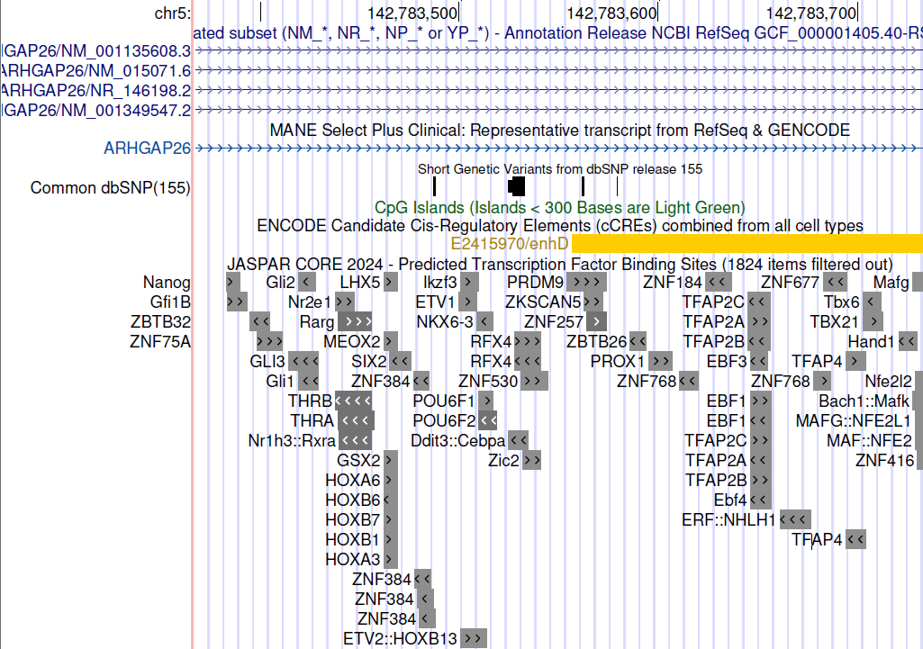

Figure 3. Genomic Annotations of the NR3C1 1F Promoter Region.
Visualization of the NR3C1 1F promoter region within the chr5:142,783,000–142,784,000 (hg38 assembly) coordinates, retrieved from the UCSC Genome Browser. The image highlights key regulatory elements used for “in silico” analysis: the CpG Island (light green track), predicted Transcription Factor Binding Sites (TFBS) (JASPAR CORE 2024 track), and candidate Cis-Regulatory Elements (cCREs). The figure provides the structural context for the 47 individual CpG sites analyzed for methylation differences in this study, including potential EGR1 binding motifs often reported in the literature related to stress response.

Several CpG dinucleotides are present in the 1F promoter region. Their distribution shows that this segment behaves like a typical CpG-rich island and may be important for methylation-based regulation. According to UCSC Genome Browser data, a total of 47 CpG dinucleotides were identified in this promoter region, indicating that it is CpG-dense and epigenetically active. Methylation in promoter region can reduce transcription factor binding, but this study did not analyze expression experimentally, so such effects are only considered as possible interpretations.

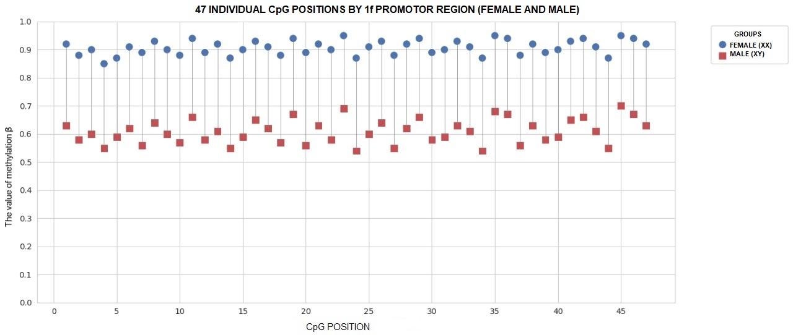
Figure 4. Representative In Silico Methylation Tracks for NR3C1 1F Promoter.
MethBank Whole-Genome Bisulfite Sequencing (WGBS) tracks are shown for a representative Male (XY) and Female (XX) donor in the NR3C1 1F promoter region. Each vertical green bar represents a CpG site, with the height of the bar indicating the β value (methylation level, 0 to 1). The visualization qualitatively demonstrates the trend of hypermethylation (β ≈ 0.8-1.0) in the Female sample compared to the Male sample (β ≈ 0.5-0.7) across the displayed region.

The “in silico” visualization showed that the 1F promoter region has high CpG density and contains the TSS and EGR1 binding motifs. The WGBS profiles from individual female (46, XX) and male (46, XY) donors aged 20-24 were compared descriptively. In the female donor sample, β-values generally ranged between 0.8-1.0, indicating higher methylation levels. In the male donor, β-values were mostly 0.5-0.7. However, since MethBank tracks represent single-donor datasets and not population data, these differences cannot be interpreted as statistically meaningful or generalizable sex differences. They simply reflect variation between the two individual samples. Higher β-values usually suggest a more compact chromatin structure, while lower values may indicate a more open structure, but the present study did not include expression, hormone or chromatin assays. Therefore, possible effects on transcription factor binding or NR3C1 expression remain theoretical and cannot be confirmed here. Similarly, references to hormone-related DNMT activity should be considered general information from the literature, not findings of this analysis (Kovács et al., 2020; McCarthy et al., 2015).
Overall, the comparison shows that methylation levels in the 1F promoter region may vary between individuals. This region appears to be epigenetically active and may be relevant in studies examining biological responses to stress. However, no conclusions can be made about cortisol regulation, HPA axis feedback, GR expression or PTSD risk based on these descriptive data alone. Further experimental and clinical studies are necessary to understand whether methylation patterns in this region have functional or diagnostic significance.
The main objective of this study was to examine whether CpG methylation levels in the 1F promoter region of the NR3C1 gene might have a possible relationship with stress-related psychological conditions, including PTSD. The “in silico” analysis showed that the 1F promoter is a CpG-dense and methylation-sensitive region, which suggests that it may play a role in the epigenetic regulation of this gene. Since promoter methylation can influence gene expression, changes in this area may approximately affect the activity of the glucocorticoid receptor (GR) and the HPA axis, although this was not directly tested in the current study. The result indicates that the 1F promoter may be one of the regions involved in the epigenetic regulation of stress response. These findings can be considered as preliminary observations showing that methylation patterns in this region might be relevant for future studies on stress biology. However, they do not serve as direct evidence of a biomarker, and interpretation should remain cautious.
Previous research (Andreasen et al., 2010; Palma-Guidel et al., 2015) has reported that hypermethylation in the 1F promoter of NR3C1 is associated with reduced GR expression and cortisol imbalance in stressed individuals. These changes have been linked to alterations in the feedback mechanism of the HPA axis. Some other studies (Li et al., 2018; Van der Knap et al., 2015; Edelman et al., 2012) show that NR3C1 methylation can vary according to individual differences, hormones and tissue type, which supports the idea that this region is epigenetically flexible. The current results are in line with such reports in terms of showing variability, but they do not confirm any functional outcomes. Although some studies agree with findings from “in silico” approaches, others give inconsistent results. For example, Radtke (Radtke et al., 2022) found an association between NR3C1 methylation and PTSD but reported no significant gender differences. Similarly, Carmi and colleges did not observe gender-specific methylation patterns (Carmi et al., 2023). Studies like Cao-Lei and Schür also indicate that the number and methylation status of CpG sites can differ across tissues and cell types (Cao-Lei et al., 2022; Schür et al., 2017). These inconsistencies highlight that methylation in this region is variable and should be interpreted carefully.
The findings of this study suggest that examining CpG methylation in the 1F promoter region might provide useful preliminary data for understanding biological vulnerability to stress. Changes in methylation patterns may reflect some aspects of HPA-axis activity or GR regulation, but this cannot be concluded from the current “in silico” data alone. If validated in future experimental and clinical studies, this region could potentially be explored as a candidate for diagnostic or prognostic purposes. However, at this stage, such interpretations remain hypothetical. Since this research is based solely on “in silico” analysis, experimental validation is necessary. Laboratory-based studies, gene expression measurements, cortisol levels and clinical evaluations would be needed to confirm any functional relevance. Another limitation is that methylation levels measured in peripheral blood may not fully represent epigenetic changes in brain tissue. Factors such as sample size, age, lifestyle and other biological differences could also influence methylation patterns. Therefore, future research with larger and well-defined cohorts is required to strengthen these findings.
CONCLUSION
Based on “in silico” analysis, the NR3C1 1F promoter region appears to be a CpG-dense and methylation-sensitive area. A total of 47 CpG dinucleotides were identified, suggesting that this segment may have an important role in epigenetic regulation. In the visual comparison of individual MethBank samples, higher β-values were seen in the female donor and relatively lower values in the male donor. However, since these tracks represent single individuals, these differences should be interpreted only as descriptive observations and not as confirmed gender-specific patterns. Although higher methylation levels are generally associated with more compact chromatin and lower levels with relatively open chromatin, the present study did not include gene expression, hormonal measurements or functional analyses. Therefore, any assumptions about GR expression, cortisol regulation or HPA-axis feedback remain hypothetical and cannot be confirmed from the current dataset.
Overall, the findings may indicate that the 1F promoter region is a potentially relevant area for future research on stress-related biological processes. Its CpG-rich structure and regulatory position suggest that it could be explored as a possible candidate region in studies investigating biological vulnerability to trauma or PTSD. However, before considering this region for diagnostic or prognostic purposes, extensive clinical and experimental validation would be required.
Future studies should include comparisons of NR3C1 1F methylation between PTSD and non-PTSD groups, assessments of trauma intensity, and follow-up analyses after treatment. Such research would help clarify whether methylation patterns in this region have consistent scientific or clinical value in the context of PTSD.
LIMITATIONS
This exploratory analysis Is based on publicly available single-donor WGBS tracks from the MethBank platform, which naturally limits the scope of interpretation. Because these datasets do not include clinical information, trauma history, gene expression results, or hormonal measurements, the observations presented here should be viewed as descriptive rather than inferential. Additionally, the differences observed between male and female samples reflect individual methylation profiles rather than population-level patterns. Therefore, the findings are intended to provide preliminary, hypothesis-generating insights into the NR3C1 1F promoter landscape, which may guide future studies involving larger cohorts and functional validation.
DISCLAIMER (ARTIFICIAL INTELLIGENCE)
Author hereby declares that generative AI technology (ChatGPT, OpenAI, version 5.1) was used exclusively for language refinement and translation purposes during the preparation of this manuscript. No part of the scientific content, data interpretation, analysis, results, or conclusions was generated or altered by AI. All scholarly ideas, structuring, argumentation and scientific reasoning were entirely developed by the author.
Details of AI usage:
- Assistance in improving grammatical clarity and academic phrasing.
- Translation of certain English and Azerbaijani sentences into formal academic English.
REFERENCES:
- Cao-Lei, L., Saumier, D., Fortin, J., & Brunet, A. (2022). A narrative review of the epigenetics of post-traumatic stress disorder and post-traumatic stress disorder treatment. Frontiers in Psychiatry, 13, 857087. https://doi.org/10.3389/fpsyt.2022.857087
- Carmi, L., Zohar, J., Juven-Wetzler, A., Desernaud, F., Makotkine, I., & Bierer, L. M. (2023). Promoter methylation of the glucocorticoid receptor following trauma may be associated with subsequent development of PTSD. International Journal of Social Psychiatry, 69(4), 859–871. https://doi.org/10.1080/15622975.2023.2177342
- Edelman, S., Shalev, I., Uzefovsky, F., Israel, S., et al. (2012). Epigenetic and genetic factors predict women's salivary cortisol following a threat to the social self. PLOS ONE, 7(11), e48597. https://doi.org/10.1371/journal.pone.0048597
- Fishbain, D. A., Pulikal, A., Lewis, J. E., & Gao, J. (2017). Chronic pain types differ in their reported prevalence of post-traumatic stress disorder (PTSD) and there is consistent evidence that chronic pain is associated with PTSD: An evidence-based structured systematic review. Pain Medicine, 18(4). https://doi.org/10.1093/pm/pnw065
- Hagenaars, M. A., Fisch, I., & van Minnen, A. (2011). The effect of trauma onset and frequency on PTSD-associated symptoms. Journal of Affective Disorders, 132(1–2), 192–199. https://doi.org/10.1016/j.jad.2011.02.017
- Harik, J. M., Matteo, R. A., Hermann, B. A., & Hamblen, J. L. (2016). What people with PTSD symptoms do (and do not) know about PTSD: A national survey. Depression and Anxiety. https://doi.org/10.1002/da.22558
- Herron, N., & Hostetler, A. (1994). The history of trauma in psychiatry. Psychiatric Clinics of North America, 17(3), 583–600. https://doi.org/10.1016/S0193-953X(18)30102-3
- Hompes, T., Izzi, B., Gellens, E., Morreels, M., et al. (2013). Investigating the influence of maternal cortisol and emotional state during pregnancy on the DNA methylation status of the glucocorticoid receptor gene (NR3C1) promoter region in cord blood. Journal of Psychiatric Research, 47(7), 880–891. https://doi.org/10.1016/j.jpsychires.2013.03.009
- Howe, K. L., Achuthan-Jarreta, J., Amode, M. R., Armean, I. M., et al. (2021). Ensembl 2021. Nucleic Acids Research, 49(D1), D884–D891. https://doi.org/10.1093/nar/gkaa942
- Javidi, H., & Yadollahie, M. (2012). Post-traumatic stress disorder. The International Journal of Occupational and Environmental Medicine, 3, 2–9.
- Kessler, R. C., Aguilar-Gaxiola, S., Alonso, J., Benjet, C., Bromet, E. J., Cardoso, G., … Koenen, K. C. (2017). Trauma and PTSD in the WHO World Mental Health Surveys. European Journal of Psychotraumatology, 8 (sup5). https://doi.org/10.1080/20008198.2017.1353383
- Klengel, T., Pape, J., Binder, E. B., & Mehta, D. (2014). The role of DNA methylation in stress-related psychiatric disorders. Neuropharmacology, 80, 115–132. https://doi.org/10.1016/j.neuropharm.2014.01.013
- Kovács, T., Szabó-Meleg, E., & Ábrahám, I. M. (2020). Estradiol-induced epigenetically mediated mechanisms and regulation of gene expression. International Journal of Molecular Sciences, 21(9), 3177. https://doi.org/10.3390/ijms21093177
- Lasiuk, G. C., & Hegadoren, K. M. (2006). Posttraumatic stress disorder Part I: Historical development of the concept. Perspectives in Psychiatric Care, 42(1), 13–20. https://doi.org/10.1111/j.1749-6632.2010.05699.x
- Li, R., Liang, F., Li, M., Zou, D., Sun, S., Zhao, Y., … Zhang, Z. (2018). MethBank 3.0: A database of DNA methylomes across a variety of species. Nucleic Acids Research, 46(D1), D288–D295. https://doi.org/10.1093/nar/gkx1139
- McCarthy, M. M., & Nugent, B. M. (2015). At the frontier of epigenetics of brain sex differences. Frontiers in Behavioral Neuroscience, 9, 221. https://doi.org/10.3389/fnbeh.2015.00221
- Palma-Gudiel, H., Córdova-Palomera, A., Eixarch, E., Deuschle, M., & Fañanás, L. (2015). Maternal psychosocial stress during pregnancy alters the epigenetic signature of the glucocorticoid receptor gene promoter in their offspring: A meta-analysis. Epigenetics, 10(10), 893–902. https://doi.org/10.1080/15592294.2015.1088630
- Radtke, K. M., Ruf, M., Gunter, H. M., Dohrmann, K., Schauer, M., Meyer, A., & Elbert, T. (2011). Transgenerational impact of intimate partner violence on methylation in the promoter of the glucocorticoid receptor. Translational Psychiatry, 1(7), e21. https://doi.org/10.1038/tp.2011.21
- Schür, R., Boks, M. P., & Hakulinen, C. (2017). Longitudinal changes in glucocorticoid receptor exon 1F methylation following stress. Translational Psychiatry, 7(8), e123. https://doi.org/10.1038/tp.2017.150
- Steenkamp, M. M., Litz, B. T., Hoge, C. W., & Marmar, C. R. (2015). Psychotherapy for military-related PTSD: A review of randomized clinical trials. JAMA, 314(5), 489–500. https://doi.org/10.1001/jama.2015.8370
- Van der Knaap, L. J., Riese, H., Hudziak, J. J., Verbiest, M. M., Verhulst, F. C., Oldehinkel, A. J., & van Oort, F. V. (2014). Glucocorticoid receptor gene (NR3C1) methylation following stressful events between birth and adolescence: The TRAILS study. Translational Psychiatry, 4(4), e381. https://doi.org/10.1038/tp.2014.22
- Xue, C., Ge, Y., Tang, B., Liu, Y., Kang, P., et al. (2015). A meta-analysis of risk factors for combat-related PTSD among military personnel and veterans. PLOS ONE, 10(3), e0120270. https://doi.org/10.1371/journal.pone.0120270

