TYPE OF ARTICLE ;ORIGINAL RESEARCH ARTICLE
LEAD INDUCED LIVER AND KIDNEY TOXICITY IN ADULT WISTAR RATS: EVALUATING THE ROLE OF COCONUT WATER

ABSTRACT
Lead is used in many different products, including as paints, pigments, solder, stained glass, lead crystal glassware, ammunition, ceramic glazes, jewellery, toys. Lead exposure can result in significant and enduring harm, particularly to the liver, which is among the most impacted organs. Coconut water is documented to be a strong antioxidants and it can help decrease blood sugar and cholesterol levels among other health benefits. In exploring the antioxidant properties of coconut , the effect of coconut water on lead poisoning on the liver and kidney of adult male rats was investigated in this study. Twenty-eight adult male rats were procured from the Pharmacological Department of Niger Delta University. The rats were weighed and categorised into five groups. The rats in the treatment groups received 2mg/kg of lead acetate via their abdominal wall. Several of these rats were administered varying quantities of coconut water. After four weeks, the animals were euthanised, and their kidney and livers were excised, processed, and stained with H&E. The findings indicated that the livers of rats exposed just to lead had enlarged central veins, regions of hepatocyte destruction, obstructed hepatic spaces, and an increased presence of immune cells known as Kupffer cells. The rats administered lead and coconut water exhibited engorged veins, compromised hepatic cells, obstructed spaces, and altered Kupffer cells. Nonetheless, the rats that exclusively consumed coconut water had normal liver morphology. The study ultimately concluded that coconut water at the dose utilised did not mitigate the detrimental effects of lead on the liver and Kidney of the rats.
KEY WORDS: Coconut water, Kidney, Liver, lead-acetate, Toxicity, rats, Central vein
1.0 INTRODUCTION
The water inside a young, green coconut is called coconut water. It helps the fruit stay healthy. It takes around 10 to 12 months for the coconut to mature [1]. Coconut water normally originates from coconuts that are 6 to 7 months old, although it may also be found in coconuts that are older. There are fewer calories and fat in this beverage. In addition to vitamins, carbohydrates, proteins, amino acids, antioxidants like salicylic acid and catechin, and substances that aid in bodily growth, it contains a variety of minerals, including sodium, potassium, phosphorus, chloride, and magnesium[2].
Coconut water can help decrease blood sugar and cholesterol levels. It can also help keep kidney stones from developing by inhibiting crystals and stones from forming [3].Studies have also shown that Coconut water has the potential to reduce blood sugar and diabetic retinal damage[4]. Coconut water also have regenerative effect on the pancreatic cells of alloxan induced diabetic rats.[27]
The Earth's crust naturally contains the hazardous element lead. In many parts of the world, the broad use has led to serious public health problems, considerable human exposure, and substantial environmental destruction. Mining, smelting, manufacturing, recycling, and the use of various products all have a major impact on the state of the environment. The manufacturing of lead-acid batteries for cars and trucks uses the majority of lead used worldwide. Lead is used in many different products, including as paints, pigments, solder, stained glass, lead crystal glassware, ammunition, ceramic glazes, jewellery, toys, some traditional cosmetics like sindoor and kohl, and some traditional medicines in nations like Mexico, Vietnam, and India are just a few of the many uses for lead [6]. Since they absorb four to five times as much lead from a source as adults do, young children are especially susceptible to lead poisoning. Children will consume anything containing lead, including contaminated dirt, dust, or flakes from decomposing lead-based paint, due to their natural curiosity and propensity to put things in their mouths during a particular developmental period. Children diagnosed with pica, a compulsion to ingest non-nutritive substances, are at an increased risk of lead exposure via this behaviour. They may gnaw on and ingest lead-based paint off walls, door frames, and furniture. Soil and dust polluted with lead from battery recycling and mining have harmed several individuals and resulted in the deaths of many young children in Nigeria, Senegal, and other nations [7].
Lead enters the body and spreads to the brain, kidneys, liver, and bones, among other organs. Over time, lead builds up in the teeth and bones, where the body stores it. During pregnancy, lead stored in bones may be released into the bloodstream, endangering the developing foetus. Children who are food insecure are more likely to get lead poisoning because their bodies absorb lead more readily when they don't have enough calcium or iron. Due to the vulnerability of their developing brain systems, infants are most at danger [6] However . no natural remedy has been developed to mitigate the effect of this dangerous metal. thus evaluating whether coconut water mitigates lead induced hepatic and renal histological alterations in adult male Wistar rats is the aim of this study.
2.0 MATERIALS AND METHODS
2.1 Location of Study/study area
The research was conducted in the Department of Medical Laboratory Science within the Faculty of Basic Medical Sciences at Niger Delta University, Wilberforce Island, Amasomma, Bayelsa State.
2.2 Procurement Of Coco Nucifera Extract and Lead acetate
The seeds of the plant Coco Nucifera were sourced from Amasomma, Bayelsa State. The tip of the coconut was meticulously punctured to facilitate the extraction of the water. The dose of coconut utilized in this study is as described by Akinjayeju & Adebolu [5]
2.3 Animal Housing
A total of twenty-eight (28) male albino wistar rats, with weights ranging from 130.58g to 179.6g, were employed in this study. The rats were sourced from the Animal House within the Pharmacology Department at Niger Delta University, located in Bayelsa State, Nigeria. The subjects were maintained under controlled temperature conditions ranging from 20 to 27 degrees Celsius, with a light and dark cycle of twelve hours each. The animals were kept in clean, gated groups and provided with standard feed pellets (Guinea feed Nigeria Plc) and access to clean water ad libitum for the entire duration of the study. The limitation for ACC was set at two weeks. The study complied with institutional policies for the care of animals in research.
2.4 Experimental Design
The rats were weighed and categorised into five groups. The experiment lasted four weeks, during which the animals were permitted to acclimatise for two weeks. Following the acclimatisation phase, 28 rats were randomly allocated into 5 groups according to the method described by Eric et al.,[8],as shown below.
TABLE 1: Experimental design showing the groups, number of animal in each group and the treatment protocol
GROUPS | Group 1 | Group 2 | Group 3 | Group 4 | Group 5
NUMBER OF RATS | 5 | 6 | 6 | 6 | 5
TREATMENT REGIME | Control (No administration) | Lead acetate only (2mg/kg) | Lead acetate (2mg/kg) and Coconut water (1.3ml) | Lead acetate (2mg/kg) and Coconut water (0.9ml) | Coconut water only (1.1ml)

Dose of Lead utilized in this study as described by Offor et al,.[26]

2.5 Route of Administration
Lead acetate was administered intraperitoneally while coconut was administered orally using gastric galvage.
2.6 Tissue processing
At the end of the 28 days , the kidney and liver was harvested and processed using the tissue processing protocol. This is a chain reaction where the tissue was allowed to pass through different changes of chemicals to prepare the tissues for subsequent treatment. The fixed tissues were subjected to secondary fixation, dehydration, clearing, and impregnation steps. The process was aimed at the production of ultra-section.

2.7 Statistical Analysis
The analysis of the results was conducted using SPSS version 21. Mean initial weights and standard deviations were computed for each group as part of the descriptive statistics. A one-way ANOVA indicated significant differences in weight changes across the groups (p < 0.05).
RESULTS & DISCUSSION
3.0 Histology Photomicrograph Plates
KIDNEY
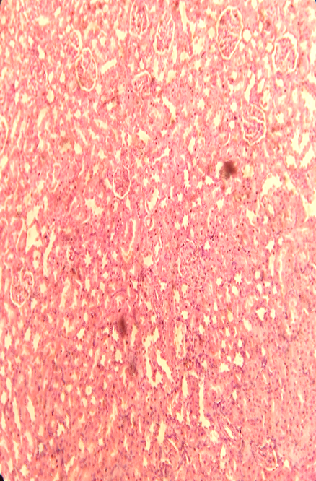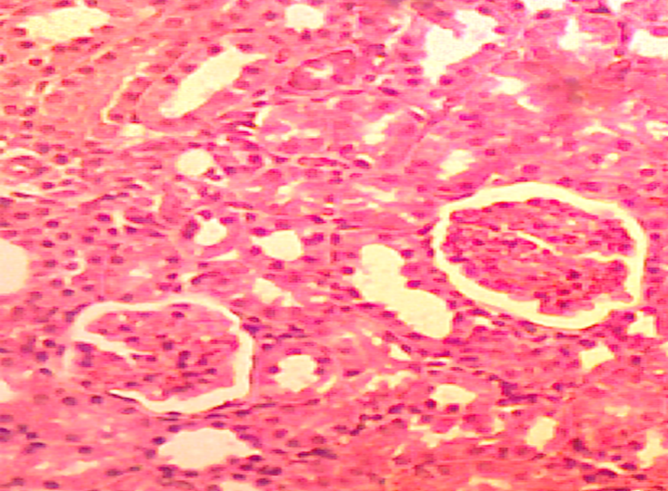

GROUP A
PLATE 1: Shows the Morphology of the kidney after the administration of the various treatments for 14 days. Slide shows normal morphology of the kidney, glomeruli (yellow arrow), distal tubules (black arrow). (X40)

.
GROUP B

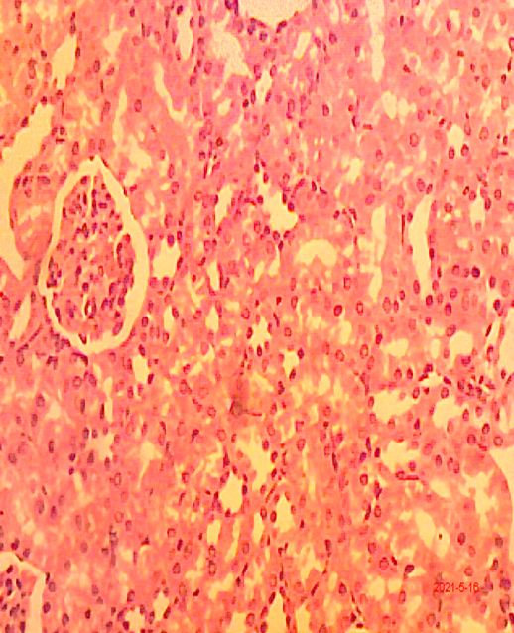
G

PLATE .2 : Shows the Morphology of the kidney after the administration of the various treatments for 14 days. Slide shows slight enlargement of glomeruli (yellow arrow) with presence of mesangial cells(blue arrow) and degeneration of tubules.(x10)(X40) H&E

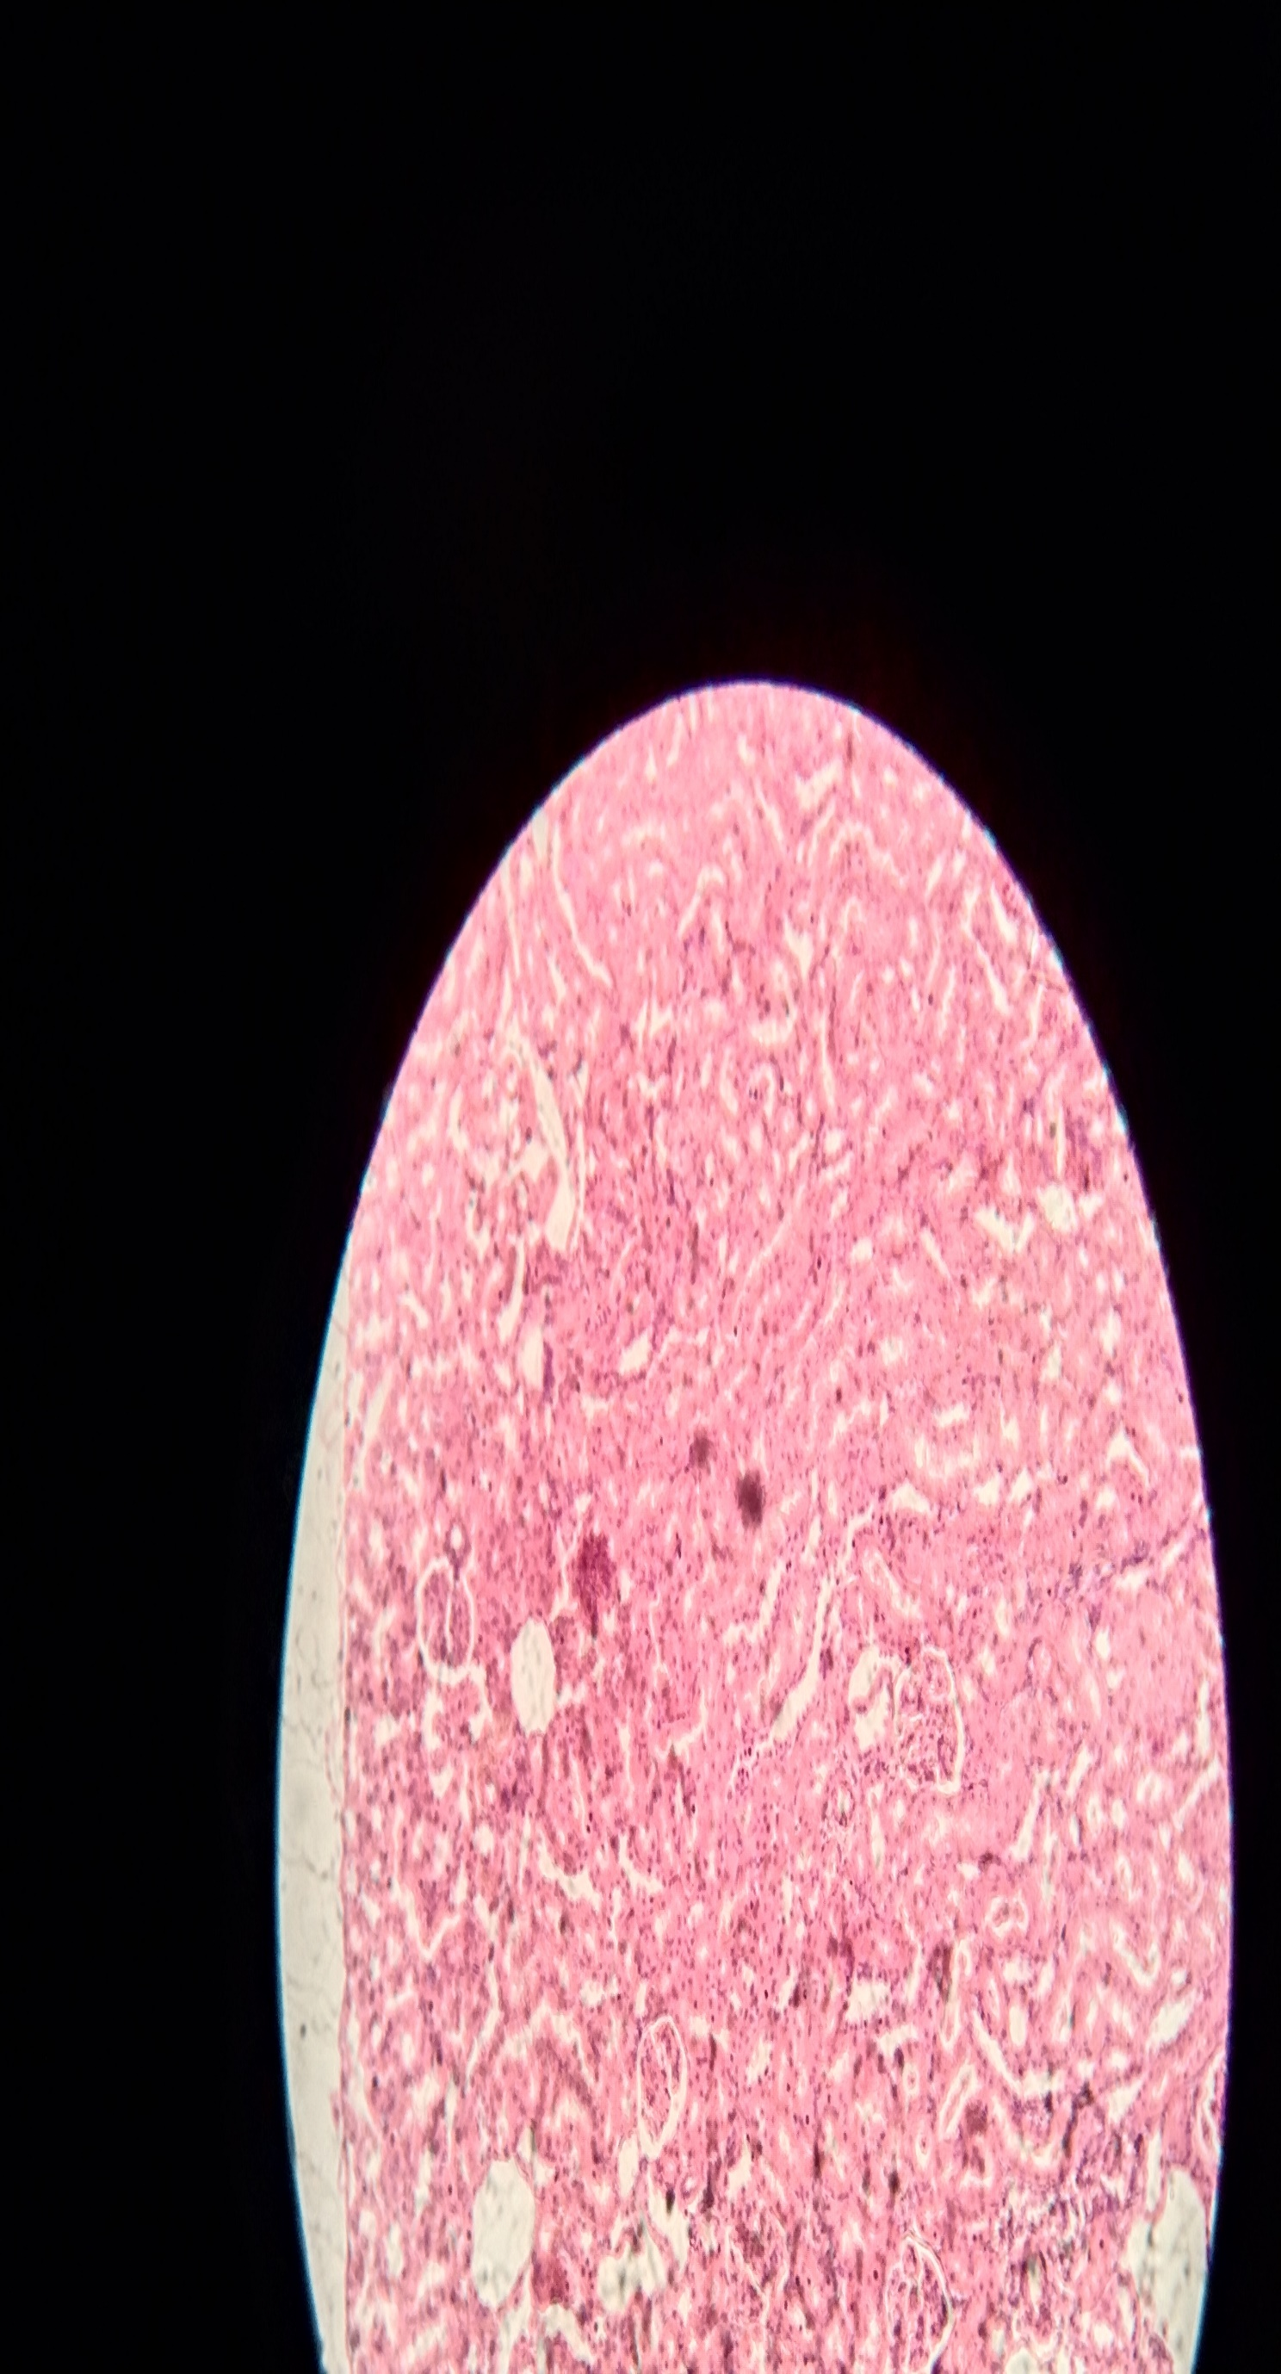
GROUP D

GROUP C
PLATE 3: Shows the Morphology of the kidney after the administration of the various treatments for 14 days. Slide shows slightly enlarged glomeruli (yellow arrow) ,distal tubules (DT) and presence of mesangial cells(blue arrow).(X40) H&E.

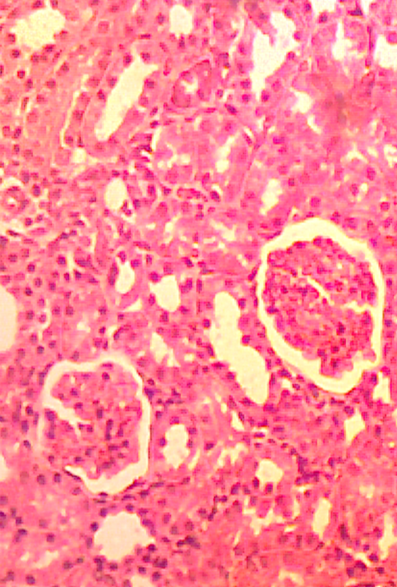
G
GROUP E
DT

PLATE 4: Shows the Morphology of the kidney after the administration of the various treatments for 14 days. Slide shows normal morphology of the kidney, glomeruli (G),distaltubule s(Blue arrow).(X40)

LIVER
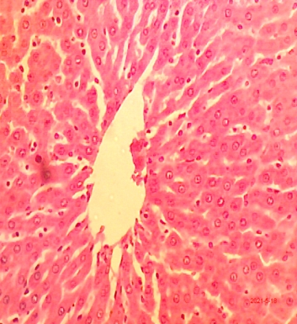
S
GROUP 1
PLATE 5: Shows the morphology of the liver after the administration of the various treatments for 14 days. Slide shows normal morphology of the liver,central vein (green arrow),hepatocytes with intact sinusoidal space (S) (X400) H&E
GROUP 2
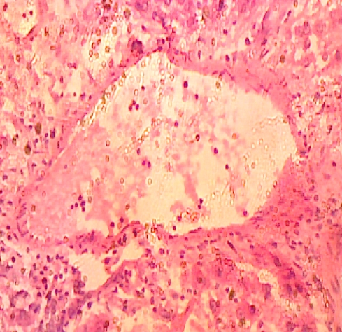

PLATE 6: Shows the morphology of the liver after the administration of the various treatments for 14 days. Slide shows congestion of the central vein (green arrow),areas of focal necrosis ( black arrow) ,occluded sinusoidal space with marked presence of Kupffer cells (X400) H&E.

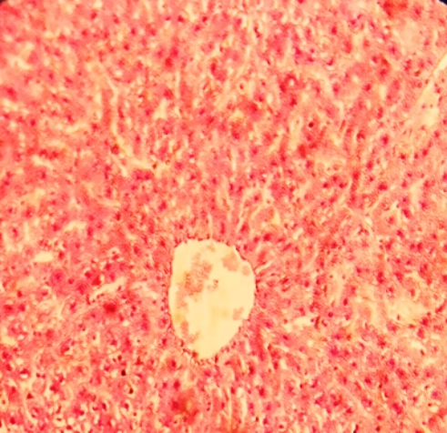
S
GROUP 3
PLATE 7: Shows the morphology of the liver after the administration of the various treatments for 14 days. Slide shows congestion of the central vein (green arrow),occluded sinusoidal space (black arrow),balloon degeneration of hepatocytes with marked presence of Kupffer cells (X400) H&E

GROUP 4
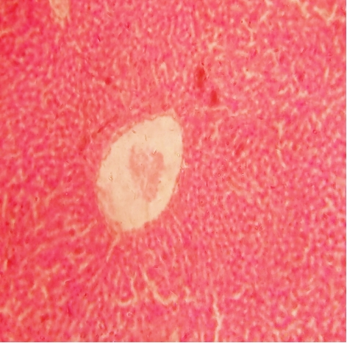
S
PLATE 8: Shows the morphology of the liver after the administration of the various treatments for 14 days. Slide shows congestion of the central vein with degeneration of it lining wall (green arrow) ,occluded sinusoidal space (S),balloon degeneration of hepatocytes with marked presence of Kupffer cells (X10) H&E

GROUP 5
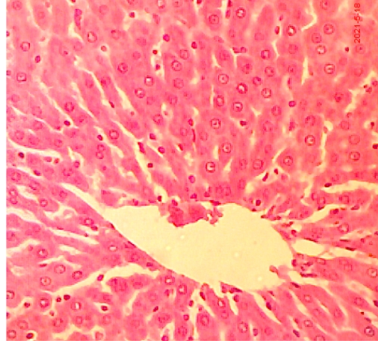
PLATE 9: Shows the morphology of the liver after the administration of the various treatments. Slide shows normal morphology of the liver, central vein (green arrow), hepatocytes with intact sinusoidal spaces (X10) H&E
Plate 1-5Kidney) show the photomicrograph of the Kidney after the administration coconut water on lead induced toxicity.
The kidney, glomeruli, and distal tubules in the control group displayed normal morphology.
Following the administration of the various therapies, the kidney's morphology is displayed in the lead group. The slide displays a slight enlargement of the glomeruli (G), along with tubule degeneration and mesangial cells. This is consistent with research by Offor et al. [9]. Azab [10] also reported similar results. Lead is one of the most toxic heavy metals of great public health significance, and exposure to low-level heavy metals like lead may be far more responsible for the development of chronic diseases (diabetes, renal disease, cancer, male infertility, etc.) and impaired functioning than previously believed [11]. However the treatment group shows enlarged glomeruli ,distal tubules and presence of mesangial cells which indicate that coconut water did not reverse the effect of lead acetate on the kidney of the treated rat. According to Elekwa et al. [12], supplementing with coconut water may reverse CCl4-induced toxicity and distortions on haematological parameters, lipid profile and antioxidant enzymes, liver and kidney biomarkers when compared to the negative control. Further more Temidayo et al., [13] documented in a study to investigate the antidepressant potential of Green coconut water in ameliorating depression-like behaviors caused by Dexamethasone treatment in female Sprague Dawley rats. When compared to the induced and recovery groups, green coconut water was shown to reduce neuronal degeneration and enhance the amount of tissue in the hippocampus and prefrontal cortex, demonstrating a significant antidepressant effect. This supports the idea that green coconut water is a natural therapy that can help reverse the effects of oxidative stress brought on by using DEX [13]. Also in contrast with our study is work by Enagbonma et al.,[14] to ascertain if coconut water may reverse the haemato biochemical alterations brought on by lead poisoning in Wistar albino rats. With the exception of the high density lipoprotein-cholesterol mean values, the study found that the mean values dropped when compared to the mean values of the groups who lead and coconut water. These findings suggest that the effects of lead poisoning may be lessened by coconut water. It's interesting to note that a study conducted by Alleyne et al.[15] found that frequent drinking of either coconut water or mauby (a beverage made from the bark of the mauby tree, Colubrina arborescens. Cytokinins, a type of cytochromes, are among the essential ingredients in coconut water. These cytokinins demonstrated antithrombotic, anti-carcinogenic, and anti-aging properties. [14].. Folate, generally referred to as vitamin B9, is also present in coconut water. Plant-derived polyphenolics' antioxidant properties have been shown to have positive health effects, including a reduction in cardiovascular illnesses. Additionally, the natural coconut water's ascorbic acid content was linked to its antioxidant qualities[14].

Plates 6 - 9(liver) illustrate the photomicrographs of the liver following the administration of coconut water in cases of lead-induced poisoning. The control group had normal liver morphology, including the central vein and hepatocytes, with preserved sinusoidal space. The primary group exhibited the liver's shape, with the slide revealing congestion of the central vein, regions of localised necrosis, blocked sinusoidal spaces, and a pronounced presence of Kupffer cells. This is consistent with the results of Bashir and Taib [16]. The findings showed that Wistar albino rats' livers had significant histological and histochemical changes as a result of extended exposure to lead [16]. Suna et al. [17] looked at how sodium selenite affected Wistar rats that had been poisoned by lead. The groups treated with lead nitrate and sodium selenite, as well as the diabetic and non-diabetic cohorts, showed statistically significant changes in lipid peroxidation levels, antioxidant enzyme activities, and liver function tests. Moreover, histological changes were seen in the same groups. [17]. The effects of different lead acetate dosages (1/20, 1/40, and 1/60 of LD50) on body weight growth, haematological parameters, plasma protein profile, and thyroid, kidney, and liver function are evaluated in a study by Nabil et al.[18], which supports our findings.
The liver morphology of the experimental group exhibits congestion of the central vein, blocked sinusoidal spaces, balloon degeneration of hepatocytes, and a significant presence of Kupffer cells. It also indicates congestion of the central vein accompanied by deterioration of its lining walls. Enagbonma et al. [14], in contrast to our study, examined the possible advantages of coconut water in lowering the hematobiochemical alterations caused by lead poisoning in Wistar albino rats over a six-week period .These findings suggest that coconut water may mitigate the consequences of lead intoxication. (Enagbonma et al., 2016). In contrast to our study, The effect of tender coconut water in preventing anaemia in rats given lead was investigated by Zulaikhah et al.[1]. According to the study, the lead group had lower levels of erythrocytes, haemoglobin, and haematocrit than the control group. The tender coconut group was shown to have significantly higher amounts of erythrocytes, haemoglobin, and haematocrit than the lead group. The hepatoprotective properties of Leucas aspera hydroalcoholic leaf extract on male albino Wistar rats were evaluated in a study by Thenmozhi et al.[19]. The hepatoprotective effectiveness of 400 mg/kg of hydroalcoholic Leucas aspera leaf extract and 50 mg/kg of oral lead acetate exposure were evaluated in male albino Wistar rats. Leucas aspera hydroalcoholic leaf extract 400 mg/kg demonstrated a significant (P<0.05) dose-dependent reduction in liver enzymes. Thus, Leucas aspera's hydroalcoholic leaf extract has shown hepatoprotective properties [19]. The group treated with coconut has normal liver morphology, including a central vein and hepatocytes with intact sinusoidal spaces.
Histological studies of the kidney and liver indicated aberrant changes, however the tubules and central veins, respectively, showed a small expansion when compared to the negative control, according to a study by Eric et al.,[21]. The delivery of coconut water demonstrated a dose-dependent protective effect in comparison to the untreated group. Liver injuries comprised distorted hepatocytes, dilated sinusoids, microvascular steatosis, and an enlarged central vein, whereas congested blood vessels and dilated tubules were observed in the kidney of the negative control. Coconut water (CW) is a naturally occurring beverage widely accessible in several tropical nations, utilised as an isotonic drink due to its electrolyte composition resembling that of human blood. The abundance of macro and micro nutrients in CW is shown to exhibit several therapeutic qualities, including hypolipidemic, cardioprotective, antihypertensive, and hepatoprotective effects [22]. Prabhakaran et al.[22] shown in their research on the oral administration of mature coconut water in diabetic rats a considerable decrease in blood glucose and glycated haemoglobin levels, accompanied by an enhancement in plasma insulin levels. The activities of carbohydrate- metabolizing enzymes were elevated in diabetic rats administered with Mature Coconut Water, accompanied by an increased concentration of hepatic glycogen [22]. Ajeigbe et al.,[23] assessed the antioxidative and anti-inflammatory properties of coconut water (CCW) and coconut milk (CCM) in phenylhydrazine (PHZ)-induced haemolysis and hepatotoxicity in rats, along with potential synergistic effects with dexamethasone (DXM). Phenylhydrazine-induced toxicity is alleviated by coconut water and milk, or in conjunction with dexamethasone, through the decrease of oxidative stress and suppression of inflammation [23]. Ekechi et al. [24] documented in their study, which aimed to evaluate the anti- diabetic effects of mature coconut water on biochemical parameters of liver and kidney functions, as well as the histological architecture of the pancreas in alloxan-induced diabetic rats, that mature coconut water may be incorporated into the treatment regimen for diabetes mellitus due to its hepatorenal protective properties.
5.0 CONCLUSION
Lead poisoning stands as a significant environmental health concern, with a profound impact on bodily functions. Virtually every aspect of human physiology can be compromised by the presence of lead. Lead is recognized as a critically hazardous heavy metal in the environment. Its significant physicochemical properties have warranted its use since antiquity. It is a widely dispersed and consequential, yet perilous, chemical in the environment. Qualities such as pliability, malleability, ductility, low conductivity, and corrosion resistance make it challenging to abandon its usage. Owing to its indestructible nature and incessant utilization, lead's levels have been progressively accumulating in the environment, escalating the dangers it poses especially to organs such as the kidney and liver.The congestion of the central vein, occluded sinusoidal space, balloon degeneration of hepatocytes The significant presence of Kupffer cells in the liver of animals treated with coconut indicates that coconut water, at the administered dose, did not mitigate lead toxicity in Wistar rats. However the dose of coconut utilized in this study may have contributed to this result. Future research should explore the effects of higher doses of coconut water in treatment protocols.

COMPETING INTERESTS DISCLAIMER:
Authors have declared that they have no known competing financial interests OR non-financial interests OR personal relationships that could have appeared to influence the work reported in this paper.

Disclaimer (Artificial intelligence)
Author(s) hereby declare that NO generative AI technologies such as Large Language Models (ChatGPT, COPILOT, etc.) and text-to-image generators have been used during the writing or editing of this manuscript.

REFRENCE
- Zulaikhah, S, T., Wahyuwibowo J, D., Aziz, R, P., Dede, R., Ahmad, F., (2019)Effect of Tender Coconut Water to Prevent Anemia on Wistar Rats Induced by Lead (Plumbum), Pharmacognosy Journal, 11( 6) 1325-1330,
- Yong, J.W.Y., Liya Ge., Yan Fei Ng., Swee Ngin (2016). "The Chemical Composition and Biological Properties of Coconut (Cocos nucifera L.) Water. Tan Molecules 14 (12):5144-5164.
- Diere, A. M. Molina, V. Más, R. Carbajal, D. Marrero, D. González, V. Rodríguez, E. (2016). "Effects of coconut oil on testosterone-induced 45prostatic hyperplasia in Sprague-Dawley rats Journal of Pharmacy and Pharmacology 59 (7): 995-999
- Dai, Y., Peng, L., Zhang, X., Wu, Q., Yao, J., Xing, Q., Zheng, Y., Huang, X., Chen, S., & Xie, Q. (2021). Effects of coconut water on blood sugar and retina of rats with diabetes. PeerJ, 9, e10667. https://doi.org/10.7717/peerj.10667
- D. O. Akinjayeju & T. T. Adebolu. (2020). Effects of Coconut (Cocos nucifera Linn.) Water and Oil on the Ileal Bacterial Flora of Apparently Healthy Wistar Albino Rats. Journal of Advances in Microbiology, 20(7), 94–102.https://doi.org/10.9734/jamb/2020/v20i730268
- Harbison, R. D., Bourgeois, M. M., Johnson, G. T. (2015). Hamilton and Hardy's Industrial Toxicology. John Wiley & Sons. ISBN 978-0-470-92973-5.
- Agrande, T. S. Roache, C. Thomas and A. Shirley, (2019). The control of hypertension by use of coconut water and by two tropical food drinks. West Indian Medical Journal, 54: 3-8.
- Eric E. U, Boloya V. E., Osuamkpe A. E. (2021) Aggravation of Aluminum Phosphide Induced Liver Damage and Hematotoxicity in Adult Wistar Rat:The Role of Allium Sativum. European Journal of Biology and Biotechnology Vol 2( 2),51-59
- Offor, S. J., Mbagwu, H. O. C., & Orisakwe, O. E. (2017). Lead-induced hepato-renal damage in male albino rats and effects of activated charcoal. Frontiers in Pharmacology, 8, 107. https://doi.org/10.3389/fphar.2017.00107
- Azab El-Saied Azab. (2014). Hepatoprotective Effect of Sesame Oil against Lead Induced Liver Damage in Albino Mice: Histological and Biochemical Studies. American Journal of BioScience, 2(6-2), 1-11. https://doi.org/10.11648/j.ajbio.s.2014020602.11
- Orisakwe, O. E. (2014). Lead and cadmium in public health in Nigeria: Physicians’ neglect and pitfalls in patient management. North American Journal of Medical Sciences, 6, 61–70. https://doi.org/10.4103/1947-2714.127740Azab, E. A. (2014). Hepatoprotective effect of sesame oil against lead-induced liver damage in albino mice: Histological and biochemical studies. American Journal of Bioscience, 2, 1– 11.
- Elekwa, I., Ude, V. C., Emmanuel, O., Amachaghi, V. O., & Ugbogu, E. A. (2021). In vivo studies on the ameliorative effect of coconut water against carbon tetrachloride-induced toxicity in rats. Biomarkers, 26(6), 570–577.https://doi.org/10.1080/1354750X.2021.1946848
- Temidayo, E. T., Adeola, B. A., & Mukhtar, S. A. (2024). Ameliorative effect of green coconut water on dexamethasone-induced depression-like behaviors in Sprague Dawley rats. Journal of Biological Research and Biotechnology, 22(2), 2369–2382.https://doi.org/10.4314/br.v22i2.6
- Enagbonma, B, J., Iyorah, I, E., Igiehon, N., Ozede,,A, F, E. (2016 ) Hematobiochemical changes of lead Poisoning and amelioration with Coconut (Cocos nucifera L.) Water in wistar albino rats. Journal Applied. Science Environment .20(1) 84-89.
- Alleyne, T., Roache, S., Thomas, C., & Shirley, A. (2005). The control of hypertension by use of coconut water and mauby: Two tropical food drinks. West Indian Medical Journal, 54, 3–8.
- Bashir, M, J., Taib, T.(2012) Histological and histochemical alterations in the liver induced by lead chronic toxicity. Saudi Journal of Biological Sciences,19(2).
- Suna, K., Fatma, G, A., Hatice, B., Yusuf, K. (2015) Protective effects of sodium selenite on lead nitrate-induced hepatotoxicity in diabetic and non-diabetic rats. Environmental Toxicology and Pharmacology, 40( 2) 568-574.
- Nabil, M, I., Esam, A, E., Hossam, S., El-Beltagi, Y. Abdel-Mobdy, E.(2012) Effect of lead acetate toxicity on experimental male albino rat. Asian Pacific Journal of Tropical Biomedicine, 2(1). 41-46.
- Thenmozhi, M., Dhanalakshmi, M., Manjula, D, K., Sushila, K., Thenmozhi, S.(2013) Evaluation Of Hepatoprotective Activity Of Leucas Aspera Hydroalcoholic Leaf Extract During Exposure To Lead Acetate In Male Albino Wistar Rats . Asian Journal of Pharmaceutical and Clinical Research . 6, Suppl 1.
- Varma, S,R., Sivaprakasam, T,O., Arumugam, I., Dilip, N., Raghuraman, M., Pavan, K,B., Rafiq, M., Paramesh, R. (2019) In vitro anti-inflammatory and skin protective properties of virgin coconut oil. Journal Traditional Complementary Medicine 9(1):5–14
- Eric, E. U,Beredugo S, Bolobolo G. (2022). “Histological and Hematoloical Assessment of the Effect of Heinsia Crinata Extract on Dichlorvos (DDVP) Induced Toxicity in Adult Wistar Rats”. Journal of Advances in Biology & Biotechnology 25 (1), 23-33.
- Prabhakaran, P, P., Vishalakshiamma, G, D.,Thankappan, R. (2013)Effects of coconut water on carbohydrate metabolism and pancreatic pathology of alloxan induced diabetic rats,European Journal of Integrative Medicine. 5(3).
- Ajeigbe, K,O., Adeleye, G,S., Owonikoko, M,W., Adelakun, M,A., Odesanmi, O,E., Awoyinka, O,A (2023) Coconut Water and Milk Modulate Intravascular Haemolysis and Hepatotoxicity Via Oxido-Inflammatory Mechanism in Rats. Tropical Journal Natural Product Research. 7(11):5308-5315. http://www.doi.org/10.26538/tjnpr/v7i11.41
- Ekechi,O.,H, Ikwuka,A.,O, Udeh,F.,C. (2023) Hepatorenal Protective Functions of Coconut Water in Alloxan-Induced Type 1 Diabetes Mellitus. World Journal of Current Medical and Pharmaceutical Research, 5(4), 114-122. https://doi.org/10.37022/wjcmpr.v5i4.276
- Zulaikhah ST (2019) Health benefits of tender coconut water (TCW). Int J Pharm Sci & Res ; 10(2): 474-80. doi: 10.13040/IJPSR.0975-8232.10(2).474-80.
- Offor, S. J., Mbagwu, H. O., & Orisakwe, O. E. (2017). Lead Induced Hepato-renal Damage in Male Albino Rats and Effects of Activated Charcoal. Frontiers in pharmacology, 8, 107. https://doi.org/10.3389/fphar.2017.00107.
- Eze K. Nwangwa, and Chukwuemeka P. Aloamaka. 2011. “Regenerative Effects of Coconut Water and Coconut Milk on the Pancreatic β–Cells and Cyto Architecture in Alloxan Induced Diabetic Wistar Albino Rats”. International Journal of TROPICAL DISEASE & Health 1 (3):137–146.https://journalijtdh.com/index.php/IJTDH/article/view/766.

