Aquatic Health Risks of Selenium, Vanadium, Molybdenum and Tin in River Niger: Insights from Fish, Water and Sediment Analysis
Abstract
Heavy metal pollution is also dangerous environmental issue, especially in water bodies that are exposed to the influence of industrial, agricultural, and urban effluents.This present study, was designed to determine the concentrations of selenium (Se), vanadium (V), molybdenum (Mo), and tin (Sn) in fish, water, and sediments collected from three stations of River Niger: Atani, Bridgehead, and Otuocha. The concentrations were determined by Atomic Absorption Spectrophotometry (AAS).Se, V, and Sn were not detectable at Atani in water and fish but Se was found in sediments (0.22 mg/kg), while Mo was found both in fish (0.68 mg/kg) and sediments (0.67 mg/kg). At Bridgehead, Se (0.12 mg/L) and V (0.14 mg/L) were found in water only, while Mo was observed both in fish (0.78 mg/kg) and sediments (0.87 mg/kg). In Otuocha, Mo and Sn were undetectable in all samples, but Se was found in fish (0.18 mg/kg), water (0.66 mg/L), and sediments (0.67 mg/kg), but sediments contained the highest levels. Vanadium was found only in water (0.32 mg/L).The findings reflect site-specific variations in the occurrence and distribution of heavy metals within the River Niger ecosystem. Regular occurrence of Se and Mo in various matrices indicates bioaccumulation, while the sporadic occurrence of V and lack of detection of Sn indicate localized anthropogenic or natural source effects. Although some of the metals are trace elements at essential levels, at high levels, they become ecological and health hazards. Surveillance is therefore recommended to safeguard water life and human health in societies dependent on the River Niger.
Keywords: Bioaccumulation; Heavy metal pollution; Molybdenum (Mo); River Niger ecosystem; Selenium (Se); Tin (Sn); Vanadium (V)
1.0 Introduction
Heavy metals have a wide distribution in the environment due to natural and anthropogenic activities (Laoyeet al., 2025). They occur due to rock weathering processes, volcanic eruption, and metal corrosion, while human contributions to their dispersal come through mining, industrial emissions, agricultural applications such as fertilizers, pesticides, and herbicides, and spontaneous dumping of wastes (Dixit et al., 2015). Due to this dual origin, heavy metals have a ubiquitous environmental distribution and are linked with multilateral ecological and health issues (Shen et al., 2025).
By definition, heavy metals are those elements which have atomic weights above 20 and densities above 5.0 g/cm³ (Gunatilake, 2016; Al-Qodahet al., 2017; Li et al., 2019). Thirteen priority toxic metals were designated by the USEPA, namely, arsenic, antimony, chromium, cadmium, beryllium, lead, copper, zinc, selenium, mercury, nickel, thallium, and silver (Ramos et al., 2002). These chemicals belong to some of the most recalcitrant and resistant environmental pollutants owing to their not being biodegradable and their stability with time (Kanamarlapudiet al., 2018). They are acutely and chronically toxic, too; it follows that they become a major threat to ecosystems and human beings (Bashir et al., 2017).
Heavy metals naturally fall under two categories: essential or non-essential, according to their biological function. The trace elements that are highly needed in metabolic, physiological, and biochemical activities include iron, zinc, selenium, molybdenum, and nickel. However, higher than accepted concentrations lead to damage (Nieset al., 2004;Kim & Lee, 2017). Some metals are non-essential and without established biological activity but toxic irrespective of their concentration, such as lead, cadmium, and mercury (Bibi et al., 2023). The dual function of some heavy metals as micronutrients and toxins calls for the application of rigorous environmental regulation to guarantee ecological and public health.
Freshwater ecosystems are most sensitive to heavy metal pollution. Rivers, lakes, and oceans act as ultimate sinks that receive these metals through atmospheric deposition, riverine inputs, and purposeful anthropogenic emissions (Kumaret al., 2023). Contaminants rest in sediments, which are long-term repositories and secondary sources of pollution. Heavy metals recycled to the water column over a period of time get assimilated into pelagic and benthic organisms, thus leading to bioaccumulation and biomagnification through the food chain (Oros, 2025). The contamination of sediments is generally higher near sewage and industrial discharge outlets.
Fish are the most sensitive bioindicators of heavy metal pollution, as they tend to bioaccumulate heavy metals rather easily in their bodies and transmit these toxic elements to human beings upon consumption (Ali & Khan, 2018a, 2018b). The accumulation of heavy metals in fish may result in immunosuppression, reproductive injury, oxidative stress, DNA damage, and growth anomalies (Authmanet al., 2015). Hence, monitoring the levels of heavy metals in fish and sediments offers information with respect to aquatic ecosystem health and possible risk to public health (Nyairoet al., 2015).
Among trace elements that are essential, Se, Mo, V, and Sn have been of increasing interest environmentally. Selenium is important for growth, immunity, and fish reproduction; its deficiency culminates in stunted growth, compromised glutathione peroxidase activity, and muscular dystrophy (Virk, 2019). In humans, Se is obtained mainly from meat and seafood, with a daily intake of 0.9 µg/kg body weight recommended by the World Health Organization and with a guideline value of 0.01 mg/L for potable water (Hsuehet al., 2003). Vanadium, naturally occurring in the earth's crust (~100 mg/kg), finds wide application in steel, ceramics, and catalysis. Industrial waste-waters are responsible for significant contribution to environmental distribution whose concentration in surface water varies from 0.04–220 µg/L (Hunter et al., 2015; Akoumainakiet al., 2015). Molybdenum is an essential component of several enzyme complexes in the purine metabolism, though less studied concerning its toxicity to fish. The U.S. EPA recommends a value of 0.08 mg/L for drinking water (Todd et al., 2017). Tin, although less abundant (2 ppm in the Earth's crust), is also applied very widely in alloys and in coating metal. Because of its persistence, it becomes an issue when present in large quantities (Emsley & John, 2001).
Due to the persistence, bioaccumulation, and toxicity of the heavy metals, continued study of their incidence, distribution, and importance in aquatic ecosystems remains an international priority. Of particular interest remains the establishment of environmental 'roles' and 'toxic thresholds' for the less common elements like selenium, vanadium, molybdenum, and tin. Whereas minute quantities of certain metals are needed for normal biological functions, excesses can disturb growth, reproduction, and immune balance and, over longer periods, threaten aquatic biodiversity and human food security. Balali-Mood et al. (2021) determined that the determination of the heavy metal composition in sediments and aquatic life is not only indicative of environmental condition but of such a potential threat to ecological sustainability and public well-being. This study evaluates the incidence, toxicity, and ecological significance of selected heavy metals and their effects on fish as indicator organisms.

2. METHODOLOGY

2.1 Collection of Samples

2.1.1 Water and Sediment Sampling
Water and sediment samples were collected from three different locations during the dry season. For water sampling, a clean, metal-free bottle was submerged approximately 0.5 feet below the water surface to obtain representative samples. The collected water was immediately transferred into airtight, stopper bottles for preservation and subsequent analysis(UNEP, 2006).

2.1.2 Fish Sampling
Fish samples were obtained with the assistance of local fishermen using cast nets. The nets were thrown and retrieved using lines attached to their openings. The captured fish were collected, washed with clean water, weighed, and stored in a refrigerator for 24 hours prior to analysis. Before analysis, the fish samples were removed from the refrigerator, and the edible flesh was carefully separated for further processing(CEN, 2005). .

2.1.2.1 Preparation of Fish Samples
The preparation of fish samples involved several steps to ensure analytical accuracy. Edible muscle tissues were dissected and rinsed thoroughly with distilled water to eliminate surface contaminants. The cleaned tissues were oven-dried at 105 °C to remove residual moisture and then ground into a fine powder. A known weight of the powdered sample was digested with a mixture of concentrated acids (such as nitric acid) and heated until a clear solution was obtained. The resulting digest was filtered and diluted to a known volume with deionized water, yielding the sample solution for heavy metal determination.

2.2 Determination of Heavy Metal Concentrations
The concentrations of heavy metals in the water samples were determined using an Atomic Absorption Spectrophotometer (AAS), model 240FS. Each metal was analyzed at its characteristic wavelength as follows: Cobalt (Co) at 240.7 nm, Manganese (Mn) at 279.5 nm, Iron (Fe) at 248.3 nm, and Silver (Ag) at 328.1 nm. Prior to analysis, all samples were appropriately digested to ensure accurate measurement of the metal concentrations.
Statistical Analysis
The results were expressed as Mean ± Standard Deviation (SD) and statistically analyzed using Analysis of Variance (ANOVA) with the SPSS software package to determine the level of significance. Where significant differences were observed, Scheffé’s Multiple Comparison Test was applied to identify the specific sources of variation among the means.
3.0 RESULTS
Table 3.1:Heavy metal concentrations in fish, water and sediments from Atani
Heavy Metals | Fish | Water | Sediments
Se | 0.00 | 0.00 | 0.22
V | 0.00 | 0.00 | 0.00
Mo | 0.68 | 0.00 | 0.67
Sn | 0.00 | 0.00 | 0.00

Table 3.1 shows the concentrations of selected heavy metals in fish, water, and sediment samples from Atani. Selenium (Se) and Tin (Sn) were not detected in fish and water samples but Se was present in sediments (0.22 mg/L). Vanadium (V) and Tin (Sn) were not detected in any of the sample types. Molybdenum (Mo) was detected in both fish (0.68 mg/L) and sediments (0.67 mg/L) but was absent in water samples. Overall, sediments contained slightly higher metal levels than fish and water, indicating minimal contamination in the aquatic environment
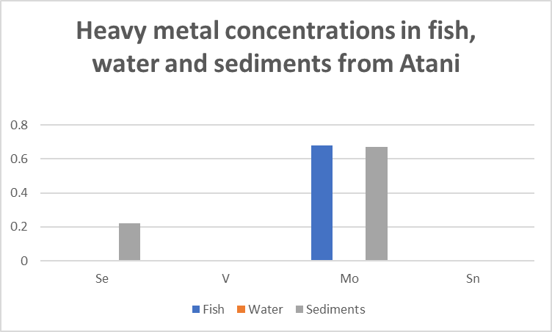
Fig 3.1 Heavy metal concentrations in fish, water and sediments from Atani

Table 3.2: Heavy metal concentrations in fish, water and sediments from Bridgehead
Heavy Metals | Fish | Water | Sediments
Se | 0.00 | 0.12 | 0.00
V | 0.00 | 0.14 | 0.00
Mo | 0.78 | 0.00 | 0.87
Sn | 0.00 | 0.00 | 0.00
Table 3.2 presents the concentrations of heavy metals in fish, water, and sediment samples from Bridgehead. Selenium (Se) and Vanadium (V) were detected only in water samples at 0.12 mg/L and 0.14 mg/L, respectively. Molybdenum (Mo) was present in both fish (0.78 mg/L) and sediments (0.87 mg/L) but absent in water. Tin (Sn) was not detected in any of the samples. Overall, the results indicate that Molybdenum was the predominant metal, while other metals were present in low or undetectable levels.
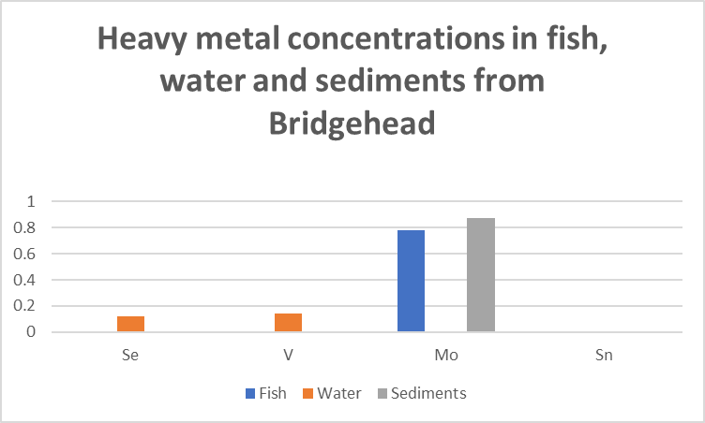
Fig 3.2: 3.2: Heavy metal concentrations in fish, water and sediments from Bridgehead

Table 3.3:Heavy metal concentrations in fish, water and sediments from Otuocha
Heavy Metals | fish | water | sediments
Se | 0.18 | 0.66 | 0.67
V | 0.00 | 0.32 | 0.00
Mo | 0.00 | 0.00 | 0.00
Sn | 0.00 | 0.00 | 0.00
Table 3.3 shows the concentrations of heavy metals in fish, water, and sediment samples from Otuocha. Selenium (Se) was detected in all sample types, with the highest concentration in sediments (0.67 mg/L) and the lowest in fish (0.18 mg/L). Vanadium (V) was found only in water samples at 0.32 mg/L, while Molybdenum (Mo) and Tin (Sn) were not detected in any of the samples. Overall, Selenium was the dominant metal across the three sample types, suggesting moderate accumulation in the aquatic environment.
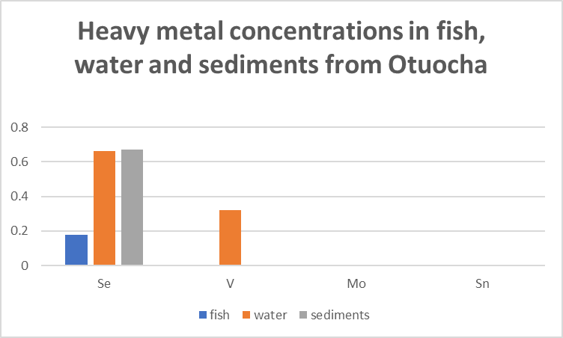
Fig3.3:Heavy metal concentrations in fish, water and sediments from Otuocha

- DISCUSSION
Considerable variability existed among Atani, Bridgehead, and Otuocha, and among fish, water, and sediments. Atani had selenium only in sediments, which would suggest poor mobility and possible legacy accumulation. Bridgehead showed selenium in water only, suggesting recent or transient input. On the other hand, Otuocha recorded selenium in all environmental media, which suggests active mobilization and high bioavailability possibly driven by geochemical conditions or anthropogenic activities. Concentration patterns followed a consistent hierarchy-Otuocha had the highest levels in water, fish, and sediments in that order-following the natural behavior of selenium in aquatic systems, where sediments are major sinks and its bioavailability increases through the food web (Lino et al., 2020). Selenium inputs can be from natural processes, such as weathering of selenium-bearing rocks, hydrothermal activity, volcanic emissions, and atmospheric deposition, and from human activities, including industrial effluents, mining, agriculture, and sewage discharge (Feinberg et al., 2020; Okonji, 2021; Ujahet al., 2023). Previous high levels reported near lead-zinc mines in Abakaliki further support anthropogenic influence (Obasi &Akudinobi, 2020). The detection of selenium in fish in Otuocha confirms its bioavailability, although selenium is an essential micronutrient with critical antioxidant functions; its narrow margin between essentiality and toxicity makes it a cause for concern (Banoet al., 2025). Water-phase selenium at Bridgehead and Otuocha exceeded the guideline limits set by WHO (0.01 mg/L) and USEPA (0.05 mg/L) (WHO, 2003; USEPA, 2015), which may pose possible ecological and human health risks (Luo et al., 2025). While the fish levels of selenium remained below the indicative 1.0 mg/kg value used in environmental studies (Lorenzo et al., 2021), prolonged exposure may elicit biomagnification (Perusini&Hammerschmidt, 2020). Selenium levels observed to be high in sediments from both Atani and Otuocha are significant because sediments serve as long-term reservoirs capable of releasing selenium upon any shift in redox or pH conditions (Song et al., 2022).
Vanadium had a different trend: it was not detected in all the media at Atani but detected only in water at Bridgehead and Otuocha, with sediment and fish remaining below detection limits. This consistent trend is most likely due to vanadium concentrations in solid phases below the detection limit of the equipment or from its predominant chemical forms having a very poor affinity for sediment binding and biological uptake. The mobility of vanadium is strictly controlled by oxidation state and water chemistry, and even though it is environmentally stable, it only accumulates much less readily than either lead or cadmium. As reported by Shaheenet al. (2019), the vanadium measured here in water is probably anthropogenic, mainly resulting from combustion of fossil fuel, oil refining, coal burning, and metallurgical processes, while some is added through the natural weathering of V-bearing minerals. According to Zhang et al. (2023), localized high levels at Otuocha and Bridgehead might have come from industrial activities, vehicular traffic emissions, and a point-source discharge. The current level of vanadium exceeded some set standards and thus indicates contamination. The absence of vanadium in fish reveals a minimum immediate food-safety concern, although the low detection limits must be considered. Current levels suggest minimal ecological risk exists, although dissolved vanadium can disrupt metabolic functions in higher concentrations. According to Meinaet al. (2020), similar regional and global trends, which include the occurrences of vanadium mainly in water and linked with fossil fuel emissions, support this observed spatial trend: Otuocha> Bridgehead >Atani.
Molybdenum was present in fish and sediments at Atani and Bridgehead but was below detection limits in water from those sites and in all media at Otuocha. This demonstrates that molybdenum is more strongly associated with particulate matter and biota than the dissolved phase. The molybdate ion, MoO₄²⁻, the predominant form of Mo in natural waters, is generally soluble under oxidizing conditions over neutral or alkaline pH, although its tendency to adsorb onto sediments or precipitate in either reducing conditions or organic-rich environments may explain its absence from water (Linnik&Ignatenko, 2015). Its presence in fish indicates dietary uptake and incorporation into metabolic processes. Anthropogenic sources include metallurgical activities, mining, oil refining, combustion of fossil fuel, and fertilizer application, while natural inputs arise through the weathering of Mo-rich minerals like molybdenite (Koślaet al., 2019); thus, elevated concentrations at Atani and Bridgehead may indicate industrial or agricultural inputs or deposition of Mo-bearing particulates. Spatially, Mo exhibited the pattern Bridgehead >Atani>Otuocha, consistent with localized upstream enrichment, and differences are likely due to variations in redox conditions, sediment character, and hydrodynamics. Although Mo is an essential micronutrient, excessive intake can disrupt copper metabolism (Thorndyke et al., 2021). International guidelines range; WHO and USEPA propose the 70µg/L drinking water limit while CCME provides an AGL of 73µg/L for aquatic life.
Tin was not detected in any media at all sites. This uniform nondetection, however, reflects either true absence or below detection limits. Inorganic tin compounds are generally of low solubility and tend to adsorb onto particulates, while organotin compounds-most notably tributyltin-usually occur only in the immediate vicinity of shipping or industrial areas (Harbison & Johnson, 2015). The lack of measurable tin is thus indicative of a generally low anthropogenic impact or effective dilution within this river system. Industrial sources of tin include metal plating, mining, smelting, alloy making, and fossil fuel combustion, as well as organotin-based paints; natural sources are through the weathering of cassiterite and associated minerals (Jagaba, et al., 2024). Lack of tin in fish excludes the immediate food-safety concern due to their well-established role as endocrine disruptors. WHO recommends 2 mg/L for inorganic tin in drinking water, while standards exist for organotins, and these are many orders of magnitude lower (<0.001 µg/L); thus, there is no cause for alarm from the results. Low levels of tin exist in Nigerian freshwater, except in very localized situations near industrial or maritime influences.
Atani shows mainly historical metal inputs (notably Se and Mo), Bridgehead reflects more recent inputs with Mo concentrated in sediments and fish, and Otuocha exhibits the highest Se and V levels, indicating active sources, while fish contain only one detected metal per site—Mo at Atani and Bridgehead and Se at Otuocha—revealing differing exposure pathways, and sediments act as sinks for Se and Mo, with overall patterns shaped by geochemical controls, hydrology, and human pressures, and Se posing the greatest concern.
Molybdenum (Mo) concentrations are strongly correlated between fish and sediments in Atani and Bridgehead, suggesting bioaccumulation.Selenium (Se) concentrations are strongly correlated between water and sediments in Otuocha, indicating environmental mobility. There was no significant differences in heavy metal concentrations between samples in Atani and Bridgehead. Otuocha showed significant difference in Vanadium (V) concentrations between water and sediments.
CONCLUSION
The results of this study indicate that selenium is distributed unevenly throughout all the sampled locations, with Otuocha showing the highest levels in fish, water, and sediments. The water at Otuocha and Bridgehead has selenium concentrations above the recommended limits set by the World Health Organization and the United States Environmental Protection Agency, which may pose some ecological risks and public health challenges for communities who depend on these waters. The findings call for continuous monitoring and effective source control and management measures of selenium inputs to protect the aquatic ecosystem and ensure food safety within the region. More generally, the results point out the existence and disparate levels of certain heavy metals such as Se, V, Mo, and Sn at Atani, Bridgehead, and Otuocha river systems. The occurrence of these metals in water, fish, and sediments may therefore be an indication of the agricultural runoff, commercial activities, and industrial wastes that enter the River Niger and further affect connected waterways in Anambra State.
Recommendation
The national, state and local authorities are should find out the sources of contamination linked to the detected metals and carry out more serious public education on pollution prevention and enforcement of environmental regulations, especially in those areas influenced by industry, agriculture, and waste disposal.
Disclaimer (Artificial intelligence)
Option 1:
Author(s) hereby declare that NO generative AI technologies such as Large Language Models (ChatGPT, COPILOT, etc.) and text-to-image generators have been used during the writing or editing of this manuscript.
Option 2:
Author(s) hereby declare that generative AI technologies such as Large Language Models, etc. have been used during the writing or editing of manuscripts. This explanation will include the name, version, model, and source of the generative AI technology and as well as all input prompts provided to the generative AI technology
Details of the AI usage are given below:
1.
2.
3.

REFERENCES
- Ali, H. & Khan, E. (2018a) Assessment of potentially toxic heavy metals and health risk in water, sediments, and different fish species of River Kabul, Pakistan. Human and Ecological Risk Assessment: An International Journal 24(8), 2101–2118.
- Ali, H. & Khan, E. (2018b) Bioaccumulation of non-essential hazardous heavy metals and metalloids in freshwater fish. Risk to human health. Environ. Chem. Lett. 16, 903–917.
- Al-Qodah, Z., Yahya, M. A. & Al-Shannag, M. (2017) On the performance of bioadsorption processes for heavy metal ions removal by low-cost agricultural and natural by-products bioadsorbent: a review. Desalin. Water Treat. 85, 339–357.
- Authman, M. M., Zaki, M. S., Khallaf, E. A. & Abbas, H. H. (2015) Use of fish as bio-indicator of the effects of heavy metals pollution. J. Aquacult. Res. Dev. 6(4), 1–13.
- Balali-Mood, M., Naseri, K., Tahergorabi, Z., Khazdair, M. R., & Sadeghi, M. (2021). Toxic mechanisms of five heavy metals: mercury, lead, chromium, cadmium, and arsenic. Frontiers in Pharmacology, 12, 643972.
- Bano, I., Hassan, M. F., &Kieliszek, M. (2025). A Comprehensive Review of Selenium as a Key Regulator in Thyroid Health. Biological Trace Element Research, 1-15.
- Bashir, N., Farid, M., Saeed, R., Tauqeer, H. M., Ali, S., Rizwan, M. &Sallah-Ud-Din, R. (2017) Measurement of different heavy metals concentration in roadside dust in the vicinity of Gujrat, Pakistan. Science 5(4), 51–57.
- Bibi, M., Samiullah, F. B., & Saba Afzal, S. (2023). Essential and non-essential heavy metals sources and impacts on human health and plants. Pure and Applied Biology (PAB), 12(2), 835-847.
- CEN. (2005). EN 14757: Water quality - Sampling of fish with multimesh gillnets. European Committee for Standardization.
- Dixit, R., Malaviya, D., Pandiyan, K., Singh, U. B., Sahu, A., Shukla, R. & Paul, D. (2015) Bioremediation of heavy metals from soil and aquatic environment: an overview of principles and criteria of fundamental processes. Sustainability 7(2), 2189–2212.
- Emsley, John (2001). "Tin". Nature's Building Blocks: An A–Z Guide to the Elements. Oxford, England, UK: Oxford University Press. pp. 445–450.
- Feinberg, A., Stenke, A., Peter, T., & Winkel, L. H. (2020). Constraining atmospheric selenium emissions using observations, global modeling, and Bayesian inference. Environmental science & technology, 54(12), 7146-7155.
- Gunatilake, S. K.( 2016) Removal of Cr (III) ions from wastewater using sawdust and rice husk Biochar Pyrolyzed at Low Temperature. Int. J. Innov. Educ. Res. 4(4), 44–54.
- Harbison, R. D., & Johnson, D. R. (2015). Tin. Hamilton & Hardy's Industrial Toxicology, 247-252.
- Hsueh, Y. M., Ko, Y. F., Huang, Y. K., Chen, H. W., Chiou, H. Y., Huang, Y. L., ... & Chen, C. J. (2003). Determinants of inorganic arsenic methylation capability among residents of the Lanyang Basin, Taiwan: arsenic and selenium exposure and alcohol consumption. Toxicology letters, 137(1-2), 49-63.
- Hunter, C. M., Lewis, J., Peter, D., Begay, M. G., & Ragin-Wilson, A. (2015). Direct from ATSDR. Journal of environmental health, 78(2), 42-45.
- Jagaba, A. H., Lawal, I. M., Birniwa, A. H., Affam, A. C., Usman, A. K., Soja, U. B., ... &Yaro, N. S. A. (2024). Sources of water contamination by heavy metals. In Membrane technologies for heavy metal removal from water (pp. 3-27). CRC Press.
- Kanamarlapudi, S. L. R. K., Chintalpudi, V. K. &Muddada, S. (2018) Application of biosorption for removal of heavy metals from wastewater. Biosorption 18, 69.
- Kim, H. T. & Lee, T. G. (2017) A simultaneous stabilization and solidification of the top five most toxic heavy metals (Hg, Pb, As, Cr, and Cd). Chemosphere 178, 479–485.
- Kośla, T., Skibniewski, M., Skibniewska, E. M., Lasocka, I., &Kołnierzak, M. (2019). Molybdenum, mo. In Mammals and Birds as Bioindicators of Trace Element Contaminations in Terrestrial Environments: An Ecotoxicological Assessment of the Northern Hemisphere (pp. 247-279). Cham: Springer International Publishing.
- Kumar, H., Singh, G., Mishra, V. K., Singh, R. P., & Singh, P. (2023). Airborne heavy metals deposition and contamination to water resources. In Metals in Water (pp. 155-173). Elsevier.
- Laoye, B., Olagbemide, P., Ogunnusi, T., &Akpor, O. (2025). Heavy metal contamination: Sources, health impacts, and sustainable mitigation strategies with insights from nigerian case studies. F1000Research, 14, 134.
- Li, C., Zhou, K., Qin, W., Tian, C., Qi, M., Yan, X. & Han, W.( 2019) A review on heavy metals contamination in soil: effects, sources, and remediation techniques. Soil Sedi. Cont. Int. J. 28(4), 380–394.
- Linnik, P. N., &Ignatenko, I. I. (2015). Molybdenum in natural surface waters: content and forms of occurrence (a review). Hydrobiological Journal, 51(4).
- Lino, A. S., Kasper, D., Carvalho, G. O., Guida, Y., &Malm, O. (2020). Selenium in sediment and food webs of the Tapajós River basin (Brazilian Amazon) and its relation to mercury. Journal of Trace Elements in Medicine and Biology, 62, 126620.
- Lorenzo, J. S. L., San Tam, W. W., &Seow, W. J. (2021). Association between air quality, meteorological factors and COVID-19 infection case numbers. Environmental Research, 197, 111024.
- Luo, X., Chen, J., Derrick, A., Li, G., Wang, H., Xue, Z., ... & Zhang, S. (2025). Toxic Effects of Acute Water Selenium Exposure on Litopenaeusvannamei: Survival, Physiological Responses, Transcriptome, and Intestinal Microbiota. Animals, 15(12), 1792.
- Meina, E. G., Niyogi, S., & Liber, K. (2020). Investigating the mechanism of vanadium toxicity in freshwater organisms. Aquatic Toxicology, 229, 105648.
- Nies, D. H., Anke, K., Ihnat, K. &Stoeppler, M. (2004). The Elements: Essential and Toxic Effects on Microorganisms. Elements and Their Compounds in the Environment, 2nd edn. Wiley-VCH, Weinheim, Germany.
- Nyairo, W. N., Owuo, P. O. &Kengara, F. O. (2015) Effect of anthropogenic activities on the water quality of Amala and Nyangores tributaries of River Mara in Kenya. Environ. Moni. Assess. 187, 691.
- Obasi, P. N., &Akudinobi, B. B. (2020). Potential health risk and levels of heavy metals in water resources of lead–zinc mining communities of Abakaliki, southeast Nigeria. Applied Water Science, 10(7), 1-23.
- Okonji, S. O., Achari, G., &Pernitsky, D. (2021). Environmental impacts of selenium contamination: a review on current-issues and remediation strategies in an aqueous system. Water, 13(11), 1473.
- Oros, A. (2025). Bioaccumulation and trophic transfer of heavy metals in marine fish: Ecological and ecosystem-level impacts. Journal of Xenobiotics, 15(2), 59.
- Perusini, H. B., &Hammerschmidt, C. R. (2020). Temporal Variation of Mercury in Effluent from Two Municipal Wastewater‐Treatment Plants in Southwest Ohio. Environmental Toxicology and Chemistry, 39(5), 1027-1031.
- Ramos, R. L., Jacome, L. B., Barron, J. M., Rubio, L. F. & Coronado, R. G. (2002) Adsorption of zinc (II) from an aqueous solution onto activated carbon. J. Hazard. Mater. 90(1), 27–38.
- Shaheen, S. M., Alessi, D. S., Tack, F. M., Ok, Y. S., Kim, K. H., Gustafsson, J. P., ... &Rinklebe, J. (2019). Redox chemistry of vanadium in soils and sediments: Interactions with colloidal materials, mobilization, speciation, and relevant environmental implications-A review. Advances in Colloid and Interface Science, 265, 1-13.
- Sharma, R. K. & Agrawal, M.( 2005) Biological effects of heavy metals: an overview. J. Environ. Bio. 26(2), 301–313.
- Shen, C., Huang, S., Huang, B., Liu, Z., Yi, Z., Tang, J., ... & Zhang, J. (2025). Distribution characteristics, risks and sources of heavy metals in surface sediments from typical industrial and mining complex area in Southwest China. Frontiers in Environmental Science, 13, 1646212.
- Song, L., Luo, W., Griffin-Nolan, R. J., Ma, W., Cai, J., Zuo, X., ... & Han, X. (2022). Differential responses of grassland community nonstructural carbohydrate to experimental drought along a natural aridity gradient. Science of the Total Environment, 822, 153589.
- Thorndyke, M. P., Guimaraes, O., Kistner, M. J., Wagner, J. J., & Engle, T. E. (2021). Influence of molybdenum in drinking water or feed on copper metabolism in cattle—a review. Animals, 11(7), 2083.
- Todd, G. D., Keith, S., Faroon, O., Buser, M., Ingerman, L., Hard, C., ... & Diamond, G. L. (2017). Toxicological profile for molybdenum: draft for public comment.
- UNEP. (2006). Mediterranean action plan. United Nations Environmental Protection Agency (pp. 4-12).
- U.S. Environmental Protection Agency. (2015). Basic information about selenium in drinking water. https://www.nrc.gov/docs/ML1513/ML15131A122.pdf
- Ujah, I. I., Nwankwo, G. U., &Nneji, E. O. (2023). Assessing the impact of heavy metal pollution in Nike River using a life cycle approach. Global Scientific Conference Journal of Biology and Pharmaceutical Sciences, 24, 018.
- Virk, H. S. (2019). Selenium Contamination of Groundwater of Malwa Belt of Punjab, India. Research & Reviews: J Toxicol, 9(1), 13-20p.
- World Health Organization.(2003). Selenium in drinking-water: Background document for development of WHO guidelines for drinking-water quality. World Health Organization. https://www.who.int/docs/default-source/wash-documents/wash-chemicals/selenium-2003-background-document.pdf
- Zhang, B., Zhang, H., He, J., Zhou, S., Dong, H., Rinklebe, J., & Ok, Y. S. (2023). Vanadium in the environment: biogeochemistry and bioremediation. Environmental science & technology, 57(39), 14770-14786.

