Original Research Article

Feeding pattern of Alosa fallax in the marine waters off the Latakia coast, eastern Mediterranean: A Two-Year Seasonal Study

ABSTRACT:

Understanding fish feeding patterns is crucial for assessing trophic interactions and sustainable fisheries management. This study examines the dietary composition of Alosa fallax, a commercially significant species within the Clupeidae family, in the marine waters off the coast of Latakia, in the eastern Mediterranean. A total of 2,400 specimens were collected using locally employed fishing techniques, including gillnets and purse nets, between October 20, 2021, and September 14, 2023. The sampled individuals exhibited a standard-length range of 10.4–21.19 cm (mean 14.27±3 cm) and a weight range of 15.72–102.81 g (mean 43.78±27.61 g), with a maximum body height averaging 3.01±0.59 cm. Dietary analysis revealed that A.fallax is a planktivorous species, consuming 12 different planktonic organisms classified into four major taxonomic groups: Crustaceans ranked first in frequency (52.51%) and relative importance (49.59%), with a total of 8141 points. The crustaceans consisted of copepods (mainly Calanoidea), as well as malacostracans, including species from the orders Euphausiacea, Isopoda, Amphipoda, and Decapoda (such as Zoea, Penaeus, Crab megalopa, and Mysidacea)., Phytoplankton: Ranked second, with a frequency of 8.94% and a relative importance of 14.07%, totaling 6262 points. Organic Detritus: Ranked third, with a frequency of 14.68% and a relative importance of 12.37%, totaling 1348 points. Fish: Ranked fourth, with a frequency of 9.10% and a relative importance of 5.04%, totaling 1459 points. The fish consumed included species such as Anguilliformes (eel), Ophidion rochei (shriat), and Trachurus trachurus (horse mackerel). Polychaete Worms: Ranked last, with a frequency of 3.43% and a relative importance of 0.18%, totaling 85 points. This study enhances our ecological understanding of A.fallax feeding habits, providing valuable insights for fisheries management and the conservation of marine biodiversity along the Latakia coastline.

Keywords: Fish feeding, Zooplankton, phytoplankton, Crustaceans, Marine environment, Sustainable fisheries management.

1. INTRODUCTION:
Biological studies of fish are essential for understanding the interactions between marine organisms and their environment, particularly concerning their feeding behavior, which plays a crucial role in the development of these species. Fish are classified based on their feeding habits into herbivores, carnivores, and omnivores, and their diet varies according to seasonal changes in environmental factors such as temperature, food availability, and the presence of diseases (Volkoff, 2020; Assan et al., 2021; Bowden, 2007). Research has shown that the diet of fish significantly affects their growth, body condition, reproductive efficiency, and migration patterns (Ganias, 2009). Furthermore, understanding fish-feeding behavior is fundamental for identifying interrelationships among species within food chains and ecological networks, thus contributing to improving fisheries management strategies (Nobili et al.,2025). While many studies have explored the feeding patterns of fish in various marine environments, research on the impact of seasonal changes on the feeding behavior of economically important fish species in Syrian waters remains limited (Galiya et al., 2025). Therefore, there is a critical need for a comprehensive study of how these seasonal changes affect important species such as Alosa fallax, which are caught in Syrian waters, to understand the factors influencing their growth and reproduction. The problem lies in the limited studies linking seasonal variations in the Syrian marine environment to the dietary habits of economically important fish species, hindering a full understanding of how these factors impact the sustainability of marine resources. It is expected that seasonal changes will significantly affect the feeding behavior of these species, which in turn will impact their growth, reproduction, and sustainabilityز This study aims to examine the impact of seasonal changes on the feeding behavior of economically important fish species on the Syrian coast, explore the relationship between their feeding habits and growth and reproduction, and evaluate the impact of these habits on the sustainability of local fisheries. The research also seeks to provide recommendations for fisheries management based on its findings. This study is a crucial step toward understanding the effects of environmental factors on economically important fish species in Syrian waters, providing scientific insights that will help develop sustainable fisheries management strategies, thereby supporting the local economy and preserving marine biodiversity.
2. material and methods:

Fish samples were collected monthly using local fishing gear (gillnets and purse nets) in the Ras Al-Basit area along the Syrian coast from October 2021 to September 2023. The fish were transferred directly to the laboratory, where their length and weight were measured according to established methods (e.g., Pravdin, 1966), and species were identified using the appropriate taxonomic keys.
The stomach contents were examined using a light microscope and magnifying lens, and the samples were preserved in 7% formalin. The food items were classified based on specific taxonomic keys (e.g., Gosner, 1971; Borutskii, 1974). Partial food items, such as crustacean eyes, were counted when possible.

2.1. Analysis Methods
Two methods were used to analyze the gut contents: frequency and point methods (Hyslop, 1980). Points were assigned based on the degree of fullness of the digestive tract, ranging from 0 for an empty tract to 50 when filled. The relative percentage of each food item was calculated based on the points awarded.

2.1.1. The Condition Factor was used to measure the efficiency of feeding, calculated using the formula:
K=$\frac{W×100}{l 3}$) W( is the total weight and) ℓ( is the standard length of the fish.

2.1.2. Food Frequency and Hunger Index : The frequency of food occurrence was calculated using the formula:
Food Frequency=$\frac{Number of Occurrences×100}{Number of Fish Examined}$

2.1.3. The Vacuum Coefficient (hunger index) was calculated using the formula:
Vacuum Coefficient=$\frac{Number of Empty Stomachs×100}{Total Number of Stomachs}$

2.1.4. The Feeding Activity was calculated using the formula:
Feeding Activity=$\frac{Number of Feeding Fish×100}{Total Number of Fish Examined}$

2.1.5. Relative Importance Index (IRI%) was calculated for each food item using the formula:
IRI%= (O×P%/ΣP% ×ΣO%) ×100
O% is the frequency of occurrence and
P% is the point method percentage.

3. results and discussion

3.1. Seasonal Variations in Stomach Vacuity Index and Feeding Activity of Alosa fallax:
The study analyzed 1,200 individuals of A.fallax, of which 40% (480 individuals) had empty stomachs. The highest percentage of empty stomachs was recorded in winter (December of both years), with a stomach vacuity index of 59.33%, coinciding with the lowest feeding activity (40.67%) as shown in Tables (1,2). This decline corresponds to lower temperatures during winter, which slow down metabolic activity and lead to increased reliance on stored energy reserves, as reflected in the condition factor.
As environmental conditions improved—particularly with rising temperatures and increased daylight hours in summer—the vacuity index gradually declined, reaching its lowest level in August (25.67%), while feeding activity peaked (74.33%). These seasonal variations suggest a direct influence of environmental factors on the feeding behavior of A.fallax. Similar trends have been observed in other marine species, where feeding intensity is typically higher during warmer seasons and declines in colder months due to temperature fluctuations and food availability (Soe et al., 2021). Furthermore, a recent study demonstrated that protein composition in fish, including freshwater species like Cyprinus carpio, is significantly influenced by seasonal changes, reinforcing the idea that environmental shifts impact fish physiological processes (Al‑Sulivany et al., 2024).

Table 1. Stomach Vacuity Index and Feeding Activity Seasonally in A.fallax during the 2021-2023 Study:

Season | Number of Fish | Full Stomach | Empty Stomach | Number of Recorded Points | Feeding Activity (%) | Stomach Vacuity Index (%)
Autumn | 300 | 197 | 103 | 3470 | 65.67 | 34.33
Winter | 300 | 122 | 178 | 1630 | 40.67 | 59.33
Spring | 300 | 178 | 122 | 3010 | 59.33 | 40.67
Summer | 300 | 223 | 77 | 4765 | 74.33 | 25.67

Table 2. Stomach Vacuity Index and Feeding Activity Monthly in A.fallax during the Study Period:
Month | Number | Empty (%) | Trace | ¼ (%) | ½ (%) | ¾ (%) | Full (%) | Overfilled (%) | Number of Recorded Points | Feeding Activity (%) | Stomach Vacuity Index (%)
Oct-21 | 50 | 26 | 13 | 6 | 4 | 3 | 0 | 0 | 270 | 48 | 52
Nov-21 | 50 | 21 | 8 | 6 | 12 | 3 | 0 | 0 | 430 | 58 | 42
Dec-21 | 50 | 40 | 3 | 5 | 2 | 0 | 0 | 0 | 85 | 20 | 80
Jan-22 | 50 | 38 | 2 | 1 | 4 | 3 | 2 | 0 | 270 | 24 | 76
Feb-22 | 50 | 15 | 23 | 12 | 1 | 0 | 0 | 0 | 245 | 70 | 30
Mar-22 | 50 | 26 | 13 | 8 | 3 | 0 | 0 | 0 | 205 | 48 | 52
Apr-22 | 50 | 33 | 3 | 8 | 5 | 1 | 0 | 0 | 225 | 34 | 66
May-22 | 50 | 9 | 10 | 12 | 12 | 5 | 2 | 0 | 640 | 82 | 18
Jun-22 | 50 | 20 | 9 | 7 | 6 | 7 | 1 | 0 | 465 | 60 | 40
Jul-22 | 50 | 18 | 2 | 5 | 19 | 6 | 0 | 0 | 620 | 64 | 36
Aug-22 | 50 | 5 | 3 | 3 | 13 | 18 | 5 | 0 | 1075 | 90 | 10
Sep-22 | 50 | 10 | 16 | 13 | 7 | 4 | 0 | 0 | 470 | 80 | 20
Oct-22 | 50 | 9 | 8 | 6 | 10 | 14 | 2 | 1 | 885 | 82 | 18
Nov-22 | 50 | 20 | 1 | 19 | 6 | 4 | 0 | 0 | 435 | 60 | 40
Dec-22 | 50 | 35 | 5 | 3 | 3 | 4 | 0 | 0 | 235 | 30 | 70
Jan-23 | 50 | 33 | 2 | 1 | 8 | 2 | 2 | 2 | 420 | 34 | 66
Feb-23 | 50 | 17 | 1 | 3 | 5 | 8 | 0 | 0 | 375 | 66 | 34
Mar-23 | 50 | 12 | 7 | 6 | 8 | 14 | 3 | 0 | 795 | 76 | 24
Apr-23 | 50 | 20 | 12 | 3 | 4 | 5 | 4 | 2 | 580 | 60 | 40
May-23 | 50 | 22 | 11 | 3 | 1 | 7 | 3 | 3 | 565 | 56 | 44
Jun-23 | 50 | 12 | 6 | 2 | 5 | 15 | 5 | 5 | 1050 | 76 | 24
Jul-23 | 50 | 16 | 5 | 1 | 16 | 10 | 2 | 0 | 735 | 68 | 32
Aug-23 | 50 | 6 | 8 | 10 | 10 | 16 | 0 | 0 | 820 | 88 | 12
Sep-23 | 50 | 17 | 1 | 1 | 6 | 17 | 5 | 3 | 980 | 66 | 34
Average | 50 | 20 | 7.17 | 6 | 7.08 | 6.92 | 1.50 | 0.67 | 536.46 | 60 | 40

3.2.Food Composition and Prey Classification in Alosa fallax During the Study Period:
The composition of nutrients in fish is not constant throughout their lifespan; it varies with factors such as distribution, physiological condition, seasonal changes, and the availability of these nutrients in their environment (Borutskii, 1974; Maisseve et al., 1981). The study found that the food components in the intestines of A.fallax varied in importance, as well as in the frequency of occurrence, percentage composition by volume (points), and the prey classification, which belonged to five major groups: phytoplankton, crustaceans, fish, polychaete worms, and organic detritus.
Based on the relative importance index (IRI%) and the frequency of food component occurrence during the study period, the composition of food components varied with monthly changes in nutrient availability. The distribution of the food components by importance, as indicated in Table (3), was as follows:
Crustaceans: Crustaceans ranked first in frequency (52.51%) and relative importance (49.59%), with a total of 8141 points. The crustaceans consisted of copepods (mainly Calanoidea), as well as malacostracans, including species from the orders Euphausiacea, Isopoda, Amphipoda, and Decapoda (such as Zoea, Penaeus, Crab megalopa, and Mysidacea).
Phytoplankton: Ranked second, with a frequency of 8.94% and a relative importance of 14.07%, totaling 6262 points.
Organic Detritus: Ranked third, with a frequency of 14.68% and a relative importance of 12.37%, totaling 1348 points.
Fish: Ranked fourth, with a frequency of 9.10% and a relative importance of 5.04%, totaling 1459 points. The fish consumed included species such as Anguilliformes (eel), Ophidion rochei (shriat), and Trachurus trachurus (horse mackerel).
Polychaete Worms: Ranked last, with a frequency of 3.43% and a relative importance of 0.18%, totaling 85 points.
The results of this study show similarities to previous research on A.fallax from different regions. For example, Aprahamian (1989) in Britain found that A.fallax primarily feeds on crustaceans, especially Amphipoda and Mysidacea. Oesmann & Thiel (2001), in their study of the Elbe estuary in the North Sea, found that A.fallax feeds on crustaceans, fish, and aquatic insect larvae. Aprahamian et al. (2003) in the Atlantic Ocean, from Iceland to Morocco, concluded that A.fallax mainly relies on crustaceans, particularly Mysidacea, which aligns with the findings of Maitland & Lyle (2005) in Scotland. The latter found that A.fallax feeds primarily on crustacean larvae, with lesser consumption of fish and phytoplankton. Similarly, Skora et al. (2012) in the Baltic Sea showed that A.fallax predominantly feeds on crustaceans, especially Mysidacea, with lesser reliance on fish and phytoplankton. In Spain, a study by Nachón et al. (2013) also from the Baltic Sea to the Curonian Lagoon (Lithuania). found that the diet comprised 32 types of prey, with Insecta (unknown Order), Chironomidae, and Daphniidae being the most prevalent taxonomic categories consumed. Analyses revealed significant differences in the abundance of prey categories (Chironomidae, Insecta—unknown order, and Mysidae) (Nobili et al.,2025) indicates that A.fallax primarily feeds on marine invertebrates and fish, which is consistent with our study’s findings.

Fig.1. The Relative importance of nutrients in the diet of A.fallax.

Table 3. Relative importance, frequency, and points scored for groups of nutrients in the A.fallax diet:
Relative importance IRI% | frequency % | Points | groups of nutrients
49.59 | 52.51 | 8141 | Crustaceans
18.75 | 16.12 | 2513.5 | Crab megalope
11.91 | 12.37 | 1988 | Amphipoda
6.39 | 7.50 | 1169 | Euphausiacea
5.97 | 7.26 | 966 | Mysidacea
2.60 | 4.79 | 567.5 | Isopoda
2.05 | 2.39 | 296 | Calanoidea
1.68 | 1.12 | 515 | Penaeus
0.24 | 0.96 | 126 | Zoea
14.07 | 8.94 | 662 | Phytoplankton
12.37 | 14.68 | 1348 | Detritus
5.04 | 9.10 | 1459 | Fish
2.49 | 2.31 | 395.5 | Anguilliformes
1.31 | 2.71 | 399 | Ophidion roche
1.06 | 3.03 | 571.5 | Trachurus trachurus
0.1 | 1.04 | 93 | fish remains
18.75 | 11.33 | 1203 | Digested food
0.18 | 3.43 | 85 | Annelida

3.3.Seasonal Variations in the Dietary Composition of A.fallax During the Study Period (2021-2023):
The dietary composition of A.fallax did not exhibit qualitative changes across the seasons; however, significant quantitative variations were observed (Figure 2). During autumn, the diet primarily consisted of crustaceans (46%), followed by phytoplankton (24%), detritus (28%), and fish (2%). In winter, the proportion of crustaceans increased to 54%, while phytoplankton, detritus, and fish accounted for 23%, 19%, and 4%, respectively.
In spring, crustaceans remained the dominant dietary component (55%), followed by detritus (22%), fish (14%), phytoplankton (7%), and polychaete worms (2%). During summer, crustaceans overwhelmingly dominated the diet, reaching 78%, whereas fish constituted 14%, detritus 6%, and polychaetes 2%.

Fig. 2. Seasonal changes in food components in A.fallax fish according to the repetition method

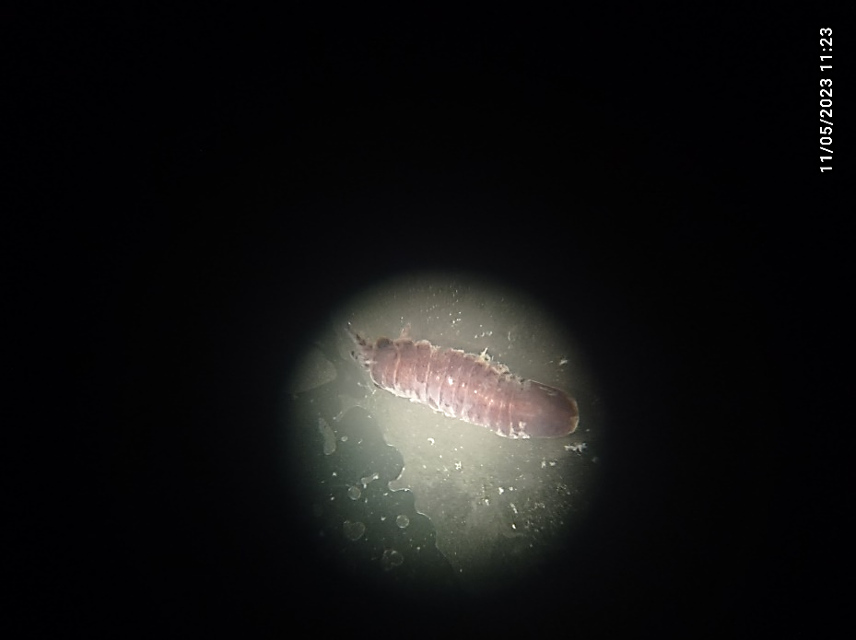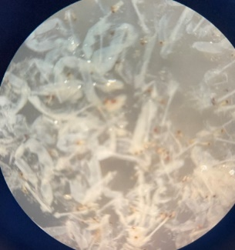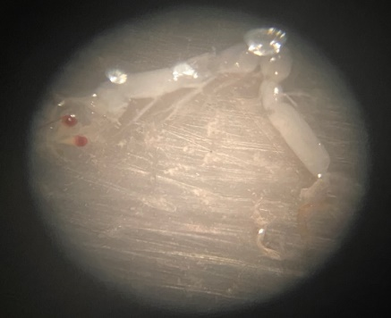
A B C
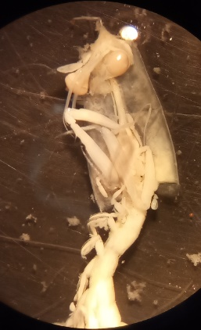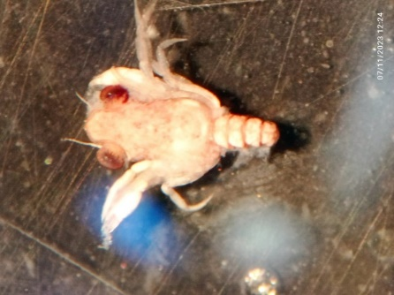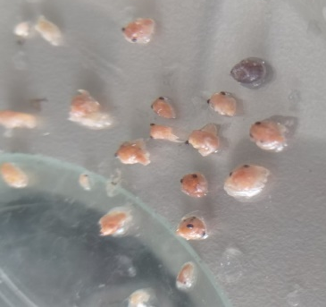
D E F
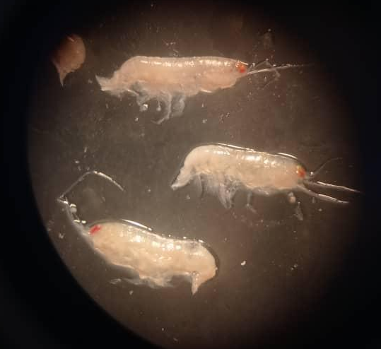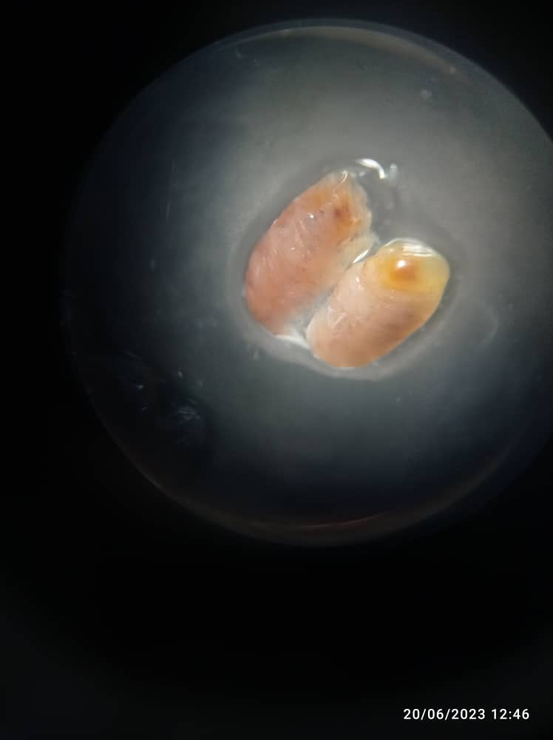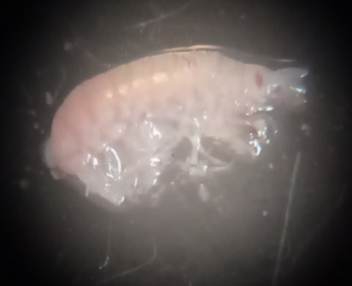
G H I
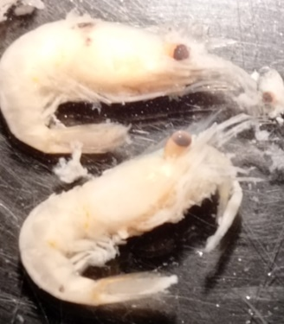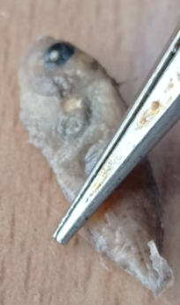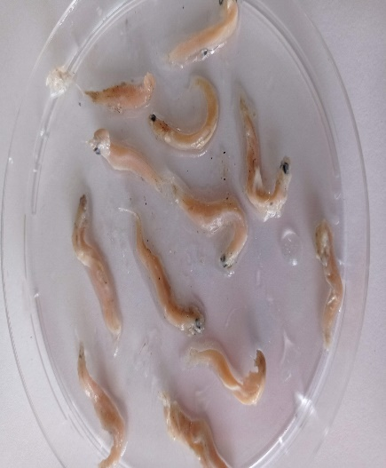
J K L
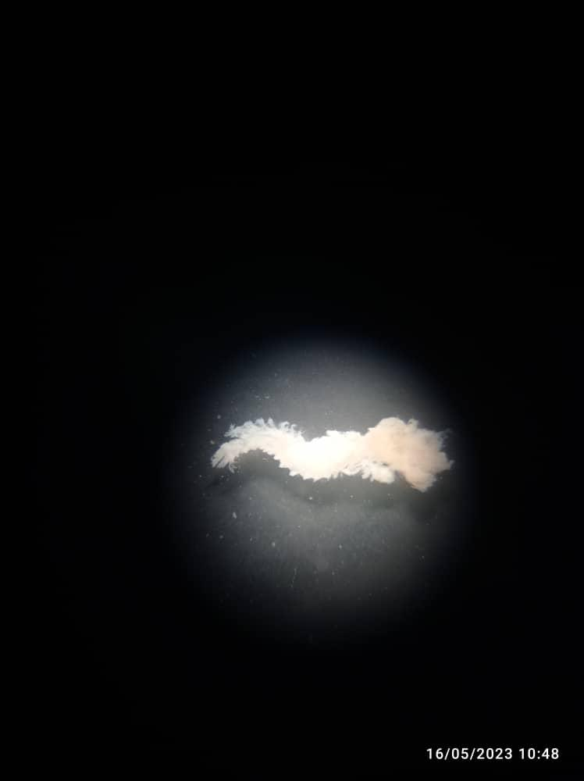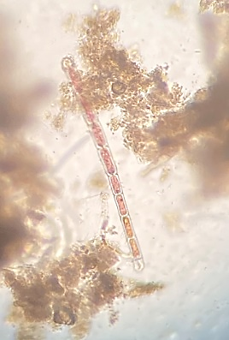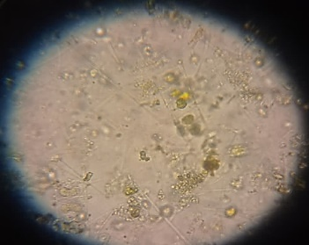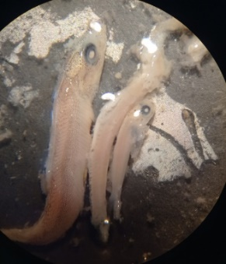
P M N O
Fig. 3. Examples of prey found inside the stomach of Alosa fallax during the research period:
A & B: Mysidacea, C: Isopoda, D: Zoea, E& F: Crab Megalope
G & H: Amphipoda , I: Euphausiacea , J: trachurus trachurus, K: Ophidion rochei
L: Penaeus - M: Anguilliformes - N: Annelida P & O: Phytoplankton

4. Conclusion

A.fallax is classified as a planktivorous species, with a diverse diet comprising phytoplankton, zooplankton, crustaceans, fish, polychaete worms, and foraminifera. Among these, crustaceans emerged as the dominant dietary component, highlighting their significance in the feeding ecology of this species.
These findings contribute to a better understanding of the trophic dynamics of A.fallax, which can aid in the sustainable management of its populations. However, gaps remain regarding the influence of environmental variations on dietary preferences. Future research should focus on exploring the feeding dynamics of this species under changing ecological conditions, with an emphasis on its role within the marine food web.

DISCLAIMER (ARTIFICIAL INTELLIGENCE)
Author(s) hereby declare that NO generative AI technologies such as Large Language Models (ChatGPT, COPILOT, etc) and text-to-image generators have been used during the writing or editing of this manuscript.

Ethical approval
Not applicable

References:
Al Sulivany, B., Owais, M., Fazal, R., Asad, F., Hussein, N., & Selamoglu, Z. (2024). Seasonal effects of protein levels on common carp (Cyprinus carpio) body composition. Iraqi Journal of Aquaculture, 21(2), 111-127. DOI: 10.58629/ijaq.v21i2.520
Aprahamian M W, Baglinière J L, Sabatie M R, Alexandrino P, Thiel R A L F, Aprahamian C D. Biology, status, and conservation of the anadromous Atlantic twaite shad Alosa fallax. In American Fisheries Society Symposium 2003 (35), 103-124.‏
Aprahamian, M. W. (1989). The diet of juvenile and adult twaite shad Alosa fallax fallax (Lacépède) from the rivers Severn and Wye (Britain). Hydrobiologia, 179(2), 173-182.
Assan, D., Huang, Y., Mustapha, U. F., Addah, M. N., Li, G., & Chen, H. (2021). Fish Feed Intake, Feeding Behavior, and the Physiological Response of Apelin to Fasting and Refeeding. Frontiers in endocrinology, 12, 798903. https://doi.org/10.3389/fendo.2021.798903
Borutskii E D. Biological aspects of fish nutrition. Proceedings of the International Symposium on Fish Nutrition 1974; 123-135. DOI: 10.1016/j.fishres.2003.11.014
Borutskii P. Ecology of Marine Fish Feeding. Leningrad- Nauka Publishing 1974, 120 pages.
Bowden, T. J., Thompson, K. D., Morgan, A. L., Gratacap, R. M., & Nikoskelainen, S. (2007). Seasonal variation and the immune response: a fish perspective. Fish & shellfish immunology, 22(6), 695–706. https://doi.org/10.1016/j.fsi.2006.08.016
Galiya, M., Laika, H. E., Almajid, Z., & Othman, R. (2025). Komposisi Makanan Ikan Tuna Kecil Euthynnus alletteratus (Rafinesque, 1810) di Perairan Laut Lattakia-Syria. Journal of Marine & Coastal Science, 14(1). https://doi.org/10.20473/jmcs.v14i1.65524
Ganias, K. (2009). Linking sardine spawning dynamics to environmental variability. Estuarine, Coastal and Shelf Science, 84(3), 402-408. https://doi.org/10.1016/j.ecss.2009.07.004
Gosner K L. Guide to Identification of Marine Zooplankton. New York: John Wiley & Sons 1971, 300 pages.
https://link.springer.com/article/10.1007/s10750-004-1571-1
Hyslop E J. Stomach content analysis: A review of methods and their application. Journal of Fish Biology 1980, 17(6), 695–704. https://doi.org/10.1111/j.1095-8649.1980.tb02775.x
Maisseven P A, Azizava n a, Kouranava I I. Ichthyology. Moscow- Food Industry 1981,384.
Maitland, P.S., Lyle, A.A. Ecology of Allis Shad Alosa alosa and Twaite Shad Alosa fallax in the Solway Firth, Scotland. Hydrobiologia 534, 205–221 (2005).
Nachón D J, Sánchez-Hernández J, Vieira-Lanero R, Cobo F. Feeding of twaite shad, Alosa fallax (Lacépède, 1803), during the upstream spawning migration in the River Ulla (NW Spain). Marine and freshwater research 2013, 64(3), 233-236.
Nobili, E., Gorfine, H., Jakubavičiūtė, E., Pūtys, Ž., & Ložys, L. (2025). Diet Composition of Twaite Shad, Alosa fallax (Lacépède, 1803), During the Spawning Migration to the Curonian Lagoon (Lithuania). Fishes, 10(6), 256. https://doi.org/10.3390/fishes10060256
Oesmann L, Thiel R. Feeding habits of Alosa fallax in the Elbe estuary. Marine Ecology Progress Series 2001, 301-312. DOI: 10.3354/meps212301
Pravdin I F. Methods of Fishery Biology. Moscow 1966: VNIRO Publishing.
Skóra M E, Sapota M R, Skóra K E, Pawelec A. Diet of the twaite shad Alosa fallax (Lacépède, 1803)(Clupeidae) in the Gulf of Gdansk, the Baltic Sea. Oceanological and Hydrobiological Studies 2012, 41, 24-32.
Soe, K. K., Pradit, S., & Hajisamae, S. (2021). Feeding habits and seasonal trophic guilds structuring fish community in the bay mouth region of a tropical estuarine habitat. Journal of Fish Biology, 99(4), 1430-1445. https://doi.org/10.1111/jfb.14851
Volkoff, H. (2020). Effects of temperature on feeding and digestive processes in fish. Temperature: Multidisciplinary Biomedical Journal, 7(2), 113–126. https://www.tandfonline.com/doi/full/10.1080/23328940.2020.1765950

