Engineering Process Design and Manufacturing Framework for an Autonomous Power Generating System

.
ABSTRACT
Process design is important in achieving technical feasibility and economic efficiency of the engineering systems. The consideration of process design in engineering manufacturing products is still a challenge for design engineers. The study aimed to develop an engineering process design, and manufacturing frame work for an Autonomous Power Generating System (APGS). With the help of the methodology, three main steps of process design, product analysis, process selection, and operation determination are combined to provide a functional and cost-effective prototype. The product analysis result revealed the number of components and material types of the APGS. Findings indicate that seven (7) major engineering materials were adopted for the development of APGS. Twelve (12) components were categorized into three (3) major assemblies, with four (4) of the parts being made locally and the remaining eight (8) purchased. The study supplied an alternative power source that was able to work autonomously in the off-grid areas. Finally, the paper shows that locally developed APGS is capable of providing viable and sustainable production of energy at a lower cost, which will help in technology advancement and energy independence in Nigeria.

Keywords: Process design, Sub-Assembly, Alphanumeric Code, Components, Parts assembly, Autonomous power generation.

- INTRODUCTION
Autonomous Power Generating System (APGS) has played a significant role in supplying safe, and affordable energy required to energize various electrical infrastructures within any given economy, especially in the off-grid areas. Amidst the common sources of sustainable energy, the mechanical energy conversion system presents an enormous potential for powering electric power, which can guarantee a big portion of the electrical energy needs of underserved regions [1]. This alternative energy source is always gaining decent admiration, particularly with the discovery of fossil fuels as the limit of sustainable energy supply, which has produced considerable research focus in most nations in the world, as per the Sustainable Development Goal [2]. The large number of mechanisms of mechanical energy storage (flywheels and springs) in template areas implies coordinated effort and investment in facilities to convert the sustainable source to useful energy [3], which is to serve multiple purposes, including lighting, powering fans, laptops, and printers. The process development and product design is a multifactorial and complex act that makes it productive and sustainable. Cost, plant and equipment requirement layout, skill, health, safety and type of production are some of the factors.

  - Process Design
Process design is a broad term for a specialized planning process about manufacturing or service operations that combines the location and capacity decisions on the production services with consequential layout, scheduling and implementation action by defining the necessary sequence of the production stages [4]. As [5] further elaborated, process design may be the design of new facilities or it may be the redesigning or expansion of the existing facilities. Originating with the idea, the design process ends with manufacturing and construction plans. Design of equipment is a different concept from process design, which is more closely related to unit operation design. Processes often involve a number of unit operations. Disclosed by [6], process design controls the combination of machines, equipment and materials in the production process. As observed by [7], the main aim of the process and product design would be to maximize the product quality and fulfil consumer desires. It is paramount to note that, although businesses are in need to maximize profits, there is a great deal of time lag between the stage of designing and the real production, which makes it more expensive. Consequently, the aspect of online quality of products should be considered in the general evaluation of design effectiveness as one of the key objectives. Process design has three main stages, namely the product analysis, process selection and operation determination [6].

  - Product Analysis
Product analysis is a good practice to exercise before filing a product design and/or technology for developing products under a patent [7]. The primary product analysis product is the product specification. Many of the choices made include the procurement of materials, the choice of equipment, worker placement, and even the magnitude and design of the manufacturing plant, all of which are subject to the product specification made [8]. Product analysis refers to the process of breaking down the product into its components to establish the components and their relationship with each other [4].

  - Process Selection
This can be viewed as a sequence of decisions, including the theoretical feasibility of the process of producing the product, the broad type of the processing approach, the type of equipment that will be used and the routine in which the product will pass through [9]. Process selection decisions can be made in four categories, including major technological choice, minor technological choice, specific components choice and specific process flow choice [10].

  - Operation Determination
Activity identification in engineering process design is the systematic process of identifying, defining, and arranging all activities required to convert raw materials into finished products. This is a detailed study of each step of production or assembly to determine which tasks must be performed, the order in which they are performed, and the resources needed to complete them [11]. This process ensures that all activities contribute effectively to achieving the desired product quality, performance and functionality. When defining operations, engineers specify the machinery, tools, fixtures and fixtures needed for each operation, as well as setup times, machining parameters and inspection methods [12]. It also involves determining labour requirements, safety considerations, and the level of precision or tolerance required for each process. The goal is to create a well-structured workflow that minimizes production time, material waste, and operational errors. By clearly recording these details, activity identification will form the basis for preparing process roadmaps, production schedules and cost estimates [13]. Ultimately, it improves consistency, improves quality control, and ensures smooth coordination between the design, planning, and production phases in the engineering manufacturing system.

  - Autonomous Power Generating System
Autonomous Power Generating System (APGS) has mechanical energy storage facilities that serve as sources of energy that are typically rotational or potential-based [14]. The flywheel is the main element, and it is stabilized with the ground. The primary mechanism is referred to as the secondary components, which include springs. Many applications are normally applied to APGS. They are classified depending on the orientation of the energy storage with the frame [15]. APGS convert rotational kinetic energy and potential energy of springs to accelerate the alternator in a clockwise and sustained rotation to maximize the amount of power produced [16]. In a study that was completed by [17], it was mentioned that APGS are more efficient compared to the use of fixed mechanical systems, as mechanical energy involves daily winding and release motions. [18], Further elaborated that, APGS integrate the two motions (rotational and release spring) to follow the energy in the best way. They are made to bear the strain of movement by winding periodically [19]. The output of the alternator is maximized using APGS as it can hold the shaft running at right angles to the load requirements anywhere on the globe, and for a longer period of time compared to fixed systems. Thus, APGS would increase the conversion efficiency of mechanical conversion.

- MATERIALS AND METHODS

2.1 Procedural steps
The method analyzes the material selection process and the three major step-by-step procedures involved in designing an APGS. It does this by assigning specific code numbers to each material and component, allowing for easy identification, organization, and tracking throughout the design stages. These stages include product design and selection, detailed process analysis to determine the most efficient workflow, and operation determination to establish how each component will function within the overall system
  - Materials used
The substances used for the fabrication and manufacturing of the APGS consist of mild steel rod, mild steel pipe, mild steel bar, mild steel plate, cast iron, alloy metal, stainless steel, and rubber. These materials were selected based on their mechanical energy, durability, cost-effectiveness, and suitability for numerous practical components of the system. Mild steel is often selected for its extremely good machinability and weldability, making it best for frames, supports, and enclosures. Cast iron and alloy steel had been used for additives requiring better energy and put on resistance, while stainless steel provided corrosion safety for exposed elements. Rubber was used for vibration damping and sealing purposes. The layout procedure of the APGS components followed three essential engineering steps: product analysis, process selection, and operation determination. Product analysis concerned the knowledge of the function, structure, and specifications of every component. Process choice is centred on figuring out the maximum suitable production methods, along with cutting, welding, machining, or assembling. Operation determination described the precise collection of operations, the machines and tools required, and the setup conditions for manufacturing. Together, these steps ensured that every part of the APGS was successfully designed, fabricated, and assembled to meet performance, reliability, and sustainability requirements.

  - Product Design and Analysis.
The evaluation of an APGS product follows a series of structured processes designed to clarify the design, construction and manufacturing requirements of that product. First, in-depth technical drawings are created for the entire system, the overall assembly, and for individual assemblies and parts. A comprehensive inventory of all subassemblies, along with the parts therein, is compiled to aid in accurate assembly planning and documentation. The specific material of each part is determined and recorded. Next, a product structure diagram is drawn to illustrate the hierarchy and interconnections between parts. A make-modify-buy review will then be performed to determine which items will be produced in-house and which items will be sourced from suppliers. The final step is to create a detailed bill of materials (BOM) listing each component, material designation, and required quantity, thereby facilitating streamlined manufacturing and assembly of APGS.

  - Process Selection
The procedures taken in the process selection of APGS were pointed out in the following;
- Each part was itemized with all the features that were to be processed.
- The surfaces to be made on each feature were also listed.
- All possible procedures that could be applied to each surface itemized were put down.
- Cost of processing estimation was made on the cost of purchasing special jigs and fixtures for each of the stated processes.

  - Operation Determination
The process for determining APGS performance follows a structured approach. First of all, all activities required to carry out each selected process have been clearly identified and defined. These activities are then sequenced chronologically and logically to ensure a smooth workflow. For each step of the process, detailed specifications have been provided, including the raw materials required, the machinery or equipment used, machine setup time, and any special tools, fixtures, or accessories required for precise production. In addition, machine productivity and other relevant parameters were recorded to facilitate cost and schedule estimation. All this information has been systematically compiled and superimposed on the corresponding manufacturing identification number and product design number. This integration leads to the development of a comprehensive process roadmap, which serves as a reference for production planning, monitoring and control. The roadmap ensures consistency, efficiency and accuracy during the manufacturing or assembly of APGS components, thereby improving process traceability and quality assurance throughout the system development and operational phases.
- RESULTS AND DISCUSSION
  - Product Analysis
Analysis of the APGS product is performed using detailed technical drawings depicting each component and complete product assembly. These technical drawings serve as the basis for identifying and defining the design, function and manufacturing requirements of the product. The primary output of this analysis is the comprehensive APGS Product Specification, which describes the parameters needed to evaluate performance and production. Figures 1 and 2 present various sketches and images of the APGS, illustrating its structural design, component layout, and overall operating concept.
Table 1 provides a detailed list of identified components and materials selected for production, ensuring that each part meets the required mechanical and electrical standards. Table 2 specifies material part numbers, making it easier to identify and verify materials during production. Additionally, Table 3 presents an alphanumeric coding system that helps organize individual products, subassemblies, and parts for efficient recording and tracking. Table 4 integrates parts lists, letter codes, and material specifications, providing a unified reference that supports efficient assembly, quality control, and maintenance of APGS systems.
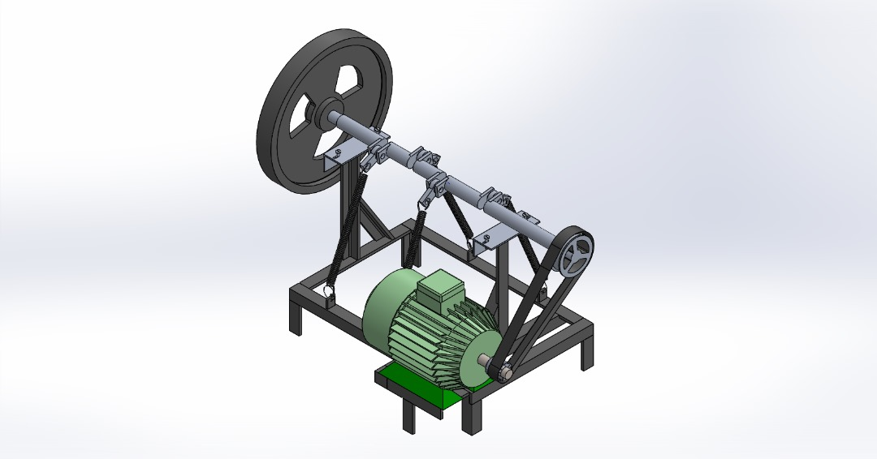
Figure 1: Autonomous power generating system

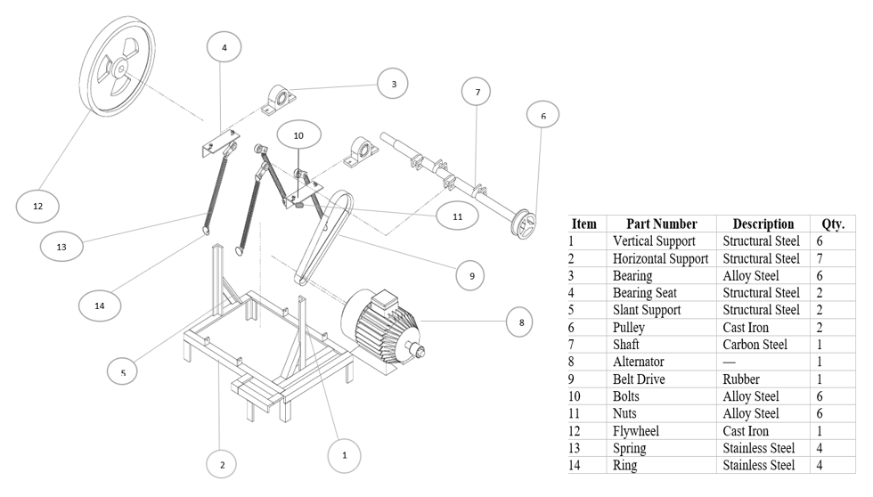
Figure 2: Part list of the autonomous power generating system

Table 1: List of Components and Material Types of the APGS Machine
S/N | Component | Material Type
1. | Vertical-Support | Structural Steel
2. | Horizontal-Support | Structural Steel
3. | Bearing | Alloy Steel
4. | Bearing Seat | Structural Steel
5. | Slant-Support | Structural Steel
6. | Pulley | Cast Iron
7. | Shaft | Carbon Steel
8. | Alternator | Copper
9. | Belt drive | Rubber
10. | Bolts | Alloy steel
11. | Nuts | Alloy Steel
12. | Flywheel | Cast Iron
13. | Spring | Stainless Steel
14. | Ring | Stainless Steel

Table 2: List of Material Specification Numbers
S/N | Material Type | Alphanumeric Code
1 | Structural Steel | SS100
2 | Alloy Steel | AS150
3 | Carbon Steel | CS200
4 | Cast Iron | CI300
5 | Stainless Steel | ST400
6 | Rubber | RB500
7 | Copper | CP600

Table 3: List of Component Parts Assembly, Sub-Assembly and Alpha-Numeric Code
S/N | Component Parts Assembly | Code | Sub-Assembly | Code | Alphas-Numeric code
(i) | Support Assembly | S | Horizontal Support | H | SH
 |  |  | Vertical Support | V | SV
 |  |  | Slant Support | S | SS
(ii) | Transmission Assembly | T | Shaft | S | TS
 |  |  | Bearing | B | TB
 |  |  | Bearing case | C | TC
 |  |  | Pulley | P | TP
 |  |  | Flywheel | F | TF
(iii) | Power | P | Alternator | A | PA
 |  |  | Pulley | P | PP
 |  |  | V-belt | V | PV
(iv) | Spring | S |  |  | S
(v) | Ring | R |  |  | R
(vi) | Bolts | B |  |  | B
(vii) | Nuts | N |  |  | N

Table 4: List of Components, Parts, Letter Codes, and Material Specification Number
S/N | Components Parts | Letter Code | Specification No
1. | Spring | S01005 | ST400
2. | Flywheel | TF05002 | CI300
3. | Nuts | N01007 | AS150
4. | Bolts | B01006 | AS150
5. | Alternator | A01003 | CP600
6. | Horizontal Support | SH01001 | SS100
7. | Vertical Support | SV02001 | SS100
8. | Slant Support | SS03001 | SS100
9. | Shaft | TS01002 | CS200
10. | Bearing | TB02002 | AS150
11. | Bearing Seat | TC03002 | SS100
12. | Pulley | TP04002 | CI300
13. | V-Belt | PV03003 | RB500
14. | Ring | R01006 | ST400

  - Process Selection
The process selection results for the production of the APGS identified a number of key operations, including drilling, turning, facing, welding, grinding and cutting. Each process selected is carefully evaluated to ensure its ability to produce parts that meet the required design specifications and dimensional accuracy. Particular attention is paid to the selection of manufacturing methods that not only ensure precision but also high-quality surface finish and operational efficiency. The selected processes have been chosen to simplify the manufacturing process, minimize material waste and ensure ease of assembly during production. Table 5 shows the details process identification and selection, highlighting the specific activities specified for each APGS component.
The final selection of these processes is guided by technical knowledge, practical experience and expert judgment to ensure that all manufacturing steps meet technical, economic and performance requirements. This systematic approach ensures that APGS components are produced efficiently and reliably. In addition, the synchronized use of these particular procedures assists unified process incorporation across all phases of manufacture. This safeguards that each element transitions efficiently from one process to the next without unnecessary interruptions or rework. The method also improves the traceability of engineering phases, permitting engineers to observe quality at every stage. By implementing standardized procedures, the production team can maintain consistent quality output regardless of batch size. This level of consistency is particularly important for APGS components, which must operate under varying environmental and load conditions.
Furthermore, the systematic process selection aids in reducing overall production time, thereby improving the productivity of the manufacturing system. It also enables better allocation of resources, ensuring that machinery, materials and labour are used efficiently. The integration of quality control checkpoints within each process further strengthens the reliability of the final assembly. These checkpoints help to identify deviations early, preventing costly defects later in production. Ultimately, the continued refinement of these processes contributes to the long-term durability, safety, and functional performance of the APGS system.

Table 5: List of parts to modify and parts to buy
Parts to Buy |  | Parts to Make
Part | Code | Part | Code
Spring | S01005 | Horizontal Support | SH01001
Flywheel | TF04002 | Vertical Support | SV02001
Bolts | B01006 | Slant Support | SS01001
Nuts | N01007 | Shaft | TS01002
Alternator | A01003 | Bearing Seat | TC03002
Bearing | TB02002
Pulley | TP03002
V-Belt | PV03003
Ring | R01006

  - Operation Determination
The results of activity determination are obtained from the combined results of the product analysis and process selection stages. These first steps provided the basic information needed to define and organize the production activities of an APGS. The hierarchical relationships between the different components and subsets of APGS are illustrated in the tree structure diagram shown in Figure 3, clearly depicting how each part contributes to the complete system while Figure 4, depict model procedure showing the process design of APGS manufacture. Additionally, Table 6 presents the APGS Bill of Materials (BOM), detailing the part letter code, quantity required, material specification number, and options selected for each component, whether purchased, modified, or produced in-house. This table serves as a comprehensive reference for materials planning and sourcing. Table 7 summarizes the combined unit processes, along with the corresponding equipment and tools identified for each manufacturing operation. It also highlights the most suitable process selected for each operation, ensuring efficiency, accuracy and consistency in the overall APGS production process.
However, this structured presentation of activities enables the production team to follow a clear and logical workflow throughout the manufacturing cycle. It also provides a standardized framework that supports accurate planning, scheduling, and resource allocation. By organizing activities in this manner, potential bottlenecks in the production line can be identified early and addressed proactively. The detailed mapping of each operation further ensures that all tasks are executed in the correct sequence, reducing errors that may arise from improper coordination.
Moreover, the systematic arrangement of activities improves traceability, allowing quality control personnel to monitor compliance with technical specifications at every stage. With these benefits, the activity determination results serve not only as a guide for current production but also as a foundation for future upgrades or system modifications. Ultimately, this structured methodology contributes significantly to achieving a reliable, cost-effective, and high-performance APGS manufacturing system.

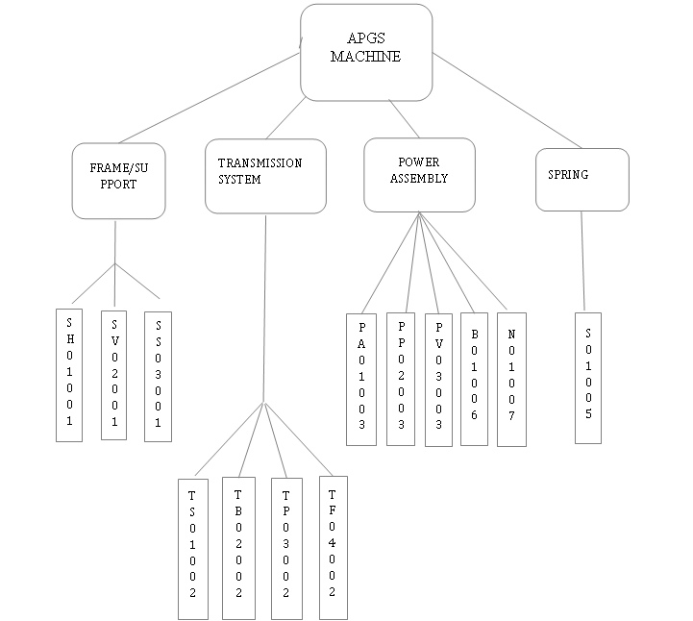

Figure 3: Tree Diagram for an APGS system

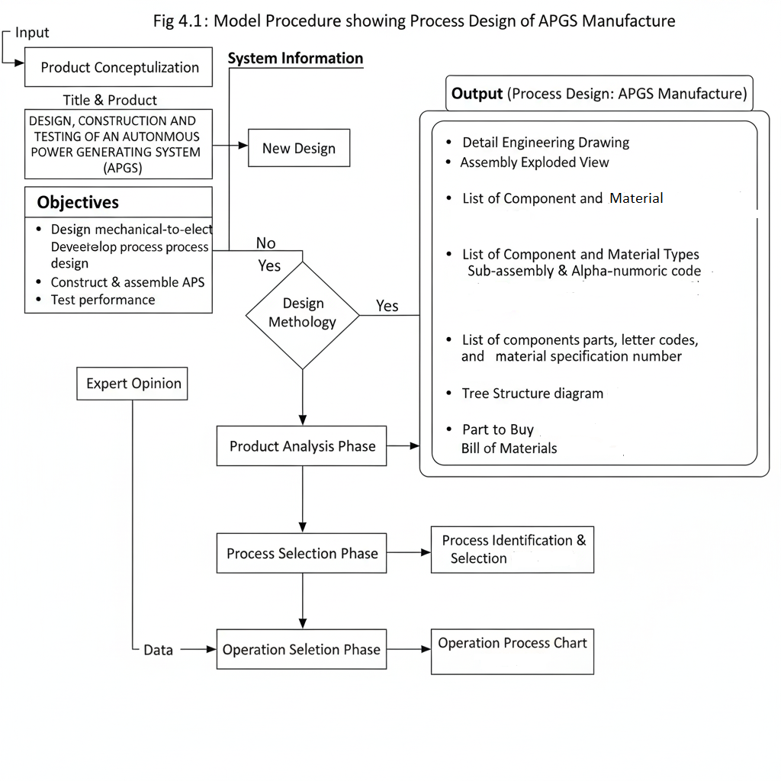
Figure 4: Model Procedure showing the process design of APGS manufacture

Table 6: Bill of materials for the APGS machine
S/N | Component Name | Part Letter Code | Material Description | Material Code | Make (M) or Buy (B) | Quantity
1 | Vertical Support | SV02001 | Structural Steel | SS100 | M | 6
2 | Horizontal Support | SH01001 | Structural Steel | SS100 | M | 7
3 | Bearing | TB02002 | Alloy Steel | AS150 | B | 6
4 | Bearing Seat | TC03002 | Structural Steel | SS100 | M | 2
5 | Slant Support | SS03001 | Structural Steel | SS100 | M | 2
6 | Pulley | TP03002 | Cast Iron | CI300 | B | 2
7 | Shaft | TS01002 | Carbon Steel | CS200 | M | 1
8 | Alternator | A01003 | Copper | CP600 | B | 1
9 | V-Belt Drive | PV03003 | Rubber | RB500 | B | 1
10 | Bolts | B01006 | Alloy Steel | AS150 | B | 6
11 | Nuts | N01007 | Alloy Steel | AS150 | B | 6
12 | Flywheel | TF04002 | Cast Steel | CI300 | B | 1
13 | Spring | S01005 | Stainless Steel | ST400 | B | 4
14 | Ring | R01006 | Stainless Steel | ST400 | B | 4

Table 7: Process identification and selection
Part Name | Code No. | Feature and Surface to be Processed | Possible Process of Manufacture | Best Process | Reason
Vertical Support | SV02001 | Plate faces, bolt holes, and weld flanges | Cutting, drilling, milling, welding, and machining of faces | Plate cutting followed by drilling and machining | Efficient shape removal; accurate holes and surface finish
Horizontal Support | SH01001 | Plate surfaces, mounting holes, and welded joints | Cutting, drilling, milling, and welding | Plate cutting followed by machining for critical faces | Economical roughing; precision on mounting surfaces
Slant Support | SS03001 | Angled plate surfaces, bolt holes, and weld edges | Cutting, bevelling, drilling, welding, and machining | Plate cutting with bevelling and subsequent machining | Accurate geometry and mating surfaces
Shaft | TS01002 | Cylindrical surface, ends, keyway, journals | Turning, grinding, broaching or slot-milling, heat treatment | Turning component, broaching keyway, final grinding | Defines major geometry, then a precise finish

- CONCLUSION
The engineering process design for the APGS provides a structured pathway from concept to prototype, emphasizing modularity and local fabrication. The major assemblies include support, transmission, and power systems with different components that ensure scalability and cost-effectiveness. The tools used in process design and all the available procedures were utilized to achieve the stated objectives. The method has proven that using alpha-numeric codes for naming the components has made the components easy to recognition. The study has revealed the process design techniques that should be adopted in advancing and enhancing the large-scale manufacturing of APGS. A major limitation of the study is that the process design validation was confined to prototype-level testing, requiring further large-scale trials to confirm long-term performance and reliability.

Disclaimer (Artificial intelligence)
Author(s) hereby declare that NO generative AI technologies such as Large Language Models (ChatGPT, COPILOT, etc.) and text-to-image generators have been used during the writing or editing of this manuscript.
References

[1] Adebayo, A. V. & Ainah, P. K. (2024). Addressing Nigeria's Electricity Challenges. American Journal of Applied Sciences and Engineering, 5 (2):1-16.
[2] Olujobi, O. J., Okorie, U. E., Olarinde, E. S., & Aina-Pelemo, A. D. (2023). Legal Responses to Energy Security and Sustainability in Nigeria's Power Sector amidst Fossil Fuel Disruptions and Low Carbon Energy Transition. Heliyon, 9 (7):1-24.
[3] Kattimani, M. A. & Inayath, M. A. (2019). Free Energy Generation Using Flywheel. International Journal of Scientific Research in Science and Technology, 5 (6):200–210. doi: https://doi.org/10.32628/IJSRST196522
[4] Glavič, P., Pintarič, Z. N., and Bogataj, M. (2021). Process Design and Sustainable development-A European Perspective. Processes, 9 (1), 148-167
[5] Onawumi, A. S., Akinrinade, N. A., Olojede, M. A., Ajayeoba, A. O. & Sanyaolu, O. O. (2022). The Engineering Process Design for a Dual-Axis Solar Power Generating System. International Journal of Innovative Science and Research Technology, 7 (12):1298-1304.
[6] Innella, G. & Anthony, R. P. (2017). The Commodity of Trade in Contemporary Design. An International Journal for All Aspects of Design, 20 (1):12-14. doi.org/10.1080/14606925.2017.1353012
[7] Martínez-Rivero, M. D., Hernández-Castellano, P., Marrero-Alemán, M. D., and Suárez-García, L. (2019). Manufacturing Process Selection Integrated in the Design Process: Test and Results. Procedia Manufacturing, 41 (4) 827-834.
[8] Lundgren, M., Hedlind, M., & Kjellberg, T. (2016). Model Driven Manufacturing Process Design and Managing Quality. 26th CIRP Design Conference Science Direct, 50 (2): 299-304. doi.org/10.1016/j.procir.2016.07.032
[9] Swift, K. G. & Booker, J. D. (2013). Manufacturing Process Selection Handbook. Oxford, United Kingdom, Butterworth-Heinemann, pp 21-60. doi. https://doi.org/10.1016/C2011-0-07343-X
[10] Cosic, P., Babic, A. & Antolic, D. (2010). Process Selection, Sequence of Operations and Shape Complexity: Criteria for Process Improvement. Strojarstvo, 52 (1):5–15.
[11] Ahad, A., Tariq, L., Niaz, S. & Inam, M. (2017). Design of Secure and Traceable Requirement Engineering Process for Security-Sensitive Projects. Journal of Software Engineering and Applications, 10 (12):873-883. https://doi.org/10.4236/jsea.2017.1012049
[12] Santolaya, J. L., Biedermann, A. M. & Serrano, A. (2016). Development of Product Design Projects Applying Specifications and Factors Matrix (SFM) as a Support Tool in Higher Education. World Journal of Engineering and Technology, 4 (2):141-152. http://dx.doi.org/10.4236/wjet.2016.42012
[13] Ogbonna, U. & Agbonde, A. (2024). Impact of Data Engineering and Sales and Operations Planning on Supply Chain Efficiency in a FMCG: A Case Study of UAC Foods. Open Journal of Business and Management, 12 (6):4188-4226. https://doi.org/10.4236/ojbm.2024.126211
[14] Flückiger, P. F. C., Schneegans, H. & Henein, S. (2024). Design of a Flexure-Based Flywheel for the Storage of Angular Momentum and Kinetic Energy. Machines, 12 (4):232–232. doi.org/10.3390/machines12040232
[15] A. Javed, M. Siddiqui, & S. Khan, (2021). Flywheel-based power systems for autonomous applications: Challenges and opportunities,” Renewable and Sustainable Energy Reviews, 146 (7);44-65.
[16] Mansoor-ul-Hassan, E. (2014). Power Generation Methods, Techniques and Economical Strategy. International Technical Sciences Journal (ITSJ), 1 (1):43–49.
[17] Peña-Alzola, R., Sebastián, R., Quesada, J. & Colmenar, A. (2011). Review of Flywheel-Based Energy Storage Systems. International Conference on Power Engineering, Energy and Electrical Drives, doi: 10.1109/POWERENG18357.2011
[18] Olabi, A. G., Wilberforce, T., Abdelkareem, M. A., & Ramadan, M. (2021). Critical Review of Flywheel Energy Storage System. Energies, 14 (5):1-33. https://doi.org/10.3390/ en14082159
[19] Rajesh, K. S., & Dash, S. S. (2019). Load Frequency Control of Autonomous Power System Using Adaptive Fuzzy Based PID Controller Optimized on Improved Sine Cosine Algorithm. Journal of Ambient Intelligence and Humanized Computing, 10(6), 2361-2373.

