Selection of Optimal 6-Benzylaminopurine (BAP) and 1-Naphthaleneacetic Acid (NAA) Combination for In Vitro Propagation of ‘Solanum tuberosum L. cv. Cardinal’ Under Nepalese Laboratory Conditions

ABSTRACT
Aim: To evaluate the effects of different concentrations of 6-benzylaminopurine (BAP) and 1-naphthaleneacetic acid (NAA) on in vitro propagation of Solanum tuberosum L. cv. ‘Cardinal’ and to identify an optimal hormonal combination for rapid shoot and node proliferation for pre-basic seed production.
Study Design: A laboratory-based in vitro experiment arranged in a Completely Randomized Design (CRD) with multiple BAP–NAA treatment combinations, including a hormone-free control.
Place and Duration of Study: Central Laboratory and Horticulture Department Laboratory, Institute of Agriculture and Animal Science (IAAS), Paklihawa Campus, Bhairahawa, Nepal. Each culture phase was evaluated for 24 days.
Methodology: Apical meristems excised from sprouted tubers of potato cv. ‘Cardinal’ was cultured on full-strength Murashige and Skoog (MS) medium. Shoot initiation was carried out on MS medium supplemented with 0.5 mg/L BAP + 0.01 mg/L NAA. For shoot proliferation and rooting, explants were subcultured onto MS media containing different BAP and NAA concentrations. Numbers of leaves, nodes, and roots were recorded up to day 24. Data were analyzed using one-way ANOVA, and means were separated using Duncan’s Multiple Range Test at p = 0.05.
Results: Shoot initiation was achieved on MS medium with 0.5 mg/L BAP + 0.01 mg/L NAA. The highest shoot and node proliferation occurred on MS medium supplemented with 1.5 mg/L BAP + 0.1 mg/L NAA, producing 8.92 ± 0.52 leaves and 2.88 ± 0.25 nodes per explant on day 24. Maximum rooting (4.83 ± 0.19 roots per explant) was obtained with 0.25 mg/L BAP + 0.3 mg/L NAA.
Conclusion: Although different hormonal combinations optimized individual growth traits, 1.5 mg/L BAP + 0.1 mg/L NAA was identified as the most effective medium for rapid shoot and node proliferation. This genotype-specific protocol for the ‘Cardinal’ variety is newly documented under Nepalese laboratory conditions and is suitable for limited-resource laboratories.
Keywords: Potato, Tissue culture, Hormones, Apical meristem, Culture medium

INTRODUCTION
Potato (Solanum tuberosum L.) is the world's third most significant food crop, after rice and wheat; it is a staple food for 1.3 billion people (Beals, 2019; Devaux et al., 2021; P. Sivakumar et al., 2024). It is produced in over 350 million tons annually(Dongyu, 2022), which demonstrates its significant contribution to the food supply. Potatoes offer high nutrients at a low price in comparison to many other vegetables. The ‘Cardinal’ potato (Solanum tuberosum L.) is a tetraploid table potato that was originally bred in the Netherlands by F. Brands and was introduced in 1972 (Van Berloo et al., 2007). The red skin pigmentation of ‘Cardinal’ is associated with anthocyanin accumulation, which provides antioxidant properties(Ben Jeddou et al., 2021). Agronomic studies report good yields (27–35 t/ha) comparable to high-yielding cultivars such as Diamant and Granola (Eaton et al., 2017; Howlader & Hoque, 2018)
Traditional tuber propagation has low yield, high disease risk, and declining seed quality. The in vitro propagation method offers advantages for producing plants with reduced pathogen load, which can reduce the risk of pathogen transmission and contribute to larger crop yields and better-quality tubers regardless of the season in a shorter period. (de MORAIS et al., 2018; Khan & Rabbani, 2001; Pradana et al., 2021; Singh et al., 2019; Smith & Drew, 1990). Tissue culture's adaptability and efficacy make it a viable approach in modern plant science and agriculture, providing solutions to a wide range of propagation and disease management issues (Akin-Idowu et al., 2009). This is especially important in locations where potato diseases are common, as it helps to ensure food production and improve food security (P. Singh, 2012; Umaro, 2022).
Apical meristem culture has been successfully used to eliminate viruses and rapidly propagate disease-free clones (Ramgareeb et al., 2010; Wang & Hu, 1982). Consequently, micropropagation has become a cornerstone of seed potato programs in many countries, which is necessary to fulfill the growing demand for seed potatoes, especially in developing nations, where food security is a serious problem (Donnelly et al., 2003; Sajid et al., 2024).
Plant growth regulators (PGRs) are vital for in vitro multiplication of potato (Solanum tuberosum). Cytokinins like 6-benzylaminopurine (BAP) and kinetin stimulate shoot growth, while auxins such as indole-3-butyric acid (IBA) and naphthaleneacetic acid (NAA) promote root induction (Hajare et al., 2021; Modawi & Khalafalla, 2009). Excessive BAP, although able to induce microtuberization, can delay tuber development and inhibit root growth (Borna et al., 2019; Suharjo et al., 2019; Tuwo et al., 2022). Similarly, high NAA concentrations increase apical dominance by encouraging apical bud growth over axillary buds (Abeuova et al., 2020; Hajare et al., 2021). Conversely, the right combinations of BAP and NAA significantly boost shoot multiplication compared to single-hormone treatments, leading to higher propagation efficiency (Babadjanova et al., 2023; (Bode) Xhulaj & Gixhari, 2018; Dhital et al., 2012).
Although protocols for in vitro propagation of potato exist, cultivar-specific optimization of PGR concentrations is essential, as responses vary significantly among genotypes. For instance, optimal concentrations of BAP and NAA differ across varieties like Gudiene, Belete, and G × N15(Arab et al., 2014; Hajare et al., 2021). These findings highlight the importance of developing cultivar-specific protocols to ensure successful propagation outcomes. The ‘Cardinal’ variety’s in vitro response under Nepali conditions remains uncharacterized. This study aimed to identify the optimal BAP and NAA concentrations for efficient in vitro propagation of the ‘Cardinal’ potato, thereby providing a reliable protocol for producing plantlets with reduced pathogen load suitable for pre-basic seed tuber production in Nepal.

MATERIALS AND METHODS

Description of research site
The research was conducted in the central laboratory and the Horticulture department laboratory of the Institute of Agriculture and Animal Science (IAAS), Paklihawa Campus, Bhairahawa, Nepal. The location is situated at 27ᵒ28'48.77" N and 83ᵒ26'51.61' E. The potato tuber of the cardinal variety developed at the Potato Crop Development Centre, Nigale, Sindhupalchowk, was chosen as a source plant for acquiring the apical meristem for the experiment.

Surface sterilization and stock solution preparation
The central lab was sterilized with 5% sodium hypochlorite, and all research equipment was thoroughly cleaned and dried in a hot air oven at 80°C for one hour. For a 1 N HCl stock solution, 83.5 mL of 37% HCl was diluted to 1 liter, with 8.35 mL used to prepare 100 mL. To make a 1 N NaOH stock, 40 g of NaOH was dissolved in 250 mL of water and diluted to 1 liter. Plant growth regulators (BAP, NAA, and IBA) were prepared by dissolving 50 mg of each in NaOH dropwise until a clear solution formed, then diluting to 50 mL to achieve a final concentration of 1 mg/mL.
For phase 1 (Shoot Initiation Phase): A packet of MS medium (Himedia) was mixed with distilled water to make 100 mL of 10× strength stock solution, and 0.5 mg/L BAP + 0.01 mg/L NAA were combined with the prepared MS medium, resulting in 1000 mL of medium. This phase was designed to initiate shoot formation from excised apical meristems over a 24-day establishment period.
For phase 2 (Shoot Proliferation and Rooting Phase): A similar stock solution of MS medium was prepared, and eight different concentrations of BAP and NAA (including a hormone-free control) were used to make 2000 mL of medium (Table 1). This phase tested the effect of different hormonal combinations on leaf formation, node proliferation, and root induction following subculture of established shoots.
Table 1: Composition of medium used in different treatment combinations of 6-benzylaminopurine (BAP) and 1-Naphthalene Acetic Acid (NAA) for in vitro culture
Treatments | Medium composition
1 | MS medium (Control- hormone-free)
2 | MS Medium +1mg/L BAP + 0.1 mg/L NAA
3 | MS Medium +0.5mg/L BAP + 0.2 mg/L NAA
4 | MS Medium +0.25mg/L BAP + 0.3 mg/LNAA
5 | MS Medium +1.5mg/L BAP + 0.1 mg/L NAA
6 | MS Medium +2mg/L BAP + 0.01 mg/L NAA
7 | MS Medium +2.5mg/L BAP + 0.25mg/L NAA
8 | MS Medium +0.5mg/L BAP + 0.01 mg/L NAA
The pH of the medium was adjusted to 5.8 with Hydrochloric Acid (HCl) or Sodium Hydroxide (NaOH), and the pH meter was calibrated using buffer solutions 4.0 and 7.0 as standards. After pH correction, 8 g of agar was added to the medium, which was then cooked on a hot plate. Following that, 30 mL of the produced medium was placed into culture jars and sterilized in an autoclave at 121°C, 15 psi for 25-30 minutes. The laminar airflow cabinet had been sterilized with 70% ethanol before all aseptic operations.

Explant preparation
Potato tubers were sprouted in a semi-dark environment at 25–27°C for 2–3 weeks. Fresh sprouts were surface sterilized by washing under running tap water for 10 minutes, then treated with 70% ethanol for 30 seconds, 2% sodium hypochlorite for 5–7 minutes, and then washed three times with sterile double-distilled water. Apical meristem (0.3–0.5 mm) (Wang & Hu, 1982) They were excised in a sterile laminar airflow cabinet and cultured into Phase 1 medium containing 0.5 mg/L BAP + 0.01 mg/L NAA for shoot initiation.

Shoot proliferation and rooting
Following shoot establishment in Phase 1 (24 days), subculture was conducted using single-node segments with up to two leaves per node onto Phase 2 medium. During the subculture, eight treatments (different concentrations of BAP and NAA, including a hormone-free control) were replicated twice; each replication included five explants, totaling 80 explants (8 treatments × 2 replications × 5 explants = 80 explants). Data on the number of leaves, nodes, and roots were collected on days 6, 11, 14, and 24 of Phase 2. Meristem cultures were grown in a growth chamber at 23 ± 2°C, with 80–90% relative humidity, a 14-hour photoperiod, and 40–50 μmol m⁻² s⁻¹ light intensity. Visual observation of cultures indicated no visible signs of contamination or disease symptoms; however, the pathogen-free status of explants was not confirmed by diagnostic methods such as ELISA or PCR due to laboratory resource limitations. Therefore, claims of “virus-free” or “pathogen-free” plantlets cannot be conclusively made in this study.
2.5 Data analysis and experimental design
The experiment was arranged in a Completely Randomized Design (CRD). Data was collected using MS Excel (2016) and processed and analyzed with R Studio software (4.3.1). Before conducting ANOVA, the data were tested for normality using the Shapiro-Wilk test and for homogeneity of variances using Levene’s test. These tests were performed in R to ensure the validity of ANOVA assumptions. The processed data were then evaluated using a one-way ANOVA (Analysis of Variance), and the treatment means were separated using Duncan’s Multiple Range Test (DMRT) at a 5% level of significance. DMRT was selected because it provides adequate control of Type I error rates while maintaining reasonable power for detecting differences among multiple treatment means (eight treatments in this study), and it is widely used in agricultural research for balanced designs with moderate replication.
.

RESULTS AND DISCUSSION

Effect of different concentrations of 6-benzylaminopurine (BAP) and 1-Naphthalene Acetic Acid (NAA) on leaves, roots, and nodes of cardinal varieties of potato

Effect of different concentrations of 6-benzylaminopurine (BAP) and 1-Naphthalene Acetic Acid (NAA) on leaves of cardinal varieties of potato
Various concentrations of BAP and NAA had a statistically significant effect on the leaf number of the Cardinal variety (Table 2). The maximum number of leaves was observed in MS Medium +1.5mg/L BAP + 0.1 mg/L NAA(8.92 ± 0.52 on day 24), and a minimum number of leaves was observed in MS Medium +2.5mg/L BAP + 0.25mg/L NAA ( Figure 1 Figure 2). The observed variability in leaf production across treatments, reflected by the coefficient of variation (CV) increasing from 8.08% on day 6 to 18.15% on day 24, suggests increasing divergence in treatment responses over time, likely due to differential hormonal effects on cellular division and expansion rates.
According to previous research, lower concentrations of BAP (usually about 1-2 mg/L) tend to be optimal for producing a larger number of shoots and improving shoot proliferation (Dilshad et al., 2021; Hajare et al., 2021). Multiple studies on Solanum tuberosum report that a high cytokinin: low auxin ratio, specifically ~1–2 mg/L BAP with ~0.1 mg/L NAA, optimizes shoot proliferation; leaf number generally tracks shoot vigor. For example, 2.0 mg/L BAP + 0.1 mg/L NAA produced the largest number of axillary shoots per main shoot in potato, a direct proxy for more leaves(Ghaffoor et al., 2003). Similarly, in Brassica oleracea, (Ahmad & Spoor, 1998) Found that low auxin levels combined with increased cytokinin concentrations stimulate shoot morphogenesis, which is consistent with our findings for the Cardinal variety. Conversely, higher concentrations of BAP (more than 4 mg/L) might cause a decrease in shoot quantity and overall growth vigor, most likely due to the inhibitory effects of excessive cytokinin on plant development (Arab et al., 2014; Gunther & Fermino Junior, 2021). This effect is corroborated by data that showed a reduction in shoot growth and an increase in callus development at increased BAP levels (Arab et al., 2014).

Table 2: Effect of different concentrations of 6-benzylaminopurine (BAP) and 1-Naphthalene Acetic Acid (NAA) on leaves of cardinal varieties of potato
Treatment | No of Leaves  (6th Day) | No. of Leaves  (11th Day) | No of Leaves  (14th Day) |  | No of Leaves  (24th Day)
MS Medium  (Control) | 2.00 ± 0.42 c | 2.67 ± 0.47 c | 3.00 ± 0.47 c |  | 3.50 ± 0.52 c
MS Medium + 1mg/L BAP + 0.1 mg/L NAA | 3.75 ± 0.42 ^{ab} | 4.42 ± 0.47 ^{bc} | 4.75 ± 0.47 ^{ab} | 6.42 ± 0.52 ^{bc}
MS Medium +0.5mg/L BAP + 0.2 mg/L NAA | 3.75 ± 0.42 ^{ab} | 4.42 ± 0.47 ^{bc} | 5.42 ± 0.47^{abc} |  | 5.50 ± 0.52^{bc}
MS Medium +0.25mg/L BAP + 0.3 mg/LNAA | 3.17 ± 0.42 ^{b} | 3.25 ± 0.47 ^{c} | 3.83±0.47^{bc} |  | 3.93 ± 0.52 ^{c}
MS Medium +1.5mg/L BAP + 0.1 mg/L NAA | 3.42 ± 0.42 ^{ab} | 4.96 ± 0.47 ^{ab} | 6.67 ± 0.47 ^{ab} |  | 8.92 ± 0.52 ^{b}
MS Medium +2mg/L BAP + 0.01 mg/L NAA | 6.17 ± 0.42 ª | 7.00 ± 0.47 ª | 7.25 ± 0.47 ª |  | 7.45 ± 0.52 ^{bc}
MS Medium +2.5mg/L BAP + 0.25mg/L NAA | 1.42 ± 0.42 ^{b}
  2.42 ± 0.47^{c}
  2.42 ± 0.47^{c}
  2.45 ± 0.47^{c}
MS Medium +0.5mg/L BAP + 0.01 mg/L NAA
  3.83 ± 0.42^{ab}
  3.90 ± 0.42 ^{ab}
  4.00 ± 0.42^{ab}
  4.83 ± 0.42^{ab}
LSD | 2.58 | 2.58 | 3.83 |  | 4.39
SEM | 0.42 | 0.47 | 0.47 |  | 0.52
CV | 8.08 | 8.84 | 14.97 |  | 18.15
Grand Mean | 3.44 | 4.13 | 4.67 |  | 5.38
F- value | 3.91* | 4.22** | 3.14* |  | 15.80***
Values are means ± SEM (n = 10). Means followed by the same letter within a column are not significantly different according to Duncan’s Multiple Range Test at p < 0.05.
Significance levels: NS = not significant; * = p < 0.05; ** = p < 0.01; *** = p < 0.001
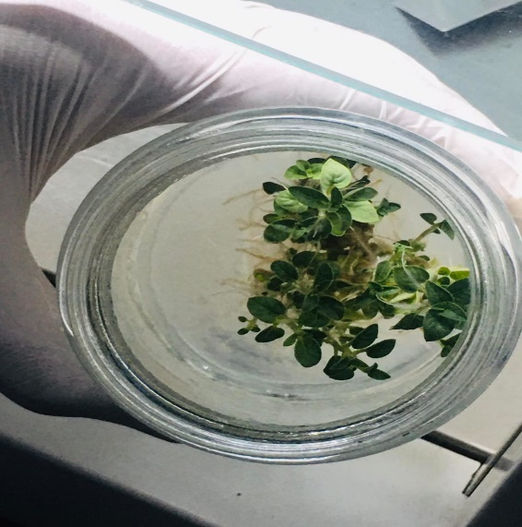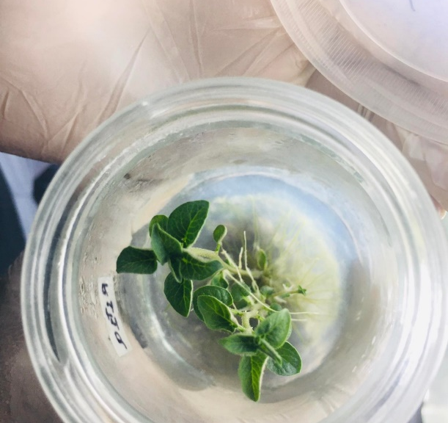
A
B
Figure 1: Representative in vitro shoots of Solanum tuberosum var. Cardinal showing differential leaf formation under varying concentrations of 6-benzylaminopurine (BAP) and 1-naphthaleneacetic acid (NAA) on Day 24. (A) Maximum leaf proliferation under MS medium supplemented with 1.5 mg/L BAP + 0.1 mg/L NAA (8.92 ± 0.52 leaves). (B) Minimum leaf development under MS medium supplemented with 2.5 mg/L BAP + 0.25 mg/L NAA (2.45 ± 0.47 leaves). Cultures were maintained at 23 ± 2°C, 14-hour photoperiod, n = 10 explants per treatment.

Figure 2: Effect of different concentrations of 6-benzylaminopurine (BAP) and 1-naphthaleneacetic acid (NAA) on leaf number of the Cardinal variety of potato. Error bars represent SEM (n = 10).

Effect of different concentrations of 6-benzylaminopurine (BAP) and 1-Naphthalene Acetic Acid (NAA) on the nodes of cardinal varieties of potato
Various concentrations of BAP and NAA had a statistically significant effect on the node number of the Cardinal variety (Table 3). The maximum number of nodes was observed in MS Medium +1.5mg/L BAP + 0.1 mg/L 1-Naphthalene Acetic Acid (NAA) (2.88 ± 0.25 on day 24), and a minimum number of nodes was observed in MS Medium +2.5mg/L BAP + 0.25mg/L NAA (0.83 ± 0.25 on day 24) (Figure 3, Figure 4). The relatively low coefficients of variation (4.54–6.82%) across all time points indicate high experimental precision and consistent treatment responses for nodal proliferation. High BAP and NAA concentrations can negatively impact node proliferation due to hyper-hydricity, a condition characterized by excessive tissue hydration and abnormal physiological conditions, potentially leading to abnormal callus development. In the present study, treatments with BAP concentrations exceeding 2 mg/L (Treatments 6 and 7) showed reduced nodal proliferation compared to moderate concentrations (1.5 mg/L), supporting this relationship. Moreover, in Eustoma grandiflorum (Raf.), the greater concentrations of cytokinin (N6-Benzyladenine (BA) and kinetin) resulted in good shoot development but large percentages of hyperhydrated shoots(Paek & Hahn, 2000). Research on Alstroemeria showed that the greater concentrations of plant growth regulators, such as BAP and NAA, can have a negative impact on micropropagation outcomes, such as node proliferation. The study found that supplementing MS medium with moderate doses of BAP (0.5-1.5 mg/L) and NAA (0.2-1.0 mg/L) improved shoot and root growth(Seyyed Rahim Seyyedyousefi, 2013; Yoong et al., 2017).This was most likely due to cytokinin-induced imbalances that influenced cell division and elongation.
Table 3: Effect of different concentrations of 6-benzylaminopurine (BAP) and 1-Naphthalene Acetic Acid (NAA) on nodes of cardinal varieties of potato
Treatments | No. of Nodes (6th Day) |  | No. of Nodes (11th Day) |  | No. of Nodes (14th Day) |  | No. of Nodes (24th Day)
MS (Control) |  | 0.67 ± 0.25 b |  | 0.83 ± 0.26 b |  | 0.75 ± 0.26 c |  | 0.83 ± 0.25 cd
MS + 1 mg/L BAP + 0.1 mg/L NAA | 1.33 ± 0.25 ^{ab} |  | 1.33 ± 0.26 ª |  | 1.35 ± 0.26 ^{ab} |  | 1.58 ± 0.25^{abc}
MS + 0.5 mg/L BAP + 0.2 mg/L NAA | 1.75 ± 0.25 ª |  | 1.83 ± 0.26 ª |  | 2.00 ± 0.26 ª |  | 2.33 ± 0.25^{bc}
MS + 0.25 mg/L BAP + 0.3 mg/L NAA | 1.17 ± 0.25 ^{ab} |  | 1.58 ± 0.26 ^{ab} |  | 1.83 ± 0.26 ^{bc} |  | 1.97 ± 0.25 ^{cd}
MS + 1.5 mg/L BAP + 0.1 mg/L NAA | 1.75 ± 0.25 ª |  | 1.92 ± 0.26 ª |  | 2.00 ± 0.26 ª |  | 2.88 ± 0.25 ª
MS + 2 mg/L BAP + 0.01 mg/L NAA | 1.58 ± 0.25 ª |  | 1.84 ± 0.26 ª |  | 1.88 ± 0.26 ^{ab} |  | 1.92 ± 0.25 ^{bc}
MS + 2.5 mg/L BAP + 0.25 mg/L NAA | 0.33 ± 0.25 ^{b} |  | 0.33 ± 0.26 ^{b} |  | 0.77 ± 0.26 ^{c} |  | 0.83 ± 0.25 ^{d}
MS + 0.5 mg/L BAP + 0.01 mg/L NAA | 1.08 ± 0.25 ^{ab} |  | 1.56 ± 0.26 ª |  | 2.11 ± 0.26 ª |  | 2.42 ± 0.25 ^{ab}
LSD (0.05) | 0.94 |  | 0.91 |  | 0.94 |  | 0.89
SEM | 0.25 |  | 0.26 |  | 0.26 |  | 0.25
CV (%) | 6.82 |  | 5.76 |  | 4.68 |  | 4.54
Grand Mean | 1.21 |  | 1.40 |  | 1.59 |  | 1.85
F-values | 2.81* |  | 3.25* |  | 5.26** |  | 6.81***
Values are means ± SEM (n = 10). Means followed by the same letter within a column are not significantly different according to Duncan’s Multiple Range Test at p < 0.05.
Significance levels: NS = not significant; * = p < 0.05; ** = p < 0.01; *** = p < 0.001
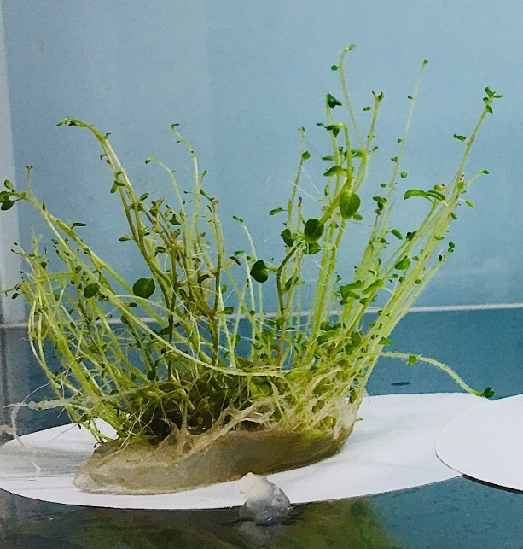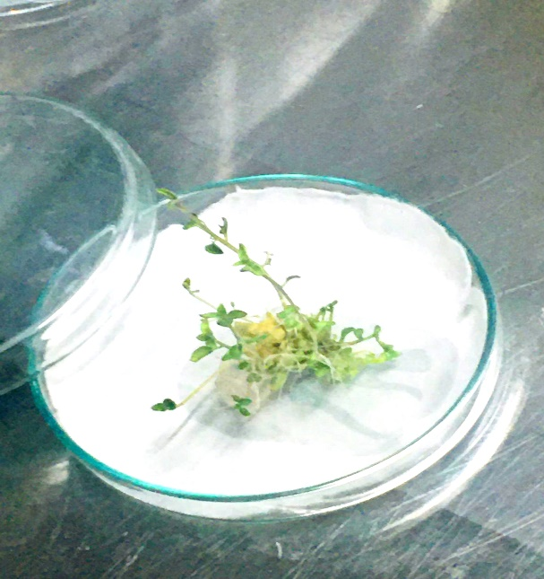
B
A

Figure 3: Representative in vitro shoot of Solanum tuberosum var. Cardinal showing shoot proliferation and node formation under different concentrations of BAP and NAA on day 24. (A) Maximum node proliferation under MS medium supplemented with 1.5 mg/L BAP + 0.1 mg/L NAA (2.88 ± 0.25 nodes). (B) Minimal shoot development under MS medium supplemented with 2.5 mg/L BAP + 0.25 mg/L NAA (0.83 ± 0.25 nodes). Cultures were maintained at 23 ± 2°C, 14-hour photoperiod, n = 10 explants per treatment.

Figure 4: Effect of different concentrations of 6-benzylaminopurine (BAP) and 1-naphthaleneacetic acid (NAA) on node number of the Cardinal variety of potato. Error bars represent SEM (n = 10).

Effect of different concentrations of 6-benzylaminopurine (BAP) and 1-Naphthalene Acetic Acid (NAA) on the root of cardinal varieties of potato
Different concentrations of BAP and NAA had a statistically significant influence on the root number of the Cardinal variety (Table 4). The highest number of roots was found in MS Medium + 0.25 mg/L BAP + 0.3 mg/L 1-Naphthalene Acetic Acid (NAA) (4.83 ± 0.19 on day 24), and minimum rooting occurred in MS medium with 2.5 mg/L BAP and 0.25 mg/L NAA(0.09 ± 0.19 on day 24) (Figure 5, Figure 6).The moderate coefficients of variation (13.94–16.14%) for rooting parameters suggest adequate experimental control, though somewhat higher variability compared to nodal data, likely reflecting the sensitivity of root induction to subtle environmental and physiological variations. Most potato micropropagation studies report the best rooting on hormone-free or low-cytokinin medium. Studies show that rooting is reduced by BAP and improves when BAP is minimized or absent. For example, hormone-free MS sometimes outperformed BAP/NAA mixes, and other cultivar studies routinely root on IBA with little or no cytokinin (A Abido & A jabal, n.d.; Chandana Javvadi Scholar et al., n.d.). Previous research found that a balanced administration of cytokinins and auxins improved root and shoot proliferation in a variety of plant species (George et al., n.d.). If the auxin-cytokinin ratio is not properly controlled, it might result in inferior root development. For instance, extremely high and low doses of growth regulators can disturb the endogenous hormone balance required for adventitious root development, resulting in unsatisfactory rooting results(Quan et al., 2022; Sun et al., 2023).
A limitation of the current study is the absence of an auxin-only treatment (e.g., NAA or IBA without BAP) or additional hormone-free controls specifically designed for rooting optimization. Future studies should include such treatments to better characterize the rooting requirements of the Cardinal variety and to determine whether hormone-free or auxin-only medium would provide superior rooting efficiency compared to the BAP + NAA combinations tested here.
Table 4: Effect of different concentrations of 6-benzylaminopurine (BAP) and 1-Naphthalene Acetic Acid (NAA) on the roots of cardinal varieties of potato
Treatment | No of Roots  (6th Day) | No. of Roots  (11th Day) | No of Roots  (14th Day) | No. of Roots (24th Day)
MS Medium  (Control) | 0.08 ± 0.19 b | 0.08 ± 0.21 b |  | 0.8 ± 0.19 b
  0.57 ± 0.19 b
MS Medium + 1mg/L BAP + 0.1 mg/L NAA |  |  |  | 0.55 ± 0.25 b
  0.17 ± 0.21 b
  0.17 ± 0.21 b
  0.25 ± 0.21 b
MS Medium +0.5mg/L BAP + 0.2 mg/L NAA |  |  |  | 4.23 ± 0.19 b
  0.5 ± 0.19 b
  1.5 ± 0.19 b
  2.83 ± 0.19 b
MS Medium +0.25mg/L BAP + 0.3 mg/LNAA |  |  |  | 4.83 ± 0.19 b
  4.17 ± 0.19 b
  4.25 ± 0.19 b
  4.27 ± 0.19 b
MS Medium +1.5mg/L BAP + 0.1 mg/L NAA |  |  |  | 1.00 ± 0.19 b
  0.75 ± 0.19 b
  0.75 ± 0.19 b
  0.79 ± 0.19 b
MS Medium +2mg/L BAP + 0.01 mg/L NAA |  |  |  | 0.80 ± 0.19 b
  0.08 ± 0.19 b
  0.08 ± 0.19 b
  0.57 ± 0.19 b
MS Medium +2.5mg/L BAP + 0.25mg/L NAA |  |  |  | 0.09 ± 0.19 a
  0.08 ± 0.19 a
  0.08 ± 0.19 a
  0.08 ± 0.19 a
MS Medium+0.5mg/L BAP + 0.01 mg/L NAA |  |  |  | 0.25 ± 0.25 a
  0.08 ± 0.19 b
  0.08 ± 0.21 b
  0.17 ± 0.25 b
LSD | 1.89 | 2.07 | 2.66 | 2.75
SEM | 0.19 | 0.21 | 0.25 | 0.25
CV | 16.14 | 15.29 | 13.94 | 14.88
Grand Mean | 0.77 | 0.92 | 1.16 | 1.49
F- value | 5.29** | 6.73*** | 5.45** | 6.95***

Significance levels: NS = not significant; * = p < 0.05; ** = p < 0.01; *** = p < 0.001
Values are means ± SEM (n = 10). Means followed by the same letter within a column are not significantly different according to Duncan’s Multiple Range Test at p < 0.05.
Note: Despite significant F-values indicating overall treatment effects, most treatments share the same significance letter (ᵇ) on day 24, with only Treatments 7 and 8 differing (ᵃ). This pattern suggests that while overall variation exists among treatments, post-hoc pairwise comparisons reveal fewer significant differences than might be expected. The large LSD value (2.75) relative to the mean differences between many treatments accounts for this pattern. Treatments 3 and 4, which show numerically higher root counts (4.23 and 4.83, respectively), would be the preferred choices for root induction despite sharing the same statistical grouping with several other treatments

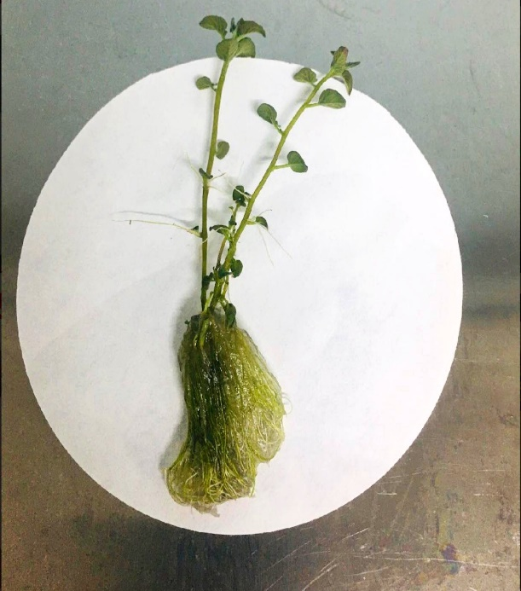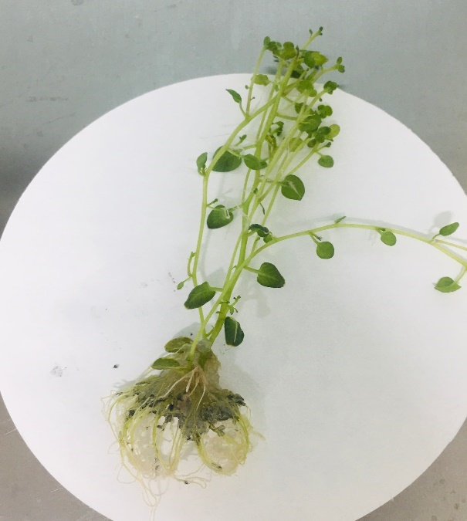
B
A
Figure 5: Representative in vitro root development of Solanum tuberosum var. Cardinal under different concentrations of BAP and NAA on day 24. (A) Maximum root proliferation under MS medium supplemented with 0.25 mg/L BAP + 0.3 mg/L NAA (4.83 ± 0.19 roots). (B) Minimal root development under MS medium supplemented with 2.5 mg/L BAP + 0.25 mg/L NAA (0.09 ± 0.19 roots). Cultures were maintained at 23 ± 2°C, 14-hour photoperiod, n = 10 explants per treatment.

Figure 6: Effect of different concentrations of 6-benzylaminopurine (BAP) and NAA on the roots of cardinal varieties of potato. Error bars represent SEM (n = 10)

3.2 Integrated Assessment of Plantlet Quality
While individual growth parameters (leaves, nodes, roots) responded optimally to different hormonal combinations, an integrated assessment of overall plantlet quality is essential for practical application. Treatment 5 (MS medium + 1.5 mg/L BAP + 0.1 mg/L NAA) demonstrated superior performance for shoot multiplication, producing the highest number of leaves (8.92 ± 0.52) and nodes (2.88 ± 0.25) on day 24, though rooting was modest (1.00 ± 0.19 roots). This treatment represents the optimal choice for the critical multiplication phase, where rapid generation of multiple shoot tips is the primary objective.
For complete plantlet development, a two-stage approach is recommended: (1) multiplication phase using Treatment 5 to maximize shoot and node proliferation, followed by (2) rooting phase using Treatment 4 (MS medium + 0.25 mg/L BAP + 0.3 mg/L NAA) or preferably a hormone-free or auxin-only medium to enhance root development before acclimatization. This sequential strategy balances the competing demands of shoot multiplication and root induction, each optimized under different hormonal regimes.
The trade-offs between vegetative growth and rooting observed across treatments reflect well-established principles of plant growth regulator interactions: high cytokinin: auxin ratios favor shoot proliferation at the expense of rooting, while lower ratios or auxin dominance promote root development. The Cardinal variety exhibits strong cytokinin responsiveness for shoot multiplication but requires careful hormonal management to achieve balanced plantlet development suitable for successful acclimatization and field transfer.

CONCLUSION
The optimal concentrations of BAP and NAA for different stages of in vitro propagation of the Cardinal variety were identified as follows: For shoot initiation, 0.5 mg/L BAP + 0.01 mg/L NAA was effective. For shoot and node proliferation, 1.5 mg/L BAP + 0.1 mg/L NAA produced the maximum number of leaves (8.92 ± 0.52) and nodes (2.88 ± 0.25) on day 24. For rooting, 0.25 mg/L BAP + 0.3 mg/L NAA was the most effective combination among the tested treatments, producing 4.83 ± 0.19 roots. Different hormonal combinations optimized distinct growth parameters: high cytokinin: auxin ratios (1.5 mg/L BAP + 0.1 mg/L NAA) favored shoot and node proliferation, while a lower ratio (0.25 mg/L BAP + 0.3 mg/L NAA) enhanced rooting. This parameter-specific optimization reflects the differential hormonal requirements of shoot multiplication versus root induction. The combination of 1.5 mg/L BAP + 0.1 mg/L NAA is recommended as the optimal medium for the multiplication phase to generate sufficient mother plants intended for pre-basic seed tuber production. This concentration provided the highest shoot and node proliferation, thereby ensuring rapid multiplication, a critical step for generating adequate uniform mother stock. Rooting can be subsequently achieved through transfer to a suitable medium with a lower cytokinin: auxin ratio, or preferably hormone-free or auxin-only medium, before acclimatization. Future research should systematically evaluate hormone-free and IBA-only rooting treatments to optimize this phase. This reproducible protocol uses standard reagents and techniques accessible to small-scale laboratories in Nepal, and provides a foundation for seed potato production through genotype-specific hormonal optimization of the Cardinal variety. Future research should include diagnostic verification of pathogen status using ELISA or PCR, explore hormone-free and auxin-only rooting treatments, increase sample sizes to better represent biological variability, evaluate the economic viability and scalability of this protocol for commercial application, and optimize these techniques for other potato varieties under varying environmental conditions.

Disclaimer (Artificial intelligence)
Author(s) hereby declare that generative AI technologies such as ChatGPT (OpenAI, GPT-5, August 2025 version) was used solely for refining the English language in the manuscript to improve clarity and grammar

REFERENCE
A Abido, A. I., & A Jabal, A. A. (n.d.). In vitro Propagation and Ex vitro Acclimatization of Potato (Solanum tuberosum L.) Using Nodal Cutting Explants. J. Adv. Agric. Res. (Fac. Agric. Saba Basha), 108(1), 2016.
Abeuova, L. S., Kali, B. R., Rakhimzhanova, A. O., Bekkuzhina, S. S., & Manabayeva, S. A. (2020). High frequency direct shoot regeneration from kazakh commercial potato cultivars. PeerJ, 2020(7). https://doi.org/10.7717/PEERJ.9447
Ahmad, S., & Spoor, W. (1998). Effects of NAA and BAP on Callus Culture and Plant Regeneration in Curly Kale (Brassica oleraces L.). Pakistan Journal of Biological Sciences, 2(1), 109–112. https://doi.org/10.3923/PJBS.1999.109.112
Akin-Idowu, P. E., Ibitoye, D. O., & Ademoyegun, O. T. (2009). Tissue culture as a plant production technique for horticultural crops. African Journal of Biotechnology, 8(16), 3782–3788.
Arab, M. M., Yadollahi, A., Shojaeiyan, A., Shokri, S., & Ghojah, S. M. (2014). Effects of nutrient media, different cytokinin types, and their concentrations on in vitro multiplication of G × N15 (hybrid of almond × peach) vegetative rootstock. Journal of Genetic Engineering and Biotechnology, 12(2), 81–87. https://doi.org/10.1016/J.JGEB.2014.10.001
Babadjanova, F. I., Ubaydullaeva, K. A., Asrorov, A. M., Rakhmanov, B. K., Abdullaev, A. N., Bolkiev, A. A., Abdullaev, S. A., Eshmurzaev, J. B., & Buriev, Z. T. (2023). Improvement of callogenesis and somatic embryogenesis by selecting optimal hormonal balance in Sarnav and Desiree potato varieties. Agriculture (Pol’nohospodarstvo), 69(1), 40–46. https://doi.org/10.2478/AGRI-2023-0004
Beals, K. A. (2019). Potatoes, Nutrition and Health. American Journal of Potato Research, 96(2), 102–110. https://doi.org/10.1007/S12230-018-09705-4
Ben Jeddou, K., Kammoun, M., Hellström, J., Gutiérrez-Quequezana, L., Rokka, V. M., Gargouri-Bouzid, R., Ellouze-Chaabouni, S., & Nouri-Ellouz, O. (2021). Profiling beneficial phytochemicals in a potato somatic hybrid for tuber peel processing: phenolic acids and anthocyanins composition. Food Science & Nutrition, 9(3), 1388–1398. https://doi.org/10.1002/FSN3.2100
(Bode) XHULAJ, D., & GIXHARI, B. (2018). IN VITRO MICROPROPAGATION OF POTATO (Solanum tuberosum L). CULTIVARS. The Journal “Agriculture and Forestry,” 64(4). https://doi.org/10.17707/AGRICULTFOREST.64.4.12
Borna, R. S., Hoque, M., & Sarker, R. (2019). In vitro Microtuber Induction and Regeneration of Plantlets from Microtuber Discs of Cultivated Potato (Solanum tuberosum L.). Plant Tissue Culture and Biotechnology, 29(1), 63–72. https://doi.org/10.3329/PTCB.V29I1.41979
Chandana Javvadi Scholar, L., Usha Kumari Associate Professor, K., Paratpara Rao Associate Professor, M., Gladis Scholar, B., Sekhar Assistant Professor, V., Supriya Scholar, N., Chandana Javvadi, L., Kiran Patro, T., Salomi Suneetha, D., Usha Kumari, K., Paratpara Rao, M., Gladis, B., Sekhar, V., & Supriya, N. (n.d.). Standardization of in vitro rooting and ex vitro hardening for in vitro propagation of potato (Solanum tuberosum L.) variety Kufri Surya. https://doi.org/10.33545/26174693.2024.v8.i9Sr.2441
de MORAIS, T. P., Asmar, S. A., Silva, H. F. de J., Luz, J. M. Q., & de MELO, B. (2018). Application of tissue culture techniques in Potato. Bioscience Journal, 34(4), 952–969. https://doi.org/10.14393/BJ-V34N1A2018-38775
Devaux, A., Goffart, J. P., Kromann, P., Andrade-Piedra, J., Polar, V., & Hareau, G. (2021). The Potato of the Future: Opportunities and Challenges in Sustainable Agri-food Systems. Potato Research, 64(4), 681–720. https://doi.org/10.1007/s11540-021-09501-4
Dhital, S. P., Lim, H. T., & Manandhar, H. K. (2012). Direct and Efficient Plant Regeneration from Different Explants Sources of Potato Cultivars as Influenced by Plant Growth Regulators. Nepal Journal of Science and Technology, 12, 1–6. https://doi.org/10.3126/NJST.V12I0.6471
Dilshad, E., Asif, A., Arooj, H., Khan, S. H., & Bakhtiar, S. M. (2021). Impact of BAP on in Vitro Regeneration of Potato (Solanum Tuberosum L.). Current Trends in OMICS, 1(2), 67–79. https://doi.org/10.32350/CTO.12.04
Dongyu, Q. (2022). Role and Potential of Potato in Global Food Security Challenges of global food security Contribution of potato to the world Potential of global potato production Strategies for promoting potato development.
Donnelly, D. J., Coleman, W. K., & Coleman, S. E. (2003). Potato microtuber production and performance: A review. American Journal of Potato Research, 80(2), 103–115. https://doi.org/10.1007/BF02870209
Eaton, T. E., Azad, A. K., Kabir, H., Siddiq, A. B., Eaton, T. E., Azad, A. K., Kabir, H., & Siddiq, A. B. (2017). Evaluation of Six Modern Varieties of Potatoes for Yield, Plant Growth Parameters and Resistance to Insects and Diseases. Agricultural Sciences, 8(11), 1315–1326. https://doi.org/10.4236/AS.2017.811095
George, E., Hall, M., Netherland, G. D. K.-T., Back, T., & 2008, undefined. (n.d.). Plant propagation by tissue culture 3rd Edition. Academia.EduEF George, MA Hall, GJ De KlerkThe Netherland, The Back Ground Springer, 2008•academia.Edu. Retrieved December 31, 2024, from https://www.academia.edu/download/29570083/20090829_13698d7c048e7dd71fd7utxawgcfw7p8.attach.pdf
Ghaffoor, A., . G. B. S., & . K. W. (2003). In vitro Response of Potato (Solanum tuberosum L.) to Various Growth Regulators. Biotechnology(Faisalabad), 2(3), 191–197. https://doi.org/10.3923/BIOTECH.2003.191.197
Gunther, K., & Fermino Junior, P. C. P. (2021). Physiological responses of 6-benzylaminopurine on multiplication and indolebutyric acid on in vitro rooting of Eucalyptus dunnii Maidenizamento in vitro de Eucalyptus dunnii Maiden. Scientia Naturalis, 3(5). https://doi.org/10.29327/269504.3.5-13
Hajare, S. T., Chauhan, N. M., & Kassa, G. (2021). Effect of Growth Regulators on in Vitro Micropropagation of Potato (Solanum tuberosum L.) Gudiene and Belete Varieties from Ethiopia. Scientific World Journal, 2021. https://doi.org/10.1155/2021/5928769
Howlader, O., & Hoque, M. (2018). Growth analysis and yield performance of four potato (Solanum tuberosum L.) Varieties. Bangladesh Journal of Agricultural Research, 43(2), 267–280. https://doi.org/10.3329/BJAR.V43I2.37330
Khan, S. A. K. U., & Rabbani, M. G. (2001). Effect of Different Media Additives on In vitro Culture of Potato (Solanum tuberosum). Khulna University Studies, 441–446. https://doi.org/10.53808/KUS.2001.3.1.0128-L
Modawi, S., & Khalafalla, M. (n.d.). Effect of Cultivar and Growth Regulator on In vitro Micropropagation of Potato (Solanum tuberosum L). Retrieved June 11, 2025, from https://www.academia.edu/29913432/Effect_of_Cultivar_and_Growth_Regulator_on_In_vitro_Micropropagation_of_Potato_Solanum_tuberosum_L_
P. Singh. (2012). Comparative study of potato cultivation through micropropagation and conventional farming methods. AFRICAN JOURNAL OF BIOTECHNOLOGY, 11(48). https://doi.org/10.5897/AJB12.584
Paek, K. Y., & Hahn, E. J. (2000). Cytokinins, auxins and activated charcoal affect organogenesis and anatomical characteristics of shoot-tip cultures of Lisianthus [Eustoma grandiflorum (Raf.) Shinn]. In Vitro Cellular and Developmental Biology - Plant, 36(2), 128–132. https://doi.org/10.1007/S11627-000-0026-2/METRICS
Pradana, O. C. P., Maulida, D., & Zaini, A. H. (2021). Effect of Potassium Dihydrogen Orthophosphate and Sucrose Concentration on Potato Growth and Development by in Vitro. IOP Conference Series: Earth and Environmental Science, 1012(1). https://doi.org/10.1088/1755-1315/1012/1/012055
Quan, J., Ni, R., Wang, Y., Sun, J., Ma, M., & Bi, H. (2022). Effects of Different Growth Regulators on the Rooting of Catalpa bignonioides Softwood Cuttings. Life, 12(8). https://doi.org/10.3390/LIFE12081231
Ramgareeb, S., Snyman, S. J., van Antwerpen, T., & Rutherford, R. S. (2010). Elimination of virus and rapid propagation of disease-free sugarcane (Saccharum spp. cultivar NCo376) using apical meristem culture. Plant Cell, Tissue and Organ Culture, 100(2), 175–181. https://doi.org/10.1007/S11240-009-9634-7
Sajid, T., Khan, J., Abbas, Z., Sultan, H. M., Mazhar, M., Zubair, M., Dilshad, M., & Kareem, K. (2024). Targeting Cancers: Uncovering the Potential Roles of Potato Tissue Culture as Anti-Cancer Agents — A Secondary Publication. Proceedings of Anticancer Research, 8(3), 36–50. https://doi.org/10.26689/PAR.V8I3.6756
Seyyed Rahim Seyyedyousefi, B. K. and N. P. D. (2013). The effect of different concentrations of NAA and BAP on micropropagation of Alstroemeria. European Journal of Experimental Biology, 3(5), 133–136. https://www.primescholars.com/abstract/the-effect-of-different-concentrations-of-naa-and-bap-on-micropropagation-of-alstroemeria-91452.html
Singh, R. K., Buckseth, T., Tiwari, J. K., Sharma, A. K., Singh, V., Kumar, D., Venkataslam, E. P., Singh, R. K., Sdawarti, M. J., Challam, C., & Chakrabarti, S. K. (2019). Seed potato (Solanum tuberosum) production systems in India: A chronological outlook. Indian Journal of Agricultural Sciences, 89(4), 578–587. https://doi.org/10.56093/IJAS.V89I4.88839
Smith, M. K., & Drew, R. A. (1990). Current applications of tissue culture in plant propagation and improvement. Australian Journal of Plant Physiology, 17(3), 267–289. https://doi.org/10.1071/PP9900267
Suharjo, U. K. J., Hasanudin, H., Pamekas, T., Pujiwati, H., & Vanturini, A. (2019). Promoting Tuber Formation In Vitro with Benzyl Amino Purine and Paclobutrazol at Different Concentrations. Akta Agrosia, 22(1), 29–35. https://doi.org/10.31186/AA.22.1.29-35
Sun, J., Li, H., Chen, H., Wang, T., Quan, J., & Bi, H. (2023). The Effect of Hormone Types, Concentrations, and Treatment Times on the Rooting Traits of Morus ‘Yueshenda 10’ Softwood Cuttings. Life, 13(4). https://doi.org/10.3390/LIFE13041032
Tuwo, M., Tambaru, E., & Izzah, N. (2022). In vitro seed germination of local red pummelo ( Citrus maxima (Burm.) Merr.) from Pangkep Regency, South Sulawesi. IOP Conference Series: Earth and Environmental Science, 1107(1). https://doi.org/10.1088/1755-1315/1107/1/012119
Umaro, S. M. (2022). Role of Tissue Culture as Applied in Seed Potato Multiplication to Improve Food Security: A Review. International Journal of Food Science and Agriculture, 6(2), 169–174. https://doi.org/10.26855/IJFSA.2022.06.006
Van Berloo, R., Hutten, R. C. B., Van Eck, H. J., & Visser, R. G. F. (2007). An online potato pedigree database resource. Potato Research, 50(1), 45–57. https://doi.org/10.1007/S11540-007-9028-3
Wang, P. jen, & Hu, C. yeh. (1982). In vitro mass tuberization and virus-free seed-potato production in Taiwan. American Potato Journal, 59(1), 33–37. https://doi.org/10.1007/BF02854881
Yoong, L. D., Kwame, K. T., & Chaw, L. (2017). Effects of different combination concentrations of BAP and NAA on types of explants and its regeneration. International Journal of Agricultural Sciences, 9(1), 1–5. https://doi.org/10.0/CSS/ALL.CSS
P. Sivakumar, K. Sasikala, T. Prabha, K. S. Vijai Selvaraj, V. Karunakaran, M. Selvamurugan, G. G. Kavitha Shree & M. Kiruba. (2024). Microtuber Induction and Plant Regeneration of Potato (Solanum tuberosum L.): A Review. International Journal of Plant & Soil Science, 36(3), 166–176. https://doi.org/10.9734/ijpss/2024/v36i34412

