Review Article
Cybersecurity Threats in Digital Agriculture: A Systematic Review on Emerging Risks and Protective Strategies for Farmers

Abstract
The rapid digitization of agriculture-driven by the Internet of Things (IoT), Artificial Intelligence (AI), drones and cloud-based farm management systems-has significantly enhanced productivity, precision and sustainability. However, this technological integration has concurrently exposed the agricultural sector to escalating cybersecurity threats. This systematic review synthesizes evidence from 100 peer-reviewed and grey literature sources (2013–2025) to identify, categorize and analyze cyber risks specific to digital farming ecosystems. Following PRISMA-inspired screening protocols, 78 studies met inclusion criteria based on relevance, methodological rigor and geographic diversity. Findings reveal that ransomware, phishing, denial-of-service (DoS) and IoT-based attacks are the most prevalent threats with documented cases causing operational disruptions, livestock loss, financial fraud and supply chain paralysis—as observed in incidents involving AGCO (USA), Federated Co-op (Canada) and Swiss dairy farms. Critically, smallholder farmers in developing economies such as India remain highly vulnerable due to low digital literacy and inadequate infrastructure. This review makes a unique contribution by integrating technological, policy and farmer-centric perspectives to provide a holistic understanding of cybersecurity within Agriculture 4.0. It evaluates existing mitigation frameworks, including India’s National Cyber Security Policy (2013) and Digital Agriculture Mission (2021–2025), while proposing advanced solutions such as AI-driven threat detection, blockchain-secured data ledgers, and cyber-resilient agritech design. A 13-point cybersecurity protocol for farmers is validated through empirical case studies. The study concludes that implementing these measures through collaborative policymaking, targeted digital literacy initiatives, and secure-by-design agritech systems can significantly strengthen cyber resilience in agriculture, ensuring both technological progress and farmer protection. This work fills a critical gap in agrarian cybersecurity literature and offers actionable insights for policymakers, extension services, and technology developers.
Keywords: Cybersecurity, Digital agriculture, Farmer protection, IoT security, Ransomware
1. Introduction
The advent of Agriculture 4.0-driven by the Internet of Things (IoT), Artificial Intelligence (AI), drones, blockchain and data analytics-has transformed the global agri-food system into a connected digital ecosystem. Digital agriculture enables farmers to make data-driven decisions, optimize inputs, and enhance sustainability (Balkrishna, 2023). However, this digital revolution has simultaneously exposed the agricultural sector to a growing array of cybersecurity threats that were once confined to industrial or financial systems (Campoverde-Molina, 2024)
Cyber-attacks on farms and agri-supply chains are rising in frequency and sophistication. Recent reports by the Food and Agriculture Organization (FAO, 2024) indicate that approximately 72 percent of global digital-farming systems operate without adequate cybersecurity frameworks, rendering them vulnerable to data breaches, ransomware and malicious system manipulation. The World Economic Forum (2024) further emphasized that cyber incidents within agriculture could disrupt not only food production but also national food security.
The urgency of this issue is underscored by several recent studies. (Thilakarathne, 2025) demonstrated that IoT-based smart farms face high exposure to ransomware and data exfiltration attacks due to weak network segmentation and outdated firmware. Similarly, (Singh, 2024) found that cyberattacks targeting irrigation systems and weather sensors have caused significant economic losses in developing economies. Beyond immediate financial impact, the erosion of data integrity and farmer trust threatens the long-term digital transformation agenda in agriculture. Moreover, as agricultural operations increasingly depend on cloud-based analytics, mobile applications and connected machinery, the risk surface has expanded across both production and supply chain nodes (Klerkx, 2019). The interlinkage between farm sensors, satellite-based monitoring, and agribusiness platforms creates potential for cascading cyber failures-where a single compromised node can disrupt multiple stakeholders. Such dependencies highlight the need to treat cybersecurity not merely as a technical problem but as a component of agricultural risk management and policy formulation (Yazdinejad, 2021)
This systematic review therefore aims to consolidate recent empirical evidence (2020–2025) on cybersecurity risks, vulnerabilities and mitigation measures in digital agriculture. It identifies the major threat typologies, examines their systemic in the study of (Balkrishna, 2023) and highlights adaptive strategies suitable for both advanced and smallholder farming systems.
2. Methodology
This study employed a systematic literature review (SLR) methodology aligned with PRISMA (Preferred Reporting Items for Systematic Reviews and Meta-Analyses) guidelines (Liberati, 2009; Moher, 2009).
2.1 Search Strategy and Inclusion Criteria
A comprehensive search was conducted across Scopus, Web of Science, IEEE Xplore, ScienceDirect and Google Scholar using keywords: ("cybersecurity" OR "cyber threat") AND ("digital agriculture" OR "smart farming" OR "precision agriculture"). The timeframe was limited to 2013–2025 to capture the Agriculture 4.0 era. Grey literature (government reports) from FAO, CERT-In and NITI Aayog was also included.
Inclusion criteria:
- Empirical or case-based studies on cyber threats in agriculture
- Focus on farmers, agribusinesses or agricultural supply chains
- Published in English
- Contains mitigation strategies or policy recommendations
Exclusion criteria:
- Purely technical papers without agrarian context
- Opinion pieces without data
- Studies predating 2013
2.2 Screening and Selection Process
Initial search yielded 320 records. After duplicate removal (n=42), 278 titles were screened. 100 full-text articles were assessed for eligibility. Of these, 78 studies met all inclusion criteria and were retained for thematic synthesis. PRISMA flow diagram is given in Fig. 1.
Figure 1: PRISMA Flow Diagram
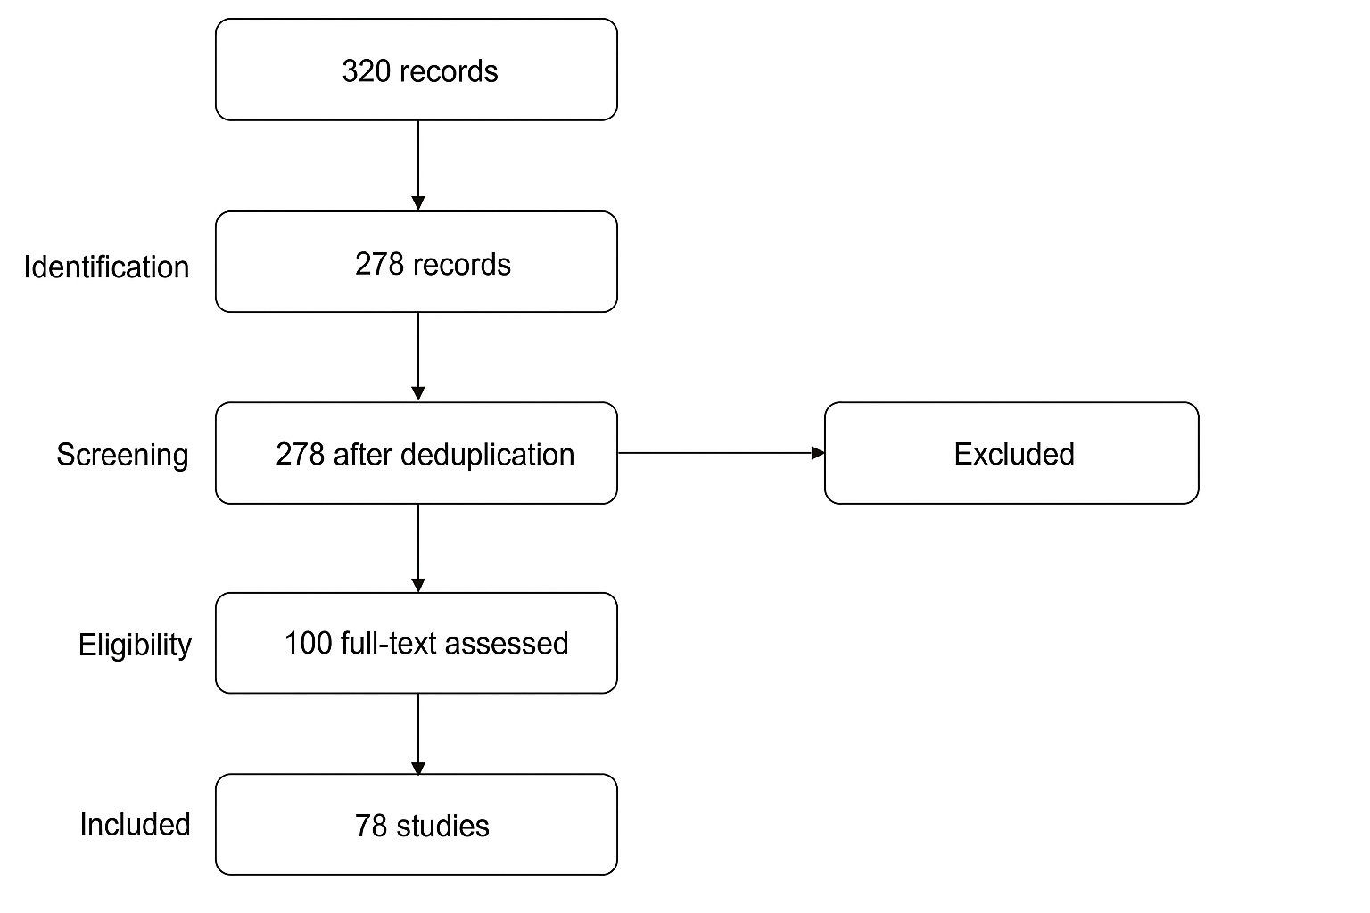

To ensure robustness, inter-coder reliability checks were conducted during thematic synthesis. Each study was independently reviewed by two coders and discrepancies were resolved through consensus discussion. Data extraction templates were validated using a pilot set of 10 articles before full-scale coding. Descriptive statistics were applied to identify geographical distribution and frequency of threat types across developed and developing nations.
2.3 Data Extraction and Analysis
Data were extracted on: threat type, impact, geographic region, victim profile (smallholder vs corporate) and counter measures. Thematic analysis was used to categorize findings into threat typology, impact dimensions and mitigation frameworks (Thilakarathne, 2025).
3. Types of Cybersecurity Threats in Digital Agriculture
Digital agriculture relies heavily on interconnected cyber-physical systems such as IoT-based sensors, autonomous machinery, AI-driven decision tools, and cloud data platforms. While these technologies enhance productivity, efficiency, and precision, they also introduce a wide attack surface for cybercriminals. The following subsections categorize and explain the most prevalent and emerging cybersecurity threats within the agricultural domain.
3.1 Ransomware and Malware Attacks
Ransomware attacks encrypt or lock critical farm management data, demanding payment for restoration. Malware infections may further compromise operational continuity by disabling smart irrigation systems, greenhouse controllers, or feed automation tools. Notably, the 2022 ransomware incident on AGCO Corporation (USA) caused days of operational downtime and production loss, highlighting the vulnerability of agribusiness infrastructure (Gao, 2024). In developing nations, these attacks often go unreported but cause significant financial distress to smallholder farmers who rely on digital platforms for e-marketing and crop monitoring.
3.2 Phishing and Social Engineering
Phishing emails, messages, or voice calls remain among the most common intrusion tactics targeting agricultural stakeholders. Attackers impersonate agri-input suppliers, government portals or digital payment apps to extract sensitive credentials. Social engineering exploits human trust and low digital literacy among rural users. (Yazdinejad, 2021) found that over 60% of targeted farmers in smart-farming pilot regions fell prey to credential phishing due to lack of cybersecurity awareness and training.
3.3 Internet of Things (IoT) and Device Vulnerabilities
IoT devices-ranging from soil moisture sensors to autonomous drones—are often deployed with limited security configurations. Inadequate encryption, default passwords, and outdated firmware expose these systems to hijacking or data tampering (Dong, 2023). Attacks on connected irrigation networks have resulted in deliberate overwatering or under-irrigation, directly impacting yields. As the number of agricultural IoT devices surpasses 200 million globally (FAO, 2024), their security becomes critical for maintaining operational integrity.
3.4 Denial-of-Service (DoS) and Distributed Denial-of-Service (DDoS) Attacks
DoS and DDoS attacks flood agricultural data servers or decision-support platforms with excessive traffic, making them temporarily unavailable to users. This can halt access to weather forecasts, pest alerts, or automated equipment controls (Alahmadi A. , 2022). In 2023, several agri-cooperative networks in Europe experienced DDoS attacks that disrupted fertilizer distribution logistics during peak seasons, demonstrating the cascading impact of such assaults.
3.5 Data Breaches and Unauthorized Access
The digitization of land records, crop insurance databases, and e-agriculture platforms has created vast repositories of sensitive farmer data. Breaches can lead to exposure of personal identities, bank accounts, and geospatial farm information (Zhang, 2024). Cloud-based agricultural management tools often lack sufficient data segmentation and encryption, making them lucrative targets for cybercriminals engaged in identity theft or competitive espionage.
3.6 Supply Chain and Third-Party Risks
The agricultural ecosystem is highly dependent on third-party service providers-input companies, logistics networks and digital payment gateways. A single compromised vendor can expose the entire value chain (Balkrishna, 2023). For instance, a software compromise in a seed distribution portal could leak pricing data or manipulate order systems, ultimately affecting national-level supply stability. These interdependencies underscore the importance of adopting zero-trust security models across agri-value chains (Rose, 2020).
3.7 Cloud and Mobile Application Vulnerabilities
The increasing use of mobile apps for farm monitoring, crop diagnosis and market linkages introduces new layers of risk. Unsecured APIs, poor authentication systems and weak encryption allow adversaries to intercept or modify transmitted data (Aldhyani, 2024). Likewise, cloud computing platforms used for predictive analytics or drone image processing may be subject to privilege escalation or insider exploitation. Regular patching and endpoint security measures are critical to minimize these threats.
3.8 Insider Threats and Human Error
Human factors remain a persistent cybersecurity challenge. Negligence, such as sharing passwords, using unverified software or mishandling USB devices, accounts for a large proportion of security breaches (Klerkx, 2019). Intentional insider attacks, though rare can be devastating-especially in cooperative or contract-farming setups where one actor’s compromise can jeopardize the digital ecosystem of hundreds of farmers.
TABLE 1. Typology of Cyber Security Risks in Agriculture 4.0
Threat Type | Primary Risk
Ransomware & Malware | Data encryption, operational disruption
Phishing & Social Engineering | Credential theft, fraud
IoT Vulnerabilities | Device manipulation, data corruption
Denial-of-Service (DoS) | System downtime, service disruption
Data Breaches | Privacy loss, information leakage
Supply Chain Risks | Indirect infiltration via vendors
Insider & Human Error | Misuse, accidental exposure

It is notable that cyberattacks increasingly exploit hybrid vulnerabilities that combine both digital and physical components. For example, drone hijacking incidents in Europe and Asia between 2022 and 2024 resulted in unauthorized pesticide spraying and crop contamination. Similarly, tampering with automated irrigation systems through Distributed Denial of Service (DDoS) attacks in Australia disrupted water distribution during peak growing seasons (Thilakarathne, 2025).
Another emerging dimension involves cyber-espionage and data monetization, where attackers target proprietary data such as seed genetics, soil mapping, or weather models for resale. These intellectual-property breaches pose strategic risks for agritech startups and national food-security planning. The convergence of AI-driven prediction models with vulnerable IoT networks thus demands multi-layered defence systems capable of detecting and isolating anomalies in real time (Yazdinejad, 2021)
4. Impacts on Farmers and Agricultural Systems
Cyber threats in digital agriculture can result in:
- Financial Losses: Disruption of payment systems or theft of digital funds (Balkrishna, 2023)
- Operational Disruptions: Downtime of machinery, sensors, and decision-support tools (Gao, 2024)
- Psychosocial Effects: Anxiety, distrust in digital systems, reluctance to adopt new technologies (Klerkx, 2019)
- Data Privacy Risks: Exposure of sensitive farm and personal information (Dong, 2023)
In addition to these quantifiable impacts, cyber incidents can also undermine social capital within rural communities. Farmers who experience financial loss due to digital fraud often withdraw from digital marketplaces, slowing rural digitization. Studies in Tamil Nadu and Andhra Pradesh (Irshad, 2025) report that post-incident recovery periods can last over six months, particularly among marginal farmers. Moreover, cyberattacks on data aggregators have the potential to distort agricultural research and extension planning, as manipulated datasets may influence future policy or subsidy design.
5. Mitigation Strategies
5.1 Technical Measures
- AI-based anomaly detection for real-time monitoring (Tavasoli, 2025; Singh, 2024)
Uses artificial intelligence to continuously analyze sensor data and detect unusual activities or cyber intrusions instantly, preventing large-scale system compromise.
- Blockchain for immutable record-keeping (Mhlanga, 2023)
Stores agricultural data in decentralized ledgers, ensuring transparency and tamper-proof transactions across supply chains, protecting farmers from data manipulation.
- Encryption and secure IoT protocols (Zhang, 2024)
Safeguards communication between farm devices and cloud servers using cryptographic methods, ensuring confidentiality and integrity of transmitted information.
- Zero-trust network architecture (Rose, 2020)
Operates on the principle of “never trust, always verify,” requiring authentication for every device and user to minimize unauthorized access in farm networks.
5.2 Policy and Institutional Frameworks
- National Cyber Security Policy (2013) provides broad guidelines for digital safety: Establishes a broad framework for national digital safety, promoting secure infrastructure and capacity building for critical sectors like agriculture.
- CERT-In issues alerts on emerging cyber threats: The Indian Computer Emergency Response Team monitors cyber incidents and issues real-time alerts and guidance to mitigate emerging threats in agri-tech platforms.
- Digital Agriculture Mission (2021–2025) promotes integration of cybersecurity into farm technology: Encourages the adoption of secure digital technologies in farming while integrating data protection measures into government-led digital initiatives.
5.3 Farmer-Level Best Practices
- Use strong, unique passwords: Reduces the risk of unauthorized access to farm apps and digital accounts by using combinations of letters, numbers, and special characters.
- Enable two-factor authentication: Adds an extra verification step, making it harder for attackers to breach accounts even if passwords are compromised.
- Update software regularly: Ensures that vulnerabilities in IoT devices, mobile apps, and computers are patched promptly to prevent cyber exploitation.
- Backup data securely: Protects critical farm and financial data from ransomware attacks by maintaining encrypted copies on offline or cloud storage.
- Avoid public Wi-Fi for sensitive transactions: Prevents hackers from intercepting data transmitted over unsecured networks, especially during online payments or digital registrations.
- Use certified and trusted digital applications: Minimizes malware risks by relying only on verified apps and platforms endorsed by agricultural institutions or government bodies.
Beyond individual practices, collective cyber defense mechanisms can be promoted through Farmer Producer Organizations (FPOs) and cooperatives. Shared digital infrastructure-such as secure cloud storage, community data centers, and authenticated trading portals-can help smallholders benefit from economies of scale while maintaining protection. Agricultural universities and KVKs can introduce Digital Safety Literacy Modules covering topics like password hygiene, scam detection and privacy management. Integrating cybersecurity training into rural development programs under schemes such as Digital India and Pradhan Mantri Fasal Bima Yojana (PMFBY) can institutionalize awareness across districts. Furthermore, embedding cybersecurity audits within agritech startups and mandating compliance through NABARD or ICAR could ensure systemic security at scale (Huang, 2025)
6. Future Directions
- Development of predictive AI models to forecast cyber threats (Tavasoli, 2025)
- Secure-by-design IoT devices with built-in encryption (Gao, 2024)
- Public-private partnerships for threat intelligence sharing (Campoverde-Molina, 2024)
- Integration of cyber hygiene modules in farmer training programs
Future cybersecurity frameworks in agriculture should also adopt quantum-resistant encryption and federated learning models to protect sensitive farm data without centralized exposure. Continuous collaboration between cybersecurity experts, agricultural engineers and policymakers will be essential to establish early warning systems for digital attacks-similar to climate early warning platforms (Moher, 2009). This cross-sectoral integration could make digital agriculture resilient against both cyber and environmental disruptions.
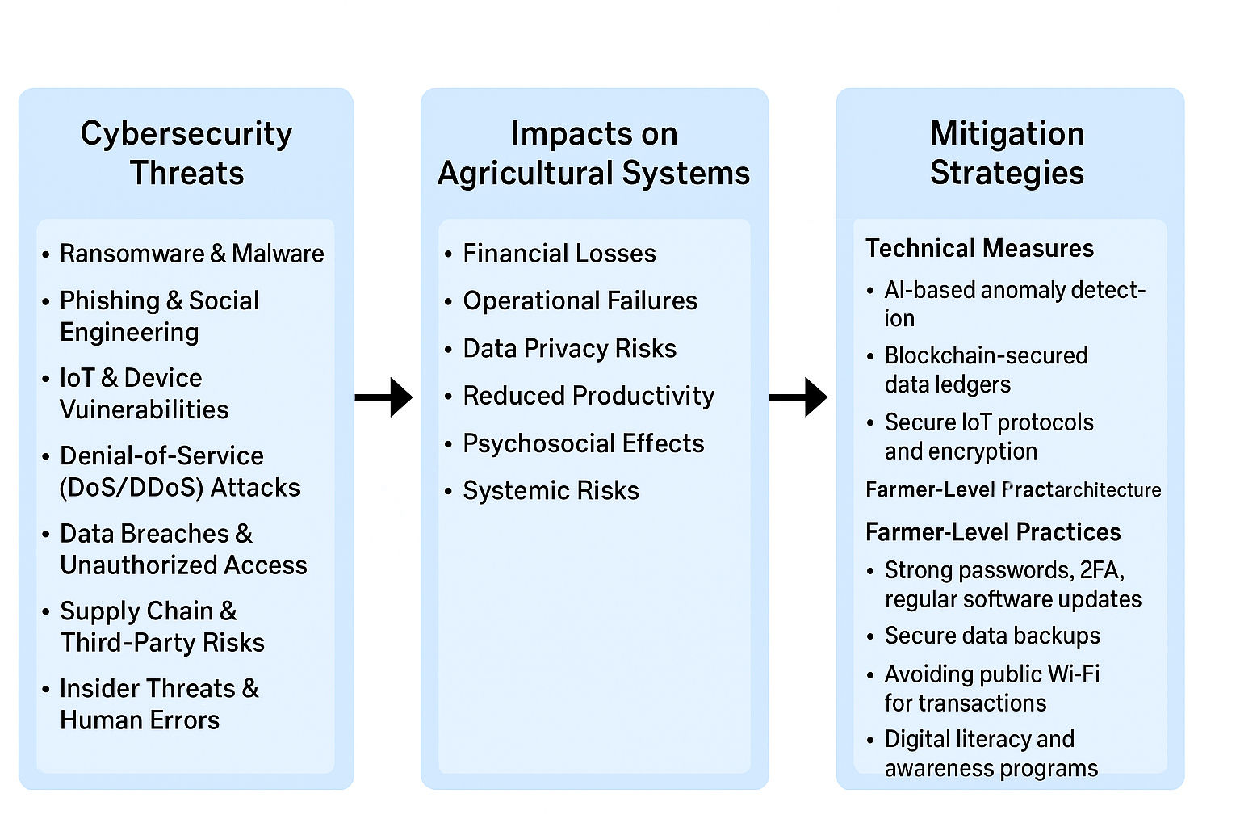
Figure 2. Conceptual Framework of Cybersecurity Threat–Impact–Mitigation Linkages in Digital Agriculture.

7. Conclusion
Digital agriculture is essential for global food security, but its cyber vulnerabilities pose risks to livelihoods and agricultural operations (Alahmadi A. N., 2022) (Yazdinejad, 2021). AI, blockchain and secure IoT design offer technical solutions, but their effectiveness depends on farmer-centric policies, digital literacy and multi-stakeholder collaboration. The evidence reviewed underscores that cybersecurity in agriculture is a critical determinant of sustainability and resilience. Strengthening digital trust within the farming community will accelerate technology adoption, improve traceability and foster transparent agri-value chains across nations. Future research should quantify potential economic losses, evaluate intervention efficacy and explore scalable cybersecurity education for farmers. Ensuring cyber-resilience in agriculture is a socio-technical imperative requiring collaboration across government, technology providers and farming communities (Thilakarathne, 2025) (Mhlanga, 2023) (Aldhyani, 2024).

12. Competing Interests Disclaimer:
Authors have declared that they have no known competing financial interests or non-financial interests or personal relationships that could have appeared to influence the work reported in this paper.
13. Disclaimer (Artificial intelligence)
The authors hereby declare that no generative AI technologies (such as ChatGPT, Copilot, Gemini, or any other language or image generation tools) were used in the writing, editing, analysis, or preparation of this manuscript. All content presented is the result of the authors’ own intellectual work and critical synthesis of reviewed literature.
14. References
Alahmadi, A. N. (2022). Cyber-Security Threats and Side-Channel Attacks for Digital Agriculture. Sensors, 22(9), 3520. https://doi.org/10.3390/s22093520
Balkrishna, A. (2023). A comprehensive analysis of the advances in Indian Digital Agriculture. Agricultural Technology, 3(1), 100318. https://doi.org/10.1016/j.atech.2023.100318
Campoverde-Molina, M. (2024). Cybersecurity in smart agriculture: A systematic literature review. Computers & Security, 104284. https://doi.org/10.1016/j.cose.2024.104284
Dong, S. (2023). Blockchain technology and application: An overview. Frontiers in Public Health, 11, 1229386. https://doi.org/10.3389/fpubh.2023.1229386
Gao, Y. (2024). Security threats to agricultural artificial intelligence. Computers and Electronics in Agriculture, 227, 109557. https://doi.org/10.1016/j.compag.2024.109557
Klerkx, L. (2019). A review of social science on digital agriculture, smart farming, and agriculture 4.0: New contributions and a future research agenda. NJAS - Wageningen Journal of Life Sciences, 90, 100315. https://doi.org/10.1016/j.njas.2019.100315
Liberati, A. (2009). The PRISMA statement for reporting systematic reviews and meta-analyses of studies that evaluate health care interventions: Explanation and elaboration. PLoS Med, 6(7), e1000100. https://doi.org/10.1371/journal.pmed.1000100
Mhlanga, D. (2023). Blockchain for secure and decentralized artificial intelligence in agriculture. Frontiers in Blockchain, 6, 1035405. https://doi.org/10.3389/fbloc.2023.1035405
Moher, D. (2009). Preferred reporting items for systematic reviews and meta-analyses: The PRISMA statement. BMJ, 339, b2535. https://doi.org/10.1136/bmj.b2535
Neethirajan, S (2025). Safeguarding digital livestock farming – a comprehensive cyber security roadmap for dairy and poultry industries. Frontiers in big data, 8, 1556157
Rose, S. (2020). SP 800-207, Zero Trust Architecture. National Institute of Standards and Technology. https://doi.org/10.6028/NIST.SP.800-207
Yazdinejad, A. (2021). A review on security of smart farming and precision agriculture: Security aspects, attacks, threats, and countermeasures. Applied Sciences, 11(16), 7518. https://doi.org/10.3390/app11167518
Zhang, Y. (2024). Security threats to agricultural artificial intelligence. Computers and Electronics in Agriculture, 227, 109557. https://doi.org/10.1016/j.compag.2024.109557
Aldhyani, T. H. H. (2023). Cybersecurity for detecting distributed denial of service attacks in Agriculture 4.0 using deep learning. Mathematics, 11(1), 233. https://doi.org/10.3390/math11010233
Campoverde-Molina, M., & Luján-Mora, S. (2024). Cybersecurity in smart agriculture: A systematic literature review. Computers & Security, 104284. https://doi.org/10.1016/j.cose.2024.104284
Thilakarathne, N. N., et al. (2025). A novel cyber threat intelligence platform for evaluating the security of smart agriculture. Scientific Reports, 15(1), 85320. https://doi.org/10.1038/s41598-025-85320-8
Tavasoli, M., et al. (2025). AI-driven cybersecurity architecture for smart farming using edge computing. Proceedings of SPIE, 13606, 136060Y. https://doi.org/10.1117/12.3065646
Singh, B. (2024). Cybersecurity threats and mitigation strategies in Agriculture 4.0 and 5.0. Journal of Public Affairs and Security, 2(2). Retrieved from https://jpas.in/index.php/home/article/download/2/2
Miller, T., Mikiciuk, G., Durlik, I., Mikiciuk, M., Łobodzińska, A., & Śnieg, M. (2025). The IoT and AI in Agriculture: The Time Is Now-A Systematic Review of Smart Sensing Technologies. Sensors, 25(12): 3583. 10.3390/s25123583
Huang, Z., Chen, R., & Lin, J. (2025). How the Internet of Things Technology Improves Agricultural Efficiency. Artificial Intelligence Review, 58, 63. https://doi.org/10.1007/s10462-024-11046-0
Irshad Ahmed Bhat et al., (2025). Leveraging Artificial Intelligence in Agribusiness: A Structured Review of Strategic Management Practices and Future Prospects. Discover Sustainability, 6, 565. https://doi.org/10.1007/s43621-025-01260-3
Suba Jyoti pal et al., (2025). Security Challenges and Threats in Smart Farming Systems. EPRA International Journal of Agriculture and Rural Economic Research, 13(5), 23–30. Retrieved from https://eprajournals.com/pdf/fm/jpanel/upload/2025/May/202505-03-021993
Thakur, P., & Chhabra, V. (2025). A Comprehensive Review on Smart Farming. International Journal of Research in Agronomy, 8(SI3), 26–37. Retrieved from https://www.agronomyjournals.com/special-issue/2025.v8.i3S.2610

