The Urban Heat Island Problem of Greater Kolkata, India

Abstract: Kolkata, a major metropolitan area in India, is vulnerable to the Urban Heat Island (UHI) effect due to rapid urbanisation and industrialisation. The city’s geographical and climatic conditions further exacerbate this phenomenon, resulting in significant impacts on the urban climate and public health. The UHI effect reflects the influence of climate change and human-induced stress on the natural environment, resulting in adverse health outcomes and higher energy consumption. This study examines the role of urban design and planning in contributing to UHI formation. It highlights the importance of integrating green infrastructure and energy-efficient solutions to reduce its effects.
Landsat-9 Level-2 Surface Reflectance and Thermal Infrared Sensor (TIRS) data were used to analyse UHI patterns and vegetation dynamics through indices such as the Normalised Difference Vegetation Index (NDVI), Normalised Difference Built-up Index (NDBI), Land Surface Temperature (LST), and a standardised UHI Z-score. LST was derived by converting the thermal infrared band to brightness temperature and applying emissivity correction.
The results showed clear temperature differences between urban and rural areas, with certain regions experiencing strong UHI effects. The rise of the average temperature of 4.4 °C highlighted the need for improved urban planning and the use of green infrastructure to reduce the negative impacts of UHI. Recommendations are the construction of Green Mark commercial buildings, skyrise greenery, gardens, and national parks to reduce building-related environmental damage. Incorporating these measures into current planning and construction practices to support micro-climatic improvements in the Kolkata metropolitan city that contribute to its sustainable development.
Keywords: Land surface temperature (LST), Normalised Difference Built-up Index (NDBI), Kolkata city, Urban Heat Island (UHI), Climate Change, Urban Sprawl
Introduction:
Urban Heat Island (UHI) is a phenomenon where urban areas experience higher temperatures than their rural surroundings due to human activities and urbanisation [1]. This project focuses on the UHI effect in Kolkata, a fast-urbanising cosmopolis in India. The study aims to analyse temperature variations, identify hotspots, and propose mitigation strategies using Geographic Information System (GIS) and Remote Sensing (RS) technologies ([2]; [3]; [4]).
Kolkata, with its dense population and extensive built-up areas, is particularly susceptible to the UHI effect. The city's unique geographical and climatic conditions further exacerbate this phenomenon, leading to significant impacts on the urban climate, public health, and energy consumption. Leveraging GIS and RS, create detailed spatial models and maps that tells the extent and intensity of UHI in Kolkata and nearby cities ([5], [6], [7], [8], [9]).

The findings of this study will provide valuable insights into the factors contributing to UHI and offer practical solutions for urban planners and policymakers to mitigate its adverse effects. Through this research, we aim to contribute to the broader efforts of addressing climate change and promoting sustainable urban development ([10], [11]).
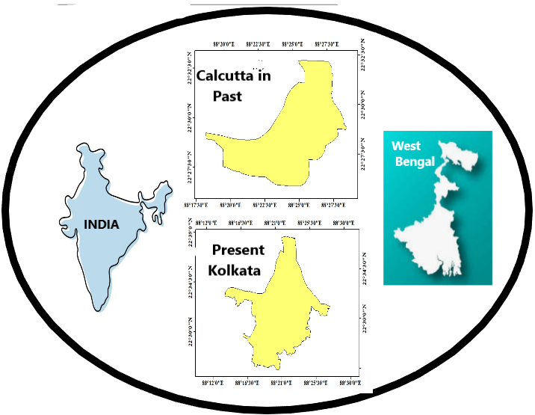
Fig 1 (a): The Index map of the Kolkata Metropolitan area, transforming the intense UHI

The UHI transformation of Britishers' cool and calm Kolkata City has posed a threat to achieving the major Sustainable Development Goals (SDGs), like SDG 11 (Sustainable Cities and Communities). The other demands can be satisfied by reducing the impact are SDGs 3, 7, 9, and 13. The UHI is not an SDG to address directly, but rather the ecology and environment challenges required to be attended to be attended to address the targets of these goals.
a.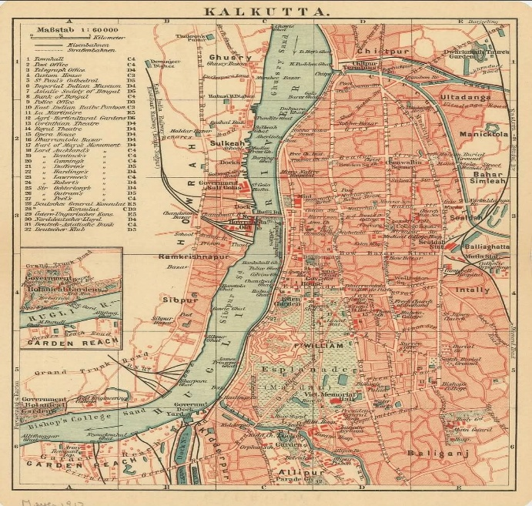b.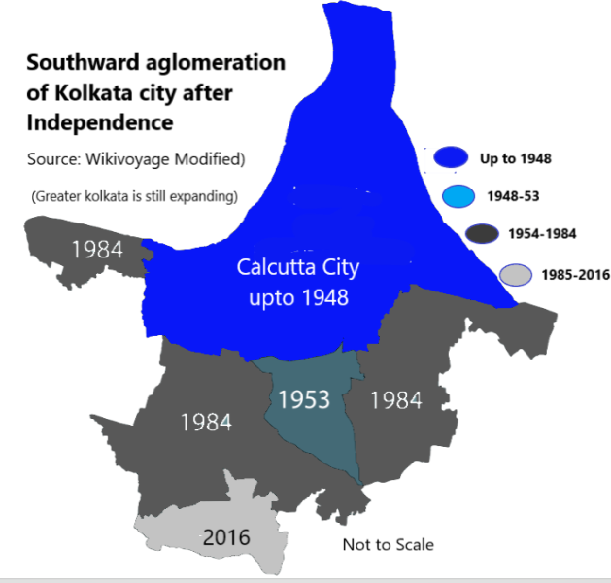
Fig 2(a to b): (a) Calcutta city during pre-independence (b) Southward movement of Kolkata City (Source: Google modified)

Review of Literature:
Conversion of cities to UHIs in the past 5-6 decades has amplified with urbanisation that transformed pervious to impervious surfaces, local energy balance modifications in densely populated cities around the globe during daytime ( [12], [13], [14]). Using remote sensing and geo-spatial tools, the land use (LU) change detection can empower the UHIs through altering Land Surface temperature (LST) in major agglomerating cities of the earth ([15], [16], [17]).
The city of Kolkata, alternately known as “Cultural Capital of India”, or “City of Joy”. The pandemic in 1653 compelled the city to rebuild to combat the challenges of rapid urbanisation, and form clusters for dwelling and industrialisation and the British rule-initiated colonisation on the banks of the mighty Hooghly River. During the city’s inception, the planners were ignorant of the huge population density and the rate of energy consumption, which has led to building up the calm and cold city to an urban heat Island (UHI) in the 21st century, [18], 19], [20], [21], [22]). Less studies exist about the green space dynamics to abate the UHI in Kolkata ([22], [23], [24]).
The primary objectives of this research are to analyse temperature variations across different parts of Kolkata, identify UHI hotspots, and assess the contributing factors. By leveraging Landsat 8 imagery and spatial data, we created detailed maps and models to visualise the extent and intensity of UHI in the city. The study also examines the impact of land use, vegetation cover, and urban agglomeration on temperature distribution ([25]).
Objectives:
The main objectives of the present research are to
1. Analyse Temperature Variations, to study the temperature differences between urban and rural areas and understand the extent of the UHI effect.
2. Identify Hotspots to pinpoint specific areas within the city that experience higher temperatures and are most affected by UHI, along with players and redemption. Like land use, vegetation cover, and urban infrastructure.
3. Propose Mitigation Strategies: To develop practical solutions and strategies to reduce the UHI effect and improve urban resilience
Methodology
ABOUT STUDY AREA: KOLKATA
Calcutta, renamed from 2001, is located on the Eastern Bank of the River Ganga. The tail end of the river Ganga flows by the side of Kolkata before it reaches the Bay of Bengal about 180 Km. downstream from Kolkata. Calcutta, renamed presently as Kolkata, is now the capital of West Bengal, a state of India. The Geographic Coordinates of Kolkata city nest at the longitude of 88º 30'E - 22º 33' N. and are situated at an average elevation of 6.4m above mean sea level. The Kolkata corporation area is 205 sq. km, and the greater Kolkata covers an area of 1480 sq. km. As per KMC, the Vehicular Population is 1.05 million, plying over 4636 km of road (main streets of 1850 km)
Climate: Maximum temperature rises during the summer months of May-June up to 24 - 42º C and the minimum temperature falls during the winter months of December-January up to 8 - 26ºC on average. The climate is humid, varying from 85 - 65 during the summer & exceeding pleasant in winter. From June to September average rainfall in Kolkata is 1580mm/yr.
Population: The population of the Kolkata Municipal Corporation (KMC) has surged to > 4.5 mi with a daily floating Population of ≈6.0 million, population Density of ≈24.760 persons/ km². Kolkata's 2025 population is estimated as 15,845,200, while in 1950, the population was 4,604,140 (growth rate 1.76%) (https://worldpopulationreview.com/cities/india/kolkata)
Necessity of Kolkata as a study area:
Kolkata is experiencing rapid urbanization due to its historical role as an economic hub for regions like Bihar, Odisha, and the northeastern states. This growth, which began in the early eighteenth century and accelerated with the British East India Company, is driven by economic development, enhanced infrastructure, and rural migration in search of better job opportunities and living conditions.
As urbanization increases, Kolkata faces a significant rise in temperature due to the "urban heat island" effect. Central Kolkata has higher heat retention from concrete surfaces and human activities, with limited green spaces exacerbating the problem at night. This analysis examines data from 2000, 2010, 2020 and 2025 to assess the impacts of urban heat Fig 3 (b).
Urbanisation is the main anthropogenic process responsible for radical changes in the nature of the atmospheric and surface characteristics of a region. Urban Heat Islands (UHIs) are anthropogenic phenomena exhibited by land use and land cover changes in urban areas with abnormal temperature rise of the landscape than the rural environs due to human exploitative activities and urbanisation. The present study uses the change detection methods to assess the UHI of Kolkata.
The primary objectives of this research are to analyse temperature variations across different parts of Kolkata, identify UHI hotspots, and assess the contributing factors. By leveraging Landsat 8 imagery and spatial data, detailed maps and models are created to visualise the extent and intensity of UHI in the city. The study also examines the impact of land use, vegetation cover, and urban infrastructure on temperature distribution.
The methodology involves preprocessing Landsat data, calculating the Normalised Difference Vegetation Index (NDVI) using ArcGIS, and deriving Land Surface Temperature (LST) from thermal infrared bands. The LST was obtained by converting the thermal infrared band to brightness temperature and applying an emissivity correction ([26]; [27]).
Result and Discussion
The findings reveal significant temperature disparities between urban and rural areas, with certain zones exhibiting pronounced UHI effects. The results underscore the need for strategic urban planning and green infrastructure to mitigate the adverse impacts of UHI. This research provides valuable insights for policymakers and urban planners to develop sustainable solutions for enhancing urban resilience and improving quality in Kolkata.
Public
Awareness
Policy planning
Impact
Assessment
Mapping and
Visualisation
Data collection

Flow chart 1: Conceptual framework

This effect is primarily driven by the extensive use of heat-absorbing materials such as concrete and asphalt, as well as the reduction of vegetation and green spaces in urban environments.
Mechanism of UHI:
The causes of the UHI in the greater Kolkata that differ between the urban and the rural areas are:
Solar Radiation: During the day with sunshine, urban surfaces like buildings, roads, and pavements absorb solar radiation and convert it into heat. Materials like concrete and asphalt have a high thermal absorption coefficient as they can store a large amount of heat ([28]).
Heat Retention: At night, these materials slowly release the stored heat, keeping urban areas warmer than rural areas. This results in higher nighttime temperatures in cities.

a. 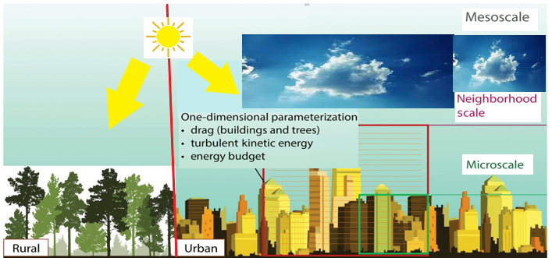b.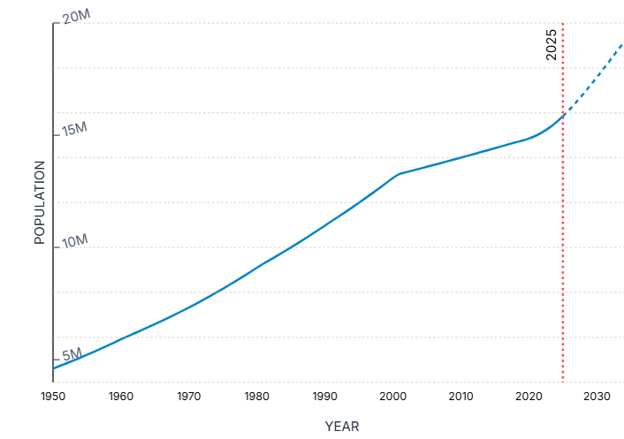
Fig. 3 (a and b): (a) The rate of rise of temperature in Kolkata city, both in Rural and Urban areas, (b) the rise in population geospatially

Reduced Vegetation: In cities, natural landscapes are replaced with buildings, drains and pavement, reducing the amount of vegetation and preventing underground seepage. Plants and trees increase evapotranspiration, which cools the air. The lack of vegetation in urban areas contributes to higher temperatures.
Anthropogenic Impacts: Activities such as transportation, industrial processes, and energy consumption generate high temperatures. The heating, ventilation, and air conditioning (HVAC) units release heat into the environment, further increasing urban heat. The overexploitation of the environment in urban areas is the main cause of UHI.
TYPES OF URBAN HEAT ISLAND
1. Surface Urban Heat Island (SUHI): Refers to higher temperatures on urban surfaces (roads, rooftops), caused by materials like concrete/asphalt absorbing heat.
2. Canopy Urban Heat Island (CUHI): Occurs within the layer of air between the ground and the tops of buildings (urban canopy layer which directly affects people at street level.
3. Boundary Layer Urban Heat Island (BLUHI): Forms above the rooftop level up to the higher atmosphere that represents the overall warming of the city’s air mass.
4. Atmospheric Urban Heat Island: Includes both canopy and boundary layer UHIs. That shows temperature differences between urban (more) and rural air.
The formation of UHI is determined by several factors, i.e. vegetative cover availability, properties of urban materials and geometry, horizontal to vertical growth, as well as the geographical location of cities. Large water bodies or mountainous terrain located near the cities can influence the general wind patterns, which in turn could influence UHI formation. Wind patterns play a significant role in the dispersion of heat. Cities near large water bodies or mountains may experience altered wind patterns that can either mitigate or intensify the UHI effect. Human activities, such as running air conditioners and vehicles, generate additional heat, further exacerbating the UHI effect Fig 4
Fig 4 : The core Kolkata city is transforming is transforming to an intense UHI
LAND USE LAND COVER MAP OF KOLKATA, 2000
The LULC map of Kolkata from 2000 was typically changing, ascertained from satellite imagery.

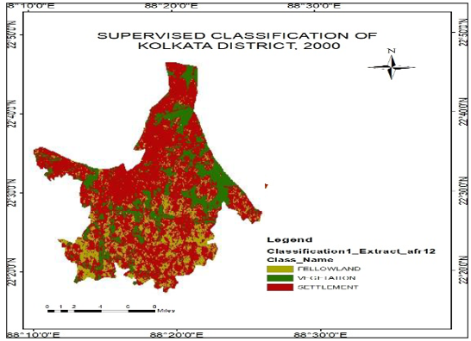

Fig 5 (a): The land use classification map of the greater Kolkata during the year 2000

The Urban built-up areas have expanded due to rapid urbanisation since the beginning of the 21st century. Urbanisation is increasing all over Kolkata City. Most of the land is covered by urban areas. The vegetation is decreasing fast due to the conversion to urban development. In this map, It is clear that deforestation is happening here, most of the vegetation has been reduced for urbanisation and making urban settlements and buildings. Water bodies are shrinking due to encroachments and rapid growth of construction in the floodplains of the Ganga River. There is a downsizing of agricultural land due to the conversion of agricultural land to build up areas. ed into urban areas. Kolkata is reducing its fallow land and swamps due to the city's agglomeration. Most of the open lands are used for settlements.
LAND USE LAND COVER MAP OF KOLKATA, 2010
The Kolkata Supervised Classification Map of 2010 was created using remote sensing and GIS technology to classify various land cover types in the Kolkata Metropolitan Area. This map categorises the land into different classes, including urban built-up areas, vegetation, water bodies, agricultural land, and open land. Fig 5 (b)

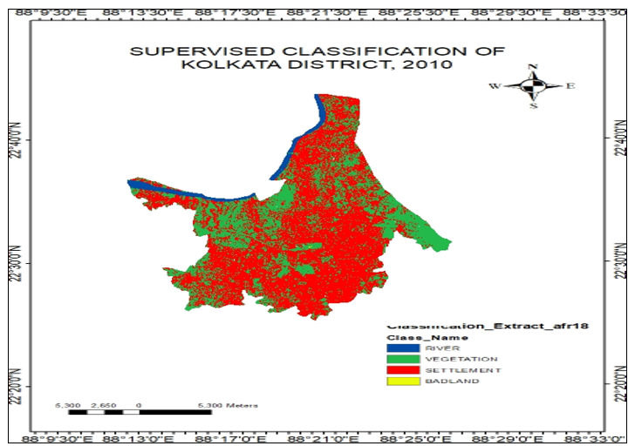

Fig 5 (b): The land use classification map of the greater Kolkata during the year 2010

LAND USE LAND COVER MAP OF KOLKATA, 2020
The Kolkata Supervised Classification 2020 is a study that used remote sensing and GIS techniques to analyse land use and land cover changes in Kolkata over time. The study classified satellite images into different categories such as urban built-up areas, open land, vegetation, agricultural land, and water bodies (41).
The supervised classification map shows: (a) Urban Expansion: There has been a significant increase in urban built-up areas, primarily due to new constructions like roads and settlements, more than in previous years of 2000 and 2010. Most of the peri-urban areas are affected and also converted into urban areas. (b) Decline in Natural Features: Vegetation, agricultural land, and water bodies have gradually decreased. Vegetation decreased so much in 2020. Agricultural lands were transformed into factories and buildings. Water bodies have decreased immensely, and the river is shrinking day by day. (c) Accuracy: The classification accuracy was high, with overall accuracy ranging from 88.27% to 92.42% for different years. (d) Urban Growth Patterns: Four main urban growth patterns were identified: low-density continuous, continuous linear, non-contiguous linear, and leapfrog development. Urban growth covered 90% area of Kolkata, and the growth is increasing rapidly.
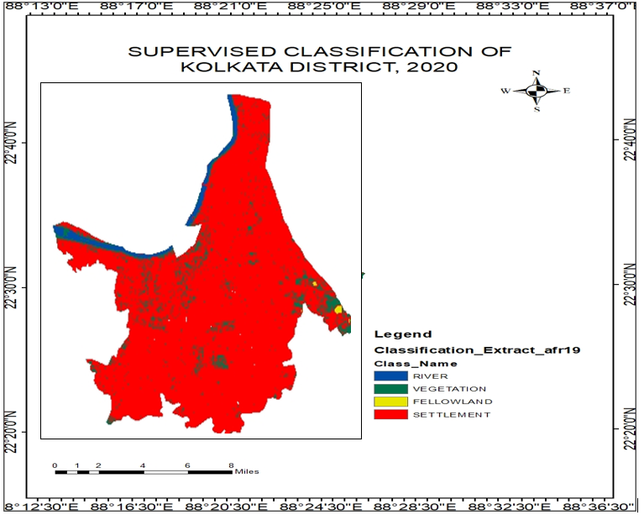
Fig 5 (c): The land use classification map of the greater Kolkata during the year 2020

Land surface temperature (LST)
Land surface temperature (LST) is a major player in Urban Microclimates in a warming world [29]. Land Surface Temperature (LST) calculation in GIS (Geographic Information System) is crucial because it helps in: (a) Monitoring Urban Heat Islands: Understanding temperature variations in cities. Increasing or decreasing temperature due to human activities or natural phenomena can be determined by doing a land surface temperature calculation in GIS. It shows the urban heat island of a particular urban area. (b) Agricultural Planning: Assessing crop health and soil moisture. Various types of agricultural activities, using crop health and soil moisture, and by knowing land surface temperature calculations. (c) Climate Change Studies: Tracking changes in Earth's surface temperature over time. The climatic changes are calculated by doing a land surface temperature calculation [40]. The increasing temperature in land and waterbodies can be determined by this calculation in an easier way. (d) Disaster Management: Predicting and managing heatwaves rises the LST. It helps to predict the natural phenomena caused by the increasing temperature on Earth's surface.
LST CALCULATION

These steps can be implemented using the Raster Calculator tool in ArcGIS
Step 1: Conversion to Top of Atmosphere (TOA) Radiance: Using the radiance rescaling factor, Thermal Infra-Red Digital Numbers can be converted to TOA spectral radiance (Lλ) in Watts/(m² * (steradian) sr * µm, Multiple band specific value (ML), is the pixel value (Q_{cal}), Additive band specific value (AL) and 𝑂_{I} is a correction value for the band 10, of Landsat 8, typically (0.29 Wm⁻²sr⁻¹µm⁻¹)..
$Lλ=ML*Qcal+AL- O_{i}$ (i)
Step 2: Conversion to Top of Atmosphere (TOA) Brightness Temperature (BT): Spectral radiance data can be converted to top of atmosphere brightness temperature using the thermal constant Values in the Metadata file. Kelvin (K) to Celsius (⁰C) Degrees and K₁ and K₂ band-specific values obtained from metadata.
$BT=\frac{K_{2}}{ln⁡(\frac{k_{1}}{Lλ+1})}- 273.15$ (ii)
Step 3: Normalised Difference Vegetation Index (NDVI): The Normalised Differential Vegetation Index (NDVI) is a standardised vegetation index which calculated using Near Infra-red (Band 5) and Red (Band 4) bands.
$NDVI= \frac{(NIR - RED)}{(NIR + RED)}=\frac{(Band 5-Band 4)}{(Band 5+Band 4)}$ (iii)
STEP 4: The Normalised Difference Vegetation Index is a standardised Building index (NDBI) given by a formula for Landsat-8
$NDBI=\frac{\left\{\left(SWIR-NIR\right)\right\}}{\left\{\left(SWIR+NIR\right)\right\}}=$ $\frac{(Band6-Band5)}{(Band6+Band5)}$ (vi)
Where (SWIR\) is the Shortwave Infrared band and (NIR\) is the Near-Infrared band. The values of the NDBI for Higher values (close to +1) show built-up areas, as zero it is vegetation, and (near -1) indicates a reflection less in the infrared spectrum.
Step 5: Land Surface Emissivity (LSE): It is the average emissivity of an element of the surface of the Earth calculated from NDVI values.
$PV=({(NDVI - NDVI min)/( (NDVI max⁡- NDVI min)}^{2}$ (iv)
Where E = Land Surface Emissivity, PV = Proportion of Vegetation and 0.986 corresponds to a correction value of the equation
a.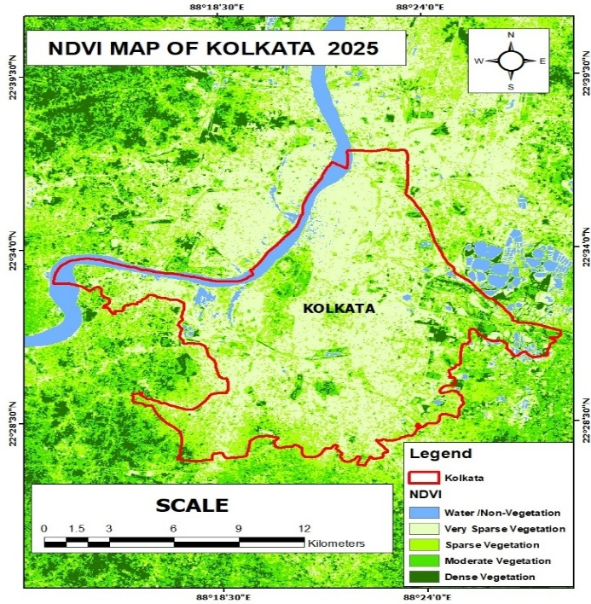.b.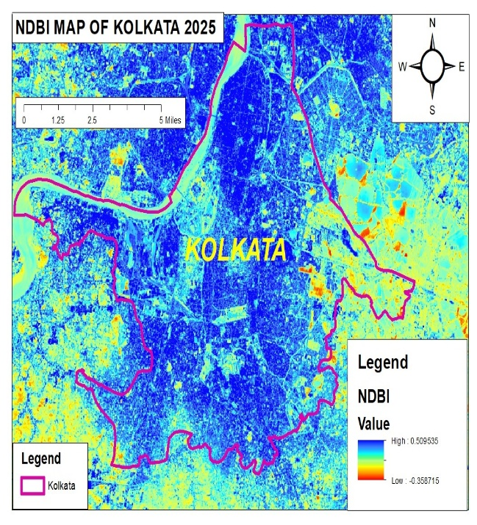c. 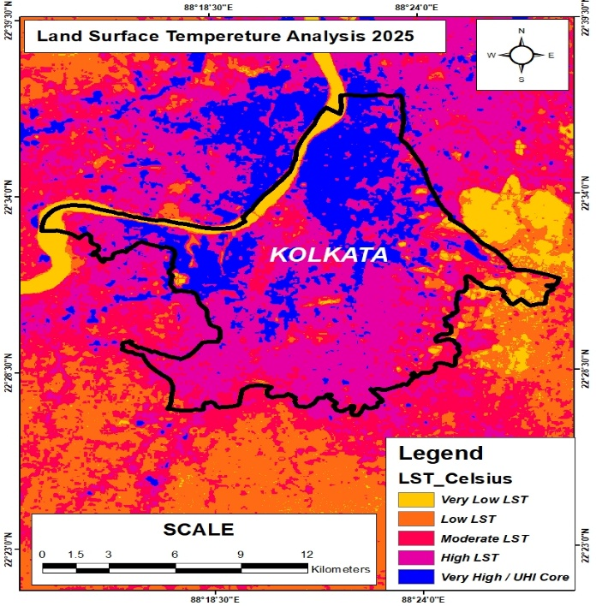d. 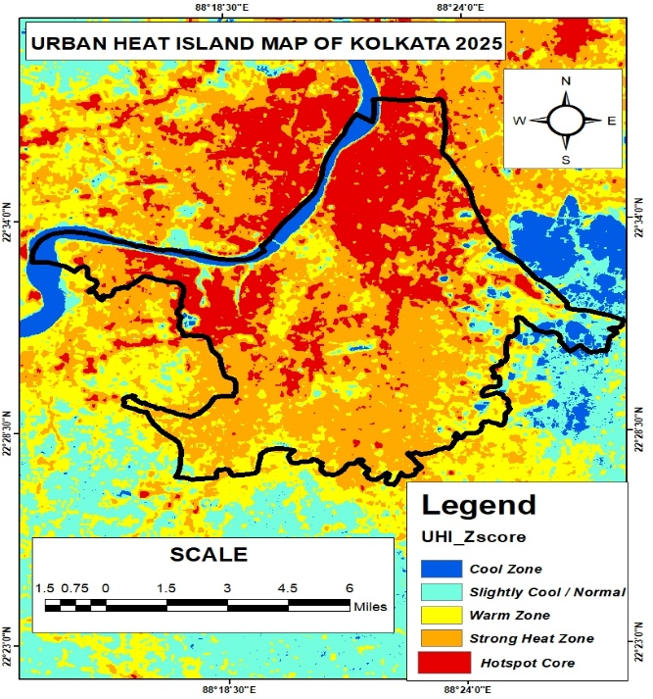
Fig 6 (a to d): (a) Normalised Difference Vegetation Index (NDVI), (b) Normalised Difference Building Index (NDBI), (c) Land surface temperature (LST) and (d) UHI map of Kolkata 2025
Step 6: Land Surface Temperature (LST): The Land Surface Temperature (LST) is the radiative temperature, which is calculated using the Top of Atmosphere brightness temperature, Wavelength of emitted radiance, and Land Surface Emissivity ([30]).
LST = BT/ (1 + (λ * BT / c2) * ln(E)) (v)
Where c2= 14388 mm K and the Values of λ for Landsat 8: For Band 10 is 10.8 and for Band 11 is 12.0, BT = Top of atmosphere brightness temperature (°C) λ = Wavelength of emitted radiance E = Land Surface Emissivity, c2= h*c/s=1.4388*10-2 mK =14388 mK h=Planck’s Constant =6.626*10-34 J s s= Boltzmann constant =1.38*10-23 JK c=velocity of light =2.998*108 m/s
In essence, this calculation provides valuable insights for environmental monitoring and sustainable planning. It has a huge impact on human daily life. That’s why we collected data from 2000, 2010, and 2020 in Kolkata to determine the climatic changes and their impact on human life ([31]).
LAND SURFACE TEMPERATURE MAP OF KOLKATA, 2000
The land surface temperature (LST) of Kolkata in 2000 is an important indicator of urban heat island (UHI) effects and environmental changes due to urbanisation. Studies have shown that urban areas like Kolkata experience higher temperatures compared to surrounding rural areas due to factors like increased impervious surfaces, reduced vegetation, and human activities.
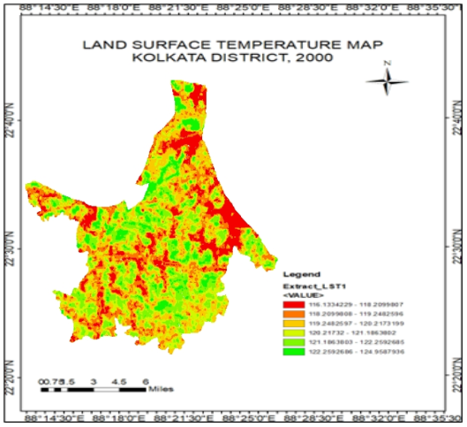
Fig 7 (a): The land surface temperature map of the greater Kolkata during the year 2000
Inferences: (a) Urban Heat Island (UHI) Effect: Kolkata, like many other urban areas, experiences the UHI effect, where temperatures are higher in urban areas compared to surrounding rural areas. This is due to factors like increased impervious surfaces (e.g., concrete and asphalt), reduced vegetation, and human activities. (b) Correlation with Vegetation: Studies have shown a correlation between LST and vegetation cover. Areas with higher vegetation cover tend to have lower LST due to the cooling effect of plants. Conversely, areas with less vegetation, often more built-up, have higher LST. (c) Seasonal Variations: LST can vary significantly between day and night and across different seasons. For example, LST tends to be higher during the night due to the heat retention properties of urban materials. This helps to know the climatic changes and their impact immensely. (d). Implications for Urban Planning: Understanding LST is crucial for urban planning and environmental health. It helps in designing strategies to mitigate UHI effects, such as increasing green spaces, using reflective building materials, and improving urban layouts to enhance airflow.
Land Surface Temperature Map of Kolkata, 2010
In 2010, Kolkata's land surface temperature (LST) continued to reflect the Urban Heat Island (UHI) effect, with higher temperatures in urban areas compared to rural surroundings. Key inferences observed from analysis were (a) Increased Urbanisation: Expansion of built-up areas led to higher LST due to more impervious surfaces like concrete and asphalt. The rapid growth of urbanisation in Kolkata is rapidly increasing, and the usage of concrete and asphalt for making roads, highways, and buildings makes the situation worse day by day. (b) Vegetation Loss: Reduced green spaces contributed to higher temperatures, as vegetation typically helps cool the environment. Rapid urbanisation in Kolkata is facing deforestation, which increases the temperature of the land surface in Kolkata. This is also affecting the climate in Kolkata, which has a huge impact on human health.

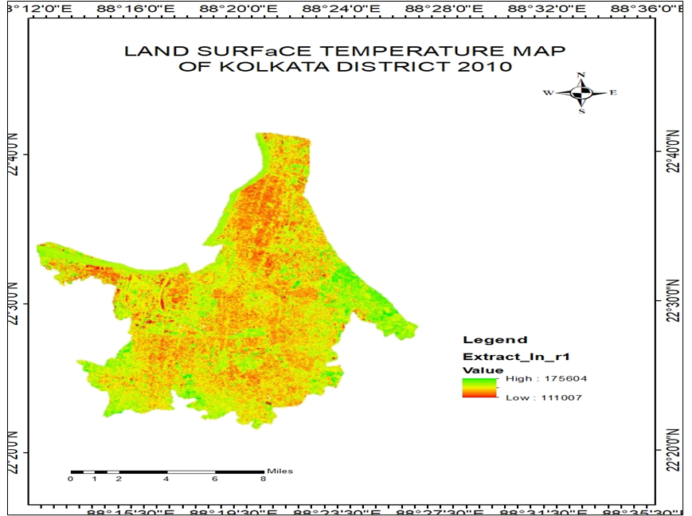

Fig 7 (b): The land surface temperature map of the greater Kolkata during the year 2010

(c) Seasonal Variations: LST was higher during the summer and at night due to heat retention by urban materials. Due to deforestation and less vegetation, the temperature is increasing significantly. The summer has a higher temperature nowadays than in 2000. This clearly denotes that the climate is changing. (d) Climate change: LST calculation of 2010 shows that an increase in temperature is also affecting the climate. The climatic changes are affecting human health and agriculture as well. LST calculation of 2010 shows that the temperature increased so much compared to 2000.
Land Surface Temperature Map of Kolkata, 2020
The Kolkata Land Surface Temperature (LST) Map 2020 is a GIS-based analysis that examines the temperature variations across Kolkata's urban landscape. Here are some key points about the interpretation of this map:

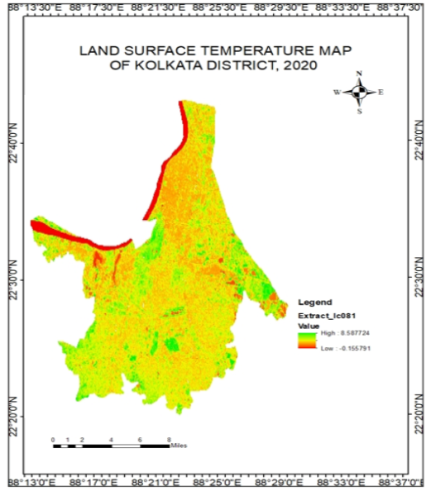
Fig 7 (c): The land surface temperature map of the greater Kolkata during the year 2020

The changes that occurred in daily temperature in the last 20years affect as follows: (a) Urban Heat Island Effect: The map indicates that urban areas experience higher temperatures than surrounding rural areas due to the Urban Heat Island (UHI) effect, caused by urbanisation, concrete surfaces, and reduced vegetation. It highlights seasonal temperature variations, where NDVI and LST may show a positive correlation in winter (more vegetation = lower temperatures) and a negative one in summer (more vegetation = higher temperatures due to evapotranspiration). The environmental impact of urbanisation includes increased temperatures, leading to higher cooling energy demands and health risks. The 2020 LST map reveals significant temperature increases since 2000, driven by rapid urbanisation in Kolkata, exacerbating climate change effects.
Change detection in KOLKATA, YEAR 2000, 2010, 2020
The land surface temperature (LST) of Kolkata for the years 2000, 2010, and 2020. They are compared in brief.
During the Year 2000:
Mean LST is approximately 22.33°C. The Urban Heat Island (UHI) Effect is considered in the Initial stages of urbanisation. The vegetation cover was high in comparison to later years
During the Year 2010:
Mean LST have increased to around 23.68°C. The Urban Heat Island (UHI) effect was pronounced due to increased urbanisation and urban agglomeration. The vegetation cover decreased, leading to higher temperatures
Kolkata’s UHI status during the Year 2020- 2025:
The Mean LST is further increased to approximately 23.79°C, and the Urban Heat Island (UHI) Effect has continued to intensify. Vegetation Cover: Further reduced, exacerbating the UHI effect
According to the result, the places Sinthi, Bagbazar, Maniktala, Beleghata, and Taltala are in the northern part of Kolkata, and Garden Reach is in the northern part of Kolkata. A part of Dhapa-Manipur in the eastern part of Kolkata has a higher UHI value, whereas major parts of Dhapa-Manipur, Ajay Nagar and Dhakuria along the eastern part have a Lower UHI value. The majority of the southern parts of Kolkata, such as Sarsuna, Thakurpukur, Behala, Garia, and Tollygunge, lie in the Moderate UHI value (Table 1).
Table 1: The UHI Temperature Milestones and climate change impacts in Kolkata city
Year | Average LST (°C) | OBSERVATION
2000 | 29.3°C | Beginning of urban expansion
2005 | 30.1°C | Growth in commercial & residential zones
2010 | 31.4°C | Rapid construction in Salt Lake, Rajarhat
2015 | 32.2°C | Noticeable reduction of green cover
2020 | 33.1°C | Major hotspots across central & eastern Kolkata
2025 | 33.77°C | North Kolkata Metropolis have an optimum UHI effect

The final inference is that the Built-up expanses have significantly surged in high LST than the green locations and lacustrine areas, as they act as cooling sinks. As per the study of “The Indian Express” on Friday, June 11, 2025, Kolkata city has the fourth-highest average LST area. The cities Delhi was at the top (43°C), Ahmedabad (38°C), Chennai (35°C), and Kolkata (33°C temperature. The players are changes in built-up areas (from 21.91% to 45.63% during 1991–2021), and a drop in sparse vegetation and alteration in urban morphology ([32]). As the city delimits the thresholds of extreme heat stress, impaired by the impacts of UHI optimum during 2020 to 2025 ([33]).
Fig 8: The high temperature areas (UHIs) in Kolkata City transformed between 2000-2025
Central Kolkata is the hottest zone, especially Esplanade, Park Street, and BBD Bagh, due to dense commercial activity. Salt Lake Sector V and New Town show strong UHI because of rapid urbanisation, high-rise buildings, and low vegetation. Howrah Station & Tangra–Topsia industrial belt act as major heat hotspots due to traffic and industrial emissions. The bypass corridor shows increasing temperatures from widespread real-estate development. Gariahat, Bhawanipur, and Dum Dum consistently warm due to high population density and narrow streets. There is a 20km buffer zone acting as UHI around the core KMA (34).

UHI Hotspot areas of the Kolkata City:
The UHI intensity in the Central Business Districts (CBD) in the Kolkata Metropolitan Area (KMA) between 2000 to 2025, with average LST, is shown in Table 2. A joint study of Calcutta University (CU) and Vidyasagar University (VU) inferred that the core CBD area of KMA has shown that the UHI advanced to 44.6sqkm in the 21st century, whereas city sprawl is 28.7sqkm. The core areas with a buffer zone of 20km towards WSW, the expanse of UHI Kolkata is extending.

Table 2: The High Land Surface Temperature Zone (UHI Hotspot) in Kolkata City
Location (Kolkata) | Avg. LST °C) | Reason for High Temperature
Esplanade (CBD) | 34–36°C | High traffic, dense buildings, commercial activity
Park Street | 33–35°C | Busy commercial zone, concrete surfaces
Salt Lake Sector V | 34–37°C | IT hub, glass buildings, low vegetation
Rajarhat–New Town | 33–36°C | Rapid urbanisation, construction, and wide concrete areas
Topsia–Tangra | 35–38°C | Industrial emissions, traffic congestion
Howrah Station Area | 34–37°C | Dense crowding, transport hub
Gariahat | 33–35°C | Commercial area, narrow streets trap heat
Dum Dum | 32–34°C | Airport + dense residential zones
Bhawanipur | 32–34°C | High population density
EM Bypass Belt | 33–36°C | High-rise buildings, increasing built-up zone

Impacts of Climatic Changes
The greatest leading players in increasing LST are changes in sun-earth geometry, but the 21st-century augmentation in UHI is mostly anthropogenic. They are identified by various indices like LULC changes, NDBI, albedo and NDVI. Urban agglomeration the Kolkata has depleted the city's all-time average surface albedo value. The decrease in the surface reflectivity is a concern for contributing towards the Urban Heat Island (UHI) effect in the metro city, as rapid expansion of concrete jungles has optimum absorption of more solar radiation.
The city has recorded the maximum rise in heating over the past seven decades among the urban areas across the globe. The Intergovernmental Panel on Climate Change (IPCC) reported recently that the Kolkata area has recorded the highest rise in the surface air temperature SAT by 2.60 °C from 2000 to 2025 ([35]).
Anthropogenic Heat Flux: The urban areas accommodate nearly 56% of the global population (as of 2021), and they are projected to exceed 68% by 2050 globally ([36],[37]). The UHI, in the KMA, people experience comparatively warmer temperatures than the peripheral suburban experiencing anthropogenic heat flux impact on the urban climate. The impact of UHI has potential adversities effects on health, causing mortality due to raised temperatures and heat fluxes ([37], [38]).

Impact of the Urban Heat Island: Some positive impacts could result from UHI, like reductions in energy required for heating, the melting of ice during the winter and erratic length in the city. These positive impacts reflect the consequences of the UHI phenomenon on the environment and human health.
Energy Consumption: UHI have increased the energy demand for cooling, and more pressure has been added to the electricity grid to buildings and housing systems like HAVC to reduce the indoor air temperature, particularly during extreme heat events. Over the last several decades, downtown temperatures have increased notably, resulting in a 5 to 10 per cent increase in community-wide demand for electricity to compensate for the heat island effect.
Fossil Fuel and Air Quality: To accommodate the increased temperature during the dry summer, more energy was consumed by large cities for cooling. Fossil fuels remain the most common source of electricity production worldwide. The high levels of air pollution and greenhouse gas emissions throughout the world are clearly correlated with the combustion of fossil fuels. Accordingly, pollutants from most power plants form nitrogen oxides (NOx), sulphur dioxide (SO2), carbon monoxide (CO), and mercury (Hg). Most of these pollutants are harmful to human health and contribute to complex air quality problems such as acid rain. Fossil-fuel-powered plants participate in global climate change by emitting greenhouse gases, especially oxides of carbon (CO2).
Human Health: The nighttime atmospheric heat islands might lead to serious health implications for urban residents in the case of heat waves. Respiratory difficulties, general discomfort, heat cramps and exhaustion, and heat-related mortality are the most common health problems related to the daytime increase of SAT and the reduction in outdoor nighttime cooling. The effects of climate change can also indirectly affect health through alterations to the environment. worsening air pollution levels can have negative impacts on respiratory and cardiovascular conditions. Changes in temperature and rainfall can alter the survival, distribution, and behaviour of insects and other species, which can lead to changes in infectious diseases [39}.
Quality of Water: Water quality could be degraded by surface urban heat islands through thermal pollutants. High rooftop and pavement surface temperatures could heat stormwater runoff. pavements that are 100°F (38°C) can raise initial rainwater temperature from roughly 70°F (21°C) to over 95ºF (35°C). The storm water (runoff) draining into storm sewers elevates water temperatures as it is released into various water bodies. However, increased run-off temperature could be stressful for aquatic life, for example, brook trout experience thermal shock and stress when the water temperature changes in a day by more than 1-2°C.
SUGGESTIONS:
Despite the phenomenon of UHI being acknowledged in the literature for decades, concern and community interest regarding UHI are more recent. The increased attention afforded by climatologists to heat-related environmental and health issues has contributed to UHI reduction in some cities in the world by the implementation of recommended strategies, for instance, promoting trees and vegetation, green roofs and cool roofs, etc.
Vegetation and Trees: One major strategy is extensive planting of trees and vegetation. Leaves and branches participate in cooling the urban area through shading. In late spring and summer time, particularly in mid-latitudes, about 10 to 30 per cent of the sun’s energy reaches the area below trees, with the remainder either reflected into the atmosphere or absorbed by leaves and used for photosynthesis.
Green Roofs: This technique involves growing a vegetative layer on a conventional rooftop. Green roofs act as trees and vegetation elsewhere; they shade surfaces and remove heat from the air through evapotranspiration. Regardless of rooftop moisture content, they also change the albedo to a certain extent. The surface of a vegetated rooftop can participate in cooling the ambient air, particularly on hot days, during the daytime.
Cool Roofs: Cool roof technology employs highly reflective and emissive materials. Cool roof products are, in most cases, bright and white. These products obtain a high reflectance primarily by reflecting the visible portion of the spectrum. Conventional roofing materials have a low solar reflectance of 5 to 15 per cent, which means they absorb 85 to 95 per cent of the energy that reaches them, instead of reflecting the energy to the atmosphere. Conversely, cool roof materials have high solar reflectance that can exceed 65 per cent; therefore, they absorb and transfer to buildings less than 35 per cent of the energy that reaches them.
Recommendations
Recommendations from this analysis include:
- Promote ongoing heat-reducing initiatives citywide and train communities to incorporate green infrastructure in street upgrades and improvement projects.
- Implement small green practices in urban areas, utilising grassy spaces, vacant lots, and rights-of-way.
- Though urban sprawl is inevitable, urban designers can mitigate the urban heat island (UHI) effect by planning for open fields, orchards, and gardens.
- Green roofs, or rooftop gardens, help cool buildings by evaporating moisture, lower roof temperatures, insulate homes, reduce energy costs, and enhance indoor comfort.

CONCLUSION:
This paper focuses on the detection and analysis of urban heat islands (UHIs) using remote sensing satellite data. The analysis was conducted using ArcGIS software to extract the surface temperature of the study area. For this research, Landsat ETM+ and OLI datasets were utilised. These datasets, which have different temporal resolutions, enabled the examination of the temporal and spatial impact of surface urban heat islands.

A significant negative relationship was found between land surface temperature (LST) and the Normalised Difference Vegetation Index (NDVI), indicating that the UHI effect was weaker in areas with existing vegetation. In contrast, a positive relationship was observed between LST and land use cover, with the majority of built-up areas registering higher LST levels.

The findings can infer about the importance of remote sensing and GIS technologies for monitoring urban spatial patterns and development trends. This is crucial for understanding urban climate changes, identifying problem areas, and establishing sustainable land use planning, particularly regarding Urban Heat Island (UHI) effects. In Kolkata, rapid urbanisation, loss of green cover, and pollution have led to rising land surface temperatures. Analysis of LST maps from 2000, 2010, and 2020 shows increasing heat hotspots, particularly in high-density commercial areas like Esplanade and New Town. The study highlights the urgent need for sustainable planning, increased greenery, cool roofs, wetland protection, and improved air quality to reduce heat stress and enhance urban liveability.

In conclusion, effective city planning, the preservation of water bodies, and the promotion of green spaces are essential for sustainable development in Kolkata City to satisfy SDG 11.
Disclaimer (Artificial intelligence)
Author(s) hereby declares that NO generative AI technologies such as Large Language Models (ChatGPT, COPILOT, etc.) and text-to-image generators have been used during the writing or editing of this manuscript.

REFERENCES
- Vikash, S. Urbanisation Induced Climate Change: Impacts and Sustainable Solutions. Asian Res. J. Arts Soc. Sci. 2025, 5, 135–142.
- Dutta D, Rahman A, Paul SK, Kundu A. Impervious surface growth and its inter-relationship with vegetation cover and land surface temperature in peri-urban areas of Delhi. Urban Clim. 2021;37: 100799. https://doi.org/10.1016/j.uclim.2021.100799.
- Cafaro, R.; Cardone, B.; D’Ambrosio, V.; Di Martino, F.; Miraglia, V. A New GIS-Based Framework to Detect Urban Heat Islands and Its Application on the City of Naples (Italy). Land 2024, 13, 1253
- Karimi Firozjaei M, Mahmoodi H, Jokar Arsanjani J. Daytime Surface Urban Heat Island Variation in Response to Future Urban Expansion: An Assessment of Different Climate Regimes. Remote Sensing. 2025; 17(10):1730. https://doi.org/10.3390/rs17101730
- Nayak S, Vinod A, Prasad AK. Spatial Characteristics and Temporal Trend of Urban Heat Island Effect over Major Cities in India Using Long-Term Space-Based MODIS Land Surface Temperature Observations (2000–2023). Applied Sciences. 2023; 13(24):13323. https://doi.org/10.3390/app132413323
- Mishra SP., Mahato GK., Mishra S., Siddique M. (2024). Innovative Infrastructure and Architecture for Slum Management in Smart City Bhubaneswar. December 20242024 2nd International Conference on Signal Processing, Communication, Power and Embedded System, DOI: 10.9734/ejnfs/2025/v17i51708
- Gorai N, Bandyopadhyay J, Halder B, Ahmed MF, Molla AH, Lei TMT. Spatio-Temporal Variation in Landforms and Surface Urban Heat Island in Riverine Megacity. Sustainability. 2024; 16(8):3383. https://doi.org/10.3390/su16083383
- Rahman, M.R.; Mark, B.G., Geospatial analysis of urban warming: a remote sensing and GIS-based investigation of winterland surface temperature and biophysical composition in Rajshahi City, Bangladesh. Sustainability 2025, 17(11), 5107-5038, DOI: 10.3390/su17115107
- Bhattacharyya S, Sinha S, Kumari M, Mishra VN, Hasher FFB, Szostak M, Zhran M. Spatio-Temporal Influences of Urban Land Cover Changes on Thermal-Based Environmental Criticality and Its Prediction Using CA-ANN Model over Kolkata (India). Remote Sensing. 2025; 17(6):1082. https://doi.org/10.3390/rs17061082
- Islam, S., Karipot, A., Bhawar, R. et al., (2024).Urban heat island effect in India: a review of current status, impact and mitigation strategies. Discov Cities 1, 34 https://doi.org/ 10.1007/s44327-024-00033-3
- Mishra S.P., Dhibar M., Roy R., Jena S.P. (2025), Spatiotemporal Hydroclimate Anomalies in Bhubaneswar City, India (2000–2024): Using GIS and Python. international Journal of Environment and Climate Change, 15(8), 22-39, DOI: 10.9734/ijecc/2025/v15i84953
- Vujovic S, Haddad B, Karaky H, Sebaibi N, Boutouil M. Urban Heat Island: Causes, Consequences, and Mitigation Measures with Emphasis on Reflective and Permeable Pavements. CivilEng. 2021; 2(2):459-484. https://doi.org/10.3390/civileng2020026
- Rahman MN, Rony MRH, Jannat FA, Chandra Pal S, Islam MS, Alam E, Islam ARMT. Impact of Urbanisation on Urban Heat Island Intensity in Major Districts of Bangladesh Using Remote Sensing and Geo-Spatial Tools. Climate. 2022; 10(1):3. https://doi.org/10. 3390/cli10010003
- Dimitriou C, Michaelides S, Themistocles’s K, Hadjimitsis DG, Papadavid G, Gitas I, Kyriakides N. Assessing the Urban Heat Island (UHI) Effect Using Land Surface Temperature (LST) and Normalised Difference Built-Up Index (NDBI): A Case Study on Paphos, Cyprus. Environmental and Earth Sciences Proceedings. 2025; 35(1):65. https://doi.org/10.3390/eesp2025035065
- Nguyen, C.; Chidthaisong, A.; Diem, P.K.; Huo, L.-Z. A modified bare soil index to identify bare land features during the agricultural fallow period in Southeast Asia using Landsat 8. Land 2021, 10, 231
- Guo, L.; Guo, X.; Li, B.; Wang, E. The impact of block morphology on urban micro-climates: A case study of three cities in cold regions of China. Urban Clim. 2024, 57, 102098.
- Karimi Firozjaei M, Mahmoodi H, Jokar Arsanjani J. Daytime Surface Urban Heat Island Variation in Response to Future Urban Expansion: An Assessment of Different Climate Regimes. Remote Sensing. 2025; 17(10):1730. https://doi.org/10.3390/rs17101730
- Biswal R., Mishra S. P., Pattanayak G. D., 2019, Environmental sensitisation of BMLW of Anthropocene epoch: in developing township: Bhubaneswar, India, Int. Jour. of Chem Tech Research 12(04):pp-127-149, DOI: 10.20902/IJCTR.2019.120417.
- Bera D, Das Chatterjee N, Mumtaz F, Dinda S, Ghosh S, Zhao N, Bera S, Tariq A. Integrated Influencing Mechanism of Potential Drivers on Seasonal Variability of LST in Kolkata Municipal Corporation, India. Land. 2022; 11(9):1461. https://doi.org/10.3390/land11091461
- Nayak S, Vinod A, Prasad AK. Spatial Characteristics and Temporal Trend of Urban Heat Island Effect over Major Cities in India Using Long-Term Space-Based MODIS Land Surface Temperature Observations (2000–2023). Applied Sciences. 2023; 13(24):13323. https://doi.org/10.3390/app132413323
- Singh, C.; Ramesh, A.; Hagenlocher, M.; Shekhar, H.; Siemons, A.S.S.; Okunola, O.H.; Werners, S.E. Applying recent advances in climate adaptation research to urban heat risk management. WIREs Clim. Change 2024, 15, e901.
- Lakra K, Sharma D. Geospatial assessment of urban growth dynamics and land surface temperature in Ajmer Region, India. J Indian Soc Remote Sens. 2019; 47:1073–8
- Halder N., Manoj Ku., Akshay Deepak, Deepak Ku., Yasmin N., Ullah S., Al-Ghamdi SG., (2025). Halder N., Kumar M., Deepak Akshay, Kumar D., Spatiotemporal assessment of urban thermal discomfort in Kolkata, india: insights from cloud-based Remote Sensing
24174 IEEE Jour. of selected topics in Applied Earth Observations & Remote Sensing, 18.
- Ullah Z, Mehmood MS, Zhai S, Qin Y. (2025). Analysis of LULC and Urban Thermal Variations in Industrial Cities Using Earth Observation Indices and Machine Learning: A Case Study of Gujranwala, Pakistan. RS.17(14): 2474. https://doi.org/10.3390/rs17142474.
- Mishra Siba Prasad, Manna S., Bohidar S., Mishra, S., Sethi KC., (2024). Pyro Geographic Management of Flammable Kolkata City, between 2006–2023. Journal of Scientific Research and Reports, 30(6), 715-736, DOI: https://doi.org/10.9734/jsrr/2024/v30i62090
- Mishra SP., Karmakar T., 2024. “Anthropocene Air Quality Impact on the Kolkata People”. Advances in Research 25 (3):50–68. https://doi.org/10.9734/air/2024/v25i31049.
- Rimal B, Rijal S, Tiwary A. Prediction of Urban Growth and Sustainability Challenges Based on LULC Change: Case Study of Two Himalayan Metropolitan Cities. Land. 2025; 14(8):1675. https://doi.org/10.3390/land14081675
- Paira, K., Ao, M., Mondal, B., & Mundu, G. B. (2025). Trend analysis of meteorological parameters in the perspective on climate change in Kolkata District during 1901-2019. Nature Environment and Pollution Technology, 24(3), B4258. https://doi.org/10.46488/NEPT.2025.v24i03.B4258
- Kara Y, Yavuz V. Urban Microclimates in a Warming World: Land Surface Temperature (LST) Trends Across Ten Major Cities on Seven Continents. Urban Science. 2025; 9(4):115. https://doi.org/10.3390/urbansci9040115
- Niroomand M, Pahlavani P, Bigdeli B, Ghorbanzadeh O. Improving the Temporal Resolution of Land Surface Temperature Using Machine and Deep Learning Models. Geomatics. 2025; 5(4):50. https://doi.org/10.3390/geomatics5040050
31. Şahin MT, Hadimli H, Çakır Ç, Yasak Ü, Genişyürek F. The Role of Urban Landscape on Land Surface Temperature: The Case of Muratpaşa, Antalya. Land. 2025; 14(4):663. https://doi.org/10.3390/land14040663
32. Mahata B., Sahu SS., Sardar A., Rana LK., (2024), Mukul Maity Spatiotemporal dynamics of land use/land cover (LULC) changes and its impact on land surface temperature: A case study in New Town Kolkata, eastern India. Regional Sustainability, 5 (2), 100138.
33. Gazi Md. AA., Mondal I., (2018). Urban Heat Island and its effect on dwellers of the Kolkata Metropolitan area using Geospatial Techniques, Int. J. of Comp. Sci. and Eng., 6(10):741-753
DOI: 10.26438/ijcse/v6i10.741753
34. Roy AK., De P., (2022). Urban sprawl and climate change resilience in Kolkata metropolitan area, India, SSRN Electronic Journal,1-29, DOI: 10.2139/ssrn..4063590
35. Islam, S., Karipot, A., Bhawar, R. et al. Urban heat island effect in India: a review of current status, impact and mitigation strategies. Discov Cities 1, 34 (2024). https://doi.org/10.1007/s44327-024-00033-3
36. Kaur, S. The Effect of Urbanisation on Environment in India. Int. J. Emerg. Technol. 2017, 8, 122–126
37. Siddiqui A, Maske AB, Khan A, Kar A, Bhatt M, Bharadwaj V, Kant Y, Hamdi R. An Urban Climate Paradox of Anthropogenic Heat Flux and Urban Cool Island in a Semi-Arid Urban Environment. Atmosphere. 2025; 16(2):151. https://doi.org/10.3390/atmos1602015
38. Raj S., Paul S., Chakraborty A., Kutippurath J. (2019). Analysis of spatial and temporal variations of surface urban heat island in Kolkata, India, using LANDSAT and MODIS data.
p- 21, EGU2019-5854, EGU General Assembly 2019.
39. Panda S., Siba Prasad Mishra, Saswat Mishra, 2020, Disaster Risk Reduction with Resilient Built Environment in Odisha coast, India, Jr. of Xidian University; 14( 5), 6024-6028; https://doi10.37896/jxu14.5/653;/
40. Chowdhury T., Singh S., Shukla A. (2023). Analysing the Land Surface Temperature Dynamics in Kolkata City, India. Conf:: 43rd INCA Int. Conference, At: Jodhpur (418-427)
41. Biswas, S., & Ghosh, S. (2022). Estimation of land surface temperature in response to land use/land cover transformation in Kolkata city and its suburban area, India. International Journal of Urban Sciences, 26(4), 604–631. https://doi.org/10.1080/12265934.2021.1997633

