Original Research Article
Experimental Investigation on Bagasse Ash s a Partial Cement and Fine Aggregate replacement on the Concrete's Compressive Strength
Abstract:
Due to the use of natural sand and Portland cement, the production of concrete becomes costly and detrimental to the environment. The byproduct of the agro-industrial industry, sugarcane bagasse ash (BA), has been identified as a viable substitute due to its abundance and pozzolanic nature.This research investigates the pozzolanic effect of bagasse ash as a partial replacement of both cement (0–30%) and fine aggregate (0–100%) on the compressive strength of concrete. The experimental program developed five mixtures comprising a control and four with the varying dual replacement levels. Change of compressive strength was recorded during a 7 and 28 day cycle, and the specimens were in the shape of regular cylinders. The results indicated a general decrease in strength with increasing BA replacement. The highest strength among BA mixes was achieved by the mix with 30% cement and 10% sand replacement, yet it represented a 35.2% reduction from the control. The strength reduction is attributed to the dilution of cementitious materials and insufficient pozzolanic activity from the BA. The optimal dual replacement level identified was 30% for cement and 10% for fine aggregate. Despite the compressive strength reductions, utilizing BA aligns with broader environmental benefits, reducing waste, conserving natural resources, and lowering carbon emissions, motivating its application in non-structural contexts.
Keywords: Bagasse Ash, Partial Replacement, Compressive Strength, Fine Aggregate, Cementitious Material, Sustainable Concrete
1. Introduction
Concrete has extensively developed as the most widely used construction material globally, but its production relies heavily on Portland cement and natural sand, contributing to environmental degradation and high costs (Hamza Hasnain et al. 2021)(Loganayagan, Mohan, and Dhivyabharathi 2021)(Chindaprasirt et al. 2020).The global demand for cement is a significant contributor to environmental degradation due to its high carbon footprint, with cement production alone accounting for approximately 7–8% of global CO₂ emissions(Hamza Hasnain et al. 2021)(Gudia et al. 2023)(Berenguer et al. 2020).Sugarcane bagasse ash (BA), an agro-industrial by-product from sugar production, has emerged as a sustainable alternative due to its pozzolanic properties and large-scale availability in sugar-processing regions(Kunchariyakun, Asavapisit, and Sinyoung 2018)(Mangi et al. 2017)(J. A. Rossignolo et al. 2018). BA is comprised predominantly of SiO₂ (65%), Al₂O₃ (3.95%), and Fe₂O₃ (9.17%), which makes it suitable for use in the manufacture of concrete (Mangi et al. 2017)(João Adriano Rossignolo et al. 2017). The use of BA in concrete is an example of waste valorization and aligns with the principles of circular economy, and simultaneously resolves environmental and resource issues (Anandaraj et al. 2023)(Nangulama and Rimoy 2025)(Setayesh Gar, Suresh, and Bindiganavile 2017). Based on the studies, BA has the potential to cut CO₂ emissions by 94 kilotons when utilized as a cement substitute (Gudia et al. 2023) as well as reduce the production cost by 20% (Loganayagan, Mohan, and Dhivyabharathi 2021). In addition to this, the use of BA in concrete has the added advantage of aiding in the disposal of waste produced by the sugar industries and reduces the exploitation of sand and cement (Torres de Sande et al. 2021)(J. A. Rossignolo et al. 2018)(Lourdu and Ali 2023).
From an environmental Point of view, The production of concrete is associated with significant depletion of global sustainability resources as well as emissions of CO₂(Alvarenga and Cordeiro 2024)(Jagadesh, Ramachandramurthy, and Murugesan 2018)(França et al. 2023). As per estimates, manufacturing of cement releases roughly 820 kg equivalent CO₂ for every ton of cement manufactured, whileThe practice of sand mining is equally destructive, resulting in ecosystem disruption (Chindaprasirt et al. 2020)(França et al. 2023).The heavy reliance of the construction sector on these materials is alarming, and calls for the development of structural alternatives with minimization of adverse impact on the environment (Jha, Sachan, and Singh 2020)(Jahanzaib Khalil, Aslam, and Ahmad 2021)(Yogitha, Karthikeyan, and Muni Reddy 2020).BA, often landfilled as waste, presents an opportunity for repurposing in concrete, potentially reducing CO₂ emissions by up to 20% (Arbelaez Perez et al. 2022)(Chindaprasirt et al. 2020). Economically, BA’s local availability in sugar-producing regions offers cost-saving benefits, with estimates suggesting it is 4.3 times cheaper than ordinary Portland cement(Chindaprasirt et al. 2020)(Rerkpiboon, Tangchirapat, and Jaturapitakkul 2015). However, despite studies on BA as a partial cement or sand replacement, limited data exist on its dual replacement potential, leaving gaps in optimizing both mechanical performance and sustainability(Jha, Sachan, and Singh 2020)(Srivani and Vamsi Mohan 2023)(Kannan 2018).Also, the differences in optimal replacement ratios (10–30% for cement, 10–100% for fine aggregate) warrant additional investigation (Bheel et al. 2022)(Imran et al. 2023)(Dineshkumar and Balamurugan 2021).
Moreover, the improper disposal of BA, the by-product of sugar industries, contributes towards landfill waste and pollution and, therefore, the environment as a whole (Anandaraj et al. 2023)(J. A. Rossignolo et al. 2018)(Francioso et al. 2023). High silica-containing BA exhibits pozzolanic activity and, as a result, used in cement concrete, help in improving the concrete strength and durability by reacting with calcium hydroxide (Mangi et al. 2017)(Setayesh Gar, Suresh, and Bindiganavile 2017)(Berenguer et al. 2020). Notably, research indicates that the use of up to 30% finely ground BA can produce high-strength concrete with enhanced resistance to chloride penetration, while a 10% replacement level optimizes strength and porosity (Rukzon and Chindaprasirt 2012).Using BA in concrete helps reduce the cement usage in the construction industry which accounts for 8% of the total CO2 emissions on the planet (Berenguer et al. 2020).Natural sand mining is also a resource depleting activity that, coupled with the above, BA is easy to harvest and helps improve large scale ecology conservation (Hamza Hasnain et al. 2021)(Jagadesh, Ramachandramurthy, and Murugesan 2018)(Wang and Lee 2020).Research shows that concrete with BA has comparable compressive strength and, more interestingly, less material costs, when the cement is replaced by 10% to 20% BA and the fine aggregate by 10% to 30% (Loganayagan, Mohan, and Dhivyabharathi 2021)(Imran et al. 2023)(Dineshkumar and Balamurugan 2021). For instance, a blend of cement with 20% BA replacement shows an 8% increase in compressive strength (Alvarenga and Cordeiro 2024), while 10% BA in fine aggregate replacement yielded 28.19 N/mm²(Srivani and Vamsi Mohan 2023). Economically, the proximity of BA in sugar-producing regions helps in decreasing construction costs and transportation emissions (Gudia et al. 2023)(Lourdu and Ali 2023).However, the reduction in workability beyond 20% BA addition, along with other other issues like variability with high LOI and quartz formation, need additional research (Anjos et al. 2020)(Barbosa and Cordeiro 2021)(Bheel et al. 2022).
In addition, natural sand depletion and cement’s environmental impact have driven research into alternative materials like BA(Jagadesh, Ramachandramurthy, and Murugesan 2018)(Yogitha, Karthikeyan, and Muni Reddy 2020)(Wang and Lee 2020). Previous studies confirm BA’s effectiveness as a supplementary cementitious material (SCM), with optimal replacements (10–20%) improving compressive strength by 4.35–12% (Mangi et al. 2017)(Dineshkumar and Balamurugan 2021). As a fine aggregate substitute, BA enhances thermal insulation and durability at ≤30% replacement(Kunchariyakun, Asavapisit, and Sinyoung 2018)(Khawaja et al. 2021a)(Rerkpiboon, Tangchirapat, and Jaturapitakkul 2015). For example,(Khawaja et al. 2021a) reported a 14.5% strength increase at 10% BA replacement, while(Wang and Lee 2020) observed 36.34 MPa when combining BA with stone dust. However, higher replacements (>30%) often reduce workability due to BA’s porous nature(Hamza Hasnain et al. 2021) (Torres de Sande et al. 2021)(Fauzi et al. 2018). Combined replacement studies remain limited, with only a few exploring dual roles (e.g., P18’s 15% cement + 20% fine aggregate mix achieving 31 MPa). Processed BA (e.g., re-burnt, ground, or microwave-calcined at 600°C) enhances reactivity and durability, mitigating drawbacks like high water demand(J. A. Rossignolo et al. 2018)(França et al. 2023). Despite these findings, no consensus exists on optimal BA ratios for dual replacement, and most studies lack long-term durability assessments(Joshaghani and Moeini 2017)(Kannan 2018)(Bheel et al. 2022).
Furthermore, numerous investigations concluded that BA can partially replace cement or fine aggregate, but no studies have comprehensively evaluated its dual role in concrete(Jha, Sachan, and Singh 2020) (Bheel et al. 2022)(Wang and Lee 2020). Key gaps include limited data on combined replacements, inconsistent optimal ratios, and a lack of integrated environmental-mechanical analyses(Arbelaez Perez et al. 2022)(Arenas-Piedrahita et al. 2016)(Gaddam 2021). This study aims to evaluate BA’s effect as a partial replacement for both cement (0–30%) and fine aggregate (0–100%) on the compressive strength of concrete. The objectives are (1) to measure the variation of compressive strength at 7 and 28 days and (2) to determine the optimal BA ratios which provide maximum strength with maximum sustainability. The focus is restricted to compressive strength testing only, with no consideration of the durability, microstructure (Subedi et al. 2022) (Mangi et al. 2017)(Fauzi et al. 2018) analysis, and others. This research is aimed to bridge the gaps by adopting sustainable practices while utilizing agroindustrial waste in concrete.
2. Methodology
The experimental program was designed to evaluate how partially replacing cement and fine aggregate effects the compressive strength of concrete with sugarcane bagasse ash (SBHA). The methodology followed ASTM standards and included material preparation, mix proportioning, specimen casting, curing, and testing.
2.1. Materials
The materials comprising this study include Ordinary Portland Cement (OPC), water, fine and course aggregate, and Sugarcane Bagasse Ash (SBHA). Stallion brand Ordinary Portland Cement was used as the main binder. The Bagasse SBHA used was obtained from the Kama District. It was incinerated in an SBHA oven, specifically designed to capture the pure ash, which was then brought to the Khurasan University Laboratory. There, it was sieved with a No. 4 sieve (4.75 mm). The fine and coarse aggregates were sourced from Zangal Bagh located in the Sra Road District. The coarse aggregate had a maximum size of 20 mm, and a loss on ignition of 24.36%. The water that was used for mixing and curing the concrete specimens was potable and obtained from a borehole at Khurasan University. This was the same procedure used in other studies which utilized processed ash, as in “SCBA (sieved to 300μm)” (Mangi et al. 2017), or “SCBA (processed at 600–800°C)” (Yogitha, Karthikeyan, and Muni Reddy 2020).
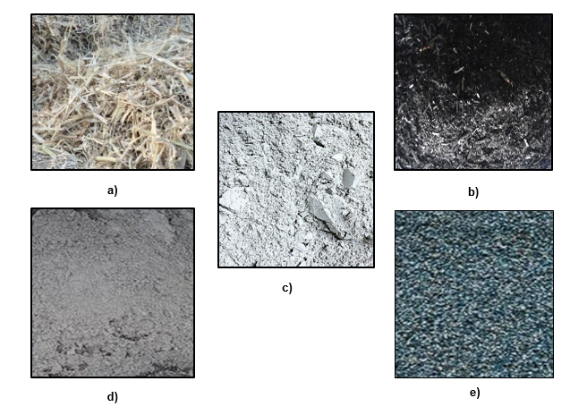
Figure 1:Materials: a) Raw Sugar Cane Bagasse, b) Bagasse Ash, c) Cement ,d) Sand and e) Coarse Aggregate
2.2. Mix Proportions
The mix design was formulated using the ACI 318 method. A total of five concrete mixes were prepared: one control mix (0% replacement) and four experimental mixes with varying replacement levels of cement and fine aggregate with SBHA. The replacement levels for cement were 10%, 20%, 25%, and 30% by weight of OPC. The corresponding replacement levels for fine aggregate were 80%, 50%, 100%, and 10% by weight of sand, respectively. This investigation of dual replacement (cement and aggregate) addresses a noted gap, as other studies have typically focused on single replacements, such as "5–40% cement replacement" or "10-40% fine aggregate" replacement alone(Jahanzaib Khalil, Aslam, and Ahmad 2021)(Bheel et al. 2022). The detailed mix proportions for all mixes, measured by weight (kg) per batch, are presented in Table 1. The water-cement ratio was maintained consistently across all mixes.

Table 1: Mix Proportions of Concrete Specimens with Partial Replacement of Cement and Fine Aggregate by Sugarcane Bagasse Ash (SBHA)
ID | Description | Total  Cylinders | C  (kg) | SBHA as C  (kg) | C  (%) | W/R  (%) | G  (kg) | S  (kg) | SBHA as S  (kg) | S  (%) | Total Fine  (S + SBHA_S)  (kg) | Total  Batch Mass  (kg)
S1 | S1(0%) | 6 | 10.61 | 0 | 0 | 0.6 | 36.8 | 29.28 | 0 | 0 | 29.28 | 76.69
S2 | S2(10C,80S) | 6 | 9.55 | 1.06 | 10 | 0.6 | 36.8 | 5.86 | 23.42 | 80 | 29.28 | 76.69
S3 | S3(20C,50S) | 6 | 8.49 | 2.12 | 20 | 0.6 | 36.8 | 14.64 | 14.64 | 50 | 29.28 | 76.69
S4 | S4(30C,10S) | 6 | 7.43 | 3.18 | 30 | 0.6 | 36.8 | 26.35 | 2.93 | 10 | 29.28 | 76.69
S5 | S5(25C,100S) | 6 | 7.96 | 2.65 | 25 | 0.6 | 36.8 | 0 | 29.28 | 100 | 29.28 | 76.69

2.3. Experimental Program and Test Procedures
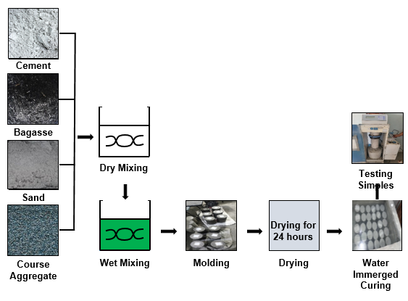
Figure 2:Schematic Diagram of Experimental Program
All materials were measured by weight (kg). The mixing sequence involved first adding the coarse aggregate, followed by the fine aggregate, then the cement and SBHA; these dry materials were mixed until a homogeneous mixture was achieved, after which water was added. Mixing was performed manually until the mixture was completely homogenous. The workability of each fresh concrete mix was assessed immediately after mixing via a slump test conducted in accordance with ASTM C143 at an ambient temperature of 25°C. The measured slump values for each mix are recorded in Table 1 and 2 .
For each mix, six cylindrical specimens (150 mm diameter and 300 mm length) were cast. The specimens were not demolded and were cured fully submerged in a water tank maintained at a temperature of 25 ± 3°C until testing. The primary test conducted was the compressive strength test, a common method employed in similar studies (Loganayagan, Mohan, and Dhivyabharathi 2021)(Joshaghani and Moeini 2017). The tests were performed at 7 and 28 days of curing using a digital compressive strength machine following the standard procedure outlined in ASTM C39. For each mix and testing age, three specimens were tested, and the results were averaged. There were no deviations from the norms defined in the standard regarding the application of the loading rate. During the various procedures of mixing, casting, curing, and testing, no issues, abnormalities, and apparent demerits such as physical cracks or segregation of the base materials were detected.
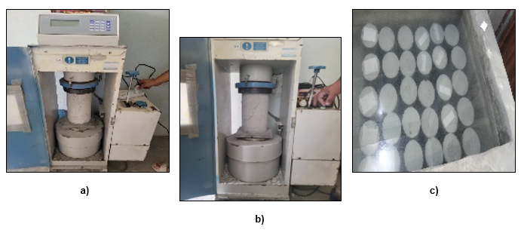
Figure 3:a) Specimen testing for compressive Strength, b) Specimen after testing and c) Specimen in curing tank.

3. Results and Discussion
This research focused on the impact concrete properties when cement and fine aggregate are substituted with sugarcane bagasse ash (SBHA) on partial basis. There are five concrete mixes which were prepared: one control mix (S1: 0% SBHA) and four experimental mixes with varying dual replacement levels (S2: 10% cement, 80% sand; S3: 20% cement, 50% sand; S4: 30% cement, 10% sand; S5: 25% cement, 100% sand). The main tests done were liquid permeability tests and compressive strength tests that were done after 7 and 28 days and.
3.1. Experimental Scope and Mix Design Summary
The objective was to examine the impact of SBHA as a replacement for both cement and fine aggregate. The mix designs had one control (S1: 0% SBHA) and four experimental mixes: S2 (10% cement, 80% sand), S3 (20% cement, 50% sand), S4 (30% cement, 10% sand), and S5 (25% cement, 100% sand). The property of interest was the compressive strength, taken within the 7 to 28 day frame.
3.2. Workability (Slump)
The workability of fresh concrete, measured by slump test, is presented in Table 1. The control mix (S1) exhibited a slump of 25.4 mm. Among the SBHA mixes, only S2 (10% cement, 80% sand) showed increased workability with a slump of 50.8 mm. Mixes S3, S4, and S5 all resulted in a slump equal to the control at 25.4 mm. This variation aligns with literature findings, where "finer SBFA improved packing density"(Alvarenga and Cordeiro 2024). which could explain the increased workability in Mix S2. However, the general consensus indicates that ">20% replacement reduces workability/strength due to higher water demand from porous ashes" (Hamza Hasnain et al. 2021). This variability aligns with findings that "Workability decreased with higher replacements"(Fauzi et al. 2018) and "Workability and density decreased with higher replacements" (Bheel et al. 2022) The similar slump values in three of the four mixes, despite high aggregate replacement, suggest that the water demand of the specific SBHA used was manageable within the established w/c ratio.

Table 2: Slump Flow vs Concrete Mix
Specimen ID | Description | Slump Flow  (mm)
S1 | S1(0%) | 25.4
S2 | S2(10C,80S) | 50.8
S3 | S2(20C,50S) | 25.4
S4 | S2(30C,10S) | 25.4
S5 | S2(25C,100S) | 25.4

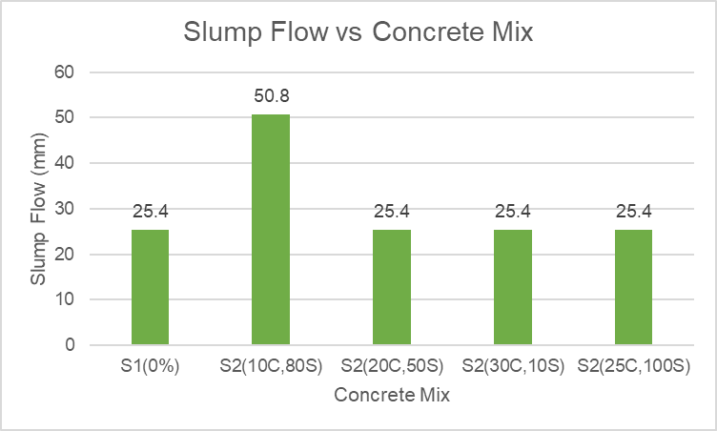
Figure 4: Slump Flow vs Concrete Mix
3.3. Compressive Strength
3.3.1. Data Presentation and Overall Trend
Compressive strength was the primary focus of this investigation. The results are summarized in Table 2 and visualized in Figure 1. A clear overall trend was observed where the incorporation of SBHA as a dual replacement led to a significant reduction in early and later-age compressive strength compared to the control. The overall trend indicates that compressive strength decreases as the replacement level of SBHA increases, with all experimental mixes showing lower strength than the control at both testing ages.
Table 3: Compressive Strength of Concrete with Partial Replacement of Cement and Fine Aggregate by Bagasse Ash
Specimen ID | Replacement Materials by SBGA | Days | Stress  (Mpa) | Days | Stress  (Mpa)
S1 | S1(0%) | 7 | 14.1 | 28 | 22.7
S2 | S2(10C,80S) | 7 | 2.3 | 28 | 11.3
S3 | S3(20C,50S) | 7 | 2.6 | 28 | 11.7
S4 | S4(30C,10S) | 7 | 5.5 | 28 | 14.7
S5 | S5(25C,100S) | 7 | 4.4 | 28 | 13.6

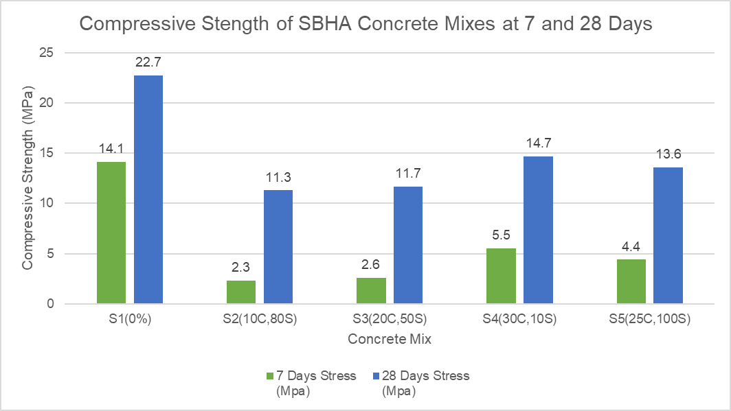
Figure 5: Compressive Strength of SBHA Concrete Mixes at 7 and 28 Days

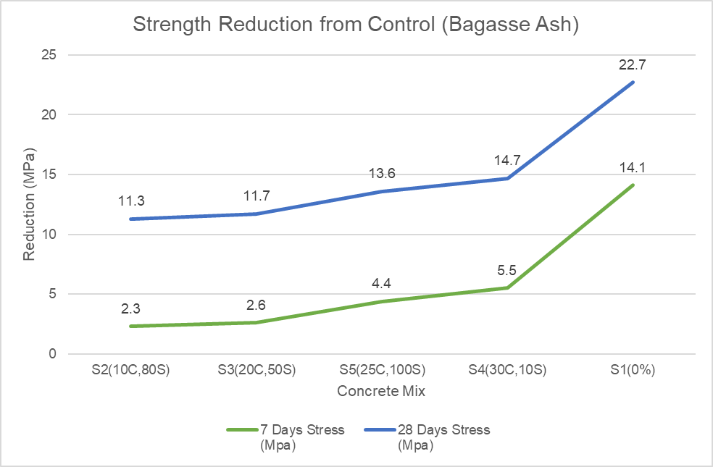
Figure 6:Compressive Strength Development of Concrete with Varying SBHA Replacement Levels

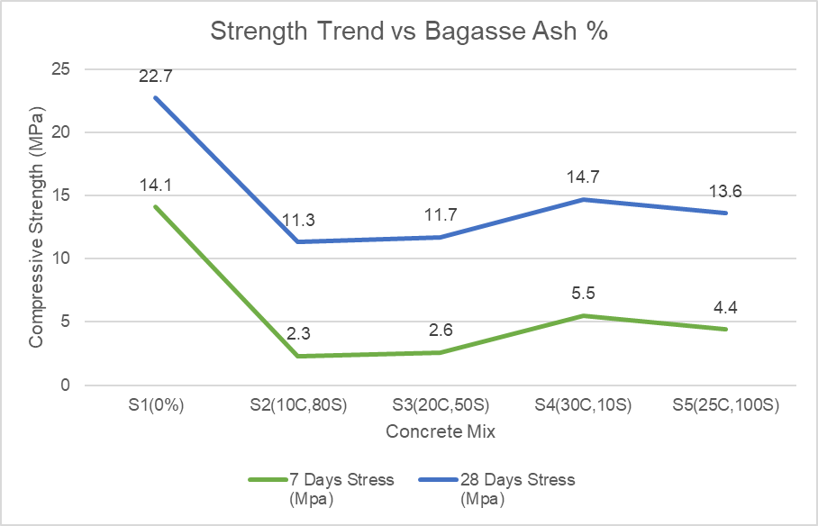
Figure 7:Compressive Strength Reduction of Concrete with Bagasse Ash Replacement at 7 and 28 Days

Table 4:Optimal Replacement Levels of Cement and Fine Aggregate with Sugarcane Bagasse Ash (SBHA)
3.3.2. Specific Results and Mechanistic Analysis
At 28 days, the control mix (S1) achieved a strength of 22.7 MPa. The experimental mixes attained strengths of 11.3 MPa (S2), 13.6 MPa (S3), 14.7 MPa (S4), and 11.7 MPa (S5). This represents a strength reduction of approximately 50.2%, 40.1%, 35.2%, and 48.5% for mixes S2, S3, S4, and S5, respectively. The highest strength among SBHA mixes was achieved by S4 (30% cement, 10% sand) at 14.7 MPa, representing a 35.2% reduction from the control. The mechanism for this strength reduction is the dilution of cementitious compounds and the potential for higher water demand, though the latter was mitigated by maintaining a constant w/c ratio. The significant strength reduction is attributed to the dilution of cementitious materials and the potential lack of sufficient pozzolanic activity from the SBHA used in this study to compensate for the reduced cement content. This aligns with findings for less reactive ashes, where "SCB BA reduced strength unless w/c adjusted" (Torres de Sande et al. 2021). The low strength results, especially in mixes S2 and S5 with high sand replacement (80% and 100%), suggest that the SBHA used may have lacked sufficient pozzolanicity or acted primarily as an inert, fine material that disrupted the packing density. This finding is consistent with literature, which states that "Higher SCBA replacements (>20%) show reduced strength"(Dineshkumar and Balamurugan 2021).
3.3.3. Comparison with Literature and Optimal Replacement Level
The results contrast with studies on processed ash, which reported strength gains; for instance, "Best compressive strength (14.5% increase) at 10% SCBA replacement" as a sand replacement(Khawaja et al. 2021b) and "Finer SBFA (10µm) showed 8% higher compressive strength than reference mortar" at 20% cement replacement(Alvarenga and Cordeiro 2024). The results of this study contrast with some literature findings that reported strength gains at certain replacement levels. For instance, one study found "Best compressive strength at 20% SCBA replacement (4.35% increase over control)"(Dineshkumar and Balamurugan 2021), while another reported "Best compressive strength with 30% SCBA"(França et al. 2023). The discrepancy can be attributed to differences in the processing of the ash, its pozzolanic activity, and the fact that this study utilized a dual-replacement strategy, whereas the cited literature often replaced only cement or fine aggregate alone, such as "5–40% cement replacement" or "10-40% fine aggregate" replacement(Jahanzaib Khalil, Aslam, and Ahmad 2021)(Bheel et al. 2022). The observed strength reduction is a common finding in studies utilizing untreated or minimally processed ash, which can be attributed to the "Lack of clarity on optimal processing methods (burning/grinding)"(Jagadesh, Ramachandramurthy, and Murugesan 2018) and the fact that under certain conditions, "SCBA acts more as filler than pozzolan"(Arif, Clark, and Lake 2016). Based on the 28-day compressive strength results, the optimal dual replacement level from the tested combinations is 30% SBHA for cement and 10% SBHA for fine aggregate (Mix S4), which achieved the highest strength among the SBHA mixes at 14.7 MPa. The superior performance of Mix S4 suggests that replacing a higher proportion of cement while minimizing disruption to the fine aggregate skeleton yields better results. The percentage strength reduction for all mixes compared to the control is shown in Figure 2.
Table 5:Percentage Reduction in Compressive Strength at 7 and 28 Days
Specimen ID | Replacement Materials by SBGA | 7-day Strength  (MPa) | 28-day Strength  (MPa) | % Reduction  (7 days) | % Reduction  (28 days)
S1 | S1(0%) | 14.1 | 22.7 | 0.0% | 0.0%
S2 | S2(10C,80S) | 2.3 | 11.3 | 83.7% | 50.2%
S3 | S3(20C,50S) | 2.6 | 11.7 | 81.6% | 48.5%
S4 | S4(30C,10S) | 5.5 | 14.7 | 61.0% | 35.2%
S5 | S5(25C,100S) | 4.4 | 13.6 | 68.8% | 40.1%

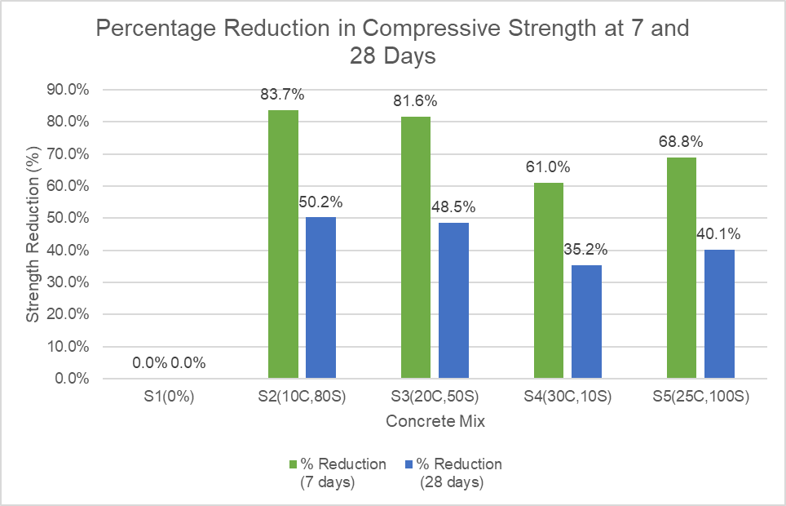
Figure 8:Percentage Reduction in Compressive Strength at 7 and 28 Days
3.4. Tensile Strength, Water Absorption, and Dry Density
This study focused exclusively on compressive strength. Tensile strength, water absorption, and dry density were not tested. The scope was limited to the evaluation of compressive strength to establish a baseline for the effect of dual SBHA replacement.
3.5. Environmental Performance
While this study did not conduct a quantitative life cycle assessment, the use of SBHA aligns with the broader environmental benefits identified in the literature. Utilizing SBHA as a partial replacement for cement and fine aggregate inherently contributes to sustainability. Numerous studies confirm that utilizing bagasse ash "reduces waste/sand depletion"(Hamza Hasnain et al. 2021)(Khawaja et al. 2021a), offers "sustainability benefits" (Anandaraj et al. 2023), and contributes to "reducing cement industry CO₂ emissions"(Alvarenga and Cordeiro 2024)(Nangulama and Rimoy 2025). The primary advantage is the "reduced CO₂ emissions" associated with lowering cement consumption(Jagadesh, Ramachandramurthy, and Murugesan 2018)(Chindaprasirt et al. 2020). This is supported by multiple studies: "Yes (reduces cement demand and waste disposal)(Memon et al. 2022)" ; "Yes (cost analysis shows 8% reduction; environmental benefits highlighted)"(França et al. 2023); and "SCBA usage reduces cement consumption, minimizes agro-industrial waste, and lowers carbon emissions"(Dineshkumar and Balamurugan 2021). Therefore, despite the compressive strength reductions observed, the significant environmental benefits provide a strong motivation for further research into optimizing its application.
3.6. Concluding Insights on Compressive Strength
The investigation revealed a general decrease in strength with increasing SBHA replacement levels. The key challenge is that the optimal mix (S4) still had a 35.2% strength reduction. This underscores a critical limitation: the use of untreated or minimally processed ash, as noted in the gap "Need for controlled processing"(Barbosa and Cordeiro 2021). The results suggest that for dual replacement to be viable, pre-treatment of the ash to enhance its pozzolanicity is essential. Future work should focus on improving the pozzolanic reactivity of the SBHA through more controlled burning and grinding processing techniques, as suggested by the need for "further optimization of SCBA processing"(França et al. 2023). This includes exploring methods like "microwave calcination (30 min at 600°C)" which "yielded SCBA with highest amorphous silica (17.5%) and pozzolanic reactivity"(J. A. Rossignolo et al. 2018) or ensuring "SCBA was calcined at 600°C and ball-milled to d=12µm"(Wu et al. 2022), a level of processing not employed in this study, which may be necessary for effective performance at high replacement levels.
4-Conclusion:
Based on the comprehensive experimental investigation into the use of sugarcane bagasse ash (SBHA) as a partial replacement for both cement and fine aggregate, the following conclusions are drawn. This study aimed to evaluate the effect of this dual replacement strategy on the compressive strength of concrete. The overarching trend portrays yield strengths decreasing with increased levels of SBHA replacement, with all of the experimental mixes confirming the control weaknesses at both testing ages. The highest strength among SBHA mixes was achieved by S4 (30% cement, 10% sand) at 14.7 MPa, representing a 35.2% reduction from the control. The significant strength reduction is attributed to the dilution of cementitious materials and the potential lack of sufficient pozzolanic activity from the SBHA used in this study to compensate for the reduced cement content, aligning with findings for less reactive ashes.
The optimal dual replacement level from the tested combinations is 30% SBHA for cement and 10% SBHA for fine aggregate (Mix S4), which achieved the highest strength among the SBHA mixes. The superior performance of Mix S4 suggests that replacing a higher proportion of cement while minimizing disruption to the fine aggregate skeleton yields better results. An additional observation is that the scope was limited to compressive strength, excluding assessments of durability properties such as water absorption and long-term performance, which remain unverified. Despite the compressive strength reductions observed, utilizing SBHA aligns with the broader environmental benefits identified in the literature. Utilizing SBHA as a partial replacement inherently contributes to sustainability by reducing waste and sand depletion, minimizing agro-industrial waste, and lowering carbon emissions associated with cement consumption.
The primary practical implication of these findings is that the significant environmental benefits provide a strong motivation for its application, particularly in non-structural or low-load applications where high compressive strength is not the primary requirement. For future research, it is recommended to focus on improving the pozzolanic reactivity of the SBHA through more controlled burning and grinding processing techniques. This includes exploring specific methods to enhance its properties. Furthermore, comprehensive evaluations of durability, microstructural analysis using techniques like SEM and XRD to understand the ash-cement interface, and a full quantitative environmental impact assessment via Life Cycle Assessment (LCA) are critical next steps to validate and optimize the use of SBHA in concrete.
5-Recommendations:
Based on the experimental outcomes of this study, it is recommended that sugarcane bagasse ash (SBHA) be used as a partial replacement for cement at 30% and for fine aggregate at 10% by weight, as this combination yielded the highest compressive strength among all tested SBHA mixes. This recommendation is directed primarily to non-structural or low-load applications where low cost and environmentally friendly practices are more important than maximum structural strength. This is the case since, even for the optimal mix, there was still a marked reduction in compressive strength compared to the conventional control. The use of SBHA in such contexts supports waste valorization and reduces the environmental footprint of concrete production. For future work, comprehensive studies on durability properties, microstructural analysis, and a full quantitative life cycle assessment are essential to validate and optimize these recommendations for broader application.

Disclaimer (Artificial intelligence)
Option 1:
Author(s) hereby declare that NO generative AI technologies such as Large Language Models (ChatGPT, COPILOT, etc.) and text-to-image generators have been used during the writing or editing of this manuscript.
Option 2:
Author(s) hereby declare that generative AI technologies such as Large Language Models, etc. have been used during the writing or editing of manuscripts. This explanation will include the name, version, model, and source of the generative AI technology and as well as all input prompts provided to the generative AI technology
Details of the AI usage are given below:
1.
2.
3.
Data availability Not applicable.
Declarations
Conflict of interest The authors declare no competing interests.

6-Refrences:
- Alvarenga, Ketlynn Passos, and Guilherme Chagas Cordeiro. 2024. “Evaluating Sugarcane Bagasse Fly Ash as a Sustainable Cement Replacement for Enhanced Performance.” Cleaner Engineering and Technology 20(April): 100751. doi:10.1016/j.clet.2024.100751.
- Anandaraj, S., S. Karthik, S. Sylesh, R. Kishor, K. Suresh, K. Jai Prakash, and KA A. Dinesh Kannan. 2023. “Experimental Investigation on Sugarcane Bagasse Fiber Reinforced Concrete Using Bottom Ash as Sand Replacement.” Materials Today: Proceedings (xxxx). doi:10.1016/j.matpr.2023.03.469.
- Anjos, Marcos A.S., Tomaz R. Araújo, Ruan L.S. Ferreira, Evilane C. Farias, and Antonio E. Martinelli. 2020. “Properties of Self-Leveling Mortars Incorporating a High-Volume of Sugar Cane Bagasse Ash as Partial Portland Cement Replacement.” Journal of Building Engineering 32(June): 101694. doi:10.1016/j.jobe.2020.101694.
- Arbelaez Perez, Oscar Felipe, Daniela Restrepo Florez, Laura Melina Zapata Vergara, and Karen Viviana Hernández Benavides. 2022. “Innovative Use of Agro-Waste Cane Bagasse Ash and Waste Glass as Cement Replacement for Green Concrete. Cost Analysis and Carbon Dioxide Emissions.” Journal of Cleaner Production 379(October). doi:10.1016/j.jclepro.2022.134822.
- Arenas-Piedrahita, J. C., P. Montes-García, J. M. Mendoza-Rangel, H. Z. López Calvo, P. L. Valdez-Tamez, and J. Martínez-Reyes. 2016. “Mechanical and Durability Properties of Mortars Prepared with Untreated Sugarcane Bagasse Ash and Untreated Fly Ash.” Construction and Building Materials 105: 69–81. doi:10.1016/j.conbuildmat.2015.12.047.
- Arif, Elisabeth, Malcolm W. Clark, and Neal Lake. 2016. “Sugar Cane Bagasse Ash from a High Efficiency Co-Generation Boiler: Applications in Cement and Mortar Production.” Construction and Building Materials 128: 287–97. doi:10.1016/j.conbuildmat.2016.10.091.
- Barbosa, Fabrício Lima, and Guilherme Chagas Cordeiro. 2021. “Partial Cement Replacement by Different Sugar Cane Bagasse Ashes: Hydration-Related Properties, Compressive Strength and Autogenous Shrinkage.” Construction and Building Materials 272: 8–11. doi:10.1016/j.conbuildmat.2020.121625.
- Berenguer, Romildo A., Ana Paula B. Capraro, Marcelo H. Farias de Medeiros, Arnaldo M.P. Carneiro, and Romilde A. de Oliveira. 2020. “Sugar Cane Bagasse Ash as a Partial Substitute of Portland Cement: Effect on Mechanical Properties and Emission of Carbon Dioxide.” Journal of Environmental Chemical Engineering 8(2): 103655. doi:10.1016/j.jece.2020.103655.
- Bheel, Naraindas, Salim Khoso, Mereen Hussain Baloch, Omrane Benjeddou, and Mamdooh Alwetaishi. 2022. “Use of Waste Recycling Coal Bottom Ash and Sugarcane Bagasse Ash as Cement and Sand Replacement Material to Produce Sustainable Concrete.” Environmental Science and Pollution Research 29(35): 52399–411. doi:10.1007/s11356-022-19478-3.
- Chindaprasirt, Prinya, Wunchock Kroehong, Nattapong Damrongwiriyanupap, Wuthisak Suriyo, and Chai Jaturapitakkul. 2020. “Mechanical Properties, Chloride Resistance and Microstructure of Portland Fly Ash Cement Concrete Containing High Volume Bagasse Ash.” Journal of Building Engineering 31(April): 101415. doi:10.1016/j.jobe.2020.101415.
- Dineshkumar, R., and P. Balamurugan. 2021. “Behavior of High-Strength Concrete with Sugarcane Bagasse Ash as Replacement for Cement.” Innovative Infrastructure Solutions 6(2): 1–12. doi:10.1007/s41062-020-00450-4.
- Fauzi, Mohd Azrizal, Siti Rahimah Rosseli, Mohd Jamuri, and Abu Seman. 2018. Regional Conference on Science, Technology and Social Sciences (RCSTSS 2016) Regional Conference on Science, Technology and Social Sciences (RCSTSS 2016). Springer Singapore. doi:10.1007/978-981-13-0074-5.
- França, Sâmara, Leila Nóbrega Sousa, Sérgio Luiz Costa Saraiva, Maria Cecília Novaes Firmo Ferreira, Marcos Vinicio de Moura Solar Silva, Romero César Gomes, Conrado de Souza Rodrigues, Maria Teresa Paulino Aguilar, and Augusto Cesar da Silva Bezerra. 2023. “Feasibility of Using Sugar Cane Bagasse Ash in Partial Replacement of Portland Cement Clinker.” Buildings 13(4). doi:10.3390/buildings13040843.
- Francioso, Vito, Marina Lopez-Arias, Carlos Moro, Nusrat Jung, and Mirian Velay-Lizancos. 2023. “Impact of Curing Temperature on the Life Cycle Assessment of Sugarcane Bagasse Ash as a Partial Replacement of Cement in Mortars.” Sustainability (Switzerland) 15(1). doi:10.3390/su15010142.
- Gaddam, Kalpana. 2021. “Sustainability Studies on Concrete Partial Replacement of Sugarcane Granular Bagasse-Ash in Cement.” IOP Conference Series: Earth and Environmental Science 822(1). doi:10.1088/1755-1315/822/1/012037.
- Gudia, Sarah Emily L., Alchris Woo Go, Marnie B. Giduquio, Roxanne G. Juanir, Janice B. Jamora, Chintya Gunarto, and Ian Dominic F. Tabañag. 2023. “Sugarcane Bagasse Ash as a Partial Replacement for Cement in Paste and Mortar Formulation – A Case in the Philippines.” Journal of Building Engineering 76(May). doi:10.1016/j.jobe.2023.107221.
- Hamza Hasnain, Muhammad, Usman Javed, Ather Ali, and Muhammad Saeed Zafar. 2021. “Eco-Friendly Utilization of Rice Husk Ash and Bagasse Ash Blend as Partial Sand Replacement in Self-Compacting Concrete.” Construction and Building Materials 273: 121753. doi:10.1016/J.CONBUILDMAT.2020.121753.
- Imran, Nik Farhanim, Nor Hafida Hashim, Daliah Hasan, Ahmad Shalabi Mohd Radzi, and Muhammad Tasnim Harizan. 2023. “Behaviour of Normal Concrete with Sugarcane Bagasse Ash (ScBA) as Partial Cement Replacement.” IOP Conference Series: Earth and Environmental Science 1238(1). doi:10.1088/1755-1315/1238/1/012016.
- Jagadesh, P., A. Ramachandramurthy, and R. Murugesan. 2018. “Evaluation of Mechanical Properties of Sugar Cane Bagasse Ash Concrete.” Construction and Building Materials 176: 608–17. doi:10.1016/j.conbuildmat.2018.05.037.
- Jahanzaib Khalil, Muhammad, Muhammad Aslam, and Sajjad Ahmad. 2021. “Utilization of Sugarcane Bagasse Ash as Cement Replacement for the Production of Sustainable Concrete – A Review.” Construction and Building Materials 270: 121371. doi:10.1016/j.conbuildmat.2020.121371.
- Jha, Pooja, A. K. Sachan, and R. P. Singh. 2020. “Investigation on the Durability of Concrete with Partial Replacement of Cement by Bagasse Ash (BAH) and Sand by Stone Dust (SDT).” Materials Today: Proceedings 43: 237–43. doi:10.1016/j.matpr.2020.11.652.
- Joshaghani, Alireza, and Mohammad Amin Moeini. 2017. “Evaluating the Effects of Sugar Cane Bagasse Ash (SCBA) and Nanosilica on the Mechanical and Durability Properties of Mortar.” Construction and Building Materials 152: 818–31. doi:10.1016/j.conbuildmat.2017.07.041.
- Kannan, V. 2018. “Strength and Durability Performance of Self Compacting Concrete Containing Self-Combusted Rice Husk Ash and Metakaolin.” Construction and Building Materials 160: 169–79. doi:10.1016/j.conbuildmat.2017.11.043.
- Khawaja, Saleh Ali, Usman Javed, Tayyab Zafar, Mamoon Riaz, Muhammad Saeed Zafar, and Muhammad Khizar Khan. 2021a. “Eco-Friendly Incorporation of Sugarcane Bagasse Ash as Partial Replacement of Sand in Foam Concrete.” Cleaner Engineering and Technology 4: 100164. doi:10.1016/J.CLET.2021.100164.
- Khawaja, Saleh Ali, Usman Javed, Tayyab Zafar, Mamoon Riaz, Muhammad Saeed Zafar, and Muhammad Khizar Khan. 2021b. “Eco-Friendly Incorporation of Sugarcane Bagasse Ash as Partial Replacement of Sand in Foam Concrete.” Cleaner Engineering and Technology 4: 100164. doi:10.1016/j.clet.2021.100164.
- Kunchariyakun, Kittipong, Suwimol Asavapisit, and Suthatip Sinyoung. 2018. “Influence of Partial Sand Replacement by Black Rice Husk Ash and Bagasse Ash on Properties of Autoclaved Aerated Concrete under Different Temperatures and Times.” Construction and Building Materials 173: 220–27. doi:10.1016/j.conbuildmat.2018.04.043.
- Loganayagan, S., N. Chandra Mohan, and S. Dhivyabharathi. 2021. “Sugarcane Bagasse Ash as Alternate Supplementary Cementitious Material in Concrete.” Materials Today: Proceedings 45: 1004–7. doi:10.1016/j.matpr.2020.03.060.
- Lourdu, Arun Raja, and Shahul Hameed Masthan Ali. 2023. “Study on Strength, Durable and Flexural Behaviour of Partial Replacement of Sugarcane Bagasse Ash over Cement.” Materials Research Express 10(9). doi:10.1088/2053-1591/acf6ad.
- Mangi, Sajjad Ali, N. Jamaluddin, M. H. Wan Ibrahim, Abd Halid Abdullah, A. S.M. Abdul Awal, Samiullah Sohu, and Nizakat Ali. 2017. “Utilization of Sugarcane Bagasse Ash in Concrete as Partial Replacement of Cement.” IOP Conference Series: Materials Science and Engineering 271(1). doi:10.1088/1757-899X/271/1/012001.
- Memon, Shazim Ali, Usman Javed, Muhammad Izhar Shah, and Asad Hanif. 2022. “Use of Processed Sugarcane Bagasse Ash in Concrete as Partial Replacement of Cement: Mechanical and Durability Properties.” Buildings 12(10). doi:10.3390/buildings12101769.
- Nangulama, Horris K., and Siya P. Rimoy. 2025. “Feasibility of Using Bagasse Ash Incorporating Limestone Calcined Clay Cement as Ordinary Portland Cement Replacement for Stabilisation of Black Cotton Soils.” Cleaner Waste Systems 10(January): 100226. doi:10.1016/j.clwas.2025.100226.
- Rerkpiboon, Aukkadet, Weerachart Tangchirapat, and Chai Jaturapitakkul. 2015. “Strength, Chloride Resistance, and Expansion of Concretes Containing Ground Bagasse Ash.” Construction and Building Materials 101: 983–89. doi:10.1016/j.conbuildmat.2015.10.140.
- Rossignolo, J. A., M. V. Borrachero, L. Soriano, and J. Payá. 2018. “Influence of Microwave Oven Calcination on the Pozzolanicity of Sugar Cane Bagasse Ashes (SCBA) from the Cogeneration Industry.” Construction and Building Materials 187: 892–902. doi:10.1016/j.conbuildmat.2018.08.016.
- Rossignolo, João Adriano, Michelle Santos Rodrigues, Moises Frias, Sérgio Francisco Santos, and Holmer Savastano Junior. 2017. “Improved Interfacial Transition Zone between Aggregate-Cementitious Matrix by Addition Sugarcane Industrial Ash.” Cement and Concrete Composites 80: 157–67. doi:10.1016/j.cemconcomp.2017.03.011.
- Rukzon, Sumrerng, and Prinya Chindaprasirt. 2012. “Utilization of Bagasse Ash in High-Strength Concrete.” JOURNAL OF MATERIALS&DESIGN 34: 45–50. doi:10.1016/j.matdes.2011.07.045.
- Setayesh Gar, Parisa, Narayana Suresh, and Vivek Bindiganavile. 2017. “Sugar Cane Bagasse Ash as a Pozzolanic Admixture in Concrete for Resistance to Sustained Elevated Temperatures.” Construction and Building Materials 153: 929–36. doi:10.1016/j.conbuildmat.2017.07.107.
- Srivani, G., and U. Vamsi Mohan. 2023. “Study on Strength Properties of Concrete by Partial Replacement of Cement with Sugarcane Bagasse Ash and Coarse Aggregate with Coconut Shells.” Materials Today: Proceedings (xxxx). doi:10.1016/j.matpr.2023.03.439.
- Subedi, Sujata, Gabriel A. Arce, Marwa M. Hassan, Michele Barbato, Louay N. Mohammad, and Tyson Rupnow. 2022. “Feasibility of ECC with High Contents of Post-Processed Bagasse Ash as Partial Cement Replacement.” Construction and Building Materials 319(May 2021): 126023. doi:10.1016/j.conbuildmat.2021.126023.
- Torres de Sande, Veronica, Monower Sadique, Paloma Pineda, Ana Bras, William Atherton, and Mike Riley. 2021. “Potential Use of Sugar Cane Bagasse Ash as Sand Replacement for Durable Concrete.” Journal of Building Engineering 39(December 2020): 102277. doi:10.1016/j.jobe.2021.102277.
- Wang, Hao, and Jong Min Lee. 2020. 8 Journal of Materials Chemistry A Recent Advances in Structural Engineering of MXene Electrocatalysts. doi:10.1039/d0ta03271a.
- Wu, Nengsen, Tao Ji, Ping Huang, Tengfei Fu, Xiaoyan Zheng, and Qing Xu. 2022. “Use of Sugar Cane Bagasse Ash in Ultra-High Performance Concrete (UHPC) as Cement Replacement.” Construction and Building Materials 317(November 2021): 125881. doi:10.1016/j.conbuildmat.2021.125881.
- Yogitha, Bayapureddy, M. Karthikeyan, and M. G. Muni Reddy. 2020. “Progress of Sugarcane Bagasse Ash Applications in Production of Eco-Friendly Concrete - Review.” Materials Today: Proceedings 33: 695–99. doi:10.1016/j.matpr.2020.05.814.

