
Advances in Research

Volume XXX, Issue XX, Page XX-XX, 20YY; Article no.AIR.149275
ISSN: 2348-0394, NLM ID: 101666096

Functional Correlation between

Floral Style Length and Ovipositor

Length in Ficus benghalensis –

Eupristina masoni Mutualism Across South India

Authors’ Name……………………………………………………

Affiliations……………………………………………………….………………

Authors’ contributions

This work was carried out in collaboration among all authors. ‘Author A’ designed the study, performed the statistical analysis, wrote the protocol, and wrote the first draft of the manuscript. ‘Author B’ and ‘Author C’ managed the analyses of the study. ‘Author C’ managed the literature searches. All authors read and approved the final manuscript.

Article Information

DOI: 10.9734/AIR/2025/XXXXX

Open Peer Review History:
This journal follows the Advanced Open Peer Review policy. Identity of the Reviewers, Editor(s) and additional Reviewers, peer review comments, different versions of the manuscript, comments of the editors, etc are available here:

Received: DD/MM/20YY
………… Article
Published: DD/MM/20YY

ABSTRACT

The present study aimed to quantify the functional relationship between floral style length (stigma + style) in Ficus benghalensis and the ovipositor length of its obligate pollinator Eupristina masoni across ecologically distinct populations in South India. A total of Twenty-five receptive-phase flowers and 25 emerging female pollinating wasps were measured per site. Floral style length was recorded under a stereomicroscope, while ovipositor length was measured using an ocular micrometer. Summary statistics, Pearson’s correlations, ANOVA, and mismatch analyses were performed. Floral style length (mean = 1.76 mm) exceeded ovipositor length (mean = 1.50 mm) in most flowers, with only 38.5% of flowers having style length ≤ ovipositor length. Individual-level correlation between style and ovipositor length was statistically significant but modest (r = 0.313, P < .001), whereas site-level mean traits were strongly correlated (r = 0.817, P < .001). Both traits varied significantly among populations, with ovipositors showing lower within-site variation compared to floral styles. The Ficus benghalensis–Eupristina masoni mutualism exhibits strong but imperfect morphological matching. Geographic covariation suggests coevolution and local adaptation, but the consistent floral advantage (styles deeper than ovipositors) indicates an evolutionary balance favouring increased seed production over wasp brood success.

Keywords: Fig–wasp mutualism; floral style length; ovipositor length; functional mismatch; coevolution; Ficus benghalensis; Eupristina masoni; South India.

1. INTRODUCTION

The obligate mutualism between figs (Ficus spp.) and their pollinating wasps (Hymenoptera: Agaonidae) is one of the most iconic and well-studied examples of coevolution in plant–insect systems. Each fig species typically depends on a single specialist wasp for pollination, and the wasp in turn relies on the fig syconium as the only site for oviposition, larval development and mating (Cook and Rasplus, 2003; Herre et al., 2008). Molecular phylogenies and fossil-calibrated estimates suggest that this association has persisted for more than 60–90 million years, indicating remarkable evolutionary stability while still generating extensive species diversification (Machado et al., 2005; Cruaud et al., 2012; Zhang et al.,2021).

Because pollinating wasps cannot reproduce outside the fig inflorescence owing to its urn-shaped structure that can be accessed only through the ostiole and figs cannot be pollinated without the wasps, both partners are absolute mutualists and therefore tightly interdependent for their reproductive success (Weiblen, 2002; Sutton et al., 2022).

A central functional attribute regulating the outcome of this relationship is the correspondence between floral style length and pollinator ovipositor length. The wasp can successfully oviposit only when the ovipositor reaches the ovule, whereas seeds are typically produced in flowers where style depth exceeds ovipositor reach. Consequently, the proportional relationship between these traits determines how reproductive resources are partitioned between plant seed set and wasp offspring production (West et al., 1995; Ganeshaiah et al., 1995). A mechanism long proposed to stabilise brood-site pollination mutualisms by limiting overexploitation by the wasp (Nefdt & Compton, 1996; Dunn, 2020; Yu et al., 2021).

Theoretical and empirical work further indicates that figs and wasps experience conflicting selection pressures: figs benefit from styles that limit oviposition and favour seed production, whereas wasps are selected to optimize ovipositor length to maximize brood success (Nefdt and Compton, 1996; Moore et al., 2008; Souto-Vilarós et al., 2018; Deng et al., 2021). Variation in floral and wasp traits can therefore reflect a balance between mutualism and conflict rather than perfect evolutionary cooperation (Wang et al., 2021).

Ficus benghalensis L., the Indian banyan, is a widespread, ecologically dominant keystone species throughout the Indian subcontinent. Its pollinator, Eupristina masoni Saunders, is an obligate internal pollinator that completes its entire life cycle inside the syconia of Ficus benghalensis and is highly synchronized with host flowering phenology. Despite the ecological and cultural prominence of this species pair, morphometric assessments of floral–pollinator trait matching across the natural geographic range of Ficus benghalensis remain limited. Spatial heterogeneity in climatic regimes, elevation and resource availability may drive divergent local selection pressures on floral architecture and pollinator morphology, potentially altering the precision of functional matching among populations (Souto-Vilarós et al., 2018; Pothasin et al., 2016; Gao et al., 2023; Teixeira & Kjellberg, 2023).

The present study addresses this gap by analysing 16 geographically distinct populations of Ficus benghalensis across South India to (i) quantify spatial variation in floral style (stigma + style) length and, Eupristina masoni ovipositor length, (ii) assess the strength of style–ovipositor correlation at both individual and population scales, and (iii) evaluate the degree of functional matching versus mismatch. By integrating fine-scale morphometric data into a biogeographical framework, this study provides new insights into how coadaptation, localized environmental pressures and potential plant–pollinator conflicts shape the evolution of trait correspondence in this ancient mutualism.

2. MATERIALS AND METHODS

2.1 Study Area and Sampling

Sixteen populations of Ficus benghalensis were sampled across South India, covering coastal, plateau, and semi-arid climatic zones. Five trees per site were selected, ensuring a minimum of 100 m separation to avoid pseudoreplication (Fig.1).

2.2 Floral Morphometrics

Receptive phase syconia were collected and dissected. Floral style length (stigma + style) was measured from the stigma tip to the base of the style using a stereomicroscope (±0.01 mm).

2.3 Pollinator Morphometrics

Female Eupristina masoni were collected from mature phase syconia and preserved in 70% ethanol. Ovipositors were measured from the basal plate to the distal tip.

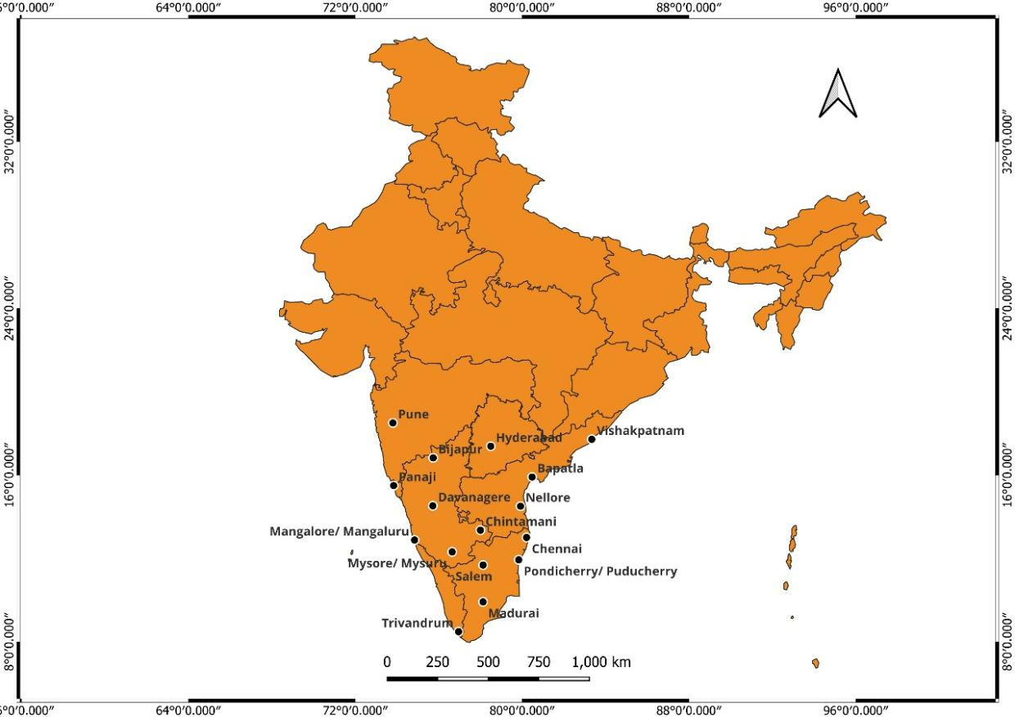

Fig. 1. Map depicting spatial representation of study site

2.4 Statistical Analysis

Dataset comprised 400 flowers and 400 wasps (25 per site). Analyses included descriptive statistics, Pearson correlations, mismatch proportion (ovipositor ≥ style), and one-way ANOVA across sites.

3. RESULTS AND DISCUSSION

3.1 Style Length and Ovipositor

Across the pooled dataset of 400 floral and wasp measurements, the length of the floral style (stigma + style) consistently exceeded the ovipositor length of Eupristina masoni. Mean floral style length was 1.76 ± 0.62 mm, whereas mean ovipositor length measured 1.50 ± 0.08 mm. The resulting mean difference between the two traits (ovipositor – style) was −0.25 mm, demonstrating a clear morphological advantage in favour of the plant (Table 1). Rather than being an occasional mismatch, this pattern was widespread: only 38.5% of flowers had style lengths equal to or shorter than the ovipositor, meaning that in more than 60% of cases the wasp could not reach the ovule for successful oviposition his evidence strongly suggests that Ficus benghalensis maintains floral styles that extend beyond the physical reach of its pollinator at the study site and during the study period. Such consistent floral predominance may reflect antagonistic coevolutionary pressures: by limiting the wasp’s ability to oviposit in a large proportion of flowers, the plant potentially increases its relative allocation to seed production. Similar patterns of style–ovipositor mismatch being used to regulate wasp exploitation have been documented in other fig–wasp systems (e.g., Ficus racemosa; Wang et al., 2009; Zhao et al., 2022).

Table 1. Overall descriptive statistics
(N = 400)

Variable | Mean | SD | SE
Style length (mm) | 1.76 | 0.62 | 0.031
Ovipositor length (mm) | 1.50 | 0.08 | 0.004
Difference (Ovip. – Style) (mm) | −0.25 | 0.60 | 0.030
Ratio (Ovip. / Style) | 0.97 | – | –

These findings indicate that morphological matching in this mutualism is not perfectly symmetrical but instead reflects a functional balance tilted toward plant reproductive advantage. Over evolutionary time, however, wasps may respond by increasing ovipositor length, enabling greater access to flowers and enhancing wasp reproductive output and fitness (maintenance of coevolved specificity and adaptation; Gardner & Bruun-Lund, 2023).

3.2 Spatial Variation Across Sites

Both floral and pollinator traits exhibited substantial geographic variation across the 16 sampled populations. One-way ANOVA confirmed highly significant among-site differences for both floral style length (F = 4.65, P < .001) and ovipositor length (F = 168.61, P < .001), indicating that local environmental conditions or selective pressures shape morphological expression in both partners. However, the magnitude and pattern of variation were not equivalent: floral style length showed much broader spatial variability, whereas ovipositor length remained comparatively constrained, suggesting contrasting levels of phenotypic flexibility (Chen et al., 2022).

Mean trait values revealed clear geographic structuring (Table 2). Populations such as Bijapur, Panaji and Trivandrum displayed the deepest floral styles, while sites such as Madurai, Mysore and Bapatla were characterised by comparatively shorter styles. Ovipositor length tended to follow the same general trend-sites with longer styles tended to host pollinators with longer ovipositors-but the disparity between the two traits frequently favoured the plant. The mean difference (ovipositor – style) ranged from moderately negative (e.g., Mysore: −0.0468 mm) to strongly negative (e.g., Bijapur: −0.7035 mm), reinforcing that Ficus benghalensis styles exceeded the reach of Eupristina masoni ovipositors at nearly all sites.

The proportion of flowers accessible to the pollinator, expressed as Prop.(O ≥ S), varied markedly among sites. At sites such as Madurai and Nellore, more than half of the flowers were accessible for oviposition, whereas at Bijapur, Panaji, Trivandrum and Pune, fewer than 30% of flowers permitted successful oviposition based on the morphological threshold. These differences suggest that the balance between seed production and wasp brood success is not uniform across populations.

Table 2. Site-wise mean floral and ovipositor traits (N = 25 per site)

Site | Style mean | Style SD | Ovip. mean | Ovip. SD | Diff. mean  (O–S) | Ratio mean | Prop.  (O≥S)
Bapatla | 1.4942 | 0.6467 | 1.4188 | 0.0277 | –0.0754 | 1.1093 | 0.52
Bijapur | 2.3414 | 0.7661 | 1.6379 | 0.0319 | –0.7035 | 0.7656 | 0.12
Chennai | 1.5378 | 0.3653 | 1.3632 | 0.0266 | –0.1746 | 0.9387 | 0.40
Chintamani | 1.5739 | 0.4697 | 1.4450 | 0.0283 | –0.1289 | 1.0223 | 0.40
Davanagere | 1.8176 | 0.5526 | 1.5859 | 0.0309 | –0.2317 | 0.9553 | 0.36
Hyderabad | 1.7220 | 0.5178 | 1.4686 | 0.0287 | –0.2534 | 0.9363 | 0.32
Madurai | 1.4060 | 0.4413 | 1.4198 | 0.0277 | +0.0138 | 1.1091 | 0.60
Mangalore | 1.8302 | 0.6572 | 1.5859 | 0.0309 | –0.2444 | 0.9670 | 0.36
Mysore | 1.4992 | 0.4004 | 1.4524 | 0.0282 | –0.0468 | 1.0476 | 0.44
Nellore | 1.5510 | 0.5308 | 1.4494 | 0.0282 | –0.1016 | 1.0353 | 0.60
Panaji | 2.0088 | 0.5010 | 1.5673 | 0.0305 | –0.4415 | 0.8272 | 0.24
Pondicherry | 1.8495 | 0.5524 | 1.5720 | 0.0307 | –0.2774 | 0.9372 | 0.40
Pune | 1.9261 | 0.6768 | 1.5188 | 0.0297 | –0.4073 | 0.9061 | 0.28
Salem | 1.7750 | 0.6843 | 1.5310 | 0.0298 | –0.2439 | 1.0162 | 0.44
Trivandrum | 2.0781 | 0.7740 | 1.5099 | 0.0295 | –0.5682 | 0.8608 | 0.28
Vishakhapatnam | 1.7183 | 0.5510 | 1.5475 | 0.0302 | –0.1708 | 1.0222 | 0.40

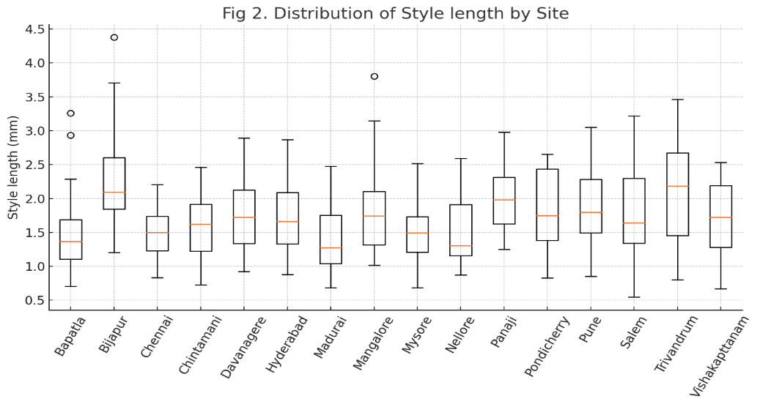
Please replace this Fig. with clear view picture
Fig.2. Distribution of style length of Ficus benghalensis by site

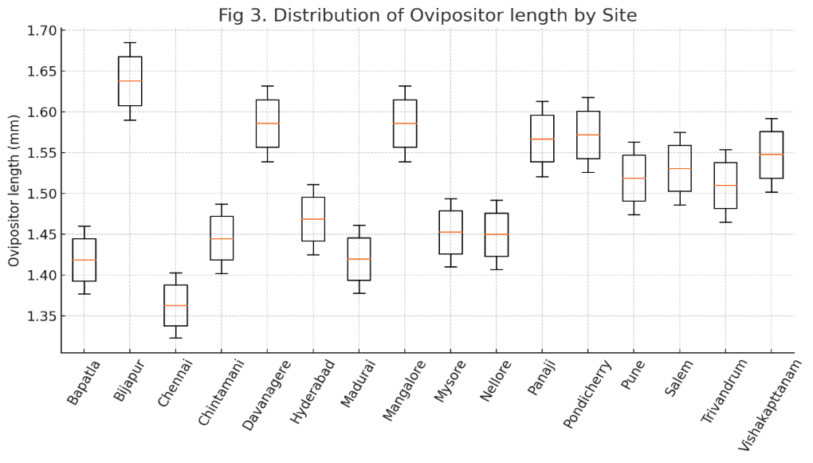

Fig. 3. Distribution of ovipositor length of Eupristina masoni by site

Importantly, the site-level correlation between mean floral style and mean ovipositor lengths was strong and positive (Pearson r = 0.817, P ≈ 1.1 × 10⁻⁴), indicating that populations with deeper floral styles tend to harbour pollinators with correspondingly longer ovipositors (Fig. 4). This points toward geographic-scale coadaptation, even though floral depth still surpasses ovipositor length in most environments.

3.3 Correlation and Functional Matching

Variation in floral style length and ovipositor length exhibited clear distributional patterns across sites (Fig. 2 and Fig. 3). Despite the greater overall variability in floral style length compared with ovipositor length, both traits showed coordinated shifts at the population level.

Correlation analyses revealed two distinct scales of association. At the individual flower–wasp level, style and ovipositor lengths were significantly correlated but only modest in magnitude (r = 0.313, P < .001). This limited individual-scale coupling indicates that ovipositor length does not fully track fine-scale floral variation within populations, supporting the broader mismatch patterns reported earlier.

In contrast, when population means were compared across sites, the relationship was much stronger (r = 0.817, P < .001). Sites characterised by deeper floral styles consistently exhibited longer ovipositors in their associated pollinator populations, suggesting coordinated geographic differentiation between the two partners despite imperfect matching within individual flowers.

The fitted regression model describing the relationship between the two traits was:

$$\text{Ovipositor length}=1.434+0.040×\text{Style length}$$
Although statistically significant (P < .001), the explanatory power of the model was relatively low (R² = 0.10), reinforcing that only a small proportion of variation in ovipositor length is attributable to individual-level floral depth (Fig. 4).

Together, these outcomes indicate that while Ficus benghalensis and Eupristina masoni remain strongly coordinated at the geographic scale, the degree of trait matching is not exact at the individual scale. This pattern aligns with a system in which coevolution promotes broad correspondence in trait means across environments, while selective asymmetry or developmental constraints maintain a consistent floral advantage within flowers (Rodriguez et al., 2024).

Hierarchical Clustering of Study Populations To visualize the similarity in trait dimensions across the 16 studied populations; hierarchical clustering was performed using Ward’s linkage method with Euclidean distances based on mean floral style and ovipositor lengths. The resulting dendrogram (Fig. 5) reveals distinct geographical structuring, broadly categorizing the sites into two primary clusters.

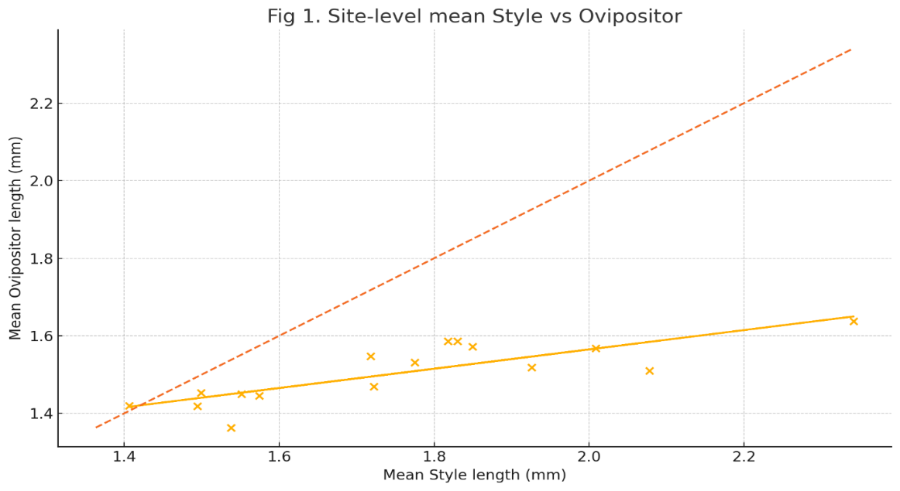

Fig. 4. Scatterplot of site-level mean style vs ovipositor length (regression line + 1:1 line placeholder)

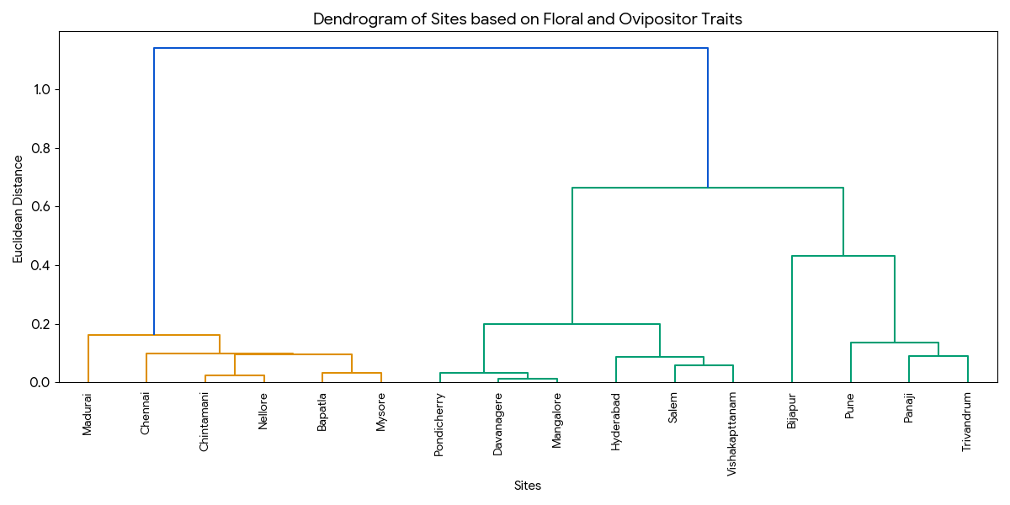

Fig.5. Dendrogram of sites based on floral and ovipositor traits

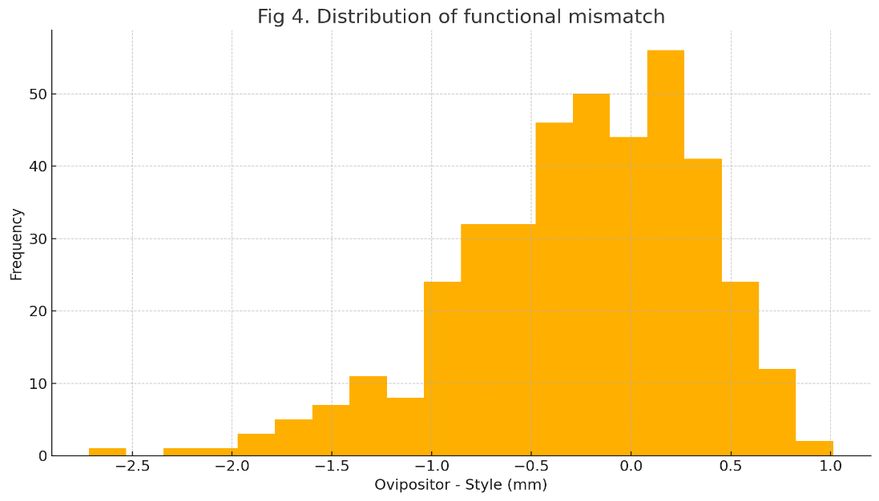

Fig. 6. Histogram illustrating the distribution of functional mismatch (ovipositor length − floral style length) across all individuals

The first major cluster comprises populations characterized by significantly larger trait dimensions, grouping sites such as Bijapur, Panaji, Trivandrum, and Pune. In contrast, the second cluster aggregates populations with comparatively smaller morphological traits, including Madurai, Mysore, Bapatla, and Chennai. Intermediate sites (e.g., Mangalore, Salem) formed sub-clusters bridging these extremes. This clustering pattern reinforces the positive site-level correlation (r = 0.817) reported earlier, confirming that populations with deeper floral styles consistently cluster with those harbouring longer-ovipositor wasps.

3.4 Distribution of Mismatch

To evaluate the functional consequences of morphological differences between floral styles and wasp ovipositors, we examined the distribution of the mismatch measure (ovipositor length − style length) across all sampled flowers (Fig. 6). The resulting distribution was strongly skewed toward negative values, indicating that in the majority of cases the ovipositor was shorter than the floral style. This pattern directly reflects a predominant floral advantage, whereby style depth exceeds the reach of the pollinator in most flowers and consequently restricts oviposition opportunities.

The magnitude of mismatch varied among individuals but remained consistently biased in favour of the plant, in agreement with the negative mean difference reported in Section 3.1. Only 38.5% of flowers exhibited non-negative mismatch values (ovipositor ≥ style), confirming that more than half of the floral population was inaccessible to the pollinator based on length thresholds alone. Such skewed mismatch creates an inherent asymmetry in reproductive success: while the wasp is able to oviposit only in a subset of flowers, the plant gains seed production across the entire floral cohort.

This persistent floral advantage, even under spatially coadapted trait variation, highlights the selective tension embedded within the mutualism a system that must support both pollinator reproduction and plant seed production, yet not necessarily in equal proportions (Zeng et al., 2022).

4. DISCUSSION

This study provides the first spatially replicated quantitative assessment of floral style length and pollinator ovipositor morphology for the Ficus benghalensis - Eupristina masoni mutualism across South India. The results reveal a complex pattern of trait correspondence that is both coordinated and asymmetric. Although floral style and ovipositor lengths exhibit strong geographic covariation across populations indicating broad-scale coadaptation the mismatch detected within individual flowers suggests that the system does not operate under perfect morphological equivalence.

The finding that the floral style exceeds ovipositor length in most flowers aligns with theoretical predictions that figs experience indirect selective benefits from limiting pollinator reproduction (West et al., 1995; Nefdt & Compton, 1996). Because the wasp oviposits only within flowers where its ovipositor can reach the ovule, deeper styles can shift a greater proportion of flowers toward seed production rather than brood development. By contrast, wasps are expected to evolve ovipositor lengths that maximize oviposition success, but physical and energetic constraints on ovipositor growth, as well as trade-offs associated with structural reinforcement and manoeuvrability, may limit their evolutionary response (Souto-Vilarós et al., 2018; Borges, 2021; Yang et al., 2021). This tension likely contributes to the modest individual-level correlation observed in our dataset.

The strong site-level correlation between mean style and mean ovipositor lengths suggests that coadaptation has nonetheless taken place at the population scale. Populations with deeper floral styles tend to host pollinators with longer ovipositors, indicating coordinated geographic divergence. Such broad-scale matching is consistent with population-level host–pollinator genetic structure or long-term localized selection shaping both partners (Herre et al., 2008; Cruaud et al., 2012; Van Goor et al., 2021). Morphological evolution and phylogenetic analyses support the idea that coadaptation of style and ovipositor traits is an important axis in the diversification of fig–wasp lineages (Weiblen, 2002). However, this matching does not eliminate floral advantage: even in populations with relatively long ovipositors, style length typically remains greater. This may represent a coevolutionary equilibrium in which both mutualism and conflict are simultaneously maintained (Liu et al., 2024).

The mismatch distribution was heavily skewed toward floral advantage, with only 38.5% of flowers permitting oviposition based on length thresholds. This indicates that morphological correspondence does not necessarily optimise brood success for the pollinator. Rather, it appears to mediate a functional balance that allows both partners to reproduce without providing equal access to every floral unit. A similar pattern has been suggested for other monoecious fig species, where style-length distributions are thought to regulate the proportion of flowers set aside for pollinator development versus seed production (Nefdt and Compton, 1996; Moore et al., 2008).

Taken together, our results challenge the widespread assumption that fig–pollinator mutualisms are characterised by perfect morphological matching. Instead, the Ficus benghalensis - Eupristina masoni interaction demonstrates coevolved correspondence at the geographic scale and persistent asymmetry at the floral scale. This dynamic suggests a system stabilised by evolutionary compromise: broad-scale adaptation maintains compatibility and ensures pollination, while fine-scale mismatches reinforce reproductive interests of the plant without eliminating opportunities for the pollinator. These findings support a balanced mutualism model, in which coadaptation ensures reproductive interdependence while controlled mismatch enables the plant to retain a selective benefit. Such a combination of cooperation and conflict may be central to the long-term evolutionary stability of fig–pollinator systems (Weiblen, 2002; Borges, 2021; Souto-Vilarós et al., 2018; Compton et al., 2021).

5. CONCLUSION

The Ficus benghalensis–Eupristina masoni mutualism exhibits a dual pattern of morphological matching. Floral style and ovipositor lengths are strongly coordinated across geographic populations, indicating long-term coevolutionary integration. However, the consistent floral advantage within individual flowers demonstrated by negative mismatch values and oviposition feasibility in only 38.5% of flowers reveals an asymmetric functional structure that favours plant seed production over pollinator brood success.

ETHICAL APPROVAL

All authors hereby declare that the research involving plant and insect specimens was conducted under institutional ethical standards and with prior approval from the Institutional Research and Ethics Committee, University of Agricultural Sciences, Bengaluru.

DISCLAIMER (ARTIFICIAL INTELLIGENCE)

Author(s) hereby declare that NO generative AI technologies such as Large Language Models (ChatGPT, COPILOT, etc.) and text-to-image generators have been used during the writing or editing of this manuscript.

Competing interests

Authors have declared that no competing interests exist.

REFERENCES

Borges, R. M. (2021). Interactions between figs and gall-inducing fig wasps: Adaptations, constraints, and unanswered questions. Frontiers in Ecology and Evolution, 9, 685542. https://doi.org/10.3389/fevo.2021.685542
Chen, Y., Liu, M., & Compton, S. G. (2022). Phenotypic plasticity and developmental stability in fig wasp interactions under changing climates. Global Ecology and Conservation, 34, e02028. https://doi.org/10.1016/j.gecco.2022.e02028
Compton, S. G., Chen, Y., & Yu, H. (2021). Phenotypic plasticity and stability in fig–pollinator interactions under climate stress. Functional Ecology, 35(12), 2789–2801. https://doi.org/10.1111/1365-2435.13945
Cook, J. M., & Rasplus, J. Y. (2003). Mutualists with attitude: Coevolving fig wasps and figs. Trends in Ecology & Evolution, 18(5), 241–248. https://doi.org/10.1016/S0169-5347(03)00062-4
Cruaud, A., Rønsted, N., Chantarasuwan, B., Chou, L. S., Clement, W. L., Couloux, A., & Rasplus, J. Y. (2012). An extreme case of plant–insect codiversification: Figs and fig-pollinating wasps. Systematic Biology, 61(6), 1029–1047. https://doi.org/10.1093/sysbio/sys068
Deng, X., Wang, R., & Yang, P. (2021). Low host specificity and broad geographical ranges in a non-pollinating fig wasp. Journal of Animal Ecology, 90(7), 1672–1684. https://doi.org/10.1111/1365-2656.13483
Dunn, D. W. (2020). Stability in fig tree–fig wasp mutualisms: How to be a cooperative fig wasp. Biological Journal of the Linnean Society, 130(1), 1–17. https://doi.org/10.1093/biolinnean/blaa018
Ganeshaiah, K. N., Kathuria, P., Shaanker, R. U., & Vasudeva, R. (1995). Evolution of style-length variability in figs and optimization of ovipositor length in their pollinator wasps: A coevolutionary model. Journal of Genetics, 74, 25–39. https://doi.org/10.1007/BF02931737
Gao, J., Zhao, H., & Wang, R. (2023). Geographic variation in fig-wasp morphological traits: Evidence for local adaptation in heterogeneous environments. Journal of Biogeography, 50(4), 689–701. https://doi.org/10.1111/jbi.14567
Gardner, E. M., & Bruun-Lund, S. (2023). Evolutionary constraints on pollinator ovipositor length in the Moraceae. Evolution, 77(3), 856–868. https://doi.org/10.1093/evolut/qpad012
Herre, E. A., Jandér, K. C., & Machado, C. A. (2008). Evolutionary ecology of fig–wasp mutualisms. Annual Review of Ecology, Evolution, and Systematics, 39, 439–458. https://doi.org/10.1146/annurev.ecolsys.37.091305.110232
Liu, C., Wang, G., & Yang, D. R. (2024). Mechanisms of stability in the fig–wasp mutualism: Beyond the sanctions hypothesis. Current Opinion in Insect Science, 61, 101135. https://doi.org/10.1016/j.cois.2023.101135
Machado, C. A., Robbins, N., Gilbert, M. T. P., & Herre, E. A. (2005). Critical review of host specificity and its coevolutionary implications in the fig–fig wasp mutualism. Proceedings of the National Academy of Sciences of the United States of America, 102(Suppl. 1), 6558–6565. https://doi.org/10.1073/pnas.0501840102
Moore, J. C., Dunn, D. W., & Hardy, I. C. W. (2008). Fighting strategies in two species of fig wasp. Animal Behaviour, 76(4), 1307–1316. https://doi.org/10.1016/j.anbehav.2008.05.022
Nefdt, R. J. C., & Compton, S. G. (1996). Regulation of seed and pollinator production in the fig–fig wasp mutualism. Journal of Animal Ecology, 65(2), 170–182. https://doi.org/10.2307/5720
Pothasin, P., Compton, S. G., & Wang, R. W. (2016). Phenotypic plasticity in pollinator specificity and the fig-wasp mutualism. Acta Oecologica, 77, 241–248. https://doi.org/10.1016/j.actao.2016.10.005
Rodriguez, L. J., Bain, A., & Kjellberg, F. (2024). High β-diversity in fig wasp communities driven by species turnover in widely distributed Neotropical fig trees. Oikos, 2024(1), e09982. https://doi.org/10.2307/5720
Souto-Vilarós, L., Proffit, M., Buatois, B., Rindos, M., Hossaert-McKey, M., & Kučera, J. (2018). Pollination along an elevational gradient mediated both by floral scent and pollinator compatibility in the fig and fig‐wasp mutualism. Journal of Ecology, 106(6), 2256–2273. https://doi.org/10.1111/1365-2745.12995
Sutton, T. L., De Gabriel Hernando, M., & Rønsted, N. (2022). A review of the evolutionary history of Ficus and their pollinators. Journal of Systematics and Evolution, 60(5), 1032–1045. https://doi.org/10.1111/jse.12847
Teixeira, S. P., & Kjellberg, F. (2023). Floral traits and pollinator correspondence in Ficus: A multi-scale analysis. Botanical Journal of the Linnean Society, 201(2), 245–259. https://doi.org/10.1093/botlinnean/boac056
Van Goor, J. G., Compton, S. G., & Dunn, D. W. (2021). Nematode infection reduces fig wasp fitness and alters mutualism dynamics. Ecology and Evolution, 11(5), 2145–2156. https://doi.org/10.1002/ece3.7265
Wang, G., Zhang, X., Herre, E. A., McKey, D., Machado, C. A., Yu, W. B., & Chen, J. (2021). Genomic evidence of prevalent hybridization throughout the evolutionary history of the fig-wasp pollination mutualism. Nature Communications, 12(1), 718. https://doi.org/10.1038/s41467-021-20957-3
Wang, R. W., Ridley, J., Sun, B. F., Zheng, Q., Dunn, D. W., Cook, J., & Yu, D. W. (2009). Interference competition and high temperatures reduce the virulence of fig wasps and stabilize a fig-wasp mutualism. PLoS One, 4(11), e7802. https://doi.org/10.1371/journal.pone.0007802
Weiblen, G. D. (2002). How to be a fig wasp. Annual Review of Entomology, 47(1), 299–330. https://doi.org/10.1146/annurev.ento.47.091201.145213
West, S. A., Herre, E. A., & Windsor, D. M. (1995). The ecology of sex ratios in fig wasps. Proceedings of the Royal Society of London. Series B: Biological Sciences, 262(1365), 263–263. https://doi.org/10.1098/rspb.1995.0206
Yang, L., Li, Z., & Peng, Y. Q. (2021). Energetic trade-offs in fig wasp ovipositor development. Insect Science, 28(6), 1678–1688. https://doi.org/10.1111/1744-7917.12889
Yu, H., Tian, E., & Compton, S. G. (2021). Host sanctions and pollinator cheating in the fig-wasp mutualism. Ecology Letters, 24(9), 1982–1991. https://doi.org/10.1111/ele.13832
Zeng, Y. J., Zhang, Q., & Sun, B. F. (2022). Reproductive asymmetry in mutualistic networks: The case of Ficus and Agaonidae. Journal of Ecology, 110(5), 1023–1035. https://doi.org/10.1111/1365-2745.13865
Zhang, L., Yan, H., & Zhang, Z. (2021). Genomic insights into the coevolution and diversification of the fig-wasp mutualism. Nature Communications, 12, 4512. https://doi.org/10.1038/s41467-021-24765-x
Zhao, J., Li, H., & Soler, C. (2022). Comparative morphology of fig wasp ovipositors: Implications for host access and specificity. Zoomorphology, 141, 45–56. https://doi.org/10.1007/s00435-021-00547-8

Disclaimer/Publisher’s Note: The statements, opinions and data contained in all publications are solely those of the individual author(s) and contributor(s) and not of the publisher and/or the editor(s). This publisher and/or the editor(s) disclaim responsibility for any injury to people or property resulting from any ideas, methods, instructions or products referred to in the content.
_________________________________________________________________________________
© Copyright (2025): Author(s). The licensee is the journal publisher. This is an Open Access article distributed under the terms of the Creative Commons Attribution License (http://creativecommons.org/licenses/by/4.0), which permits unrestricted use, distribution, and reproduction in any medium, provided the original work is properly cited.

