Original Research Article
ANALYTICAL METHOD DEVELOPMENT AND VALIDATION OF MARKETED PRODUCT OF PHENYTOIN SODIUM BY UV SPECTROPHOTOMETER AND STRESS DEGRADATION STUDIES

ABSTRACT:
A quick, accurate, and cost-effective UV spectroscopy method was developed to estimate the Phenytoin sodium in bulk, tablet dosage formulations using a solvent 0.1 N NaOH .Due to the high cost of antiepileptic drugs there is a need to develop a simple, accurate and cost effective method.UV-Spectrophotometric method was developed using 0.1 N NaOH as a solvent. According to ICH Q2(R1) requirements, the created technique was standardized in terms of validation parameters linearity, precision, accuracy, specificity, Limit of Detection(LOD), and Limit of Quantification(LOQ), like parameters like parameters were validated by using UV/visible spectroscopy technique and developed method was so simple, sensitive, precise, linear, accurate, robust, reproducible, and cost-effective. This newly established approach was effectively used to estimate phenytoin sodium in marketed formulation Eptoin. Phenytoin sodium API exhibits λ_{max} at 216nm in the Beer’s range 2 to 10µg/ml So,Beer’s law was obeyed. The limit of detection (LOD) was found to be 0.564µg/ml and limit of quantification (LOQ) was found to be 1.71µg/ml. Recovery of phenytoin sodium in marketed formulation as Eptoin was observed in the range of 100 – 104%. The entire precision range was achieved at under 2% in accordance with ICH Q2(R1) standards. In both inter and intra-day examinations, it was found that the created UV method was precise, with % relative standard deviation varying from 0.27 to 0.46 and 0.26 to 0.46, respectively. The overall recovery percentage of Vinpocetine was found to range from 98.42 to 99.82%. LOQ and LOD were determined to assess the sensitivity of the method, yielding values of 0.4565 µg/ml and 0.1506 µg/ml, respectively. The estimation of Phenytoin sodium in its bulk form and commercial formulation was accomplished using the established method: A rapid, precise, and cost-effective UV spectrophotometric technique has been created to measure the concentration of Phenytoin sodium in bulk and tablet dosage forms.

Keywords:Phenytoin sodium, Beer’s law, 0.1N NaOH, UV-Spectrophotometer, commercial samples

1.INTRODUCTION
Phenytoin sodium or sodium 5,5-diphenyl-2,4-imidazolidinedione can be useful in the treatment of epilepsy since it is an anticonvulsant drug.^{1,2,3} Phenytoin sodium is an non-sedative antiepileptic drug^{3,4}. Which is used to control tonic-clonic seizures^{1,2,3} and partial seizures^{1,2,3}. It has five membered ring, For Example 5,5-diphenylhydantoin(Dilantin)⁵. It’schemical structure is related to the barbiturates⁵⁻⁸. Phenytoin sodium is commonly prescribed to be administer orally and intravenously^{3,4}. Phenytoin sodium is used to treat some types of cardiacarrhythmias which is caused by digitalis toxicity⁵⁻⁸.
Various formulations of phenytoin sodium are available in the market for exampleEpcin-100, Phenyfine-100, Epilan-P, Hightin-100, Daxytoin-300 ER, Zotoin-100, Epsotoin, Fenicure-100, Elion-50 etc.Many other researchers have been recommended a few UV Spectroscopic methods for the estimation of phenytoin sodium in the available marketed formulations. But the suggested methods have their own limitations and some of them are the high expense and hazardous solvents involved in the procedure. Hence, the main objective of our work was to develop and standardize a UV Spectroscopic method for the estimation of phenytoin sodium in the available marketed formulations.
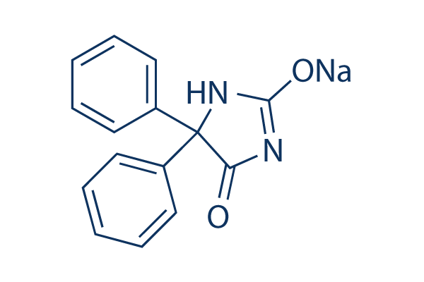
Figure 1: Structure of Phenytoin Sodium
2.MATERIALS AND METHODS
2.1 Reagents and chemicals:
All the chemicals like NaOH, ethanol, distilled water, phenytoin sodium,conc. HCl were
purchased from Sigma- Aldrich and Merck and were used .
2.2 Melting point:
Melting point of phenytoin sodium was examined by filling a capillary tube with phenytoin sodium sample in it and sealed the other end of the capillary by holding it on flame. Tied up this capillary tube to the thermometer and then placed it in Thiel’s tube which contains the liquid paraffin and after heating it , the sample starts to melt and this was considered as the melting point of the sample.
2.3 Selection of wavelength:
Multiple concentration of phenytoin sodium were produced in 0.1N NaOH. 10µg/ml of working standard solution of phenytoin sodium was scanned in between 200-400 nm and maximum absorption appears at 216 nm.
2.4 Preparation of stock solution:
Firstly 0.1g of phenytoin sodium was correctly weighed and dissolved in 100ml 0.1 N NaOH then sonicate the solution for 10 min.Take 1 ml of above solution and transfer into 100 ml of volumetric flask and adjust volume upto the mark with 0.1N NaOH. The above solution is used as a standard stock solution having concentration 10µg/ml. Further standard stock solution was used for the dilutions⁹.
2.5 Preparation of calibration curve:
Serial dilutions was prepared from stock solution in the range of concentration 2-10µg/ml. The concentration of solution was analyzed and the absorbance was measured at 216 nm. The calibration curve was plotted with concentration on the X-axis and absorbance on the Y-axis, and linearity regression was performed⁹.
2.6 Method development and validation:
0.1N NaOH was taken because phenytoin sodium was soluble in it and choosed that solvent by gravimetric analysis method. The suggested approach was validated in accordance with the International Conference of Harmonisation (ICH) principles.i.e.Q2(R1). As stated in ICH guidelines, the method was validated to demonstrate that it was appropriate to use parameters for the validation by analytical techniques^{9,10}.

2.6.1 Specificity and selectivity:

The selective method was determined since phenytoin sodiumhad a highest absorbance at 216 nm, 0.1N NaOH is the solvent which did not show it’s absorbance at 216 nm, hence this method was found to be specific¹¹.

2.6.2 Linearity:
In the range of 2-10µg/ml the linearity was analysed. 100mg of phenytoin sodium was appropriately weighed and taken in clean and dried volumetric flask and adjust the volume with 0.1N NaOH. Stock solution was prepared by using phenytoin sodium and NaOH. From the above solution pipette out 1ml and transferred into another volumetric flask (2nd stock solution), multiple dilutions are prepared using this solution to check the linearity¹².

2.6.3 LOD and LOQ:
The limit of detection refers to the concentration at which an analyte in the test sample was identified. The limit of quantification is the concentration at which an analyte in the test sample is measured.The formulas below are used to determine LOD and LOQ¹³⁻¹⁵.

LOD= 3.3x standard deviation of regression/slop
LOQ= 10x standard deviation of regression/slop

2.6.4 Precision:
Precision was dependent on the three duplicates of a solution of 2µg/ml, 6µg/ml and 10µg/ml of phenytoin sodium, and in 216nm it’s absorbance was measured, and the percentage RSD computed.
Method precision was determined by executing two trials,

- Intraday precision
- Interday precision

The concentration of 2µg/ml, 6µg/ml and 10µg/ml of drug was examined with three duplicates o solution for the intraday precision. The % of RSD at different time intervals was analysed and calculated of the phenytoin sodium.

Three replicates of the solution containing concentration 2µg/ml, 6µg/ml and 10µg/ml of phenytoin sodium for interday precision was analysed at different time intervals and % RSD was calculated.

2.6.5 Ruggedness:
Ruggedness was performed by different analyst by using same proposed method to check reproducibility¹⁶⁻¹⁹.

2.6.6 Robustness:
The determination of phenytoin sodium performed by recovery experiment. Prepared different levels of the sample solution 50%, 100%, 150%. A sample was determined by % mean recovery¹⁶⁻¹⁹.

2.6.7 Analysis of marketed formulation:
The validated method was used for the measurement of phenytoin sodium in marketed formulations..Weighing accuratly 20 tablets to calculate average weight of tablets and then triturated. By finding the amount of drug in a sample was found to be in a good range with the label claim of formulation.

2.7 Degradation studies:
The goal of this study was to conduct stress degradation experiments on phenytoin sodium using the established method, which is covered by the ICH recommendations for stability assessment of novel medicinal compounds.

2.7.1 Stress degradation by hydrolysis under acidic condition:

Weighed exactly 100mg of the medication in 100ml of 0.1N NaOH to generate 1000µg/ml of the solution. It is considered as the stock solution, from that 1ml of stock solution and 1ml of 0.1N HCl was transfered in a 10ml volumetric flask and the volume is make upto the mark with 0.1N NaOH solution. Further this solution was prepared for several dilutions in 30 minutes time interval. After that the dilutions were observed in the UV-Spectroscopy²⁰.

2.7.2 Stress degradation by hydrolysis under alkaline condition:

Weigh 100 mg of the drug in 100ml of 0.1N NaOH to produce 1000µg/ml of the solution. it is considered as the stock solution, from that 1ml of stock solution and 1ml of 0.1N NaOH was added in a 10ml volumetric flask and the volume is make up to the mark with 0.1N NaOH. Further this solution was prepared for several dilutions in 30 minutes time interval. After that the dilutions were observed in UV-Spectroscopy²¹⁻²⁶.

3.RESULT AND DISCUSSION:

3.1 Melting point:
The melting point of phenatoin sodium was performed to check the purity of compound was found to be 296-298°c.So the Phenytoin sodium API was was supposed to be pure.

3.2 Method development:
UV- Spectrophotometric method was developed using UV-1800 model and 0.1N NaOH as a solvent. Maximum absorbance of phenytoin sodium was found at 216nm. Details of method development were presented in Table 1.

Table 1: Developed method parameters

Sl.  No. | Parameters | Specifications
1 | Method | Spectrometric
2 | Instrument | UV
3 | Model | 1800
4 | Make | Shimadzu
5 | Software | UV Probe
6 | Synthesized drug | Phenytoin Sodium
7 | Solvent | 0.1N NaOH
8 | Scanning wavelength range | 400-200nm
9 | λ_{max} | 216nm

3.3 Method validation:
The validation parameters such as specificity,selectivity,linear,range,precision, robustness,ruggedeness, and reproducibility, as per ICH guidelines were validated by developed method.

3.4 Specificity and selectivity
The maximum absorbance of phenytoin sodium was showed absorbance at 218nm and 0.1N NaOH solvent didn’t show absorbance at 218nm. Hence the method was found to be specific and selective.

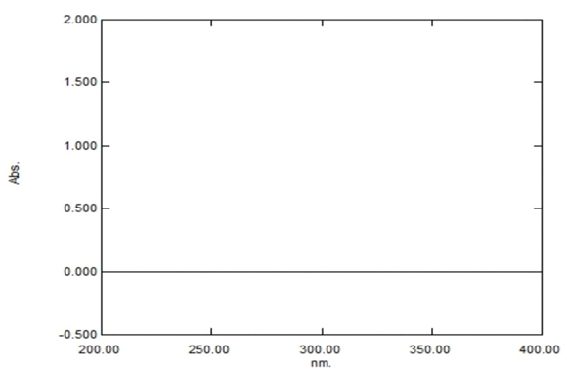

Figure 2: UV Spectrum of solvent

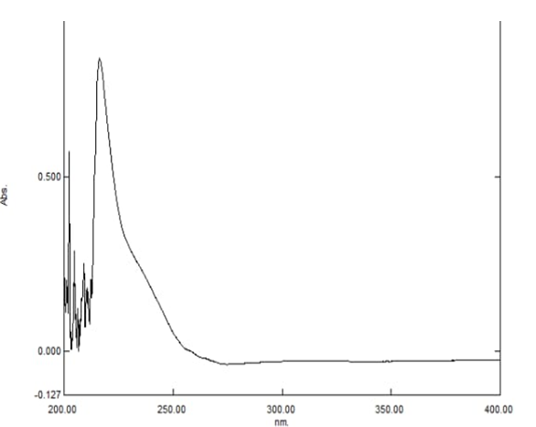

Figure 3: UV Spectrum of phenytoin sodium

3.5 linearity:
Linearity was found in range of 2-10µ/ml. the linearity graph is showed in fig4. The linearity and range is showed in table.2 and calibration curve is given in Figure5

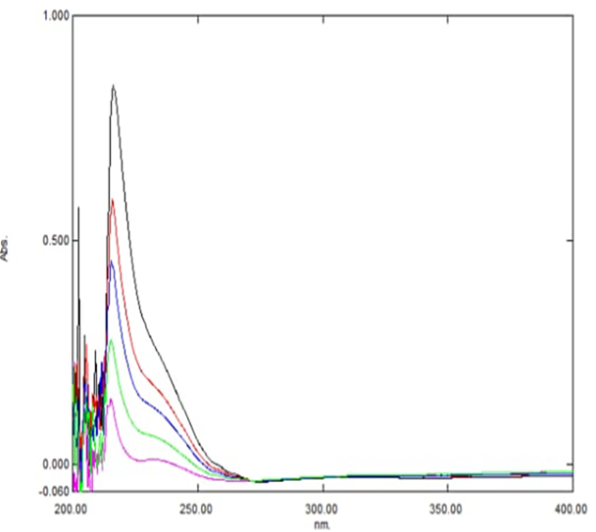

Figure 4: Linearity and range data of phenytoin sodium

Table 2: Linearity and range data of Phenytoin sodium

Sr. no. | concentration(µg/ml) | Absorbance
1 | 2 | 0.131
2 | 4 | 0.321
3 | 6 | 0.499
4 | 8 | 0.659
5 | 10 | 0.865
 | r² | 0.998
 | SLOPE | 0.083
 | LOD | 0.564
 | LOQ | 1.71

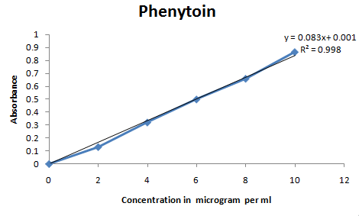

Figure 5: Calibration curve of phenytoin sodium

3.6 Precision:
3.6.1 system precision: To identify the system precision three duplicates of phenytoin sodium solution i.e. 2µg/ml, 6µg/ml, 10µg/ml was prepared as per the method and each solution’s absorbance was measured at 216nm. The % RSD was calculated and it was found to be less than 2%(table 3).

Table 3: System precision data of phenytoin sodium

Concentration  (µg/ml) | Absorbance* | Standard Deviation | % Relative Standard Deviation
2 | 0.131 | 0.001 | 0.76
6 | 0.498 | 0.001 | 0.31
10 | 0.864 | 0.001 | 0.12
*= average absorbance of six replicates

3.6.2 Intraday precision:
For this three replicates of phenytoin sodium solution with concentration of 2µg/ml, 6µg/ml, 10µg/ml was prepared and evaluated and on the same day at different time intervals it’s % RSD was calculated and % RSD was found to be less than 2% (Table 4).

Table 4: Intraday precision data of phenytoin sodium
Concentration (µg/ml) | Absorbance * |  | Standard deviation | % Relative standard deviation
2 | Aft 1hr | 0.133 | 0.002 | 1.5
2 | Aft 4hr | 0.133 | 0.0015 | 1.15
2 | Aft 8hr | 0.132 | 0.0015 | 1.15
6 | Aft 1hr | 0.497 | 0.002 | 0.4
6 | Aft 4hr | 0.499 | 0.0023 | 0.46
6 | Aft 8hr | 0.497 | 0.0026 | 0.53
10 | Aft 1hr | 0.865 | 0.002 | 0.23
10 | Aft 4hr | 0.864 | 0.0015 | 0.18
10 | Aft 8hr | 0.864 | 0.0012 | 0.13
*= average absorbance of three replicates

3.6.3 Interday precision: For this three replicates of phenytoin sodium solution with concentration of 2µg/ml, 6 µg/ml, 10 µg/ml was prepared and evaluated and it’s % RSD was calculated on three days and % RSD was found to be less than 2% (Table 5).

Table 5: Interday precision data of phenytoin sodium
Concentration (µg/ml) | Absorbnce |  | Standard deviation | % Relative standard deviation
2 | Day 1 | 0.133 | 0.0012 | 0.87
2 | Day 2 | 0.132 | 0.0015 | 1.15
2 | Day 3 | 0.131 | 0.0015 | 1.16
6 | Day 1 | 0.494 | 0.0026 | 0.54
6 | Day 2 | 0.495 | 0.0025 | 0.51
6 | Day 3 | 0.494 | 0.0031 | 0.62
10 | Day 1 | 0.861 | 0.001 | 0.12
10 | Day 2 | 0.865 | 0.0021 | 0.24
10 | Day 3 | 0.864 | 0.0031 | 0.35
*= average absorbance of three replicates

3.7 Ruggedness:
It was identified using the same procedure by different analysts to ensure reproducibility.The % RSD was got less than 2% so it indicates that the method development was rugged(Table 6).
Table 6: Ruggedness data of phenytoin sodium

Concentration (µg/ml) | Absorbance * |  | Standard deviation | % Relative standard deviation
2 | Analyst 1 | 0.131 | 0.0006 | 0.44
2 | Analyst 2 | 0.132 | 0.001 | 0.76
6 | Analyst 1 | 0.499 | 0.0006 | 0.12
6 | Analyst 2 | 0.499 | 0.0015 | 0.31
10 | Analyst 1 | 0.863 | 0.002 | 0.23
10 | Analyst 2 | 0.864 | 0.002 | 0.23
*= average absorbance of three replicates

3.8 Robustness:
In this 0.1N NaOH solvent was used because phenytoin sodium was soluble in it. It’s maximum absorbance was found at 216nm. Robustness is performed with the sonication for 5min and by changing the wavelength 215nm,216nm,217nm. The % RSD was obtained to be less than 2%(Table 7).

Table 7: Robustness data of phenytoin sodium

Concentration (µg/ml) | Absorbance * |  |  | Standard deviation | % Relative standard deviation
2 | Change in wavelength | 215 | 0.132 | 0.001 | 0.76
2 | Sonication 5 min | 216 | 0.132 | 0.001 | 0.76
2 | Sonication 5 min | 217 | 0.132 | 0.001 | 0.76
6 | Change in wavelength | 215 | 0.498 | 0.001 | 0.2
6 | Sonication 5 min | 216 | 0.498 | 0.001 | 0.2
6 | Sonication 5 min | 217 | 0.499 | 0.0015 | 0.31
10 | Change in wavelength | 215 | 0.865 | 0.001 | 0.12
10 | Sonication 5 min | 216 | 0.864 | 0.0015 | 0.18
10 | Sonication 5 min | 217 | 0.864 | 0.001 | 0.12

3.9 Accuracy:
By performing the recovery trials, accuracy was established in which the sample's% mean recovery was identified by the standardisation approach at three stages.Eptoin marketed formulation was used to prepare sample solution. Due to the high cost of antiepileptic drugs there is a need to develop a simple, accurate and cost effective method. The sample solutions were made in proportions of 50%, 100%, and 150%. The percent recovery ranged from 100 to 104%.(Table 8).

Table 8: Recovery data of phenytoin sodium

Total concentration  (µg/ml) | Standard concentration  (µg/ml) | Sample concentration  (µg/ml) | Absorbance  (216nm) |  | Concentration  Y=mx+c (µg/ml) | Sample concentration difference  (µg/ml) | % Recovery
Total concentration  (µg/ml) | Standard concentration  (µg/ml) | Sample concentration  (µg/ml) | Standard | Sample | Concentration  Y=mx+c (µg/ml) | Sample concentration difference  (µg/ml) | % Recovery
2  (50%) | 1 | 1 | 0.131 | 0.132 | 2.015 | 1.015 | 101.5
2  (50%) | 1 | 1 | 0.131 | 0.133 | 2.030 | 1.030 | 103
2  (50%) | 1 | 1 | 0.131 | 0.131 | 2 | 1 | 100
4  (100%) | 1 | 3 | 0.321 | 0.325 | 4.049 | 3.049 | 101.66
4  (100%) | 1 | 3 | 0.321 | 0.322 | 4.012 | 3.012 | 100.41
4  (100%) | 1 | 3 | 0.321 | 0.326 | 4.062 | 3.062 | 102.07
6  (150%) | 1 | 5 | 0.499 | 0.505 | 6.072 | 5.072 | 101.4
6  (150%) | 1 | 5 | 0.499 | 0.509 | 6.120 | 5.120 | 102.4
6  (150%) | 1 | 5 | 0.499 | 0.515 | 6.192 | 5.192 | 103.8

3.10 Stress degradation study:
These studies are crucial for understanding the intrinsic stability of a molecule and establishing the shelf life and storage conditions for drug substances. The observations of acid degradation and alkali degradation was depicted in table 9.

Table 9: Stress degradation study of phenytoin sodium

Condition | Time | Degration (%)
0.1N NaOH (1ml) | 30 minutes | 83.23
0.1N NaOH (1ml) | 60 minutes | 94.2
0.1N NaOH (1ml) | 90 minutes | 101.9
1N HCl (1ml) | 30 minutes | 29.01
1N HCl (1ml) | 60 minutes | 37.57
1N HCl (1ml) | 90 minutes | 60.11

SUMMARY :

This study provides a straightforward, exact, repeatable, accurate, and cost-effective UV-visible spectrophotometric method for quantifying Phenytoin sodium in bulk and formulation as eptoin using 0.1N NaOH solvent . The value of the correlation coefficient (R2) was found to be 0.998 in the range of 2-10 µg/mL. The percent recovery of Phenytoin sodium was found in the range of100 – 104%. The % RSD for every parameter was less than 2%, which indicated that the developed method was accurate, precise, specific, and suitable for the analysis of commercial samples.

CONCLUSION:
According to ICH Q2(R1) guideline the present analytical method was validated and it comply with specific acceptance criteria. It is concluded that the developed method was accurate, precise, specific, straightforward, repeatable, and cost-effective and suitable for the analysis of commercial samples as the cost of antiepileptic drug is more.

DISCLAIMER(ARTIFICIAL INTELLIGENCE)
The authors declare that there is no generative AI technologies such as ChatGPT, COPILOT, etc and text to image generators have been used during writing this manuscript.

ABBREVIATIONS :
µ : microgram, LOD: Limit of detection, LOQ: Limit of quantification, UV: ultra violet sprectraphotometer.

REFERENCES:

- Mulsa, N., Sanghvi, G., Purohit, P., Sheth, N., & Vaishnav, D. (2013). Development of the UV Spectrophotometric Method of Phenytoin Sodium in API and Stress Degradation Studies. Inventi Rapid: Pharm Analysis & Quality Assurance, 1-5.
- James, D., Scott, S. M., Ali, Z., & O’hare, W. T. (2005). Chemical sensors for electronic nose systems. Microchimica Acta, 149(1), 1-17.
- Agrawal S, Gaikwad S, Patel R, Shinde L, Deshmukh A,(2021). Synthesis and formulation development of phenytoin by inclusion complexation. Indian J. Pharm. Sci. ;83(5):955-62.
- Bosch J, Roca T, Domenech J, Suriol M,(1999). Synthesis of water soluble phenytoin prodrugs. Bioorg, Med. Chem Leff, 9,(2),1859- 1862,.
- Gul S, Hameed A,(2018). UV Spectroscopic method for determination of phenytoin in bulk and injection forms. Chem Int.;4(3):177-82.
- Ayala G. F., Lin S. and Johnston D. (1977) The mechanism of action of diphenylhydantoin on invertebrate neurons. I. Effects on basic membrane properties. Brain Res. 121, 245- 258.
- Jamilakhan, Arifullah khan, Tahirabashir,(2015). Synthesis and characterization of phenytoin drug and alpha benzilmonoxime from BEA711. Int.J. med.works. ;1(2):5-8.
- Varprasad A, Sriram N, Godwin Isaac Blessing A, Jawahar M, Thangamuthu S,(2012). Method development and Validation of phenytoin sodium in bulk and it’s pharmaceutical dosage form by RP – HPLC method. Int J Bio Pharm Res .;3:126-9.
- International Conference on Harmonization of technical requirements for registration of pharmaceuticals for Human use. Validation of Analytical Procedures; Text and Methodology ICH Q2(R1);2005.
- Safari, J., Naeimi, H., Ghanbari, M. M., & Sabzi Fini, O. (2009). Preparation of phenytoin derivatives under solvent-free conditions using microwave irradiation. Russian journal of organic chemistry, 45(3), 477-479.
- Dey, S., Pradhan, P. K., Upadhayay, U., Patel, C., & Lad, B. (2012). Method development and validation of simvastatin by UV spectrophotometric method. Journal of Pharmacy Research, 5(12), 5380-5382.
- Rao PV, Harini K, Chaithanya GV, Reddy NS, Sireesha A,(2018). Method development and Validation of UV Spectrophotometric method for determination of diazepam in it’s pure and pharmaceutical dosage form. ARC J Pharm Sci.;4(2):18-23.
- Inamadar TM, Bolmal U, Anagalli C, Rajput B, Chougale S, Kanbarkar N,(2024). UV-Spectrophotometric method development and validation of synthesized phenytoin.;16(1):26.
- Ankush JP, Datar PA, Kedar TR, Kardile DP, Shete RV,(2021). Analytical method development and validtion of thiocolchicoside and ibuprofen in tablet dosage form by UV-Spectrophotometry method. Res J Pharm Technol. ;14(2):981-5.
- Sanjay SS, Kavalapure R, Palled MS, Alegaon SG,(2020). Development and Validation of UV-Spectrophotometric method for determination of ciprofloxacin and curcumin in bulk powder. Int J Pharm Sci and Res.;11:1161-6.
- HIREMATH, S. I., PALLED, M., SURYAWANSHI, S. S., & CHOUHAN, M. K. (2021). Development and standardization of UV-Spectrophotometric method for estimation of Azadirachtin in marketed formulation. International Journal of Pharmaceutical Research (09752366), 13(3).
- Haq SI, Singh T, Salman SM, Namreen A, Rasheed A,(2017). Analytical method validation of Azadirachtin extracted from Azadirachtaindica.Int J Pharm Sci Res.;2(04):99-106.
- Cazedey EC, Salgado HR,(2014). Development and Validation of UV-Spectrophotometric method for orbifloxacin assay and dissolution studies.Braz. J. Pharm. Sci.;50(3):457-65.
- Murage JK, Amugune BK, Njogu P, Ndwigah S,(2020). Development and application of a spectrophotometric method in quality evaluation of benzimidazole anthelminthics in Nairobi city county. Future J. Pharm. Sci. ;6(1):1-7.
- Panchamurthy R, Anusha S, Babu PS,(2018). Development and Validation of UV-Spectrophotometric method for determination of Dasatinib in bulk and pharmaceutical dosage form and it’s degradation behavior under various stress conditions. Int J Pharm Sci Rev Res. ;53:45-50.
- Parveen, N. E. H. A., Routh, T. I. A. S. H. A., Goswami, A. K., & Mondal, S. U. M. A. N. T. A, (2023). A new robust analytical method development, validation, and stress degradation studies for estimating ritonavir by UV-spectroscopy and hplc methods.Int J App Pharm.; 214-224.
- Chakraborty, S., & Mondal, S. (2023). A Green Eco-friendly Analytical Method Development, Validation, and Stress Degradation Studies of Favipiravir in Bulk and Different Tablet Dosages Form by UV-spectro-photometric and RP-HPLC Methods with their Comparison by Using ANOVA and in-vitro Dissolution Studies. International Journal of Pharmaceutical Investigation, 13(2).
- Vyas, A. J., Gol, D. A., Patel, A. I., Patel, A. B., Patel, N. K., & Chudasama, A, (2020). A stress degradation kinetic study of Tadalafil bulk and tablet dosage form by UV Spectrophotometry. Asian Pharm. Anal.; 10(4): 177-181.
- Tighre, K. V., & Sawale, A. V,(2021). Evelopment and validation of stress degradation studies for quantification of teneligliptin by UV spectroscopic method. World J Pharm Res.;10(7):902-918.
- Ravisankar, P., Babu, P. S., Taslim, S. M., Kamakshi, K., & Manasa, R. L, (2019). Development and validation of UV-spectrophotometric method for determination of sorafenib in pharmaceutical dosage form and its degradation behaviour under various stress conditions. Int J Pharm Sci Rev Res.; 5:,12-17.
- Zhang, C., Xing, W., Zhang, G., Li, Z., Xia, Y., Wang, C., & Fan, (2025). Dual-Stress aging of UV-CIPP composites: Microbial and mechanical degradation mechanisms in corrosive environments. J Hazard Mater, 139938.

