Original Research Article

Recycled Bricks in Circular Construction: A Comparative Analysis of Material use and Env Performance in Shuijingfang Museum and the West Village Basis Yard

.
ABSTRACT

Aims: With the rapid acceleration of urbanization, the construction industry has generated a sharp increase in construction waste, while traditional disposal methods such as landfilling and incineration have failed to meet the requirements of sustainable development. This study aims to explore the application, challenges, and environmental significance of recycled bricks within circular construction systems, providing both theoretical and practical insights into the resource-efficient reuse of construction waste.
Study design: A comparative case study design integrating architectural, environmental, and cultural analysis was employed to examine how recycled bricks function within different architectural contexts and sustainability frameworks.
Place and Duration of Study: The study focuses on two representative projects—the Shuijingfang Museum in Chengdu and West Village·Basis Yard in Shanghai—conducted between June 2022 and December 2024.
Methodology: Online investigations, documentary analysis, and comparative case studies were employed to examine the application and performance of recycled bricks in architectural practice. The study further applied the theoretical framework of circular construction to analyze their ecological, aesthetic, and socio-cultural implications, while identifying key challenges related to material performance, cost efficiency, and policy support.
Results: The study finds that recycled bricks enhance aesthetic, functional, and environmental performance in both cases. The Shuijingfang Site Museum uses standardized recycled bricks from demolition waste, achieving efficient material substitution at a smaller scale. West Village·Basis Yard applies diverse recycled masonry units extensively across the complex, producing greater overall carbon-reduction effects. Aligned with established LCA ranges for recycled masonry, both projects demonstrate notable environmental gains while representing two distinct circular-construction pathways—cultural expression and large-scale community application. Together, they underline the environmental and cultural value of recycled materials in contemporary architecture.
Conclusion: As a sustainable building material, recycled brick embodies the convergence of environmental responsibility, cultural continuity, and architectural innovation. This study concludes that integrating recycled materials within circular construction frameworks can significantly reduce ecological impact, promote material reuse, and enrich architectural expression. Future advancement requires coordinated policy support, technological innovation, and public engagement to accelerate the industrialization and normalization of green circular materials in the construction sector.
Keywords: recycled bricks; circular construction; Shuijingfang Museum; West Village·Basis Yard; sustainability
1. INTRODUCTION

1.1 Research Background
In contemporary society, the accelerating pace of urbanization has driven the rapid expansion of the construction industry, consequently leading to a dramatic increase in construction waste generation (Figure 1). Such waste not only occupies substantial land resources but also poses long-term and severe threats to the environment [1]. Traditional disposal methods—such as landfilling and incineration—are increasingly inadequate to meet current environmental protection and sustainability requirements. Therefore, identifying environmentally friendly, economically viable, and sustainable approaches to construction waste management has become a pressing necessity.

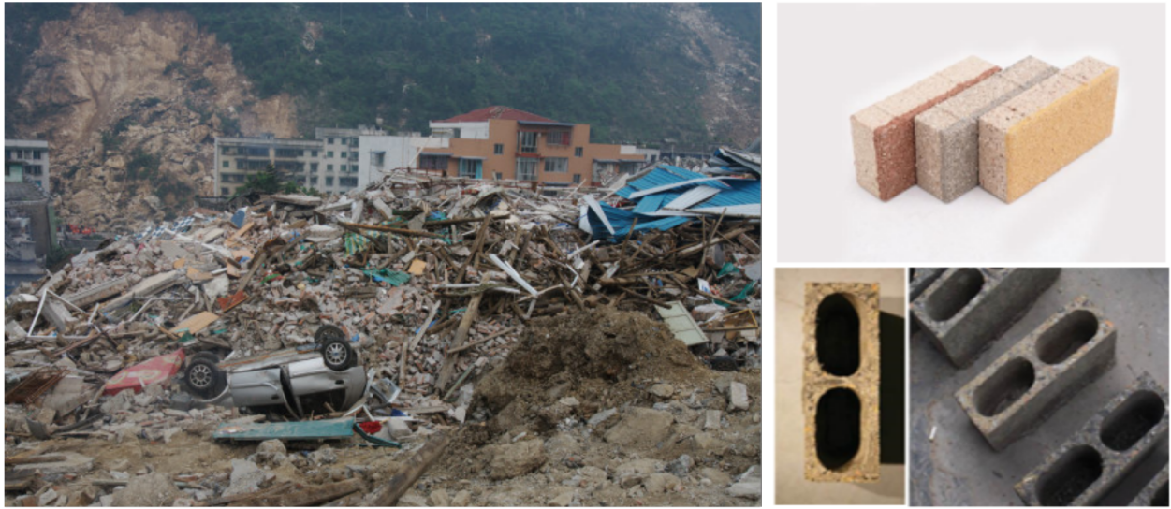 Fig. 1. Building Rubbish and Rebirth Brick
*Image source:https://www.jiemian.com/article/646215.html

Against this backdrop, the concept of circular construction and the utilization of recycled bricks have emerged as viable solutions [2]. Recycled bricks (Figure 1), as the name suggests, are manufactured through the processing and reuse of waste materials derived from construction debris. This approach not only mitigates environmental pollution caused by construction waste but also reduces dependence on natural resources, thereby promoting the circular use of materials and advancing sustainable development.

Circular construction represents an emerging architectural paradigm that emphasizes resource conservation and environmental protection throughout the entire life cycle of a building—from planning and design to construction and demolition. By adopting the principles of circular construction, it becomes possible to minimize, reutilize, and neutralize construction waste, thereby steering the building industry toward a greener, low-carbon, and circular mode of development.

Nevertheless, despite the growing recognition of recycled bricks and circular construction concepts, their practical implementation continues to face numerous challenges. Key issues include improving the performance and quality of recycled bricks, reducing production costs, and promoting the widespread adoption and realization of circular construction practices.

Therefore, this paper aims to examine the utilization of recycled bricks and the underlying philosophy of circular construction, along with the challenges and prospects of their real-world application. Through an in-depth analysis of the current social context and a comprehensive study of recycled brick technologies and circular construction methods, this research seeks to provide valuable insights for advancing the sustainable development of the construction industry and to offer meaningful guidance for scholars, policymakers, and industry practitioners.

1.2 Development of Recycled Bricks
With the rapid acceleration of urbanization, the volume of construction waste has increased exponentially. Traditional disposal methods, such as landfilling and incineration, not only result in severe resource wastage but also cause irreversible environmental pollution. Against this backdrop, developing new building materials capable of both effectively managing construction waste and achieving efficient resource recycling has become a critical issue in both scientific research and engineering practice. Recycled bricks—characterized by their environmental and economic advantages—emerged precisely in response to these dual social and environmental demands.

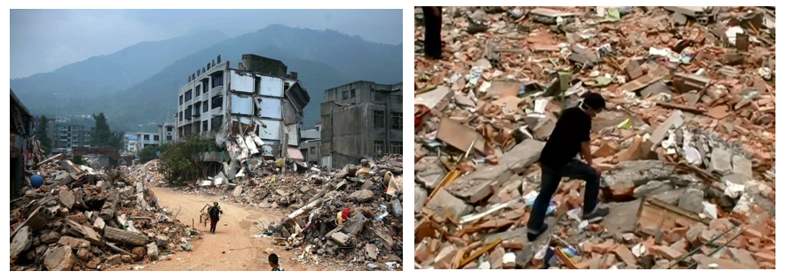

Fig. 2. Wenchuan earthquake building ruins
*Image source: https://www.davidguttenfelder.com/chinas-sichuan-quake

The inception of recycled bricks stems from a profound reconsideration of the reuse of discarded construction materials. During their production, crushed demolition debris is primarily used as aggregate. After undergoing strict disinfection and treatment, these materials are mixed with chopped straw, cement, and sand, and subsequently processed in brick-manufacturing plants to form lightweight yet durable masonry units. This innovative approach not only enables the full utilization of recyclable components within construction waste but also achieves low-cost and high-efficiency production through relatively simple processing techniques, thereby encouraging broader public participation in sustainable building practices.

Particularly in post-disaster reconstruction scenarios—such as the rebuilding efforts following the Wenchuan earthquake—where vast quantities of building materials were urgently required (Figure 2), recycled bricks were extensively utilized [3]. During the reconstruction process, architect Liu Jiakun played a leading role in promoting and applying recycled brick technology. He mobilized local villagers from the affected areas (Figure 3) and employed a series of simple and easily implementable production techniques to transform construction debris into recycled bricks (Figure 3). These bricks were subsequently used to rebuild numerous residential structures in the disaster-stricken regions [4].

Building upon this experience, Liu Jiakun continued to apply recycled bricks in his later projects, notably in the design of the Shuijingfang Museum (Figure 4) and West Village·Basis Yard (Figure 4). In these works, recycled bricks were employed as primary building materials, replacing traditional elements such as fired clay bricks. The resulting architecture not only demonstrates the practicality and aesthetic potential of recycled materials but also embodies the principles of environmental stewardship and sustainable development. From Liu’s post-earthquake reconstruction projects to his subsequent architectural works, these examples collectively establish a compelling model for the promotion and implementation of recycled brick construction in contemporary architectural practice.

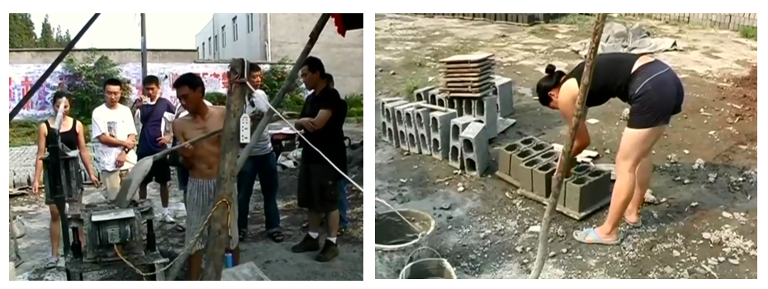

Fig. 3. Villagers participating in the preparation and demolding of Rebirth Bricks.
*Image source:https://www.bilibili.com/video/av973770787/

In terms of material composition, the aggregates used in recycled bricks are primarily derived from demolition debris—materials once regarded as waste but revitalized through professional processing. The inclusion of chopped straw, serving as a natural fiber reinforcement, effectively enhances the strength and durability of the recycled bricks. Meanwhile, an appropriate proportion of cement and sand, when scientifically mixed, forms the structural framework of the recycled brick matrix (Figure 5).

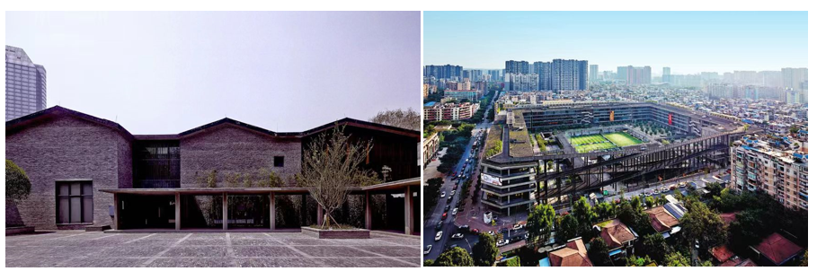
Fig. 4. The Shuijingfang Site Museum and West Village·Basis Yard designed by Liu Jiakun.
*Image source:https://divisare.com/projects/331220-jiakun-architects-arch-exist-shuijingfang-museum

From a technological perspective, the processing of recycled bricks is characterized by its simplicity, practicality, and adaptability. The production process requires no complex equipment and can be readily implemented in suburban or even rural areas. This localized mode of production not only reduces transportation costs but also benefits from a relatively low technical threshold. Consequently, strong public participation has become one of the major advantages of recycled brick manufacturing—through basic training, local residents can actively engage in this environmentally beneficial endeavor [5].

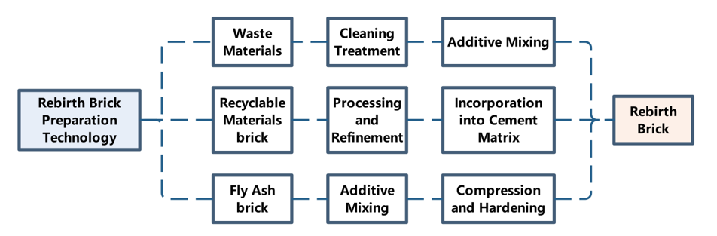
Fig. 5. Main Preparation Process of Rebirth Bricks
*Image source:The author's own illustration

From an environmental standpoint, the non-fired nature of recycled bricks ensures that no harmful substances are released during production, thereby significantly reducing environmental pollution. Moreover, by fully utilizing renewable components from construction waste, the process minimizes resource wastage and aligns closely with the principles of sustainable development.

As an eco-friendly and sustainable building material, recycled bricks possess broad application prospects. Although they have not yet been formally classified under a specific national standard category, their compressive strength already meets the required construction benchmarks, making them suitable for use in enclosure and infill wall systems. With the growing public awareness of environmental protection, recycled bricks are expected to play an increasingly vital role in the architectural field. Their widespread adoption not only contributes to addressing construction waste management challenges but also promotes resource recycling, thereby serving as a significant driver for sustainable societal development.

1.3 Circular Construction: The Integration of Tradition and Modernity

The concept of “circular construction” was first introduced by architect Wang Shu [6]. Deeply influenced by traditional Chinese building techniques—such as the 瓦爿 (tile-chip) craft (Figure 6)—Wang reinterpreted this ancient practice through a contemporary lens. His notion of circular construction not only revives and extends the philosophical essence of traditional craftsmanship but also embodies the enduring wisdom of Chinese architectural heritage .

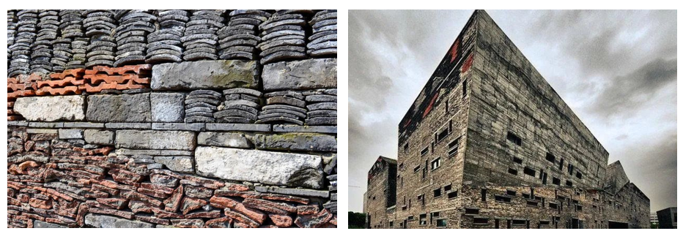
Fig. 6. Reclaimed bricks and tiles collected by Wang Shu and his architectural work – Ningbo History Museum.
*Image source:https://kknews.cc/zh-cn/culture/ara2j36.html

In Wang Shu’s extensive architectural practice (Figures 7), the profound embodiment of the circular construction concept is clearly evident. He skillfully employs discarded materials of various sizes—such as old bricks, tiles, stones, and ceramic fragments—integrating them artfully into the fabric of architectural walls. Each wall, through this meticulous assemblage, bears visible traces of history, as if inscribed with the memory of time. These materials, originating from different historical periods, are revitalized through Wang’s design, collectively composing an architectural tableau rich in temporal depth and cultural resonance.

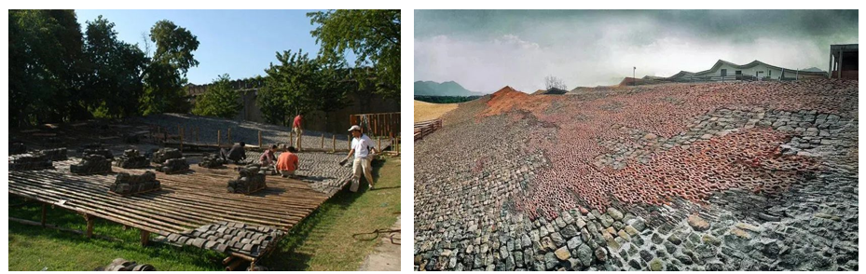
Fig. 7. Wang Shu's work- "Wa Garden" and Fuchun Mountain Residence Hall
*Image source:
https://www.world-architects.com/bm/amateur-architecture-studio-hangzhou/project/tiled-garden

Wang Shu has remarked that circular construction is not his invention but rather a revival of a great Chinese architectural tradition that has been gradually forgotten. This concept transcends the simple reuse of materials—it represents a deep respect for nature, culture, and history. To Wang, circular construction is not merely a building technique but also a philosophical stance and way of life. It calls for an appreciation of resources, reverence for history, and continuity of cultural heritage, ultimately striving for a harmonious coexistence between humanity and nature.

In contemporary Chinese architecture, the concept of circular construction has been widely embraced and put into practice. From a material perspective, architects have increasingly emphasized the reuse and recycling of discarded building materials—a strategy that not only reduces construction costs but also significantly alleviates environmental pressures. Aesthetically, circular construction introduces a distinctive sense of beauty and rustic character, offering the public a renewed and thought-provoking visual experience. Culturally, the historical memory and cultural depth embodied in this approach endow architectural works with a richer and more profound significance and value [7].

As an emerging architectural paradigm, circular construction represents both an inheritance and reinterpretation of traditional craftsmanship while simultaneously challenging and innovating upon modern architectural thought.However, existing studies rarely provide a comparative analysis that integrates recycled brick technology with the broader theoretical framework of circular construction, leaving a gap that this study aims to address.

2. Architectural Practice of Recycled Bricks

2.1 Shuijingfang Site Museum
The Shuijingfang Site Museum, located at No. 19–21 Shuijing Street, Jinjiang District, Chengdu (Figure 8), was designed by architect Liu Jiakun and constructed with investment from Sichuan Shuijingfang Co., Ltd. Officially opened to the public on July 18, 2013, the museum functions not only as a venue for cultural relic exhibitions and demonstrations of intangible cultural heritage but also as an experiential center for liquor culture and a showcase of the origin of China’s renowned spirits (Figure 9).

The museum primarily preserves and displays the original remains of the Shuijing Street distillery, which has a history of more than 600 years. Through the faithful reconstruction of the national intangible cultural heritage process—“Traditional Liquor Brewing Techniques of Shuijingfang”—the site authentically recreates historical production scenes, offering visitors an immersive experience of Shuijingfang’s rich liquor-making culture [8].

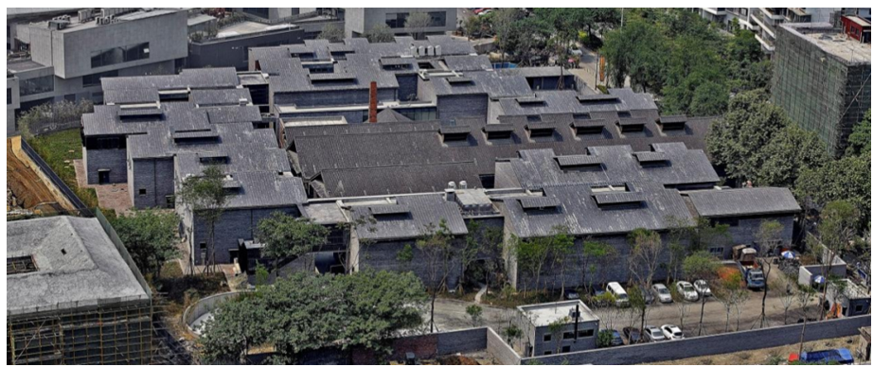
Fig. 8. Bird's eye view of the Shuijingfang Site Museum
*Image source:https://www.itsliquid.com/now-and-here-chengdu.html

In its exterior form, the museum employs traditional architectural materials such as grey bricks and clay tiles. These vernacular elements not only evoke a strong sense of historical continuity but also preserve the distinctive charm of ancient Chinese architecture through refined details. The upturned eaves and layered dougong brackets (Figure 9) exemplify exquisite craftsmanship and a profound respect for traditional aesthetics.

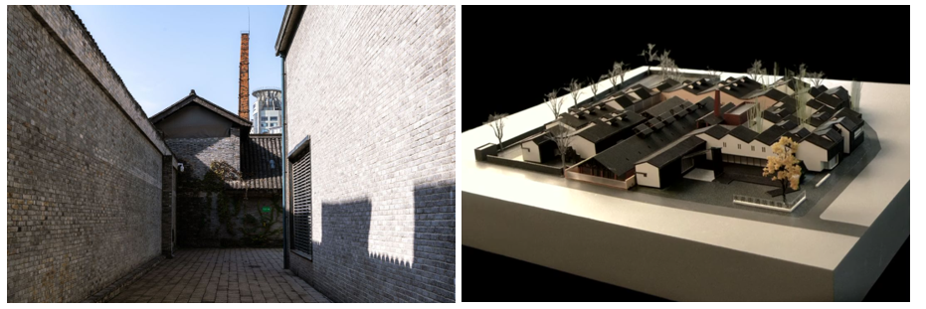

Fig. 9. Outside the space of the Shuijingfang Site Museum and the model of the Swellfun Museum
*Image source:https://www.itsliquid.com/now-and-here-chengdu.html

Upon entering the museum, visitors encounter an interior organized around a courtyard-style spatial layout—an arrangement that is both elegant and contemplative. This design transforms the visitor’s journey into an experiential passage through time, allowing one to sense the depth and grace of traditional Chinese architecture with every step. Notably, while embracing traditional architectural language, the museum also integrates contemporary design concepts. By employing advanced multimedia and interactive display technologies, it presents the ancient art of liquor brewing in a vivid, immersive, and multidimensional manner—imbuing traditional culture with renewed modern vitality.

Furthermore, the architectural design harmoniously integrates the museum into its surrounding environment. The roof form draws inspiration from nearby residential structures, subtly transformed and staggered to achieve a seamless transition between the new building and the historic fabric of the protected district. The result is an architecture that appears to have naturally evolved from the landscape—a cultural landmark organically rooted in its site.
In terms of heritage conservation, the museum demonstrates remarkable sensitivity. Guided by the principle of “complementarity,” the new structures are designed to echo the spatial character of the old distillery and adjacent dwellings, forming interconnected alleyways consistent with the traditional urban morphology. This “embracing” gesture not only safeguards the archaeological remains but also enables visitors to experience the profound historical continuity and cultural legacy embedded within the site.

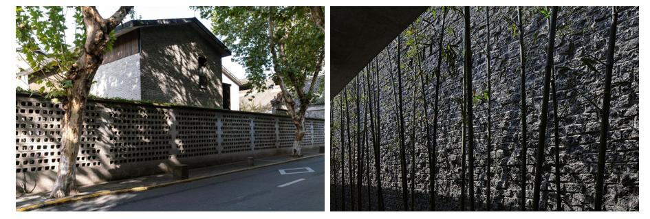

Fig. 10. The exterior walls of the museum and the bamboo structures inside the museum.
*Image source:https://www.itsliquid.com/now-and-here-chengdu.html

The substitution of recycled bricks for traditional grey bricks , laminated bamboo for wooden panels (Figure 10), and slate tiles for small clay tiles reflects both an inheritance and a reinterpretation of traditional architectural character. Through these material correspondences, the design establishes an architectural ensemble that is modern in technique yet traditional in spirit. The architectural distinction of the Shuijingfang Museum lies in its successful synthesis of vernacular architectural style and contemporary design philosophy, while maintaining a sensitive integration with the surrounding environment and demonstrating profound respect for the preservation of cultural relics. Together, these design features create a visitor experience that harmoniously blends historical resonance with modern sensibility.

The recycled bricks used in this project differ significantly from those first presented at the Venice Architecture Biennale, which were originally employed in the post-earthquake reconstruction of Wenchuan. At that time, the recycled bricks were produced by using fragments of debris as aggregate [9], combined with chopped straw as reinforcing fibers, and mixed with cement. These materials were processed in local brick factories within the disaster-stricken area, transforming the remnants of destruction into lightweight yet resilient masonry units. The rustic, unrefined texture of those early bricks embodied not only the memory of the disaster zone but also the symbolic strength of rebirth from the ruins, serving as a tangible foundation for reconstruction efforts.

In contrast, the recycled brick technology applied in the Shuijingfang Museum represents a more advanced and refined stage of development. Here, the bricks are produced through a rigorous and highly automated process: construction waste is first collected, cleaned, crushed, and screened, followed by the addition of specific additives before being compressed into uniform blocks. This meticulous procedure ensures both the structural reliability and aesthetic consistency of the final recycled brick product, demonstrating the technological maturity of contemporary sustainable material production.

2.2 West Village·Basis Yard

West Village·Basis Yard constitutes Phase III of the Chengdu West Village Creative Industry Park and, like its predecessors, was designed by architect Liu Jiakun. Situated on Beisen North Road in Qingyang District, Chengdu, the project occupies approximately 42,000 m² with a total floor area of about 135,000 m². As the largest and most programmatically diverse component of the West Village complex, it aspires to serve as a “Chengdu lifestyle center,” integrating office courtyards, distinctive cultural retail, a themed boutique hotel, and multipurpose exhibition and performance spaces. Within this project, Liu likewise deploys recycled bricks; a close examination of their application at West Village·Basis Yard reveals how the design strategically leverages recycled masonry to reconcile functional demands with aesthetic expression [10].

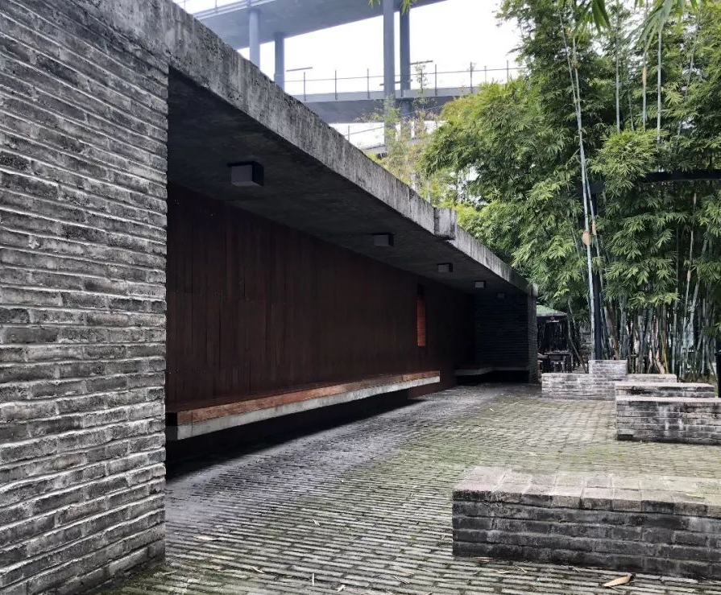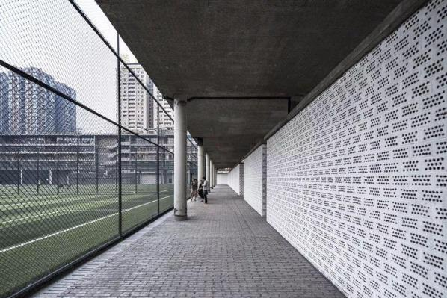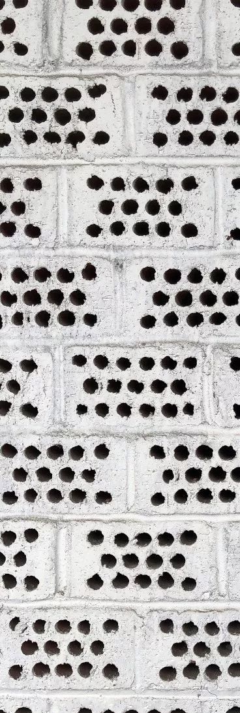
Fig. 11. The inner courtyards and Rebirth Brick walls of West Village·Basis Yard.
*Image source:https://www.instagram.com/p/DHIYoYiIuXm/

The architectural identity of West Village·Basis Yard is distinguished by its strong environmental ethos (Figure 11), innovative use of materials, and the seamless fusion of traditional and contemporary design elements. Foremost among these strategies is the extensive use of recycled bricks—an eco-friendly and cost-effective material composed of construction debris as aggregate, combined with straw fibers and cement. This choice reflects the architect’s deep commitment to resource circularity and sustainable development.

Structurally, the project adopts a large-span, beam-free floor system, which increases usable space and enhances spatial flexibility, meeting the diverse functional requirements of commercial tenants. The inclusion of dual inner and outer corridors improves building permeability while creating comfortable semi-public zones for relaxation and social interaction. Rejecting standardized spatial typologies, the design employs a dynamic architectural language to orchestrate a well-balanced mixture of different program types, thereby maximizing the marginal benefits of functional overlap.

Particular attention is also devoted to courtyard design, which forms the compositional core of the complex (Figure 12). The courtyards are meticulously arranged to achieve spatial harmony and visual coherence, reinforcing both the aesthetic refinement and human-scaled quality of the environment.
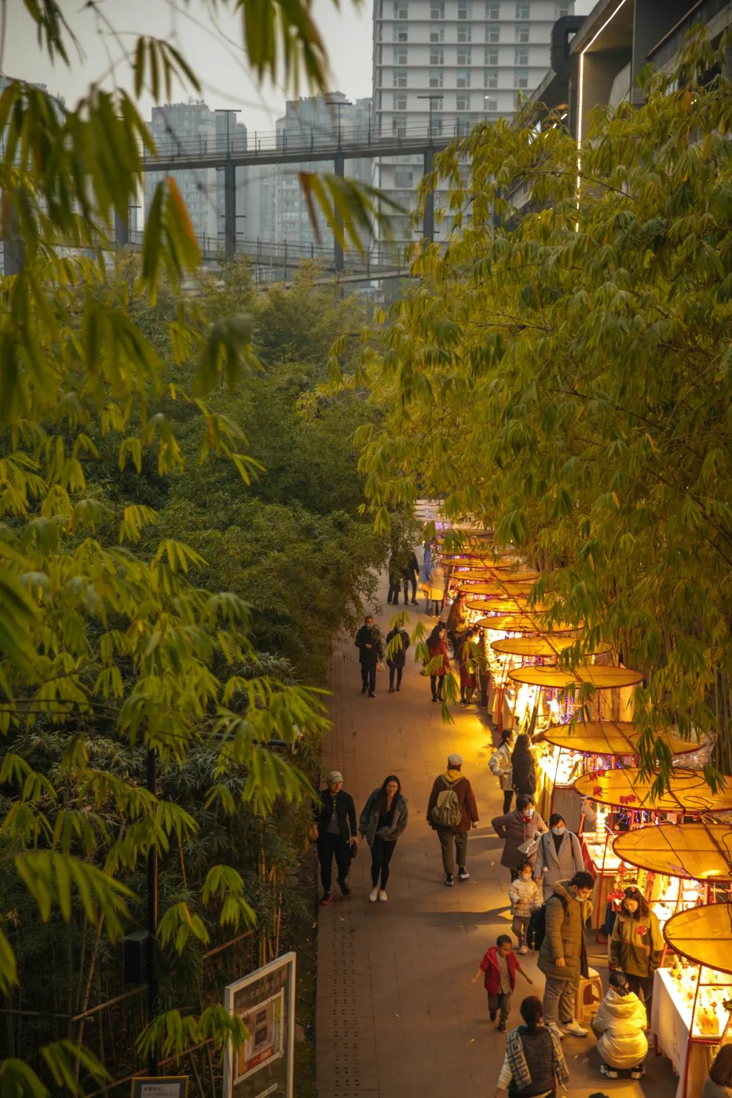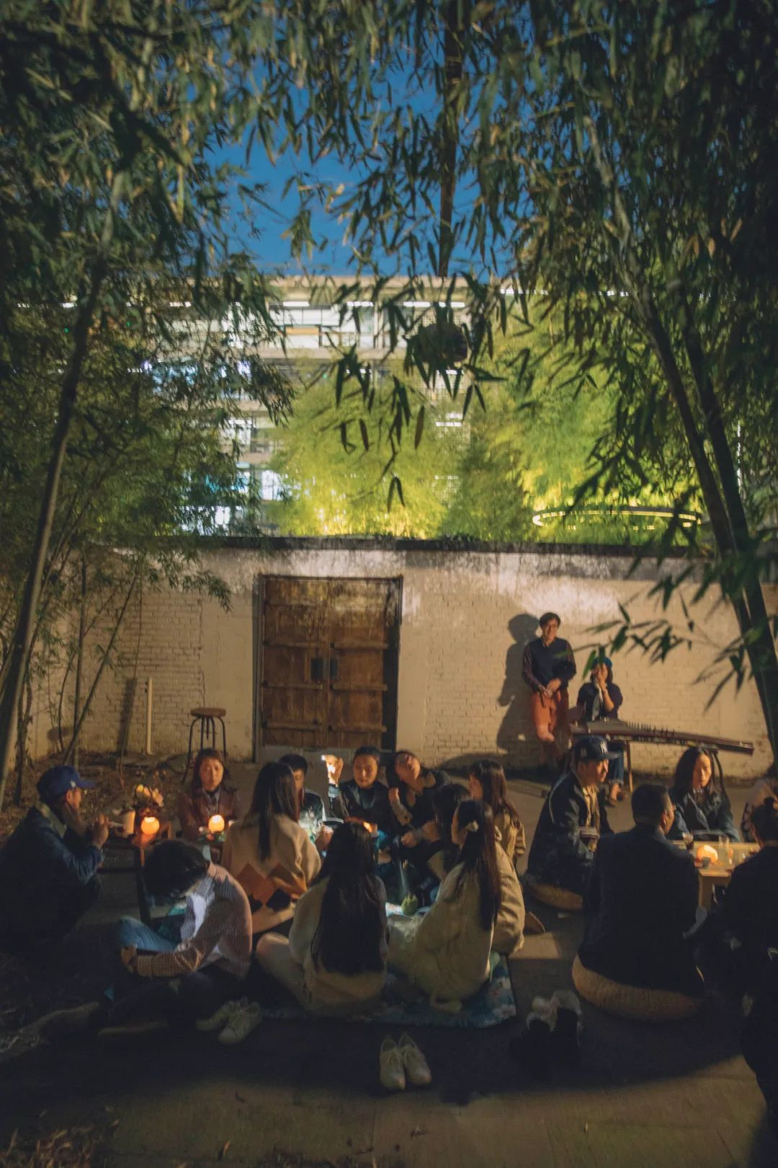
Fig. 12. The night market of West Village·Basis Yard and the bamboo grove tea gathering in its courtyard.
*Image source:https://www.instagram.com/p/DHIYoYiIuXm/

Overall, the architectural design of West Village·Basis Yard successfully balances functionality with aesthetic expression. By integrating ecological consciousness, material innovation, and traditional architectural sensibility, the project stands as a contemporary masterpiece that is at once practical, expressive, and deeply rooted in cultural continuity.

Unlike the Shuijingfang Museum, where recycled bricks were employed as substitutes for traditional grey bricks or other conventional materials, their use in West Village·Basis Yard serves a fundamentally different purpose. Here, the recycled bricks appear in their most commonplace commercial form—as standard porous units readily available on the market—seemingly distant from the refined materials typically used to construct traditional courtyard spaces. Yet, paradoxically, it is precisely this ordinariness that lends the courtyard its distinctive charm (Figure 12)[12].

Through the modest materiality of recycled bricks, the space evokes a poetic and timeless atmosphere reminiscent of classical Chinese gardens—serene, contemplative, and free from the distractions of the outside world. The tranquil courtyards, devoid of ornate embellishment, offer a refuge from the burdens of daily life, embodying the aesthetic ideal long cherished in Chinese culture: simplicity, harmony, and quiet elegance. Despite being constructed with modern materials, the setting achieves a seamless sense of authenticity, where visitors may sip tea, converse, or play the qin in an environment that feels at once contemporary and deeply rooted in tradition.

2.3 ANALYSIS OF RECYCLED BRICK APPLICATIONS IN THE TWO CASE STUDIES

Against the backdrop of an increasingly mature circular construction paradigm, the two case studies—the Shuijingfang Site Museum and the West Village·Basis Yard—demonstrate distinct approaches to the application of recycled bricks. As shown in the comparative table, the two projects exhibit differentiated material strategies and design logics in terms of product form, surface treatment, application scale, and functional positioning, reflecting the adaptability and diversity of recycled materials across varying architectural typologies.

Comparison Dimension | Shuijingfang Site Museum |  | West Village·Basis Yard
Product Form | No customized product types; mainly standard whole bricks and fractured bricks serving as the two fundamental categories. | 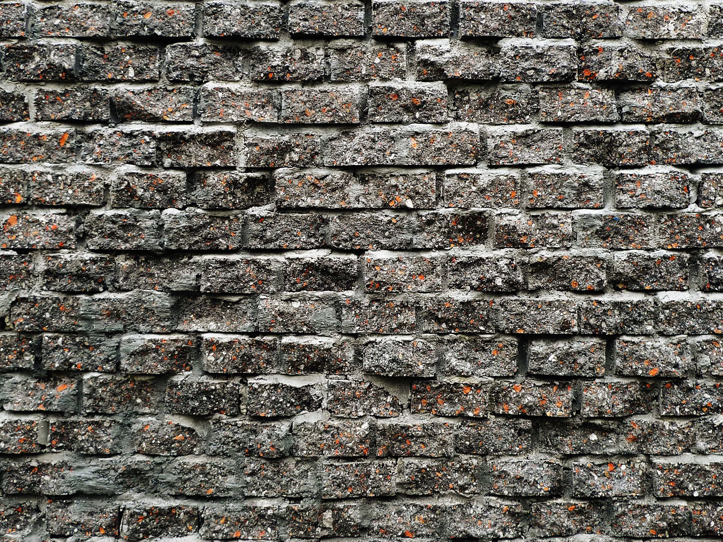   | Diverse recycled brick forms, including double-perforated recycled bricks, large-perforation recycled bricks, and roof-specific perforated units; highly customized morphology. | 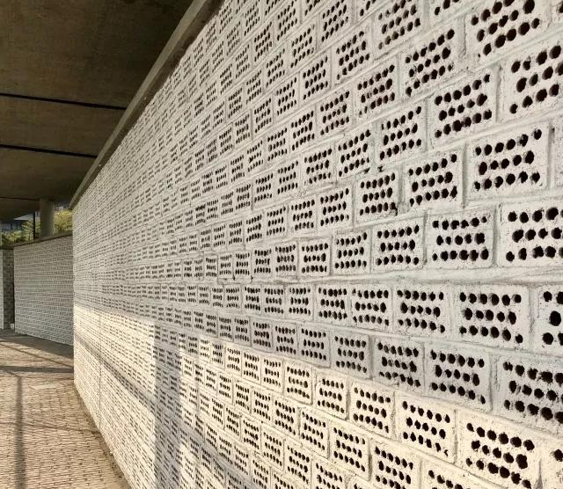  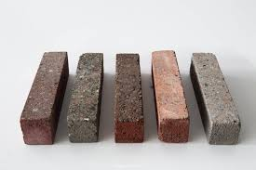
Surface Treatment | Fractured bricks keep their natural rough surfaces, while cut surfaces are brushed with oil to create a smooth finish, forming a “rough + polished” contrast. |  | No special finishing; original color variations and crushed-stone textures are retained, producing a raw and “anti-refined” material quality.
Application Scale | Total construction area approx. 8,670 m²; recycled bricks mainly used for perimeter wall construction and vertical façade treatments, with overall masonry volume far smaller than in West Village. |  | Total construction area approx. 135,000 m²; total masonry volume exceeding 6,018 batches, with recycled bricks used as core auxiliary materials for wall infill, roof paving, and equipment-related structures across multiple zones.
Functional Positioning | Serves cultural and heritage-related functions, expressing the material character of traditional local construction to create a “new place for old memories” and reinforce cultural continuity. |  | Supports large-scale public spaces with an urban “market-like character,” balancing decorative expression with functional needs such as roof planting, ventilation, and low-carbon circulation strategies.
Table. 1. A Comparative Analysis of the Application of Recycled Bricks in Shuijingfang Site Museum and West Village·Basis Yard.
*Table source:Self-drawn by the author
Image source:https://epaper.scdaily.cn/shtml/scrb/20250325/324322.shtml

In terms of product form, the Shuijingfang Site Museum employs a standardized system of whole and fractured bricks, emphasizing material stability and controllability—qualities aligned with the demands of cultural exhibition buildings for structural integrity and refined detailing. In contrast, the West Village·Basis Yard adopts a highly customized suite of recycled brick products, including double-perforated bricks, large-perforation bricks, and roof-specific units. This degree of morphological variation reveals a deliberate pursuit of material experimentation and spatial heterogeneity, enabling recycled bricks to perform differently in contexts oriented toward cultural representation versus community-oriented spatial production.

Surface treatment further distinguishes the two cases. The Shuijingfang Site Museum utilizes a deliberate contrast between rough, naturally fractured surfaces and smooth, oil-brushed cut faces, thereby heightening the tactile qualities and historical expressiveness of the material. By comparison, the West Village·Basis Yard retains the raw textures and chromatic inconsistencies of recycled bricks without additional finishing, resulting in a more modest, unrefined, and authentically “anti-refined” aesthetic. These divergent approaches demonstrate the versatility of recycled bricks in negotiating between visual expression and material authenticity.

Differences in application scale are even more pronounced. With a total floor area of approximately 135,000 m² and a masonry volume exceeding 6,018 batches, the West Village·Basis Yard represents a large-scale circular construction practice in which recycled bricks occupy a dominant role across wall enclosures, roof paving, and ancillary structures. Conversely, the Shuijingfang Site Museum, with an area of roughly 8,670 m², employs recycled bricks more selectively—primarily in boundary walls and façade treatments—highlighting a fine-grained material strategy oriented toward evoking site memory within a cultural building. These distinctions in scale further determine the differing roles each project plays within urban renewal, community construction, and heritage conservation.

With respect to functional positioning, the Shuijingfang Site Museum operates as a vessel for historical interpretation and cultural display, and its use of recycled bricks reinforces the architectural lineage of traditional western Sichuan construction. Meanwhile, the West Village·Basis Yard, serving as a community-centered public complex, prioritizes accessibility, ventilation, durability, and spatial flexibility. Here, recycled bricks become an organizational medium for structuring multi-layered public experiences rather than merely a representational material.

Taken together, the comparative analysis reveals not only the distinct ways recycled bricks are deployed across different architectural contexts but also two representative trajectories of circular construction practice: a culturally expressive pathway centered on material narrative and craftsmanship, and a community-oriented pathway emphasizing scale, diversity, and functional adaptability. Collectively, these cases illustrate the broad potential of recycled bricks within contemporary sustainable architecture.

Regarding environmental performance, established life-cycle assessment (LCA) studies and emissions accounting standards—including EN 15804 and ISO 14040/14044—indicate that recycled bricks generally reduce carbon emissions by approximately 30–50% relative to conventional clay or concrete bricks. This reduction results primarily from decreased dependence on virgin materials, the reuse of construction and demolition waste, and, in some cases, lower energy consumption associated with non-fired or low-temperature manufacturing processes. Within this widely validated range, the two case studies exhibit differentiated outcomes: the West Village·Basis Yard achieves greater total carbon reduction due to its substantially larger volume of recycled brick application, whereas the Shuijingfang Site Museum demonstrates higher carbon-reduction efficiency on a per-area basis. The latter advantage is closely linked to its simplified processing requirements and higher substitution ratio. These findings suggest that while recycled bricks offer environmental value in both large-scale urban projects and culturally oriented architectures, the underlying mechanisms of carbon reduction vary and should be evaluated in relation to project typology, material processing pathways, and construction methods.[12]

2.4 Environmental Significance of Recycled Bricks

Recycled bricks are produced from construction waste, thereby reducing the consumption of new raw materials and mitigating the environmental impact of discarded building debris. In addition to these environmental benefits, both case studies make extensive and effective use of recycled bricks, demonstrating substantial improvements in material utilization efficiency.The Shuijingfang Museum achieves an estimated 40–50% reuse rate of demolition-derived aggregates within its recycled brick system, while West Village·Basis Yard incorporates approximately 35% recycled masonry units across its courtyard wall assemblies, contributing to a more balanced integration of circular materials throughout the complex. As such, recycled bricks serve as a key eco-friendly material that supports resource circularity and advances the sustainable transformation of the construction industry.

(1) Reduction of Resource Consumption
The manufacturing of recycled bricks makes extensive use of materials that were previously regarded as waste, significantly diminishing the need for new resources such as clay, sand, and gravel. This process of reusing discarded materials constitutes an effective form of natural resource conservation, lessening the ecological footprint of construction activities.

(2) Mitigation of Construction Waste
By transforming construction debris into recycled bricks, this approach not only absorbs a substantial portion of accumulated waste but also reduces the volume of materials destined for landfills or incineration. Such waste-to-resource conversion helps address urban construction waste management challenges while minimizing the environmental pollution associated with excessive waste accumulation.

(3) Promotion of a Circular Economy
The production and application of recycled bricks are fully aligned with the principles of the circular economy, establishing a closed-loop system of “resource–product–renewable resource.” This cyclical model promotes sustainable economic growth and provides strong support for the building industry’s transition toward a green, low-carbon, and circular development paradigm.

2.5 Challenges in the Application of Recycled Bricks

As a sustainable building material, recycled bricks are increasingly gaining recognition within the construction industry. Produced from construction waste, they not only breathe new life into discarded materials but also demonstrate clear advantages in environmental protection and resource efficiency. Nevertheless, the widespread adoption of recycled bricks still encounters a range of practical challenges.

(1) Production Technology and Quality Control
Although the environmental significance of recycled bricks is well established, ensuring consistent production quality remains a major technical challenge. Because recycled bricks are composed of diverse waste materials, maintaining standardized strength, stability, and durability requires continuous research and technological refinement. The establishment and enforcement of rigorous quality control systems are therefore critical to guaranteeing the performance and safety of these materials and to securing their broader acceptance in the construction market.

(2) Innovative Integration in Architectural Design
Not all architectural projects are inherently suited to the use of recycled bricks. The challenge for architects lies in how to integrate these materials into design practice in a way that highlights both their aesthetic and functional potential. Achieving this demands a forward-looking perspective and creative experimentation, enabling designers to transform recycled bricks into expressions of environmental responsibility and architectural beauty.

(3) Market Acceptance and Policy Support
Market acceptance of recycled bricks is influenced by multiple factors—including cost, performance, visual appeal, and public awareness of green building materials. Unlike exemplary clients such as Novartis Shanghai, not every developer readily accepts materials derived from waste rather than newly manufactured products. Enhancing market receptivity thus requires both improved product quality and strong institutional support. Government incentives—such as tax reductions, financial subsidies, and preferential procurement policies—can play a decisive role in encouraging developers and consumers to adopt recycled materials, thereby accelerating the construction industry’s transition toward a greener, more circular model of development.

3.Reflections from Recycled Bricks to “Circular Construction”

3.1 From Recycled Bricks to Recycled Building Materials

With technological advancement and the growing public awareness of environmental sustainability, the reutilization of construction waste has become a defining trend in the contemporary building industry. Among various strategies for waste valorization, the development of recycled building materials stands out as a key pathway—and recycled bricks represent one of the most concrete and widely adopted manifestations of this approach. Yet, the scope of recycled building materials extends far beyond bricks, encompassing a diverse range of innovative products that combine structural strength with durability.

In architectural practice, the use of recycled building materials has become increasingly prevalent. Processed through specialized techniques, construction waste is granted a renewed lifecycle, while its environmental and economic advantages render it an increasingly indispensable component of sustainable construction. Whether applied to building structures, road paving, or landscape design, recycled materials consistently demonstrate superior performance and long-term sustainability.

The future prospects for recycled building materials are undoubtedly promising. As global attention toward environmental protection and sustainable development continues to intensify, and as resource-recycling technologies advance, both the variety and scope of these materials will continue to expand. Their application not only mitigates the environmental burden of construction waste but also alleviates the overexploitation of natural resources, providing robust support for the construction industry’s green transformation. It is foreseeable that recycled building materials will play an increasingly pivotal role in shaping a more sustainable, efficient, and environmentally responsible future for architecture.

3.2 The “Circular Construction” Model and Its Feasibility

The “circular construction” model has demonstrated significant advantages and far-reaching practical implications within the contemporary architectural industry. Centered on the cyclical reuse of materials, this model can be categorized into two primary approaches: direct recycling and indirect recycling. In direct recycling, discarded materials such as bricks, tiles, and ceramics are reused directly in new construction projects. A notable example is the “瓦爿墙” (tile-chip wall) of the Ningbo History Museum, which not only imparts a distinctive sense of historical depth to the architecture but also maximizes the reuse of existing resources. Indirect recycling, on the other hand, involves reprocessing waste materials through modern technology to create entirely new construction products, such as recycled bricks. This approach simultaneously conserves resources and reduces the environmental burden caused by construction waste.

The feasibility of the circular construction model can be demonstrated across several dimensions. Economically, it substantially lowers construction costs and enhances resource efficiency, aligning with the broader objectives of a green and low-carbon economy. Technologically, the continuous advancement of modern processing techniques has greatly improved the treatment and reuse of discarded materials, providing solid technical support for the implementation of circular construction. Environmentally, this model helps reduce the generation of construction waste, mitigates ecological stress, and fosters a more harmonious relationship between the built environment and nature [13].

Beyond its technical and economic dimensions, circular construction also embodies a profound cultural significance. It is not merely a building method or technological innovation, but also a vehicle for cultural continuity and emotional resonance. By incorporating reclaimed materials into new designs, architects embed layers of history and cultural memory within contemporary structures—allowing people to experience not only the aesthetics of architecture but also the enduring spirit of cultural inheritance [14].

Overall, the circular construction model holds broad feasibility and transformative potential for the architectural sector. It embodies the principles of ecological responsibility, sustainability, and cultural preservation while ensuring efficient resource utilization. As environmental awareness continues to deepen and the importance of cultural heritage gains greater recognition, circular construction is poised to become an increasingly prevalent and influential paradigm in the future of architectural practice.

4.Conclusion

As a representative form of green and circular building material, recycled bricks have demonstrated remarkable value and potential through their successful application in projects such as the Shuijingfang Museum and West Village·Basis Yard. By skillfully integrating recycled bricks into architectural practice, these projects not only achieve efficient resource reuse and reduce the environmental burden of construction waste but also introduce new dimensions of aesthetic expression and functional innovation. The widespread adoption of recycled bricks signifies the growing importance of green building materials in advancing the sustainable transformation of the architectural industry.

Looking ahead, green and circular materials are poised to play an increasingly pivotal role in future architectural practice. In the face of escalating global environmental challenges, the construction sector must urgently transition toward more sustainable and eco-conscious development models. The promotion and application of green circular materials will effectively mitigate the environmental impact of construction activities, enhance resource efficiency, and provide practical pathways for integrating material reuse into urban renewal and adaptive-reuse projects.

In this transformative process, governments, architects, and the public each play indispensable roles. Policy incentives and clear technical standards are essential for advancing the adoption of circular materials, ensuring that recycled brick products meet both performance expectations and regulatory requirements. Architects must strengthen their capacity for sustainable design, translating circular construction principles into actionable design strategies and leveraging the environmental and aesthetic advantages of recycled materials. Meanwhile, public awareness and acceptance must be further cultivated to foster broad societal participation in sustainable development.

Through the joint efforts of policymakers, designers, and society at large, green building materials—epitomized by recycled bricks—will undoubtedly assume an increasingly vital role in future architectural practice, contributing meaningfully to the creation of a sustainable and resilient built environment.

Disclaimer (Artificial intelligence)
Option 1:
Author(s) hereby declare that NO generative AI technologies such as Large Language Models (ChatGPT, COPILOT, etc.) and text-to-image generators have been used during the writing or editing of this manuscript.
Option 2:
Author(s) hereby declare that generative AI technologies such as Large Language Models, etc. have been used during the writing or editing of manuscripts. This explanation will include the name, version, model, and source of the generative AI technology and as well as all input prompts provided to the generative AI technology
Details of the AI usage are given below:
1.
2.
3.

References

[1]Yuan, L.; Yang, B.; Lu, W.; Peng, Z.; et al.Carbon footprint accounting across the construction waste lifecycle: A critical review of research.Environmental Impact Assessment Review, 2024, 107: 107551.
DOI: 10.1016/j.eiar.2024.107551

[2]Sovová, S.; Kaplan, P.; Hrdlicka, J.; Andertová-Berberichová, A.; Pospíšil, J.Recycling of building materials: an overview.Sustainable Materials and Technologies, 2025, 38, e00767.
https://doi.org/10.1016/j.susmat.2024.e00767.

[3]Bektaş, N.; Shmlls, M. Earthquake-Induced Waste Repurposing: A Sustainable Solution for Post-Earthquake Debris Management in Urban Construction. Buildings 2024, 14, 948. https://doi.org/10.3390/buildings14040948

[4]Xiao, J., Lu, Y., Yu, J. et al. Post-earthquake construction waste reuse: advancing green reconstruction and sustainability. Low-carbon Mater. Green Constr. 3, 2 (2025). https://doi.org/10.1007/s44242-025-00064-y

5.Dubale, M.; Vasić, M.V.; Goel, G.; Kalamdhad, A.; Singh, L.B. Utilization of Construction and Demolition Mix Waste in the Fired Brick Production: The Impact on Mechanical Properties. Materials 2023, 16, 262. https://doi.org/10.3390/ma16010262

[6]E.H.K. Yung, E.H.W. Chan, Implementation challenges to the adaptive reuse of heritage buildings: Towards the goals of sustainable, low carbon cities, Habitat International, 36 (3) (2012) 352-361.
https://doi.org/10.1016/j.habitatint.2011.11.001

[7]Zanelli, C.; Marrocchino, E.; Guarini, G.; Toffano, A.; Vaccaro, C.; Dondi, M. Recycling Construction and Demolition Residues in Clay Bricks. Appl. Sci. 2021, 11, 8918. https://doi.org/10.3390/app11198918

[8]Liu X ,Yang J ,Zhang Y , et al.Dramaturgy for a serious leisure space: Testing tourists’ cognitive reflections and emotional arousal at the Sanxingdui Museum[J].Journal of Hospitality and Tourism Management,2025,63275-289.DOI:10.1016/J.JHTM.2025.05.005.

[9]Glaydson S R, Bogdan G C, Alexis C, et al.Fabrication, microstructure, and properties of fired clay bricks using construction and demolition waste sludge as the main additive,[J].Journal of Cleaner Production,2020,0959-6526,https://doi.org/10.1016/j.jclepro.2020.120733.

[10]Lopez A S N ,Biona M M B J ,Chiu S A .Electricity trading and its effects on global carbon emissions: A decomposition analysis study[J].Journal of Cleaner Production,2018,195532-539.DOI:10.1016/j.jclepro.2018.05.231..

[11] Zhu Y ,Zhang A ,Bart D , et al.Research on the traditional courtyard typology and wind environment comfort - A case study of Qingshan Fishing Village in Qingdao, China[J].Sustainable Cities and Society,2025,130106511-106511.DOI:10.1016/J.SCS.2025.106511.

[12] Kosajan V ,Pan W ,Zhang Y . Life cycle assessment of embodied carbon from buildings’ demolition waste management systems in Hong Kong [J]. Journal of Cleaner Production, 2025, 536 147141-147141. DOI:10.1016/J.JCLEPRO.2025.147141.

[13] Bellini, A., Andersen, B., Klungseth, N. J., & Tadayon, A. (2024). Achieving a circular economy through the effective reuse of construction products: A case study of a residential building. Journal of Cleaner Production, 450, 141753. https://doi.org/10.1016/j.jclepro.2024.141753
.

[14]Dubale, M.; Vasić, M.V.; Goel, G.; Kalamdhad, A.; Singh, L.B. Utilization of Construction and Demolition Mix Waste in the Fired Brick Production: The Impact on Mechanical Properties. Materials 2023, 16, 262. https://doi.org/10.3390/ma16010262

