Case report
Leukemia Cutis as an isolated extra-medullary blast crisis in Chronic Myeloid Leukemia: A rare case report

.
ABSTRACT

Leukemia Cutis, characterized by infiltration of skin by leukemic cells leading to clinically recognizable coetaneous lesions, is a rare manifestation found in various underlying leukemias and sometimes as sole presentation. Its presence often correlates with underlying advanced stages of the disease and invariably associated with a dismal prognosis. Moreover, coetaneous leukemic proliferations often pose a diagnostic challenge. In this article, we report a rare case of biopsy proven leukemia cutis in a patient of chronic myeloid leukemia without bone marrow or other organ involvement, successfully treated with intensive chemotherapy. We emphasize the importance of early clinical identification, pathological diagnosis and apt initiation of definitive therapy.

Keywords: Chronic Myeloid Leukemia, Skin lesions, Leukemia Cutis, Extra-medullary Blast Crisis

1. INTRODUCTION:

Leukemia Cutis (LC) refers to infiltration of epidermis, dermis & subcutaneous tissue by neoplastic leukocytes and its precursors. Its variable clinical presentations make it difficult to distinguish from close differentials in various types of leukemias [1]. On microscopy most LCs show small blue round cell tumour morphology with perivascular &/or peri adnexal pattern along with infiltration of blasts into dermis & subcutis with sparing of upper papillary dermis i.e. Grenz zone. The exact pathology is still not well understood, but the theory of chemotaxis mediated migration of leukemic cells to skin via skin selective homing process is well accepted [2].Frequency of LC varies from 2-30% in different types of leukemias, most frequent in congenital leukemias (25-30%) and acute myeloid leukemias (AML) [3].In AML, extra medullary involvement is found in almost 10% of cases, skin manifestations in the form of LC being the most common (approximately 2-3%) [4].Other leukemic subtypes associated with higher incidence of LC include chronic Lymphoblastic leukemia (CLL), Acute lymphoblastic leukemia (ALL) & T-cell leukemias and rarely in myelodysplastic syndrome (MDS),myeloproliferative neoplasms (MPN) including chronic myeloid leukemia (CML) [4].LC usually represents an advanced disease , frequently involves other extramedullary sites as well and carries a poor prognosis [5].On the other hand, dermatological manifestations are present in almost 25-30% cases of leukemias and mostly include Leukemoids like petechiae, purpura, erythema , infections etc. [1].Here we present a case of 34 year old male , diagnosed as CML (without any circulating blasts in periphery or any excess blasts in Bone Marrow Biospy) and later developing LC as sole extramedullary myeloid blast crisis (proven from skin biopsy and proper Histopathological Examination with Immunohistochemistry) and successfully treated with intensive chemotherapy.

2. CASE REPORT:

A 34-year-old male with no known comorbidity presented with gradually progressive abdominal fullness, early satiety, weight loss over three months period; subsequently diagnosed as a case of CML-Chronic phase (CML-CP) 10 months back and was put on 1st generation tyrosine kinase inhibitor (TKI) imatinib 400 mg once daily. Two months after the initial diagnosis, he developed reddish discoloration of skin near the left flank of abdomen, which gradually leads to excoriation followed by ulceration. At this time, he also developed reddish nodule over left arm inner aspect, gradually increasing in size. On examination there was moderate pallor & splenomegaly 4 cm below left costal margin. One granulomatous nodular skin lesion noted in left flank of approximately 5 x 6 cm size having central ulceration with everted & necrotic margins (Fig. 1a). Two other nodular skin lesions also noted over left arm inner aspect (Fig. 1e). On Investigations, peripheral blood was free from blasts and further Bone Marrow Aspiration with biopsy revealed trilineage hematopoiesis. For the skin lesions, differentials of LC, pyoderma gangrenosum, leukocytoclastic vasculitis were considered and we proceeded with skin biopsy. Histopathological Examination revealed infiltration of dermis and epidermis by atypical mononuclear cell suggestive of myeloid precursor cells along with collection of immature myeloid cell in perineural and peri adnexal region of cuticular dermis (Fig. 2a, b).Immunohistochemical (IHC) analysis showed atypical cells focally positive for CD34, CD117, CD68 & CD45 and immunonegative for cytokeratin, HMB 45, CD3 and CD20, consistent with the diagnosis of leukemia cutis/Myeloid sarcoma (Fig. 2c-h).To rule out central nervous system involvement, contrast enhanced magnetic resonance imaging of brain with spectroscopy was performed which was within normal limit and CSF was free from blasts.
A final diagnosis of isolated extramedullary myeloid blast crisis in CML was made and patient was inducted with intensive systemic chemotherapy in the form of (3+7) regimen (daunorubicin 60mg/m² for 3 days and cytarabine 100mg/m²/day over 7 days via continuous infusion) along with 2nd generation TKI dasatinib 50mg once daily. The patient tolerated the chemotherapy well and his skin lesions gradually healed (Fig. 1b-d, f). Now the patient is being given consolidation with high dose cytarabine (HiDAC) with dasatinib and performing well four months post LC diagnosis.

3. discussion:

Leukemia Cutis, though, usually diagnosed in the context of known leukemia (55-77% of cases) or during initial presentation (23-44% of cases) ,it might even precede systemic disease or may be the sole manifestation of the same (2-3% of cases) where it is termed as Aleukemic LC [3].Virtually any leukemia can infiltrate skin[14].But, Clinically & histologically LC can be confused with a wide range of malignant (both hematological malignancies like sclerosing extramedullary hematopoietic tumour i.e. SEMHT, blastic plasmacytoid dendritic cell neoplasm i.e. BPDCN ; and non-hematological malignancies like merkel cell carcinoma, mesenchymal chondroblastoma etc.) [1]. and benign condition (like vasculitis, erythema nodosum, blistering dermatoses, herpesvirus disease etc.) Hence the diagnosis of LC is often missed even after IHC as stains for hematolymphoid markers beyond CD45 (which may be dim or even negative in LC) are seldom performed [6]. First set of IHC markers in suspected LC should comprise & characteristically reveal CD43+ CD45± INSM1- Lysozyme± MPO± CK22- & TdT±. Further myeloid LC is favoured by positivity for CD14 CD68 CD117 lysozyme MPO or CD123/IRF8 with a negative CD3 CD20.As the final step, WHO-5/ICC 2022 diagnosis should be established [7].
Skin infiltration in CML-CP is extremely rare, found in only 2-3% of cases and more common in blastic phase or might even precede blast crisis [8]. In the literature there are few reports of CML having LC which includes both lymphoblastoid as well as AML blastic transformation [9, 10]. In a systematic review of 184 biopsy proven LC cases , CML constitutes only 2.7% of total cases ; overall average time of leukemia to LC diagnosis was 25.6 months (range 0-180 months), chemotherapy was the most common modality of treatment (81.9%) and with a 11 months mean follow up duration (range 1 day -100 months), only 33.15% patients were alive having an average duration of leukemia diagnosis to death ranged from 1.75 – 10.3 months [4].The frequency of LC might differ as per age and leukemia subtype [13],but median survival of LC patients was 7.2 months in a recent study, with no statistically significant difference among underlying leukemia subtypes [11].In another study, 93% of LC patients died within 10 months of diagnosis [8].Therapeutic approach to LC encompasses systemic chemotherapy based on underlying leukemia. In cases resistant to chemotherapy (or contraindicated), radiotherapy (total skin electron beam therapy) may achieve remission [12].

4. Conclusion:

As Leukemia Cutis is invariably associated with a dismal prognosis and its difficulty in diagnosis due to rarity, paucity of data and close mimicry with other differentials, Clinicians as well as pathologists should be very vigilant in suspected cases and should always advise skin biopsy before proceeding to any therapy. In clinically contextless LC cases, especially in aleukemic LC, an algorithm based diagnostic approach is, therefore, strongly recommended. Early recognition and prompt initiation of appropriate chemotherapy might alter disease progression and prolong survival.

Consent (where ever applicable)

All authors declare that ‘written informed consent was obtained from the patient (or other approved parties) for publication of this case report and accompanying images. A copy of the written consent is available for review by the Editorial office/Chief Editor/Editorial Board members of this journal

Ethical approval (where ever applicable)

As per international standards or university standards written ethical approval has been collected and preserved by the author(s).

DISCLAIMER :
The Authors hereby declare that no forms of Artificial Intelligence (including any language based models or text to image generators) has been used while writing or editing this manuscript.

References

- Alex Jenei, Alexandar Tzankov, Diagnostic approach to leukemia cutis: A differential diagnostic step-by-step algorithm, American Journal of Clinical Pathology, 2024;, aqae133. https://doi.org/10.1093/ajcp/aqae133
- Cho-Vega JH, Medeiros LJ, Prieto VG, Vega F. Leukemia cutis. Am J Clin Pathol. 2008;129(1):130-142. https://doi.org/10.1309/WYACYWF6NGM3WBRT
- Parsi, M.; Go, M.S.; Ahmed, A. Leukemia Cutis. StatPearls Publishing: Treasure Island, FL, USA, 2023. Available online: https://www.ncbi.nlm.nih.gov/books/NBK541136/title of StatPearls. Accessed 16 Nov 2024.
- Dawood Findakly; Leukemia Cutis: A Systematic Review. Blood 2020; 136 (Supplement 1): 1. https://doi.org/10.1182/blood-2020-134860
- Robak, E.;Braun, M.; Robak, T. Leukemia Cutis—The Current View on Pathogenesis, Diagnosis, and Treatment. Cancers 2023, 15, 5393. https://doi.org/10.3390/cancers15225393
- Xu G, Zhang H, Nong W, et al. Isolated intracranial myeloid sarcoma mimicking malignant lymphoma: a diagnostic challenge and literature reviews. Onco Targets Ther. 2020;13:6085-6092. https://doi.org/10.2147/OTT.S245828
- Arber DA, Orazi A, Hasserjian RP, et al. International Consensus Classification of Myeloid Neoplasms and Acute Leukemias: integrating morphologic, clinical, and genomic data. Blood. 2022;140(11):1200-1228. https://doi.org/10.1182/blood.2022015850
- Yook, H.J.; Son, J.H.; Kim, Y.H.; Han, J.H.; Lee, J.H.; Park, Y.M.; Chung, N.G.; Kim, H.J.; Bang, C.H. Leukaemia Cutis: Clinical Features and Outcomes of 56 Patients. Acta Derm. Venereol. 2022, 102, adv00647. https://doi.org/10.2340/actadv.v102.1123
- Afroz, S.; Ayub, M.; Joshi, U.; Mahapatra, E.; Mba, B. Leukemia cutis: A rare presentation in chronic myeloid leukemia masquerading as cellulitis. In Proceedings of the Hospital Medicine, Orlando, FL, USA, April 2018; Abstract 431. Available online: https://shmabstracts.org/title of Abstracts. Accessed 30 Nov 2024.
- Qi, J.; Zhang, F.; Liu, Y.; Yao, J.; Xu, Y.; He, H. Extramedullary blast crisis of chronic myelogenous leukemia with a skin lesion: A case report and literature review. Am. J. Dermatopathol. 2021, 43, 450–453. https://doi.org/10.1097/dad.0000000000001897
- Chang, Y.W.; Lee, C.H.; Tseng, H.C. Leukemia cutis in a medical center in southern Taiwan: A retrospective study of 42 patients. J. Formos. Med. Assoc. 2021, 120 Pt 1, 226–233. https://doi.org/10.1016/j.jfma.2020.04.025
- Bakst RL, Dabaja BS, Specht LK, Yahalom J. Use of radiation in extramedullary leukemia/chloroma: guidelines from the International Lymphoma Radiation Oncology Group. Int J Radiat Oncol Biol Phys. 2018;102(2):314-319. https://doi.org/10.1016/j.ijrobp.2018.05.045
- Wagner G, Fenchel K, Back W, Schulz A, Sachse MM. Leukemia cutis - epidemiology, clinical presentation, and differential diagnoses. J Dtsch Dermatol Ges. 2012 Jan;10(1):27-36. doi: 10.1111/j.1610-0387.2011.07842.x. Epub 2011 Nov 17
- De Santis, V.; Mariani, S.; Pileggi, G.; Lubrano Lobianco, F.; Conte, E.; Maiorana, G.; Togni, C.; Piedimonte, M.; Di Napoli, A.; Persechino, S.; et al. Leukemia Cutis, a Tricky Diagnosis: A Case Report and Literature Review. Hemato 2025, 6, 38. https://doi.org/10.3390/hemato6040038

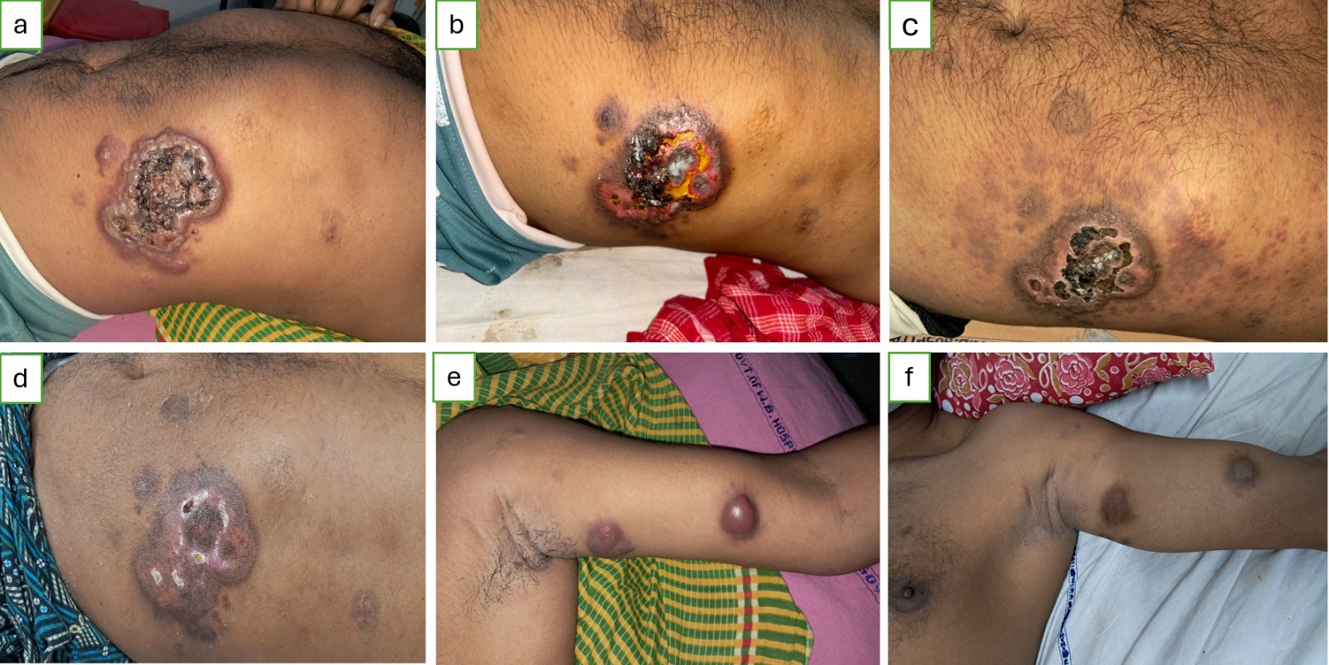

Fig. 1 : Images of the skin lesions and gradual resolution with treatment a. initial skin lesions at left flank having central ulceration with everted & necrotic margins with perilesional erythema ; b. 2 weeks post intensive therapy central ulceration area being replaced by granulation tissue and appearance of blacking scar formation ; c. post (3+7) induction at day 28, showing resolution of ulceration with stages of healing ; d. post 1st consolidation , healed ulcer with scar and appearance of healthy skin margin ; e. nodular skin lesions at presentation in left arm inner aspect ; f. disappearance of nodules post chemotherapy.

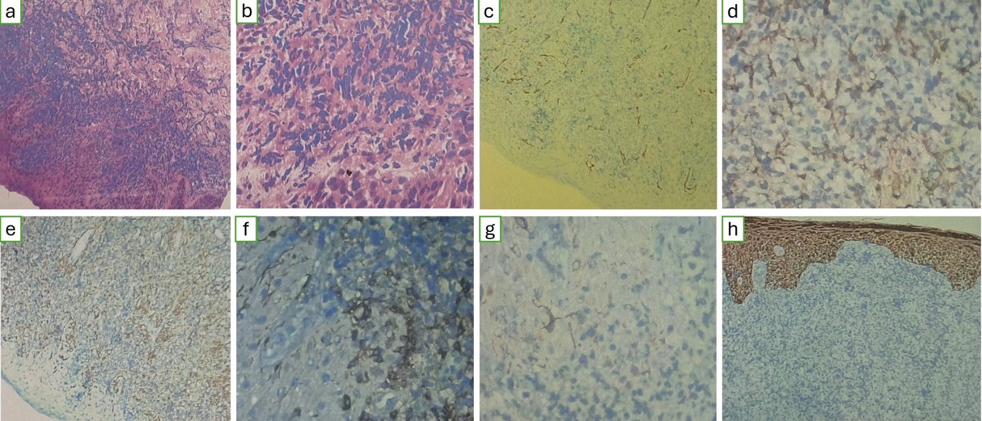
Fig. 2 : Histo-microscopic description of the lesion a,b. Punch biopsy of lesion on H & E stain (a on 10X & b on 40X) shows skin covered tissue with intact epidermis & dermis. Dermis shows infiltration by atypical cells in single files.Cells are hyperchromatic with high N:C ratio.Occasional cells show vacuolated cytoplasm, epidermis is free of infiltration by atypical cells; Further Immunohistochemistry shows these cells are immunopositive focally for CD34 (c), CD68 (d) CD45 (e) & CD117 (f) and negative for HMB-45 (g) Cytokeratin (h).

