Microbial Community Structure and Volatile Flavor Composition of High-Temperature Daqu with Different Colors

.
ABSTRACT

Aims: This study aimed to compare white (WQ), black (BQ), and yellow (YQ) high-temperature Daqu to determine how color differences correspond to variation in microbial community structure and volatile metabolite profiles, and to elucidate how these factors influence functional performance in Baijiu fermentation.

Study design: This was an experimental, laboratory-based comparative analysis that integrated culture-dependent microbial enumeration, high-throughput sequencing, and volatile profiling to characterize three Daqu types differing in color and fermentation ecology.

Place and Duration of Study: The study was conducted at the College of Food Science and Nutritional Engineering, China Agricultural University, Beijing, over three months from December 2024 to February 2025.

Methodology: White, black, and yellow Daqu samples were collected and subjected to culture-dependent plate counts, PacBio high-throughput sequencing, and HS-SPME–GC–MS volatile analysis. Microbial abundance, diversity indices, and taxonomic composition were quantified and compared across Daqu types. Volatile compounds were identified and categorized into esters, alcohols, acids, aldehydes, and pyrazines. Microbial metabolite correlations were assessed to reveal functional associations between dominant genera and key aroma compounds.

Results: Substantial microbial variation was observed among the Daqu types. WQ exhibited the highest total viable counts, whereas BQ showed reduced microbial abundance, likely attributable to greater thermal stress during maturation. Sequencing identified Kroppenstedtia, Bacillus, Thermoascus, and Thermomyces as core genera, with Saccharopolyspora enriched specifically in BQ. YQ demonstrated the highest microbial richness and evenness. More than 80 volatile compounds were detected across samples. WQ contained elevated alcohols and pyrazines, YQ showed higher concentrations of organic acids, and BQ exhibited increased esters and aldehydes. Strong positive correlations were observed between dominant microbial taxa and their corresponding volatile classes.

Conclusion: Daqu color reflects distinct microbial and metabolic functional profiles that shape fermentation behavior and aroma development in Baijiu production. Differences in microbial abundance, community structure, and volatile formation highlight the role of Daqu color as an indicator of fermentation potential. These findings provide scientific guidance for Daqu classification, quality control, and targeted flavor optimization.

Keywords: Daqu, microbial diversity, volatile compounds, Baijiu, fermentation quality

1. INTRODUCTION

Daqu is the core fermentation starter used in the production of Baijiu, China’s traditional distilled alcoholic beverage (Bai et al., 2024). It plays a pivotal role in shaping the biochemical transitions that occur during fermentation. As a complex, solid-state starter, Daqu harbors diverse consortia of bacteria, yeasts, and filamentous fungi that collectively drive the degradation of macromolecules such as starches, proteins, and lipids into fermentable substrates and aroma-active metabolites (Zhong et al., 2024). During its production, raw materials such as wheat undergo a series of microbial successions and thermophilic metabolic reactions under naturally fluctuating environmental conditions (Wu et al., 2024). These processes generate the distinct heat profiles, enzymatic activities, and microbial interactions that ultimately define the quality and functional performance of Daqu in Baijiu fermentation.
Traditionally, Daqu is categorized by its color, white, yellow, or black, which arises from differences in temperature gradients, humidity levels, oxygen availability, and microbial metabolic intensity during production (Cui et al., 2025). These color types are not merely aesthetic variations but serve as indicators of underlying microbial colonization and biochemical processes. White Daqu typically reflects mild fermentation with lower temperature accumulation, yellow Daqu results from moderate Maillard reactions and richer enzymatic activities, while black Daqu often forms under high-temperature fermentation, carbonization, or intense thermophilic microbial metabolism (Shi et al., 2024; Shanqimuge et al., 2025). Emerging research suggests that these color-related differences correspond to unique microbial assemblages, enzyme profiles, and volatile compound compositions, all of which contribute to Baijiu’s sensory identity (Tang et al., 2024; Zhang et al., 2024).
High-temperature Daqu (60–65 °C), common in strong-aroma Baijiu production, is particularly enriched in heat-tolerant and thermophilic taxa, including Bacillus, Thermoascus, Lichtheimia, Aspergillus, and Kroppenstedtia (Shi et al., 2024). These microorganisms secrete abundant hydrolases such as amylases, proteases, esterases, and glucoamylases that promote starch liquefaction, protein breakdown, and precursor generation for subsequent ethanol and aroma formation. Bacillus species, in particular, contribute to the production of pyrazines and other nitrogen-containing odorants that impart roasted, nutty, or savory notes characteristic of certain Daqu types (Lu et al., 2024). Meanwhile, yeasts and molds shape the formation of key alcohols, acids, and esters, thereby influencing aroma complexity and flavor balance (Zhao et al., 2025). Despite the extensive traditional knowledge surrounding Daqu color and its perceived quality attributes, detailed scientific mapping of how microbial community structure varies across Daqu colors and how these communities drive the production of specific volatile compounds remains incomplete.
Understanding the microbial ecology of Daqu is central to improving Baijiu fermentation quality and consistency. Microbial enumeration provides foundational insight into the abundance and distribution of viable microbial groups within Daqu. Total Colony Count (TCC) reflects overall microbial load, while targeted counts of lactic acid bacteria (LAB), yeasts, molds, and Bacillus species offer a quantitative view of functional microbial guilds responsible for acidification, saccharification, alcohol formation, and flavor generation (Houngbédji et al., 2018). LAB, for example, contribute to organic acid synthesis, pH regulation, and aroma precursor formation, while yeasts influence ethanol production, ester synthesis, and secondary metabolism (Li Z. et al., 2025). Molds enhance enzymatic hydrolysis through the secretion of amylases and proteases, and Bacillus species support aroma complexity through amino acid metabolism, peptide cleavage, and the generation of characteristic nitrogenous volatiles (Li Z. et al., 2024). However, culture-based enumeration captures only a fraction of the total microbial diversity in Daqu, as many microbes are unculturable or enter viable-but-non-culturable (VBNC) states under selective growth conditions. Advances in molecular biology, particularly DNA extraction, full-length 16S rRNA and ITS amplification, and high-throughput sequencing, have transformed our ability to comprehensively profile microbial communities in complex fermentation matrices. DNA-based approaches allow researchers to visualize community structure, identify dominant and rare taxa, and characterize microbial interactions that are otherwise undetectable using classical microbiological techniques (Mandal & Das, 2025). Full-length sequencing platforms, such as PacBio, further enhance taxonomic resolution at the species or even strain level, thereby offering unprecedented insight into microbial diversity within Daqu.
Alpha diversity indices, including Shannon, Simpson, and Chao1, provide quantitative metrics for evaluating microbial richness, evenness, and diversity within each Daqu sample (Guo et al., 2025). These indices are essential for assessing whether certain Daqu colors harbor more diverse or more specialized microbial communities, which in turn may influence fermentation performance and aroma contribution. Meanwhile, taxonomic profiling at the phylum and genus levels helps uncover dominant microbial groups that may serve as biomarkers for Daqu quality or color classification (Que et al., 2025). Such data enable a more mechanistic understanding of how microbial community structure translates into biochemical function during Baijiu fermentation. In addition to microbial profiling, volatile compound analysis, typically performed using Gas Chromatography Mass Spectrometry (GC–MS), is crucial for connecting microbial metabolism to aroma outcomes (Ma et al., 2024). Volatile compounds such as esters, alcohols, acids, aldehydes, ketones, and pyrazines are key determinants of Baijiu’s sensory character (Sun et al., 2025). Many of these compounds originate directly from microbial metabolism or through microbially mediated biochemical pathways. For example, yeasts contribute to higher alcohols and esters, molds influence aldehydes and organic acid formation, and Bacillus species generate distinctive pyrazines through amino acid degradation and the Maillard reaction (Zhong et al., 2024). Comparing volatile profiles across Daqu color categories provides insight into how microbial activity and fermentation conditions drive aroma differentiation.
Recent studies by Deng et al., (2020) on color-based high-temperature Daqu have shown that the four major types, white (QW), black (QB), yellow (QY), and red (QR), each develop under distinct fermentation conditions that shape their microbial and functional profiles. Across all colors, Kroppenstedtia, Bacillus, and Thermoascus were dominant, while Saccharopolyspora and Thermomyces were characteristic of QB and QR, and unclassified Eurotiales predominated in QY. Physicochemically, QW displayed higher protease activity and lower acidity, QB showed the opposite pattern, QR achieved the highest esterification yield, and QY had the strongest saccharification capacity but the lowest esterification yield. Functional predictions further revealed that the elevated bacterial enzyme genes in QW and QY were linked to their high proportions of Kroppenstedtia, whereas the abundance of fungal enzyme genes in QB corresponded to its dominance of Thermomyces.
Despite significant progress, there remains a scientific gap regarding how Daqu color specifically correlates with microbial ecology and volatile compound formation. Most existing studies focus on single Daqu types or limited microbial groups. Few integrate culturable enumeration, full-length sequencing, and comprehensive volatile profiling within the same framework. Addressing this gap is essential for advancing quality control, standardization, and mechanistic understanding of Baijiu fermentation. Therefore, this study was designed to provide an integrated, multidimensional investigation of Daqu of different colors. The specific objectives included quantifying key culturable microbial groups, such as total colony count, lactic acid bacteria (LAB), molds, yeasts, and Bacillus species, to establish baseline microbial loads across various Daqu color types. It also aimed to characterize the bacterial and fungal communities using full-length 16S rRNA and ITS sequencing to explore differences in microbial diversity, richness, and taxonomic composition. The study further sought to determine the major volatile flavor compounds in Daqu samples through gas chromatography-mass spectrometry (GC–MS) analysis, while examining the correlations between microbial taxa and volatile compound classes to identify functional links between microbiota and aroma formation. By integrating culture-based microbiology, advanced sequencing, and aroma chemistry, this research provides a comprehensive view of how Daqu color reflects underlying microbial diversity and influences the production of volatile compounds essential for Baijiu aroma and quality. The findings contribute to a deeper scientific understanding of Daqu fermentation ecology and offer insights that may support the improvement, stabilization, and modernization of Baijiu production processes.

2. material and methods

2.1 Sample collection
Samples of white Daqu (WQ), yellow Daqu (YQ), and black Daqu (BQ) were collected from high-temperature solid-state fermentation workshops in central China. Approximately 500 g of each Daqu type was randomly sampled from the interior and surface layers to ensure representativeness. Samples were transported to the laboratory under cooled conditions and homogenized aseptically before storage at 4 °C for microbiological and molecular analysis. Table 1 summarizes the materials and reagents used in this study.2.2 Physicochemical Analysis
Table 1: Materials and reagents
Laboratory Material & Reagent | Article No. | Brand
Normal saline
Aspergillus suspension
Plate Count Agar | 02-035A | AOBOX BIOTECHNOLOGY
Rose Bengal Medium | 02-082 | AOBOX BIOTECHNOLOGY
Yeast Extract Peptone Dextrose Agar | 02-107 | AOBOX BIOTECHNOLOGY
MRS Broth | 02-291 | AOBOX BIOTECHNOLOGY

2.3 Enumeration of Culturable Microbial Groups
2.3.1 Preparation of Daqu Suspensions
For each Daqu type, 5.0 g of powdered sample was mixed with 45 mL of sterile 0.85% normal saline and vortexed in a shaker at 120–150 rpm for 15 min to obtain the primary suspension according to the protocol of (Cui et al., 2025). For microbial plating, serial 10-fold dilutions were prepared. An Aspergillus suspension (1 mL stock diluted in 9 mL sterile water) served as the standard for mold enumeration.
    - Plate Inoculation and Cultivation
Bacterial inoculation was done according to (Topaloğlu & Yolci, 2025). Aliquots of 100 μL from appropriate dilutions were spread-plated on different selective media, Plate Count Agar (PCA), incubated at 37 °C for 12 h, PCA at 55 °C for 12 h, Rose Bengal Agar (RBA), incubated at 37 °C for 48 h, YPD agar, incubated at 37 °C for 48 h, MRS broth/agar incubated under conditions optimized for LAB growth Each dilution (10⁻¹ to 10⁻³) was plated in duplicate to ensure reliability. Only plates containing 30–300 CFU were selected for enumeration, following the microbiological standards outlined in GB 4789.2-2016. Microbial counts were expressed as colony-forming units per gram (CFU/g) of Daqu.

2.4 DNA Extraction, PCR Amplification, and High-Throughput Sequencing
2.4.1 DNA Extraction
Microbial genomic DNA was extracted from 0.5 g homogenized Daqu using the PowerSoil DNA Isolation Kit, according to the manufacturer’s protocol. DNA purity (A260/A280 ratio), concentration, and integrity were assessed to ensure suitability for downstream analyses.
    - PCR Amplification of Bacterial and Fungal Communities
The full-length 16S rRNA gene was amplified using the primers 5'-AGRGTTTGATYNTGGCTCAG-3' and 5'-TASGGHTACCTTGTTASGACTT-3' according to (Lei et al., 2025) with minor modifications. The PCR conditions included an initial pre-denaturation step at 95 °C for 2 minutes, followed by 25 cycles consisting of denaturation at 98 °C for 10 seconds, annealing at 55 °C for 30 seconds, and an extension at 72 °C for 1.5 minutes. The process concluded with a final extension at 72 °C for 2 minutes. For the full-length fungal ITS region, amplification was carried out using ITS1F (5'-CTTGGTCATTTAGAGGAAGTAA-3') and ITS4R (5'-TCCTCCGCTTATTGATATGC-3'). The PCR conditions here started with a pre-denaturation step at 95 °C for 5 minutes, followed by a touchdown stage comprising 8 cycles: 95 °C for 30 seconds, 55 °C for 30 seconds, and 72 °C for 45 seconds. This was followed by an amplification stage of 24 cycles at 95 °C for 30 seconds, 60 °C for 30 seconds, and 72 °C for 45 seconds, concluding with a final extension at 72 °C for 5 minutes.
The resulting PCR products were purified, quantified, normalized, and pooled together to create sequencing libraries. We ensured the quality of the libraries before proceeding with sequencing on the PacBio platform.
2.5 Bioinformatics and Microbial Diversity Analysis
Raw sequencing reads were carefully filtered to eliminate low-quality sequences, chimeras, and non-specific fragments (Kim et al., 2025). The remaining high-quality sequences were then organized into Operational Taxonomic Units (OTUs) based on a 97% similarity threshold. For taxonomic classification, standard reference databases were utilized at various levels: phylum, class, genus, and species. To evaluate within-sample diversity, we calculated alpha diversity indices using QIIME, including the Shannon index (diversity), Simpson index (evenness), and Chao1 index (richness). Additionally, relative abundance plots were created to illustrate the microbial composition across major taxonomic levels.
2.6 Volatile Compound Profiling by HS-SPME-GC-MS
Volatile compounds were extracted using headspace solid-phase microextraction (HS-SPME) and analyzed via GC–MS following (Chen et al., 2025). Samples were equilibrated in sealed vials before extraction with an SPME fiber at controlled temperature and time conditions. Compounds were identified by comparison with the NIST mass spectral library and verified using retention indices where necessary. Semi-quantification was performed based on relative peak area normalization.

2.7 Statistical Analysis
One-way ANOVA was conducted to identify statistically significant differences in microbial counts, diversity indices, and volatile compound abundances across Daqu color types (p ≤ 0.05). Chemometric analyses, including Principal Component Analysis (PCA), were performed using GraphPad Prism 10.2 to visualize sample clustering and identify major discriminating variables.

3. results and discussion

3.1 Microbial Enumeration
3.1.1 Total Coliform Count (TCC)
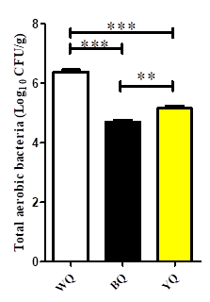
Total coliform count (TCC) serves as a critical indicator of hygienic quality and potential contamination in fermentation starters such as Daqu (Qu et al., 2025). There was a significant variation in TCC among white, black, and yellow Daqu samples, as shown in Figure 1. White Daqu exhibited the highest TCC, followed by yellow Daqu, whereas black Daqu showed the lowest values. Elevated TCC in white and yellow Daqu suggests greater exposure to contamination sources or environmental conditions that favor coliform proliferation (Ayitey et al., 2025). Because coliforms, including Escherichia coli, signal possible fecal or ecological contamination, their presence in high numbers can compromise both the safety and functional microbiota of Daqu (Zhao Y. et al., 2025).

Figure 1: Microbial enumeration of Daqu with different colors in respect to total aerobic bacteria.
Where *, 0.01 ≤ p < 0.05; **, 0.001 ≤ p < 0.01; ***, p < 0.001. The Y-axis shows the concentration level, while the X-axis shows the different Daqu samples.
High TCC may interfere with fermentation dynamics by competing with beneficial microbiota, altering pH patterns, and affecting enzymatic activities responsible for flavor generation (Zhang, J. et al., 2025). These discrepancies likely arise from variations in raw material handling, fermentation temperature, moisture distribution, aeration conditions, and post-fermentation storage. Thus, Daqu producers must implement stringent hygienic controls to prevent coliform interference and preserve starter culture integrity.

3.1.2 Lactic Acid Bacteria (LAB)
Lactic acid bacteria count differed significantly across samples, with white Daqu exhibiting the highest LAB content, as depicted in Figure 2. LAB are crucial for acidification, inhibition of spoilage organisms, and modulation of flavor development through organic acid production (Zhang, J. et al., 2025). Their dominance in white Daqu suggests more favorable moisture and temperature conditions for LAB proliferation during heap fermentation.

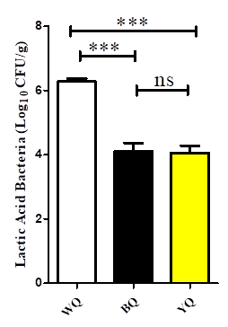

Figure 2: Microbial enumeration of Daqu with different colors in respect to Lactic acid bacteria
Where *, 0.01 ≤ p < 0.05; **, 0.001 ≤ p < 0.01; ***, p < 0.001. The Y-axis shows the concentration level, while the X-axis shows the different Daqu samples.
The moderate LAB populations in yellow Daqu and comparatively lower counts in black Daqu may reflect harsher thermal profiles in black Daqu production, where higher temperatures can reduce LAB viability. Similar results were obtained by (Zong, E et al. 2024; Lei, Z et al., 2025), who noted that maintaining adequate LAB levels is essential for ensuring microbial stability and enhancing the biochemical transformations characteristic of high-quality Daqu. Targeted control strategies such as optimizing humidity and turning intervals may therefore be beneficial.
3.1.3 Bacillus
Bacillus populations also varied among the Daqu types, with white Daqu showing the highest counts (Figure 3). Bacillus spp. are heat-tolerant, spore-forming microorganisms that thrive in the high-temperature zones typical of Daqu fermentation (Song et al., 2025). Many species, such as Bacillus licheniformis and Bacillus subtilis, are desirable due to their production of proteases, amylases, and volatile pyrazines, which contribute to flavor complexity. However, elevated Bacillus levels may also indicate potential spoilage risks, depending on strain composition (Snyder et al., 2024). The low Bacillus counts in black Daqu may result from more intense thermal stress and reduced oxygen exposure (Ge et al., 2024). Understanding Bacillus community structure is therefore essential for balancing enzymatic contributions with safety and quality considerations.

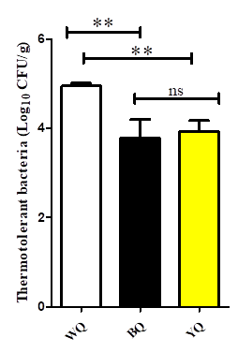

Figure 3: Microbial enumeration of Daqu with different colors in respect to thermotolerant bacteria (Bacillus)
Where *, 0.01 ≤ p < 0.05; **, 0.001 ≤ p < 0.01; ***, p < 0.001. The Y-axis shows the concentration level, while the X-axis shows the different Daqu samples.

3.1.4 Yeasts
Yeast enumeration revealed that white Daqu exhibited the highest yeast populations, followed by yellow and black Daqu (Figure 4). Yeasts are fundamental to the processes of ethanol production, aroma development, and the secretion of hydrolases that hydrolyze starches and proteins (Bretträger et al., 2024). The observed variations in yeast counts can be attributed to factors such as fermentation temperature, porosity, oxygen diffusion, and substrate availability. Given that yeast-driven metabolic activities influence the concentrations of higher alcohols, esters, and other volatile compounds, samples with higher yeast abundance, particularly white Daqu, are likely to exhibit more intricate aromatic profiles (Hu et al., 2025). Consequently, strategic management of yeast populations is crucial for fostering beneficial yeast species while suppressing undesirable ones that may lead to off-flavor production.

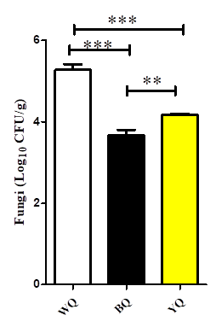

Figure 4: Microbial enumeration of Daqu with different colors in respect to fungi
Where *, 0.01 ≤ p < 0.05; **, 0.001 ≤ p < 0.01; ***, p < 0.001. The Y-axis shows the concentration level, while the X-axis shows the different Daqu samples.

3.1.5 Mold

Molds such as Aspergillus, Rhizopus, and Monascus are critical in the production of Daqu, primarily due to their capacity to secrete amylolytic and proteolytic enzymes that promote the saccharification process (Bai et al., 2024). Analysis of mold counts shows no significant variation between black and yellow Daqu; however, white Daqu exhibited significantly higher mold loads, as illustrated in Figure 5. It is essential to note that excessive mold proliferation could lead to concerns regarding mycotoxin contamination and spoilage, necessitating meticulous monitoring strategies. Environmental parameters, particularly moisture content, aeration, and temperature, are crucial determinants of mold development (Qiao et al., 2024). The comparable mold counts observed in black and yellow Daqu may indicate the stabilizing influence of high-temperature fermentation, which tends to favor thermophilic and xerophilic fungal populations.

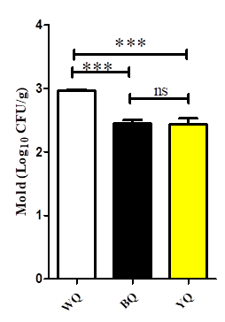
Figure 5: Microbial enumeration of Daqu with different colors with respect to mold
Where *, 0.01 ≤ p < 0.05; **, 0.001 ≤ p < 0.01; ***, p < 0.001. The Y-axis shows the concentration level, while the X-axis shows the different Daqu samples.

3.2 Microbial Diversity and Community Composition
3.2.1 Bacterial Community Structure
At the phylum level, bacterial communities across all Daqu types were dominated by Firmicutes (>90%), followed by Actinobacteria (Figure 6). White Daqu exhibited the highest Firmicutes proportion, consistent with its elevated Bacillus and LAB counts. Black Daqu showed comparatively higher Actinobacteria levels, aligning with its enrichment in Saccharopolyspora. At the genus level (Figure 7), Kroppenstedtia, Virgibacillus, and Bacillus were dominant across samples, though with distinct compositional patterns. Black Daqu was notably enriched in Kroppenstedtia and Saccharopolyspora, microorganisms that contribute to high-temperature resilience and pyrazine formation. White and yellow Daqu showed higher Virgibacillus abundance, consistent with enhanced enzyme production and saccharification potential. These compositional differences reflect the influence of fermentation temperature gradients and heap-turning practices.
Figure 6: Relative abundance of bacteria at the phylum level
Figure 7: Relative abundance of bacteria at genus level

3.2.2 Fungal Community Structure

Fungal communities in all Daqu samples were overwhelmingly dominated by Ascomycota, which accounted for 97.89%–99.45% of the total fungal biomass. This phylum is well recognized for its thermotolerance and strong saccharification potential in high-temperature fermentation systems (Yang et al., 2024). At the genus level, Thermoascus, Thermomyces, and Rasamsonia consistently emerged as the core functional taxa (Figure 8), confirming their central role in carbohydrate degradation and aroma precursor formation during Daqu maturation. Interestingly, White Daqu contained the highest relative abundance of Rasamsonia, a genus associated with vigorous hemicellulase and cellulase production. Its enrichment suggests a more active saccharification environment in WQ, potentially supporting the higher availability of fermentable sugars observed in similarly processed Daqu. In contrast, Black and Yellow Daqu exhibited greater proportions of Thermomyces and Thermoascus thermophilic genera known to secrete a suite of thermostable enzymes, including amylases, lipases, and proteases. Their dominance is consistent with the elevated thermal load typically experienced by BQ and YQ during heap fermentation.

These patterns highlight that fungal community succession is highly responsive to fermentation temperature gradients, localized moisture redistribution, and oxygen penetration, which together shape enzyme expression and metabolic directionality. The findings align with recent observations that high-temperature niches selectively enrich fungi capable of sustaining intense biochemical turnover (Yao et al., 2025), underscoring their importance in driving distinct flavor trajectories across Daqu types.
Figure 8: Relative abundance of fungi at genus level

3.3 Alpha Diversity

For fungal communities, alpha diversity indices also revealed distinct patterns across the Daqu samples, highlighting the influence of thermal gradients and substrate composition on community assembly (Table 2; Figures 9 and 10). Yellow Daqu demonstrated the highest Shannon and Chao1 values, indicating superior species richness and evenness compared to the white and black variants. This suggests that Yellow Daqu provides a more favorable ecological niche for fungal proliferation, potentially due to its intermediate fermentation temperature and balanced moisture conditions, which support both thermophilic and moderately thermotolerant taxa (Zhong et al., 2024). The elevated fungal diversity in Yellow Daqu likely contributes to its broader enzymatic repertoire, particularly in the decomposition of starches, proteins, and cell wall polysaccharides. Diverse fungal genera, including Thermoascus, Thermomyces, and Rasamsonia known producers of thermostable hydrolases such as amylases, proteases, and xylanases, which play essential roles in the formation of aroma precursors (Yang et al., 2024). A richer fungal community thus enhances metabolic flexibility and may partly explain the more complex and acidic volatile profile observed in Yellow Daqu.
Fungal alpha diversity showed similar trends, with white Daqu displaying the highest Shannon and Simpson values. Sequencing coverage exceeded 99% for all samples, confirming sufficient depth for community analysis.
Table 2: Sequencing outcomes and Daqu samples' alpha diversity statistical analysis
Sample | Bacteria |  |  |  |  |  |  |  |  |  | Fungi
Sample | Chao1 |  | Faith_pd |  | Goods_coverage |  | Shannon |  | Simpson |  | Chao1 | Goods_coverage | Shannon | Simpson
BLACK |  | 176.39 |  | 6.0951 |  | 0.999859 |  | 3.397807 |  | 0.808612 | 30.378 | 0.999988 | 1.58257 | 0.57972
WHITE |  | 307.9307 |  | 5.848823 |  | 0.999945 |  | 5.47742 |  | 0.929308 | 36.96943 | 0.999993 | 2.19630 | 0.72436
YELLOW |  | 186.713 |  | 3.58677 |  | 0.999952 |  | 4.5161 |  | 0.885695 | 31.3617 | 0.999999 | 1.70595 | 0.613059

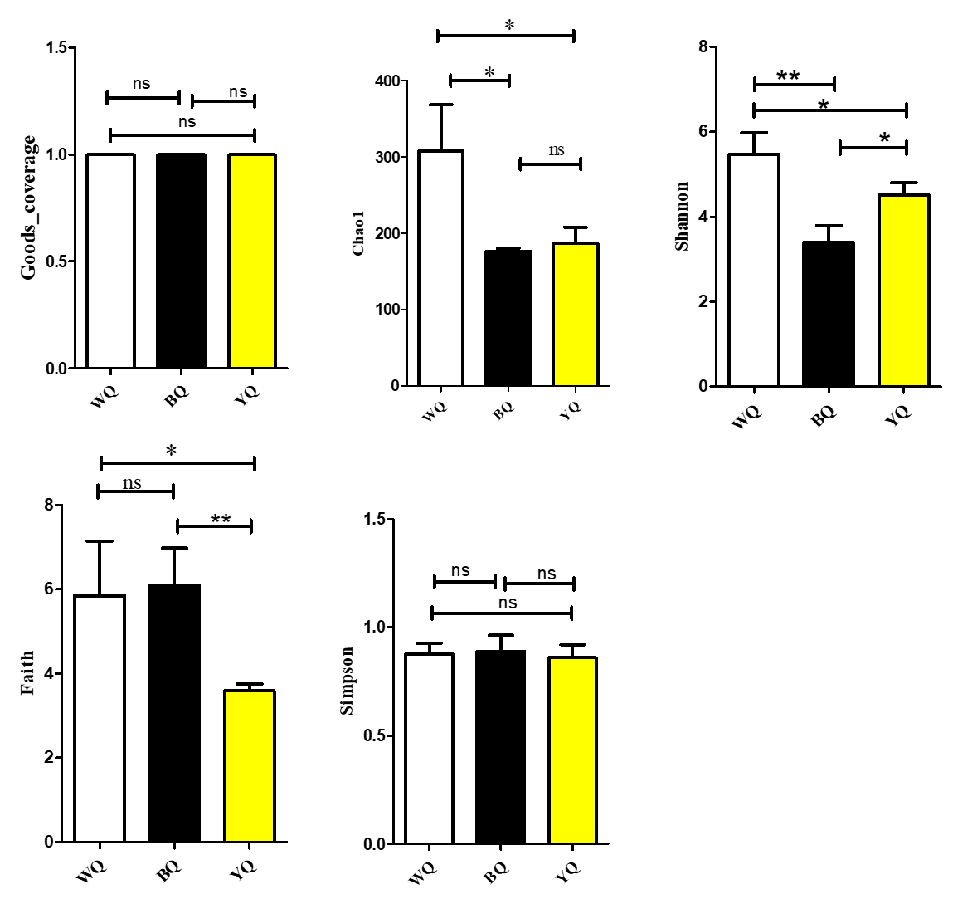

Figure 9: Bacteria Alpha diversity indices
Goods-coverage, chao1, Shannon, faith, and Simpson. Where *, 0.01 ≤ p < 0.05; **, 0.001 ≤ p < 0.01; ***, p < 0.001. The concentration level is represented on the Y-axis, while the distinct Daqu samples are displayed on the X-axis.
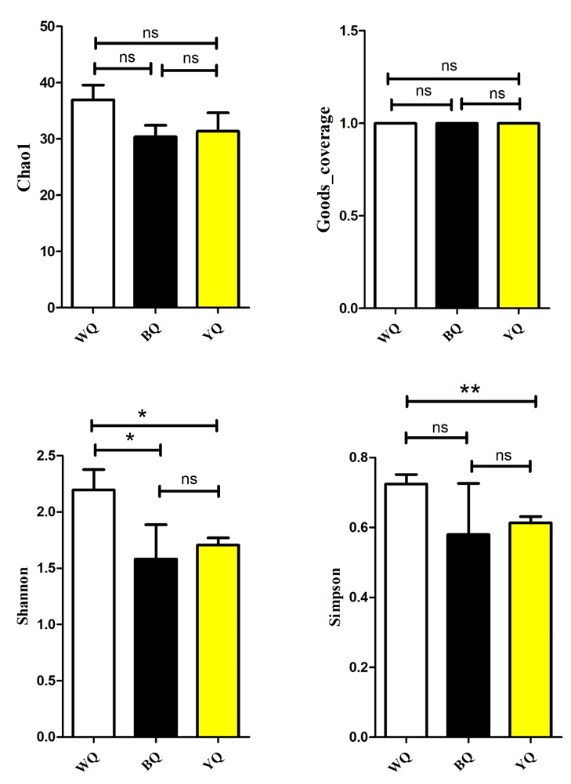
Figure 10: Fungi Alpha diversity indices.
Goods-coverage, chao1, Shannon, faith, and Simpson. Where *, 0.01 ≤ p < 0.05; **, 0.001 ≤ p < 0.01; ***, p < 0.001. The concentration level is represented on the Y-axis, while the distinct Daqu samples are displayed on the X-axis.

The elevated microbial diversity observed in White Daqu implies a broader and more functionally versatile enzymatic repertoire, enabling a wider range of biochemical transformations during fermentation. This expanded metabolic capacity spanning carbohydrate hydrolysis, amino acid conversion, organic acid metabolism, and Maillard-related precursor formation likely underpins the stronger aroma intensity and greater volatile complexity characteristic of White Daqu when compared with black and yellow varieties (Wang et al., 2025).

3.4 Volatile Compilation and Microbial Correlations
GC–MS profiling revealed a diverse volatile landscape, identifying over 80 distinct compounds spanning key aroma-active classes such as esters, pyrazines, aldehydes, alcohols, and organic acids. White Daqu exhibited markedly higher levels of alcohols (e.g., ethanol, isoamyl alcohol) and pyrazines, a profile that aligns with the metabolic capabilities of its dominant Bacillus and Kroppenstedtia populations both well-known producers of amino-acid-derived pyrazines and fermentation-related higher alcohols (Chen et al., 2025). Yellow Daqu, by contrast, contained the highest concentrations of organic acids, a trend that corresponds with the strong presence of Thermomyces, a thermophilic genus capable of driving robust acidification through carbohydrate and lipid breakdown pathways (Cairns et al., 2021). Black Daqu was characterized by elevated aldehydes and esters, compounds typically enriched during Maillard reactions, thermal degradation, and lipid oxidation under high-temperature fermentation. The prominence of these aroma groups reinforces the role of black Daqu’s harsher thermal environment in shaping its distinctive fruity floral and mildly toasted aromatic attributes. These findings highlight the microbiota-driven nature of Daqu fermentation and confirm earlier reports on color-specific fermentation ecology (Liang et al., 2023).

Table 3: Volatile flavor compounds identified in Daqu with the different colors
Categories | Name | BQ | WQ | YQ
ALCOHOL | (R)-(-)-2-Pentanol | 0 | 8.566667 | 0
ALCOHOL | (S)-(+)-1,2-Propanediol | 9.426667 | 0 | 0
ALCOHOL | .beta.-Ethylphenethyl alcohol | 34.62333 | 22.02333 | 3.04
ALCOHOL | 1-Butanol, 3-methoxy- | 0.303333 | 0 | 0
ALCOHOL | 1-Butanol, 3-methyl- | 42.13333 | 35.16 | 5.543333
ALCOHOL | 1-Nonanol | 0 | 9.016667 | 0
ALCOHOL | 1-Nonen-3-ol | 7.536667 | 10.34 | 0
ALCOHOL | 1-Pentanol, 2-ethyl-4-methyl- | 0 | 2.766667 | 0
ALCOHOL | 1-Penten-3-ol | 0 | 5.546667 | 1.973333
ALCOHOL | 1-Propanol, 2-methoxy- | 0 | 3.676667 | 0
ALCOHOL | 1,7-Octanediol, 3,7-dimethyl- | 1.216667 | 0 | 0
ALCOHOL | 2-Methoxy-4-vinylphenol | 22.75 | 104 | 0
ALCOHOL | 2-Methyl-1-phenylbut-3-en-1-ol | 6.57 | 0 | 0
ALCOHOL | 2-Nonen-1-ol | 0 | 4.79 | 2.7
ALCOHOL | 2,3-Butanediol | 64.02 | 51.71667 | 33.00667
ALCOHOL | 2,4-Di-tert-butylphenol | 5.36 | 3.623333 | 2.693333
ALCOHOL | 3-Octanol | 0 | 2052.953 | 0
ALCOHOL | 6-Hepten-3-ol, 4-methyl- | 0 | 2.91 | 0
ESTER | 11-Octadecenoic acid, methyl ester | 0 | 0 | 4.173333
ESTER | 1H-Pyrrole-2-carboxaldehyde | 27.66 | 7.273333 | 18.98
ESTER | 1H-Pyrrole-2-carboxaldehyde, 1-methyl- | 11.62667 | 0 | 19.99667
ESTER | 2-Butenoic acid, 2-propenyl ester | 0 | 0 | 5.953333
ESTER | 2-Propenoic acid, 3-methoxybutyl ester | 0 | 30.74333 | 0
ESTER | 2(3H)-Furanone, 5-butyldihydro-4-methyl- | 0 | 0 | 1.656667
ESTER | 2(3H)-Furanone, 5-heptyldihydro- | 1.93 | 0 | 0
ESTER | 3-Pentenoic acid, 4-methyl-, methyl ester | 0 | 2.246667 | 0
ESTER | Acetic acid, pentyl ester | 0 | 0 | 11.74
ESTER | 9,12-Octadecadienoic acid, methyl ester | 154.3367 | 93.68667 | 21.29333
ESTER | Butanoic acid, 2-hydroxy-, ethyl ester | 0.166667 | 0 | 0
ESTER | Hexadecanoic acid, ethyl ester | 0.78 | 0 | 2.683333
ESTER | Hexadecanoic acid, methyl ester | 300.3867 | 243.5533 | 49.62667
ESTER | Linoleic acid ethyl ester | 0 | 0 | 0.463333
ESTER | Methyl formate | 0 | 0 | 0.833333
ESTER | Methyl isovalerate | 0 | 1.59 | 0
ESTER | Methyl stearate | 13.13 | 0 | 0
ESTER | Methyl tetradecanoate | 9.623333 | 8.663333 | 0.386667
ESTER | Nonanoic acid, methyl ester | 3.296667 | 0 | 0
ESTER | Octanoic acid, methyl ester | 6.436667 | 0 | 0
ESTER | Pentadecanoic acid, methyl ester | 3.063333 | 24.61 | 0
ESTER | Pentanoic acid, 3-hydroxy-2-methyl-, propyl ester | 0 | 24.45 | 0
ESTER | Propanoic acid, 2-hydroxy-, ethyl ester | 0 | 0 | 3.816667
ESTER | Propanoic acid, 2-hydroxy-, methyl ester, (.+/-.)- | 3.11 | 0 | 2.626667
ESTER | Propanoic acid, 2-hydroxy-2-methyl-, methyl ester | 1.06 | 0 | 0.103333
ESTER | Benzeneacetic acid, methyl ester | 61.47333 | 34.47 | 0.653333
ESTER | Dodecanoic acid, methyl ester | 0 | 0.983333 | 0
KETONES | 3-Octanone | 0 | 63.38667 | 0
KETONES | 2-Octanone | 0 | 6.103333 | 0
KETONES | 2-Pentanone | 0 | 10.26667 | 0
KETONES | 2,4-Nonanedione | 2.016667 | 0 | 0
KETONES | 2,5-Hexanedione | 0 | 12.74 | 0
KETONES | 3,5-Dimethyl-4-heptanone | 0 | 0 | 0.27
KETONES | 5-Hepten-2-one, 6-methyl- | 0 | 2.073333 | 0
KETONES | Ethanone, 1-(1-cyclohexen-1-yl)- | 0 | 1.926667 | 0
KETONES | Ethanone, 1-(1H-pyrrol-2-yl)- | 0 | 41.27 | 67.37333
KETONES | Ethanone, 2-hydroxy-1-phenyl- | 33.32333 | 0 | 0
Pyrazine | 2,3-Dimethyl-5-ethylpyrazine | 36.76333 | 56.16333 | 0.566667
Pyrazine | 2,3,5-Trimethyl-6-ethylpyrazine | 25.90667 | 37.21333 | 0
Pyrazine | Pyrazine, 2-butyl-3,5-dimethyl- | 0 | 8.813333 | 0
Pyrazine | Pyrazine, 2-ethyl-6-methyl- | 0 | 1.55 | 0
Pyrazine | Pyrazine, 2,3-dimethyl- | 46.34333 | 43.51667 | 0
Pyrazine | Pyrazine, 2,5-dimethyl- | 13.72 | 15.75 | 0
Pyrazine | Pyrazine, 2,6-dimethyl- | 8.73 | 11.95 | 0
Pyrazine | Pyrazine, 3-butyl-2,5-dimethyl- | 0 | 300.4233 | 0
Pyrazine | Pyrazine, tetramethyl- | 3175.527 | 3117.313 | 154.69
Pyrazine | Pyrazine, trimethyl- | 263.68 | 0 | 18.99
Pyrazine | Pyridine, 2-phenyl- | 0 | 0 | 1.146667
Pyrazine | Pyridine, 3-phenyl- | 14.59667 | 11.72333 | 0
ALDEHYDE | 3-Furaldehyde | 0 | 0 | 2.083333
ALDEHYDE | 5-Methyl-2-phenyl-2-hexenal | 17.11667 | 0 | 18.72333
ALDEHYDE | Benzeneacetaldehyde, .alpha.-ethylidene- | 0 | 0 | 2.07
ALDEHYDE | Butanal, 3-methyl- | 74.52667 | 11.55667 | 40
ALDEHYDE | Hexanal | 0 | 0 | 0.38
ALDEHYDE | Nonanal | 0 | 0 | 2.546667
ALDEHYDE | Pentanal | 0 | 4.656667 | 0
ACID | 3-Hydroxymyristic acid | 0 | 0.103333 | 0
ACID | Hexanoic acid | 0 | 0 | 0.916667
ACID | L-Lactic acid | 0 | 0 | 4.606667
ACID | Propanoic acid, 2-(methoxymethoxy)- | 0 | 0.403333 | 0.073333
HYDROCARBON | Butanamide, 3-methyl- | 0 | 0 | 2.61
HYDROCARBON | Butane, 1-(2-propenyloxy)- | 21.45 | 0 | 0
HYDROCARBON | Furfural | 0 | 0 | 2.006667
Aromatic | Phenol | 0 | 0 | 4.886667
Aromatic | Phenol, 2-methoxy- | 7.606667 | 0 | 2.91
Aromatic | Phenol, 5-ethenyl-2-methoxy- | 9.293333 | 0 | 0
Aromatic | Phenylethyl Alcohol | 206.86 | 258.9667 | 80.48
Aromatic | Phenylglyoxal | 63.29 | 28.6 | 34.67333
Aromatic | Benzeneethanol, .alpha.-methyl- | 21.88 | 23.17 | 0
Aromatic | Benzyl alcohol | 7.376667 | 9.4 | 15.49667
Aromatic | Mequinol | 0 | 0 | 1.023333
Aromatic | Benzene, 1,2-dimethoxy- | 0 | 0 | 4.493333
Aromatic | Furan, 3-phenyl- | 14.8 | 12.13667 | 0.7
ETHERS | Disulfide, dimethyl | 0 | 0 | 0.49
ETHERS | Hexane, 2,5-dimethoxy-2,5-dimethyl- | 142.3733 | 117.1933 | 15.65667
ETHERS | Pentane, 2-methoxy- | 0.733333 | 0 | 0
ETHERS | Pentane, 2-methoxy-2,4,4-trimethyl- | 0 | 35.39333 | 0
ETHERS | Dimethyl trisulfide | 0 | 0 | 6.476667
OTHERS | Linalool | 14.8 | 15.06 | 0
OTHERS | Vanillin | 0 | 0 | 1.496667
OTHERS | Methyl formate | 0 | 0 | 0.833333
OTHERS | Acetoin | 0 | 0 | 0.996667

4.0 Conclusion
This study provides a comprehensive understanding of how Daqu color corresponds to microbial structure, metabolic potential, and volatile compound formation in high-temperature Baijiu fermentation. By integrating microbial enumeration, sequencing, and aroma profiling, the work demonstrates that white, yellow, and black Daqu represent distinct fermentation ecologies shaped by thermal gradients, oxygen exposure, and substrate transformation. White Daqu exhibited the highest microbial abundance and was strongly associated with alcohol and pyrazine production, reflecting robust saccharification and Maillard-related pathways. Yellow Daqu showed the greatest microbial diversity, a feature that supports its broad metabolic capacity and elevated production of organic acids, which are essential precursors for ester synthesis. Black Daqu, influenced by intense heat, displayed selective enrichment of thermotolerant taxa such as Saccharopolyspora and Thermomyces, contributing to enhanced esterification and aldehyde formation.
The observed correlations between specific taxa and volatile compounds further emphasize the pivotal role of microbe–metabolite networks in shaping Baijiu aroma complexity. Understanding these relationships allows producers to better regulate Daqu fermentation conditions, enabling targeted manipulation of flavor profiles. Overall, this study advances the scientific basis for quality evaluation, standardization, and precision control in Baijiu manufacturing, supporting more consistent and desirable sensory outcomes.

Disclaimer (Artificial intelligence)
Option 1:
Author(s) hereby declare that NO generative AI technologies such as Large Language Models (ChatGPT, COPILOT, etc.) and text-to-image generators have been used during the writing or editing of this manuscript.
Option 2:
Author(s) hereby declare that generative AI technologies such as Large Language Models, etc. have been used during the writing or editing of manuscripts. This explanation will include the name, version, model, and source of the generative AI technology and as well as all input prompts provided to the generative AI technology
Details of the AI usage are given below:
1.
2.
3.

References

Ayitey, S., Nijamdeen, T. W. G. F. M., Peiris, H., Arachchilage, S. K., George, I. F., Dahdouh-Guebas, F., & Deepananda, K. A. (2025). Environmental factors affecting the presence of coliform bacteria in water and oysters (Crassostrea cucullata Born, 1778) in Negombo lagoon, Sri Lanka. Marine Environmental Research, 107561.
Bai, Y., Miao, Z., Yan, R., Wang, X., Cheng, Z., Yang, J., ... & Sun, B. (2024). Daqu regulates the balance of saccharification and alcoholic fermentation to promote Chinese baijiu fermentation. Food Bioscience, 61, 104723.
Bretträger, M., Sacher, B., Gastl, M., & Becker, T. (2024). The black gap: understanding the potential roles of black fungal-derived enzymes in malting and brewing quality: a review. Journal of the american Society of Brewing chemiStS, 82(2), 93-108.
Cairns, T. C., Zheng, X., Zheng, P., Sun, J., & Meyer, V. (2021). Turning Inside Out: Filamentous Fungal Secretion and Its Applications in Biotechnology, Agriculture, and the Clinic. Journal of fungi (Basel, Switzerland), 7(7), 535. https://doi.org/10.3390/jof7070535
Chen, X., Yin, J., Zhang, Y., Chen, J., Bie, S., Song, X., ... & Yu, H. (2025). Analysis of Volatile Organic Compounds Differences of Black and White Pepper by HS‐GC‐IMS and HS‐SPME‐GC‐MS. Rapid Communications in Mass Spectrometry, 39(13), e10036.
Cui, M., Hou, Q., Wang, Y., Zhao, X., Xin, C., Xu, L., & Guo, Z. (2025). High-temperature Daqu of different colors from the Zibo region of China: Analysis of microbial community structure, physicochemical characteristics, and enzymatic activities. World Journal of Microbiology and Biotechnology, 41(10), 382.
Deng L, Mao X, Liu D, Ning X-Q, Shen Y, Chen B, Nie H-F, Huang D and Luo H-B (2020) Comparative Analysis of Physicochemical Properties and Microbial Composition in High-Temperature Daqu With Different Colors. Front. Microbiol. 11:588117. doi: 10.3389/fmicb.2020.588117
Houngbédji, M., Johansen, P., Padonou, S. W., Akissoé, N., Arneborg, N., Nielsen, D. S., Hounhouigan, D. J., & Jespersen, L. (2018). Occurrence of lactic acid bacteria and yeasts at species and strain level during spontaneous fermentation of mawè, a cereal dough produced in West Africa. Food microbiology, 76, 267–278. https://doi.org/10.1016/j.fm.2018.06.005
Ge, D., Cai, W., Guo, Z., Wang, B., Liu, M., Shan, C., & Wang, Y. (2024). Comparative analysis of bacterial community structure and physicochemical quality in high-temperature Daqu of different colors in Qingzhou production area. Heliyon, 10(11).
Guo, X., Li, Q., Zhang, B., Qiao, J., Ren, H., Song, L., ... & Ding, X. (2025). Differences between second-and third-generation sequencing in capturing microbial community dynamics during Nongxiangxing Daqu storage. International Journal of Food Microbiology, 111501.
Hu, A., Zhu, Y., Gao, Z., Zheng, J., Zhou, D., Zhang, L., ... & Xu, S. (2025). Study on the correlation between microbial community succession and main flavor substances in the mashes of Tanggou liquor. Food Chemistry: X, 102486.
Kim, Y., Cho, M., Jeon, C. J., Goh, G., & Kim, M. (2025). Neuroinflammatory suppression with protocatechuic acid attenuates Alzheimer’s disease phenotypes in 5× FAD transgenic mice. Biomedicine & Pharmacotherapy, 192, 118598.
Liang, Y., Shi, W., Wu, L. H., Zhang, X. J., Chai, L. J., Liu, G. Q., Zheng, L., Wang, S. T., Zhang, S. Y., Chen, F. W., Shen, C. H., Xu, Z. H., & Lu, Z. M. (2023). Solibacillus daqui sp. nov., isolated from high-temperature Daqu. International journal of systematic and evolutionary microbiology, 73(11), 10.1099/ijsem.0.006109. https://doi.org/10.1099/ijsem.0.006109
Li, Z., Li, D., Pan, D., Xia, Q., Sun, Y., Du, L., ... & Cao, J. (2024). Insights into the mechanism of extracellular proteases from Penicillium on myofibrillar protein hydrolysis and volatile compound evolutions. Food Research International, 175, 113774.
Li, Z., Chen, Y., Zheng, J., Su, J., Lu, Y., Xia, Y., & Luo, H. (2025). From fungi to lactic acid bacteria: Dominant microorganisms govern stage-specific esters biosynthesis in pit microecology of strong-flavor baijiu. Food Research International, 117797.
Lei, Y., Deng, Y., Xia, R., Xie, B., Yang, Z., Xi, S., ... & Tao, R. (2025). Full-length 16S rRNA-based exploration of body site-specific bacterial signatures for origin determination and individual identification. Forensic Science International, 112475.
Lei, Z., Zhang, Z., Huang, J., Tang, Q., & Zhou, R. (2025). Dynamic patterns of high-temperature Daqu attributes in continuous production: Investigating the impact of Muqu attributes, production site, and process heterogeneity. Food Bioscience, 68, 106417.
Lu, Y., Yan, Q., Zhang, K., Zhang, J., Zou, W., Yang, J., & Li, H. (2024). Generation of a synthetic autochthonous microbiota responsible for the essential flavors and brewing properties of Daqu. Food Research International, 197, 115180.
Mandal, B., & Das, B. K. (2025). eDNA Approaches for Ecosystem Health Monitoring: Focus on Pathogens, Vectors, and Microbial Assessment. In Laboratory Techniques for Fish Disease Diagnosis (pp. 573-622). Singapore: Springer Nature Singapore.
Ma, Q., Liu, L., Jiao, Y., Qiao, X., Han, R., Li, X., ... & Kouame, K. J. E. P. (2024). Insights into flavor quality and metabolites profiles of fresh cheese with different probiotics by SPME-GC-MS and untargeted metabolomics. Food Research International, 197, 115154.
Qiao, J., Zhang, X., Xiao, F., Li, Y., & Gao, W. (2024). Experimental investigation of mold growth risk among typical residential indoor materials: Case study in coastal city, China. Energy and Buildings, 304, 113885.
Que, P., Yao, S., Hu, J., Hu, F., Wang, D., & Huang, W. (2025). Associations of microbial communities with metabolites and enzyme activities in different colors of high-temperature Daqu. World Journal of Microbiology and Biotechnology, 41(9), 324.
Qu, D., Wang, Y., Cao, L., Hou, Q., Liu, Z., Zhong, J. A., & Guo, Z. (2025). Low-temperature Daqu types differentially shape microbial and metabolic profiles in fermented grains: Insights from metagenomics and flavor omics. Food Bioscience, 107139.
Shanqimuge, Tang, P., Qiao, M., Wang, F., Guo, Y., Wang, L., ... & Lu, J. (2025). Unveiling the Metabolic Function of Three Types of High‐Temperature Daqu During Baijiu Fermentation. Journal of Food Biochemistry, 2025(1), 6762405.
Shi, W., Chai, L. J., Zhao, H., Song, Y. N., Mei, J. L., He, Y. X., ... & Xu, Z. H. (2024). Deciphering the effects of different types of high-temperature Daqu on the fermentation process and flavor profiles of sauce-flavor Baijiu. Food Bioscience, 61, 104917.
Snyder, A. B., Martin, N., & Wiedmann, M. (2024). Microbial food spoilage: impact, causative agents and control strategies. Nature Reviews Microbiology, 22(9), 528-542.
Song, D., Zhong, X., Wu, Y., Guo, J., Song, L., & Yang, L. (2025). From Artisan Experience to Scientific Elucidation: Preparation Processes, Microbial Diversity, and Food Applications of Chinese Traditional Fermentation Starters (Qu). Foods, 14(22), 3814.
Sun, J., Zhu, Y., Wang, P., & Sun, B. (2025). Research progress in the flavor chemistry and health effects of Baijiu. Agricultural Products Processing and Storage, 1(1), 1-21.
Tang, Q., Zhang, Y., Huang, J., & Zhou, R. (2025). Unraveling the unique microbiota and metabolites in three different colors Jiangqu through multidimensional analysis. Food chemistry, 466, 142256. https://doi.org/10.1016/j.foodchem.2024.142256
Topaloğlu Günan, K., & Yolci Ömeroğlu, P. (2025). Evaluation of Plant-Based Egg Substitutes in Vegan Muffins: Functional, Structural, and Nutritional Characterization. Foods (Basel, Switzerland), 14(17), 3012. https://doi.org/10.3390/foods14173012
Wang, F., Li, H., Wu, Z., Yan, J., Feng, H., Liu, R., ... & Wang, P. (2025). Genomic and Metabolomic Insights into Volatile and Nonvolatile Metabolite Variation from Fresh Leaves to the Turning Stages in Wuyi Rock Tea “Rougui”. Journal of Agricultural and Food Chemistry, 73(39), 25089-25102.
Wu, M., Luo, Y., Yao, Y., Ji, W., & Xia, X. (2024). Multidimensional analysis of wheat original crucial endogenous enzymes driving microbial communities metabolism during high-temperature Daqu fermentation. International Journal of Food Microbiology, 413, 110589.
Yang, Y., Niu, M. S., Yu, H., Shi, W., Chai, L. J., Lu, Z. M., ... & Shi, J. S. (2024). Exploring the contribution of temperature-adapted microbiota to enzyme profile of saccharification in Daqu using metagenomics and metaproteomics. Lwt, 197, 115916.
Yao, Y., Luo, Y., Wu, M., Gao, L., Zhang, J., Jiang, Z., ... & Xia, X. (2025). Contribution of moisture to functional microbial succession and functional expression in medium-high temperature Daqu. Food Bioscience, 106831.
Zhang, M., Guo, D., Wang, H., Wu, G., Shi, Y., Zhou, J., ... & Li, X. (2024). Analyzing microbial community and volatile compound profiles in the fermentation of cigar tobacco leaves. Applied Microbiology and Biotechnology, 108(1), 243.
Zang, J., Lin, T., Xu, C., Lin, Y., Ma, K., Zhang, C., ... & Li, W. (2025). Advances in Lactic Acid Bacteria and Their Metabolites in Fermented Foods: Mechanisms of Food Quality Enhancement, Gut Microbiota modulation, and Future Prospects. Food Reviews International, 1-35.
Zhao, H., Liu, S., Zhu, L., & Wang, Y. (2025). Microorganisms: The Key Regulators of Wine Quality. Comprehensive Reviews in Food Science and Food Safety, 24(3), e70198.
Zhao, Y., Han, Y., Cao, R., Xu, Y., & Mu, X. (2025). Multiomics Insights into Microbiome Succession throughout Medium-Temperature Daqu Fermentation. ACS Food Science & Technology, 5(3), 1193-1207.
Zhong, Z., Liu, T., He, K., Zhong, M., Chen, X., Xue, Y., ... & Liu, J. (2024). Microbial enzymes: the bridge between Daqu flavor and microbial communities. Food Innovation and Advances, 3(4), 426-437.
Zong, E., Bo, T., Dang, L., Zhang, J., Li, H., Lv, N., ... & Fan, S. (2024). Different functions can be provided by low temperature Daqu with different appearance features due to variations in the microbial community structure during fermentation. LWT, 193, 115763.

