THE EFFECT OF PLEUROTUS TUBERREGIUM (AN OYSTER MUSHROOM) SCLEROTIA ON THE WEIGHT, PROTEIN CONTENT AND LIPID PROFILE OF BROILER CHICKENS

ABSTRACT
Introduction: Edible mushrooms have become increasingly attractive as functional foods for their potential beneficial effects on human health. Many studies have demonstrated that oyster mushroom consumption affects lipid profile and can prevent or treat cardiovascular diseases. This study, for the first time, investigated the cholesterol-lowering properties of the sclerotia of Pleurotus tuberregium in broiler chickens.
Methods: A total of 30 broiler chickens were shared into six groups of five chickens per group and fed with feed containing different percentages (0%, 5%, 10%, 15%, 20% and 25%) of dried powdered sclerotia of Pleurotus tuberregium for 8 weeks. A General Linear Model (GLM) was used to evaluate the impact of different feed supplementation levels on chicken weight and standard analytical methods were used for the protein and biochemical analysis after 8 weeks of feeding.
Results: The body weight decreased progressively with increasing dietary percentage from 0% to 25%. Chickens in the 0% group had the highest weight (3300 g), while those in the 25% group had the lowest weight (2320 g). The highest cholesterol was observed in the 15% group (4.13 ± 0.18), and the lowest was in the 25% group (3.23 ± 0.24). The triglyceride among the treatment groups are statistically significant ((p < 0.05).). The differences in HDL levels between groups are highly significant (p < 0.01), indicating a strong treatment effect of the mushroom on HDL. There is no significant difference in LDL levels between the treatment groups (p > 0.05). This indicated that the lowering effect of the mushroom on the LDL in broiler chickens is not dose dependent. There is a significant difference in VLDL levels across the treatment groups (p < 0.05), suggesting a treatment effect of the mushroom on the VLDL.
Conclusion: This study showed that sclerotia of Pleurotus tuberregium affect the growth performance, protein content, and cholesterol of broiler chickens.
Keywords: Broilers, Cholesterol, Diet, Sclerotia

- INTRODUCTION
Mushrooms are the earliest form of macro fungi known to mankind because of their nutritional values. Their use in the diet in recent times is increasingly being recognized because of their significant roles in human nutrition and disease management. It has been reported that edible mushrooms are a valuable source of nutrients and bioactive compounds, and they have a growing appeal for humans due to their flavours and culinary feature. Recently, they have become attractive as functional foods because of their potential beneficial effects on human health (Łysakowska et al., 2023, Cerletti et al., 2021, Jee et al., 2024). Mushrooms have gained increasing attention in scientific research due to their nutritional value and therapeutic properties. They are not only food sources but also potential functional foods and nutraceuticals with health-promoting effects (Feeney,et al., 2014, Valverde et al,. 2015, Wasser 2017, Zaidman, et al., 2005, Zhang et al., 2007, Jeong, et al., 2010). Many edible mushrooms have been reported to decrease low-density lipoprotein-cholesterol (LDL-C) in serum by increasing the expression of LDL receptor at mRNA level and LDL receptor activity (Nuhu et.al, 2009, Lisa and Sabine, 2020, Shanggong et.al. 2016). Their roles in the reduction of cholesterol and triglycerides levels in animals have been investigated and results so far appear promising (Nuhu et.al. 2010, Guillamón et al., 2010, Schneider et.al. 2011, Shanggong 2016, Nur et.al. 2018, Dong Hoon et.al. 2019, Dicks and Ellinger, 2020, Handayani et al., 2011).
Pleurotus tuberregium Fr. known as king tuber oyster or tiger milk mushroom is a tropical and subtropical edible mushroom that is highly consumed and highly priced in Nigeria and other West African sub-regions. The mushroom has been reported to possess properties that are attributable in part to its health promotion and immune surveillance (Yashvant, et.al. 2012). Reports have shown that Pleurotus tuberregium is rich in β-glucans, which enhance immune response, contains high levels of phenolics, flavonoids, and polysaccharides that protect cells from oxidative stress and aging (Ogbomida et al., 2018, Nworu et al., 2015). It support heart health by lowering cholesterol levels, improves cardiovascular function because it contains fiber and unsaturated fatty acids, which reduce bad cholesterol (LDL) (Ying et.al. 2024). Studies suggest that oyster mushrooms can help lower triglyceride level because of the compounds in them that appear to influence lipid metabolism and reduce the triglyceride amount in the blood stream (Chorvathoba et al., 1993). Their consumption can reduce concentrations of triglycerides, cholesterol and oxidized LDL, potentially benefiting heart health and lower the risk of heart diseases.
Elevated cholesterol and triacylglycerol levels are known risk factors for cardiovascular diseases which is one of the most prominent causes of death for both men and women in most developed and developing countries (WHO, 2003). Certain conditions, such as hyperlipidemia, hypertension, obesity, diabetes mellitus, and a positive family history of Cardiovascular Heart Disease (CHD), are considered to put an individual at greater risk of CHD (Assmann et al., 2002, The International Task Force for Prevention of Coronary Heart Disease, 1998). Some of these conditions are diet-related conditions. Lipid-related diseases remain a major public health challenge worldwide. While conventional drugs are effective, they have notable limitations. Dietary interventions, particularly those emphasizing natural, functional, and bioactive-rich foods, provide a viable complementary or preventive approach. Mushrooms such as Pleurotus tuberregium represent a promising natural resource due to their antioxidant, hypocholesterolemic, and hepatoprotective properties, making them valuable in dietary strategies for managing dyslipidemia and reducing cardiovascular risk (Ogbomida et al., 2018, Nworu et al., 2015).
Poultry production is a major agricultural industry worldwide and an essential source of animal protein for human consumption. Poultry products especially chickens and eggs are a staple of many human diets. These common animal proteins are also sources of fat that can elevate human risk for high cholesterol, heart disease, and cardiovascular problems. Chicken meat has fat; therefore, we should lower cholesterol in chicken meat. A high-fat diet (HFD) induces obesity and for this reason, eating a low-cholesterol diet is important for anyone interested in managing their cholesterol intake. It is therefore imperative to formulate poultry diets that can reduce the cholesterol level of poultry products. This study aimed to evaluate the effect of the sclerotia of Pleurotus tuberregium supplementation with poultry feed on the weight, protein content and lipid profile of broiler chickens.
- MATERIALS AND METHODS
2.2 Experimental Animals and Housing: A poultry house of 7 by 3 meters was constructed and partition into six compartments of 3 by 1.5 meters. . Broiler chickens (n = 30) with each initial body weights of approximately 50g were purchased from a hatchery farm (Agritech) in Ibadan, Nigeria. The chickens were shared into six groups of five (5) chickens per group. Each group was kept in one apartment. The poultry house was netted and connected to electricity source where a bulb of 100 watt capacity was fixed into each compartment as source of heat and light for the first two weeks during the experiment. Thereafter, the 100 watt bulbs were removed and conditions of the apartments were left at room temperature until the end of the experiment
2.3 Preparation of P. tuberregium Sclerotia: Sclerotia of Pleurotus tuberregium (Plate1) were purchased from local market in Anyigba, Kogi State Nigeria. The sclerotia were sliced into pieces and dried in the oven at 40⁰C, crushed into powder form and stored at room temperature (22 ± 2⁰ C) until used.

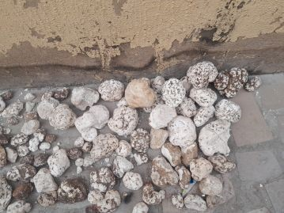
Plate 1: Sclerotia of Pleurotus tuberregium

2.4 Experimental Design and Diet Formulation: Commercial feed (Ultima poultry feed) with the composition as shown in Table 1 were used as the basal feed for the study. Broiler chickens (n = 30) with each initial body weights of approximately 50g were purchased from a hatchery farm (Agritech) in Ibadan, Nigeria. The chickens were shared into six groups of five (5) chickens per group. The sclerotia powder was thoroughly mixed with the basal feed. In group 1(Control), the chickens were fed with unsupplemented feed (feed without the sclerotia) while the other groups, 2, 3, 4, 5 and 6 were fed from day 1 to 8 weeks with basic feed containing the following compositions of the sclerotia 5%, 10%, 15%, 20% and 25% (w:w). The weights of the chickens were taken every week for the 8 weeks.

2.5 Data Collection (Weight, Slaughter, and Sample Collection): The weight of the day old chickens was determined on the arrival and subsequently every week throughout the eight weeks of the experiment. A General Linear Model (GLM) was used to evaluate the impact of different feed supplementation levels on chicken weight across eight weeks of the experiment. After eight weeks of feeding, the chickens were slaughtered and the tissues were collected for crude protein analysis. The crude protein of the meat samples were determined according to the methods described by Kjeldahl Method (AOAC Official Method 984.13). Blood samples were collected by a licensed veterinarian. The blood samples were taken under the wing of the chickens (Plate 2) and were collected in triplicates in ethylenediaminetetraacetic acid (EDTA-) coated tubes and taken to the laboratory for analysis.

Plate 2: Collection of blood samples from the Broiler Chickens

2.6 Biochemical Analyses (Protein, Lipid Profiles): Total glyceride was measured enzymatically using the method of Burtis and Ashwood, (2006). Glycerophosphate oxidase assay was used. Lipase catalyzed the hydrolysis of triglycerides to yield glycerol and free fatty acids. Glycerol concentration was then determined with the Trinder reaction using glycerol kinase, glycerol-3 phosphate oxidase and peroxidase. Red dye which was quinoneimine was formed. The absorbance of the product was measured at 546 nm using spectrophotometer and this was directly proportional to triglyceride concentration in the plasma.
The total cholesterol was measured using oxidase assay described by Burtis and Ashwood, (2006). Cholesterol esterase was first used to catalyze the hydrolysis of cholesterol which was then oxidized by cholesterol oxidase to yield hydrogen peroxide. Through coupled reaction catalized by peroxidase, red dye was formed from hydrogen peroxide, 4-aminoantipyrine and phenol. The absorbance of the dye was measured at 546 using spectrophotometer. The result was directly proportional to the concentration of cholesterol in the blood.
The same method of Burtis and Ashwood, (2006) was used to measure High-density lipoprotein (HDL), Low-density lipoprotein (LDL) and Very-low density lipoprotein (VLDL). They were measured after precipitating the low-density lipoprotein and low-density lipoprotein using magnesium sulfate and phosphotungstic acid. The LDL calculation was done using the
Standard Friedewald equation: LDL = TC - HDL - (TG/5). VLDL is then derived as VLDL = TG / 5.
The blood samples were centrifuged at 3000x rpm at 22⁰C for 25 minutes. After centrifugation, the High-density lipoprotein (HDL) was isolated from plasma with dextran sulphate and magnesium chloride as described by Sjoblom and Eklund (1989). The total plasma cholesterol (TC), TG and HDL cholesterol were measured using the Konelab 20XT with infinity reagent from Thermo Fisher Scientific (Auburn NSW, Australia).
2.7 Statistical Analysis: All results were expressed as mean ± Standard Error (SE). All parameters for inter group differences were analyzed by one way ANOVA followed by post hoc operation. The statistical programme used was SPSS 25. (P< 0.05 was considered statistically significant)
The weight of the chickens and blood lipids profiles were reported as mean and standard errors. SPSS software (version 25. SPSS Inc, Chikago, Ill, USA was used for the Statistical analysis. One-way ANOVAs were used, and it was followed by a post hoc Tukey-Kramer significant differences test for multiple comparisons among the groups. Differences were considered significant when p < 0.05.
- RESULTS
3.1 Body weight: The body weights of the chickens were affected by the addition of the mushroom in the diet. The study found significant effects of the mushroom on the body weight gain. It also suggests a possible inverse relationship between the level of treatment inclusion of the mushroom and body weight gain. The body weight decreased progressively with increasing percentage of the sclerotia from 0% to 25% (Fig. 1). The 0%, 5%, and 10% feed levels produced significantly heavier chickens than 20–25%, with 15% intermediate. Growth was linear and steep. Week 1 mean was135.6 g while week 8 mean was 2406.7 g. The differences between feed levels were minor early but became marked after Week 5. There is a possible inverse relationship between the level of treatment inclusion of the mushroom and body weight gain.
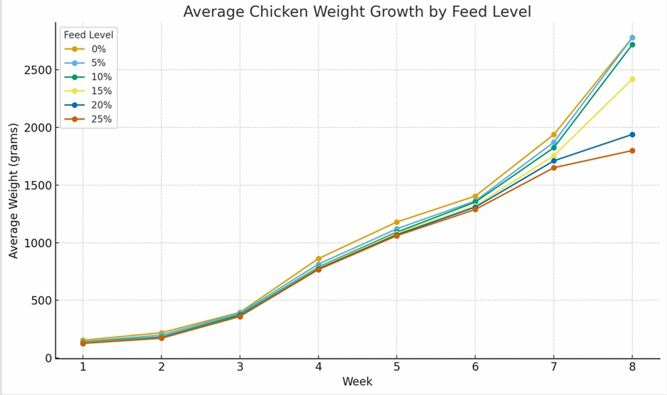
Fig 1: Weight of Chickens every week for 8 weeks

3.2 Protein Content of Meat: The results of the protein contents in the broiler chickens after the eight weeks of the experiment showed a clear decline in mean protein content in the meat with increasing feed level supplementation, from 43.07% at 0% feed additive to 26.84% at 25% (Fig 2). Statistical analysis revealed a highly significant difference in protein content across feed levels (P < .001). Turkey HSD post hoc comparisons indicated that all feed levels differed significantly from each other (P = .05), except for minor overlaps at the highest supplementation levels (20% and 25%).

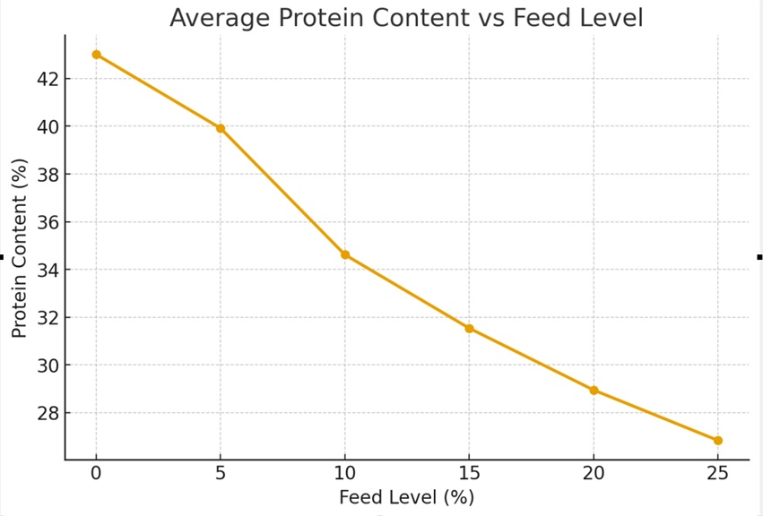
Fig 2: Protein Contents of the Chickens after 8 Weeks of Feeding

3.3 Lipid profile parameters: The lipid profile parameters after feeding the chicken for 8 weeks are presented in Table 1. The highest mean cholesterol was observed in the 15% group (4.13 ± 0.18), and the lowest was in the 25% group (3.23 ± 0.24), (Table 2). There is no statistically significant difference in cholesterol levels across the treatment groups (p > 0.05).
Table 1: Nutritional Compositions of Ultima Feed Used as Basal Feed
S/N | Ingredients | % Composition
1 | Crude protein (Min.) | 18.00
2 | Crude fat (Min.) | 5.00
3 | Crude Fiber (Max.) | 5.00
4 | Calcium (Min.) | 0.85
5 | Phosphorus (Min.) | 0.42
6 | Lysine (Min.) | 1.05
7 | Methionine (Min.) | 0.46
8 | Metabolizable energy (Min.) | 3150 Kcal/kg

Table 2: Effect of Pleurotus tuberregium Sclerotia on the Lipid Profile of Broiler Chickens (Mean ± Standard Error)
Level of Supplementation % | Cholesterol | Triglycerides | High Density Lipoprotein (HDL) | Low Density Lipoprotein (LDL) | Very Low Density Lipoprotein (VLDL)
0 | 3.97±0.49 | 1.33±0.28 | 1.23±0.15 | 2.10±0.32 | 0.63±0.13
5 | 3.27±0.19 | 1.07±0.15 | 1.13±0.03 | 1.63±0.12 | 0.50±0.06
10 | 3.93±0.18 | 0.53±0.20 | 1.50±0.00 | 2.20±0.10 | 0.30±0.10
15 | 4.13±0.18 | 0.40±0.20 | 1.53±0.03 | 2.40±0.25 | 0.20±0.10
20 | 3.53±0.22 | 0.60±0.10 | 1.47±0.03 | 1.80±0.20 | 0.27±0.03
25 | 3.23±0.24 | 0.97±0.20 | 1.10±0.06 | 1.67±0.29 | 0.47±0.09
The mean triglyceride levels ranged from 0.40 ± 0.20 (15%), to 1.33 ± 0.28 (0%). The differences in triglyceride levels among groups are statistically significant (p < 0.05). This suggests that dietary treatments had a measurable effect on triglyceride levels in the chickens.
The High-Density Lipoprotein (HDL) increased with the treatment from 10% (1.50 ± 0.00) up to the 20% group (1.47 ± 0.03) before declining at 25% (1.10 ± 0.06). The differences in HDL levels between groups are highly significant (P < 0.01), indicating a strong treatment effect of the mushroom on HDL.
Low-Density Lipoprotein (LDL) peaked in the 15% group (2.40 ± 0.25) and was lowest in the 5% group (1.63 ± 0.12). There is no significant difference in LDL levels between the treatment groups (p > 0.05). This indicated that the lowering effect of the mushroom on the LDL in the chickens is not dose dependent.
Very Low-Density Lipoprotein (VLDL) was highest in control (0%) 0.63 ± 0.13 and the lowest was observed in 15% 0.20 ± 0.10 (15%). There is a significant difference in VLDL levels across the treatment groups (p < 0.05), suggesting a treatment effect of the mushroom on the VLDL.
The association between the dosage of sclerotia, body weight gain and lipid profile showed significant treatment effects on Triglycerides, HDL, and VLDL, but no significant effects were found on Cholesterol and LDL. The final weight decreased with increasing dietary treatment levels, suggesting a potential impact of the mushroom on the growth performance.
- DISCUSSION
This is the first study evaluating the effect of mushroom on weight protein and blood lipid profile in chickens. Most of the animal studies on the effect of mushrooms on the lipid profile are on hamsters, rat, minipigs and humans (Peter, 1998, Berger, et al., 2004, Handayani, et al., 2011 , Shanggong et al., 2016,). This study showed that the sclerotia of Pleurotus tuberregium reduced weight gain in broilers chickens. Chicken weights decreased significantly over time. Feed level has a robust effect on growth, with minimal or no supplementation (0–5%) yielding superior weight gain. Excessive supplementation (20–25%) reduces growth performance, suggesting an inverse relationship between supplementation level and weight. The results suggest that minimal or no feed supplementation optimized weight gain, highlighting a potentially inverse relationship between feed level and growth efficiency. Poultry farmers could consider 0–5% feed levels as optimal for maximizing growth efficiency when incorporating this mushroom during formulation of feeds.
This finding is of special significance because weight gain leads to obesity that is associated with numerous diseases like diabetes and coronary heart diseases. The results of this study supported many studies that have shown that adding mushrooms powder to diets affect body weight gain in animals (Simopoulus and Pavlou, 1997, Berger, et al., 2004, Kim et al., 2005, Nuhu et al., 2009). The findings also supported the work of Handayani et al. (2011) who reported that Lentinus edodes prevents fat deposition and lowers Triglycerides in rats.
The result of the protein contents revealed a highly significant difference in protein content across feed levels. The statistical analysis showed that protein values form six distinct groups, showing a progressive, statistically reliable decline as feed additive concentration increased. This finding suggests higher supplementation with the sclerotia reduces or lowers the protein contents in broilers, indicating moderate supplementation (5–10%) may best balance nutritional quality of feeds.
The observed trends, though not statistically significant for total cholesterol, suggest a potential biological effect of the mushroom on the chicken. The reduction of the cholesterol is not dose dependent. This implies that addition of the mushroom at any dose has the same biological effect on the broiler chickens. The mechanism by which the sclerotia reduced the cholesterol levels may be due to the hypocholesterolaemic agent in the sclerotia which may be involved in decreasing the activity of the enzymes for cholesterol biosynthesis in the broilers. Addition of this mushroom into poultry feed may involve the suppression of endogenous cholesterol biosynthesis in chickens. This finding is in line with the reports that addition of oyster mushrooms in animal diet exhibit beneficial effects on cholesterol metabolism as reported by Fukushima et al. (2001), Shanggong et al. (2016) and Handayani et al. (2011).
Our findings showed the lowering effect of the sclerotia on the triglyceride level in broiler chickens. This observation suggests that there may be compounds within the sclerotia which appear to influence lipid metabolism, and reduced the glyceride amount in the blood stream of chickens. This observation is in line with the findings of Berger et al., (2004) who observed the effects of Ganoderma lucidum on the cholesterol and glycerides in rats and minipigs.
In this study, the high-density lipoprotein (HDL) known as good cholesterol was increased by the addition of the sclerotia. The effect was significant between 10% to 20%. The study has shown that adding less than 10% and above 20% (w:w) of the sclerotia does not increase the HDL. No significant differences in LDL levels were observed between the treatment groups (p > 0.05
The result of this study suggests the lowering effect of the sclerotia on the low density lipoprotein (LDL). The low-density lipoprotein (LDL) referred to as bad cholesterol decreased at high level of the sclerotia inclusion. The observed result of the effect of the sclerotia on the LDL in this study is in agreement with the observations of Krittanawong et al., (2021), Igba et al., (2024), Kleftaki et al.,(2022), Uffelman, et al., (2023) and Shanggong et al., (2016).
Conclusion: In conclusion, this study suggests that addition of sclerotia of Pleurotus tuberregium in the diet of broilers reduced the weight and lowered the cholesterol level. The mechanism involved and the components of sclerotia in the cholesterol lowering effect in broilers were not evaluated in this study and we recommend that it should be investigated in the further studies.

Ethical Approval: All experimental procedures and Animal use protocols were approved by the Ethic Committee of the National Open University of Nigeria in September 2024 (Ethical Approval NO ETC/006/08/05003).
ACKNOWLEDGEMENTS
This project was funded by 2024 Senate Research Grant (SRG) of National Open University of Nigeria. Our appreciation goes to the Management of the National Open University for the provision of the grant for this project.
DISCLAIMER (ARTIFICIAL INTELLIGENCE): The authors hereby declare that NO generative AI technologies such as Large Language Models (ChatGPT, COPILOT, etc.) and text-to-image generators have been used during the writing or editing of this manuscript.
COMPETING INTERESTS: Authors have declared that no competing interests exist

REFERENCES
Adekalu, T. B., Ojuawo, R. O. and Adekalu, O. A. (2011). Proximate and Elemental Analysis of Banana (Musa paradisiaca) During the Ripening Process. NIFOJ, 29 (1) 29-35

Burtis, C. A., and Ashwood, E. R. (2006). Teitz Fundamental of Clinical Chemistry, pp. 348 – 488. Reed Elsevier India Private Limited, New Delhi, India.

Cerletti, C.; Esposito, S.; Iacoviello, L.(2021). Edible Mushrooms and Beta-Glucans: Impact on Human Health. Nutrients 13, 2195. https://doi.org/10.3390/nu13072195
Chorvathoba, V., Bobek, P., Ginter, E. and Klvanova, J. (1993). Effect of oyster fungus on glycemia and cholesterolemia in rats with insulin depended diabetes. Physol. Res. 42:175-179

Dong Hoon Lee, Meng Yang, Edward L Giovannucci, Qi Sun and Jorge E Chavarro (2019). Mushroom consumption, biomarkers, and risk of cardiovascular disease and type 2 diabetes: a prospective cohort study of US women and men. Am. J. Clin. Nutr. 110:666–674
Feeney, M. J., Dwyer, J., Hasler-Lewis, C. M., Milner, J. A., Noakes, M., Rowe, S., & Beelman, R. B. (2014). Mushrooms and health summit proceedings. Journal of Nutrition, 144(7), 1128–1136.
Guillamón, E.; García-Lafuente, A.; Lozano, M.; D´arrigo, M.; Rostagno, M. A.; Villares, A.; Martínez, J. A. (2010). Edible Mushrooms: Role in the Prevention of Cardiovascular Diseases. Fitoterapia. 81(7), 715.

Iqbal T, Sohaib M, Iqbal S, Rehman H. (2024). Exploring Therapeutic Potential of Pleurotus ostreatus and Agaricus bisporus Mushrooms against Hyperlipidemia and Oxidative Stress Using Animal Model. Foods 13(5), 709; https://doi.org/10.3390/foods13050709
Jee Yeon Hong, Mi Kyung Kim and Narae Yang (2024). Mushroom consumption and cardiometabolic health outcomes in the general population: a systematic review. Nutr Res Pract. 18(2):165-179 https://doi.org/10.4162/nrp.2024.18.2.165 pISSN 1976-1457·eISSN 2005-6168
Jeong, S. C., Jeong, Y. T., Yang, B. K., Islam, R., Koyyalamudi, S. R., Pang, G., & Song, C. H. (2010). White button mushroom (Agaricus bisporus) lowers blood glucose and cholesterol levels in diabetic and hypercholesterolemic rats. Nutrition Research, 30(1), 49–56.
Kleftaki SA, Amerikanou C, Gioxari A, Lantzouraki DZ, Sotiroudis G, Tsiantas K, Tsiaka T, Tagkouli D, Tzavara C, Lachouvaris L, Zervakis GI, Kalogeropoulos N, Zoumpoulakis P, Kaliora AC. (2022). A Randomized Controlled Trial on Pleurotus eryngii Mushrooms with Antioxidant Compounds and Vitamin D₂ in Managing Metabolic Disorders. Antioxidants 11(11):2113. 3. https:// doi.org/10.3390/antiox11112113
Krittanawong, C., Isath, A., Hahn, J., Wang, Z., Fogg, S. E., Bandyopadhyay, D., Jneid, H., Virani, S. S., & Tang, W. H. W. (2021). Mushroom Consumption and Cardiovascular Health: A Systematic Review. American Journal of Medicine, 134(5), 637-642
Lisa Dicks and Sabine Ellinger (2020). E ectofthe Intake of Oyster Mushrooms (Pleurotus ostreatus) on Cardiometabolic Parameters—A Systematic Review of Clinical Trials. Nutrients 12, 1134

Łysakowska, P.; Sobota, A.; Wirkijowska, A. (2023). Medicinal Mushrooms: Their Bioactive Components, Nutritional Value and Application in Functional Food Production—A Review. Molecules 28, 5393. https://doi.org/ 10.3390/molecules28145393

Nur A. A., Nurhayati Z. A. , Noorlidah A. (2018). The potential applications of mushrooms against some facets of atherosclerosis: A review. Food Research International. 105, 517-536

Nworu CS, Ihim SA, Okoye FB, Esimone CO, Adikwu MU, Akah PA (2015). Immunomodulatory and immunorestorative activities of β-D-glucan-rich extract and polysaccharide fraction of mushroom, Pleurutus tuberregium. Pharm Biol. 53(11):1555-66. doi:
Ogbomida ET, Omofonmwan K, Aganmwonyi I, Fasipe IP, Enuneku A, Ezemonye LIN. (2018). Bioactive profiling and therapeutic potential of mushroom (Pleurotus tuberregium) extract on Wistar albino rats (Ratus norvegicus) exposed to arsenic and chromium toxicity. Toxicol Rep. 15(5):401-410
Schneider, I., Kressel, G., Meyer, A., Krings, U., Berger, R.G., and Hahn, A. (2011). Lipid Lowering Effercts of Oyster Mushroom (Pleurotus ostreatus) in Humans. Journal of Functional Food 3(1): 17 - 24
Shanggong Y. Xianli, W., Mathew,F., Rosalia, C. M. S., Mario, A. C., Frank, A. S., and Nianbai, F. (2016). Diet Containing Shitake Mushroom Reduce Serum Lipids and Serum Lipophilic Antioxidant Capacity in Rats. J. Nutr 146(12(2491 - 2496
Simopoulus, A. P. and Pavlou (1997). Nutrition and Fitness, Metabolic and Behavioral Aspect in Health and Disease. World Review of Nutrition and Dietetics Karger, Basel, pp. 1-266.
Sjoblom, L. and Eklund, A. (1989). Determination of HDL2 cholesterol by precipitation with dextran sulfate and magnesium chloride: establishing optimal conditions for rat plasma. Lipids, 24 (6): 532-534

Uffelman, C.N.; Chan, N.I.; Davis, E.M.; Wang, Y.; McGowan, B.S.; Campbell, W.W. (2023). An Assessment of Mushroom Consumption on Cardiometabolic Disease Risk Factors and Morbidities in Humans: A Systematic Review. Nutrients 2023, 15, 1079. https://doi.org/10.3390/ nu15051079
Valverde, M. E., Hernández-Pérez, T., & Paredes-López, O. (2015). Edible mushrooms: improving human health and promoting quality life. International Journal of Microbiology, 2015, 1–14.
Wasser, S. P. (2017). Medicinal mushrooms as a source of antitumor and immunomodulating polysaccharides. Applied Microbiology and Biotechnology, 60(3), 258–274.
World Health Organization (WHO) (2003). WHO's World Health Report 2003: Shaping the future depends on strengthening health systems. Geneva, 2003.

Ying Zhou, Minghang Chu, Farhad Ahmadi, Osman Tuncay Agar, Colin J. Barrow, Frank R. Dunshea & Hafiz A.R. Suleria (2024). A Comprehensive Review on Phytochemical Profiling in Mushrooms: Occurrence, Biological Activities, Applications and Future Prospective, Food Reviews International, 40:3, 924-951
Zaidman, B. Z., Yassin, M., Mahajna, J., & Wasser, S. P. (2005). Medicinal mushroom modulators of molecular targets as cancer therapeutics. Applied Microbiology and Biotechnology, 67, 453–468.
Zhang, M., Cui, S. W., Cheung, P. C., & Wang, Q. (2007). Antitumor polysaccharides from mushrooms: a review on their isolation process, structural characteristics, and antitumor activity. Trends in Food Science & Technology, 18(1), 4–19.

