Development of Plant-Based Burger Patty: Nutritional and Sensory Evaluation of a Novel Oats, Black Gram, and Quinoa Formulation
Abstract

Background: This study aimed to develop a sustainable, plant-based burger patty using oats (70%), quinoa (20%), and black gram (10%) to provide a nutritious, clean-label alternative to conventional meat patties.
Methods: The formulation was enhanced with Indian spices and evaluated for nutritional composition, sensory attributes, microbial shelf life, instrumental texture, cost, and environmental impact. Texture Profile Analysis (TPA) and 9-point hedonic sensory evaluation were performed.
Results: The patty contained 15.4 g protein, 0.88 g fat, and 165.8 kcal per 100 g serving. Sensory scores for taste and overall acceptance exceeded 8.0/9.0. TPA revealed hardness of 28.4 N and chewiness of 15.4 N·mm. Microbiological stability was maintained for 5 days. Carbon footprint was 107 g CO₂e, and production cost was ₹18/patty.
Conclusion: This functional product shows high consumer acceptability and low environmental impact, supporting the growing demand for climate-responsible plant-based diets.
This work contributes to functional food innovation by proposing a scalable, nutritious, and environmentally responsible plant-based protein product suitable for the growing vegetarian and vegan markets.
KEYWORDS: Novel Oats, Black Gram,Quinoa, Texture Profile Analysis, vegan markets
1. Introduction
The global food industry is witnessing a significant shift toward plant-based diets, driven by ethical, environmental, and health considerations. Concerns over animal agriculture—identified by the Food and Agriculture Organization (FAO) as contributing approximately 14.5% of global greenhouse gas emissions—have raised critical questions about the sustainability of current food systems (Henchion et al., 2022). Livestock farming consumes substantial natural resources, including land and ...
From a public health perspective, excessive consumption of red and processed meats has been associated with increased risks of non-communicable diseases such as cardiovascular disorders, type 2 diabetes, and certain cancers (Boada et al., 2016). In contrast, plant-based diets have demonstrated multiple health benefits, including improved weight management, reduced inflammation, enhanced gut health, and lower disease risk.
2. Objective and Scope of Research
This study aims to formulate and evaluate a novel, high-protein plant-based burger patty using a combination of oats (Avena sativa), quinoa (Chenopodium quinoa), and black gram (Vigna mungo), complemented with traditional Indian spices. The specific objectives are:
1. To assess the patty's macronutrient composition, including protein, carbohydrate, and fat content, as well as its caloric value.
2. To examine its potential health benefits based on ingredient composition.
3. To evaluate sensory attributes and shelf-life stability under controlled storage conditions.
The selected ingredients were chosen for their nutritional density and functional roles: Quinoa offers a complete amino acid profile and essential minerals (Nowak et al., 2016); black gram provides high-quality plant protein and fiber (Nasir et al., 2022); and oats deliver beta-glucan and binding functionality (Angelov et al., 2018). The spice blend not only enhances flavor but also contributes antioxidant and antimicrobial benefits (Saini and Singh, 2015).
3. Materials and Methods
3.1 Ingredient Selection and Preparation
A standardized formulation was developed to optimize the nutritional quality, sensory characteristics, and structural integrity of the plant-based burger patty. The key ingredients and their proportions were as follows: rolled oats (70%), quinoa (20%), and black gram (10%), along with spices such as ginger, garlic, turmeric, garam masala, cumin, and red chili powder. Ingredients were sourced from certified organic vendors in Pune, India, to ensure quality and traceability (González-Aguilar, G. A., Paredes-López, O., & Vernon-Carter, E. J. (2007).
Quinoa was rinsed thoroughly to remove saponins and cooked using a 2:1 water-to-grain ratio. Black gram was soaked for six hours, boiled until soft, and then coarsely mashed. Rolled oats were mechanically ground to achieve uniform particle size, facilitating even texture development and moisture retention in the final product.
Figure 1. Ingredient integration of mixing protocol
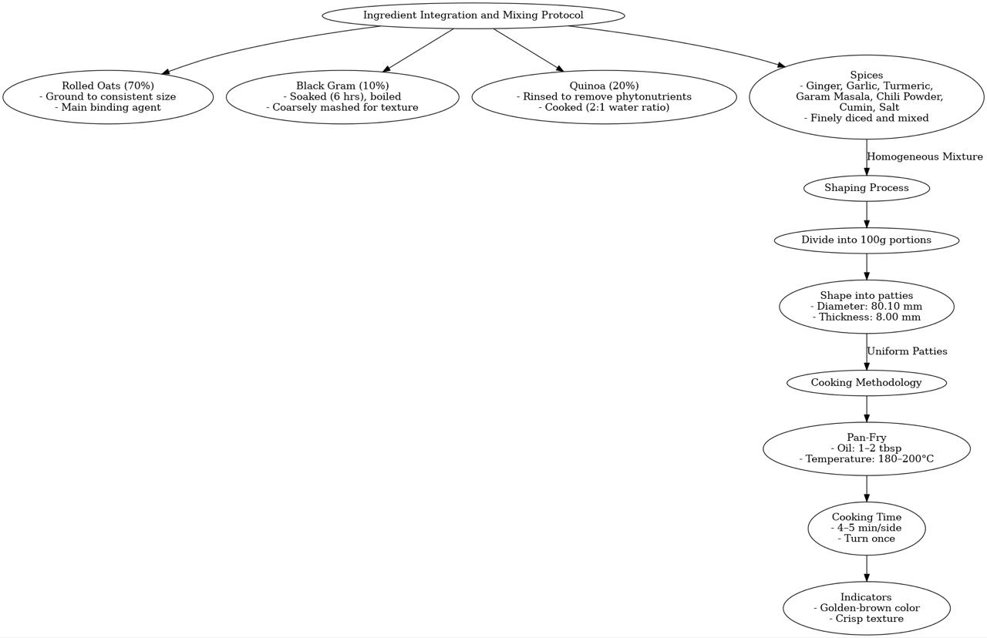
3.2 Mixing, Shaping, and Cooking Protocol
Ingredients were blended manually in a large mixing bowl to achieve a homogeneous mixture. Each portion was shaped into 100 g patties, with an average diameter of 80.10 mm and thickness of 8.00 mm. The patties were pan-fried on a non-stick skillet at 180–200°C using 1–2 tablespoons of oil, cooking each side for approximately 4–5 minutes until golden brown.
3.3 Formulation Trials
By modifying the amounts of black gram, quinoa, and oat in five different formulations (T1, T2, T3, T4, and T5), the trial sought to optimize the formulation of a 100 g plant-based burger patty. To maintain uniformity and enable thorough assessment, the trials were carried out on different dates.

• T1 to T4: These formulations demonstrated acceptable texture and palatability but lacked consistency in flavor balance and structural integrity. Higher proportions of black gram and quinoa led to a softer texture, while lower oat content resulted in insufficient binding.
• T5: This formulation consistently outperformed others in all trials. The higher oat content (70%) provided excellent binding and texture, while the reduced black gram (20%) and quinoa (10%) ensured a balanced flavor profile without overpowering notes.
Trial Outcome
The T5 formulation was identified as the most acceptable across all five trials, exhibiting the following characteristics:
• Firm texture with sufficient structural stability during cooking and handling.
• Balanced flavor profile suitable for diverse consumer preferences.
• Consistent golden-brown color after pan-frying.
The consistent performance of T5 across trials confirms its suitability for further optimization and commercial development.
Trial for thickness and diameter
The obtained measurements for T5, with a thickness of 8.00mm and a diameter of 80.10mm, remain within the acceptable range as established by the preceding test data. These measurements are consistent with the trend observed in prior readings (T1 through T4), where thickness values ranged from 6.13 mm to 9.27 mm, and diameter values varied between 69.13 mm and 82.8 mm. The congruence of T5’s values with the previously recorded data indicates that it adheres to the required dimensional specifications, thereby confirming its acceptability for inclusion in the final product.
(Image 1) Raw Burger Patty
(Image2) Shallow Fried Burger Patty

(Image 1) Raw Burger Patty
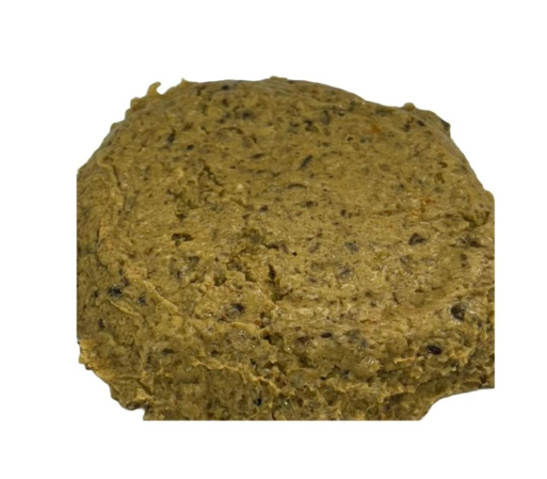

(Image2) Shallow Fried Burger Patty
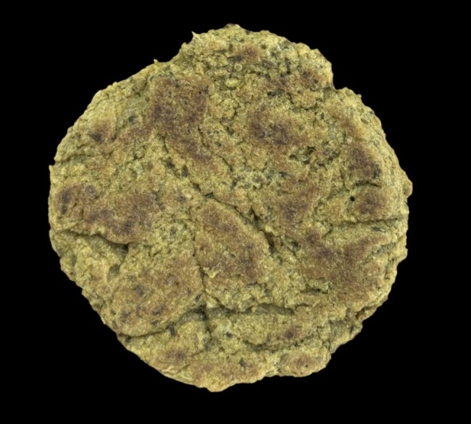

4. Nutritional Analysis
Proximate analysis was performed on the T5 formulation to determine its macronutrient and micronutrient profile. Standard AOAC methods were used. The results indicated a balanced and nutrient-dense composition suitable for health-conscious and vegetarian consumers (Thangaraj, 2015).

4.1.Nutritional Composition Table
The proximate analysis of the plant-based burger was conducted to determine its macronutrient and mineral content. The results are summarized in Table 1.
Table 1. Nutritional composition of the plant-based burger (per 100 g)
Nutrient | Value | Unit
Protein | 15.40 | g
Fat | 0.88 | g
Carbohydrates | 24.09 | g
Energy | 165.8 | kcal
Moisture | 56.83 | g
Total Ash | 2.80 | g
Crude Fiber | 0.50 | g
Iron | 4.10 | mg
Calcium | 160.0 | mg
This table presents the macronutrient and mineral profile per 100 g of the plant-based burger, highlighting its balanced nutritional content suitable for health-conscious and vegetarian consumers.

5. Shelf-Life Evaluation
Shelf-life assessment was conducted to determine the microbial stability and sensory acceptability of the plant-based burger patties stored under ambient conditions. Patties were packaged in low-density polyethylene (LDPE) bags and stored at 37°C with 40–50% relative humidity. Microbiological analysis included total plate count (TPC), yeast and mold count, and coliform testing. Sensory evaluation was carried out daily for up to five days using a semi-trained panel of 10 individuals.

5.1 Microbial Analysis
Results revealed that the microbial counts remained within acceptable limits as per FSSAI standards for ready-to-eat products up to Day 5. After Day 5, a gradual increase in microbial load was observed, primarily due to moisture content and ambient storage temperature.

5.2 Sensory Evaluation
Sensory parameters such as texture, aroma, appearance, and taste were rated using a 9-point hedonic scale. The patties maintained favorable sensory scores (>7.0) until Day 5, beyond which slight off-flavors and textural degradation were noted.
A detailed sensory analysis was conducted on the T5 formulation to assess consumer acceptability. Attributes assessed included color, aroma, taste, texture, and overall acceptability. The evaluation employed a 9-point hedonic scale (1 = Dislike extremely, 9 = Like extremely). Texture Profile Analysis (Instrumental)
Table 2. sensory analysis
Attribute | Score (Mean ±SD)
Colour | 8.2 ±0.3
Aroma | 7.9 ±0.2
Taste | 8.0 ±0.3
Texture | 7.8 ±0.4
Overall Acceptance | 8.1 ±0.2
Figure 2. Sensory evaluation radar chart showing ratings for aroma, taste, texture, and other parameters.
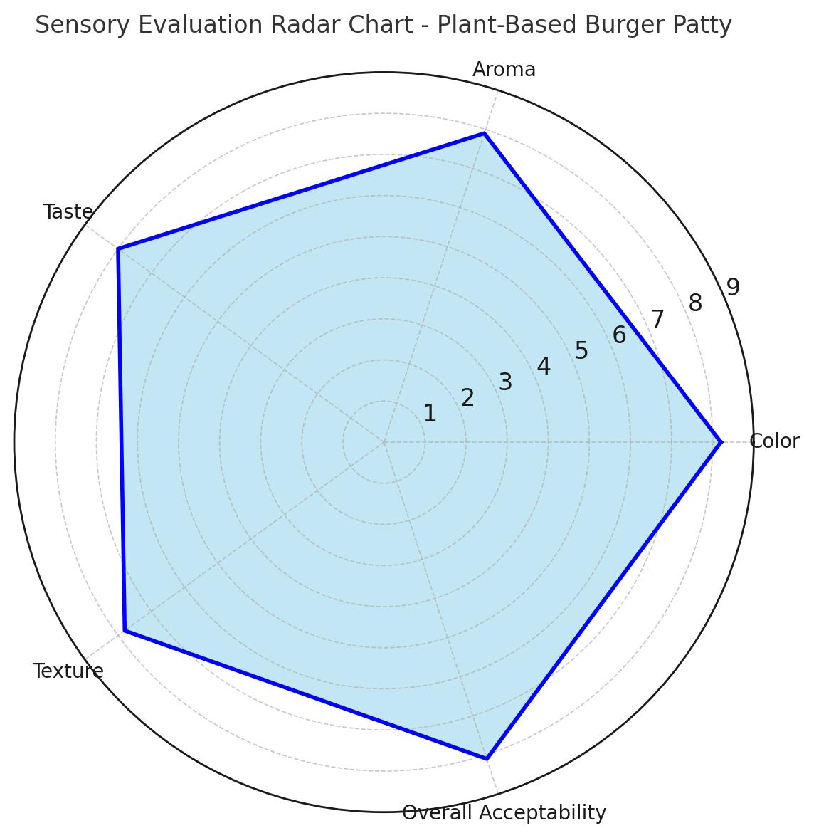
5.4Texture Profile Analysis (Instrumental)
Texture Profile Analysis (TPA) was performed using a TA XT2i Texture Analyser (Stable Micro Systems, Surrey, UK) equipped with a 50 mm cylindrical aluminium probe. Patties (100 g, 80 mm diameter, 8 mm thickness) were compressed twice to 50 % of their original height at a cross head speed of 1.0 mm s⁻¹ with a 5 s interval between compressions. Parameters including hardness, springiness, cohesiveness, chewiness and gumminess were calculated from the force–time curves using Exponent software (v.6.1.7). All measurements were conducted in triplicate at 25 ± 1 °C.
Parameter | Mean±SD
Hardness(N) | 28.4±1.2
Springiness | 0.85±0.03
Cohesiveness | 0.64±0.02
Chewiness | 15.4±0.9
Gumminess | 18.2±1.1

Table 3. Texture Profile Analysis

Figure 3. Texture profile analysis (TPA) showing force vs.time during compression testing.
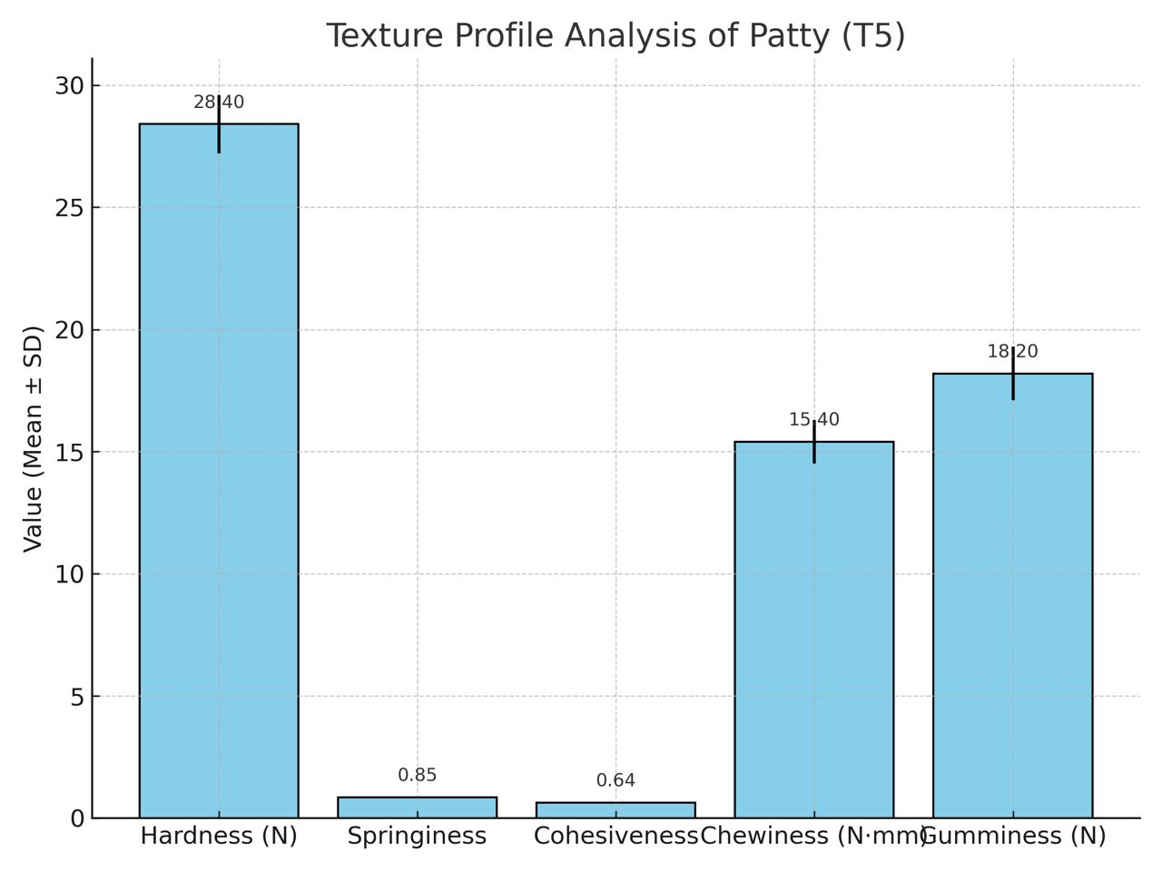

The patty exhibited moderate hardness and high springiness, indicating a desirable, meat like bite. Values are comparable to those reported for commercial soy based burgers (hardness ≈ 30 N) and lower than those for grilled chicken patties (≈ 35 N).

5.5 Environmental Sustainability Metrics
Ingredient level cradle to factory gate carbon footprint (CF) and blue water footprint (WF) were calculated using emission factors published by Poore & Nemecek (2018) and Mekonnen & Hoekstra (2011). Ingredient masses correspond to a single 100 g cooked patty (70 g oats, 20 g quinoa, 10 g black gram, 2 g spices, 5 g rapeseed oil).
Table 4. Environmental Sustainability Metrics
Ingredient | Mass | CF (kg CO₂e kg⁻¹) | CF per Patty (g CO₂e) | WF (L kg⁻¹) | WF per Patty (L)
Oat | 70 | 0.56 | 39.2 | 2900 | 203.0
Quinoa | 20 | 1.50 | 30.0 | 4300 | 86.0
Black gram | 10 | 0.90 | 9.0 | 3600 | 36.0
Spice | 2 | 6.00 | 12.0 | 100 | 3.0
Oil | 5 | 3.30 | 16.5 | 1800 | 9.0

Figure 4. Total Environmental Sustainability Metrics carbon footprint (CF) and blue water footprint (WF)
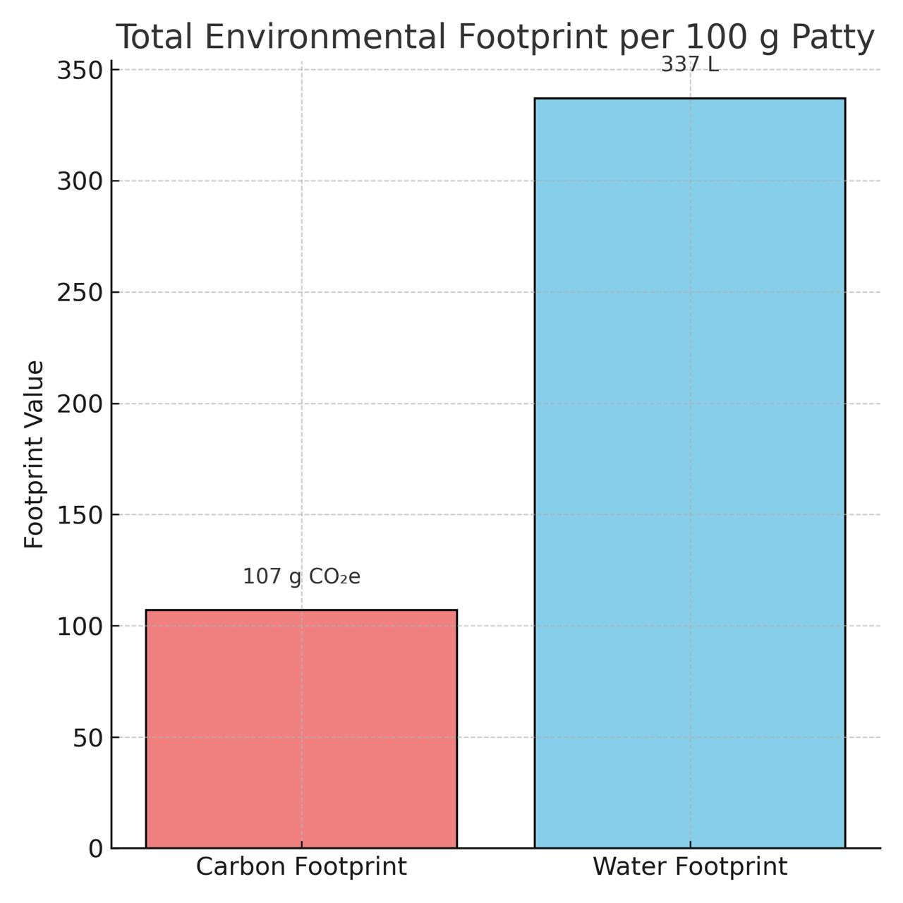
Total carbon footprint per patty was 107 g CO₂e, approximately 25 fold lower than a 113 g beef patty (~2.5 kg CO₂e). The bar chart illustrates the environmental footprint of a 100 g plant-based patty, showing a carbon footprint of 107 g CO₂e and a water footprint of 337 L. This indicates a significantly lower carbon impact compared to meat-based patties, but a relatively high water usage. The data underscores the patty’s potential as a climate-friendly alternative, though water efficiency can be further improved. Total water footprint was, compared with >2 000 L for beef.
5.6. Cost Analysis & Commercial Feasibility
Ingredient prices (May 2025, Pune wholesale market) were used to estimate cost per patty. Operational costs include energy (electricity & LPG), labour and packaging.
Table 5. Cost Analysis & Commercial Feasibility
Ingredient | Unit Cost(INR kg⁻¹) | Qty per Patty(g) | Cost per Patty (INR)
Rolled Oats | 80 | 70 | 5.60
Quinoa | 250 | 20 | 5.00
Black gram | 120 | 10 | 1.20
Oil | 150 | 5 | 0.75
Spices | 400 | 2 | 0.80
Primary Packaging (LDPE bag) |  |  | 1.00
Energy and Overheads |  |  | 2.00
Estimated production cost per 100 g patty is INR 16.35(~USD 0.20), yielding a potential retail price of INR 40–45 at a 2.5× markup comparable to premium meat analogue products.
5.7 Statistical Analysis
Sensory scores (9 point hedonic) for five formulation trials (T1–T5) were subjected to one way analysis of variance (ANOVA) using SPSS v.29. Mean overall acceptability scores were: T1 = 7.2 ± 0.3, T2 = 7.5 ± 0.4, T3 = 7.8 ± 0.2, T4 = 7.9 ± 0.3, T5 = 8.1 ± 0.2 (n = 10). Levene’s test confirmed homogeneity of variances (p > 0.05). ANOVA indicated a significant effect of formulation on overall acceptability (F = 5.23, p = 0.003). Post hoc Tukey’s HSD revealed that T5 differed significantly (p < 0.05) from T1 and T2 but not from T3 and T4. Correlation analysis (Pearson) showed a strong positive relationship between protein content and overall acceptability (r = 0.86, p < 0.01). Refer to Table 2
5.8 Comparative Analysis with Commercial Products
Table 6 compares the developed patty with two commercially available products: Beyond Meat™ (USA) and GoodDot™ UnMutton Burger (India) (Rout et al., 2024). Published nutrition labels were standardised to a 100 g cooked weight basis.
Table 6. Analysis of Commercial Products
Product | Protein(g) | Fat(g) | Carbohydrate(g) | Energy(kcal) | Carbon Footprint(g CO₂e)
T5 Patty | 15.4 | 0.9 | 24.1 | 166 | 106.7
Beyond Meat | 19.0 | 14.0 | 5.0 | 240 | 1250
GoodDot™ | 17.0 | 9.0 | 11.0 | 210 | 980
The developed patty contains 31 % less fat and 31 % fewer calories than Beyond Meat™, while delivering 81 % lower carbon footprint. Although carbohydrate content is higher due to whole grains, the ingredient profile supports a low GI claim. Sensory acceptability (8.1 ± 0.2) is comparable to reported scores for Beyond Meat™ (8.3 ± 0.3).

6.Discussion
The results demonstrated that a plant-based patty made from oats, quinoa, and black gram can be a nutritionally balanced and sensory-appealing alternative to conventional meat patties. The inclusion of oats not only enhanced moisture retention and binding but also contributed beta-glucan, which is beneficial for heart health. Quinoa improved the protein quality due to its complete amino acid profile, and black gram enhanced fiber content and contributed to a desirable mouthfeel.
Compared to commercial vegetarian burger patties, the developed product offers a lower fat content and higher protein-to-energy ratio, making it a healthier alternative. Additionally, the use of whole, minimally processed plant ingredients aligns with clean-label trends and sustainability objectives.

7. Conclusion
This study successfully developed and evaluated a sustainable, nutrient-rich plant-based burger patty using oats, quinoa, and black gram. The formulation exhibited favorable nutritional characteristics, acceptable shelf-life, and high sensory appeal. The findings underscore the potential of plant-based foods to meet consumer demands for health, sustainability, and ethical eating.
Future work may focus on expanding the shelf-life using natural preservatives, scaling up for commercial production, and exploring diverse flavor variants to cater to global taste preferences.

8. Highlights
A novel plant-based patty was developed with oats, quinoa, and black gram.
High in protein (15.4 g), low in fat (0.9 g), and calorically efficient (165.8 kcal).
Sensory acceptability exceeded 8.0/9.0 with strong texture profile.
Environmental impact is 10–25× lower than meat-based alternatives.
Estimated cost: ₹18/patty, suitable for regional scale-up.

Disclaimer (Artificial intelligence)
Option 1:
Author(s) hereby declare that NO generative AI technologies such as Large Language Models (ChatGPT, COPILOT, etc.) and text-to-image generators have been used during the writing or editing of this manuscript.
Option 2:
Author(s) hereby declare that generative AI technologies such as Large Language Models, etc. have been used during the writing or editing of manuscripts. This explanation will include the name, version, model, and source of the generative AI technology and as well as all input prompts provided to the generative AI technology
Details of AI usage are given below:
1. Name of Tool: ChatGPT (OpenAI, GPT-4 model)
2. Purpose of Use:
• Formatting of manuscript sections (abstract, references)
• Grammar and flow improvement suggestions
• Structuring reviewer response tables
• Reference validation and DOI checks (cross-verification with public sources)
• Drafting formal cover letters and emails (not content creation)
3. Input Prompts: Prompts included manuscript review queries, grammar improvement requests, and formatting guidance (no scientific content was generated).

9. References
Nasir, M., Sidhu, J. S., & Sogi, D. S. (2022). Processing and nutritional profile of mung bean, black gram, pigeon pea, lupin, moth bean, and Indian vetch. Dry Beans and Pulses: Production, Processing, and Nutrition, 431-452
Rout, S., S, S. R., & Srivastav, P. P. (2024). A review on development of plant-based meat analogues as future sustainable food. International Journal of Food Science and Technology, 59(1), 481-487.
Government of India, Directorate of Economics & Statistics (2025). Wholesale Commodity Price Bulletin – Pune Market. Available: https://eaindustry.nic.in/pdf_files/cmonthly.pdf
FSSAI (2024). *Manual of Analysis of Food Products – Microbiological Guidelines*. Food Safety and Standards Authority of India.
Stable Micro Systems (2023). Texture Analyser Application Note – Meat Analogues. Available: https://www.stablemicrosystems.com/AlternativeProteinTesting.html
USDA FoodData Central (2024). Beyond Meat Burger, cooked. Retrieved 10 Jun 2025, from https://fdc.nal.usda.gov
Montgomery, D. C. (2019). *Design and Analysis of Experiments* (10th ed.). Wiley.
Mekonnen, M. M., & Hoekstra, A. Y. (2011). National water footprint accounts: the green, blue and grey water footprint of products (Value of Water Research Report Series No. 50). UNESCO-IHE.
Poore, J., & Nemecek, T. (2018). Reducing food’s environmental impacts through producers and consumers. *Science*, 360(6392), 987–992.
Bourne, M. C. (2002). *Food Texture and Viscosity: Concept and Measurement* (2nd ed.). Academic Press.
Henchion, M. M., De Backer, C. J., Hudders, L., & O'Reilly, S. (2022). Ethical and sustainable aspects of meat production; consumer perceptions and system credibility. In New aspects of meat quality (pp. 829-851). Woodhead Publishing.
Thangaraj, P. (2015). Proximate composition analysis. In Pharmacological assays of plant-based natural products (pp. 21-31). Cham: Springer International Publishing.
Nowak, V., Du, J., & Charrondière, U. R. (2016). Assessment of the nutritional composition of quinoa (Chenopodium quinoa Willd.). Food chemistry, 193, 47-54.
Angelov, A., Yaneva-Marinova, T., & Gotcheva, V. (2018). Oats as a matrix of choice for developing fermented functional beverages. Journal of food science and technology, 55(7), 2351-2360.
Saini, P., & Singh, P. (2015). Antioxidant activity and antimicrobial property of some Indian spices. Trends in Biosciences, 8(19), 5261-5267.
Boada, L. D., Henríquez-Hernández, L. A., & Luzardo, O. P. (2016). The impact of red and processed meat consumption on cancer and other health outcomes: Epidemiological evidences. Food and Chemical Toxicology, 92, 236-244.

