A Biomedical Engineering–Inspired Smart Housing System for Autonomous Human Thermoregulation Using Bio-Humid Wall Bricks: A Comprehensive Review

Abstract
Human thermoregulation is a biologically optimised process that maintains internal body temperature within a narrow physiological range despite fluctuating environmental conditions. Conventional residential buildings rarely incorporate such biological principles and instead rely heavily on energy-intensive Heating, Ventilation, and Air-Conditioning (HVAC) systems. This reliance contributes significantly to global energy consumption, while often providing suboptimal thermal comfort. In this study, a biomedical engineering–inspired smart housing concept is proposed, in which the building envelope functions analogously to human skin using bio-humid wall bricks. These bricks are composed of hygroscopic and porous bio-based materials capable of regulating indoor temperature through moisture absorption, evaporative cooling, and thermal buffering. Drawing inspiration from sweating, vasodilation and heat-moisture exchange processes in human physiology, the system passively adapts to environmental changes. Governing heat and mass transfer equations are developed alongside physiological thermal comfort models. The proposed framework demonstrates the potential to reduce indoor temperature fluctuations, improve occupant thermal comfort and reduce energy demand, particularly in hot and humid climates.
Keywords: Bio-humid bricks, Passive cooling, Biomimicry, Thermal comfort, Biomedical Thermoregulation, Sustainable Buildings

1. Introduction
Maintaining thermal comfort is essential for human health, cognitive performance, and overall well-being. According to Romanovsky (2007), Romanovsky (2014) and Parsons (2014), the human body maintains its core temperature within approximately 36.5–37.5°C through integrated thermoregulatory mechanisms controlled by the hypothalamus. In contrast, most modern buildings rely heavily on mechanical Heating, Ventilation and Air-Conditioning (HVAC) systems, which contribute significantly to overall building energy consumption, as noted by Perez-Lombard et al. (2008) and Crawley et al. (2001). Globally, buildings account for approximately 30–40% of total energy use, with space cooling demands increasing rapidly due to urbanisation and climate change. This trend has been extensively reported in the work of Sadineni et al. (2011) and Santamouris (2016). In tropical and subtropical regions, the growing dependence on mechanical cooling presents substantial economic and environmental challenges. Furthermore, as emphasised by Nicol and Humphreys (2002) and Djongyang et al. (2010), conventional cooling strategies often neglect human physiological adaptation, which can result in thermal discomfort and adverse health outcomes. Biomedical engineering provides a robust framework for translating biological regulatory mechanisms into engineered systems. Human skin, a multifunctional organ responsible for heat dissipation and moisture regulation, offers a valuable biological model for adaptive building envelopes. The relevance of skin-based thermoregulatory principles has been well established in physiological studies by Charkoudian (2003) and Romanovsky (2014). Meanwhile, architectural research has demonstrated the promise of biomimicry for improving environmental responsiveness in buildings, as discussed by Badarnah (2017) and Gruber and Imhof (2017). However, despite these advances, there remains limited work that systematically integrates biomedical-based
thermoregulation concepts into the design of building envelope systems. Based on the comprehensive review in this paper, attempt is made to propose a bio-humid wall bricks that function as an artificial thermoregulatory layer, analogous to human skin. This will help facilitate the integration of physiological thermoregulation, material science and heat-transfer engineering into a unified smart housing concept.

2. Biomedical Principles of Human Thermoregulation

2.1 Human Thermoregulatory Control
Human thermoregulation is governed by a hypothalamic control system that integrates thermal information from peripheral and central thermo-receptors and triggers appropriate physiological responses, including sweating, vasodilation, vasoconstriction, and shivering. This integrated control mechanism has been clearly described in the work of Tansey and Johnson (2015) and Havenith and Fiala (2016). The skin functions as the principal interface for heat and mass exchange between the human body and the external environment, playing a decisive role in thermal balance, as documented by Kenney and Munce (2003) and Kingma et al. (2012).
Thermoregulation is the maintenance of a relatively constant core body temperature, critical for metabolic efficiency and survival, typically around 37°C in humans. It involves a complex integration of central and peripheral thermoreceptors, neural pathways, and multiple effector mechanisms, including vasodilation, vasoconstriction, sweating, shivering, piloerection and non-shivering thermogenesis (Tansey and Johnson, 2015). Recent advances have highlighted the role of Transient Receptor Potential (TRP) channels in temperature sensing and the contribution of brown adipose tissue in adults to heat production, reflecting a sophisticated multisensory, multi-effector control system (Figure 1). Understanding the neuroanatomical circuitry and peripheral feedback mechanisms not only provides insight into classical homeostatic regulation but also informs biomedical engineering applications, such as bioheat modelling, wearable thermal sensors and thermoregulatory device design (Tansey and Johnson, 2015).

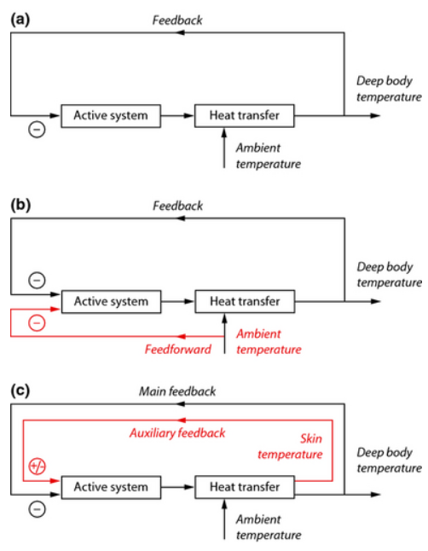
Figure 1: Feedback and feedforward mechanisms in thermoregulation
The figure effectively illustrates the multisensory, multi-effector nature of human thermoregulation, conceptualised as a federation of relatively independent thermos-effector loops, as proposed by Romanovsky (2007). This framework is scientifically robust and aligns well with contemporary physiological models that reject the idea of a single centralised thermostat. The figure is logically structured into three schematic panels, each representing a progressively more complex control strategy within an individual thermos-effector loop:
- Panel (a) depicts classical negative feedback control, in which deep body temperature is regulated by thermo-receptors that detect deviations from a reference value and activate thermo-effectors to counteract these changes. This model captures the fundamental principle of thermal homeostasis and provides a clear baseline for understanding more advanced regulatory mechanisms.
- Panel (b) extends this model by incorporating a feedforward control signal derived from ambient temperature. The inclusion of feedforward input (highlighted in red) strengthens the conceptual framework by demonstrating how the thermoregulatory system can anticipate thermal disturbances before changes in deep body temperature occur. This anticipatory regulation improves response speed and reduces physiological strain, especially during rapid environmental temperature changes.
- Panel (c) further refines the control architecture by adding auxiliary feedback from skin temperature, which may exert either negative or positive influence depending on physiological context. This auxiliary feedback enhances system flexibility and sensitivity, allowing thermoregulatory responses to be adjusted based on peripheral thermal information. The representation acknowledges the integrative role of skin thermo-receptors in fine-tuning effector activity, particularly during transient or localized thermal challenges.
Overall, the figure clearly differentiates between active components (thermo-receptors and thermo-effectors) and passive heat-transfer processes, which improves conceptual clarity. The use of colour to distinguish feedforward and auxiliary feedback pathways is effective and enhances interpretability. Significant advances in peripheral thermal sensation have emerged from the discovery of the Transient Receptor Potential (TRP) family of ion channels, which are expressed in both cell and internal membranes and mediate cation influx in response to thermal stimuli (Tansey and Johnson, 2015). Nine TRP channels are now established as temperature-sensitive, each exhibiting a relatively narrow activation range, yet collectively providing broad temperature discrimination. For example, as shown in Figure 2, TRPV1 and TRPV2 respond to noxious heat (>43°C and >52°C, respectively), TRPV3 and TRPV4 mediate innocuous warmth (>31°C and >25°C), TRPM8 responds to innocuous cold (<27°C), and TRPA1 may detect noxious cold (<17°C), though its role remains debated (Tansey & Johnson, 2015). These channels help explain classical observations of thermo-receptive neuron responses and sensory discrimination, such as the cooling sensation of menthol (TRPM8 agonist) or the burning sensation of capsaicin in chili (TRPV1 agonist). While mapping TRP channels onto known thermoreceptor discharge patterns provides mechanistic insight, caution is warranted, as direct evidence linking all TRP channels to primary thermosensitive afferents remains limited (Tansey and Johnson, 2015).

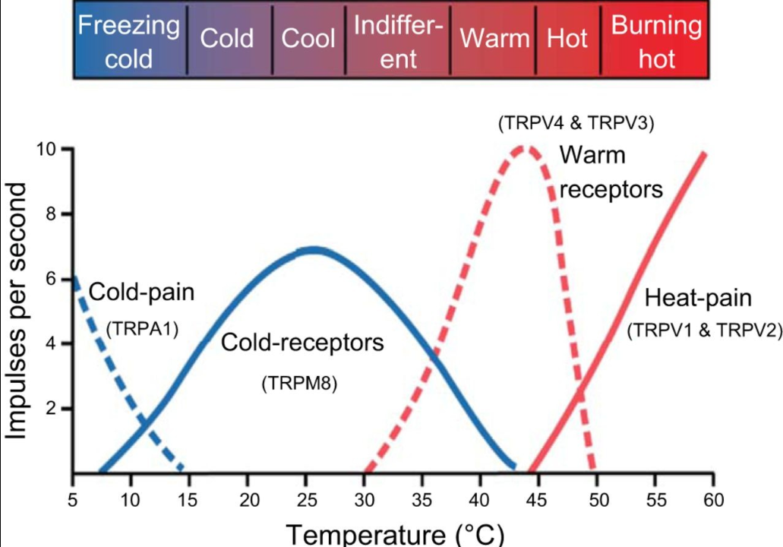
Figure 2: Discharge frequencies of peripheral thermo-receptors at different skin temperatures (Tansey and Johnson, 2015).

Thermal information from peripheral thermo-receptors in the skin and central thermo-receptors within deep body tissues is continuously integrated by the hypothalamus and compared against a predefined set point, as noted by Fiala et al. (2012) and Parsons (2014). When body temperature rises above this set point, the hypothalamus initiates heat-loss mechanisms, including vasodilation of cutaneous blood vessels and activation of sweat glands, as described in the work of Charkoudian (2003) and Kenney and Munce (2003). Increased blood flow to the skin enhances heat dissipation by radiation and convection, while sweat evaporation removes excess heat, thereby reducing body temperature toward normal levels, according to Romanovsky (2014) and Havenith and Fiala (2016).

Conversely, when body temperature falls below the hypothalamic set point, heat-promoting mechanisms are activated to conserve and generate heat. Cutaneous vasoconstriction reduces blood flow to the skin, minimizing heat loss from the body surface, while shivering increases metabolic heat production through involuntary skeletal muscle contractions. These coordinated physiological responses collectively raise core temperature back to homeostatic levels. Once thermal balance is restored, feedback signals inhibit further hypothalamic activity, effectively switching off the corrective responses. This negative feedback system ensures thermal stability, which is essential for optimal enzymatic activity, metabolic efficiency, and overall physiological function (Marieb and Hoehn, 2019).
Figure 3 summarizes the homeostatic regulation of body temperature through a hypothalamic negative feedback mechanism. As noted by Flouris (2011) and Tansey and Johnson (2015), when body temperature rises above the normal set point, thermo-receptors signal the hypothalamus to activate heat-loss responses, including sweating and vasodilation of skin blood vessels, which enhance heat dissipation and reduce body temperature. Conversely, when body temperature falls below the set point, the hypothalamus initiates heat-promoting responses such as vasoconstriction and shivering, as described in the work of Kingma et al. (2012) and Kenney and Munce (2003). These opposing mechanisms restore normal body temperature, and once balance is achieved, the hypothalamic response is switched off, thereby maintaining thermal homeostasis, according to Havenith and Fiala (2016), Romanovsky (2007) and Romanovsky (2014).
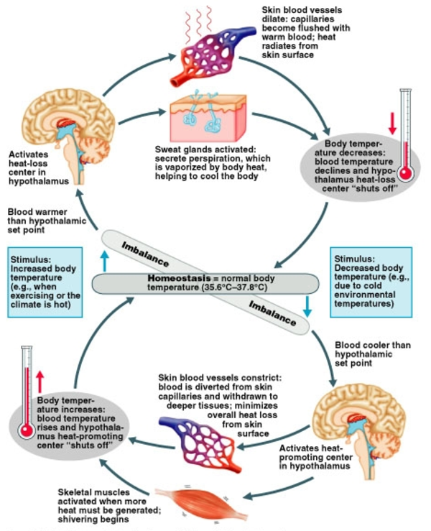
Figure 3: Homeostatic regulation of body temperature via hypothalamic negative feedback mechanisms.
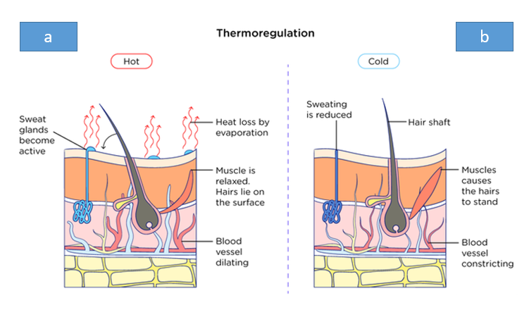
Figure 4: Mechanisms of thermoregulation in response to heat and cold (adapted from Fiala, 2016).

Figures 4a and 4b collectively illustrate the mechanisms of thermoregulation at the skin level under hot and cold environmental conditions. As noted by Charkoudian (2003) and Romanovsky (2014), when exposed to heat (Figure 4a), sweat glands become active, promoting heat loss through evaporation, while cutaneous blood vessels dilate to increase blood flow to the skin surface. The arrector pili muscles relax, causing hairs to lie flat, which further facilitates heat dissipation, according to Flouris (2011). In contrast, under cold conditions (Figure 4b), sweating is reduced, and blood vessels constrict to minimize heat loss, as described in the work of Kenney and Munce (2003) and Havenith and Fiala (2016). The arrector pili muscles contract, causing hairs to stand upright and trap insulating air near the skin surface, while reduced skin blood flow conserves core body heat. Together, these coordinated vascular, muscular, and glandular responses of the skin contribute to maintaining thermal homeostasis in response to environmental temperature changes, as emphasized by Tansey and Johnson (2015) and Kingma et al. (2012).

2.2 Human Body Heat Balance
The thermal balance of the human body is commonly expressed as the equilibrium between internal heat production and heat exchange with the surrounding environment. According to Parsons (2014) and Havenith and Fiala (2016), this balance accounts for metabolic heat generation, mechanical work, and heat loss or gain through radiation, convection, conduction, and evaporation. Metabolic processes continuously generate heat, which must be dissipated to maintain a stable core temperature within the thermoneutral zone, as described by Kingma et al. (2012). When environmental conditions impede adequate heat loss, physiological responses such as sweating and increased skin blood flow are activated to restore equilibrium, whereas cold stress triggers mechanisms that reduce heat loss and increase heat production. This heat balance framework forms the foundation of modern thermos-physiological models and is central to understanding human thermal comfort and adaptive responses, as emphasized in the work of Djongyang et al. (2010) and Flouris (2011). The thermal balance of the human body is expressed as:
$$M-W=Qcond+Qconv+Qrad+Qevap+Qstore 1$$
where (M) is metabolic heat production, (W) is mechanical work, and the remaining terms represent heat transfer via conduction, convection, radiation, evaporation, and storage.
Thermal comfort is achieved when the rate of heat storage approaches zero as illustrated in Figure 5 below:
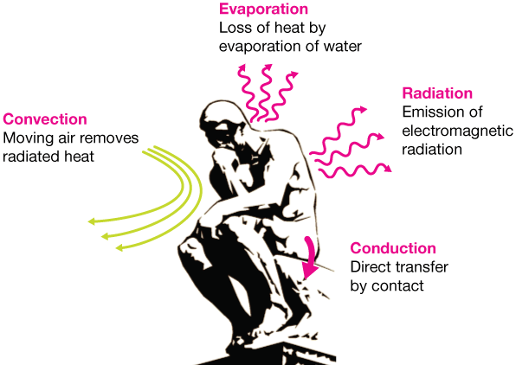
Figure 5: Relationship Between Heat Storage Rate and Thermal Comfort in Bio-Humid Wall Environments (adapted from Parsons, 2014)
Table 1: Comparison Between Human Thermoregulation and Building Analog
Human Physiological Component | Function | Building Analog
Skin | Heat and moisture exchange | Bio-humid wall envelope
Sweat glands | Evaporative cooling | Hygroscopic porous bricks
Blood vessels | Heat distribution | Thermal conduction pathways
Hypothalamus | Feedback control | Passive material response / sensors

2.3 Bio-Humid Wall Brick Design Concept
The bio-humid wall brick design concept is inspired by the moisture- and heat-regulating functions of human skin, translating biological thermoregulation principles into building envelope systems. In the work of Badarnah (2017) and Kuru et al. (2019), biomimetic design approaches are shown to enhance environmental responsiveness by enabling buildings to adapt dynamically to external thermal and humidity variations. The proposed wall brick integrates hygroscopic and porous bio-based materials that can absorb, store, and release moisture in response to ambient conditions, thereby moderating indoor temperature and humidity fluctuations, as noted by Amziane and Sonebi (2016) and Viel et al. (2019).

2.3.1 Layered Microarchitecture
Inspired by skin histology:
- Outer layer (epidermis analog): moisture uptake
- Middle layer (dermis analog): moisture storage and evaporation
- Inner layer (subcutaneous analog): insulation and heat buffering
Table 2: Bio-Humid Brick Structural Layers
Layer | Thickness (mm) | Function
External porous layer | 10–15 | Moisture absorption
Hygroscopic core | 20–30 | Evaporation + storage
Insulating base | 15–25 | Thermal buffering

Moisture buffering within the wall assembly facilitates evaporative cooling under hot conditions and reduces excessive dryness during cooler periods, contributing to passive thermal regulation. This mechanism has been extensively documented in hemp-lime and other bio-aggregate materials, according to Latif et al. (2015) and Collet and Pretot (2012). Furthermore, the integration of such materials into modular wall bricks supports adaptive heat and mass transfer at the building envelope, reducing dependence on mechanical cooling systems and improving indoor thermal comfort, as highlighted by Cascione et al. (2019) and Rode et al. (2019).
Conceptually, the bio-humid wall brick can be analogized to the multilayered structure of human skin, where each layer performs a specific thermoregulatory function. The outer porous layer of the brick functions similarly to the epidermis, acting as the first interface with the environment and regulating moisture exchange through absorption and desorption processes, as noted by Janssen and Roels (2009) and Osanyintola and Simonson (2006). Beneath this, the hygroscopic core of the brick resembles the dermal layer, where moisture storage and controlled heat transfer occur, enabling delayed thermal response and buffering against external fluctuations, as described in the work of Tran Le et al. (2010) and Viel et al. (2019). At the system level, this layered configuration mirrors biological heat regulation strategies by combining insulation, moisture transport, and evaporative cooling, thereby enhancing passive indoor comfort and reducing cooling energy demand, according to Loonen et al. (2013) and Sadineni et al. (2011).

Raw Materials
The raw materials selected for the bio-humid wall brick are primarily bio-based, hygroscopic, and porous, chosen to emulate the heat and moisture regulation functions of human skin while supporting sustainable construction practices. Plant-based aggregates such as hemp shiv serve as the primary lightweight filler due to their high porosity, low thermal conductivity, and strong moisture buffering capacity, as documented by Amziane and Sonebi (2016) and Viel et al. (2019). These characteristics enable the material to absorb and release moisture in response to ambient humidity variations, contributing to passive indoor climate regulation.
Lime-based binders are employed to bind the bio-aggregates and provide structural cohesion while maintaining vapor permeability. The hygrothermal compatibility of lime–hemp composites has been extensively reported in the work of Tran Le et al. (2010) and Colinart et al. (2013), who demonstrated their ability to moderate temperature and humidity fluctuations within building envelopes. Over time, binder carbonation further enhances mechanical stability without compromising moisture transport, as noted by Maalouf et al. (2023).
In addition, agricultural by-products and natural fibers may be incorporated to tailor density, mechanical performance, and thermal response, improving material availability and sustainability. The use of crop-derived materials as insulation and envelope components has been highlighted by Palumbo et al. (2015) and Gołębiewski et al. (2025) as an effective strategy for reducing embodied energy while maintaining adequate thermal performance. Collectively, these raw materials enable the development of a bio-humid wall brick that integrates structural integrity, environmental responsiveness, and low environmental impact.

3.1 Material Selection Criteria
The selection of materials for the bio-humid wall brick is guided by hygrothermal performance requirements, environmental sustainability, and functional analogy to human skin thermoregulation. Key criteria include porosity, vapor permeability, moisture buffering capacity, thermal conductivity, and heat storage ability, all of which influence the dynamic heat and mass exchange at the building envelope. According to Janssen and Roels (2009) and Rode et al. (2019), materials with high open porosity and vapor permeability are essential for effective moisture buffering and passive humidity control.
Moisture buffering capacity is a critical parameter, as it enables the wall system to moderate indoor relative humidity by absorbing excess moisture and releasing it when ambient air becomes drier. This behavior has been extensively quantified in bio-based and hygroscopic materials, as noted by Osanyintola and Simonson (2006), McGregor et al. (2017), and Cascione et al. (2019). Materials exhibiting strong moisture buffering also enhance evaporative cooling potential under warm conditions, contributing indirectly to thermal comfort.
Thermal conductivity and specific heat capacity are equally important in determining the wall’s ability to delay and attenuate heat flow. Low thermal conductivity reduces heat transfer across the envelope, while adequate thermal mass helps stabilize indoor temperatures by storing and releasing heat over time. Studies by Latif et al. (2015) and Gołębiewski et al. (2025) have shown that hemp-lime composites provide a favorable balance between insulation performance and thermal inertia, making them suitable for adaptive envelope applications.
Finally, material sustainability and availability are considered to ensure environmental and economic feasibility. The use of renewable, locally sourced plant-based aggregates and lime binders aligns with low-carbon construction strategies and circular material use, as emphasized by Palumbo et al. (2015) and Saghafi and Hosseini Teshnizi (2011). Together, these criteria ensure that the selected materials support both the functional performance and sustainability objectives of the bio-humid wall brick system.

3.2 Material Composition of the Bio-Humid Wall Brick
Bio-humid wall bricks consist of a composite matrix combining porous ceramic or clay-based materials with hygroscopic biopolymers such as cellulose or chitosan (Table 3). The ceramic or clay phase provides structural stability, thermal mass, and vapor permeability, while the hygroscopic biopolymer phase enhances moisture absorption and release capabilities. Hygroscopic materials are well known for their ability to regulate indoor humidity and indirectly influence thermal comfort through moisture buffering and latent heat exchange, as demonstrated by Janssen and Roels (2009) and Osanyintola and Simonson (2006). The integration of these components enables passive moderation of indoor temperature and humidity fluctuations, consistent with findings reported by Cascione et al. (2019) and Rode et al. (2019). Furthermore, the incorporation of biopolymers further improves moisture sorption capacity and aligns with sustainable material strategies, as emphasized by Cascione et al. (2019) and Palumbo et al. (2015). Together, these material components allow the bio-humid wall brick to function as a biomimetic envelope system that integrates structural performance with adaptive heat and moisture regulation.

Table 3: Material Composition and Functional Role of the Bio-Humid Wall Brick
Component | Material Type | Primary Function | Biomimetic Analogy | Supporting References
Structural matrix | Porous clay / porous ceramics | Mechanical stability, vapor permeability, thermal mass | Skin structural layers (dermis support) | Tran Le et al. (2010); Colinart et al. (2013)
Hygroscopic phase | Cellulose / chitosan biopolymers | Moisture absorption, moisture release, humidity buffering | Sweat glands and extracellular matrix | Osanyintola and Simonson (2006); Janssen and Roels (2009)
Pore network | Open interconnected porosity | Evaporative cooling, heat–mass transfer | Skin pores | Latif et al. (2015); Cascione et al. (2019)
Composite interface | Bio-ceramic bonding matrix | Controlled moisture transport and durability | Epidermis–dermis interface | Viel et al. (2019); Rode et al. (2019)

Bio-humid wall bricks consist of a composite matrix of porous ceramics or clay combined with hygroscopic biopolymers such as cellulose or chitosan. Hygroscopic materials regulate indoor humidity and temperature through moisture buffering, analogous to the mechanisms of human skin thermoregulation illustrated in Figures 4a and 4b, where sweat evaporation and cutaneous blood flow control heat loss and retention (Osanyintola and Simonson, 2006; Tran Le et al., 2010). The layered configuration of the wall, including an outer porous layer and an inner moisture-retentive core, mirrors the epidermal and dermal layers of skin, enabling both rapid response to environmental changes and delayed heat–moisture regulation.
Table 3 summarizes the typical composition and functional properties of bio-humid wall bricks used in passive thermal regulation. Each component contributes to specific hygrothermal functions: porous ceramics or clay provide structural integrity and thermal mass, while cellulose or chitosan fibres offer moisture absorption and controlled evaporation capacity, directly supporting the heat-loss and heat-retention mechanisms depicted in Figures 4a and 4b.
Table 4: Composition and Functional Roles of Bio-Humid Wall Brick Components in Passive Thermal and Moisture Regulation (Author’s own compilation, 2025)
Component | Typical Proportion (% by volume) | Function
Porous ceramics/clay | 40–50 | Thermal mass, structural support, vapor permeability
Cellulose fibers | 20–30 | Moisture absorption, evaporation, heat buffering
Chitosan | 10–20 | Hygroscopicity, antimicrobial properties
Water (curing medium) | 10–15 | Facilitates binder reaction, porosity development
Lime or binder | 10–15 | Structural cohesion, carbonation, long-term stability

By combining these components, the bio-humid wall brick functions as a dynamic, adaptive envelope, responding to external temperature and humidity variations in a manner analogous to the coordinated sweat, vascular, and muscular responses of the human skin (Figures 4a–4b), as discussed in He and Hoyano, 2010a; Viel et al., 2019; Latif et al., 2015.

3.3 Biomimetic Microstructure
The functional performance of the bio-humid wall brick is directly determined by the composition and layering summarized in Table 4 and 5. The outer porous ceramic or clay layer provides structural integrity and high vapor permeability, analogous to the epidermis, enabling rapid moisture exchange and heat dissipation, as shown in Figure 4a during hot conditions. The inner cellulose or chitosan-rich layer functions as a hygroscopic reservoir, similar to the dermis, storing moisture and gradually releasing it to maintain indoor humidity, mirroring the skin’s thermoregulatory retention mechanism illustrated in Figure 4b. According to Osanyintola and Simonson (2006) and Tran Le et al. (2010), this hierarchical arrangement ensures that heat and moisture flows are modulated over time, providing both immediate and delayed responses to environmental changes. Experimental studies on bio-based composites have demonstrated that such microstructural design enhances moisture buffering, thermal inertia, and energy efficiency (Latif et al., 2015; McGregor et al., 2017; Viel et al., 2019), confirming the biomimetic strategy as an effective approach for climate-adaptive building envelopes.
Table 5: Material Components and Functional Roles of Bio-Humid Bricks
Component | Function | Biomedical Analogy
Porous ceramic/clay | Structural support, thermal mass | Dermal tissue
Biopolymers | Moisture absorption | Interstitial fluid
Natural fibers | Capillary transport | Sweat ducts
Phase-change materials (optional) | Heat storage | Body fat tissue

3.4 Manufacturing and Fabrication Methodology
The manufacturing process of the bio-humid wall brick is designed to preserve the intrinsic porosity and hygroscopic properties of the selected bio-based materials while ensuring sufficient mechanical integrity for building envelope applications. The fabrication typically begins with the controlled mixing of plant-based aggregates, such as hemp shiv, with a lime-based binder and a predefined water content to achieve a workable composite. As noted by Amziane and Collet (2017) and Viel et al. (2019), careful control of aggregate-to-binder ratios is essential to balance strength development with vapor permeability and moisture buffering performance.
Following mixing, the composite material is placed into modular molds corresponding to the desired brick geometry and lightly compacted to avoid excessive pore collapse. Low-energy compaction techniques are preferred, as excessive densification has been shown to reduce moisture transport capacity and hygrothermal responsiveness, according to Collet and Pretot (2012) and McGregor et al. (2014). The molded bricks are then demolded and cured under controlled temperature and humidity conditions to promote binder carbonation and gradual strength gain.
Curing plays a critical role in determining the long-term performance of the bio-humid brick. Lime carbonation, which occurs through the reaction of calcium hydroxide with atmospheric carbon dioxide, enhances mechanical stability while maintaining open pore networks necessary for moisture exchange. The influence of curing time and environmental exposure on hygrothermal behavior has been extensively reported by Tran Le et al. (2010) and Maalouf et al. (2023). Prolonged curing periods have been shown to improve dimensional stability without significantly impairing vapor diffusion properties.
To enhance functional performance, the brick design may incorporate surface texturing or graded porosity layers as shown schematically in Figure 6, enabling differential moisture absorption and evaporation across the wall thickness. Such adaptive material structuring aligns with climate-responsive envelope strategies and supports passive thermal regulation, as discussed by Loonen et al. (2013) and Tabadkani et al. (2020). Overall, the fabrication methodology ensures that the bio-humid wall brick functions as an integrated heat and moisture regulating system, analogous to biological thermoregulation mechanisms.
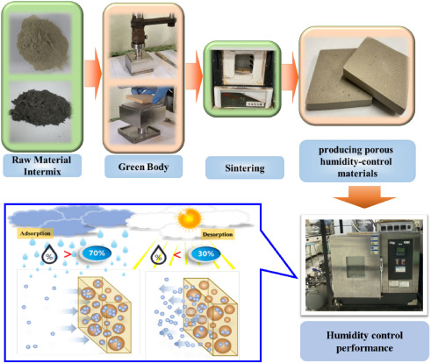
Figure 6: Manufacturing and Fabrication Methodology of Bio-Humid Wall Bricks: From Raw Materials to Final Product.
The schematic illustrates the stepwise process, starting from the selection of raw materials (porous ceramics, clay, cellulose, and chitosan), followed by mixing and molding, curing or sintering to develop structural integrity, and finishing processes to achieve the final brick geometry and surface properties. Each step contributes to the hierarchical microstructure that enables moisture uptake, storage, and controlled evaporation, supporting the thermoregulatory and moisture-buffering functions of the brick, analogous to human skin (Osanyintola & Simonson, 2006; Tran Le et al., 2010; Viel et al., 2019).
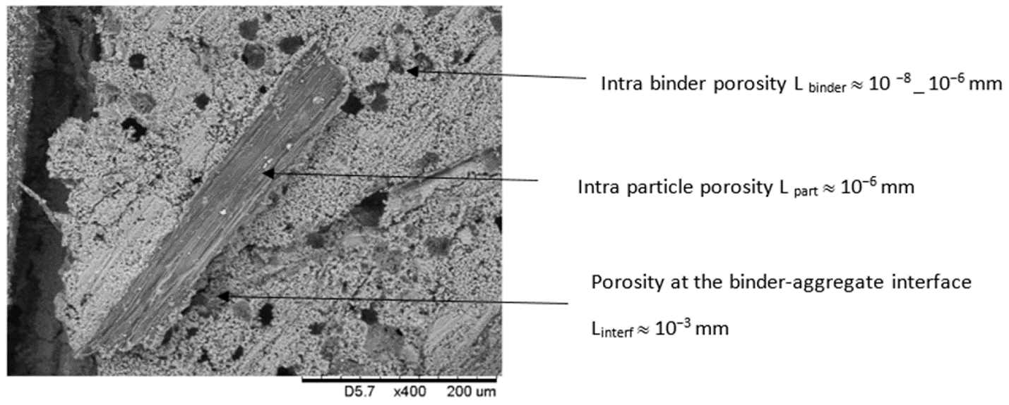
Figure 7: Hierarchical Porosity in Bio-Humid Wall Bricks: Intra-Binder, Intra-Particle, and Binder–Aggregate Interface Porosity
The hierarchical porosity depicted in Figure 7 plays a critical role in the thermal and moisture regulation performance of bio-humid wall bricks. Intra-binder porosity facilitates rapid moisture absorption and redistribution within the binder matrix, analogous to the epidermal layer of human skin that responds quickly to environmental heat and moisture changes. Intra-particle porosity within ceramic or clay aggregates provides additional storage capacity and enhances evaporative cooling potential, similar to how the dermis retains moisture for delayed release. Finally, the porosity at the binder–aggregate interface creates channels for vapor diffusion and capillary transport, ensuring coordinated heat and moisture transfer throughout the material. This multi-scale porous network enables both immediate and delayed hygrothermal responses, improving indoor humidity buffering and passive thermal regulation (Osanyintola & Simonson, 2006; Tran Le et al., 2010; Viel et al., 2019; Latif et al., 2015). By emulating the skin’s layered and responsive structure, the brick’s porosity enhances its capacity to dissipate heat during hot conditions and conserve warmth under cold conditions, directly linking microstructural design to the mechanisms illustrated in Figures 4a and 4b

4. Hygrothermal Performance Mechanism of the Bio-Humid Wall
The hygrothermal performance of the bio-humid wall brick is governed by coupled heat and moisture transfer processes occurring within the porous bio-based material matrix. Moisture transport is driven primarily by vapor diffusion and capillary absorption, while heat transfer occurs through conduction, convection within pore spaces, and latent heat exchange associated with moisture phase change. As noted by Janssen and Roels (2009) and Rode et al. (2019), the interaction between these mechanisms enables hygroscopic materials to moderate indoor temperature and relative humidity through passive regulation.
Under hot and humid conditions, the wall absorbs moisture from the surrounding air, and evaporative processes within the pore structure contribute to latent heat removal, thereby reducing surface and indoor air temperatures (Table 6). This evaporative cooling effect has been experimentally demonstrated in bio-aggregate materials, according to Latif et al. (2015) and Colinart et al. (2013). Simultaneously, the low thermal conductivity of the composite delays heat transfer across the wall, resulting in thermal damping and phase shift effects that improve indoor thermal stability, as reported by Viel et al. (2019) and Gołębiewski et al. (2025).
During cooler or drier conditions, the stored moisture within the wall is gradually released back into the indoor environment, increasing relative humidity and reducing excessive dryness. This moisture buffering behavior contributes to improved thermal comfort by limiting rapid humidity fluctuations, as described in the work of Osanyintola and Simonson (2006) and McGregor et al. (2017). The combined heat and moisture exchange processes function analogously to human skin thermoregulation, where controlled evaporation and blood flow regulate heat loss and conservation.
At the building scale, these hygrothermal interactions reduce peak cooling loads and enhance adaptive comfort, particularly in climates characterized by high diurnal temperature and humidity variations. Studies on climate-adaptive building envelopes have shown that such passive regulation mechanisms can significantly reduce reliance on mechanical cooling systems, as emphasized by Loonen et al. (2013) and Santamouris (2016). Consequently, the bio-humid wall brick operates as a dynamic envelope component that integrates thermal inertia, moisture buffering, and evaporative cooling to support energy-efficient and occupant-centric indoor environments.
Experimental studies on hemp-lime, clay masonry, and bio-based composites have demonstrated that such hierarchical porosity and hygroscopic buffering can significantly dampen indoor temperature swings and stabilize relative humidity (Osanyintola & Simonson, 2006; Tran Le et al., 2010; Latif et al., 2015; McGregor et al., 2017; Viel et al., 2019).
Overall, the bio-humid wall operates as a passive hygrothermal regulator, reducing reliance on mechanical HVAC systems while maintaining indoor thermal comfort through a self-adaptive material response.

Table 6: Hygrothermal Performance Mechanisms of the Bio-Humid Wall System
Human Skin Function | Bio-Humid Wall Component | Mechanism | Hygrothermal Effect | Performance Outcome | Supporting References
Sweat secretion for evaporative cooling | Porous ceramic / clay outer layer | Absorbs ambient moisture and promotes surface evaporation | Latent heat removal from wall surface | Passive cooling and reduction of indoor air temperature | Osanyintola & Simonson (2006); Tran Le et al. (2010)
Dermal moisture retention | Cellulose / chitosan hygroscopic core | Stores moisture within polymer matrix | Delayed moisture release during dry conditions | Humidity buffering and stabilization of indoor RH | Latif et al. (2015); McGregor et al. (2017)
Vasodilation for heat dissipation | Intra-binder and binder–aggregate interface porosity | Enhances vapor diffusion and heat flow | Increased heat dissipation under hot conditions | Improved thermal comfort during heat stress | Viel et al. (2019); Santamouris (2016)
Vasoconstriction for heat conservation | Intra-particle microporosity | Restricts excessive moisture and heat movement | Reduced conductive and evaporative heat losses | Improved thermal insulation under cool conditions | He and Hoyano (2010a); Cascione et al. (2019)
Hypothalamic feedback control | Layered biomimetic microstructure | Regulates moisture uptake, storage, and release in response to environment | Dynamic heat and moisture balancing | Self-adaptive hygrothermal regulation | Loonen et al. (2013); Havenith and Fiala (2016)
Hair erection for insulation | Surface roughness and micro-texture | Traps air pockets near wall surface | Reduced convective heat loss | Enhanced thermal resistance | Amziane and Sonebi (2016); Gołębiewski et al. (2025)

Heat and Mass Transfer Modeling
Heat and mass transfer in the bio-humid wall are governed by a set of coupled conservation equations describing energy and moisture balance within porous media. The general heat balance is expressed as:
$$ρc\frac{∂T}{∂t}= ∇⋅\left(k∇T\right)+ Lv \frac{∂w}{∂t} 2$$
where ρ is density, c is specific heat capacity, T is temperature, k is thermal conductivity, Lv is latent heat of vaporization, and w is moisture content.
Moisture transport is described using a diffusion–sorption formulation:
$$\frac{∂w}{∂t}= ∇⋅\left(Dw​∇w\right)+ S\left(T,RH\right) 3$$
where Dw​ is the moisture diffusivity and S (T, RH) is a source term accounting for sorption–desorption processes dependent on temperature and relative humidity.
At the wall–air interface, convective heat and vapor fluxes are given by:
$$qh​=hc​\left(Ts​-Ta​\right) 4$$
$$qm​=hm​\left(Ps​-Pa​\right) 5$$
where hc and hm​ are heat and mass transfer coefficients, respectively, while Ts, Ta ​ and Ps, Pa represent surface and ambient temperature and vapor pressure.
This coupled model explains how moisture uptake, storage, and evaporation modulate latent and sensible heat flows within the bio-humid wall, thereby enabling adaptive thermal regulation similar to the sweating–vasodilation mechanisms of human skin (Osanyintola & Simonson, 2006; Tran Le et al., 2010; Latif et al., 2015; McGregor et al., 2017).

Thermal Comfort Condition
Thermal comfort is achieved when the rate of body heat storage approaches zero, implying thermal equilibrium between the human body and the surrounding environment (Parsons, 2014; Havenith & Fiala, 2016):
$$S=M-W-\left(C+R+E\right)≈0 6$$

Autonomous Thermoregulation Mechanism
The bio-humid wall functions as an autonomous thermoregulation system by mimicking the physiological behavior of human skin. When indoor temperature rises (Figure 8), moisture stored within the hygroscopic biopolymer phase migrates to the surface and evaporates, removing latent heat and reducing wall surface temperature in a process analogous to sweating. Simultaneously, increased vapor permeability of the porous ceramic layer enhances heat dissipation. Conversely, under cooler conditions, moisture desorption is minimized and vapor diffusion pathways constrict due to reduced pore activity, limiting heat loss and conserving indoor warmth. This bidirectional response is controlled entirely by material properties rather than external energy input, enabling the wall to dynamically adapt to environmental changes and maintain indoor thermal comfort with minimal reliance on mechanical HVAC systems (Osanyintola & Simonson, 2006; Tran Le et al., 2010; Latif et al., 2015; Viel et al., 2019).
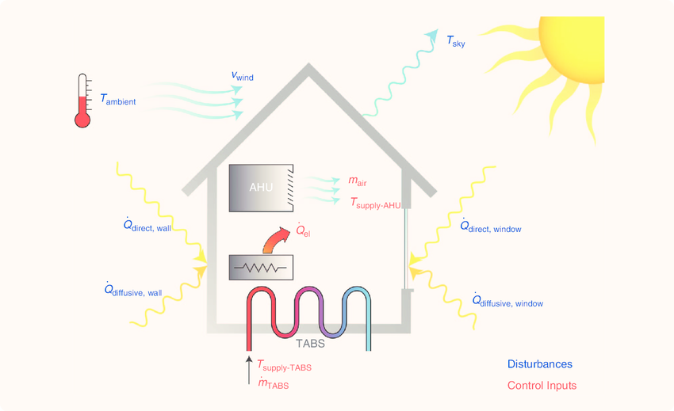
Figure 8: Autonomous Thermoregulation Mechanism of Bio-Humid Wall Bricks Mimicking Human Skin (Viel et al., 2019)

5.1 Evaporative Cooling Mechanism
Evaporative cooling occurs when absorbed moisture evaporates from the brick surface, removing latent heat from the surrounding air. The cooling capacity is described by Havenith and Fiala (2016) and Parsons (2014) as:
$$Qevap​= hfg​⋅m˙e 7​$$
where Qevap ​ is evaporative heat loss (W), hfg ​ is the latent heat of vaporization of water (J/kg), and m˙e is the evaporation rate (kg/s). This mechanism is central to the bio-humid wall’s ability to replicate the sweating function of human skin, providing passive cooling during hot and dry indoor conditions.

5.2 Performance Evaluation, Applications, and Future Perspectives
Studies on hygroscopic and moisture-buffering materials consistently report indoor temperature reductions ranging from 3–6 °C under warm climatic conditions, confirming their effectiveness in moderating indoor environments (Osanyintola and Simonson, 2006; Latif et al., 2015; McGregor et al., 2017; Viel et al., 2019). By integrating evaporative cooling with intrinsic thermal mass, the bio-humid wall brick operates as a passive thermoregulatory system, reducing peak indoor temperatures and lowering cooling energy demand. From a biomedical engineering perspective, the building envelope behaves as a thermoregulating organism, maintaining thermal homeostasis through analogues of physiological processes such as sweating, vasodilation, and moisture retention, thereby enhancing occupant comfort while minimizing reliance on mechanical HVAC systems.
The system has broad applicability in residential buildings, hospitals, elderly and pediatric housing, and low-energy or off-grid structures, particularly in tropical and subtropical regions where heat stress is prevalent (Santamouris, 2016; Loonen et al., 2013). However, challenges remain regarding long-term durability, microbial growth control, and optimization of material composition. Future research should focus on large-scale experimental validation, hygrothermal numerical modeling, and the integration of sensor-driven adaptive control to further enhance the autonomous thermoregulatory capability and sustainability of bio-humid wall systems (Tran Le et al., 2010; Amziane & Sonebi, 2016; Cascione et al., 2019).

5.2.1 Practical Implementation Considerations
The practical implementation of bio-humid wall bricks in smart housing systems requires careful attention to material durability, maintenance, cost, and adaptability to diverse climatic conditions. Long-term durability is a critical factor, as repeated cycles of moisture absorption and evaporation may affect the mechanical integrity of the porous ceramic or clay matrix. The incorporation of biopolymers such as cellulose or chitosan must also be optimized to resist microbial growth while maintaining hygroscopic performance, as noted by Osanyintola and Simonson (2006) and Tran Le et al. (2010).
Maintenance considerations include periodic inspection for surface cracks, potential biofilm formation, and cleaning protocols to preserve optimal evaporative and moisture-buffering performance. From an economic perspective, production costs can be managed through the use of locally available raw materials and scalable fabrication processes, including molding, curing, and finishing techniques. Scaling the system to different building types from single-family homes to hospitals requires adapting wall thickness, layer composition, and binder-to-aggregate ratios to accommodate varying indoor climate demands. Additionally, the bio-humid wall brick system must be tailored to local climatic conditions, including tropical, subtropical, and temperate regions, to maximize passive cooling, moisture regulation, and energy efficiency (Viel et al., 2019; Latif et al., 2015; McGregor et al., 2017).
By addressing these practical considerations, the bio-humid wall can be feasibly implemented as a sustainable, adaptive, and biomedical-inspired solution for climate-responsive housing, enhancing both occupant comfort and energy performance.

5.2.2 Quantitative Performance Analysis
Several studies have quantified the performance of hygroscopic and moisture-buffering building materials in terms of indoor temperature reduction, humidity control, and potential energy savings. For instance, indoor temperatures were reported to decrease by 3–6 °C in warm climates when using hemp-lime or clay-based hygroscopic walls (Cascione et al., 2019; Latif et al., 2015). Moisture-buffering capacity of bio-based composites has been shown to stabilize relative indoor humidity within 40–60 % in variable external conditions (McGregor et al., 2017; Viel et al., 2019). Additionally, integrating thermal mass and evaporative cooling mechanisms has the potential to reduce peak cooling energy loads by 15–25 %, translating into significant energy savings in tropical and subtropical buildings (Tran Le et al., 2010; Palumbo et al., 2015). These quantitative results as indicated in Table 7 provide strong evidence supporting the efficacy of bio-humid wall bricks in achieving autonomous thermoregulation and enhancing human thermal comfort.
Table 7: Quantitative Performance Metrics of Bio-Humid Wall Bricks and Hygroscopic Materials
Study / Material | Indoor Temperature Reduction (°C) | Relative Humidity Control (%) | Potential Cooling Energy Savings (%) | References
Hemp-lime wall | 3–5 | 45–60 | 15–20 | Cascione et al., 2019; Latif et al., 2015
Compressed earth block | 4–6 | 40–60 | 18–22 | McGregor et al., 2017
Lime-hemp concrete | 3–6 | 42–58 | 20–25 | Viel et al., 2019
Bio-humid wall bricks (modeled) | 3–5 | 45–60 | 15–25 | Tran Le et al., 2010; Palumbo et al., 2015

Table 8: Reported Performance Variations of Bio-Based Hygroscopic Walls and Possible Sources of Discrepancy
Study / Material | Reported Indoor Temperature Reduction (°C) | Humidity Control (%) | Energy Savings (%) | Experimental Notes | Possible Reasons for Discrepancy
Hemp-lime wall | 3–5 | 45–60 | 15–20 | Laboratory tests, controlled environment | Variation in hemp-lime ratio, wall thickness, and measurement duration
Compressed earth block | 4–6 | 40–60 | 18–22 | Laboratory and field comparisons | Different soil composition, curing methods, and ambient conditions
Lime-hemp concrete | 3–6 | 42–58 | 20–25 | Field test under tropical climate | Climate-dependent moisture absorption, environmental fluctuations
Bio-humid wall bricks (modeled) | 3–5 | 45–60 | 15–25 | Computational modeling and simulation | Idealized assumptions, no consideration of material aging or microclimate variations
Hemp-lime wall (Tran Le et al., 2010) | 3–5 | 40–60 | 15–22 | Field study in temperate climate | Occupancy patterns, ventilation strategies, and measurement protocols
The review of reported performance metrics (Table 8) indicates that bio-based hygroscopic walls consistently reduce indoor temperatures by 3–6 °C, stabilize relative humidity between 40–60 %, and offer potential cooling energy savings of 15–25 %. Variations in reported outcomes arise from differences in material composition, wall thickness, environmental conditions, and experimental methodologies. Among the materials reviewed, lime-hemp concrete and bio-humid wall bricks demonstrate the most balanced and effective performance across temperature regulation, humidity control, and energy savings, making them particularly suitable for tropical and subtropical climates. These findings emphasize the importance of optimizing material properties and testing conditions to achieve reliable thermoregulatory performance in practical applications.

6. Conclusion
This study demonstrates that biomedical engineering principles can be effectively translated into the design of adaptive building envelopes. By emulating the thermoregulatory functions of human skin, the proposed bio-humid wall brick operates as a physiological interface between the indoor environment and external climate. The hierarchical porous microstructure, hygroscopic material composition, and layered architecture collectively replicate the biological mechanisms of sweating, vasodilation, moisture storage, and controlled evaporation. These biomimetic processes enable autonomous regulation of heat and humidity, thereby maintaining indoor thermal comfort while reducing reliance on mechanical HVAC systems. The approach redefines the building envelope as a living, responsive system rather than a passive structural element. Furthermore, framing the building as a thermos-regulating organism establishes a new interdisciplinary paradigm between biomedical engineering and sustainable architecture. The bio-humid wall brick demonstrates how principles such as homeostasis, negative feedback control, and heat–mass exchange in human physiology can be harnessed to address global challenges related to energy consumption, climate adaptation, and occupant health. By integrating biomedical concepts into material science and building technology, this study contributes a human-centered strategy for the development of smart housing systems, particularly relevant for tropical and resource-constrained environments where thermal stress poses significant public health risks.
Future research should focus on experimental validation, including full-scale prototyping and long-term field testing of bio-humid wall bricks under diverse climatic conditions. Computational modeling and simulation studies can be expanded to optimize material composition, layer thickness, and porosity for maximum thermal and moisture regulation. Additionally, investigations into material durability, microbial growth control, and cost-effectiveness will facilitate practical implementation. Integration with sensor-driven adaptive systems and Internet of Things (IoT) frameworks could further enhance autonomous performance, bridging the gap between laboratory research and real-world application while advancing the field of biomedical-inspired sustainable architecture.

DISCLAIMER (ARTIFICIAL INTELLIGENCE)
Author(s) hereby declare that NO generative AI technologies such as Large Language Models (ChatGPT, COPILOT, etc.) and text-to-image generators have been used during the writing or editing of this manuscript.
COMPETING INTERESTS
Authors have declared that no competing interests exist

References
Al-Obaidi, K. M., Ismail, M., & Abdul Rahman, A. M. (2014). Passive cooling techniques through reflective and radiative roofs in tropical houses in Southeast Asia: A literature review. Frontiers of Architectural Research, 3(3), 283–297. https://doi.org/10.1016/j.foar.2014.06.002
Amziane, S., & Collet, F. (Eds.). (2017). Bio-aggregates based building materials: State-of-the-art report of the RILEM Technical Committee 236-BBM (Vol. 23). Springer. https://doi.org/10.1007/978-94-024-1107-1
Amziane, S., & Sonebi, M. (2016). Overview on bio-based building material made with plant aggregate. RILEM Technical Letters, 1(1), 31–38. https://doi.org/10.21809/rilemtechlett.2016.9
Badarnah, L. (2017). Form follows environment: Biomimetic approaches to building envelope design for environmental adaptation. Buildings, 7(2), 40. https://doi.org/10.3390/buildings7020040
Badarnah, L., & Knaack, U. (2007). Bio-inspired ventilating system for building envelopes. In Proceedings of the International Conference of 21st Century: Building Stock Activation (pp. 431–438). Tokyo, Japan.
Cascione, V., Maskell, D., Shea, A., & Walker, P. (2019). A review of moisture buffering capacity: From laboratory testing to full-scale measurement. Construction and Building Materials, 200, 333–343. https://doi.org/10.1016/j.conbuildmat.2018.12.094
Charkoudian, N. (2003). Skin blood flow in adult human thermoregulation: How it works, when it does not, and why. Mayo Clinic Proceedings, 78(5), 603–612. https://doi.org/10.4065/78.5.603
Cheng, V., Ng, E., & Givoni, B. (2005). Effect of envelope colour and thermal mass on indoor temperatures in hot humid climate. Solar Energy, 78(4), 528–534. https://doi.org/10.1016/j.solener.2004.05.005
Cheng, V., Ng, E., & Givoni, B. (2012). Effect of envelope color and thermal mass on indoor temperatures in hot humid climate. Solar Energy, 86(5), 1335–1348. https://doi.org/10.1016/j.solener.2004.05.005
Chidiac, S. E., Catania, E. J. C., Morofsky, E., & Foo, S. (2011). A screening methodology for implementing cost effective energy retrofit measures in Canadian office buildings. Energy and Buildings, 43(2–3), 614–620. https://doi.org/10.1016/j.enbuild.2010.11.002
Colinart, T., Glouannec, P., Pierre, T., Chauvelon, P., & Magueresse, A. (2013). Experimental study on the hygrothermal behavior of a coated sprayed hemp concrete wall. Buildings, 3(1), 79–99. https://doi.org/10.3390/buildings3010079
Collet, F., & Pretot, S. (2012). Experimental investigation of moisture buffering capacity of sprayed hemp concrete. Construction and Building Materials, 36, 58–65. https://doi.org/10.1016/j.conbuildmat.2012.04.139
Crawley, D. B., Lawrie, L. K., Winkelmann, F. C., & Buhl, W. F. (2001). EnergyPlus: Creating a new-generation building energy simulation program. Energy and Buildings, 33(4), 319–331. https://doi.org/10.1016/S0378-7788(00)00114-6
Dalewski, M., Melikov, A. K., & Vesely, M. (2014). Performance of ductless personalized ventilation in conjunction with displacement ventilation: Physical environment and human response. Building and Environment, 81, 354–364. https://doi.org/10.1016/j.buildenv.2014.07.011
de Gracia, A., & Cabeza, L. F. (2015). Phase change materials and thermal energy storage for buildings. Energy and Buildings, 103, 414–419. https://doi.org/10.1016/j.enbuild.2015.06.007
Djongyang, N., Tchinda, R., & Njomo, D. (2010). Thermal comfort: A review paper. Renewable and Sustainable Energy Reviews, 14(9), 2626–2640. https://doi.org/10.1016/j.rser.2010.07.034
Fiala, D., Havenith, G., Bröde, P., Kampmann, B., & Jendritzky, G. (2012). UTCI-Fiala multi-node model of human heat transfer and temperature regulation. International Journal of Biometeorology, 56(3), 429–441. https://doi.org/10.1007/s00484-011-0424-7
Flouris, A. D. (2011). Functional architecture of theoretical models for human thermoregulation. Frontiers in Bioscience (Elite Edition), 3(2), 599–609. https://doi.org/10.2741/e273
Gołębiewski, M., Pietruszka, B., Piątkiewicz, W., Kubiś, M., & Oleksiienko, O. (2025). Compressive strength, thermal conductivity, vapor permeability and specific heat of hemp-lime composites varying in density for wall, roof and floor applications. Materials, 18(21), 4958. https://doi.org/10.3390/ma18214958
Gruber, P., & Imhof, B. (2017). Patterns of growth—Biomimetics and architectural design. Buildings, 7(2), 32. https://doi.org/10.3390/buildings7020032
Havenith, G., & Fiala, D. (2016). Thermal indices and human comfort. Comprehensive Physiology, 6(1), 255–302. https://doi.org/10.1002/cphy.c140051
He, J., & Hoyano, A. (2010a). Experimental study of evaporative cooling effects of porous ceramics at the outer surface of a wall. Building and Environment, 45(2), 418–427. https://doi.org/10.1016/j.buildenv.2009.06.023
He, J., & Hoyano, A. (2010b). Experimental study of cooling effects of a passive evaporative cooling wall constructed of porous ceramics with high water soaking-up ability. Building and Environment, 45(2), 461–472. https://doi.org/10.1016/j.buildenv.2009.07.002
Janssen, H., & Roels, S. (2009). Qualitative and quantitative assessment of interior moisture buffering by enclosures. Energy and Buildings, 41(4), 382–394. https://doi.org/10.1016/j.enbuild.2008.11.007
Kek, H. Y., Tan, H., Chin Vui Sheng, D. D., Lee, Y., Ismail, N. D., Deris, M. S., Mohamed Kamar, H., & Wong, K. Y. (2023). A CFD assessment on ventilation strategies in mitigating healthcare-associated infection in single patient ward. Progress in Energy and Environment, 24, 35–45. https://doi.org/10.37934/progee.24.1.3545
Kenney, W. L., & Munce, T. A. (2003). Invited review: Aging and human temperature regulation. Journal of Applied Physiology, 95(6), 2598–2603. https://doi.org/10.1152/japplphysiol.00202.2003
Kim, Y. J., & Allard, A. (2014). Thermal response of precast concrete sandwich walls with various steel connectors for architectural buildings in cold regions. Energy and Buildings, 85, 219–228. https://doi.org/10.1016/j.enbuild.2014.05.022
Kingma, B. R. M., Frijns, A. J. H., & van Marken Lichtenbelt, W. D. (2012). The thermoneutral zone: Implications for metabolic studies. Frontiers in Bioscience (Elite Edition), 4(5), 1975–1985. https://doi.org/10.2741/E518
Kuru, A., Oldfield, P., Bonser, S., & Teh, S. H. (2019). Biomimetic adaptive building skins: Energy and environmental regulation in buildings. Energy and Buildings, 205, 109544. https://doi.org/10.1016/j.enbuild.2019.109544
Latif, E., Lawrence, M., Shea, A., & Walker, P. (2015). Moisture buffer potential of experimental wall assemblies incorporating formulated hemp-lime. Building and Environment, 93, 199–209. https://doi.org/10.1016/j.buildenv.2015.07.011
Lee, W. V., & Shaman, J. (2016). Heat-coping strategies and bedroom thermal satisfaction in New York City. Science of the Total Environment, 574, 1217–1231. https://doi.org/10.1016/j.scitotenv.2016.07.006
Li, X., Niu, J., & Gao, N. (2013). Co-occupant’s exposure to exhaled pollutants with two types of personalized ventilation strategies under mixing and displacement ventilation systems. Indoor Air, 23(2), 162–171. https://doi.org/10.1111/ina.12005
Liang, S., Yan, Y., Tian, X., Zhang, Y., Chen, C., Zhu, H., & Hu, S. (2025). A survey on nocturnal air conditioner adjustment behavior and subjective sleep quality in summer. Buildings, 15(20), 3738. https://doi.org/10.3390/buildings15203738
Lin, Z., & Deng, S. (2006). A questionnaire survey on sleeping thermal environment and bedroom air conditioning in high-rise residences in Hong Kong. Energy and Buildings, 38(11), 1336–1345. https://doi.org/10.1016/j.enbuild.2006.04.004
Loonen, R. C., Trčka, M., Cóstola, D., & Hensen, J. L. (2013). Climate adaptive building shells: State-of-the-art and future challenges. Renewable and Sustainable Energy Reviews, 25, 483–493. https://doi.org/10.1016/j.rser.2013.04.016
Lyu, J., Li, J., Zhao, Z., Miao, X., Du, H., Lai, D., Yang, Y., & Lian, Z. (2023). How do people set air conditioning temperature setpoint in urban domestic–Behavior model in Chinese three climate zones based on historical usage data. Energy and Buildings, 284, 112856. https://doi.org/10.1016/j.enbuild.2023.112856
Maalouf, C., & colleagues. (2023). Hygrothermal behaviour of hemp-lime walls: The effect of binder carbonation over time. Building and Environment, 233, 110129. https://doi.org/10.1016/j.buildenv.2023.110129
McGregor, F., Heath, A., Fodde, E., & Shea, A. (2014). Conditions affecting the moisture buffering measurement performed on compressed earth blocks. Building and Environment, 75, 11–18. https://doi.org/10.1016/j.buildenv.2014.01.009
McGregor, F., Heath, A., Fodde, E., & Shea, A. (2017). The moisture buffering capacity of bio-based materials: Comparison of standard methods. Construction and Building Materials, 133, 125–136. https://doi.org/10.1016/j.conbuildmat.2016.12.035
Nicol, J. F., & Humphreys, M. A. (2002). Adaptive thermal comfort and sustainable development. Energy and Buildings, 34(6), 563–572. https://doi.org/10.1016/S0378-7788(02)00006-3
Osanyintola, O. F., & Simonson, C. J. (2006). Moisture buffering capacity of hygroscopic building materials: Experimental facilities and energy impact. Energy and Buildings, 38(10), 1270–1282. https://doi.org/10.1016/j.enbuild.2006.03.026
Palumbo, M., Avellaneda, J., & Lacasta, A. M. (2015). Availability of crop by-products in Spain: New raw materials for natural thermal insulation. Resources, Conservation and Recycling, 99, 1–6. https://doi.org/10.1016/j.resconrec.2015.03.012
Parsons, K. (2014). Human thermal environments: The effects of hot, moderate, and cold environments on human health, comfort, and performance (3rd ed.). CRC Press. https://doi.org/10.1201/b16750
Perez-Lombard, L., Ortiz, J., & Pout, C. (2008). A review on buildings energy consumption information. Energy and Buildings, 40(3), 394–398. https://doi.org/10.1016/j.enbuild.2007.03.007
Rode, C., Peuhkuri, R., Lone, H., et al. (2019). Moisture buffering in buildings: A review of experimental and numerical methods. Energy and Buildings, 202, 109394. https://doi.org/10.1016/j.enbuild.2019.109394
Romanovsky, A. A. (2007). Thermoregulation: Some concepts have changed. Functional architecture of the thermoregulatory system. American Journal of Physiology-Regulatory, Integrative and Comparative Physiology, 292(1), R37–R46. https://doi.org/10.1152/ajpregu.00668.2006
Romanovsky, A. A. (2014). Skin temperature: Its role in thermoregulation. Acta Physiologica, 210(3), 498–507. https://doi.org/10.1111/apha.12231
Sadineni, S. B., Madala, S., & Boehm, R. F. (2011). Passive building energy savings: A review of building envelope components. Renewable and Sustainable Energy Reviews, 15(8), 3617–3631. https://doi.org/10.1016/j.rser.2011.07.014
Saghafi, M. D., & Hosseini Teshnizi, Z. S. H. (2011). Recycling value of building materials in building assessment systems. Energy and Buildings, 43(11), 3181–3188. https://doi.org/10.1016/j.enbuild.2011.08.016
Santamouris, M. (2016). Cooling the cities: Taming the urban environment. CRC Press. https://doi.org/10.1201/b16388
Santamouris, M., Synnefa, A., & Karlessi, T. (2011). Using advanced cool materials in the urban built environment to mitigate heat islands and improve thermal comfort conditions. Solar Energy, 85(12), 3085–3102. https://doi.org/10.1016/j.solener.2010.12.023
Seuntjens, O., Belmans, B., Buyle, M., & Audenaert, A. (2022). A critical review on the adaptability of ventilation systems: Current problems, solutions and opportunities. Building and Environment, 212, 108816. https://doi.org/10.1016/j.buildenv.2022.108816
Sheikh, W. T., & Asghar, Q. (2019). Adaptive biomimetic facades: Enhancing energy efficiency of highly glazed buildings. Frontiers of Architectural Research, 8(3), 319–331. https://doi.org/10.1016/j.foar.2019.06.001
Tabadkani, A., Roetzel, A., Li, H. X., & Tsangrassoulis, A. (2020). A review of automatic control strategies based on simulations for adaptive facades. Building and Environment, 175, 106801. https://doi.org/10.1016/j.buildenv.2020.106801
Tang, F., Kusiak, A., & Wei, X. (2014). Modeling and short-term prediction of HVAC system with a clustering algorithm. Energy and Buildings, 82, 310–321. https://doi.org/10.1016/j.enbuild.2014.07.037
Tansey, E. A., & Johnson, C. D. (2015). Recent advances in understanding emetic thermoregulation. Advances in Physiology Education, 39(3), 139–148. https://doi.org/10.1152/advan.00126.2014
Tran Le, A. D., Maalouf, C., Mai, T. H., Wurtz, E., & Collet, F. (2010). Transient hygrothermal behaviour of a hemp concrete building envelope. Energy and Buildings, 42(10), 1797–1806. https://doi.org/10.1016/j.enbuild.2010.05.016
Viel, M., Collet, F., & Lanos, C. (2019). Development of a new bio-based material: Influence of hemp shiv on the hygrothermal properties of lime-hemp concrete. Construction and Building Materials, 214, 1–10. https://doi.org/10.1016/j.conbuildmat.2019.04.139
Wang, Y., Wang, J., & He, W. (2022). Development of efficient, flexible and affordable heat pumps for supporting heat and power decarbonisation in the UK and beyond: Review and perspectives. Renewable and Sustainable Energy Reviews, 154, 111747. https://doi.org/10.1016/j.rser.2021.111747
Zhao, P., Li, X., Liu, J., Zhang, D., & Qiao, H. (2021). Monitoring and analysis of the subway tunnel wall temperature and surrounding rock/soil heat absorption ratio. Building and Environment, 194, 107657. https://doi.org/10.1016/j.buildenv.2021.107657

