Optimization of the Helical Blade during Centrifugal Load at Different Diameters and Blade Speed on SolidWorks

Abstract
The optimization of helical blades subjected to centrifugal loads is crucial for enhancing performance and structural integrity in rotating machinery. This study focuses on analysing the effects of varying diameters and blade speeds on the mechanical behaviour of helical blades using SolidWorks. The Finite Element Analysis (FEA) module in SolidWorks is employed to simulate centrifugal forces at different rotational speeds and diameters to evaluate stress distribution, deformation, and failure criteria. A parametric approach is utilized to modify blade geometry, considering key performance indicators such as weight reduction, material efficiency, and durability. The optimization process involves altering the blade's structural properties to achieve the best combination of strength and lightweight design. The effect of centrifugal load on the stress, displacement, and strain of the helical blade at different blade diameters and blade speeds was analyzed using response surface methodology (RSM). The results showed that the equivalent stress varied between 0.12526 N/mm² and 0.325 N/mm², while the total displacement ranged from 0.000498 mm to 0.001904 mm. The strain value of the helical blade varied between 1.879E-07 and 5.216E-07. The findings indicated that optimal blade performance is highly dependent on the balance between rotational speed and diameter, with specific configurations reducing stress concentrations and improving fatigue resistance. This research provides valuable insights into the structural optimization of helical blades, offering guidelines for enhanced efficiency in applications such as turbines, compressors, and industrial mixing systems. Future studies may explore advanced composite materials and real-world experimental validation to further refine optimization strategies.
Keywords
Helical blade, centrifugal load, SolidWorks, finite element analysis, stress distribution, blade speed, blade diameter

Introduction
Helical blades are widely used in various industrial applications, including turbines, compressors, mixers, and propellers, where they experience significant centrifugal forces due to high-speed rotation. The structural integrity and performance of these blades are influenced by key parameters such as diameter, rotational speed, and material properties. Blades are often exposed to harsh environments during mechanical operations, including centrifugal loads, aerodynamic forces, or high temperatures (Hagninou et al., 2020; Sanaye & Farvizi, 2024; Zhong et al., 2025). Consequently, optimizing the blade design under centrifugal loads is essential to enhance efficiency, reduce material stress, and extend operational lifespan (Pretsch et al., 2023; Ragab & Fayed, 2024; Tasharrofi et al., 2025).
This study focuses on the optimization of helical blades subjected to centrifugal forces at varying diameters and blade speeds using SolidWorks. The Finite Element Analysis (FEA) tool in SolidWorks is employed to simulate real-world loading conditions and evaluate stress distribution, deformation, and failure potential. FEA involves dividing a system into simpler and smaller parts to find an approximate fix to a boundary value problem (Fu, 2018; Navadeh et al., 2021; Vardaan & Kumar, 2022). By modifying geometric parameters and analyzing their impact, the study aims to determine the optimal blade design that balances strength, weight reduction, and performance.
Materials and methods
The research methodology involves a parametric study where different blade configurations are tested under varying rotational speeds and diameters. Key performance indicators such as von Mises stress, displacement, and safety factors are analyzed to identify the most efficient design.
Brief information about SolidWorks simulation producer
Before the simulation, the shaft and blade assembly was designed and put together using SolidWorks (2018) software. SolidWorks is a low-cost competitor to the other parametric modeling software products. The part and assembly were considered as Solid Work simulation products. A static study was chosen for the simulation of the shaft and blade in the new tab that was launched to choose the type of study. A static study was chosen for the simulation of the component and blade. SolidWorks' material library has a wide variety of materials. SOLIDWORKS Materials, a library offered by SolidWorks, contains materials such as steel, iron, various non-ferrous metal alloys, as well as plastics, rubber, and wood. Additionally, there is a library called SOLIDWORKS DIN Materials that offers a variety of materials following the DIN standard for Germany.
Three types of primary supports are available in Solid Works: Fixed Geometry, Roller/Slider, and Fixed Hinge. However, it is also feasible to mimic Elastic Supports and Contacts. The advanced option allows for the specification of limitations, such as the constraint of a specifically shaped face, such as a sphere or cylinder. One degree of freedom cannot be left unconstrained in SolidWorks. This causes the solution to run into numerical issues. Since the solution cannot handle rigid body modes, it was required to provide at least a little rotational velocity or a weak spring in the case of the shaft. By choosing a surface and specifying the location using the part's local coordinate system, a point mass is inserted. The mass and the mass moment of inertia of at least one axis must be equal to the specified values for the point mass. For the simulation, the fixed Geometry support was chosen and applied to the shaft's left and right sides in the same way.
For solid structures, only the first and second-order tetrahedron elements are available. It was discovered during mesh creation that the number of elements needed could not be achieved by using the same element size. This is a result of the various mesh parameter settings in the software. There are a few mesh parameter settings that can be changed to enhance the mesh and influence the outcome. For instance, the local mesh refinement settings curvature-based mesh and Blended curvature-based mesh can be useful in resolving meshing issues. Additionally, the elements' Jacobian point totals can be changed. In addition to tetrahedron elements, beam and rod elements as well as triangular shell elements of the first and second orders can be used to determine stress, displacement, and strain under various loads and speeds.
3.5.1 Simulation of the Shaft and helical blade
Using SolidWorks, helical blade and shaft were created with respective parameter given in Table 1 to perform the analysis of stress, strain and deformations of the blade assembly. The stresses and deformations of the blade assembly were observed as the primary cause of failure. Reducing such failures and attaining optimal design has led to the emergence of stress and deformation analysis is a burgeoning research area. The primary aim of this study was to investigate the alterations in stress and strain experienced by identical material of helical blades under centrifugal load. The study aimed to demonstrate that the material's capacity to withstand load and distribute it to the helical blade results in high stiffness values, characterized by minimal material deformation.
A 3D solid model could be created faster and with less effort through the use of computer-aided design (CAD) software like SolidWorks. When compared to other CAD software, SolidWork’s primary advantage is its accessibility, making it usable for anyone. Numerous sectors had adopted SolidWorks for the design and manufacturing of their products, thereby enhancing efficiency and reducing costs. In the calculation of stress, the shaft of the helical blade was generated using SolidWorks. The helical blade's shaft was subjected to compressive load due to flight load, making it important to study its material properties. It was crucial to apply material for visualizing the part or product. Steel grade AISI 1080 was utilized, which had various elements and properties such as Young’s modulus, Poisson ratio, etc., as shown in Table.2.
Table 1: Design parameters of helical blade
S. No parameters value (mm)
1 Total length of hollow shaft 560
2. Outer diameter 90
3. Inner diameter 85
4. Thinness of hollow 05
5. Length of solid shaft of both end 70
6. Diameter of solid shaft 30
7 Thickness of flight 0.6
8 Inner diameter of flight 90
9 Flight of revaluation 1.75
Table 2 Material properties of the helical blade shaft
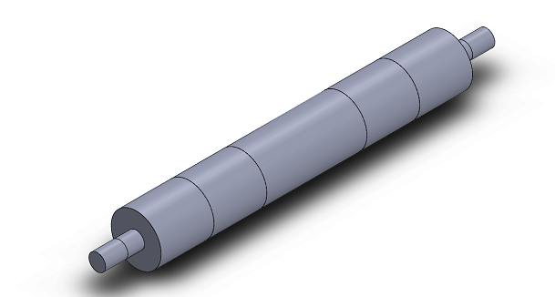
  Name: | Steel AISI 1080
  Model type: | Linear Elastic Isotropic
  Default failure: | Max von Mises Stress
  Yield strength: | 351.57 MPa
  Tensile strength: | 421MPa
  Elastic modulus: | 200000 MPa
  Poisson's ratio: | 0.29
  Mass density  Mass:  Weight:  Length  Surface area  Volume | 0.001 g/mm³  4270.35g  42 N  700 mm  350798.09  540550 mm³
  Shear modulus: | 7700000
  Thermal expansion | 1.5e-05 /Kelvin

When computing stress, deformation, and strain, the infinite element boundary condition is crucial. By applying boundary conditions, a finite element is employed with SolidWorks software to calculate the stress that has been generated inside the shaft and blade assembly. Bearing loads are present in this shaft at both of its ends, and flight loads are applied to the hollow shaft from both of its ends. To apply a constraint and load in the illustration, the shaft of the helical blade was separated into subsections. The fixture command was used appropriately before adding load on the blade to investigate the simulation as shown in the Fig. 2. Fixed geometry commands were employed at the ends of both sides of shaft in immovable and fixed condition during helical blade for the analysis of the stress, displacement, and strain of the blade assembly at various flight diameters. The modelling of the blade assembly along with the flight is illustrated in Fig 2. The objective was to assess the influence of stress induced by centrifugal load on the blade assembly. The mass properties of the flight at various diameters were observed using SolidWorks software prior to the application of mess command, as presented in Table 5. Following the application of boundary conditions, the helical blade was meshed using a solid mesh with high quality, which adjusted the number of nodes for blade based on their configuration. This approach significantly reduced computation time. The outlines of various configurations of helical blades facilitated by meshing and the meshing model presented in Table 3.
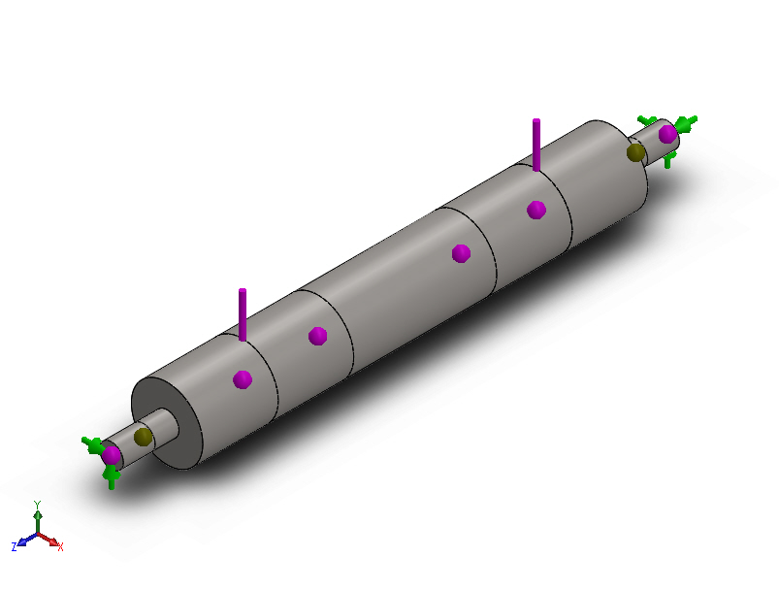 | 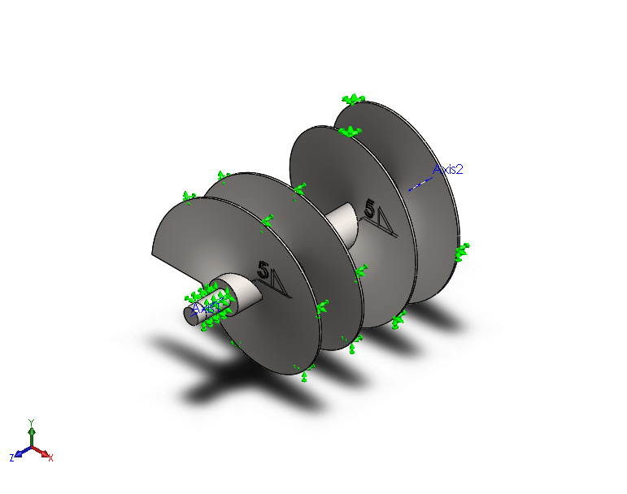
Fig. 1 Boundary application of shaft before simulation | Fig. 2 Boundary application of helical blade before simulation

Table 3: Design properties of helical at different diameters
Solid Geometry | Mass Property |  | Mess Geometry |  | Mess Property
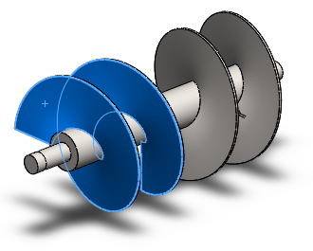 |  | Mass: 6506.82grams  Volume: 823648.07 mm³  Density: 0.001 g/mm³  Weight: 63.76N  Surface area 298269.63 mm² |  | 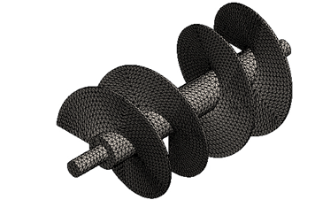 |  | Total Nodes:45835  Total Elements:22720  Maximum Aspect Ratio:27.835  % of elements with Aspect Ratio < 3:42  % of elements with Aspect Ratio > 10:0.599  % of distorted elements (Jacobian):0  Time to complete mesh (hh; mm; ss)00:00:26
1st Blade with flight diameter 240 mm
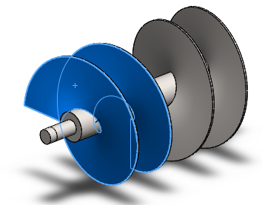 |  | Mass: 9689.07g  Volume: 1226465.0 mm³  Density: 0.001 g/mm³  Weight: 95.04 N  Surface area: 42162.25 mm² |  | 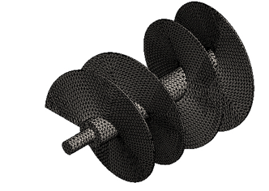 |  | Total Nodes:59227  Total Elements:29620  Maximum Aspect Ratio:27.835  % of elements with Aspect Ratio < 3:44.3  % of elements with Aspect Ratio > 10:0.523  % of distorted elements (Jacobian):0  Time to complete mesh (hh; mm; ss) 00:00:33
2nd Blade with flight diameter 310 mm
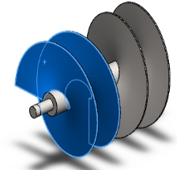 |  | Mass: 12317.23 grams  Volume: 1559142.88mm³  Density: 0.001 g/mm³  Weight: 120.76 N  Surface area:561345.78 mm² |  | 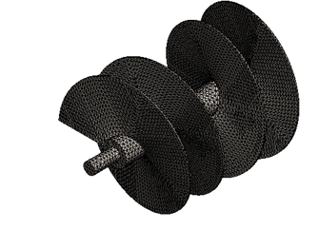 |  | Total Nodes: 70627  Total Elements: 35192  Maximum Aspect Ratio: 111.64  % of elements with Aspect Ratio < 3:45.8  % of elements with Aspect Ratio > 10:0.435  % of distorted elements (Jacobian):0  Time to complete mesh (hh; mm; ss) 00:00:41
3rd Blade with flight diameter 360 mm

3.5.2 Optimization of stress simulation during application of centrifugal load.
The optimal (custom) design of response surface methodology (RSM) using three levels has been employed to study the effect of three independent variables namely the Speed of the blade (rpm, X₁), the diameter of the blade(mm, X₂) of the helical blade for analysis of stress during application of centrifugal load in SolidWorks as shown in Table 5 The level of various input variables has been selected based on the preliminary experimental results in SolidWorks software as shown in Table 5. Sixteen runs as shown in Table 6 have been carried out to select the best combination of input variables which could result in the most suitable form for an experiment during stress optimization.
Table 4: Independent parameters and their levels used for optimal custom design
Independent variables |  | Code levels
Independent variables |  | -1 | 0 | 1
Name | Code | Actual levels
Helical Blade speed (rpm) | X₁ | 105 | 1.20 | 135
Diameter of helical blades (mm) | X₃ | 330 | 400 | 450

Table 5: Design matrix of evacuated helical blade stress using simulation in
SolidWorks
Runs | Coded levels |  | Real values
Runs |  |  | Blade speed | Blade diameter
Runs | X₁ | X₂ | (rpm) | (mm)
1 | -1 | 1 | 105 | 450
2 | 1 | -1 | 120 | 330
3 | ] | 0 | 135 | 400
4 | 0 | 1 | 120 | 450
5 | 0 | 1 | 120 | 450
6 | -1 | -1 | 105 | 330
7 | -1 | 0 | 105 | 400
8 | -1 | 0 | 105 | 400
9 | 0 | 1 | 120 | 450
10 | 0 | 0 | 120 | 400
11 | 0 | 0 | 120 | 400
12 | 1 | 1 | 135 | 450
13 | 0 | 0 | 120 | 400
14 | -1 | -1 | 105 | 330
15 | 1 | 0 | 135 | 400
16 | 0 | 0 | 120 | 400

Numerical optimization procedures were carried out to predict the optimum level of process parameters within selected ranges which generated the desired response goal. To operate, Design Expert version 11.0.6 of the STATEASE software (Stat ease Inc, Minneapolis, USA), was used for simultaneous optimization of the multiple responses (Jain et al., 2011 and Jawake, 2016). The desired goals for each factor and response were chosen and different weights were assigned to each goal to adjust the shape of its desirability function (Ade-Omowaye et al., 2002). To optimize the process parameters by numerical optimization for maximizing the desirability function; equal importance of '2' was given to all the three process parameters and three responses.
To optimize the process variables, the following considerations were taken:
1) Blade speed (rpm)
2) Blade diameter (mm),
The desired goals for each factor and response are shown in Table 6. The goal-seeking begins at a random starting point and proceeds up and down the steepest slope on the response surface.
Table 6: Optimization criteria for different process variables and responses
Name Goal Lower Limit Upper Limit Lower Weight Upper Weight Importance
A: blade speed is in the rang of 105 135 1 1 3
B: blade diameter is in the range 330 450 1 1 3
stress (vonMises) maximize 0.118269 0.337179 1 1 3
Displacement maximizes 0.0004346 0.001913 1 1 3
Strain maximizes 1.791E-07 5.216E-07 1 1 3

Result and discussion
Analysis of helical blade during centrifugal load
The stress, strain, and displacement analysis of the helical blade was calculated on the SolidWorks software 2018 at different parameters of the blade concerning centrifugal load application. The analysis of the blade depends on the design matric (optimal design) which was designed by a design expert before the operation of SolidWorks. Table 7 shows the calculated values of response as per the design matrix of optimal custom for independent variables stress (N/mm²) of the helical blade, displacement (mm) of the helical blade, and strain (mm) of the helical blade.
Table 7: Optimal Design Matrix with calculated value of responses
Run blade speed Blade diameter Stress Displacement Strain
rpm mm N/mm2 mm mm
X₁ X₂
1 105 450 0.1987 0.00152 2.941E-07
2 135 400 0.2757 0.001335 4.1021E-07
3 135 330 0.2075 0.0007436 3.106E-07
4 120 330 0.16353 0.0005875 2.34E-07
5 120 330 0.16342 0.0005875 2.45E-07
6 105 330 0.12526 0.000498 1.87E-07
7 105 400 0.1625 0.0008077 2.566E-07
8 105 400 0.1668 0.0008077 2.566E-07
9 120 450 0.259 0.001628 3.841E-07
10 120 400 0.2178 0.001055 3.551E-07
11 120 400 0.2178 0.001048 3.551E-07
12 135 450 0.325 0.001904 5.216E-07
13 120 400 0.2178 0.001505 3.241E-07
14 105 330 0.1252 0.000498 1.879E-07
15 135 400 0.2757 0.001335 4.102E-07
16 120 400 0.2178 0.0015055 3.551E-07
The effect of centrifugal load on the stress, displacement, and strain of the helical blade at different blade diameters and blade speeds was analyzed using response surface methodology (RSM). All three responses exhibited significant models at the 1% level of significance, confirming the adequacy of the developed quadratic regression equations. The non-significant lack-of-fit values in all cases indicated that the models were well-suited to predict the experimental data.
Stress
The variation in stress was observed between 0.12526 N/mm² and 0.325 N/mm². The minimum stress occurred at 105 rpm and 300 mm diameter, while the maximum stress was recorded at 135 rpm and 450 mm diameter. The model is significant at the one percent significance level, according to the Model F-value of 6504.18, and there is only a 0.01 percent probability that a "Model F-value" this large could occur due to noise of such a magnitude could occur due to noise. The lack of fit F-value of 0.3370 implies that it is non-significant (Table 8). The regression model showed in equation 5.1 a very high coefficient of determination (R² = 0.9997), with adjusted R² (0.9995) and predicted R² (0.9990) being very close, thereby confirming model adequacy. Blade diameter had the most dominant influence on stress, followed by blade speed. Stress consistently increased with higher blade speed and diameter, with positive interaction effects amplifying the response. Fig shows the generated response surface diagram between blade speed (X₁) and blade diameter (X₂) fixed. The figure indicates increased stress of the blade with an increase in X₁ and X₂.
Stress = +0.2097+0.0528 X₁ +0.0477 X₂+0.0113 X₁ X₂+0.0027 X₁²+0.0018 X₁² … 5.1)
(R² = 0.9997)
Displacement
The overall displacement ranged from 0.000498 mm to 0.001904 mm. The minimum displacement was obtained at 105 rpm and 300 mm diameter, whereas the maximum displacement was found at 135 rpm and 450 mm diameter. The model is significant at the one percent significance level, according to the Model F-value of 24.71, and there is only a 0.01 percent probability that a "Model F-value" this large could occur due to noise of such magnitude could occur due to noise The lack of fit F-value of 0.3516 implies that it is non-significant (Table 8) The regression model showed in equation in 5.2 a coefficient of determination (R² = 0.9291), with adjusted R² (0.8570) and predicted R² (0.7929) being within the acceptable difference (< 0.2). Displacement decreased with an increase in both blade speed and diameter initially; however, excessive increases in these parameters resulted in higher displacement values due to the quadratic effects of the variables. Blade diameter again emerged as the dominant factor. Fig 3 shows the generated response surface diagram between blade speed X₁and blade diameter X₂ keeping blade speed fixed. The figure indicates a decrease in displacement with an increase in X₂ however, an excessive increase in the levels of these variables resulted in a significant increase in displacement.
Displacement = +0.0011+0.0002X₁+0.0005X₂+0.0001X₁X₂-0.0001X₁²+0.0001X₂²…5.2)
(R²=0.9291)
Strain
The strain of the helical blade varied between 1.879E-07 and 5.216E-07. The lowest strain was recorded at 105 rpm and 300 mm diameter, while the highest occurred at 135 rpm and 450 mm diameter. The model is significant at the one percent significance level, according to the Model F-value of 3120.15, and there is only a 0.01 percent probability that a "Model F-value" this large could occur due to noise of such a magnitude could occur due to noise The lack of fit F-value of 0.1772 implies that it is non-significant(Table.8). The regression model for strain was highly significant, with a very high coefficient of determination (R² = 0.9994) and acceptable predicted and adjusted R² values. Linear terms (blade speed and diameter) contributed positively to strain, while quadratic terms indicated curvilinear effects, leading to sharp increases in strain at higher levels of blade speed and diameter. Fig 3 shows the generated response surface diagram between blade speed X₁and blade diameter X₂ keeping blade speed fixed. The figure indicates a decrease in strain with an increase in X₂ however, after excessive increase in the levels of these variables resulted in a significant increase in strain of the helical blade
Strain =+3.281E-07+8.084E-08X₁+7.845E-08 X₂+2.375E-08X₁X₂-1.170E-09X₁²-5.858E-09X₂²
R²(0.9994)
… 5.5
Overall Effect
Across all responses—stress, displacement, and strain—it was evident that both blade diameter and blade speed significantly influenced the mechanical behaviour of the helical blade under centrifugal load. Blade diameter was the major contributing factor, followed by blade speed. In all three cases, responses increased with higher blade speed and larger diameter, with interaction terms amplifying the effects. The quadratic contributions confirmed that excessive increases in these parameters led to steep rises in stress, displacement, and strain. The developed quadratic regression models demonstrated high accuracy and predictive capability, with R² values exceeding 0.92 for all responses. Adequate precision ratios (all > 4, with stress reaching 272.18) confirmed strong signal-to-noise ratios, ensuring that the models could be reliably used to navigate the design space.
The five best solutions obtained for the various combinations of independent variables and the results of the responses. The highest desirability value (nearest to the response goal), which is 0.768 (solution 1), was selected as the optimum condition for product development.
The optimum solution from the package emerged as Blade speed (A) 135 rpm and Blade diameter (B) 450 mm to obtain optimized as Stress (von Mises) 0.335, Displacement 0.002, Strain 0.000 with desirability of 0.994.. Analysing the response surface plots and how the operating conditions affect the responses, the best operating conditions of variables were obtained by numerical optimization, and optimization graphs of desirability vs responses have been presented in the figure.3.
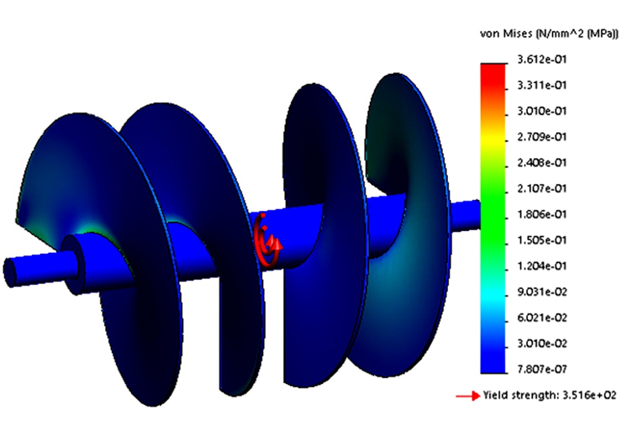 | 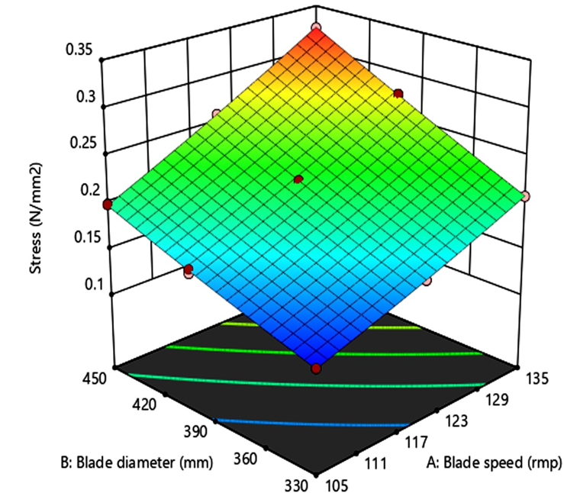
Stress effect on helical blade
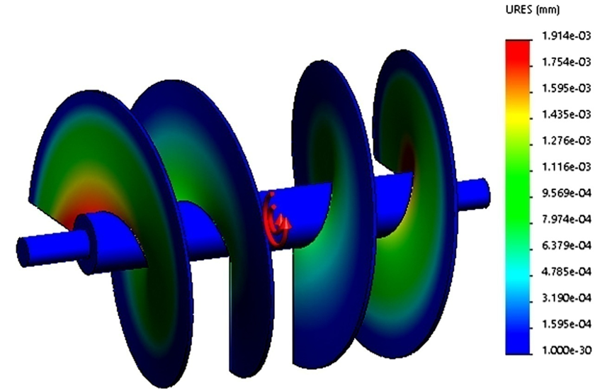 | 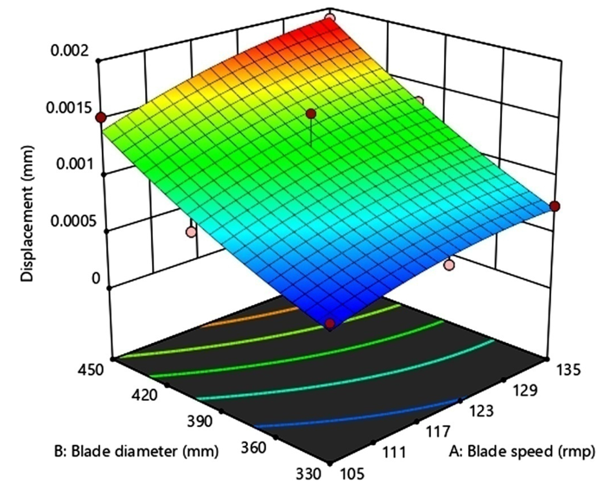
Displacement effect on helical blade
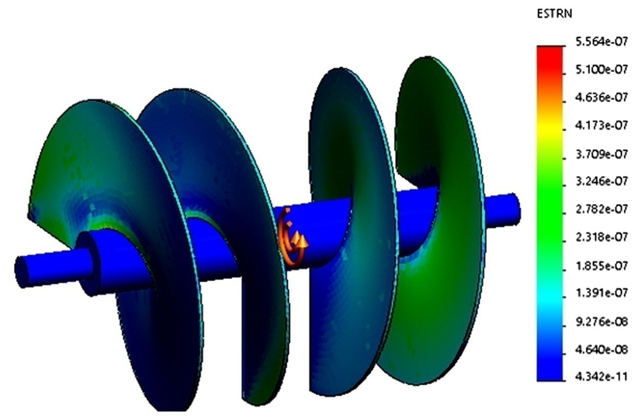 | 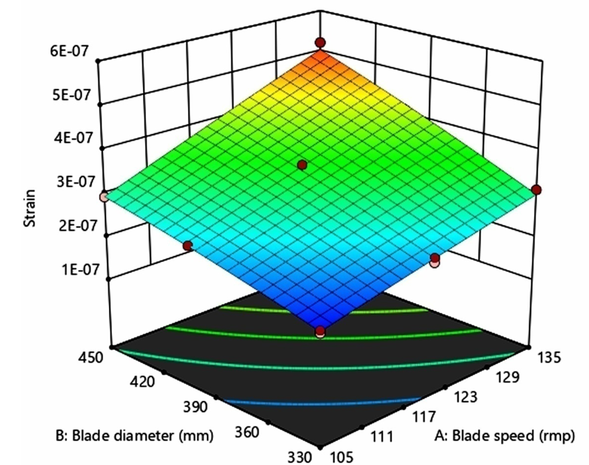
Strain effect on helical blade

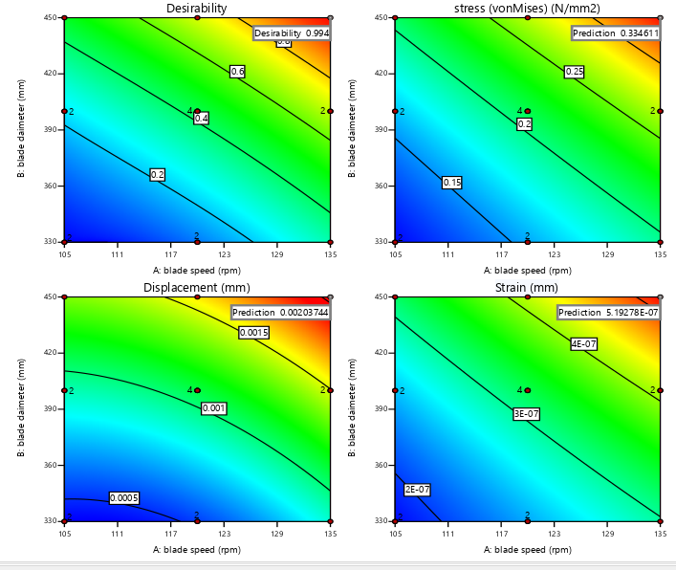
Fig. 3 Numerical optimized contours graph of desirability vs all response of parameters
Table 8: Software generated Solutions for Optimum Condition
Number Blade Blade Stress Displacement Strain Desirability
Speed diameter (von-Mises)

1 135.000 450.000 0.335 0.002 0.000 0.994 Sel
2 134.337 450.000 0.332 0.002 0.000 0.985
3 135.000 447.485 0.331 0.002 0.000 0.982
4 135.000 441.640 0.322 0.002 0.000 0.956
5 132.281 450.000 0.322 0.002 0.000 0.956

 |  | Model | X₁ | X2 | X1 X2 | X₁² | X₂² | Residual | Lack of Fit | Pure Error | Cor Total
Stress | SS | 0.0473 | 0.0244 | 0.0166 | 0.0006 | 0 | 0 | 0 | 5.31E-06 | 9.25E-06 | 0.0474
 | DF | 5 | 1 | 1 | 1 | 1 | 1 | 10 | 3 | 7 | 15
 | MS | 0.0095 | 0.0244 | 0.0166 | 0.0006 | 0 | 0 | 1.46E-06 | 1.77E-06 | 1.32E-06
 | F-Value | 6504.18 | 16794.9 | 11414.5 | 423.66 | 18.6 | 7.17 |  | 1.34
 | p-Value | < 0.0001 | < 0.0001 | < 0.0001 | < 0.0001 | 0.0015 | 0.0232 |  | 0.337
 |  | significant | significant | significant | significant | significant |  |  | not significant
Displacement | SS | 3.13E-06 | 6.83E-07 | 2.01E-06 | 1.70E-08 | 1.70E-08 | 1.25E-08 | 2.54E-07 | 9.00E-08 | 1.63E-07 | 3.39E-06
 | DF | 5 | 1 | 1 | 1 | 1 | 1 | 10 | 3 | 7 | 15
 | MS | 6.26E-07 | 6.83E-07 | 2.01E-06 | 1.70E-08 | 1.70E-08 | 1.25E-08 | 2.54E-08 | 3.00E-08 | 2.34E-08
 | F-Value | 24.71 | 26.96 | 79.35 | 0.6691 | 2.29 | 0.494 |  | 1.29
 | p-Value | < 0.0001 | 0.0004 | < 0.0001 | 0.4324 | 0.1614 | 0.4982 |  | 0.3516
 |  | significant | significant | significant | significant |  |  |  | not significant
Strain | SS | 1.29E-13 | 5.50E-14 | 5.85E-14 | 2.31E-15 | 3.87E-17 | 8.73E-16 | 8.24E-17 | 3.99E-17 | 4.25E-17 | 1.29E-13
 | DF | 5 | 1 | 1 | 1 | 1 | 1 | 10 | 3 | 7 | 15
 | MS | 2.57E-14 | 5.50E-14 | 5.85E-14 | 2.31E-15 | 3.87E-17 | 8.73E-16 | 8.24E-18 | 1.33E-17 | 6.07E-18
 | F-Value | 3120.15 | 6672.8 | 7107.03 | 281.01 | 4.69 | 106.03 |  | 2.19
 | p-Value | < 0.0001 | < 0.0001 | < 0.0001 | < 0.0001 | 0.0555 | < 0.0001 |  | 0.1772
 |  | significant | significant | significant | significant |  | significant |  | not significant

Summary and conclusions
The experiment was conducted a multi-response optimization using desirability functions, with blade speed (105-135 rpm) and blade diameter (330-450 mm) as the controllable factors, and with stress, displacement, and strain as the responses that were to be maximized. All factors and responses had been weighted equally, and equal importance had been assigned, resulting in a composite desirability measure that ranged from 0 (totally unacceptable) to 1 (ideal). From the software output, the best solution had achieved a desirability of about 0.994, which corresponded to operating at the extreme values: blade speed of 135 rpm and blade diameter of 450 mm, yielding a stress of ≈ 0.335 N/mm², displacement ≈ 0.002 mm, and strain at its highest observed level. Near-optimal alternatives (with slightly lower speeds or diameters) had shown similar but marginally lower desirabilities (above about 0.95), indicating that a region around those extreme settings had performed almost as well.
While this result had suggested that pushing both blade speed and diameter to their upper bounds produced the best outcome under the specified goals, there had been important caveats. First, maximizing stress, displacement, and strain was not always desirable in practice—structural safety, fatigue, material limits, vibration, or long-term wear might have been compromised. Second, because the model had predicted values at or near the extremes of the data region, predictive accuracy might have been lower; extrapolation beyond well-supported data could have led to optimistic or unrealistic forecasts. Third, treating all responses with equal weight had assumed that they were equally critical, but in actual applications some might have been more important than others (for example, keeping strain low might have been more critical than maximizing stress).
To have improved the robustness and practical utility of the optimization, you could have introduced constraints—such as upper limits on stress or strain for safety or maximum permissible displacement—to avoid designs that might have performed well on the desirability metric but poorly under service conditions. A sensitivity analysis could also be conducted to see how changes in criterion weights, bounds, or factor ranges affected the optimum, so that the chosen solution would have remained robust under real-world variation. Finally, the optimal design should be validated through conducting confirmatory experiments at the recommended settings to check whether actual behavior (including secondary effects) matched the model’s predictions.
The results of this study provide valuable insights for industries seeking to improve the durability and efficiency of rotating helical blades in high-speed applications. Future work may extend to incorporating advanced materials, experimental validation, and multi-objective optimization techniques to further enhance the robustness of the blade design.

Disclaimer (Artificial intelligence)
Option 1:
Author(s) hereby declare that NO generative AI technologies such as Large Language Models (ChatGPT, COPILOT, etc.) and text-to-image generators have been used during the writing or editing of this manuscript.
Option 2:
Author(s) hereby declare that generative AI technologies such as Large Language Models, etc. have been used during the writing or editing of manuscripts. This explanation will include the name, version, model, and source of the generative AI technology and as well as all input prompts provided to the generative AI technology
Details of the AI usage are given below:
1.
2.
3.

References

- Dassault Systèmes. Centrifugal Load PropertyManager, SOLIDWORKS Help. (2021). Retrieved from “Defining Centrifugal Loads” in SOLIDWORKS structural loads documentation. SolidWorks Help+1
- Peiravi, M. M., & Ashabi, A. (2022). Hybrid investigation of the helical blades of Savonius wind turbine in novel patent of lighting base. Results in Engineering, 15, 100565. https://doi.org/10.1016/j.rineng.2022.100565
- Zhang, X., & Li, J. (2024). Study on the structure parameters and design method optimization of blade-type screw steel pipe pile. Heliyon. https://doi.org/10.1016/j.heliyon.2024.e35046
- Velásquez, L., Rubio-Clemente, A., Tobón, D., Botero, F., Arrieta, C., & Chica, E. (2024). Experimental Optimization of the Propeller Turbine Performance Using the Response Surface Methodology. Sustainability, 16(19), 8476. https://doi.org/10.3390/su16198476
- Benyounis, K. Y., Olabi, A. G., & Hashmi, M. S. J. (2008). Multi-response optimization of CO2 laser welding process of austenitic stainless steel. Optics & Laser Technology, 40(1), 76-87. https://doi.org/10.1016/j.optlastec.2007.03.009
- Rosli, M. U., Ahmad Termizi, S. N. A., Khor, C. Y., Nawi, M. A. M., Omar, A. A., & Ishak, M. I. (2020). Simulation Based Optimization of Thin Wall Injection Molding Parameter Using Response Surface Methodology. IOP Conference Series: Materials Science and Engineering, 864(1), 012193. https://doi.org/10.1088/1757-899X/864/1/012193
- Vardaan, K., & Kumar, P. (2022). Design, analysis, and optimization of thresher machine flywheel using Solidworks simulation. Materials Today: Proceedings, 56(3), 3651–3655. https://doi.org/10.1016/j.matpr.2021.12.348
- Sanaye, S., & Farvizi, A. (2024). Optimizing a vertical axis wind turbine with helical blades: Application of 3D CFD and Taguchi method. Energy Reports, 12, 2527-2547. https://doi.org/10.1016/j.egyr.2024.08.059
- Ragab, S. A., & Fayed, H. E. (2024). Introduction to finite element analysis for engineers. CRC Press. https://doi.org/10.1201/9781003323150
- Zhong, S., Jin, G., Chen, Y., Ye, T., & Zhou, T. (2025). Review of vibration analysis and structural optimization research for rotating blades. Journal of Marine Science and Application, 24(1), 120-136. https://doi.org/10.1007/s11804-024-00405-6
- Pretsch, L., Arsenyev, I., Czech, C., & Duddeck, F. (2023). Interdisciplinary design optimization of compressor blades combining low-and high-fidelity models. Structural and Multidisciplinary Optimization, 66(4), 70. https://doi.org/10.1007/s00158-023-03516-w 11.
- Tasharrofi, M., Shahri, M. H., & Madadi, A. (2025). Three-dimensional design, simulation and optimization of a centrifugal compressor impeller with double-splitter blades. Heliyon, 11(3). 12.
- Hagninou E. V. Donnou, Drissa Boro, Donald Abode, Brunel Capo-Chichi & Aristide B. Akpo. (2020). Design of Vertical Axis Wind Turbine Darrieus Type (H- Darrieus Rotor) of 0.20 KW from the Software Topsolid. Physical Science International Journal, 24(11), 52–70. https://doi.org/10.9734/psij/2020/v24i1130227
- Fu, F. (2018). Design and analysis of complex structures. In F. Fu (Ed.), Design and analysis of tall and complex structures (pp. 177–211). Butterworth-Heinemann. https://doi.org/10.1016/B978-0-08-101018-1.00006-X 14.
- Navadeh, N., Goroshko, I., Zhuk, Y., Etminan Moghadam, F., & Soleiman Fallah, A. (2021). Finite Element Analysis of Wind Turbine Blade Vibrations. Vibration, 4(2), 310-322. https://doi.org/10.3390/vibration4020020

