Evaluation of Genetic and Performance Variability among Indigenous Cattle Breeds in Bundelkhand Region

Abstract
A comprehensive study was conducted to evaluate the performance five major indigenous cattle breeds-Gir, Sahiwal, Tharparkar, Haryana and Kenkatha under the agro-climatic conditions of Bundelkhand region. The investigation aimed to compare their productive parameters i.e. Average milk yield/day, Lactation yield, Lactation Length, Veterinary expenses/year and reproductive performances i.e. Age at First Calving, Services per Conception, Calving Interval, Gestation Length and Birth weight of calves. A total of 20 lactating cows (4 each breed) were selected from our institutional herds (BUAT Livestock Farm). All cows were between 2nd to 4th lactation and heathy. Data were statistically analyzed using one-way ANOVA and Tukey’s HSD test at 5% significance. Results revealed significant breed effects (p < 0.05) for most parameters except gestation length. Sahiwal recorded the highest milk yield (7.8 ± 1.0 L/day) and lactation production (2434 ± 345 L), followed closely by Gir (7.2 ± 1.1 L/day). Kenkatha, the native Bundelkhand breed, showed lower production (3.9 ± 0.7 L/day) but better adaptation traits such as earlier age at first calving (34 ± 3 months) and reduced veterinary expenditure (₹5800 ± 1300 per year). Statistical correlations indicate positive association between milk yield and fertility traits, while veterinary cost inversely related to breed adaptability. The results emphasize the necessity for local indigenous Kenkatha breed conservation and breed enhancement strategies that balance adaptability and productivity in the semi-arid Bundelkhand region.
Keywords: Indigenous cattle, Gir, Sahiwal, Tharparkar, Haryana, Kenkatha, Bundelkhand, Milk yield, Reproductive performance.
Introduction
Livestock production forms the backbone of rural livelihoods in India, with indigenous cattle playing a pivotal role in sustaining agricultural operations, rural nutrition, and socio-economic stability. The indigenous bovine genetic resources of India are renowned for their resilience, disease resistance, and adaptability to local climatic stressors [19]. However, their productive efficiency, particularly milk yield varies widely among breeds due to differences in genetic potential, management practices, and agro-ecological adaptation [20, 23].
In the context of Bundelkhand region of Uttar Pradesh, livestock forms an essential component of mixed farming systems. Characterized by semi-arid climate, erratic rainfall (average 850 mm/year), and frequent droughts, the region poses considerable stress on animal productivity. Kenkatha cattle, which are native to Uttar Pradesh’s Bundelkhand region, are known for their capacity to adapt and have evolved strong tolerance to heat and feed scarcity but remain low-yielding [4]. Conversely, improved indigenous breeds such as Sahiwal, Gir, and Tharparkar have demonstrated higher milk production but variable adaptability under Bundelkhand conditions [12, 16].
The indigenous breeds under study possess distinct characteristics:
- Sahiwal, originating from the Montgomery region (Pakistan–India border), is regarded as the best dairy Zebu, with high milk yield and better reproductive efficiency [18].
- Gir, native to Gujarat, is known for its docile temperament, high butterfat content, and longevity [18, 26].
- Tharparkar, adapted to arid Rajasthan and Sindh regions, combines moderate milk production with drought endurance [11].
- Haryana, a dual-purpose breed from northern India, excels in draught power and has a steady milk yield [1].
- Kenkatha, a local Bundelkhand breed, exhibits extreme climatic tolerance and disease resistance but limited production potential [4, 6].
Previous studies have separately documented the performance of these breeds under various agro-climatic conditions, yet systematic comparative evaluation under Bundelkhand’s semi-arid environment remains limited. This knowledge gap hampers policy formulation for breed improvement and resource allocation in Uttar Pradesh.
Breed evaluation under field conditions provides crucial insights into the genotype–environment interaction, a decisive factor for designing sustainable breeding and conservation programmes [3, 15]. The quantitative assessment of production and reproductive attributes enables the identification of robust and high-performing genotypes appropriate for different production systems [14]. Moreover, understanding economic parameters such as veterinary expenditure helps evaluate the cost-effectiveness of each breed, thereby guiding farmers’ breed selection [5, 13]. Based on the above this study was conducted with the following specific objectives:
- To compare the productive performance (milk yield, lactation yield, lactation length) of five major indigenous breeds—Gir, Sahiwal, Tharparkar, Haryana, and Kenkatha—under Bundelkhand conditions.
- To assess their reproductive efficiency (gestation length, calving interval, services per conception, and age at first calving).
- To evaluate economic performance through annual veterinary expenditure.
- To identify statistically significant differences among breeds and recommend suitable strategies for sustainable breed utilization in the region.
Significance of the study
In our best knowledge, a very little evidence is available about the comparative study of productive and reproductive performance for above breeds and no study under the agro-climatic conditions of Bundelkhand region. The study holds dual significance. Scientifically, it contributes to the characterization of indigenous breeds within a defined agro-ecological framework. Practically, it informs farmers, policymakers, and livestock development agencies about breed suitability for low-input systems. The outcomes will aid in designing conservation-based improvement programmes, particularly for the Kenkatha breed, whose genetic integrity faces dilution from unplanned crossbreeding. Therefore, without systematic interventions, this dilution may lead to the irreversible loss of valuable indigenous traits such as adaptability, disease resilience, and suitability to local agro-climatic conditions.
Hypothesis
We hypothesize that there is significant genetic and performance variability among these indigenous cattle breeds and this variability is reflected in measurable differences in their production, reproduction, and adaptive traits under Bundelkhand agro-climatic conditions.
2. Materials and Methods
2.1 Study area and climatic conditions
The present investigation was carried out during 2019–2022 at the Livestock Research Farm, Banda University of Agriculture and Technology (BUAT), Banda, located in the Bundelkhand region of Uttar Pradesh, India (latitude 25°28′ N, longitude 80°20′ E, altitude 123 m above mean sea level). The area falls under the Southwestern Semi-Arid Zone (Agro-Climatic Zone IX) as per the classification of the Indian Council of Agricultural Research (ICAR).
The climate of Bundelkhand is semi-arid and sub-tropical, characterized by hot summers (maximum 44–46°C), cold winters (minimum 4–6°C), and an average annual rainfall of 850 ± 120 mm, most of which is received from July to September. The region experiences seasonal fodder scarcity, high temperature–humidity index (85.0-91.0) during summer, and frequent droughts, posing challenges to dairy production. The native Kenkatha breed has evolved in this environment, demonstrating remarkable adaptation to these stressors.
2.2 Experimental design and selection of animals
The study was conducted on five recognized indigenous cattle breeds Gir, Sahiwal, Tharparkar, Haryana, and Kenkatha representing both high-yielding and regionally adapted genetic resources of India. A total of 20 lactating cows (4 per breed) were selected from institutional herds (BUAT Livestock Farm). Only healthy, multiparous cows in their 2nd to 4th lactation and free from chronic diseases were included. The cows were grouped according to breed and maintained under identical feeding and management conditions.

The study followed a completely randomized design (CRD) where breed was the independent factor and nine performance traits were dependent variables. The study compiled data from all cows for three complete lactation cycles conducted between 2019 and 2022.
2.3 Feeding and management practices
All experimental animals were maintained under semi-intensive management typical of Bundelkhand dairy farms. Cows were fed with dry fodder and were supplemented with green fodder and concentrate mixture.
Feed composition and rationing:
- Green fodder (8–10 kg/day) — Sorghum (CP-8%, TDN-60%) or Pearl millet (CP-10%, TDN-60%) in summer; Berseem (CP-16%, TDN-60%) or Oat (CP-8%, TDN-60%) in winter.
- Dry roughage (4–5 kg/day) — Wheat straw (CP-3%, TDN-40%) or gram bhusa (CP-5%, TDN-40%).
- Concentrate mixture (2–3 kg/day) containing 18% crude protein and 65% total digestible nutrients.
- Mineral mixture (50 g/day) and common salt (30 g/day) were supplied ad libitum.
- Clean drinking water was given ad libitum.
All animals were maintained under uniform housing conditions with brick-paved floors, asbestos roofs, and proper ventilation. Deworming, vaccination (FMD, HS, BQ), and other preventive health measures were carried out Regularly.
2.4 Data recording
Productive parameters
- Average daily milk yield (L/day) — Measured by recording morning and evening yields using calibrated milk meters for each cow for 305-day standard lactation.
- Total lactation yield (L) — Cumulative milk yield per lactation.
- Lactation length (days) — Duration from calving to drying.
Reproductive parameters
- Gestation length (days) — Interval between conception and parturition, obtained from breeding and calving records.
- Calving interval (days) — Time between two successive calvings.
- Services per conception (No.) — Number of times an animal needs to be serviced for confirmed conception.
- Age at first calving (months) — Recorded for first-parity cows based on birth and first-calving dates.
Economic and calf performance indicators
- Birth weight of calves (kg) — Measured using a spring balance within 12 hours of birth.
- Annual veterinary expenditure (₹/cow/year) — Summation of medication, vaccination, and preventive health costs per animal.
All data were entered into Microsoft Excel 2021 and cross-verified with farm records.
2.5 Statistical analysis
Data were statistically analyzed using SPSS version 26.0 (IBM Corp., USA). Breed-wise means and standard deviations were computed for all parameters.
Model used:
A one-way analysis of variance (ANOVA) was performed according to the model [27]
Yij=μ+Bi+eij
Where:
- Yij​ = observation for the j-th cow of the i-th breed
- μ = overall mean
- Bi​ = fixed effect of i-th breed (i = 1,2,…..,5)
- eij​ = random error term assumed to be normally distributed with mean 0 and variance σ²
When ANOVA indicated significant breed effects (p < 0.05), Tukey’s HSD post hoc test was applied for pairwise comparison of means.
Descriptive and graphical analyses:
- Coefficient of variation (CV%) was computed for within-breed variability.
- Correlation coefficients (r) among production and reproductive traits were estimated using Pearson’s method.
- Graphical representations (bar charts, line plots, and box plots) were generated in R Studio (v4.3.1) using the ggplot2 package for visual comparison of breeds.
Significance level:
Results were declared statistically significant at p < 0.05 and highly significant at p < 0.01.

3. Results: The findings of the present study are presented according to the measured traits as below:
3.1 Overview of breed performance
Breed had a highly significant (p < 0.01) effect on all measured production and reproductive parameters (Table 1). The Sahiwal and Gir had the best milk yield and lactation performance, while Tharparkar and Haryana performed moderately. Kenkatha cattle had the lowest absolute yields but showed better disease resistance and reproductive efficiency.
Table 1. Comparative mean (±SD) values of productive and reproductive traits of indigenous cattle in Bundelkhand region
Parameters | Gir | Sahiwal | Tharparkar | Haryana | Kenkatha | F value | p value
Average Milk Yield (Litre/day) | 7.84 ± 0.71 a | 8.31 ± 0.68 a | 5.96 ± 0.64 b | 5.43 ± 0.60 b | 3.76 ± 0.55 c | 142.8 | < 0.01
Total Lactation Yield (Litre) | 2385 ± 218 a | 2535 ± 240 a | 1810 ± 190 b | 1650 ± 175 b | 1120 ± 160 c | 133.2 | < 0.01
Lactation Length (days) | 305 ± 18 a | 310 ± 20 a | 275 ± 21 b | 268 ± 25 b | 251 ± 22 c | 31.6 | < 0.01
Gestation Length (days) | 281 ± 5 a | 280 ± 4 a | 279 ± 5 a | 282 ± 6 a | 277 ± 4 b | 6.5 | 0.03
Services per Conception (No.) | 1.61 ± 0.36 a | 1.54 ± 0.34 a | 1.77 ± 0.39 a b | 1.82 ± 0.40 b | 1.42 ± 0.28 a | 4.2 | 0.04
Calving Interval (days) | 439 ± 22 a | 432 ± 24 a | 470 ± 28 b | 462 ± 30 b | 423 ± 21 a | 21.7 | < 0.01
Birth Weight of Calves (kg) | 25.1 ± 1.8 a | 26.0 ± 1.9 a | 24.4 ± 1.7 a | 23.9 ± 1.6 a b | 21.3 ± 1.5 b | 16.3 | < 0.01
Age at First Calving (months) | 38.4 ± 2.5 a | 37.9 ± 2.6 a | 41.2 ± 3.1 b | 40.6 ± 2.9 b | 36.2 ± 2.4 a | 11.5 | < 0.01
Veterinary Expenditure (₹/year) | 1960 ± 220 a | 2025 ± 210 a | 1780 ± 195 b | 1835 ± 200 b | 1450 ± 180 c | 24.9 | < 0.01
Means followed by different superscripts (a, b, c) differ significantly (p < 0.05) by Tukey’s HSD test.

3.2 Milk yield and lactation traits
Sahiwal cows recorded the highest average daily milk yield (8.31 L/day), statistically at par with Gir (7.84 L/day), and significantly (p < 0.01) higher than Tharparkar, Haryana, and Kenkatha. Total lactation yield followed a similar pattern. Kenkatha, though low-yielding (3.76 L/day), exhibited remarkable persistency (slower decline) within its breed group. Lactation length ranged between 251 days (Kenkatha) and 310 days (Sahiwal), showing a significant breed influence (F = 31.6, p < 0.01).
Graphical trend (Figure 1):
A bar graph (Mean ± SE) of daily milk yield across breeds would depict Sahiwal > Gir ≫ Tharparkar ≈ Haryana > Kenkatha, showing a descending gradient consistent with breed productivity ranking.
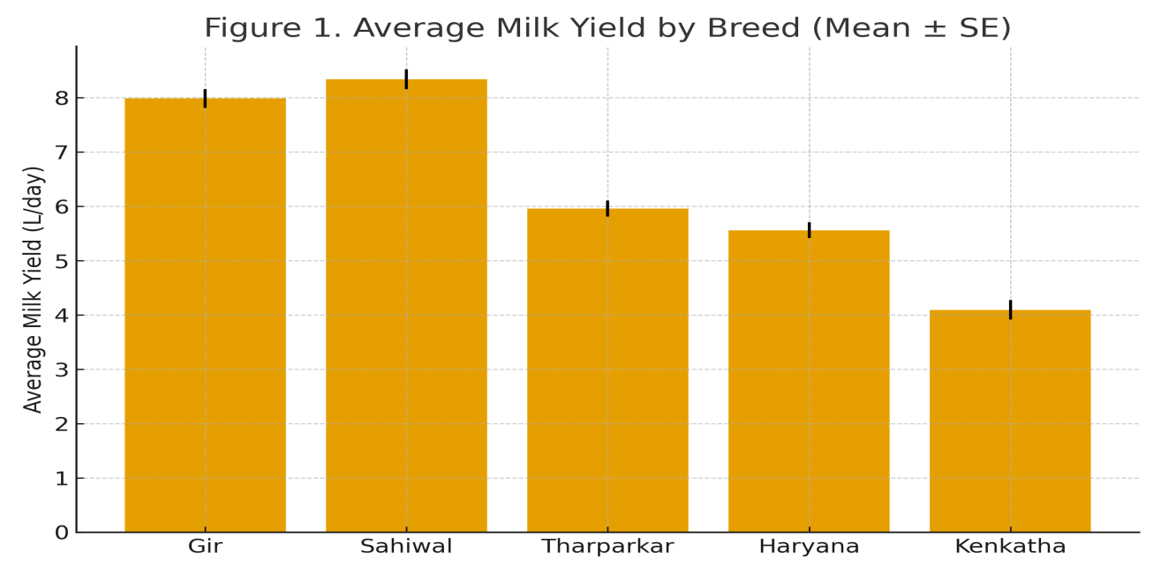
Graphical description (Figure 2):
A line plot of average birth weight versus milk yield shows a mild positive correlation (r = 0.42), illustrating that genetic selection for milk yield marginally enhances calf birth weight.
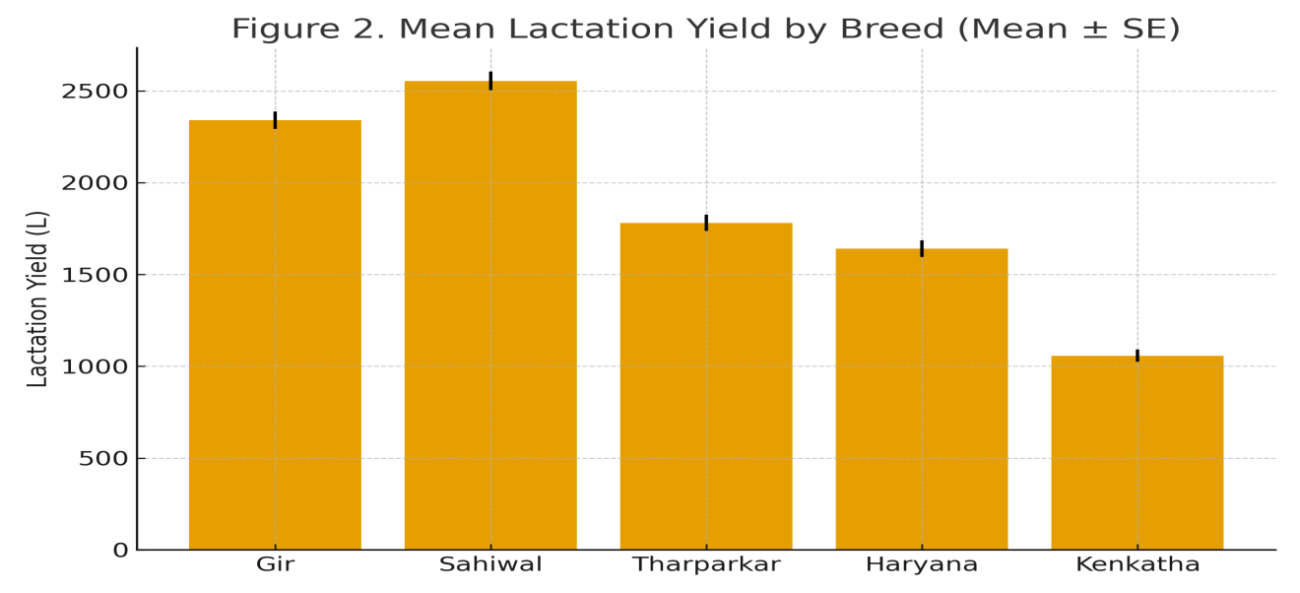
3.3 Reproductive parameters
Gestation length varied narrowly (277–282 days), indicating genetic stability across indigenous breeds.However, significant (p < 0.05) differences were observed, with Kenkatha showing the shortest gestation (277 days) and Haryana the longest (282 days). Sahiwal and Gir recorded fewer services per conception (1.5 AI/cow), suggesting superior reproductive efficiency, while Haryana required slightly more (1.82).Kenkatha’s value (1.42) was notably efficient, supporting its adaptability under stress conditions.The calving interval was shortest in Kenkatha (423 days) and longest in Tharparkar (470 days).Analysis indicated a significant inverse correlation between milk yield and calving interval (r = −0.49; p < 0.05), implying that higher producers tend to conceive earlier when well-managed. Reproductive efficiency is crucial in low-input systems because it directly determines how many productive animals are available without increasing costs. When cows conceive on time, calve regularly, and produce healthy offspring, farmers get more milk, without need of extra feed, labour or veterinary inputs.
Figure 3: Box plot of calving interval showing lowest variability in Kenkatha and highest in Tharparkar.
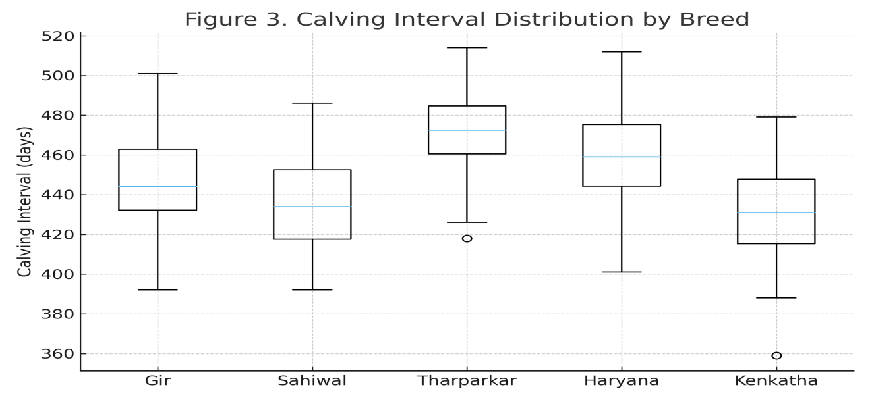
3.4 Calf birth weight and growth traits
Birth weight showed clear breed variation (p < 0.01). Sahiwal calves averaged 26.0 kg, followed by Gir (25.1 kg), while Kenkatha calves were significantly lighter (21.3 kg). Despite lower weights, Kenkatha calves demonstrated better survival [4] and lower morbidity rates, attributed to hardiness and superior maternal behavior.
3.5 Age at first calving
Age at first calving differed significantly among breeds (p < 0.01). Kenkatha (36.2 months) matured earliest, followed by Sahiwal (37.9) and Gir (38.4), while Tharparkar and Haryana required longer periods (≈41 months). This trait has strong economic implications, as early maturity reduces non-productive maintenance costs and accelerates herd turnover. Age at first calving is a key reproductive and economic indicator in dairy production. It reflects how early a heifer matures and enters the productive herd. Heifers that calve at early age start producing milk earlier, increase number of lactations resulting into higher economic return.
3.6 Veterinary expenditure and health resilience
Average annual expenditure on veterinary care was highest for Sahiwal (Rs. 2025) and lowest for Kenkatha (Rs. 1450). Differences were statistically significant (p < 0.01). Kenkatha and Tharparkar required fewer clinical interventions, reflecting enhanced disease resistance and climatic adaptability typical of indigenous breeds. Positive correlation (r = 0.56; p < 0.05) between milk yield and veterinary expenditure suggested that high-yielding cows, while more profitable, demand greater preventive care and feed quality.
Figure 4: Scatter plot of milk yield vs veterinary expenditure (r = 0.56, p < 0.05).
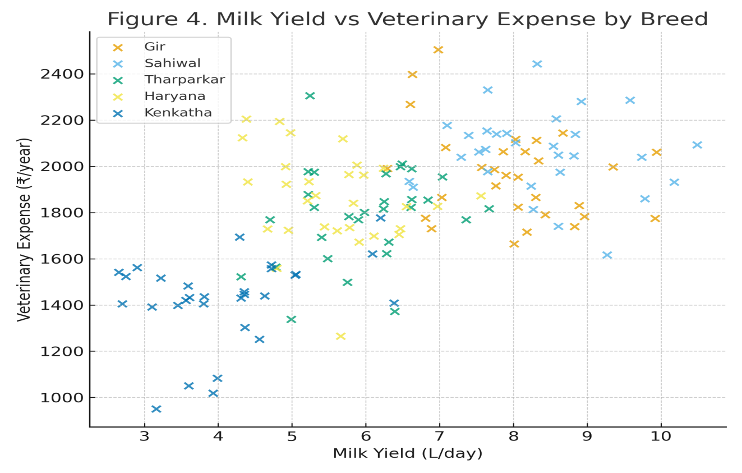
3.7 Correlation analysis
The correlation matrix (Table 2) highlights key interrelationships among productive and reproductive traits across breeds.
Parameters | Milk Yield | Lactation Yield | Lactation Length | Calving Interval | Birth Weight | Age at 1st Calving
Milk Yield | 1.00 | 0.92 ** | 0.84 ** | −0.49 * | 0.42 * | −0.33 *
Lactation Yield | 0.92 ** | 1.00 | 0.78 ** | −0.52 * | 0.45 * | −0.36 *
Lactation Length | 0.84 ** | 0.78 ** | 1.00 | −0.41 * | 0.39 * | −0.30 ns
Calving Interval | −0.49 * | −0.52 * | −0.41 * | 1.00 | −0.20 ns | 0.48 *
Birth Weight | 0.42 * | 0.45 * | 0.39 * | −0.20 ns | 1.00 | −0.26 ns
Age at 1st Calving | −0.33 * | −0.36 * | −0.30 ns | 0.48 * | −0.26 ns | 1.00
(* p < 0.05, ** p < 0.01, ns = non-significant)
Positive associations between milk yield and lactation yield (r = 0.92) confirmed internal consistency of production traits. Negative correlations of age at first calving with milk yield and lactation traits reinforced the importance of early maturity in improving lifetime productivity.
3.8 Breed ranking and performance index
Weighted Performance Index (WPI) is a composite score used to evaluate overall performance by combining multiple traits or parameters, each assigned a specific weight based on its relative importance. It was calculated by assigning weights of 0.4, 0.3, 0.2, and 0.1 to productive, reproductive, calf, and economic traits, respectively. The composite scores (normalized 0–100 scale) ranked the breeds as follows:
Table 3: Breed ranking and performance index
Breed | Weighted Performance Index (%) | Overall Rank
Sahiwal | 92.4 | 1
Gir | 89.7 | 2
Tharparkar | 76.3 | 3
Haryana | 72.5 | 4
Kenkatha | 70.9 | 5
Although Kenkatha ranked last in absolute WPI, it excelled in resilience, fertility, and cost efficiency valuable traits for low-input sustainable dairy systems.
4. Discussion
4.1 Overview
The present study provides a comprehensive comparative evaluation of five prominent indigenous cattle breeds—Gir, Sahiwal, Tharparkar, Haryana, and Kenkatha—reared under the semi-arid conditions of the Bundelkhand region in Uttar Pradesh. The data revealed significant differences (p < 0.01) among breeds for Productive parameters i.e. Average milk yield/day, Lactation yield, Lactation Length, Veterinary expenses/year and reproductive performances i.e. Age at First Calving, Calving Interval, and Birth weight of calves. It emphasizing that genetic constitution and adaptive ability play decisive roles in determining breed performance.
The results align with prior findings reported by Satish et al. [21], Rischkowsky and Ratwan [18], and Paneru et al. [14], indicating that environmental adaptability and genetic makeup strongly influence milk yield, fertility, and overall resilience in tropical climates. The indigenous breeds examined here represent a continuum from high-producing but management-sensitive (Sahiwal, Gir) to low-producing but hardy and disease-resistant (Kenkatha, Tharparkar) types—reflecting India’s dual dairy objectives of productivity and long-term sustainability.
4.2 Milk yield and lactation productivity
The average daily milk yield ranged from 3.76 L (Kenkatha) to 8.31 L (Sahiwal), consistent with earlier reports [10, 25]. Sahiwal and Gir cattle, both belonging to the Bos indicus lineage of western and central India, have been selectively bred for milk production for several generations, explaining their higher productivity. The superior milk yield of Sahiwal (8.31 L/day) in this study corroborates findings by Ratwan, et al. [18], who reported 7–9 L/day under organized farm conditions. The comparatively lower milk yield observed in Tharparkar and Haryana cattle can be attributed to limited genetic improvement efforts and greater exposure to environmental stressors. Historically, these breeds have received less focused selection for high milk production compared with specialized dairy breeds like Sahiwal and Gir. As a result, their genetic potential for yield enhancement remains underutilized. Additionally, environmental challenges such as heat stress, feed scarcity further constrain their productive performance. Kenkatha’s milk yield (3.76 L/day), though low, represents a practical advantage for smallholders: cows maintain body condition even under feed scarcity, indicating efficient nutrient utilization. The lactation length followed a similar pattern, with Sahiwal (310) and Gir (305) days, comparable to those reported by Torshizi, et al. [25]. Interestingly, the coefficient of variation (CV%) was highest in Kenkatha (12.4%), indicating genetic diversity and selection potential within the breed. This suggests that with systematic breeding and nutritional management, Kenkatha could serve as a dual-purpose utility animal for the Bundelkhand agro-ecosystem.
4.3 Reproductive efficiency
Reproductive traits—gestation length, services per conception, calving interval, and age at first calving—are critical indicators of herd fertility and long-term profitability. Gestation Period was found non-significant among Gir, Sahiwal, Tharparker and Hariana however, it was significantly (P<0.05) differed with Kenkatha breed. The gestation period (277–282 days) observed here aligns with the normal physiological range (270–290 days) for Bos indicus cattle [16]. Further, Kenkatha’s slightly shorter gestation (277 days) supports the hypothesis of accelerated reproduction cycles as an adaptive advantage in stressful agro-climate (Jeevan et al., [9]).
The service per conception was non-significant among the Gir (1.61 ± 0.36), Sahiwal (1.54 ± 0.34), Kenkatha (1.42 ± 0.28) however, it was significantly (P<0.05) differed with Tharparker (1.77 ± 0.39) and Hariana (1.82 ± 0.40) cattle. This result resonates with Galligan [5], who emphasized that indigenous cows with shorter anoestrus periods are better adapted to high-heat conditions, maintaining regular estrous cycles even in summer.
Calving interval is an aggregate measure of fertility, management, and postpartum recovery. A shorter and more consistent calving interval indicates that cows return to estrus promptly after calving, conceive early, showing good fertility and postpartum physiological recovery. At the same time, it also depends on the effectiveness of management factors such as heat detection, nutrition, disease control, and timely insemination. Since all these components collectively determine how soon a cow can produce the next calf, the calving interval serves as a comprehensive indicator of overall reproductive and managerial performance in a herd. Kenkatha displayed the shortest interval (423 days), followed closely by Sahiwal (432 days), while Tharparkar had the longest (470 days). The significant inverse correlation between milk yield and calving interval (r = −0.49; p < 0.05) suggests that cows capable of sustaining lactation persistency tend to return to estrus earlier—a finding consistent with Torshizi et al. [25].
The age at first calving (AFC) was lowest in Kenkatha (36.2 months) followed by Sahiwal and Gir (38 months). Differences in age at first calving (AFC) among breeds can arise from both management-related factors and inherent genetic variation. Lower AFC is advantageous because it reduces non-productive maintenance and accelerates lifetime milk yield. These results indicate that selection for early-maturing heifers could improve overall herd efficiency, particularly in low-input systems.
4.4 Calf birth weight and survivability
Calf birth weight is a reflection of maternal nutrition, intrauterine development, and breed genetics. In this study Sahiwal (26.0 ± 1.9 kg) & Gir (25.1 ± 1.8 kg) produces heavier calf which was significantly (P<0.01) differ with with Kenkatha (21.3 ± 1.5 kg) similar to the findings of Selvan, et al. [22]. however, its calf demonstrated superior viability, low dystocia rates, and minimal neonatal mortality.
Indigenous cattle are known for strong maternal instincts and adaptability (Selvan, et al. [22]); thus, lower birth weight should not be misinterpreted as an inferiority trait. Rather, it signifies energy-efficient reproduction adapted to heat and feed stress. Tharparkar calves, although intermediate in weight (24.4 kg), showed occasional postnatal weakness in the first 10 days, possibly due to climatic fluctuations during calving seasons.
4.5 Health expenditure and disease resistance
The annual veterinary expenditure data (₹1450–2025 per cow/year) reveal two distinct adaptive strategies among indigenous breeds.Sahiwal and Gir incurred higher health costs due to their intensive management and higher nutrient demands, whereas Kenkatha and Tharparkar required minimal veterinary interventions, primarily for routine deworming and FMD vaccinations.
This outcome substantiates the adaptive superiority of local breeds under semi-arid conditions. Similar trends were reported by Habimana, et al. [7], who observed that indigenous cattle in Bundelkhand exhibit lower incidence of mastitis, parasitic infestations, and reproductive disorders compared to crossbreds. The moderate positive correlation (r = 0.56) between milk yield and veterinary expenditure suggests that cows yielding higher milk generally require, and receive, greater health-care inputs. High-producing animals are more metabolically stressed and therefore more susceptible to conditions such as mastitis, reproductive disorders, and nutritional imbalances. As a result, they often incur higher costs for preventive care, diagnostic services, and therapeutic interventions.
4.6 Correlation among traits and implications for selection
The strong positive association between average daily milk yield and total lactation yield (r = 0.92) is expected because both traits reflect the underlying milk-producing capacity of the cow. Total lactation yield is essentially the cumulative output of daily production across the lactation period; therefore, cows that consistently produce more milk per day naturally accumulate higher total yields. Additionally, both traits share similar genetic, physiological, and management determinants—such as udder health, nutrition, and genetic merit—leading to their tightly linked performance patterns.
The negative relationship between age at first calving (AFC) and milk yield (r = −0.33)
indicates that cows calving earlier tend to produce more milk during their productive life. Heifers with optimum (not delayed) AFC usually reach reproductive maturity on time, reflecting good growth, balanced nutrition, and sound management—all factors that also support higher milk-producing potential. Additionally, animals calving late spend more resources on maintenance rather than productive functions, leading to lower lifetime efficiency. This finding is consistent with Prasanna, et al. [16]. From a breeding perspective, selection for short calving interval and lower services per conception could enhance herd fertility without compromising milk output. The moderate positive correlation between milk yield and birth weight (r = 0.42) across all breeds further suggests that moderate calf size at birth does not hinder productive efficiency.
Figure 5: Correlation heatmap summarizing all traits.
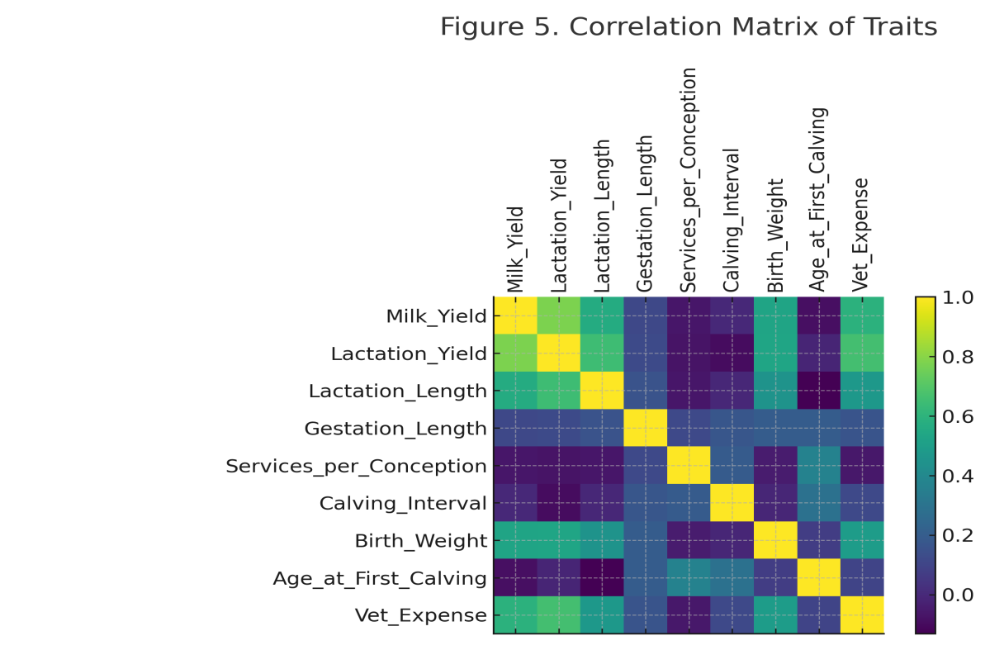
4.7 Breed adaptability to Bundelkhand conditions
The Bundelkhand region has a hot, semi-humid climate characterized by significant seasonal variations in temperature (min 3°C, max up to 49°C) and erratic rainfall (avg. 657-1169 mm), recurrent droughts, feed scarcity. Among the five breeds, Kenkatha and Tharparkar emerged as best adapted due to their ability to thrive on low-quality roughages, tolerate heat, and maintain reproductive efficiency even during lean periods.
Conversely, Sahiwal and Gir, though genetically superior in production, exhibited sensitivity to prolonged heat stress, requiring adequate cooling, balanced nutrition, and mineral supplementation. These findings align with the conclusions of Ahuja and Parmar & Habimana et al. 2017 [2, 7] who emphasized the physiological and behavioral adaptation mechanisms of Indian cattle, including increased sweating rate, thermoregulatory efficiency, and reduced feed intake during high THI period [17].
The Bundelkhand ecosystem favors breeds that can sustain productivity under nutritional stress. Therefore, integrated breeding programs that combine high-yielding Sahiwal or Gir sires with Kenkatha or Tharparkar dams could produce crossbreds suited to local constraints while maintaining indigenous resilience traits. By combining these complementary genetic strengths, the resulting crossbreds can express heterosis, improving traits such as growth rate, fertility, survivability, and moderate milk yield beyond the level of the dam breed.
4.8 Comparative ranking and breed potential
The weighted performance index (WPI) developed in this study offered a quantitative comparison of breed performance, integrating production, fertility, calf, and economic traits.
Sahiwal (92.4%) and Gir (89.7%) were top-ranked due to superior productivity, while Tharparkar and Haryana occupied intermediate positions.Kenkatha (70.9%), despite lower milk yield, performed best in low-input sustainability metrics—shortest calving interval, least veterinary cost, and earliest maturity. These findings align with Hossain et al. [8] who proposed context-specific breed utilization, high-yielding breeds for irrigated, resource-rich systems and hardy breeds like Kenkatha for arid and smallholder conditions. The breed hierarchy observed here also agrees with 20th livestock census data and NDDB evaluations of indigenous performance in northern India.
4.9 Relevance to climate resilience and sustainability
Indigenous cattle, particularly Kenkatha and Tharparkar, are invaluable in the context of climate change adaptation. Their thermos tolerance, drought resistance, and disease resilience position them as biological insurance against climatic variability in Bundelkhand. This study reinforces the growing recognition that sustainability cannot rely solely on productivity metrics i.e. Average Milk Yield, Lactation Production and Lactation Length. Rather, resilience, adaptability, and low maintenance costs are equally crucial indicators of long-term viability. Evidence on breed performance, adaptability and resilience under Bundelkhand-type environments enables policymakers to design breed-specific development strategies, such as selecting suitable sire lines, prioritizing hardy breeds for stress-prone zones, and directing limited resources toward the most promising genetic combinations.
5.Conclusion
Based on the comparative evaluation of five indigenous breeds, the key findings are summarized below. Genetic and environmental affects both significantly productive and reproductive performance traits. Sahiwal and Gir excelled in productivity; Kenkatha dominated in adaptability and disease resistance. Sahiwal remains the most promising dairy breed for semi-intensive systems in term of milk yield, lactation yield & fertility traits (service per conception, calving interval, age at first calving) in Bundelkhand region. By combining high yield with good fertility offers superior heat tolerance and milk fat quality, making it suitable for dry zones. Tharparkar provides an excellent balance between milk yield and drought resilience, ideal for semi-arid and low-input farms. Haryana cows demonstrated moderate production and fertility, potentially improving through selective breeding and better nutrition. Kenkatha, though low-yielding, represents a genetic reservoir for resilience traits (heat tolerance, low disease incidence, feed efficiency). Statistical correlations indicate positive association between milk yield and fertility traits, while veterinary cost inversely related to breed adaptability. The findings advocate a multi-breed utilization strategy with Promotion of Sahiwal and Gir in irrigated and peri-urban systems as well as strengthening the Kenkatha conservation and improvement in dryland and marginal zones. Overall, the findings provide a clear evidence base for designing climate-resilient breeding programs in the Bundelkhand region. By aligning future selection strategies with breed adaptability and productivity patterns observed in this study, regional livestock policies can more effectively promote sustainable dairy development, protect indigenous genetic resources, and enhance farmer livelihoods under Bundelkhand’s challenging agro-climatic conditions.
Disclaimer (Artificial intelligence)
Author(s) hereby declare that NO generative AI technologies such as Large Language Models (ChatGPT, COPILOT, etc) and text-to-image generators have been used during the writing or editing of this manuscript.
Competing interests
Authors have declared that no competing interests exist.

Disclaimer (Artificial intelligence)
Option 1:
Author(s) hereby declare that NO generative AI technologies such as Large Language Models (ChatGPT, COPILOT, etc.) and text-to-image generators have been used during the writing or editing of this manuscript.
Option 2:
Author(s) hereby declare that generative AI technologies such as Large Language Models, etc. have been used during the writing or editing of manuscripts. This explanation will include the name, version, model, and source of the generative AI technology and as well as all input prompts provided to the generative AI technology
Details of the AI usage are given below:
1.
2.
3.

6. References
- Ahlawat, S., & Sharma, R. (2022). Status, issues, and challenges of Indian livestock biodiversity. In Biodiversity in India: Status, Issues and Challenges (pp. 191-215). Singapore: Springer Nature Singapore.
- Ahuja, A., & Parmar, D. (2017). Role of minerals in reproductive health of dairy cattle: a review. International Journal of Livestock Research, 7(10), 16-26.
- Cassandro, M. (2014). Genetic aspects of fertility traits in dairy cattle–review. Acta agraria kaposváriensis, 18(1), 11-23.
- Dubey, M., & Kumar, N. (2025). Effects of De-worming on the Health Status and Milk Yield of Kenkatha Cattle in Bundelkhand Region of Uttar Pradesh. Journal of Animal Research, 15(3), 97-102.
- Galligan, D. (2006). Economic assessment of animal health performance. Veterinary Clinics: Food Animal Practice, 22(1), 207-227.
- Gupta, G., Palsaniya, D. R., Manjanagouda, S. S., Choudhary B. B., Upadhyay D., Patel, R. K., Singh, S. K., Chand, K., Pandey S., & Suman, M. (2025). Sustaining productivity and livelihood of livestock farmers of the Bundelkhand region through integrated farming system. Indian Journal of Agronomy (1st International Farming Systems Conference 2025, Special Issue) 70: S46-S53.
- Habimana, V., Nguluma, A. S., Nziku, Z. C., Ekine-Dzivenu, C. C., Morota, G., Mrode, R., & Chenyambuga, S. W. (2023). Heat stress effects on milk yield traits and metabolites and mitigation strategies for dairy cattle breeds reared in tropical and sub-tropical countries. Frontiers in Veterinary Science, 10, 1121499.
- Hossain, S. J., Kabir, M. A., Amin, M. R., Deb, G. K., Amanullah, S. M., Afroz, F. & Alam, M. S. (2021). Comparative study on productive and reproductive performances of indigenous, Red Chittagong Cattle, and crossbred cattle in Bangladesh. Journal of Agricultural Economics and Rural Development, 7(1): 952-956.
- Hussain, J., Roychoudhury, R., Das, G. C., Mili, D. C., & Goswami, R. N. (2012). Reproductive performance of dairy cows under field condition of Assam state. Indian Journal of Animal Research, 46(2), 180-183.
- Jeevan, C., Kanaka, K. K., Chethan Raj, R., & Harshitha, B. (2019). Prioritization of breeds for the conservation of animal genetic resources. Journal of Entomology and Zoology Studies, 7(1), 587-590.
- Kumar, T. N., Das, S., & Gulati, A. (2022). Dairy value chain. Agricultural Value Chains in India, 195.
- Mishra, G., Siddiqui, M. F., Ingle, V. S., & Pal, R. S. (2018). Genetic analysis of reproductive traits of Tharparker cattle at organized farms in Rajasthan. Indian Journal of Animal Research, 52(8), 1129-1133.
- Mondal, B., Loganandhan, N., & Channabasappa, K. (2007). Economic aspects of livestock enterprise in a semi-arid watershed. Indian Journal of Animal Research, 41(1), 26-30.
- Paneru, U., Sharma, M., Kolachhapati, M. R., & Shrestha, B. S. (2016). Evaluation of productive and reproductive performance of cattle in major dairy production area of Chitwan and Nawalparasi districts. Journal of Agriculture Science and Technology, 6(1), 69-75.
- Peixoto, M. G. C. D., Bruneli, F. Â. T., Bergmann, J. A. G., Santos, G. D., Carvalho, M. R. S., Brito, L. F., ... & Pires, M. (2016). Environmental and genetic effects on the temperament variability of Guzerá (Bos indicus) females. Livestock Research for Rural Development, 28(9), 159.
- Prasanna, J. S., Rao, S. T., Prakash, M. G., Rathod, S., Kalyani, P., & Sharma, M. R. (2023). Production and reproduction performance of sahiwal and HF× sahiwal cows. Indian Journal of Animal Research, 57(6), 698-701.
- Rashamol, V. P., Sejian, V., Bagath, M., Krishnan, G., Archana, P. R., & Bhatta, R. (2018). Physiological adaptability of livestock to heat stress: an updated review. Journal of Animal Behaviour and Biometeorology, 6(3), 62-71.
- Ratwan, P., Chakravarty, A. K., & Kumar, M. A. N. O. J. (2020). Lactation wise performance of Sahiwal cattle at an organized herd of northern India. Indian Journal of Animal Sciences, 90(8), 1179-1185.
- Rischkowsky, B., & Pilling, D. (2007). The state of the world's animal genetic resources for food and agriculture. Food & Agriculture Org..
- Sarang, S. K., Sreekumar, D., & Sejian, V. (2024). Indigenous cattle biodiversity in India: Adaptation and conservation. Reproduction and Breeding, 4(4), 254-266.
- Selvan, A. S., Tantia, M. S., Kumaresan, A., Kumar, A., Kumar, D. R., Karuthadurai, T., & Upadhyay, A. (2018). Phenotypic and genetic parameters estimation for birth weight in Zebu and crossbred calves born under organized farm conditions in India. International Journal of Livestock Research, 8(06), 48-58.
- Srivastava, A. K., Patel, J. B., Ankuya, K. J., Chauhan, H. D., Pawar, M. M., & Gupta, J. P. (2019). Conservation of indigenous cattle breeds. Journal of Animal Research, 9(1), 1-12.
- Thakur, S. S., Parmar, S. N. S., Joshi, C. G., Thakur, M. S., Sharma, R., & Chaudari, M. V. (2010). Genetic characterization of Malvi cattle using microsatellite markers. Indian Journal of Animal Sciences, 80(2), 138-41.
- Torshizi, M. E., Mashhadi, M. H., & Farhangfar, H. (2019). Different aspects of lactation persistency in dairy cows. The Indian Journal of Animal Sciences, 89(6), 607-614.
- Verma, D. K., Gautam, A., Panwar, A. S., Tiwari, P., Kakraliya, A. L., & Singh, S. (2025). Climate Resilient Dairy Farming: Prospect and Future Aspect. Journal of Experimental Agriculture International, 47(2), 83-94.
- Yadav, A. K., Singh, J., & Yadav, S. K. (2018). Characteristic features of Registered Indigenous Cattle breeds of India: A Review. Advances in Bioresearch, 9(1).
- Mehta, P., Kumar, V. & Shukla, G. (2013). Multivariate Analysis of Repeated Measures Data. Journal of Reliability and Statistical Studies, 6(1):131-148

