Seasonal Stress Induces Oxidative Imbalance, Hematological Changes, and Modulation of Key Metabolic Enzymes in Yorkshire Pigs
Abstract
Climate change driven heat stress increasingly challenges livestock and contributes to substantial production losses. Therefore, a comprehensive evaluation of the impact of seasonal stress is essential to understand these physiological disruptions and to develop strategies that can mitigate heat induced production losses. This study evaluated the impact of winter, spring and summer seasons on oxidative stress parameters, hematological and biochemical parameters in Yorkshire pigs reared under intensive production. A total of 24 healthy pigs (12 growers and 12 finishers) were monitored, and blood samples were collected during each season for analysis. Oxidative stress assessment revealed markedly elevated activity of glutathione reductase, significantly low reduced glutathione levels and further elevated malondialdehyde levels during summer season. This confirms oxidative stress with enhanced lipid peroxidation compromising the integrity of the cells. Hematological results showed significantly lower hemoglobin and packed cell volume during winter and summer, with the decline more evident in summer. Total leukocyte count decreased significantly in summer, accompanied by elevated neutrophil percentage, reduced lymphocyte percentage and an increased neutrophil-to-lymphocyte ratio, likely associated with compromised membrane integrity under seasonal stress. Metabolic enzymes, including alanine transaminase, aspartate transaminase, gamma glutamyl transferase and lactate dehydrogenase, recorded significantly higher activities during summer, suggesting heat induced metabolic strain and potential tissue leakage. Our findings demonstrate that seasonal stress, particularly summer heat, leads to marked oxidative imbalance and hemato-biochemical alterations in Yorkshire pigs. Understanding these physiological responses is essential for developing management strategies to mitigate the adverse effects of thermal stress on pig health and productivity.
INTRODUCTION
Animal husbandry plays an important role in development of the country especially for the rural community. India, with the highest livestock population, possesses 11.54% of the total world livestock population (1). Different hereditary traits of pigs like high feed conversion efficiency, high fecundity, short generation interval and early maturation contribute to the greater potential to help farmers see a faster rate of economic return as compared to other livestock species (2). Different factors affecting the development of livestock includes climate, health, diseases and nutrition, among which, climate plays the most significant factor (3). The global climate change has accelerated due to different human activities in the recent years leading to drastic changes in the atmospheric temperature and humidity. Climate change affects the livestock production with a rise in livestock diseases, environmental stress and biodiversity loss and by competition for natural resources, quantity and quality of feeds (3, 4).
The Thermo-Neutral Zone (TNZ) is the ambient temperature range in which animals maintain physiological functions with minimal energy expenditure (5). In pigs, the TNZ is narrow (18–25°C), making them highly susceptible to heat stress due to their limited sweating ability and thick subcutaneous fat (6, 7). Acclimatization to the extreme weather can inflict different behavioural, physiological and metabolically adaptive responses aimed at maintaining their homeostasis; which causes stress to the animals thus leading to decrease in the health status (8). Exposure to temperatures beyond the TNZ disrupts homeostasis and triggers behavioural and physiological adaptations such as wallowing, reduced gut blood flow, elevated body temperature and respiration rate that ultimately impair growth, metabolism and production (9, 10, 11).
With the rapid progression of global warming and climate change, there is an urgent need for a comprehensive understanding of the physico-biochemical changes that occur in animals exposed to heat stress. Adaptation to heat stress results in increased production of reactive oxygen species (ROS), often exceeding the neutralizing capacity of endogenous antioxidants (4, 12). This imbalance leads to ROS accumulation, which damages cell membranes and intracellular components, ultimately causing oxidative stress (13). Oxidative stress compromises cellular integrity by altering membrane permeability and disrupting normal physiological functions (4). Therefore, the aim of this study was to evaluate seasonal variations in oxidative stress markers, hematological parameters and metabolic enzymes in grower and finisher pigs during winter, spring and summer.
MATERIALS AND METHOD
Experimental animals
All experimental procedures were conducted in accordance with the guidelines approved by the Institutional Animal Ethics Committee (IAEC), Guru Angad Dev Veterinary and Animal Sciences University (GADVASU), Ludhiana (Memo No. GADVASU/2020/IAEC/54/07). A total of 24 healthy Yorkshire pigs were selected from a local pig farm in Ludhiana, Punjab. These comprised 12 grower pigs (3–4 months old; 6 males and 6 females) and 12 finisher pigs (6–7 months old; 6 males and 6 females). All animals were reared under an intensive management system and provided with a standard diet and ad libitum access to water.
Blood sample collection and plasma separation
4 mL of blood was collected from each animal into both heparinized and EDTA-coated vacutainer tubes during the morning hours in three different seasons: winter (December–January), spring (February–March), and summer (April–May). Plasma was separated by centrifuging the blood samples in a Remi R-8C laboratory centrifuge at 3000 rpm for 15 minutes. The collected plasma was aliquoted and stored at –20°C until biochemical analyses were performed.
Oxidative stress parameters
Erythrocytic malondialdehyde (MDA), an indicator of lipid peroxidation, was estimated using the method described by Placer et al. (1966) (14), which involves the measurement of thiobarbituric acid reactive substances. Glutathione reductase activity was measured following the procedure of Krohne-Ehrich et al. (1977) (15). Whole-blood reduced glutathione (GSH) was determined using Ellman’s method (1959) (16), based on the reaction of GSH with 5,5′-dithiobis-(2-nitrobenzoic acid) (DTNB) to form a yellow colored 5-thio-2-nitrobenzoic acid derivative.
Hematological parameters
Hemoglobin (Hb) concentration was determined using the method given by Dacie and Lewis (17). Packed cell volume (PCV) was measured using the microhematocrit technique. Differential leukocyte count (DLC) was performed with Giemsa staining, and total leukocyte count (TLC) was determined using a hemocytometer.
Metabolic enzymes
Plasma activities of alkaline phosphatase (ALP), alanine aminotransferase (ALT), aspartate aminotransferase (AST), gamma-glutamyl transferase (GGT), and lactate dehydrogenase (LDH) were analyzed using Erba Mannheim kits on a Merck semi-automatic chemistry analyzer.
Statistical analysis
Data for all parameters were analyzed using three-way analysis of variance (ANOVA) in the Statistical Package for Social Sciences (SPSS), version 26 (IBM Corp) (18). Statistical significance was set at p < 0.05. Results are presented as mean ± standard error.
RESULTS
Oxidative stress parameters
The levels of MDA and GSH, as well as the activity of glutathione reductase, were evaluated to assess the seasonal effects on oxidative stress. MDA concentrations were significantly higher (p < 0.05) in the summer than in the winter and spring, and winter values were also significantly higher (p < 0.05) than those observed in spring (Fig. 1A, Table 1).
GSH levels were highest in spring and lowest in summer. Across all groups, GSH concentrations were significantly reduced (p < 0.05) in summer compared to winter and spring, and winter values were likewise significantly lower (p < 0.05) than those in spring (Fig. 1B, Table 1).
Glutathione reductase activity was highest in summer, intermediate in winter, and lowest in spring (Fig. 1C, Table 1). In all groups, glutathione reductase activity was significantly elevated (p < 0.05) in summer compared to winter and spring. Additionally, glutathione reductase activity in winter was significantly higher (p < 0.05) than in spring (Fig. 1C, Table 1).
Hematological parameters
Across all groups, the mean values of Hb and PCV were significantly lower (p < 0.05) during the winter and summer seasons compared to spring, with the reduction more pronounced in summer (Table 2). TLC also declined significantly (p < 0.05) during summer. The mean percentage of neutrophils was significantly higher (p < 0.05), whereas the percentage of lymphocytes was significantly lower (p < 0.05), in both winter and summer relative to spring (Table 2). Consequently, the mean neutrophil to lymphocyte (N:L) ratio was significantly elevated (p < 0.05) during winter and summer compared with spring (Table 2).
Metabolic enzymes
Mean values of metabolic enzymes showed significant seasonal variation (Table 3). The highest activities of ALT, GGT, and LDH were recorded during summer, while the lowest values were observed in spring. ALT and GGT were significantly higher (p < 0.05) in both summer and winter compared to spring (Table 3). Additionally, ALP and GGT values were significantly higher (p < 0.05) in summer compared to winter. LDH and AST levels were significantly elevated (p < 0.05) in summer across all groups relative to winter and spring, with no significant differences between winter and spring. Season, age, and gender showed no significant effect on plasma ALP concentrations (Table 3).
DISCUSSION
Rising global temperatures demand a clearer understanding of how heat stress alters physiological and biochemical processes in livestock. In this study, we investigated seasonal variations in oxidative stress indicators, hematological parameters, and metabolic enzyme activities in grower and finisher pigs. Under normal physiological conditions, cells maintain a highly reduced intracellular environment, and reduced glutathione (GSH) serves as a principal biomarker of redox balance (19).
In our study, the average THI values recorded during winter, spring, and summer were 48.23, 66.32, and 79.92, respectively (data not shown). According to the National Weather Service Central Region, THI values more than 75 indicate an alert condition, values between 79 and 83 are considered dangerous, particularly for confined livestock such as pigs, and THI values more than 84 represent an emergency situation (20). Based on these thresholds, the THI recorded during summer in our study fell within the “dangerous” category, clearly reflecting substantial heat load on the animals. Although the winter THI was comparatively low, pigs possess substantial subcutaneous adipose insulation and efficient thermoregulatory adaptations—such as behavioral adjustments, reduced peripheral blood flow, and increased metabolic heat production—that collectively minimize cold-induced physiological strain.
Heat stress is known to elevate ROS production and disrupt cellular redox homeostasis (21). Elevated ROS oxidize GSH to its disulfide form, GSSG, which is subsequently reduced back to GSH by glutathione reductase using NADPH to preserve intracellular reducing potential. In the present study, glutathione reductase activity was significantly higher during summer than in winter and spring, with winter also showing elevated activity relative to spring (Fig. 1C). At the same time, reduced GSH concentrations declined markedly during summer (Fig. 1B). These patterns align with findings reported across cattle, goats, sheep, buffaloes, broilers, quails, and pigs (22, 23, 24, 25, 26, 27, 28, 29, 30, 31, 32). Collectively, the increased glutathione reductase activity in conjunction with diminished GSH levels provides compelling evidence of intensified oxidative pressure during summer, and to a lesser degree during winter.
Oxidative stress promotes lipid peroxidation, compromising membrane integrity (34). MDA, a terminal product of polyunsaturated fatty acid peroxidation (35), increased significantly during both winter and summer (Fig. 1A), with the highest levels observed in summer. This trend reflects elevated ROS-mediated damage to erythrocytic membranes (36) and corroborates earlier seasonal reports in cattle, buffalo, poultry, sheep, goats, and pigs (22, 23, 26, 27, 28, 29, 30, 31, 32, 36). These findings strongly suggest that both thermal extremes, especially summer, impose marked oxidative stress on pigs.
Oxidative stress often leads to hematological alterations due to membrane damage and impaired erythropoiesis (33, 37). In our study, Hb and PCV values were lowest in summer, moderate in winter, and highest in spring (Table 2). TLC also declined significantly in summer. Neutrophils increased, while lymphocytes decreased during both winter and summer, resulting in an elevated N:L ratio—consistent with stress leukogram patterns. These findings match earlier reports in pigs, goats, and cattle (36, 38, 39, 40, 41, 42). Heat stress may suppress erythropoiesis, increase respiratory effort, and promote oxidative hemolysis, while reduced feed intake may further limit key nutrients required for hemoglobin synthesis.
To assess metabolic responses to seasonal stress, we evaluated ALP, AST, GGT, and LDH. AST, GGT, and LDH increased significantly during summer (Table 3). Our results indicate greater cellular stress and leakage of hepatic and muscular enzymes. LDH elevations during heat stress have been widely reported in pigs and cattle (43, 44, 45). GGT also increased in summer and winter, consistent with earlier studies in goats and pigs (46, 47). Although ALP showed a nonsignificant decrease in summer, higher winter ALP activity may reflect compensatory adjustments in vitamin D metabolism (39). Seasonal increases in AST and ALT have also been documented across livestock species (32, 40, 45, 48, 49). These enzyme shifts highlight a marked physiological challenge during summer, characterized by increased cellular leakage and altered hepatic and muscular function.
Effective management of heat stress is crucial for maintaining livestock health and performance. Taurine and functional feed additives, such as probiotics, prebiotics, and phytochemicals, support growth, gut health, and immune function while mitigating oxidative and inflammatory effects of heat stress (50, 51). Environmental strategies, including cooling systems and optimized housing with shading and reflective materials, further reduce heat load and energy expenditure, stabilizing the animal’s microclimate (52, 53). Together, nutritional and environmental strategies can substantially mitigate the adverse effects of high ambient temperatures on animal welfare and productivity.
CONCLUSION
Overall, the present study demonstrates that seasonal stress especially heat stress induces a marked oxidative burden in Yorkshire pigs, characterized by elevated glutathione reductase activity, depleted GSH levels, and increased erythrocytic lipid peroxidation. These oxidative disruptions appear to compromise cellular and membrane integrity, contributing to altered hematological profiles, including reduced Hb, PCV and TLC, alongside shifts in neutrophil and lymphocyte proportions. Concurrent elevations in metabolic enzymes such as AST, GGT and LDH further indicate seasonal stress related alterations in hepatic and muscular cellular function, likely driven by oxidative damage and metabolic shifts such as increased gluconeogenesis during reduced feed intake. Collectively, these findings highlight the profound physiological strain imposed by extreme seasonal temperatures, underscoring the need for targeted management strategies to mitigate heat induced oxidative and metabolic disturbances in pigs.
Acknowledgments
The authors would like to share their gratitude to the Dean, College of Veterinary Science and Director of Research, GADVASU, Ludhiana for providing the infrastructure and other necessary facilities to perform this research.

Conflict of interest
None reported.
Disclaimer (Artificial intelligence)
Author(s) hereby declare that NO generative AI technologies such as Large Language Models (ChatGPT, COPILOT, etc.) and text-to-image generators have been used during the writing or editing of this manuscript.

References
- Singh, A. (2020). Livestock Production Statistics of India–2019. Originally uploaded at www. vetextension. com and updated till, 9, 19. DOI: 10.13140/RG.2.2.32034.86721
- Knap, P. W., Knol, E. F., Sørensen, A. C., Huisman, A. E., van der Spek, D., Zak, L. J., ... & Lewis, C. R. (2023). Genetic and phenotypic time trends of litter size, piglet mortality, and birth weight in pigs. Frontiers in Animal Science, 4, 1218175. https://doi.org/10.3389/fanim.2023.1218175
- Cheng, M.; McCarl, B.; Fei, C. (2022). Climate Change and Livestock Production: A Literature Review. Atmosphere, 13, 140. https://doi.org/10.3390/atmos13010140.
- Prates, J. A. (2025). Heat Stress Effects on Animal Health and Performance in Monogastric Livestock: Physiological Responses, Molecular Mechanisms, and Management Interventions. Veterinary Sciences, 12(5), 429. doi: 10.3390/vetsci12050429
- Edition, T. (2001). Glossary of terms for thermal physiology. The Japanese Journal of Physiology, 51(2), 245.
- EFSA Panel on Animal Health and Welfare (AHAW), Nielsen, S. S., Alvarez, J., Bicout, D. J., Calistri, P., Depner, K., ... & Velarde, A. (2020). Welfare of pigs at slaughter. Efsa Journal, 18(6), e06148. DOI: 10.2903/j.efsa.2020.6148
- Mayorga, E. J., Renaudeau, D., Ramirez, B. C., Ross, J. W., & Baumgard, L. H. (2019). Heat stress adaptations in pigs. Animal Frontiers, 9(1), 54-61. DOI: 10.1093/af/vfy035
- Bernabucci, U.; Lacetera, N.; Baumgard, L. H.; Rhoads, R. P.; Ronchi, B.; Nardone, A. (2010). Metabolic and hormonal acclimation to heat stress in domesticated ruminants. animal, 4(7), 1167–1183. doi:10.1017/S175173111000090X.
- Silva, B. A., Noblet, J., Donzele, J. L., Oliveira, R. F., Primot, Y., Gourdine, J. L., & Renaudeau, D. (2009). Effects of dietary protein level and amino acid supplementation on performance of mixed-parity lactating sows in a tropical humid climate. Journal of animal science, 87(12), 4003–4012. https://doi.org/10.2527/jas.2008-1176
- Ross, J. W., Hale, B. J., Gabler, N. K., Rhoads, R. P., Keating, A. F., & Baumgard, L. H. (2015). Physiological consequences of heat stress in pigs. Animal Production Science, 55(12), 1381-1390. https://doi.org/10.1071/AN15267
- Teixeira, A. D. R., Veroneze, R., Moreira, V. E., Campos, L. D., Januário Raimundi, S. C., & Reis Furtado Campos, P. H. (2021). Effects of heat stress on performance and thermoregulatory responses of Piau purebred growing pigs. Journal of thermal biology, 99, 103009. https://doi.org/10.1016/j.jtherbio.2021.103009
- Mujahid, A., Akiba, Y., & Toyomizu, M. (2004). Acute Heat Stress Induces Oxidative Stress and Decreases Adaptation in Young White Leghorn Cockerels by Downregulation of Avian Uncoupling Protein. Poultry Science, 86(2), 364–371. https://doi.org/10.1093/ps/86.2.364
- Slimen, I.B.; Najar, T.; Ghram, A.; Dabbebi, H.; Mrad, B.; Abdrabbah, M. (2014). Reactive oxygen species, heat stress and oxidative induced mitochondrial damage. A review. Int. J. Hyperth. 30, 513–523. https://doi.org/10.3109/02656736.2014.971446
- Placer, Z. A., Cushman, L. L., & Johnson, B. C. (1966). Estimation of product of lipid peroxidation (malonyl dialdehyde) in biochemical systems. Analytical biochemistry, 16(2), 359–364. https://doi.org/10.1016/0003-2697(66)90167-9
- Krohne-Ehrich, G., Schirmer, R. H., & Untucht-Grau, R. (1977). Glutathione reductase from human erythrocytes. Isolation of the enzyme and sequence analysis of the redox-active peptide. European Journal of Biochemistry, 80(1), 65–71. DOI: 10.1111/j.1432-1033.1977.tb11856.x
- Ellman, G. L. (1959). Tissue sulphydryl groups. Archives of Biochemistry and Biophysics, 82, 70-77. DOI: 10.1016/0003-9861(59)90090-6
- Bain, B. J., Bates, I., Laffan, M. A., & Lewis, S. M. (2011). Dacie and Lewis practical haematology (11th ed.). Churchill Livingstone / Elsevier. https://doi.org/10.1016/b0-443-06660-4/x5001-6.
- IBM Corp. Released 2019. IBM SPSS Statistics for Windows, Version 26.0. Armonk, NY: IBM Corp
- Sies, H., Mailloux, R.J. & Jakob, U. (2024). Fundamentals of redox regulation in biology. Nat Rev Mol Cell Biol 25, 701–719. https://doi.org/10.1038/s41580-024-00730-2
- Huynh, T. T. T., Aarnink, A. J. A., Verstegen, M. W. A., Gerrits, W. J. J., Heetkamp, M. J. W., Kemp, B., & Canh, T. T. (2005). Effects of increasing temperatures on physiological changes in pigs at different relative humidities. Journal of animal science, 83(6), 1385-1396. https://doi.org/10.2527/2005.8361385x
- Emami, N. K., Greene, E. S., Kogut, M. H., & Dridi, S. (2021). Heat Stress and Feed Restriction Distinctly Affect Performance, Carcass and Meat Yield, Intestinal Integrity, and Inflammatory (Chemo)Cytokines in Broiler Chickens. Frontiers in physiology, 12, 707757. https://doi.org/10.3389/fphys.2021.707757
- Bernabucci, U., Ronchi, B., Lacetera, N., & Nardone, A. (2002). Markers of oxidative status in plasma and erythrocytes of transition dairy cows during hot season. Journal of Dairy Science, 85, 2173-2179. DOI: 10.3168/jds.S0022-0302(02)74296-3
- Altan, Ö., Pabuçcuoǧlu, A., Altan, A., Konyalioǧlu, S., & Bayraktar, H. (2003). Effect of heat stress on oxidative stress, lipid peroxidation and some stress parameters in broilers. British Poultry Science, 44(4), 545–550. https://doi.org/10.1080/00071660310001618334
- Kataria, N., Kataria, A. K., & Maan, R. (2010). Evaluation of oxidative stress due to hot environmental condition in healthy Marwari goats from arid tract in India. Philippine Journal of Veterinary and Animal Sciences, 36(2), 175-184.
- Maan, R., Kataria, N., Pilania, P. K., Sharma, A., Sankhala, L. N., & Kataria, A. K. (2013). Fluctuations of serum glutathione reductase activities due to changes in extreme ambient temperatures in Marwari sheep from arid tracts. Extreme Life, Biospeology and Astrobiology, 5(1), 9-13.
- Sahin, K., Orhan, C., Akdemir, F., Tuzcu, M., Iben, C., & Sahin, N. (2012). Resveratrol protects quail hepatocytes against heat stress: modulation of the Nrf2 transcription factor and heat shock proteins. Journal of Animal Physiology and Animal Nutrition, 96(1), 66–74. DOI: 10.1111/j.1439-0396.2010.01123.x
- Zachut, M., Kra, G., Livshitz, L., Portnick, Y., Yakoby, S., Friedlander, G., & Levin, Y. (2017). Seasonal heat stress affects adipose tissue proteome toward enrichment of the NRF-2-mediated oxidative stress response in late-pregnant dairy cows. Journal of Proteomics, 158, 52–61. DOI: 10.1016/j.jprot.2017.02.011
- Chaudhary, S. S., Singh, V. K., Upadhyay, R. C., Puri, G., Odedara, A. B., & Patel, P. A. (2015). Evaluation of physiological and biochemical responses in different seasons in Surti buffaloes. Veterinary World, 8(6), 727–731. DOI: 10.14202/vetworld.2015.727-731
- Rathwa, S. D., Vasava, A. A., Pathan, M. M., Madhira, S. P., Patel, Y. G., & Pande, A. M. (2017). Effect of season on physiological, biochemical, hormonal, and oxidative stress parameters of indigenous sheep. Veterinary world, 10(6), 650–654. DOI: 10.14202/vetworld.2017.650-654
- Lakhani, P., Alhussien, M. N., Lakhani, N., Jindal, R., & Nayyar, S. (2018). Seasonal variation in physiological responses, stress and metabolic-related hormones, and oxidative status of Murrah buffaloes. Biological Rhythm Research, 1–9. DOI: 10.1080/09291016.2018.1424775
- Sahoo, R., Nayyar, S., Singh, C., Kaswan, S., Kakkar, S. S., & Jindal, R. (2020). Effect of fenugreek seeds and probiotic supplementation on antioxidant status and milk production in heat stressed Beetal Goats. Indian Journal of Animal Research, 54(11), 1379-1384. DOI: 10.18805/ijar.B-3892
- Karthik, D., Suresh, J., Reddy, Y. R., Sharma, G. R. K., Ramana, J. V., Gangaraju, G., Reddy, P. P. R., Reddy, Y. P. K., Yasaswini, D., Adegbeye, M. J., & Reddy, P. R. K. (2021). Adaptive profiles of Nellore sheep with reference to farming system and season: physiological, hemato-biochemical, hormonal, oxidative-enzymatic and reproductive standpoint. Heliyon, 7(5), e07117. https://doi.org/10.1016/j.heliyon.2021.e07117
- Obeagu, E. I., Igwe, M. C., & Obeagu, G. U. (2024). Oxidative stress’s impact on red blood cells: Unveiling implications for health and disease. Medicine, 103(9), e37360. DOI: 10.1097/MD.0000000000037360
- Gaschler, M. M., & Stockwell, B. R. (2017). Lipid peroxidation in cell death. Biochemical and biophysical research communications, 482(3), 419–425. https://doi.org/10.1016/j.bbrc.2016.10.086
- Eze, C. C., Nwamba, H. O., Omeje, F. U., Anukwu, J. U., Okpe, M. N., & Nwani, C. D. (2021). Effects of diclofenac on the oxidative stress parameters of freshwater fish Oreochromis niloticus. Journal of Applied Life Sciences International, 24(10), 44-51. https://doi.org/10.9734/jalsi/2021/v24i1030267
- Cui, Y., Wang, C., Hao, Y., Gu, X., & Wang, H. (2019). Chronic heat stress induces acute phase responses and serum metabolome changes in finishing pigs. Animals, 9(7). https://doi.org/10.3390/ani9070395
- Fibach, E., & Rachmilewitz, E. (2008). The role of oxidative stress in hemolytic anemia. Current molecular medicine, 8(7), 609–619. https://doi.org/10.2174/156652408786241384
- Koubková, M., Knížková, I., Kunc, P., Härtlová, H., Flusser, J., & Doležal, O. (2002). Influence of high environmental temperatures and evaporative cooling on some physiological, hematological and biochemical parameters in high-yielding dairy cows. Czech J Anim Sci., 47(8), 309-318.
- Mayengbam, P., & Tolenkhomba, T.C. (2015). Seasonal variation of hemato-biochemical parameters in indigenous pig: Zovawk of Mizoram. Vet World., 8(6), 732-737. doi:10.14202/vetworld.2015.732-737
- Banerjee, D., Upadhyay, R.C., Chaudhary, U.B., Kumar, R., Singh, S., Ashutosh, Das, T.K., & De, S. (2015). Seasonal variations in physio-biochemical profiles of Indian goats in the paradigm of hot and cold climate. Biol Rhythm Res, 46(2), 221-236. doi:10.1080/09291016.2014.984999
- Morar, D., Ciulan, V., Simiz, F., Moț, T., Hutu, I., & Văduva, C. (2018). Effect of heat stress on haematological parameters in dairy cows. Animal Breed. Pathol. Day, 51, 65-70. DOI: 10.13140/RG.2.2.36806.22081
- Palova N, Marchev Y, Nedeva R, Nakev J, Krusheva D, Slavov T, Nedeva I, & Popova T. (2019). Hematological and serum biochemical profile in East Balkan pigs at different age and seasons. AGROFOR International Journal., 4(3), 164-175. DOI: 10.7251/AGRENG1903164P
- Chu G and Song Y. 2013. Growth performance, blood characteristics and immune responses of fattening pigs in different seasons. Asian Journal of Animal and Veterinary Advances., 8(5), 691-702. DOI: 10.3923/ajava.2013.691.702
- Vashi Y, Naskar S, Chutia T, et al. 2018. Comparative assessment of native, crossbred and exotic pigs during different seasons (winter, spring and summer) based on rhythmic changes in the levels of serum cortisol, lactate dehydrogenase levels and PBMC HSP-70 mRNA expression pattern. Biol Rhythm Res., 49(5):725-734. doi:10.1080/09291016.2017.1410019
- Borah S, Soren S, Talukdar R, et al. 2020. Study on the effect of seasonal variation on expression of serum biochemicals in pigs. Indian J Anim Sci., 90(9), 1265-1269. DOI: 10.56093/ijans.v90i9.109487
- Chmielowiec-Korzeniowska A, Tymczyna L, Babicz M. 2012. Assessment of selected parameters of biochemistry, hematology, immunology and production of pigs fattened in different seasons. Arch Anim Breed., 55(5), 469-479. doi:10.5194/aab-55-469-2012
- Ribeiro NL, Costa RG, Pimenta Filho EC, et al. 2016. Adaptive profile of Garfagnina goat breed assessed through physiological, haematological, biochemical and hormonal parameters. Small Rumin Res., 144(November), 236-241. doi:10.1016/j.smallrumres.2016.10.001
- Shaffer, L., Roussel, J.D, & Koonce, K.L. 1981. Effects of age, temperature-season, and breed on blood characteristics of dairy cattle. Journal of Dairy Science., 64(1), 62-70. DOI: 10.3168/jds.S0022-0302(81)82529-5
- Huang S, Yang H, Ur Rehman M, Tong Z. 2018. Acute heat stress in broiler chickens and its impact on serum biochemical and electrolyte parameters. Indian J Anim Res., 52(5), 683-686. doi:10.18805/ijar.v0iOF.8490
- Reddy, P. B., Goud, P. M. K., Katam, D., & Supriya, R. (2023). Nutritional strategies for amelioration of heat stress in dairy cows : A Review. 8(3), 33–39. DOI: https://doi.org/10.22271/veterinary.2023.v8.i3Sa.613
- He, Y., Maltecca, C., & Tiezzi, F. (2021). Potential Use of Gut Microbiota Composition as a Biomarker of Heat Stress in Monogastric Species : A Review. https://doi.org/10.3390/ani11061833
- Sesay, A. R. (2023). Effect of heat stress on dairy cow production , reproduction , health , and potential mitigation strategies. 13–25. https://doi.org/10.21839/jaar.2023.v8.8371
- Silva, T. D. De, Sarada, S. A., & Pagthinathan, M. (2024). Effect of Heat Stress on Cattle : A Review. 3(2), 135–151. DOI: https://doi.org/10.31357/ait.v3i2.7339

Fig. 1: Oxidative stress parameters. Erythrocytic MDA was estimated following Placer et al. (1966) (14). Glutathione reductase activity was assayed as per Krohne-Ehrich et al. (1977) (15). Whole-blood GSH was determined using Ellman’s method (1959) (16). Data are presented as Mean ± SEM (n = 6). The values with different lower-case letters (a, b, c) superscripts indicate significant difference at p < 0.05 between seasons.

Fig. 1A

Fig. 1B

Fig. 1C
Table 1: Oxidative stress parameters.
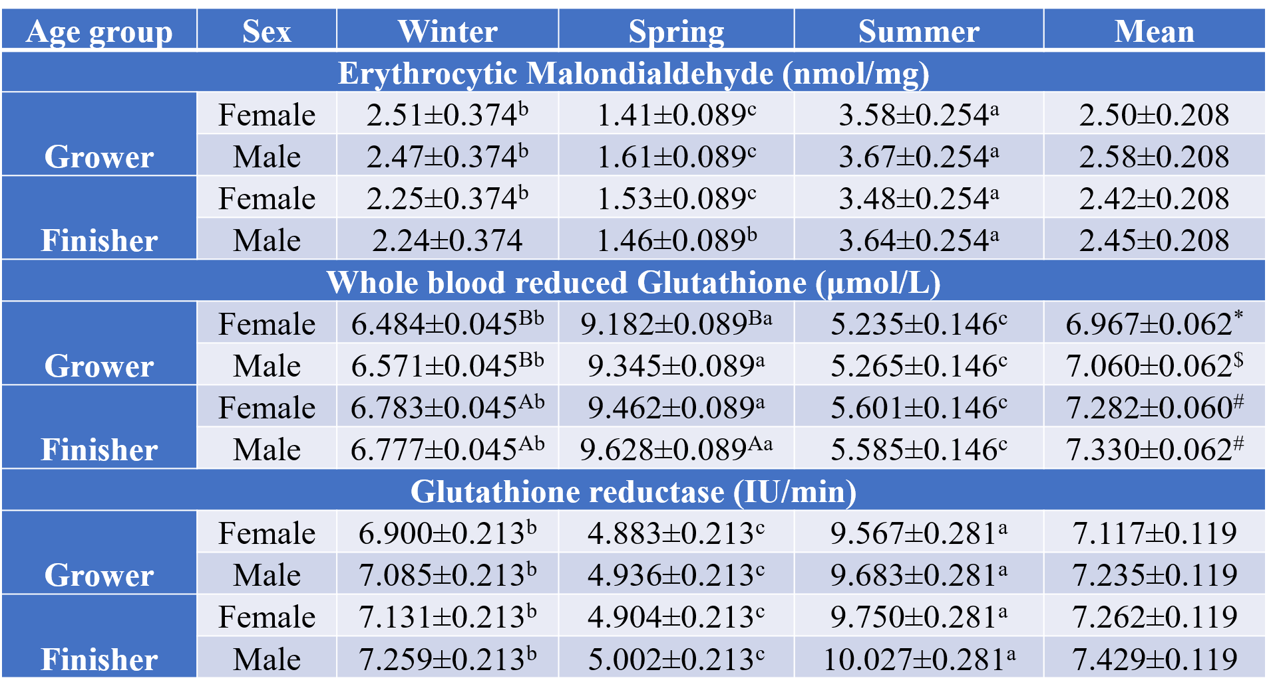
Table 2. Seasonal variations in hematological parameters. Hb was measured following method from Dacie and Lewis practical haematology (17), PCV by the microhematocrit method, DLC using Giemsa-stained smears, and TLC using a hemocytometer. Data are presented as Mean ± SEM (n = 6). Different lowercase superscripts (a, b, c) denote significant differences among seasons (p < 0.05), while symbols (*, #, $) indicate significant differences among age groups (p < 0.05).

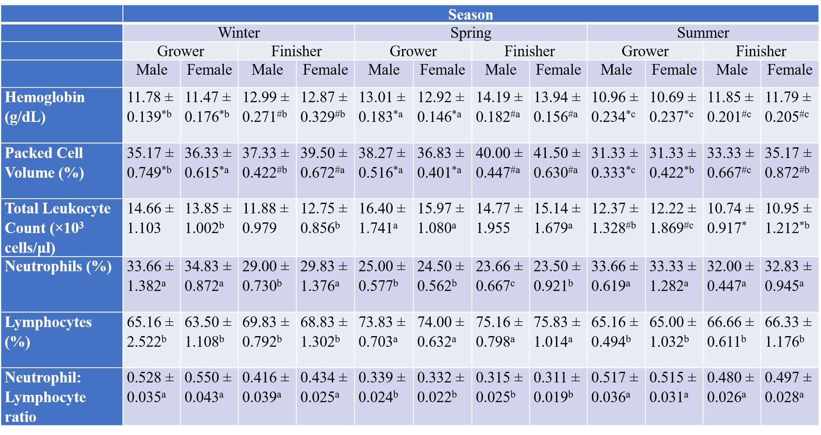
Table 3: Seasonal variations in metabolic enzyme activities. Plasma levels of ALP, ALT, AST, GGT, and LDH were measured using Erba Mannheim kits on a semi-automatic chemistry analyser (Merck). Data are presented as Mean ± SEM (n = 6). The values with different lower-case letters (a, b, c) superscripts indicate significant difference at p < 0.05 between seasons.

