Navigating Constraints and Exploring Solutions: A Review on Subject Matter Specialists (SMSs) in KVKs in India
Abstract
Krishi Vigyan Kendras (KVKs) are India's front-line institutions for technology evaluation, improvement, and distribution; nevertheless, ongoing structural and operational limitations frequently impede the efficacy of Subject Matter Specialists (SMSs), who are essential to these responsibilities. In order to identify and classify the main constraints affecting SMS performance, this review critically synthesizes material from eight peer-reviewed publications published between 2013 and 2023, supplemented by government reports and secondary literature. To create a thorough understanding of the difficulties inside the agricultural innovation system, constraints were categorized into technological, administrative, economical, ICT-related, and personal domains. According to the analysis, 28.57% of the reviewed studies reported technological gaps, such as inadequate climate-resilient practices, limited access to emerging innovations, and weak linkages for technology refinement; an equal percentage highlighted administrative barriers, such as staff shortages, delayed fund flow, inadequate mobility support, and poor inter-departmental coordination. Similarly, socioeconomic limitations specifically, poor farmer awareness, high input costs, and restricted risk-taking capacity were highlighted in 28.57% of research. Poor digital infrastructure, inadequate ICT training, and limited adoption of digital extension tools were the main causes of the 14.29% of studies that reported ICT-related problems. SMS underperformance is made worse by cross-cutting issues such fragmented institutional support, limited field exposure, and inadequate capacity building. The results imply that SMSs will continue to be underutilized until these complex limitations are addressed comprehensively, jeopardizing KVKs' ability to improve farmer knowledge, encourage technology adoption, and bolster agricultural resilience. Key policy imperatives to realign KVK operations toward greater efficacy, inclusivity, and sustainability include strengthening ICT-enabled extension systems, guaranteeing timely fund allocation, enhancing capacity development, and mainstreaming SMS roles within climate-smart and digital agriculture frameworks.
Keywords: Constraints, Suggestions, Subject Matter Specialists, Problems, KVKs, Review

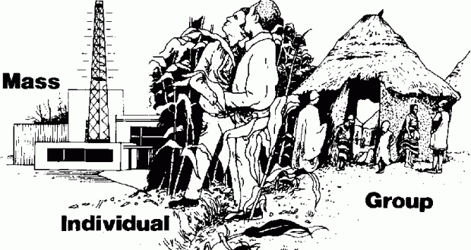

Graphical Abstract
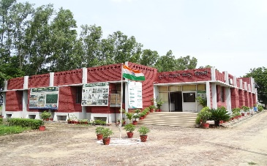
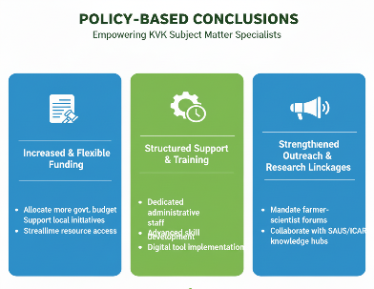
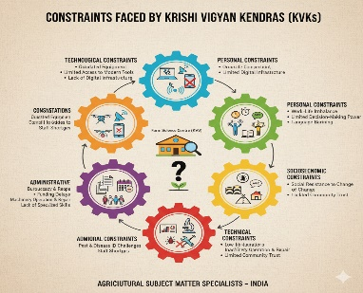
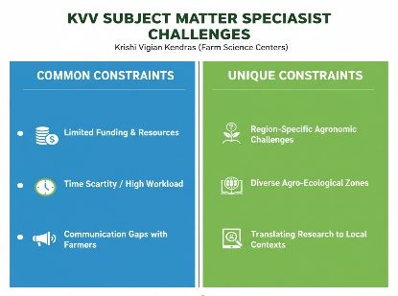

Introduction
Agriculture in India faces tremendous problems, such as resource degradation, climate variability, and diminishing farm profitability. The Indian Council of Agricultural Research (ICAR) created Krishi Vigyan Kendras (KVKs) as district-level hubs for technology evaluation, improvement, and capacity building to close the gap between farmers and research institutions (Das, 2007; Kumari et al., 2020). These organisations, which now have 731 KVKs in operation, are vital hubs for skill development, livelihood improvement, and participatory technology transfer (Gautam et al., 2024).
It is impossible to exaggerate the importance of Subject Matter Specialists (SMSs) in KVKs. SMSs are tasked with performing on-farm testing (OFTs), frontline demonstrations (FLDs), farmer training, and stakeholder convergence in their capacity as frontline scientists. The degree to which farming communities’ profit from scientific advancements depends on their capacity to efficiently spread technologies (Bashir & Narmatha, 2016). However, SMSs usually face obstacles that hinder their effectiveness, such as a lack of institutional support, administrative workloads, and obstacles at the farmer level (Ramannanavar & Nagnur, 2019).
The research that is currently available indicates that these limitations are multifaceted. Adoption potential is diminished by technological obstacles like the lack of location-specific innovations (Kumar & Kaur, 2015), and the digital extension mandate is compromised by ICT-related bottlenecks such inadequate internet connectivity (Kale et al., 2017; Dashora & Henry, 2022). Extension initiatives are further complicated by socioeconomic constraints such manpower shortages, conservative farmer attitudes, and market price changes (Talukdar et al., 2023). Together, these problems undermine SMSs' productivity and morale, especially when combined with individual difficulties like insufficient rewards and an unbalanced work-life schedule.
Studying these challenges is critical for three reasons. First, SMSs represent the backbone of the KVK system, and their constraints directly affect the reach and impact of agricultural innovations. Second, regional disparities in constraints call for customised policy responses rather than one-size-fits-all solutions (Lalhmachhuana & Devarani, 2017). Third, with agriculture increasingly reliant on climate-smart and ICT-enabled practices, resolving SMSs’ systemic challenges is essential to ensure effective scaling of technologies for resilience and sustainability (ICAR, 2023a; ICAR, 2023b). Hence, this review consolidates empirical findings to provide a comprehensive understanding of the constraints faced by SMSs in KVKs and highlights strategic areas for policy intervention.
Objective of this study
To determine and examine the different constraints and their corresponding dimensions that substantially impair scientists' performance. Furthermore, a comparative evaluation of these dimensions is intended to identify the unique difficulties encountered by subject matter experts in particular regions. This method will make it easier to comprehend the significant and subtle constraints that affect their efficacy, offering insights into regional problems that might call for customised solutions.
Methodology
To find peer-reviewed research publications analysing the challenges faced by Subject Matter Specialists (SMSs) and scientists employed in Krishi Vigyan Kendras (KVKs) throughout India, a thorough and methodical literature search was carried out. Several academic databases, including Google Scholar, PubMed, Research Gate, AGRIS, KrishiKosh, and Science Direct, as well as institutional repositories of ICAR and State Agricultural Universities, were included in the search, which spanned the years 2013 to 2023. The following keywords were used in conjunction with Boolean operators: "Krishi Vigyan Kendra," "KVK constraints," "Subject Matter Specialist," "extension personnel challenges," "agricultural extension limitations," "KVK performance," "technology dissemination barriers," and "extension functionaries." To make sure that further pertinent articles were included, the selected research' reference lists were also examined. To guarantee methodological quality and relevance, inclusion criteria were used. Research was incorporated if it were published in peer-reviewed journals between 2013 and 2023; especially concentrated on frontline extension networks led by ICAR or KVKs; presented original data gathered from KVK scientists, program coordinators, or SMSs; reported specific findings on limitations, difficulties, or problems with performance; were carried out in Indian settings with precise methodological explanations. Review papers, conference abstracts, opinion pieces, and studies without primary data about SMS limits were all removed.
More than thirty pertinent articles were found in the first search. After screening titles and abstracts for relevance, the complete text was evaluated in accordance with the inclusion criteria. Eight research articles were chosen for final synthesis following this multi-stage screening because they offered the most thorough and empirically validated insights on SMS-specific restrictions across various micro-locations in India. A structured coding sheet was used for data extraction in order to record important variables such as study location, sample size, respondent characteristics, methodological approach, types of restrictions stated, major findings, and authors' recommendations. A comparative and integrative synthesis across research was made possible by the grouping of extracted data into five theme categories: technological, administrative, economical, ICT-related, and personal restrictions. This procedure reduced reviewer bias, guaranteed consistency, and allowed for a strong triangulation of the evidence.
Mandates and objectives of KVKs (KVK Network Portal, 2025)
KVK's Mandate is to assess technology and demonstrate its application and capacity development.
Objectives are followed carefully to fulfil the mandate successfully
1. On-farm testing to evaluate agricultural technologies' location specificity under different farming systems.
2. Frontline demonstrations to determine the technologies' production potential on farmers' fields.
3. The enhancement of farmers' and extension workers' ability to stay current on the latest agricultural technologies.
4. To serve as an agricultural technology knowledge and resource centre to support public, private, and nonprofit sector initiatives aimed at enhancing the district's agricultural economy.
5. Use ICT and other media to deliver farm advisories on a range of topics that farmers must follow well for information receiving and dissemination.
KVKs produce high-quality technological products, including seeds, planting materials, bio-agents, livestock, and provide these to farmers. They also organise frontline extension activities, identify and document selected farm innovations, and align with ongoing schemes and programs within their mandate.
Principle tasks and obligations of Subject Matter Specialists (SMSs)
1. Arrange and organise the different KVK activities and promptly provide the Senior Scientist and Head/Program Coordinator with information on the activities that have been finished
2. Using PRA techniques, conducting a survey of farmers' families and villages while critically evaluating any technology shortcomings
3. Determine the farming communities' training requirements and gaps in their various fields
4. Developing, creating, and delivering pertinent training programs
5. Outfitting their departments on KVK property with the necessary tools and facilities for hands-on instruction
6. Creating appropriate extension materials in the local tongue for farmers and aspiring extension agents
7. Keeping commercial farms and animals as training resources
8. Continue to assess their daily effectiveness in providing successful programs
9. Choosing young farmers who plan to pursue self-employment or farming, as well as extension agents and active farmers
10. Setting up field demonstrations and offering consulting services to reinforce the training sessions
11. Preserving functional connections and professional contacts with development projects/agencies in their respective domains
12. Giving local farmers and young business owners the best possible access to enhanced seeds, plants, and animals, or helping them obtain them from the appropriate sources or organisations (source: duty of kvk staff/ Mizoram.gov.in)

Reviews
1. Bashir and Narmatha, 2016., conducted a study on opinion of subject matter specialists working in Krishi Vigyan Kendra’s. The present study was conducted among subject matter specialists (SMSs) of three KVKs each from non-governmental organization and state university hosted KVKs of Tamil Nadu and Kerala. The study summarized the results of obstacles experienced by SMS of KVKs sponsored by NGOs were a lack of incentives as a rank first followed by ranks in lower order, Paucity of funds for extension work, Lack of assistants for clerical work, Non availability of vehicles to travel in the interior places, Political inference in day-to-activities, Specialists being used as generalists, Lack of resources and inputs with the farmers, Lack of motivation among the farmers, Emphasis on table work and lack of leadership to SMS team.
Constraints experienced by SMSs of State University hosted KVKs were Lack of assistants for clerical work as a first rank followed by the lower order of ranks were heavy administrative procedure, paucity of funds for extension work, lack of leadership to SMS team, specialists being used as generalist, emphasis on table work, lack of incentives and recognition, interpersonal relationship, lack of motivation among the farmers, Lack of resources and inputs with the farmers and inadequate books, journals and study materials for teaching
2. Ramannanavar and Nagnur, 2019., Job stress and constraints of subject matter specialist’s (SMSs) of Krishi Vigyan Kendra’s in Karnataka. All 31 KVKs were selected for this study. 120 SMSs were responded to the mailed questionaries. The study results revealed that in technological constraints, difficulties in disseminating complex technologies (61.66%), lack of response from farmers (56.66%) and lack of location specific technologies (43.33%) were observed. In socioeconomic constraints, lack of interest among farmers (51.66%), lack of support from farmers in conducting FLDs and OFTs (40.00%), lack of decision-making ability among farmers (35.00%) and lack of communication between farmers (31.66%) were observed.
In administrative constraints, major were too many reports to be written (67.50%), Shortage of transport facility (65.00%), lack of co-ordination from sub-ordinates (60.00%) followed by some other constraints. In materials related constraints, untimely supply of budget (61.66%), insufficient supply of inputs (56.66%), insufficient infrastructure (35.83%) followed by lack of electricity and internet. In personal constraints, lack of freedom to express (57.50%), lack of freedom to disagree with opinions of superiors (47.50%), workload affecting other activities (40.00%) followed by lack of cooperation from workmates (28.33%) and lack of frequent field visits (23.33%).
3. Kale. et. al., 2017., conducted a study called Constraints and Suggestions Perceived by KVK Scientists in Utilization of ICT for Agricultural Extension in KVKs of Rajasthan and Gujarat states. A questionnaire was issued to the 87 scientific staff members of KVKs to gather their responses which comprises 3 randomly selected staffs from 16 KVKs and 13 KVKs of Rajasthan and Gujarat respectively. The study results revealed that in organizational level constraints, scientists' biggest obstacle, was a lack of training facilities for ICT learning (75.86%) followed by inadequate ICT funding (66.67%) followed by lack of fund for ICT (66.67%), poor ICT-based infrastructure facilities (56.32%) and a lack of organisational technical support (55.17%).
Regarding personal constraints, the top three factors were lack of ICT proficiency (62.07%), time management issues during ICT learning (47.13%), lack of learner motivation for ICT use (28.74%) and the bottom as well as last two constraints were use of ICT leading to health issues such as body pain, eye pain, etc. (27.59%), and lack of confidence to use (16.09%). In terms of technical constraints, showed that the most common technical limitation was slow internet/server malfunction (81.61%) followed by a lack of helpful software (67.82%), unstable electrical supply (63.22%), no mobile network coverage (59.77%), and a high risk of virus infection (55.17%).
4. Talukdar. et. al., 2023., conducted a study on Constraints as Perceived by the Subject Matter Specialists of Selected Krishi Vigyan Kendra’s of Assam. In the end, the study's sample of responses consisted of 80 SMSs from 21 KVKs. Research results revealed that, In the technological constraints, difficulties in disseminating complex technology (41.25%) ranked first followed by second and third as respectively were lack of women friendly technology (36.25%) and lack of location specific technologies (31.25%). Overload of work outside of required activities (57.50%) was the top administrative limitation, followed by a lack of transport facilities (45.00%) and a staff shortfall (28.75%). Farmers' low socioeconomic status and social barriers (58.75%) were the top socioeconomic constraints, followed by their inability to accept agriculture as a business due to a lack of financial stability (41.25%), reluctance to pursue scientific technology (38.75%), conservative nature (36.25%), and self-centred attitude (30.00%).
High input costs (30.00%), delayed availability of high-quality inputs (17.50%), and inadequate infrastructure for improved execution (46.25%) are examples of input/material restrictions. based on individual constraints, the impact of an increased workload on social and personal life (42.50%), and the challenge of time management (27.50%). The KVK-assisted farmers' inability to market their produce came in last and third place among miscellaneous obstacles, followed by inadequate infrastructure maintenance (16.25%) and fewer HRD training for SMSs (15.00%).
5. Kumar and Kaur, 2015., conducted a study on Constraints Faced by the Subject Matter Specialist of Selected Krishi Vigyan Kendra’s of Northern India. The study was conducted in the 20 KVKs of Punjab, Haryana and Himachal Pradesh, comprising of 97 SMSs. The research results in the technological constraints were lack of location specific technologies (69.10%) followed by difficulty in disseminating complex technology (65.90%) and non-recommendation of farmers own used technologies (62.90%). In administrative point, major constraints were too much reporting work (85.60%), delay in recruitment (72.20%), lack of incentives (69.10%), frequent transfer of staffs (53.60%) minor constraints such as shortage of transport, lack of motivation and lack of cooperation from subordinates.
In terms of socioeconomic, major constraints were price fluctuations in crops except paddy and wheat (95.90%), labour shortage (87.60%), rivalries in the village (70.00%), low risk-taking ability (67.00%) and weak decision-making ability (60.80%). In materials related constraint, majority of the respondents (80.40%) reported untimely supply of input, irregular supply of electricity (67.00%) and insufficient supply of inputs (43.30%). In personal constraints, lack of freedom to disagree with superiors (52.60%), workload affecting social life (45.40%), lack of freedom of expression and dedication among colleagues shares the same amount of per cent which is 25.80 per cent. Finally mentioned some miscellaneous constraints were having less than 03.00 per cent support only.
6. Dashora and Henry, 2022., conducted a study on Major Constraints Faced by KVK Scientists During Use of ICT Tools in Rajasthan. The study was conducted with 210 scientists of KVKs. The study revealed the results in general constraints, cost of repairing ICT tools ranked first followed by problems of virus which corrupt data, fear of misguiding the users and in the bottom unreliability of content and difficulty in sorting of information. In personal constraints, lack of ICT oriented training ranked first followed by belief that internet is not safe in knowledge provider, lack of time to access internet, haven’t own computer, lack of skills using the internet, lack of confidence in using, lack of interest towards ICT and lack of knowledge about ICT.
Poor internet connectivity ranked highest among technical constraints, followed by issues with viruses, connection instability, frequent power outages, software issues, electrical fluctuations, limited availability of ICT devices, inverter unavailability, limited availability of ICT tools, and incompetence with ICT tools. First among the economic restraints were the high cost of ICT tools, which were followed by a lack of internet connectivity in remote areas, a lack of institutional financial resources, and a lack of government funding. Reducing valuable time spent with panchayat members was ranked first in terms of social constraints, followed by excessive use that has impacted socialising with friends, reading books, newspapers, and other materials, and spending less time with family because of excessive ICT use. Lastly, in terms of physiological constraints, physical pain like headaches, eyestrain, and backaches ranked first, followed by other constraints like lack of focus, blurred vision, nerve pain, behavioural changes, depression, and aggression.
7. Lalhmachhuana and Devarani, 2017., conducted a study on Perceived Job Performance and Constraints Hindering Performance of Krishi Vigyan Kendra’s in Mizoram. Kolasib, Lunglei and Aizwal KVKs were selected for this study with 18 respondents only. The researchers revealed the results of various constraints faced by scientific and technical staff were special budgetary provisions for conducting demonstrations (77.78%), delay in releasing salary (72.22%), lack of manpower (61.11%), too much reporting and lack of location specific technologies share the same 4th rank (55.56%), no externally funded project (50.00%), lack of travelling allowances for follow up activity (44.44%), poor residential quarter facilities and lack of adequate training to the staff concern shares the same 7th rank (38.89%), poor office facilities (33.33%), less availability of audio-visual aids for teaching & communication and low pay scales share the same 9th rank (22.22%) followed by excessive adoption of bossism and frequent transfers (16.67%) were the last and 10th constraints of the Subject Matter Specialists working in the KVKs.
8. Ranjan. et. al., 2019. conducted a study on Constraints Experienced by the KVKs Scientists and Beneficiaries for Improvement of KVKs Performance: A Study in Uttarakhand, India. Only 8 scientists were selected from two KVKs named as Dhakrani and Sindhuri of Uttarakhand. The research results were revealed in the category of organizing effective training programmes, lack of transport and insufficient funds for execution ranked first followed by lack of freedom to work, unavailability of timely input and lack of manpower or staffs. In organizing frontline demonstrations, difficulties in selection of demonstration plots were ranked first followed by lack of transportation facilities in hills/plain, lack of proper mechanism to find out the rate of adoption of showcased varieties by farmers, lack of proper knowledge of SMSs in conducting FLDs and unavailability of input in timely manner.
Farmers' lack of trust in OFT technologies was the biggest obstacle to conducting on farm trails. This was followed by the inability to obtain technological inputs on time, the lack of funds, vehicles, and staff, as well as ignorance of the protocols for conducting OFTs and a failure to perform prior needs assessments regarding OFTs. Lack of manpower was the biggest obstacle to conducting other extension activities (field days, exhibition mela’s, movie shows, etc.). This was followed by freedom to work, lack of funds and vehicles, lack of administrative authority for the program coordinator, and the recommendation that KVKs not be opened in areas with access to basic amenities like a market, schools, and hospitals.
Major findings
Table no. 1. Major constraints faced by SMSs in different dimensions
S. No. | Authors & Year | Dimensions | Major Constraints Reported
1 | Kumar & Kaur (2015) | Technological | Lack of location-specific technologies (69.10%), difficulty in disseminating complex technologies (65.90%), and unendorsed farmer practices (62.90%).
 |  | Administrative | Heavy reporting workload (85.60%), delayed recruitment (72.20%), and frequent transfers (53.60%).
 |  | Socioeconomic | Price fluctuations in crops (95.90%), labour shortages (87.60%), and low risk-taking abilities (67.00%).
2 | Bashir & Narmatha (2016) | Administrative | Lack of clerical assistance (first rank), political interference, and lack of leadership.
 |  | Socioeconomic | Lack of resources among farmers, poor interpersonal relationships, and low farmer motivation.
 |  | Personal | Specialists being used as generalists, lack of incentives, and lack of recognition.
3 | Lalhmachhuana & Devarani (2017) | Administrative | Budget delays (77.78%), lack of manpower (61.11%), excessive reporting (55.56%), and inadequate office facilities (33.33%).
 |  | Personal | Poor residential facilities (38.89%), low salaries, and lack of training resources (22.22%).
4 | Kale. et al., (2017) | Technical/ICT | Lack of ICT training facilities (75.86%), slow internet (81.61%), and insufficient ICT funding (66.67%).
5 | Ramannanavar & Nagnur (2019) | Technological | Difficulty in disseminating complex technologies (61.66%), lack of location-specific innovations (43.33%), and farmer unresponsiveness (56.66%).
 |  | Administrative | Heavy reporting workload (67.50%), insufficient transport facilities (65.00%), and poor coordination among subordinates (60.00%).
 |  | Socioeconomic | Lack of interest among farmers (51.66%), poor decision-making abilities (35.00%), and lack of communication among farmers (31.66%).
 |  | Personal | Workload affecting personal life (57.50%), lack of freedom to express opinions (47.50%), and infrequent field visits (23.33%).
6 | Ranjan. et al., (2019) | Administrative | Lack of funds and freedom to work (first rank), and inadequate transport facilities.
 |  | Technological | Lack of trust in new technologies (first rank) and untimely input availability.
7 | Dashora & Henry (2022) | Technical/ICT | Slow internet (81.61%), unstable power supply (63.22%), and lack of ICT training (62.07%).
 |  | Personal | ICT-related stress, lack of time for training (47.13%), and low ICT proficiency.
8 | Talukdar. et al., (2023) | Technological | Difficulty disseminating complex technologies (41.25%), lack of women-friendly innovations (36.25%), and location-specific gaps (31.25%).
 |  | Administrative | Overload of work beyond mandate (57.50%), manpower shortages (28.75%), and inadequate transport facilities (45.00%).
 |  | Socioeconomic | Conservative farmer attitudes (36.25%), low financial stability (58.75%), and resistance to scientific methods (38.75%).

Inferred from table no.1. It finds major constraints encountered by Subject Matter Specialists working in KVKs in several dimensions. The lack of location-specific innovations (43.33% to 69.10%), difficulties in spreading sophisticated technology (41.25% to 61.66%), and unapproved farming techniques (62.90%) are examples of technological restrictions. With effect levels ranging from 62.07 per cent to 81.61 per cent, technical constraints include problems like sluggish internet speeds, erratic power supplies, inadequate ICT funding, and a lack of ICT training facilities. Heavy reporting burdens (53.60% to 85.60%), a lack of personnel (28.75% to 77.78%), poor transportation, and delayed hiring (72.20%) are the main causes of administrative limitations. Crop price volatility (95.90%), labour shortages (87.60%), farmer resource scarcity, low financial stability (58.75%), and reluctance to embrace scientific methods (38.75%) are constraints of socioeconomic dimension. Lastly, personal obstacles include restricted training possibilities, a lack of incentives, and workload stress that affects personal life (23.33% to 57.50%). When taken as a whole, these dimensions show the intricate, interrelated problems that impede the successful execution of programs, emphasising the necessity for all-encompassing solutions.
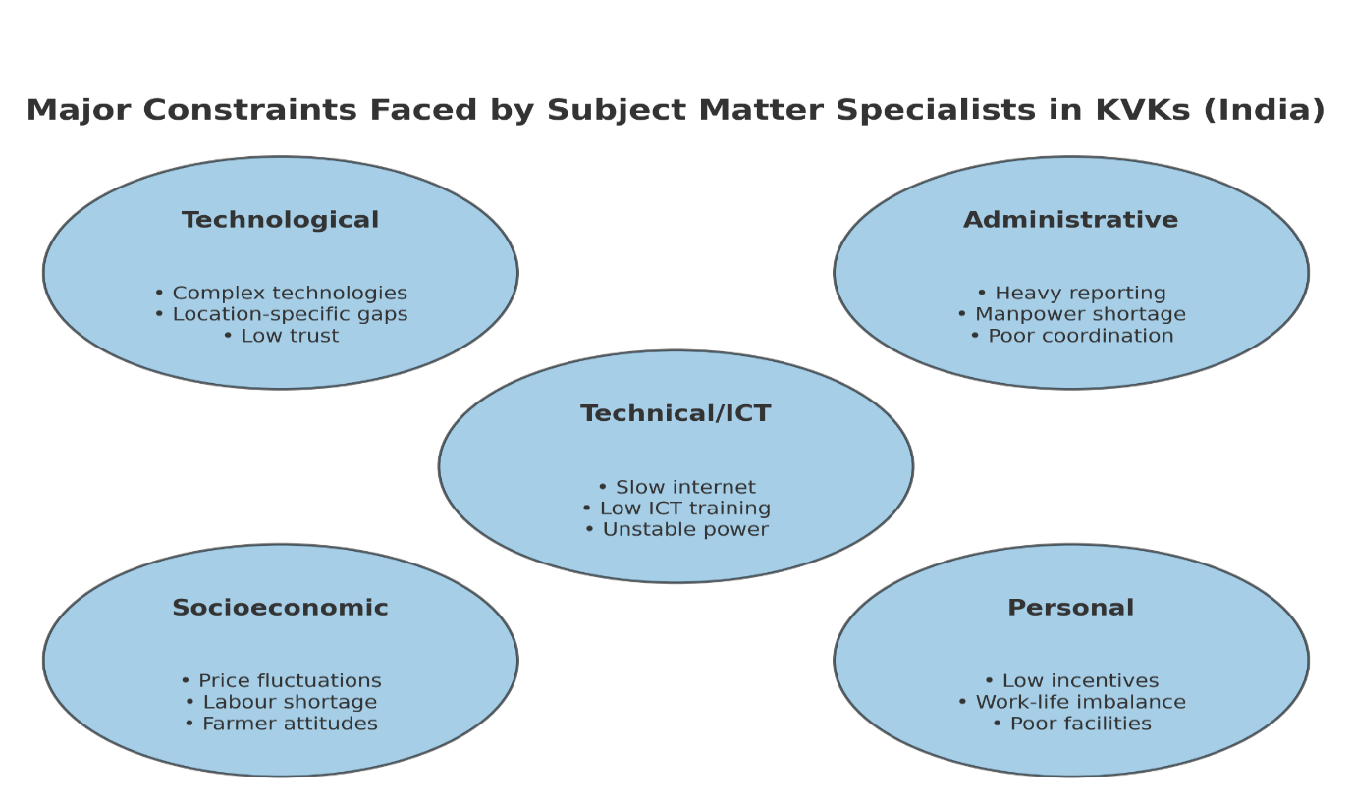
Fig. 1. Depicting the major constraints faced by SMSs in KVKs in India

Table no. 2. Compare and contrast of top five dimensions of constraints faced by SMSs
S. No. | Dimensions of Constraints | Similarities | Differences
1 | Technological | Difficulty in disseminating complex technologies  (Kumar & Kaur, Ramannanavar & Nagnur, Talukdar. et al.) | Lack of women-friendly technologies  (Talukdar. et al.)
 |  | Lack of location-specific technologies  (Kumar & Kaur, Ramannanavar & Nagnur, Talukdar. et al.) | Farmer distrust in new technologies  (Ranjan. et al.).
2 | Administrative | Heavy reporting on workload (Kumar & Kaur, Ramannanavar & Nagnur, Lalhmachhuana & Devarani). | Budget sanction delays (Lalhmachhuana & Devarani)
 |  | Lack of transport facilities (Bashir, Ramannanavar & Nagnur, Talukdar. et al.) | Frequent staff transfers (Kumar & Kaur).
 |  | Manpower shortages (Lalhmachhuana & Devarani, Talukdar. et al.) | Overload of work beyond mandate (Talukdar. et al.)
3 | Socioeconomic | Lack of farmer motivation and decision-making ability (Ramannanavar & Nagnur, Talukdar. et al.) | Labour shortages noted by (Kumar & Kaur)
 |  |  | Rivalries in villages noted only by Kumar & Kaur.
 |  |  | Conservative attitudes among farmers (Talukdar. et al.)
4 | Personal | Workload affecting personal life (Ramannanavar & Nagnur, Kumar & Kaur). | ICT-related personal challenges like lack of training (Dashora & Henry).
 |  | Lack of freedom to express opinions (Ramannanavar & Nagnur, Kumar & Kaur). | Residential and salary-related issues reported  (Lalhmachhuana & Devarani).
5 | Technical/ICT | Slow internet and lack of ICT infrastructure (Kale. et al. Dashora & Henry). | Health issues caused by ICT tools (Dashora & Henry).

Inferred from the above table no. 2. Both parallels and contrasts are shown by comparing the limitations that subject matter experts working in KVKs experience along five different dimensions. While some studies highlight challenges like women-friendly technologies (Talukdar. et. al., 2023) and farmer mistrust of new innovations (Ranjan. et. al., 2019), problems like the difficulty of spreading complex technologies and the absence of location-specific innovations are common in technological constraints. Heavy reporting workloads and a lack of personnel are common administrative restrictions; yet there are differences in the delays in budget sanction (Lalhmachhuana & Devarani, 2017) and staff transfers (Kumar & Kaur, 2015). Lack of farmer motivation and decision-making skills is a prevalent problem in the socioeconomic component, whilst labour shortages and local rivalries are especially mentioned by Kumar & Kaur (2015). Workload stress and restricted freedom of expression are common examples of personal restrictions. However, there are also unique difficulties such personal ICT-related concerns (Dashora & Henry, 2022) and troubles with housing or pay (Lalhmachhuana & Devarani, 2017). Finally, technical/ICT limitations mostly relate to slow internet and poor infrastructure, with a special reference to health problems brought on by ICT tools (Dashora & Henry, 2022). The comparison emphasises that whereas certain limitations are generally the same, others differ based on situations and local difficulties that KVK professional’s encounter.
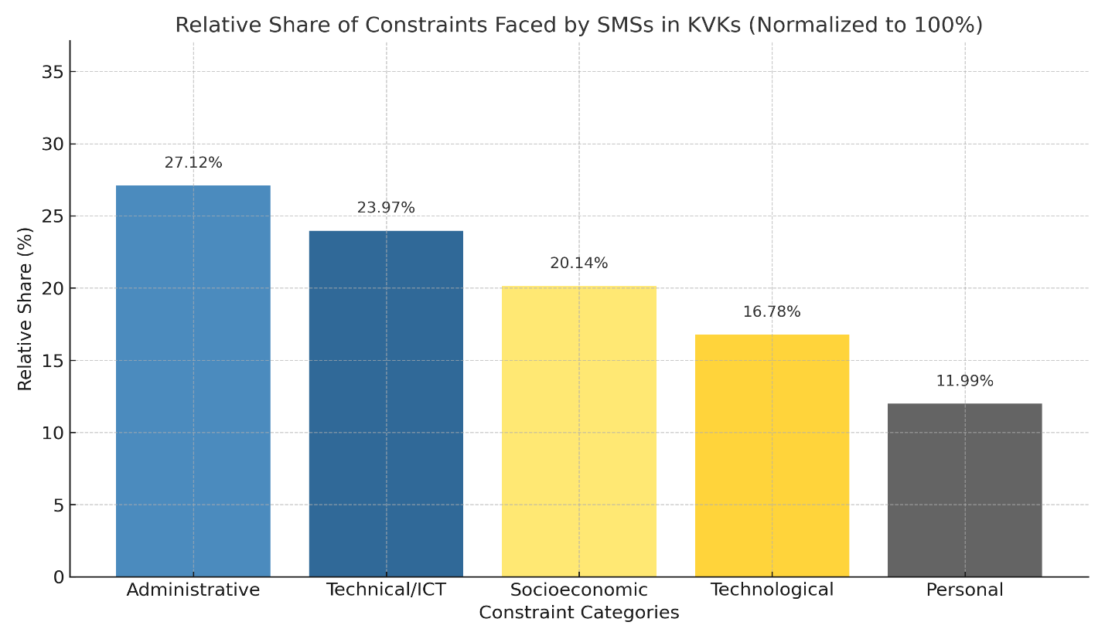
Fig. 2. Illustrating the normalized per cent of constraints faced by SMSs in KVKs
The normalised bar chart shows the proportion of significant problems encountered by Subject Matter Specialists (SMSs) employed in Krishi Vigyan Kendras (KVKs) must deal with, broken down by five important dimensions. The information, which was compiled from several empirical studies carried out between 2015 and 2023, has been normalised to show the percentage of each category in relation to the overall constraint burden (i.e., adding up to 100%). According to the analysis, administrative constraints make up the largest portion
(about 27.12%), highlighting problems like a high workload for reporting, a delayed hiring process, and insufficient transportation options. Technical/ICT limitations, which are caused by issues like sluggish internet, erratic power, and a lack of ICT training, come in second (23.17%) followed by socioeconomic constraints (20.14%), which include things like price fluctuation, a lack of workers, and farmers' limited resources. The lack of location-specific innovations and the challenge of spreading complex technologies account for a large portion of technological constraints (16.78%). Although personal constraints account for the smallest portion (11.99%), they nevertheless draw attention to important issues like an unbalanced work-life schedule, little exposure to the field, and insufficient rewards.
Because constraints are complex and interconnected, this proportional representation emphasises the necessity of a comprehensive and dimension-specific approach to policymaking and institutional development within the KVK system.
Suggestions expressed by Subject Matter Specialists
A variety of suggestions have been made by the Subject Matter Specialists (SMSs) employed by KVKs to address administrative, institutional, and infrastructure issues. One of the most often stressed points is hiring enough supporting personnel and filling open positions. This will help lessen the disproportionate workload that SMSs currently bear and free them up to concentrate more on technology assessment and dissemination efforts. (Krishi-Kosh Thesis, 2021).
Another common recommendation has to do with incentive programs and job progression. To increase job satisfaction and act as motivators, SMSs advise implementing a clear promotion structure and offering sufficient monetary and non-monetary incentives (Krishi-Kosh Thesis, 2021). They also stress the necessity to lessen the administrative load, especially the superfluous paperwork that takes up a lot of time and effort. SMSs may focus more on farmers' training, field demonstrations, and research-extension connections if reporting systems were made simpler and unnecessary paperwork was reduced
(Krishi-Kosh Thesis, 2021).
It is seen to be essential to provide ICT tools and current infrastructure. To effectively deliver extension programs and on-farm trials, SMSs recommended strengthening demonstration units, training laboratories, computer facilities, field visit vehicles, and improved ICT connectivity (Krishi Kosh, 2021).
It was also highly advised that KVKs, research institutes, line departments, and host institutions improve their cooperation and connections. To prevent duplication of effort, improve convergence, and guarantee that farmers profit from the most recent scientific advancements, effective collaboration is crucial (Krishi Kosh Thesis, 2021).
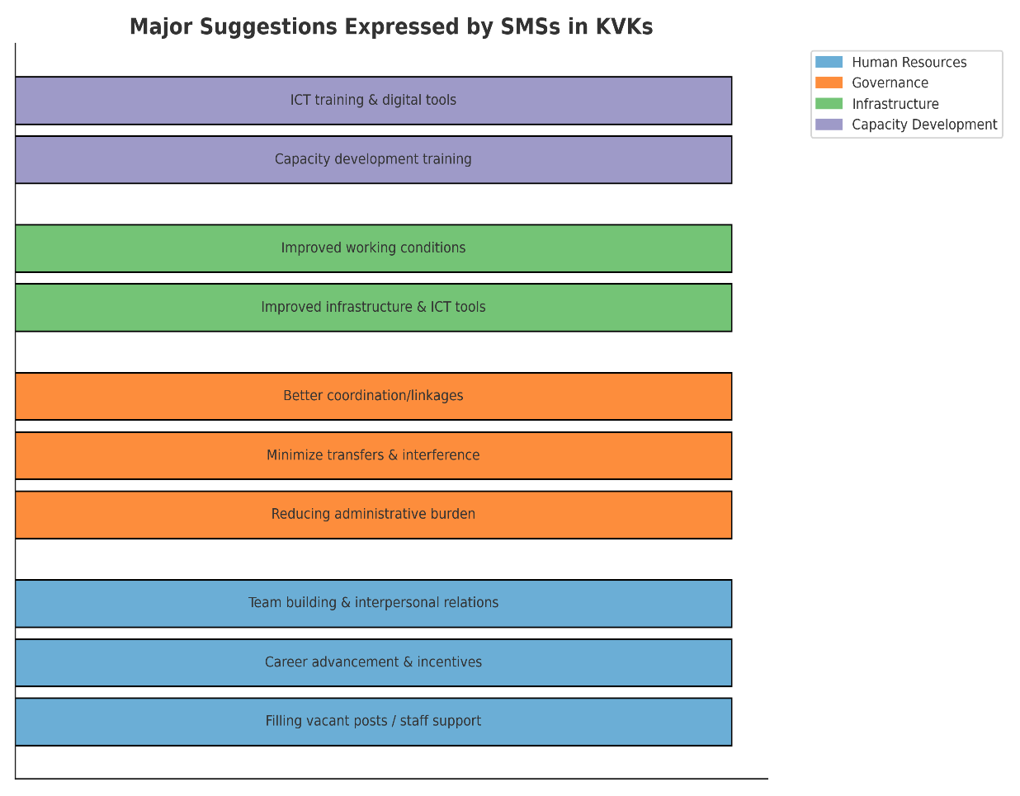
Fig. 3. Major suggestions grouped under four categories as expressed by SMSs in KVKs
Additionally, SMSs called for a reduction in political meddling and frequent transfers. Political influence frequently impairs KVKs' autonomy in making decisions, and frequent staff changes interrupt program continuity and erode rapport with rural communities
(Krishi Kosh, 2021). Another important recommendation has to do with training to increase capacity. To improve their technical and extension abilities, SMSs suggested frequent, brief, demand-driven training programs in aquaculture, entrepreneurial development, success story documentation, and other specialised subjects (ICAR, 2023a).
Accordingly, SMSs underlined the necessity of more investment in communication infrastructure and training in ICT tools. They noted that while digital extension techniques and sophisticated ICT applications might enhance outreach, they also necessitate sufficient infrastructure and practical training assistance (ICAR, 2023b). Enhancing amenities and working conditions was also prioritised. To guarantee an enabling work environment and improve performance, it was thought that adequate housing, educational facilities, greater office space, and the availability of automobiles for mobility were necessary
(Krishi Kosh Thesis, 2021). Lastly, SMSs recommended initiatives for improving interpersonal relationships and team building. Enhancing superior-subordinate relationships, encouraging teamwork, and promoting harmony among coworkers were all considered crucial steps in developing a more collaborative and effective institutional culture (Journal of Krishi Vigyan, 2016).
Conclusion
Technological, administrative, social, personal, and ICT-related limitations are all linked for Subject Matter Specialists in KVKs; the most significant of these are administrative overburden and inadequate digital infrastructure. These obstacles limit uptake and lessen the efficiency of technology distribution, especially when combined with farmer-level issues like labour shortages and unstable markets. Therefore, KVKs must increase their SMS capacity to fulfil their role as hubs for grassroots innovation. The simplification of administrative duties, prompt hiring, sufficient finance, and the development of ICT infrastructure should be the main objectives of policy. Human resource reforms, including steady postings, incentive programs, and skill building in ICT, entrepreneurship, and gender-responsive extension, are equally important. Receptivity can be increased by farmer-centric initiatives including price stabilisation, prompt input supply, and awareness campaigns. Together, these interventions will improve SMS efficiency, accelerate technology adoption, and advance sustainable and climate-resilient agriculture in India.
Disclosure statement
The author reported no potential conflict of interest.
Highlights
- This review summarizes the primary constraints experienced by Subject Matter Specialists at Krishi Vigyan Kendra's across India.
- Administrative, technological, and budgetary difficulties continuously impede successful extension service delivery.
- Education, ICT integration, and farmer-focused techniques emerge as major drivers for increased outreach.
- Policy reforms and institutional assistance are critical for improving KVK performance and sustainability.

Disclaimer (Artificial intelligence)
Option 2:
Author(s) hereby declare that generative AI technologies such as Large Language Models, etc. have been used during the graphical representation works only not on the any written parts in this article
Details of the AI usage are given below:
- ChatGpt-5.1
References
Baliram, M. S. M. (2019). Utility perception of kvk kisan mobile advisory service (KMAS) perceived by users. Unpublished M.Sc. Thesis, VNMKV, Maharashtra.
Bashir, B. P., & Narmatha, N. (2016). Opinion of Subject Matter Specialists Working in Krishi Vigyan Kendra's. Journal of Krishi Vigyan, 5(1), 83-87.
Bhuvana, N., RAO, I. S., Sontakki, B. S., Vidyasagar, G., & Chary, D. S. (2021). Status and prospects of Krishi Vigyan Kendra activities in southern India. Part i: plant sciences, 55.
Chauhan, N. M., & Chauhan, N. B. (2012). Constraints faced and suggestions offered by the programme coordinators of KVKs' in India.
Das, P., Proceedings of the Meeting of DDG (AE), ICAR, with Officials of State Departments, ICAR Institutes and Agricultural Universities, NRC Mithun, Jharnapani on 5th October 2007, Zonal Coordinating Unit, Zone-III, Barapani, Meghalaya, India.
Dashora, P., & Henry, C. (2022). Major constraints faced by KVK Scientists during use of ICT tools in Rajasthan. Indian Research Journal of Extension Education, 22(5), 266-270.
Dhananjaya, B., Hanumanthappa, M., Ranjith, T. H., Nagaraj, R., & Jayaprakash, R. (2016). Impact of KVK free SMS Services on the farmers of Udupi District of Coastal Karnataka. Journal of Global Communication, 9(conf), 329-334.
Gautam, U. S., Singh, R. K., & Kumar, A. (2024). Krishi Vigyan Kendras Glorious Journey of Five Decades. Indian Farming, 74(3), 05-08.
Kale, R. B., Meena, M. S., & Singh, S. K. (2017). Constraints and Suggestions Perceived by KVK Scientists in Utilization of ICT for Agricultural Extension.
Kumar, P., & Kaur, P. (2015). Constraints faced by the subject matter specialist of selected Krishi Vigyan Kendras of Northern India. Journal of Krishi Vigyan, 4(1), 10-17.
Kumar, S., Singh, L., Singh, R., Thombare, P., and Devi, S. R., (2020). Agroecological approaches for strengthening of Krishi Vigyan Kendra’s (KVKs) in India, Andhra Agric. J. 67, 75–80.
Kumar, U., Kumar, A., & Thakur, P. K. (2012). Status and constraints of extension services. Status of Agricultural Development in Eastern India. ICAR Research Complex for Eastern Region, Patna, 479-492.
Lalhmachhuana, P., & Devarani, L. (2017). Perceived Job Performance and Constraints Hindering Performance of Krishi Vigyan Kendras in Mizoram. Indian Journal of Extension Education, 53(1), 35-40.
Nargawe, L. (2019). Constraints and suggestions faced by the scientists/service providers and beneficiaries of kisan mobile advisory services in Barwani district of Madhya Pradesh. Journal of Pharmacognosy and Phytochemistry.
Nath, D., Jain, P. K., Talukdar, R. K., & Hansra, B. S. (2016). A study on constraints faced by KVK scientists of NE Region of India and Suggestion for Improvement.
Patil, K. V., Patel, V. T., & Prajapati, R. R. (2017). Constraints in using Kisan Mobile Advisory Service as perceived by farmers in Banaskantha district of Gujarat, India. Int. J. Curr. Microbiol. App. Sci, 6(11), 237-240.
Ramannanavar, A., & Nagnur, S. (2019). Job stress and constraints of subject matter specialist’s (SMSS) of Krishi Vigyan Kendras. Journal of Pharmacognosy and Phytochemistry, 8(1), 2317-2320.
Ranjan, R., Ansari, M. A., Shekhar, S., Singh, C. V., & Singh, R. K. (2019). Constraints experienced by the KVKS scientists and beneficiaries for improvement of kvk performance: A study in Uttarakhand, India.
Saroj Kumari, S. K., Nishi Sethi, N. S., Raman Jodha, R. J., & Vinay Mehala, V. M. (2017). Implications and limitations in mobile based advisory services through KVKs in Haryana.
Shinde, M. B., Suradkar, D. D., & Gawali, M. B. (2019). Constraints in Using Kisan Mobile Advisory Service as Perceived by Farmers in Latur District of Maharashtra, India. International Journal of Current Microbiology and Applied Sciences, 8(7), 177-179.
Supriya, P. (2023). Impact of Kisan Mobile Advisory Services of Krishi Vigyan Kendra on farmers of Srikakulam district.
Talukdar, N., Das, P. K., & Borah, A. (2023). Constraints as Perceived by the Subject Matter Specialists of Selected Krishi Vigyan Kendras of Assam. Int. J. Curr. Microbiol. App. Sci, 12(07), 70-75.
Yadav, P. K. (2020). A study on ICT initiative in agriculture through kisan mobile advisory services by KVK in Bilaspur district of Chhattisgarh.
ICAR. (2023a). Training needs of Subject Matter Specialists of KVKs. Indian Council of Agricultural Research. Retrieved from https://ebook.icar.gov.in/index.php/JIFA/article/view/141731
ICAR. (2023b). ICT usage among Subject Matter Specialists in KVKs: Constraints and suggestions. Indian Council of Agricultural Research. Retrieved from https://ebook.icar.gov.in/index.php/IJEE/article/view/143877
Krishi Kosh. (2021). Constraints and suggestions of Subject Matter Specialists working in KVKs. ICAR Repository. Retrieved from https://krishikosh.egranth.ac.in/items/ea339a51-1ece-4ae1-b799-797d8c7f65ed

