Temporal Dynamics of Diatoms as “Early Warning Indicators” of Ecosystem Stress in Jakarta Bay, Indonesia

ABSTRACT
Jakarta Bay, one of Indonesia’s most heavily urbanized coastal systems, has experienced ongoing eutrophication caused by rapid urban growth and high human nutrient inputs. To evaluate how the ecosystem responds to nutrient enrichment, we analyzed long-term (2008–2019) phytoplankton data collected from the inner, middle, and outer zones of the bay during different monsoon seasons. Environmental parameters such as temperature, salinity, dissolved oxygen, nitrate, phosphate, and silicate were measured using standard oceanographic procedures, and phytoplankton composition, abundance, and diversity indices were used to assess trophic status. Results show a consistently diatom-dominated community, with Chaetoceros, Skeletonema, and Thalassiosira accounting for over 90% of total abundance. A notable bloom occurred between 2009 and 2010 during an intense La Niña phase, coinciding with increased nitrate levels and high N:P ratios (>16). Diversity (H′ = 0.7–1.6) and evenness (E = 0.3–0.6) remained low, indicating community simplification and ecological stress. Spatial analysis revealed that the inner bay was hypertrophic, while the outer bay remained mesotrophic. This dominance pattern correlates with consistently high inorganic nitrogen levels, elevated N:P ratios, and nutrient-loading hotspots near major river mouths. These findings demonstrate that diatom dominance is an effective bioindicator of eutrophication. The strong link between diatom blooms and altered nutrient ratios highlights that diatoms serve as “early warning indicators” of ecosystem degradation and imbalance in tropical megacity coasts. Urgent measures such as integrated nutrient management, improved wastewater treatment, and routine phytoplankton monitoring are essential to restore ecological resilience and prevent recurrent harmful algal blooms in Jakarta Bay.

Keywords: Coastal ecosystem resilience, diatom dominance, early warning indicators, eutrophication, Jakarta Bay.

1. INTRODUCTION

Jakarta Bay is one of Indonesia’s most ecologically stressed yet socioeconomically vital coastal ecosystems. Located near the capital city, the bay supports fisheries, aquaculture, transportation, and trade, while also receiving significant human inputs from industrial, domestic, and river sources. Over recent decades, rapid urbanization, land reclamation, and untreated wastewater discharge have greatly disrupted its ecological balance, showing eutrophication-driven changes typical of tropical coastal systems under heavy human influence (Damar et al., 2020; Malone & Newton, 2020; Firdaus et al., 2023). As a result, assessing the bay’s ecological condition through biological indicators has become crucial for evaluating its environmental health and resilience.

Phytoplankton, as primary producers at the base of aquatic food webs, respond quickly to nutrient increases and physical changes in the water column, making them reliable indicators of trophic status and ecosystem stress (Peppa et al., 2020; Lefebvre & Dezcache, 2020). They serve as highly sensitive and trustworthy early warning indicators of aquatic ecosystem health, reflecting environmental changes at both the molecular and community levels. Ugya et al. (2025) demonstrate that phytoplankton respond to environmental stressors through complex molecular mechanisms, including changes in gene expression and stress-related signaling pathways. Specifically, the community structure can vary significantly across hydrologic cycles and nutrient conditions, with different taxonomic groups (chlorophytes, diatoms, cyanobacteria) responding differently to environmental shifts (Paerl et al., 2007; Spilling et al., 2018; Ge et al., 2020). Hsieh C.H. et al. (2010) further confirm that phytoplankton communities can reorganize dramatically in response to changes in trophic status and water column properties. These findings collectively highlight phytoplankton’s vital role as quick, comprehensive indicators of ecosystem stress and potential ecological imbalance. Understanding shifts in phytoplankton communities can therefore provide early warnings of environmental imbalance and help guide mitigation efforts.

Among phytoplankton groups, diatoms show exceptional sensitivity to nutrient availability and stoichiometric ratios, especially nitrogen (N), phosphorus (P), and silicate (Si) (Ge et al., 2020). Their growth and dominance are closely tied to dissolved inorganic nitrogen (DIN) and silicate levels, making them dependable indicators of nutrient-driven changes in estuarine and coastal ecosystems. The relative abundance of diatoms compared to other phytoplankton, such as cyanobacteria or dinoflagellates, reflects both nutrient conditions and the degree of eutrophication (Andersen et al., 2019). In nutrient-limited systems, conditions that restrict nitrogen or phosphorus can alter dominance patterns, impacting productivity and promoting harmful algal blooms (HABs) that damage ecosystem health and water quality (Wentzky et al., 2018; Karpowicz et al., 2020).

In Jakarta Bay, the N:P ratio and spatial nutrient gradients are key factors affecting phytoplankton community composition (Sidabutar & Srimariana, 2020; Krisna et al., 2025). Higher nutrient levels and very high N/P ratios promote the growth of bloom-forming diatoms like Skeletonema, Chaetoceros, and Thalassiosira, as well as toxin-producing dinoflagellates (Dwiyitno et al., 2022; Sidabutar et al., 2021). When excess phytoplankton biomass breaks down through microbial processes, it reduces dissolved oxygen levels, creating hypoxic conditions that threaten fish and benthic organisms (Genitsaris et al., 2019; Puspasari et al., 2018). Moreover, HAB events are linked to toxin accumulation in commercially important species such as the green mussel (Perna viridis), posing risks to human health and food security (Dwiyitno et al., 2022).

Despite numerous investigations into nutrient loading and primary productivity in Jakarta Bay, the ecological significance of phytoplankton community structure, particularly diatom dominance, remains poorly understood, particularly with respect to nutrient stoichiometry and the intensity of eutrophication. Long-term observations elsewhere show that diatom-dominated communities generally occur under moderate eutrophic conditions, while shifts toward dinoflagellates or cyanobacteria indicate advanced or chronic nutrient stress (Li et al., 2021; Zhang et al., 2021). Determining Jakarta Bay’s position along this trophic spectrum is essential for effective coastal management and for developing nutrient-reduction strategies before irreversible damage occurs (Marzetz et al., 2020; Wijayanti et al., 2025).

Therefore, this study investigates the relationship between phytoplankton community composition, especially diatom dominance, and environmental factors in Jakarta Bay. We hypothesize that prolonged nutrient enrichment and altered hydrodynamics have simplified community structures, resulting in diatom-dominated but ecologically unstable assemblages. The findings are expected to clarify the role of diatoms as indicators of eutrophication severity and to support comprehensive monitoring strategies to enhance ecological resilience in Jakarta Bay’s coastal ecosystem.

2. MATERIALS AND METHODS

2.1. Study Area and Sampling Period

Jakarta Bay (5°58′–6°07′ S; 106°33′–106°50′ E) is a shallow, semi-enclosed tropical bay on the northern coast of Java, Indonesia. It covers approximately 514 km² with an average depth of 15 meters. The bay is heavily influenced by runoff from thirteen major rivers, including the Ciliwung, Angke, and Bekasi, which carry nutrient-rich effluents, sediments, and pollutants from the Jakarta metropolitan area. Its hydrodynamics are affected by a monsoonal climate, characterized by the northwest (wet) monsoon from December to March and the southeast (dry) monsoon from June to September. Seasonal changes in rainfall and wind direction influence salinity and nutrient levels, which in turn regulate phytoplankton distribution and productivity (Damar et al., 2020; Wijayanti et al., 2025).

Sampling campaigns were conducted during the east monsoon seasons of 2008, 2009, 2010, 2011, 2013, 2015, and 2019, periods when algal blooms typically occur following high nutrient inputs and increased sunlight. Ten stations were chosen along a transect from the inner (river-influenced) to the outer (marine-influenced) bay, representing different levels of human impact. The study area was split into inner, middle, and outer zones based on hydrological and nutrient criteria, following Damar et al. (2020).

2.2. Sampling Design and Environmental Data Collection

Water sampling was conducted during both the wet (February–March) and dry (August–September) monsoon seasons to monitor temporal changes in phytoplankton and environmental conditions. Surface water samples (from 0.5 m deep) were collected at each station using a Niskin bottle. In situ measurements of temperature, pH, salinity, and dissolved oxygen (DO) were taken with a multiparameter YSI ProDSS probe. Water transparency and turbidity were measured using a Secchi disk, and total dissolved solids (TDS) were determined with a conductivity meter (Firdaus et al., 2023; Nastiti & Hartati, 2016).

Temperature and salinity profiles were recorded using a CTD (SBE 603). Data were processed with the programs Term19, DATCNV, and BINAVG (Sea-Bird et al., 1998) to obtain depth-averaged values. Nutrient analyses included nitrate (NO₃⁻), phosphate (PO₄³⁻), and silicate (SiO₄⁴⁻), determined following the standard spectrophotometric methods described by Parsons et al. (1984). Approximately 1 L of seawater was collected at each station and filtered through Whatman GF/C filters (0.45 μm pore size, 47 mm diameter) using a vacuum pump. Absorbance was measured with a Shimadzu spectrophotometer at wavelengths of 885 nm for phosphate, 543 nm for nitrate, and 810 and 680 nm for silicate. Nutrient concentrations were expressed in μg-at/L.

2.3. Phytoplankton Sampling and Identification

Phytoplankton samples were collected using a conical plankton net (mesh size 20 μm; length 125 cm; mouth diameter 25 cm) equipped with a ballast for vertical hauls. The net was slowly lowered from the surface to the desired depth and retrieved at the same speed to ensure representative sampling. Collected samples were transferred to polyethylene bottles and preserved with neutralized formalin (final concentration 2–4%) for laboratory analysis.

In the laboratory, samples were concentrated and analyzed using a Sedgwick–Rafter counting chamber under a compound microscope (Michael, 1995). Phytoplankton abundance was calculated following Sournia (1978), and taxa were identified to the genus level based on established references (Yamaji, 1966; Newell & Newell, 1977; Thomas, 1997). Taxonomic identification was cross-checked with recent updates in diatom taxonomy (Hasle & Syvertsen, 1997; Guiry & Guiry, 2024) to ensure consistency with current nomenclature.

2.4. Data Analyses

The phytoplankton community structure was assessed using the Shannon–Wiener diversity index (H′), Pielou’s evenness index (E), and Margalef’s species richness index (J) according to Odum (1998). These indices help evaluate species diversity, evenness, and richness. H′ values of ≤ 1 indicate low diversity and community instability, 1 < H′ ≤ 3 suggest moderate stability, and H′ ≥ 3 reflect high diversity and ecological balance. Evenness (E) values below 0.5 indicate stressed conditions, 0.5–0.75 indicate moderate stability, and values above 0.75 indicate stable communities (Brower & Zar, 1989; Smith, 1980). Simpson’s dominance index (D) was also calculated to analyze species dominance patterns.

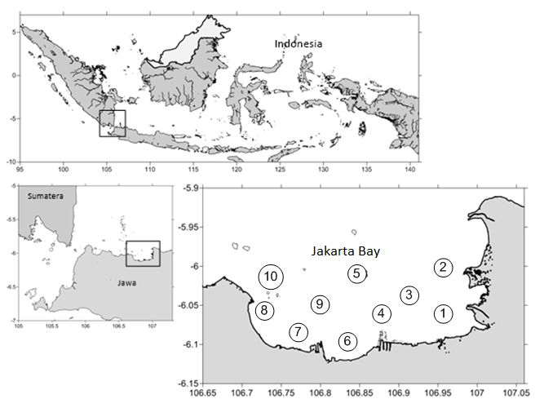
Figure 1. Map of Indonesia showing locations and research stations in
Jakarta Bay.

3. RESULTS AND DISCUSSION

3.1 Oceanographic characteristics

The average water temperature during the study was 29.97°C, ranging from 29.72 to 30.48°C. The lowest monthly temperature (29.37°C) occurred in May 2008, while the highest (30.48°C) was recorded in March 2013. Salinity averaged 28.98 PSU, ranging from 27.72 to 30.88 PSU. The lowest salinity (26.41 PSU) was observed in March 2009, and the highest (30.88 PSU) in May 2010; overall, salinity remained relatively stable except for notable drops in May 2008 and March–June 2009. Dissolved oxygen (DO) ranged from 2.96 to 4.12 ppm, with an unusually low value of 2.96 ppm in March 2009, for which there is no clear explanation. The average pH was 8.03, ranging from 7.68 to 8.30. The lowest pH (7.68) was in July 2015, while the highest (8.19) occurred in May 2015. A summary of these oceanographic parameters is provided in Table 1. Overall, no extreme values were observed during the study, except for the notably low DO in March 2009. Due to the bay’s shallow depth (6–15 m) and constant tidal and current mixing, Jakarta Bay exhibited no pronounced water-column stratification.

Table 1. Averages of oceanographic parameters during the study (2007-2019)

Parameters | Range | Averages
Temperature (°C) | 29.72-30.48 | 29.97
Salinity (psu) | 27.72-30.88 | 28.98
pH | 7.68-8.30 | 8.03
Dissolved Oxygen (ppm) | 2.96-5.17 | 4.12

3.2 Phytoplankton Abundance

3.2.1 Trend of phytoplankton abundance in Jakarta Bay from 2008 to 2019.

The temporal trend of phytoplankton abundance in Jakarta Bay from 2008 to 2019 (Figure 2) shows significant yearly and seasonal variations, with a notable bloom between 2009 and 2010 when cell density reached about 2.85 × 10⁸ cells m⁻³. This rapid growth, likely driven by diatom genera such as Chaetoceros and Skeletonema, indicates an episodic response to favorable environmental conditions, high nutrient input, stable water movement, and increased sunlight during the dry season. Such short, intense events are typical of eutrophication pulses caused by river runoff or untreated wastewater discharge, followed by a quick decline due to nutrient depletion, grazing, or self-shading (Damar et al., 2020; Sidabutar & Srimariana, 2020).

After this bloom, phytoplankton numbers dropped sharply and stayed low and relatively stable from 2011 to 2019, with only small yearly changes. The ongoing decrease in bloom strength suggests a shift from sporadic nutrient boosts to a consistently nutrient-rich but less productive state, probably due to changes in nutrient ratios, sediment build-up, and increased turbidity from continued coastal reclamation and pollution. The persistent low levels despite ongoing nutrient input point to changes in ecosystem functioning, including poor water quality, frequent hypoxia, and limited light, which hinder phytoplankton growth (Puspasari et al., 2018; Karpowicz et al., 2020; Dwiyitno et al., 2022). Overall, the data show a typical rise-and-fall pattern of phytoplankton biomass common in highly urbanized tropical coastal areas, reflecting nutrient-related instability and lowered ecological resilience (Heery et al., 2018; Damar et al., 2020).

3.2.2 La Niña as the Driver of the 2010 Phytoplankton Peak

The exceptionally high phytoplankton abundance observed in 2010 closely coincides with a strong La Niña event that affected much of the Indonesian maritime region. During this period, sea-surface temperatures in the central Pacific were unusually warm, which strengthened the Walker circulation and led to above-average rainfall and river discharge across Java (Rodysill et al., 2019; Ward et al., 2010). Increased precipitation caused flooding in lowland areas and transported significant nutrients from the Ciliwung and other rivers into Jakarta Bay, thereby boosting dissolved inorganic nitrogen, phosphate, and silicate inputs. These conditions are typical of La Niña years, which enhance the monsoonal flow and increase terrestrial runoff. Similar climate, biological links have been documented in regional studies showing that ENSO and Indian Ocean Dipole (IOD) variability strongly influence chlorophyll-a levels and phytoplankton biomass in Indonesian coastal waters (Siswanto et al., 2020). Therefore, the 2010 La Niña event created hydrological and nutrient conditions favorable for rapid diatom growth, explaining the extraordinary peak in abundance observed in Jakarta Bay that year.

While the La Niña anomaly served as the climatic trigger, the severity of the 2010 bloom was exacerbated by ongoing eutrophication driven by persistent human nutrient inputs. Years of unregulated wastewater discharge, urban runoff, and sedimentation increased nutrient levels in Jakarta Bay (Sidabutar & Srimariana, 2020; Damar et al., 2020). The combination of natural climate factors and existing eutrophic conditions intensified nutrient enrichment beyond ecological limits, encouraging the rapid growth of opportunistic diatoms like Chaetoceros and Skeletonema. The bloom's decay likely intensified oxygen-depletion events typical of post-bloom eutrophic systems. This interaction between La Niña-driven hydrological changes and human nutrient overload highlights the multiscale nature of ecosystem instability in Jakarta Bay, where regional climate variability affects an already nutrient-saturated and hydrodynamically restricted coastal environment.

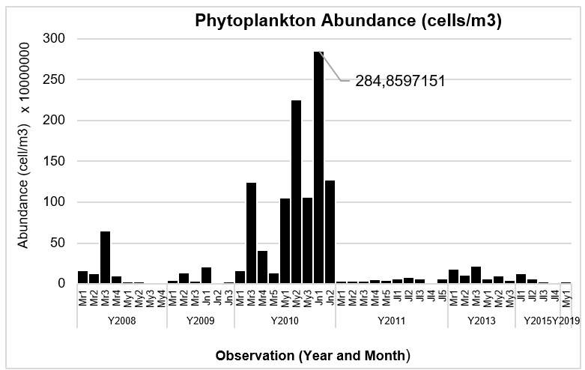

Figure 2. Temporal trend of phytoplankton abundance (cells m⁻³) in Jakarta Bay
from 2008 to 2019. A pronounced peak in 2010 corresponds to a strong
La Niña event, which enhanced rainfall and terrestrial runoff, increasing
nutrient input and promoting extensive phytoplankton blooms.
3.3 Phytoplankton Composition

Figure 3 shows that the phytoplankton community in Jakarta Bay is dominated by diatoms, accounting for over 95% of total abundance. Chaetoceros has the largest share at 49%, followed by Skeletonema at 21% and Thalassiosira at 19%, while other genera account for less than 9%. This dominance indicates the bay’s hypertrophic condition, caused by significant nutrient inputs from river discharge and human activities (Wijayanti et al., 2025; Damar et al., 2020). The dominance of chain-forming species, especially Chaetoceros and Skeletonema, is typical of eutrophic, turbid waters where high nutrient levels and low water exchange support rapid population growth (Sidabutar et al., 2021).

Diatoms are widely recognized as sensitive indicators of coastal ecosystem health, and changes in their dominant genera reflect shifts in nutrient levels, water movement, and temperature. The limited presence of other phytoplankton groups indicates decreased biodiversity and low functional redundancy, conditions often found in nutrient-rich systems (Li et al., 2021). This simplified community structure weakens ecological stability and increases vulnerability to stressors such as hypoxia and harmful algal blooms. Similar patterns of diatom-driven community simplification have been observed in other urbanized eutrophic estuaries (Duprey et al., 2019; Heery et al., 2018).

The persistent dominance of a few rapidly reproducing diatom taxa indicates that primary production in Jakarta Bay heavily depends on a narrow functional group, making the system highly vulnerable to bloom collapses and subsequent oxygen depletion. Similar patterns have been seen in Manila Bay and the Pearl River Estuary, where ongoing nutrient enrichment promotes diatom growth but reduces overall ecosystem resilience (Duprey et al., 2019). Understanding these dominance patterns is therefore essential for evaluating eutrophication severity, guiding nutrient management efforts, and supporting ecological restoration in Jakarta Bay.

3.4 Temporal Dynamics of Diatom and Dinoflagellate Abundance

Long-term observations from 2008 to 2019 (Figure 4) reveal significant temporal and seasonal shifts in the relative abundance of diatoms and dinoflagellates in Jakarta Bay. Diatoms consistently dominated the community, often exceeding 10⁹ cells m⁻³, with notable increases during the dry season when reduced river discharge, higher salinity, and longer water residence times created favorable conditions for rapid growth (Rahayu et al., 2019). Conversely, dinoflagellates were much less abundant, generally peaking at around 10⁷ cells m⁻³ and often rising only after diatom populations declined. These secondary peaks indicate a successional transition influenced by changing nutrient stoichiometry, light availability, and hydrodynamic stability mechanisms commonly observed in eutrophic tropical estuaries (Wijayanti et al., 2025; Li et al., 2021). Such alternating dominance patterns highlight the vulnerability of primary producers to short-term environmental fluctuations and persistent nutrient enrichment.

Figure 3. Percentage composition of dominant phytoplankton genera in Jakarta
Bay. Diatoms (Chaetoceros, Skeletonema, and Thalassiosira)
collectively accounted for >95% of total abundance, indicating a
strongly eutrophic community structure.

Figure 4 clearly illustrates these contrasting dynamics using dual axes that emphasize the difference in magnitude and variability between the two groups. The area plot shows that dinoflagellate pulses, although infrequent, tend to occur during periods of water-column stratification or changes in nutrient inputs, conditions that can support motile, mixotrophic species capable of thriving in low-turbulence environments (Zhang et al., 2022). Meanwhile, the diatom trend line confirms their ongoing dominance but also highlights year-to-year variability related to climatic factors, such as shifts in monsoonal forcing and rainfall-driven freshwater input.

These patterns collectively suggest that Jakarta Bay’s phytoplankton dynamics are influenced by nutrient imbalance, hydrological changes, and climate-related forcing, all of which affect bloom size and development. The notable difference in abundance between diatoms and dinoflagellates further indicates a nutrient environment that favors opportunistic silicified species. This points to a community structure with lower resilience, disrupted food-web processes, and increased vulnerability to bloom-associated hypoxia and water quality problems.

Figure 4. Temporal changes in the abundance of diatoms and dinoflagellates
(cells m⁻³) in Jakarta Bay from 2008 to 2019. The increased diatom
abundance in 2010 suggests high nutrient levels and intensified
eutrophic conditions caused by hydrological variability.

3.5 Ratio of Diatoms (dt) and Dinoflagellates (dn)

Figure 5 illustrates long-term changes in the diatom-to-dinoflagellate ratio (Dt/Dn), showing noticeable shifts in dominance between the two groups. Very high ratios, surpassing 700 in mid-2009, indicate strong diatom dominance, linked to increased nutrient levels and ideal growth conditions. Lower ratios signal transitional periods when dinoflagellates such as Alexandrium and Gymnodinium spp became more prevalent (Dwiyitno et al., 2022). These dinoflagellate blooms are ecologically significant because several species are known producers of saxitoxins, which can accumulate in filter feeders like Perna viridis, posing hazards to marine life and human health (Sidabutar et al., 2021; Anderson et al., 2012).

Temporal fluctuations in the Dt/Dn ratio closely align with eutrophication patterns in Jakarta Bay. Initially, nutrient-rich conditions caused by river runoff, wastewater inputs, and monsoon-driven hydrodynamics typically trigger rapid diatom blooms. As nutrient ratios change and water-column stability increases, dinoflagellates often replace diatoms, showing a typical nutrient-driven succession pattern observed in many eutrophic coastal ecosystems (Sidabutar & Srimariana, 2020; Lin et al., 2021). Although gaps in observations from 2011–2013 and 2013–2015 likely result from inconsistent sampling, they do not obscure the overall trend of alternating dominance and community shifts. Global studies also demonstrate that changes in N:P and N:Si ratios can shift communities from diatom- to dinoflagellate-dominant, especially with warming and stratification (Glibert, 2020).

Figure 5 illustrates how Jakarta Bay’s phytoplankton community actively responds to changing nutrient levels and water conditions. The persistent dominance of diatoms indicates ongoing eutrophic conditions, while occasional increases in dinoflagellates signal short-term bloom events caused by shifts in nutrient ratios or water movement patterns. These patterns emphasize the importance of long-term phytoplankton monitoring to detect community changes, assess eutrophication, and predict impacts on the food web, harmful algal blooms, and overall ecosystem health.

Figure 5. Temporal variation in diatom and dinoflagellate abundance and the
diatom–dinoflagellate ratio (Dt/Dn) in Jakarta Bay from 2008 to
2015. High Dt/Dn values, such as those observed in 2009 and 2013,
indicate strong diatom dominance, whereas lower ratios correspond to
periods when dinoflagellates became relatively more abundant.

3.6 Spatial Distribution Patterns

Spatial mapping from March 2010 (Figure 6) shows that phytoplankton levels were highest in nearshore and estuarine areas, especially around the Ciliwung and Angke river mouths, where nutrients and suspended solids were concentrated. Levels decreased gradually toward offshore stations, creating a transparent coastal–offshore gradient influenced by river inputs and limited hydrodynamic mixing in the inner bay (Surya et al., 2019). This pattern matches TRIX-based assessments indicating hypereutrophic conditions near the coast and mesotrophic–eutrophic conditions further offshore (Krisna et al., 2025), and supports previous findings that sedimentation and restricted water exchange, exacerbated by coastal reclamation, encourage localized eutrophication (Puspasari et al., 2018).

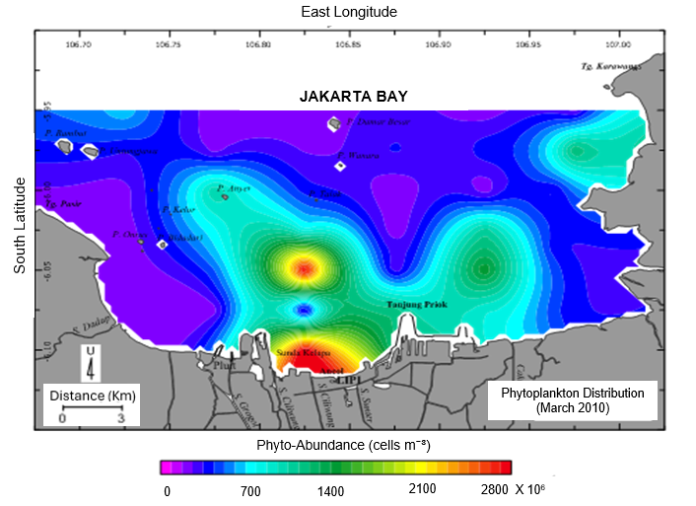
The spatial distribution shown in Figure 6 reflects underlying environmental gradients and highlights areas of increased biological activity affected by terrestrial runoff. Nearshore zones with higher phytoplankton biomass may serve as productivity hotspots but also as potential sites for harmful algal blooms and oxygen depletion. In contrast, offshore areas show lower concentrations due to dilution and stronger currents. This spatial mapping is essential for assessing water quality, identifying ecologically sensitive habitats, and guiding management actions, including pollution control, fisheries planning, and long-term monitoring of climate- or human-driven changes in primary productivity.

Figure 6. Spatial distribution of phytoplankton abundance in Jakarta Bay during
March 2010. This map illustrates the horizontal distribution of
phytoplankton abundance across Jakarta Bay, revealing high
concentrations in nearshore and estuarine zones, especially near the
river mouths.

3.7 Species-Specific Bloom Patterns

Time-series observations from 2008 to 2019 (Figure 7) show that Chaetoceros consistently had the highest abundance, with peak blooms occasionally surpassing 140 × 10⁶ cells L⁻¹, especially during the dry season. This persistent dominance reflects the species’ opportunistic bloom-forming strategy, thriving under nutrient-rich conditions, calm hydrodynamics, and increased light availability (Wijayanti et al., 2025). Skeletonema showed more moderate and less variable abundance patterns, reaching occasional peaks of about 20 × 10⁶ cells L⁻¹, while Thalassiosira remained the least abundant and most stable, rarely exceeding 10 × 10⁶ cells L⁻¹. These differences in timing highlight distinct ecological strategies among major diatom groups, consistent with patterns seen in other eutrophic coastal systems (Smayda, 1997).

The significant interannual and seasonal variability, especially the notable Chaetoceros peaks in 2009 and 2010, indicates that diatom dynamics are closely linked to short-term environmental changes and longer-term climatic factors. Variations in temperature, sunlight, nutrient availability, and water-column stability greatly influence bloom initiation and decline. At the same time, episodic monsoonal forces, storms, or shifts in circulation can enhance or suppress population growth (Paerl & Otten, 2016). These cyclical changes also reflect broader trends related to climate variability and human-caused nutrient loading, suggesting that bloom-forming diatoms respond quickly to both immediate environmental shifts and long-term ecosystem changes.

As primary producers that form the foundation of the marine food web, diatom blooms directly affect ecosystem function and water quality. High diatom biomass boosts productivity but also increases the risk of hypoxia during bloom decay, as microbial decomposition raises Biological Oxygen Demand (BOD) (Damar et al., 2020). These oxygen-depletion events are known to cause fish kills and benthic mortality in Jakarta Bay and other eutrophic coastal waters (Puspasari et al., 2018). Therefore, this long-term dataset is essential for understanding the balance between nutrient-driven productivity and ecological vulnerability, providing key insights for predicting changes in phytoplankton and guiding fisheries management and conservation efforts.

Figure 7. Temporal fluctuations in the abundance of dominant diatom genera
(Chaetoceros, Skeletonema, and Thalassiosira) in Jakarta Bay from
2008 to 2019. This figure shows the long-term variation in the abundance
of the three predominant diatom genera, highlighting strong seasonal
and interannual differences.

3.8 Phytoplankton Community Structure and Ecological Implications

Table 2 and Figure 8 show that the phytoplankton community in Jakarta Bay generally has low diversity and uneven species distribution, with an average H′ of 1.14 and E of 0.46. Diversity values ranged from 0.7 to 1.8, with particularly low H′ values in March 2008 and 2013, indicating strong dominance by a few taxa. A significant increase in diversity from 2008 to 2009 was followed by a sharp decline in 2010 and a slow partial recovery afterward, reflecting recurring shifts between moderately diverse and highly dominated community states caused by environmental instability.

Temporal variability in the indices is considerable, showing clear differences between the lowest community structure conditions (e.g., March 2010, J = 0.34) and the highest values (e.g., May 2019, H′ = 1.62; J = 0.91). These fluctuations demonstrate that the phytoplankton community responds rapidly to seasonal shifts, nutrient pulses, and episodic disturbances. Low diversity during periods of diatom dominance, particularly Chaetoceros and Skeletonema, suggests reduced resilience and heightened vulnerability to ecological stress (Susanti et al., 2022). Decreases in H′ and E during key bloom years, especially 2010, align with eutrophication-driven dominance cycles typical of nutrient-rich coastal systems (Cloern & Jassby, 2010).

These diversity shifts are closely linked to ongoing environmental pressures in Jakarta Bay, such as nutrient enrichment, pollution, sedimentation, and hydrodynamic changes. Increased nutrient input promotes bloom-forming species, suppresses less tolerant taxa, and reduces both evenness and richness. Similar low-diversity assemblages and simplified community structures have been observed in other urban coastal environments affected by continuous human activities (Heery et al., 2018; Duprey et al., 2019). Although occasional improvements happen, the continued low evenness (<0.6) suggests that the community remains structurally unbalanced and functionally simplified, conditions often associated with decreased ecological stability.

Index variability also reflects the interaction of seasonal hydrodynamics and climate-related processes. During wet seasons and La Niña years (e.g., 2010), heavy rainfall increases river discharge from the Ciliwung and Angke systems, carrying nutrient loads that trigger diatom blooms and temporarily reduce diversity (Rodysill et al., 2019; Siswanto et al., 2020). In contrast, dry-season conditions, characterized by decreased runoff and more vigorous mixing, allow for higher species evenness as dinoflagellates, cyanobacteria, and small flagellates reappear. Coastal reclamation and sediment resuspension further disrupt light penetration and salinity patterns, contributing to recurring changes in community composition (Damar et al., 2020). The coexistence of moderate diversity with persistently low evenness reflects an adaptive yet chronically stressed phytoplankton community, shaped by alternating nutrient surpluses, hydrodynamic retention, and human-induced environmental changes (Sidabutar & Srimariana, 2020; Wijayanti et al., 2025).

Table 2. Temporal variation of phytoplankton community structure indices
(H′, E, J) in Jakarta Bay from 2008 to 2019.

Year | Month | Community Structure Indexes
Year | Month | (H') | (E) | (J)
2008 | Mar | 0,74 | 0,31 | 0,56
 | May | 1,44 | 0,56 | 0,79
2009 | Mar | 1,53 | 0,57 | 0,78
 | Jun | 1,58 | 0,59 | 0,82
2010 | Mar | 0,77 | 0,43 | 0,34
 | May | 0,90 | 0,42 | 0,38
 | Jun | 1,14 | 0,51 | 0,41
2011 | Mar | 1,29 | 0,52 | 0,66
 | Jul | 0,95 | 0,43 | 0,49
2013 | Mar | 0,74 | 0,29 | 0,62
 | May | 0,96 | 0,39 | 0,60
2015 | Jul | 1,18 | 0,45 | 0,78
2019 | May | 1,62 | 0,58 | 0,91
Range |  | 0,74 -1,62 | 0,29 - 0,59 | 0,34 - 0,91
Avrg |  | 1,14 | 0,46 | 0,63

Figure 8. Temporal variation in phytoplankton community structure indices (H′, E,
J) in Jakarta Bay from 2008 to 2019. This figure illustrates long-term
fluctuations in Shannon diversity (H′), evenness (E), and equitability (J).
Diversity peaks in 2009 and 2011 indicate periods of more balanced
community composition, whereas sharp declines in 2010 and 201
3 reflect strong dominance by bloom-forming diatoms such as
Chaetoceros and Skeletonema.
3.9 Nutrient Ratios (N, P, Si) in Jakarta Bay (2008-2019)

Figure 9 shows long-term changes in nitrate (NO₃⁻) and phosphate (PO₄³⁻) levels in Jakarta Bay from 2008 to 2019, highlighting clear episodic patterns in nutrient inputs. Nitrate exhibits significant fluctuations, ranging from nearly zero to about 22 µg/L, with notable peaks in 2010, 2013, and 2015, periods linked to increased river flow, stormwater runoff, and monsoon-driven inflows. In comparison, phosphate levels stay relatively steady, usually between 0.5 and 3 µg/L, probably because of quick biological uptake and adsorption onto suspended sediments (Sidabutar & Srimariana, 2020). The marked difference in variability between these nutrients indicates a long-standing nitrogen-focused system, typical of human-affected tropical coastal waters (Damar et al., 2020). These time-based patterns imply that seasonal rainfall, extreme climate events like La Niña, and urban wastewater inputs are key factors causing recurring nitrate spikes.

This nutrient imbalance plays a key role in shaping the bay’s trophic dynamics. Elevated nitrate levels, combined with relatively low phosphate, promote rapid phytoplankton growth and may trigger harmful algal blooms (HABs) under favorable hydrodynamic conditions. Earlier studies in Jakarta Bay have shown that sustained nitrogen enrichment favors bloom-forming species such as Noctiluca scintillans and opportunistic diatoms (Damar et al., 2019; Sidabutar et al., 2021). These changes reduce water clarity, speed up oxygen depletion during bloom decay, and contribute to long-term ecological decline, especially in areas impacted by land reclamation and heavy pollution (Puspasari et al., 2018; Heery et al., 2018). The patterns in Figure 8, therefore, reveal a consistent eutrophication trend driven by nutrient runoff from rivers, coastal development, and inadequate wastewater management.

The strong link between nitrate peaks and periods of high phytoplankton abundance, especially the diatom blooms in 2010 and 2013, shows that nitrogen is the main factor driving phytoplankton growth in this system. High nitrogen-to-phosphorus (N:P) ratios, often exceeding 16:1, favor fast-growing diatoms such as Chaetoceros and Skeletonema (Sidabutar & Srimariana, 2020; Wijayanti et al., 2025). At the same time, consistently low phosphate levels suggest P limitation during peak productivity, supporting the dominance of opportunistic taxa that thrive under nutrient pulse conditions typical of eutrophic bays (Glibert, 2020). Over time, this imbalance can destabilize the ecosystem by increasing HAB frequency, worsening hypoxia, and reducing biodiversity. Therefore, Figure 8 not only records the chemical signal of nutrient enrichment but also shows the ecological feedback loop among nutrient inputs, phytoplankton dynamics, and the ongoing eutrophication in Jakarta Bay.

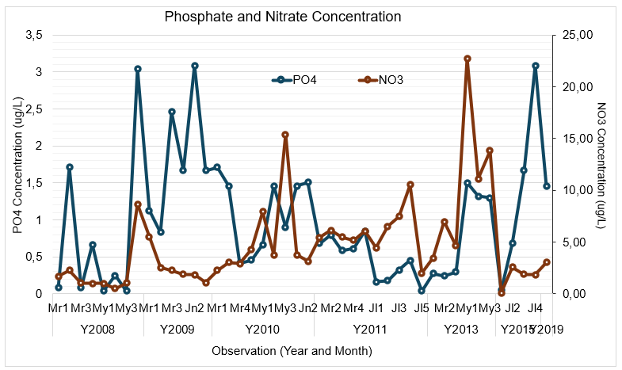

Figure 9. Temporal trends in phosphate (PO₄³⁻) and nitrate (NO₃⁻) concentrations
in Jakarta Bay (2008–2019). This figure shows episodic but recurrent
nitrate peaks, particularly in 2010, 2013, and 2015, associated with
monsoon-driven runoff and urban wastewater inputs.

3.10 Variability of N:P and N:Si Ratios and Ecological Implications

Table 3 and Figure 10 show that nutrient levels and their ratios in Jakarta Bay change a lot over time, revealing a clear imbalance among nitrogen, phosphorus, and silicon. Nitrate (NO₃⁻) has the widest range (1.50–67.38 µg/L) and the highest average (4.80 µg/L), indicating ongoing nitrogen input from land sources. Phosphate (PO₄³⁻), however, remains low (average 1.08 µg/L), suggesting chronic phosphorus limitation. Silicate (SiO₃) levels are consistently higher (1.75–151.83 µg/L; average 35.85 µg/L), reflecting continuous supply from watershed runoff and sediment resuspension. Ammonia (NH₃) contributes moderately to the nitrogen pool (0.46–8.99 µg/L), further emphasizing nitrogen dominance. These patterns align with an unbalanced nutrient system in which nitrogen is abundant, phosphorus is limited, and silicon remains sufficiently available to support diatom growth.

The N/P ratios, which range from 0.66 to 47.38, often surpass the Redfield threshold of 16:1, indicating conditions favorable for bloom formation when nitrogen exceeds phosphorus (Damar et al., 2020). Lower ratios, sometimes below 1, imply periods of nitrogen depletion or increased phosphorus supply, which coincide with decreased phytoplankton productivity (Sidabutar & Srimariana, 2020). These variations reflect episodic nutrient pulses driven by monsoon runoff, wastewater discharge, and other human-related inputs, aligning with nutrient dynamics found in many eutrophic urban coastal systems (Puspasari et al., 2018). Such fluctuations suggest that nutrient limitation can change seasonally, creating alternating periods of nutrient stress that influence phytoplankton growth and succession.

The N/Si ratios (0.01–0.69) remain well below 1.0 during most of the study period, indicating silicon-rich conditions that promote diatom dominance. Since diatoms require dissolved silicate for frustule formation, the persistently low N/Si ratio suggests strong riverine silicate input and active vertical mixing (Heery et al., 2018). Only in certain years (e.g., 2009 and 2019) do N/Si ratios approach 0.66–0.69, suggesting transitional phases in which reduced silicate availability could enable non-siliceous groups, including dinoflagellates, to compete more effectively (Wijayanti et al., 2025). These transitional conditions, combined with higher N/P ratios, create ecological windows conducive to harmful algal blooms (HABs), particularly for mixotrophic and bloom-forming taxa like Noctiluca scintillans (Damar et al., 2019; Sidabutar et al., 2021; Glibert, 2020).

The nutrient stoichiometry indicates a system heavily influenced by human activities and monsoon-driven hydrodynamics, leading to an environment rich in nitrogen, deficient in phosphorus, and periodically low in silicon. These nutrient imbalances boost phytoplankton productivity but also create unstable conditions that increase the likelihood of blooms, hypoxia, and shifts in community composition (Krisna et al., 2025; Firdaus et al., 2023). The dominance of a few diatom genera, recurring bloom cycles, and moderate yet changing diversity highlight a coastal ecosystem under ongoing eutrophication pressure. Since phytoplankton serve as both indicators and drivers of ecological change, managing nutrient loads, especially reducing nitrogen inputs and balancing phosphorus levels, is crucial for stabilizing ecosystem functions, minimizing HAB risks, and protecting fisheries and food web stability (Dwiyitno et al., 2022).

Nitrogen levels, elevated N:P ratios, and spatial hotspots near major river discharges. Community metrics, including consistently low diversity and evenness, indicate structural simplification and reduced ecological resilience. The recurring shift from diatom peaks to occasional dinoflagellate increases, along with their association with monsoon-driven hydrology and climate anomalies such as La Niña, underscores the strong connection between nutrient enrichment, hydrodynamic variability, and bloom patterns in urbanized tropical estuaries. These findings confirm that diatoms serve as reliable early warning indicators of eutrophication, providing a precise diagnosis of the bay’s nutrient imbalance and ongoing human impacts.

Table 3. Nutrient concentration and ratio of N-P-Si in Jakarta Bay (2008-2015)
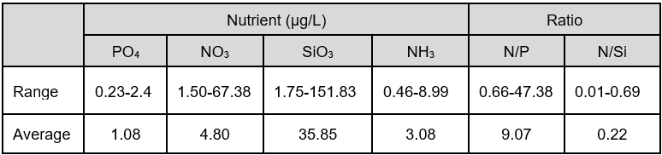
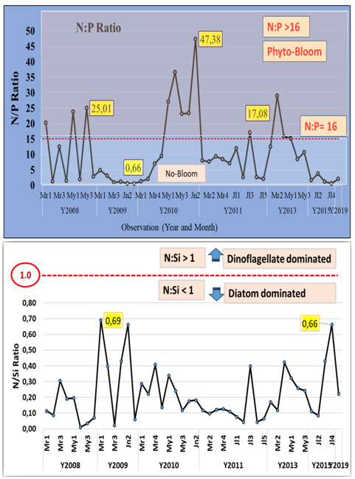

Figure 10. Temporal fluctuations of N:P and N:Si ratios and their relation to
phytoplankton dominance in Jakarta Bay. The upper panel shows the
N:P ratio, which frequently exceeds the Redfield threshold of 16:1,
indicating conditions favourable for phytoplankton blooms and nitrogen-
driven eutrophication. The lower panel illustrates N:Si ratios that remain
below 1.0 for most of the period, signalling silicate-sufficient conditions
that support diatom dominance.

4. CONCLUSION

Long-term observations from 2008 to 2019 show that Jakarta Bay consistently remains a eutrophic coastal ecosystem dominated by diatoms. Seasonal and interannual patterns in diatom community composition reliably reflect fluctuations in environmental variables, including temperature, nutrient availability, hydrological regimes, and anthropogenic stressors. Increased nutrient inputs, mainly from human activities, have caused repeated phytoplankton blooms, with genera such as Chaetoceros, Skeletonema, and Thalassiosira clearly indicating nutrient enrichment. The strong link between diatom abundance, high inorganic nitrogen levels, and elevated N:P ratios reflects the bay’s ongoing eutrophic state. Steadily low species diversity and evenness signal ecological simplification and decreased resilience, while the quick response of diatoms to nutrient changes confirms their role as sensitive bioindicators of ecosystem stress.

In summary, diatoms provide dependable early warning signals of ecosystem decline across various time frames and environmental conditions. Their community patterns reveal both sudden and gradual environmental changes, making them crucial for identifying ecological thresholds and guiding management strategies.

RECOMMENDATIONS

The dominance and behaviors of diatoms provide reliable early-warning signs of eutrophication and serve as a practical tool for monitoring environmental health in Jakarta Bay. Incorporating diatom-based assessments into long-term coastal monitoring programs would allow for early detection of nutrient imbalances and ecosystem decline. Effective management should focus on reducing human-caused nutrient inputs and restoring hydrodynamic balance to enhance ecological stability. The phytoplankton-based diagnostic framework shown in this study can act as a model for other tropical coastal ecosystems facing similar eutrophication challenges. Using diatoms as bioindicators offers a cost-effective, scientifically sound approach to guiding future coastal management and conservation efforts.

DISCLAIMER (ARTIFICIAL INTELLIGENCE)
During the preparation of the work, the authors used Grammarly as a writing assistant to review grammar and tone. After utilizing the service, the authors reviewed and edited the manuscript. All authors take full responsibility for the content of the publication.

COMPETING INTERESTS DISCLAIMER:
The authors have declared that there are no known competing financial interests, non-financial interests, or personal relationships that could have appeared to influence the work reported in this paper.

REFERENCES

- Andersen, I. M., Williamson, T. J., Gonzlez, M. J., & Vanni, M. J. (2019). Nitrate, ammonium, and phosphorus drive seasonal nutrient limitation of chlorophytes, cyanobacteria, and diatoms in a hypereutrophic reservoir. Wiley. https://doi.org/https://doi.org/10.1002/lno.11363
- Aprilia, M., Effendi, H., Hariyadi, S., & Permatasari, P. (2023). Aquatic eDNA Metabarcoding Reveals Biodiversity and Plankton Composition in River Ecosystems. Polish Journal of Environmental Studies. https://doi.org/10.15244/pjoes/163625
- Bach, L. T., Boxhammer, T., Larsen, A., Hildebrandt, N., Schulz, K. G., & Riebesell, U. (2016). Influence of plankton community structure on the sinking velocity of marine aggregates. Global Biogeochemical Cycles, 30(8), 1145–1165. https://doi.org/10.1002/2016gb005372
- Brower J.E. dan Zar J.H. Field and laboratory method for general ecology. Wm. C. Brown Pub. Dubuque. Iowa, 1989.
- Cloern, J.E., & Jassby, A.D. (2010). Patterns and scaling of phytoplankton variability in estuarine–coastal ecosystems. Estuaries and Coasts, 33, 230–241.
- Damar, A., Hesse, K.-J., Colijn, F., & Vitner, Y. (2019). The eutrophication states of the Indonesian sea large marine ecosystem: Jakarta Bay, 2001–2013. Deep-Sea Research Part II-Topical Studies in Oceanography, 163, 72–86. https://doi.org/10.1016/j.dsr2.2019.05.012
- Damar, A., Colijn, F., Hesse, K.-J., Adrianto, L., Yonvitner, Y., Fahrudin, A., et al. (2020). Phytoplankton Biomass Dynamics in Tropical Coastal Waters of Jakarta Bay, Indonesia in the Period between 2001 and 2019. Journal of Marine Science and Engineering, 8(9), 674. https://doi.org/10.3390/jmse8090674
- Duprey, N., et al. (2019). Phytoplankton responses in urbanized tropical bays. Estuarine, Coastal and Shelf Science, 222, 165–176.
- Dwiyitno, D., Barokah, G. R., Rustiani, R., & Wibowo, S. (2022). Distribution of saxitoxin-producing algae in Jakarta Bay and the implications for saxitoxin concentration in green mussel. IOP Conference Series: Earth and Environmental Science, 967, 012037. https://doi.org/10.1088/1755-1315/967/1/012037
- Firdaus, M. R., Thoha, H., Rachman, A., Fitriya, N., Sianturi, O. R., Intan, M. D. B., et al. (2023). Study of plankton in Jakarta Bay and surrounding Java Sea: a comparison of community and water quality. IOP Conference Series: Earth and Environmental Science, 1271, 012040. https://doi.org/10.1088/1755-1315/1271/1/012040
- Ge, J., Shi, S., Liu, J., Xu, Y., Chen, C., Bellerby, R. G. J., & Ding, P. (2020). Interannual Variabilities of Nutrients and Phytoplankton off the Changjiang Estuary in Response to Changing River Inputs. Wiley. https://doi.org/https://doi.org/10.1029/2019jc015595
- Genitsaris, S., Stefanidou, N., Sommer, U., & Moustakas-Gouni, M. (2019). Phytoplankton Blooms, Red Tides and Mucilaginous Aggregates in the Urban Thessaloniki Bay, Eastern Mediterranean. Multidisciplinary Digital Publishing Institute. https://doi.org/https://doi.org/10.3390/d11080136
- Glibert, P. M. (2020). Harmful algal blooms: Nutrient sources, composition, and consequences. Harmful Algae, 91, 101–108.
- Heery, E. C., et al. (2018). Urban coral reefs: Degradation and resilience of hard corals across gradients of anthropogenic stress in Jakarta Bay, Indonesia. Marine Pollution Bulletin, 135, 678–689. https://doi.org/10.1016/j.marpolbul.2018.07.052
- Hsieh C.H., K. Ishikawa, Y. Sakai, T. Ishikawa, S. Ichise, Y. Yamamoto, Ting‐Chun Kuo, Ho-Dong Park, N. Yamamura, M. Kumagai (2010). Phytoplankton community reorganization driven by eutrophication and warming in Lake Biwa. Aqua. Sci. 72:467-483. https://doi.org/10.1007/s00027-010-0149-4
- Karaouzas, I., Dimitriou, E., Tsirtsis, G., & Smeti, E. (2021). Benthic Diatoms in River Biomonitoring: Present and Future Perspectives within the Water Framework Directive. Multidisciplinary Digital Publishing Institute. https://doi.org/https://doi.org/10.3390/w13040478
- Karpowicz, M., EjsmontKarabin, J., Kozowska, J., Feniova, I. Yu., & Dzialowski, A. R. (2020). Zooplankton Community Responses to Oxygen Stress. Multidisciplinary Digital Publishing Institute. https://doi.org/https://doi.org/10.3390/w12030706
- Krisna, H. N., Maslukah, L., Wirasatriya, A., Indrayanti, E., & Widiaratih, R. (2025). Modeling Seasonal Variability of Trophic Index (TRIX) in Indonesian Waters Using PISCES Biogeochemical Data. ILMU KELAUTAN: Indonesian Journal of Marine Sciences, 30(3), 373–381. https://doi.org/10.14710/ik.ijms.30.3.373-381
- Lefebvre, A., & Dezcache, C. (2020). Trajectories of Changes in Phytoplankton Biomass, Phaeocystis globosa and Diatom (incl. Pseudo-nitzschia sp.) Abundances Related to Nutrient Pressures in the Eastern English Channel, Southern North Sea. Multidisciplinary Digital Publishing Institute. https://doi.org/https://doi.org/10.3390/jmse8060401
- Li, Y., et al. (2021). Diatom dominance as a transitional indicator of eutrophication. Marine Ecology Progress Series, 667, 15–29. https://doi.org/10.3354/meps13689
- Lin, Q., Zhang, K., McGowan, S., Capo, R., & Shen, J. (2021). Synergistic impacts of nutrient enrichment and climate change on long-term water quality and ecological dynamics in contrasting shallow lake zones. Wiley. https://doi.org/https://doi.org/10.1002/lno.11878
- Lin. L., Wang, Y., & Liu, D. (2021). Phytoplankton shifts in the Central Bohai Sea over the last 250years reflect eutrophication and input from the Yellow River. Elsevier BV. https://doi.org/https://doi.org/10.1016/j.ecolind.2021.107676
- Malone, T. C., & Newton, A. (2020). The Globalization of Cultural Eutrophication in the Coastal Ocean: Causes and Consequences. Frontiers Media. https://doi.org/https://doi.org/10.3389/fmars.2020.00670
- Marzetz, V., Spijkerman, E., Striebel, M., & Wacker, A. (2020). Phytoplankton Community Responses to Interactions Between Light Intensity, Light Variations, and Phosphorus Supply. Frontiers Media. https://doi.org/https://doi.org/10.3389/fenvs.2020.539733
- Nastiti, A. S., & Hartati, S. T. (2016). Plankton Community Structure and Aquatic Environmental Conditions in Jakarta Bay. Prohibited, 5(3), 131–150.(In: Indonesian). https://doi.org/10.15578/bawal.5.3.2013.131-150
- Newell G.E. and Newell R.C. Marine Plankton. A Practical Guide. Anchor Press, London, 1977.
- Odum E.P. Dasar-dasar ekologi: Alih bahasa Samingan, T. Edisi ketiga. Universitas Gadja Mada. Yogyakarta. Odum EP. 1971. Fundamentals of Ecology. 3rd Edition. W.B. Sounders Company. Philadelphia. London. Toronto, 1998.
- Paerl H., L. M. Valdes-Weaver, A. R. Joyner, V. Winkelmann (2007). Phytoplankton indicators of ecological change in the eutrophying Pamlico Sound system, North Carolina. Ecological Applications, 17(5) Supplement, 2007, pp. S88–S101. https://doi.org/10.1890/05-0840.1
- Paerl, H. W., & Otten, T. G. (2016). Duelling ‘CyanoHABs’: unravelling the environmental drivers controlling dominance and succession. Environmental Microbiology, 18(2), 316–324.
- Peppa, M. V., Vasilakos, C., & Kavroudakis, D. (2020). Eutrophication Monitoring for Lake Pamvotis, Greece, Using Sentinel-2 Data. Multidisciplinary Digital Publishing Institute. https://doi.org/https://doi.org/10.3390/ijgi9030143
- Puspasari, R., Hartati, S. T., & Anggawangsa, R. F. (2018). Analysis of the Impact of Reclamation on the Environment and Fisheries in Jakarta Bay. Indonesian Journal of Fisheries Policy, 9(2), 85–94. https://doi.org/10.15578/jkpi.9.2.2017.85-94
- Rodysill, J.R., et al. (2019). ENSO-driven hydrological variability in Java. Climate Dynamics, 52, 4079–4092
- Sidabutar, T., & Srimariana, E. (2020). The Connectivity of Nutrient Ratios on the Abundance of the Phytoplankton Population in Jakarta Bay. E3S Web of Conferences, 147, 02012. https://doi.org/10.1051/e3sconf/202014702012
- Sidabutar, T., Srimariana, E. S., & Wouthuyzen, S. (2021). Phytoplankton species potentially Harmful Algal Blooms (HABs) in Jakarta Bay. IOP Conference Series: Earth and Environmental Science, 744, 012077. https://doi.org/10.1088/1755-1315/744/1/012077
- Smayda, T. J. (1997). Harmful algal blooms: Their ecophysiology and general relevance to phytoplankton ecology. Limnology and Oceanography, 42(5), 1137–1153.
- Siswanto, E., et al. (2020). Monsoonal drivers of coastal productivity. Journal of Geophysical Research–Oceans.
- Spilling, K., Olli, K., Lehtoranta, J., Kremp, A., Tedesco, L., Tamelander, T., Klais, R., Peltonen, H., & Tamminen, T. (2018). Shifting Diatom Dinoflagellate Dominance During Spring Bloom in the Baltic Sea and Its Potential Effects on Biogeochemical Cycling. Frontiers Media. https://doi.org/https://doi.org/10.3389/fmars.2018.00327
- Subambang, R. B., Damar, A., Taryono, T., Kurnia, R., & Bengen, D. (2025). Optimization of institutional framework for mangrove ecosystem management in Jakarta Bay: A multi-stakeholder collaborative approach. International Journal of Innovative Research and Scientific Studies, 8(8), 10548. https://doi.org/10.53894/ijirss.v8i8.10548
- Susanti, E., Widoretno, M. T., Prihatinningtyas, E., Akhdiana, I., Riffiani, R., Henny, C., & Toruan, R. L. (2022). Phytoplankton Diversity in Jakarta Bay Estuary, Indonesia. IOP Conference Series, 1062(1), 012014–012014. https://doi.org/10.1088/1755-1315/1062/1/012014
- Ugya, A.Y., Yan, C., Chen, H., & Wang, Q. (2025). Unravelling the eco-monitoring potential of phytoplankton towards a sustainable aquatic ecosystem. Marine pollution bulletin, 216, 118021 DOI:10.1016/j.marpolbul.2025.118021
- Wentzky, V. C., Tittel, J., Jger, C. G., & Rinke, K. (2018). Mechanisms preventing a decrease in phytoplankton biomass after phosphorus reductions in a German drinking water reservoir result from more than 50 years of observation. Wiley. https://doi.org/https://doi.org/10.1111/fwb.13116
- Wijayanti, L. A. S., Pratama, G. B., Utama, M. I. C., Umbekna, S., Nugraha, T. A., et al. (2025). Phytoplankton Functional Types in Tropical Hypertrophic Waters: A Case Study of the Coastal Waters of Jakarta Bay, Indonesia. Environmental Quality Management. https://doi.org/10.1002/tqem.70173
- Yamaji I. E. Illustration of the Marine Plankton of Japan. Houkusho. Osaka, Japan, 1966.
- Zhang, S., Xu, H., Zhang, Y.-F., Li, Y., Wei, J., & Pei, H. (2020). Variation of phytoplankton communities and their driving factors along a disturbed temperate river-to-sea ecosystem. Ecological Indicators, 118, 106776–106776. https://doi.org/10.1016/j.ecolind.2020.106776
- Zhang, Y., Gao, W., Li, Y., Jiang, Y., Chen, X., Yao, Y., Messyasz, B., Yin, K., He, W., & Chen, Y. (2021). Characteristics of the Phytoplankton Community Structure and Water Quality Evaluation in Autumn in the Huaihe River (China). Multidisciplinary Digital Publishing Institute. https://doi.org/https://doi.org/10.3390/ijerph182212092
- Zhang, Y., et al. (2022). Hydrodynamic controls on phytoplankton succession in monsoon-influenced estuaries. Estuarine, Coastal and Shelf Science, 271, 107897. https://doi.org/10.1016/j.ecss.2022.107897

